https://www.google.ie/maps/place/Letter+Lower,+Co.+Cork/@51.5628999,-9.7606008,16z/data=!3m1!4b1!4m2!3m1!1s0x484583af7861609f:0x51bba18059bc3c3b

Kilcrohane seems to be an outlier for the Tobins. The name is more usually associated with Wet Wateford.

Perhaps there may be a link here, From the Municipal Rolls we learn that in 1558 the principal families in Youghal and district were—Angus, Blewett (Bluett), Fforest, Gough, Portingale, Ronayne, Shryes, Uniacke and Tobyn. The majority of these are now extinct.

Some of the townlands in Kilcrohane vested in the College of St. Marys Youghal maybe a harp back to the Normans.

The Tobins of Kilcrohane, West Cork, from Catholic Church Records, Muintervara from 1819, the Seven Sisters of Gloun early 19th Century and John F Kennedy Connection, 1740s Lease of Donemark Mills, 1820s Lease of Part of Whiddy Island, Richard 'King' Tobin and Lord Bantry, Road Contractors, Richard Tobin, Letter, Member Bantry Board of Guardians.

There was a certain amount of difficulty associated with the Whiteboys in the 1820s at the western end of the Muintervara peninsula. The times were unsettled with a slump caused by the end of the Napoleonic wars. This was on Lord Bantry’s estate which was managed by Mr Bird. Lord Bantry remarked that Tobin of Lower Letter had done more than all the magistrates to root out ‘Whiteboyism’ and that he was ‘King of the West’ after which he was known as ‘King Tobin’.

A remarkable character formerly lived in the Sheep’s Head district, and is not many years dead. He lived to the great age of ninety-six years, and was well known for three quarters of a century as the King of the West. I have often conversed with him, and heard him relate how he watched, when a boy, the French fleet sailing up Bantry Bay. King Tobin, or the ‘King of the West’, although uneducated, was a very intelligent, shrewd, honest man. He was one of Nature’s noblemen. His son, the present King of the West, a P.L.G. of the Bantry Union, farms extensive tracts of land which have been held by his ancestors under the Evanson family, for generations.

It was said locally of the Tobins that they would be seen on a horse, with a gun and a dog.

The Kilcrohane 'King', Tobins were part of a network of prosperous Catholic families in the general area. these would include The McCarthys and Murnanes from 1820s leases of Hutchinson estate. The Catholic Shannons who married into the Tobins would be in the category, there were Wards Minor Landlords of Glenlough and Droumatinaheen early 1800s. The Rosses of Glendart and Crowleys of Ballyourane, Caheragh. These families even though far apart tended to inter marry and as the 19th century went up produced clergy, teachers and later professionals.

Applications to set up National Schools Durrus, West Cork 1830.
Father Quinn applied from Durrus and the form is in the National Archive. The Durrus school set up in 1810 was in the grounds of the Chapel where the National School is located. The old church was on the site until it was replaced c 1900. Father Quinn’s application 16th November 1830 ED1/13/74/2, signed by for Roman Catholics Richard O’Donovan, Timothy O’Donovan, Richard Tobin, Edmond Tobin, Daniel Daly, Richard O’Donovan, John Murphy, John Carthy, Thomas Cormack?, Elias Roycroft, Andrew Caverly, Richard Caverly, Protestants E. Evanson, Richard L. Blair, Thomas Ferguson, Thomas Duklow, Charles Ducklow, John Ducklow. Rev. Alcock of the Church of Ireland was asked to consent but declined but his parishioners signed.
Grand Jury Presentments:

Bantry:

1838, Denis Murphy, Senior Denis Murphy Junior, Richard and Thomas Tobin to build a bridge over Thaignacrusha river on road from Bantry to Skibbereen in and dividing the townlands of Droumclough and Boulhennagh, £180, (one of largest bridge contracts)

Richard Tobin Junior, probably in the 1850s in Durrus but from Letter, Kilcrohane, was probably a member of the Bantry Board of Guardians from the late 1850s and represented Cess Payers at meetings of Magistrates. One of the Richard Tobins was probably the contractor with Thomas Donovan who got the contract for the road repair from Durrus to Kilcrohane 1869 for £2.

Contract July 1864 for new road from Skibbereen to Dunmanway and Bantry and also Inchigeela to Richard Tobin, Daniel Gallagher, James Fitzgerald for £272. The Tobins were intermarried with the Baltimore Fitzgeralds who were the same family as JF Kennedy's mothers. The Kilcrohane Gallaghers were also related by marriage. Skibbereen Eagle 16th July 1864.

In the family lore it is believed that an early form of gelignite was used in the roadworks. Many of the extended family were later to go to the USA and engage in road works.

A 3 year contract from O'Donovan's Cove to Ahakista with George Bird (also Agent to Lord Bantry) to keep road in repair: Skibbereen Eagle 17th January 1863.

In Kilcrohane Black Jack Mahony of Killeen, had the contract for burying the dead of the area during the Famine. Frank O'Mahony Solicitor Bantry would be his grandson. His brother Florence O’Mahony married Kate Tobin of Lower Letter (one of the Kings). ‘King’ Tobin was the local agent for Lord Bantry, a road contractor and property owner.
1830

Father Quinn's application for National School 16th November 1830 ED1/13/74/2, signed by for Roman Catholics Richard O'Donovan, Timothy O'Donovan, Richard Tobin, Edmond Tobin, Daniel Daly, Richard O'Donovan, John Murphy, John Carthy, Thomas Cormack?, Elias Roycroft, Andrew Caverly, Richard Caverly, Protestants E. Evanson, Richard L. Blair, Thomas Ferguson, Thomas Duklow, Charles Ducklow, John Ducklow. Rev Alcock of the Church of Ireland was asked to consent but declined but his parishioners signed.

1841 Election:

For O’Connell/Roche, mostly £10 freeholders, some registered since 1835.

Edmund Tobin, Gortavollig, probably related to extended ’King’ Richard Tobin family he was local agent to Lord Bantry active in land dealings, road building, son Richard Junior businessman in Durrus.

Thomas Tobin, Reenavannagh Whiddy Island

Patrick Tobin, Gortavollig, gave evidence to enquiry Bantry 1844. Witnesses at Bantry (Rev Christopher Freeman Curate, Richard White Esq. Landlord, Michael Murphy Miller Middleman Donemark, William Neale, Rev. Somers Payne, Land Agent, John O'Connell Esq., Rev. Thomas Barry Parish Priest, Samuel Hutchins Esq. Landlord, Alexander Donovan, Patrick Tobin Farmer Gortavallig Kilcrohane, Timothy Connor, Cornelius Connor, Cornelius Henry Donovan, into Her Majesty's Commissioners into The Law and Practice of Occupation of Land in Ireland. His Landlord Richard O'Donovan, resident holds from Congreve in Waterford another lot from Lord Riversdale

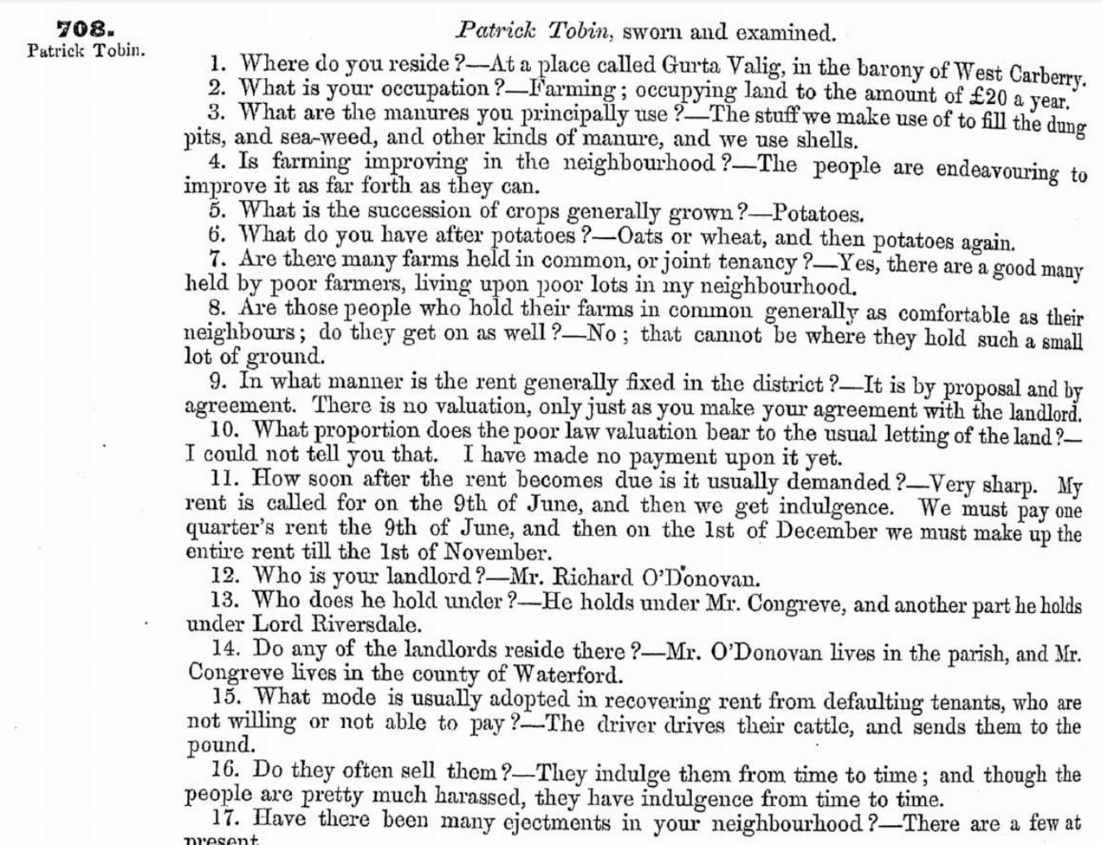
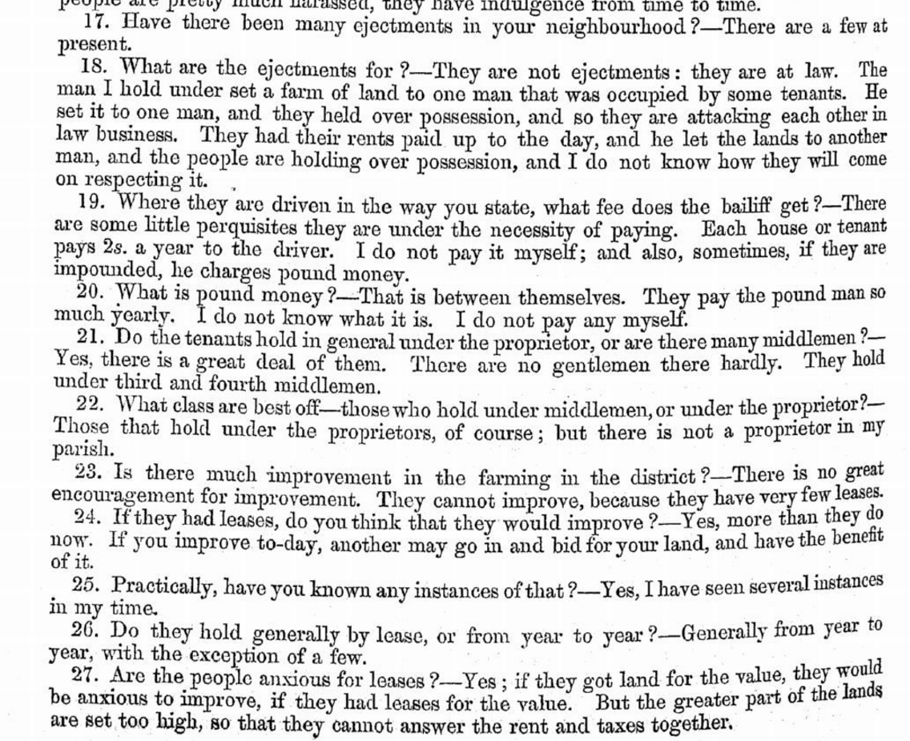
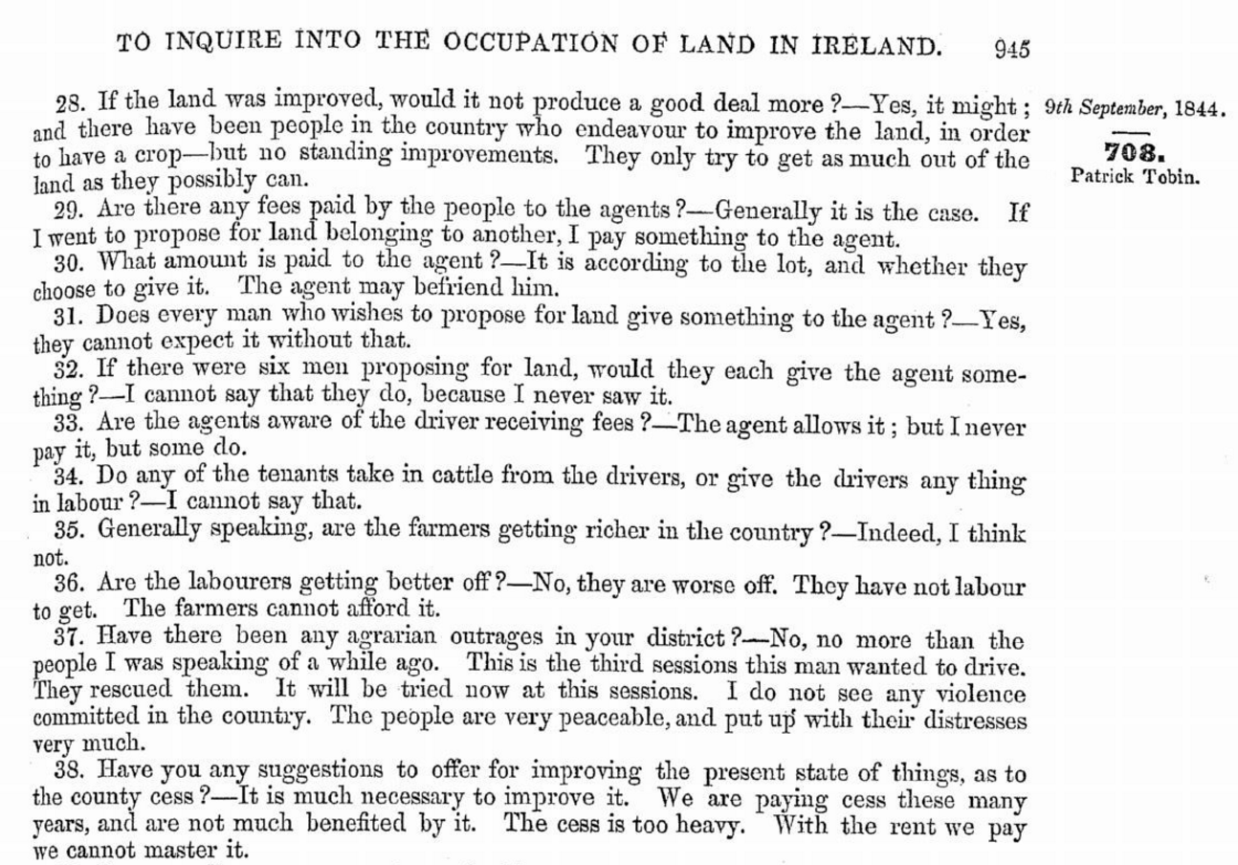

There is were also Tobins members of the Church of Ireland in Fahane possibly associated with the Atteridges.
The local O'Donovan Landlord Family:

https://docs.google.com/document/d/1eq_IayaxdUyWZWbpDf6LWlLNg7o-3tNJiqPGYIALy80/edit

Reverend/Father Daniel McCarthy and the Blairs:

https://docs.google.com/document/d/1BnjAwZ6eFk_0sTMsjxYBo3YFQLNqJ4J2utWIftpJXqs/edit

In the surname distribution post 1845 in the Registration districts. The name is clearly based in the West Waterford, South Tipperary and South Kilkenny areas. There are outliers in Clonakilty and Bantry. The Bantry ones are most likely based in Kilcrohane or people who were originally based there.

There are long standing links between Waterford and Kilcrohane. In the 1780s ledgers of the Cathedral of St.Finbarrs of Cork there are townland of Kilcrohane listed. This probably arises from the Norman Monastery of St. Catherines? of Waterford having an interest which later transferred to the Earl of Cork.

From the Municipal Rolls we learn that in 1558 the principal families in Youghal and district were—Angus, Blewett (Bluett), Fforest, Gough, Portingale, Ronayne, Shryes, Uniacke and Tobyn. The majority of these are now extinct.

Some of the townlands in Kilcrohane vested in the College of St. Mary's Youghal maybe a harp back to the Norman.

In family lore the seven Tobin sisters were from Gloun in the farm currently farmed by Charlie Donovan. One of them married a Fitzgerald of Baltimore and they are the ancestors of US President JF Kennedy's mother of Boston.

In the Kenmare Estate records of the 1740s a Richard Tobin is leasing the Mills of Donemark outside Bantry. There is a later lease on the Bantry Estate c 1820 involving the Tobins. Interestingly one of the lives named is one of the children of Timothy O'Donovan, of O'Donovan's Cove, a Catholic Landlord and Magistrate.

In the 19th century the Tobins of Kilcrohane were the local agents to that part of the Bantry Estate. One, the 'King' became notorious. In one reputed instance he cleared an area of the smaller tenants. One of their descendants who emigrated to America, did very well and had a lifetime ambition to urinate on the grave of the 'King', in later life he succeeded in doing so.

Richard Tobin of Durrus originally Kilcrohane was in the late 19th century a very successful businessman, with a hotel in Durrus probably now Rosses, landing sea sand opposite the Good Time Cafe and paying royalties to the Bandon Estate, He was also renting large tracts of land. In the 1901 census his daughter was an art student most unusual for the time.

He made his money in the Australian Gold Rush (according to local lore) in the 1860s and returned. His family is most likely associated with the memorials in Durrus Church built 1900 and the enormous Celtic Cross Tombstone just opposite the church. He may also be of the same.

ntial tenant and also paying royalties for landing sea sand (At the Sand Quay opposite the 'Good Times Cafe':

The name is clearly based in the West Waterford, South Tipperary and South Kilkenny areas. There are outliers in Clonakilty and Bantry. The Bantry ones are most likely based in Kilcrohane or people who were originally based there.
There are long standing links between Waterford and Kilcrohane. In the 1780s ledgers of the Cathedral of St.Finbarrs of Cork there are townland of Kilcrohane listed. This probably arises from the Norman Monastery of St. Catherines? of Waterford having an interest which later transferred to the Earl of Cork.
In family lore the seven Tobin sisters were from Gloun in the farm currently farmed by Charlie Donovan. One of them married a Fitzgerald of Baltimore and they are the ancestors of US President JF Kennedy’s mother of Boston.
In the Kenmare Estate records of the 1740s a Richard Tobin is leasing the Mills of Donemark outside Bantry. There is a later lease on the Bantry Estate c 1820 involving the Tobins. Interestingly one of the lives named is one of the children of Timothy O’Donovan, of O’Donovan’s Cove, a Catholic Landlord and Magistrate.

King Tobin from c 1780 began buying farms, 9 in all. Tradition has it that the King built the Signal Tower. Re building the tower this could be true as there are loads of examples of the Tobins contracting for the Grand Jury not just in Muintervara but well outside their home place.

In the 19th century the Tobins of Kilcrohane were the local agents to that part of the Bantry Estate. One, the ‘King’ became notorious. In one reputed instance he cleared an area of the smaller tenants. One of their descendants who emigrated to America, did very well and had a lifetime ambition to urinate on the grave of the ‘King’, in later life he succeeded in doing so.
Richard Tobin of Durrus originally Kilcrohane was in the late 19th century a very successful businessman, with a hotel in Durrus probably now Rosses, landing sea sand opposite the Good Time Cafe and paying royalties to the Bandon Estate, He was also renting large tracts of land. In the 1901 census his daughter was an art student most unusual for the time.
He may have made his money in the Australian Gold Rush (according to local lore) in the 1860s and returned. His family is most likely associated with the memorials in Durrus Church built 1900 and the enormous Celtic Cross Tombstone just opposite the church. He may also be of the same.

1860. The Pope’s Irish Brigade and Named Subscribers to Papal Tribute from Bantry, Durrus, Kilcrohane, Caheragh, Drimoleague. Included in Richard Tobin for 5 shillings
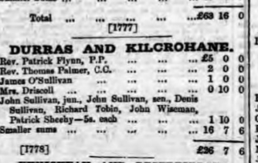

Sale of Charles Evanson Junior Estate 1860 Richard Tobin listed as tenant:

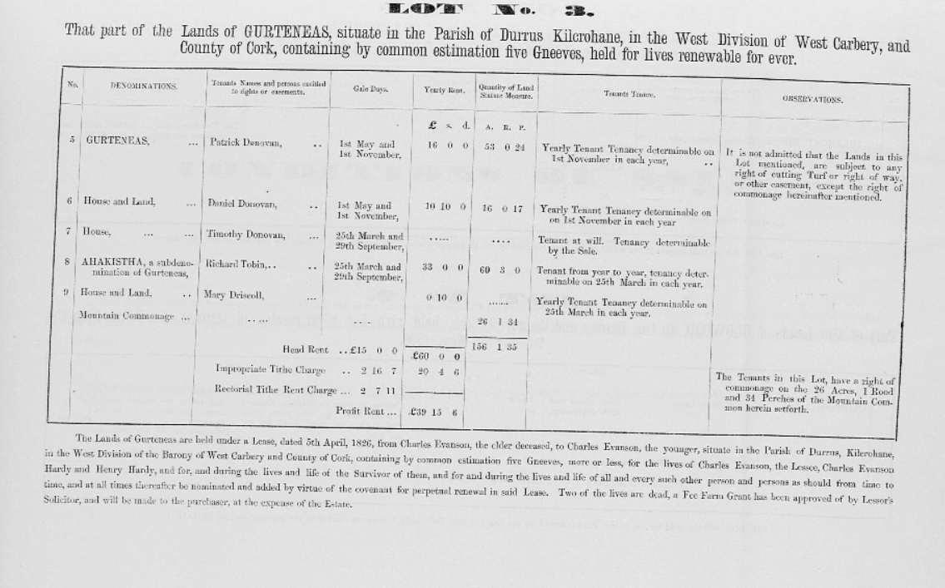
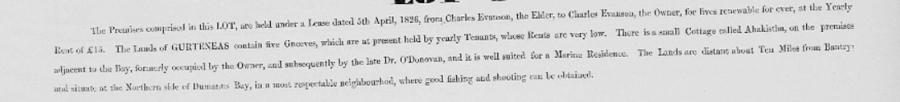
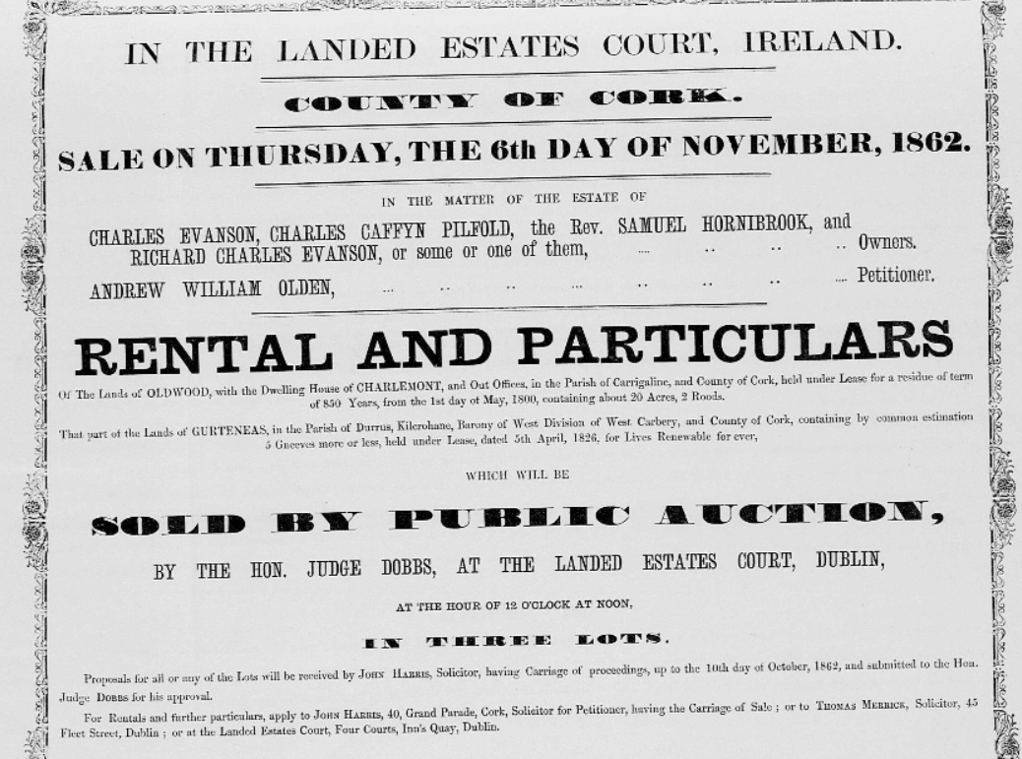

Kilcrohane, the Church of Our Lady of the Sea was opened in 1897; it was built on a site donated by the landlord Mary Furlong and tenant James Tobin.

In July 1908 the owner of the leasehold interest in Durrus Dispensary house Mr Tobin offered to sell his interest to the Bantry Board of Guardians for £350 and the owner of the freehold the Earl of Bandon would sell for £112, the property was held on a 99 year lease from 1895 and Mr Tobin’s tenant Dr Levis was paying a rent of £22.

In December 1915 there was an application by James Gilhooley MP to co-opt a member for Durrus West arising from the resignation of J Hurley, Ballycomane. Bert Dukelow Durrus was nominated as it was said that there should be a Protestant representative, there was a vote as Daniel Coakley was also nominated and Jane Tobin’s name was mentioned but her nomination did not proceed. On a vote Bert Dukelow was elected.

Cork Examiner 08 June 1860, Pope’s Tribute

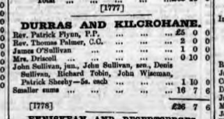

Richard Tobin (1832-1904), Durrus Church Yard

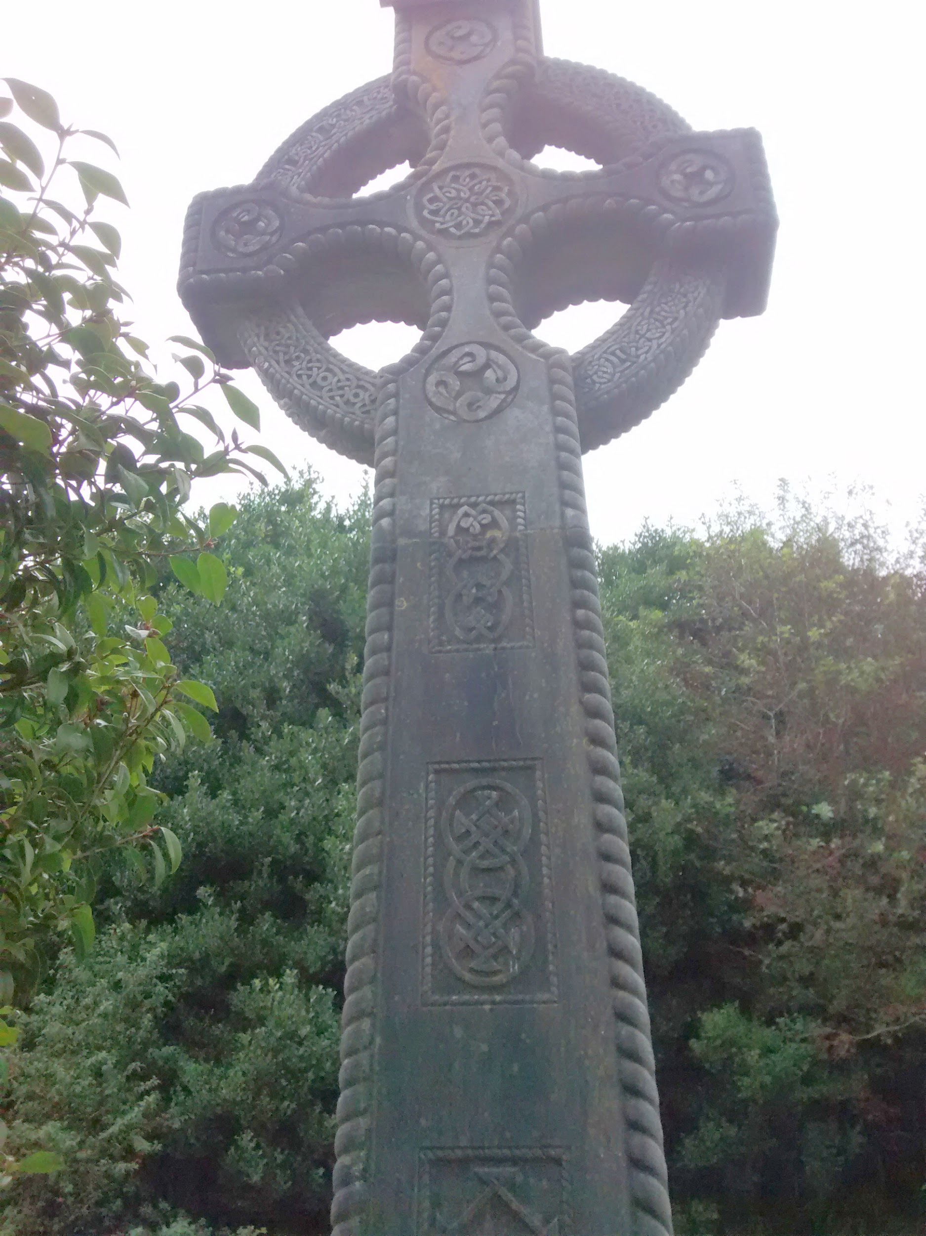

Inscription in Old Irish Unusual for Period:

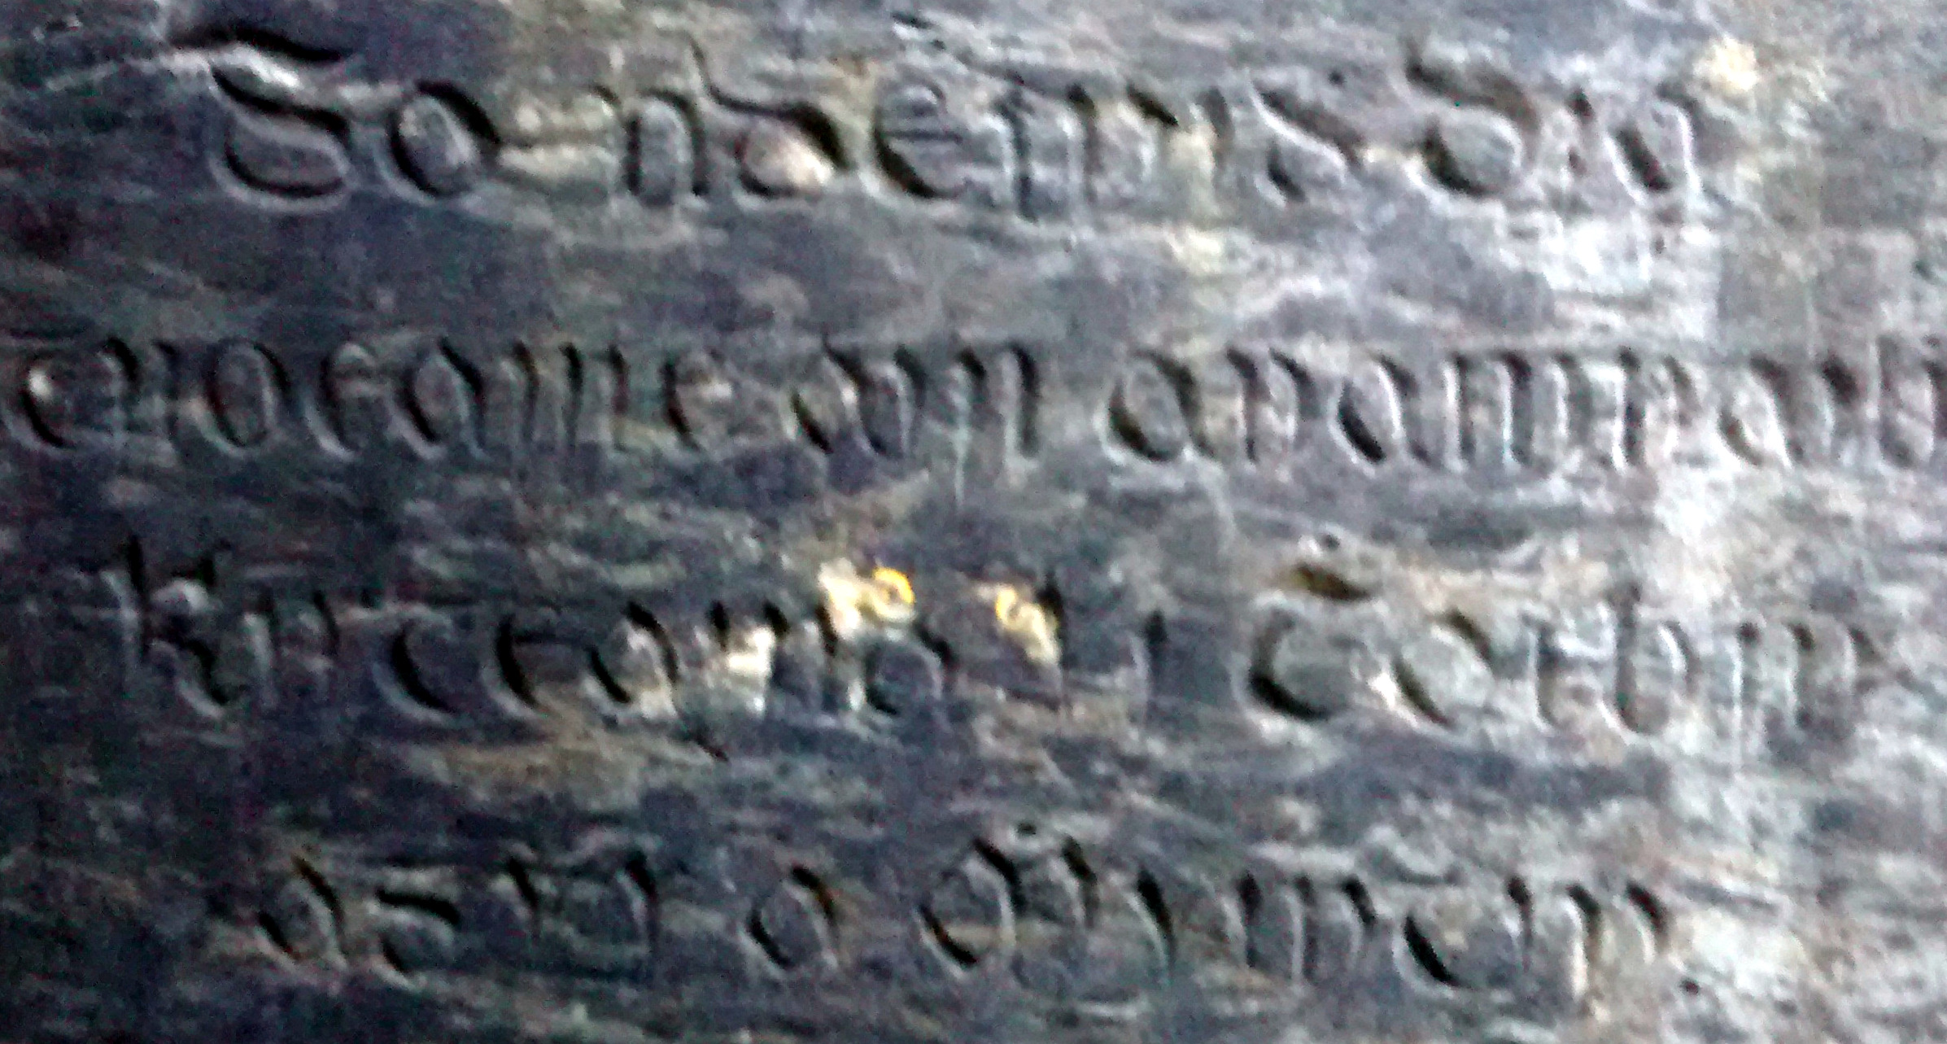

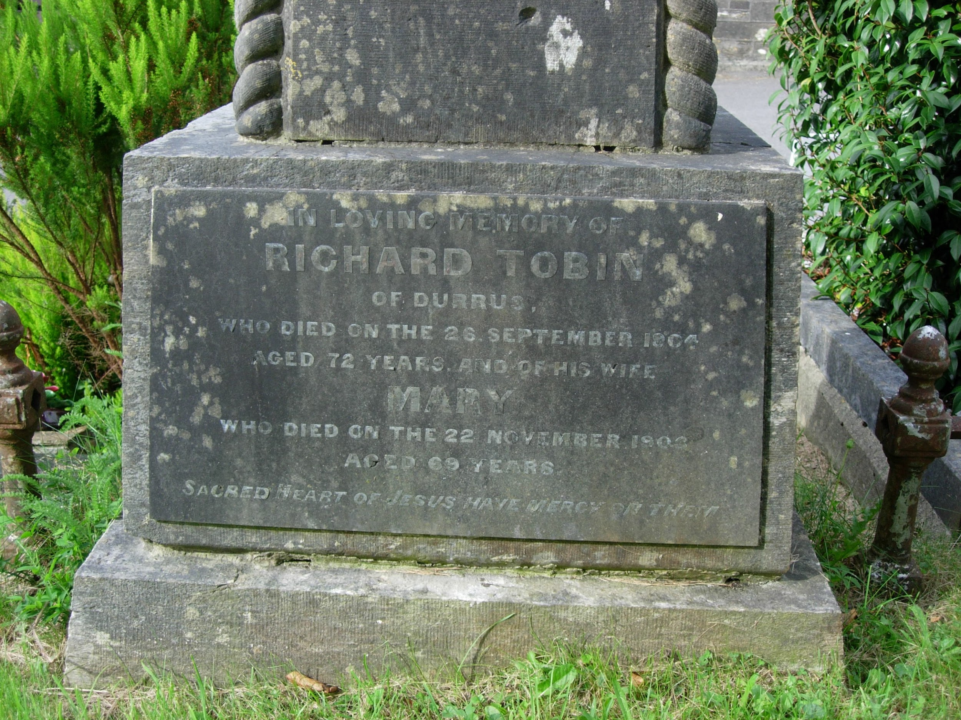

Memorial Tobin Plates Durrus Church 1900

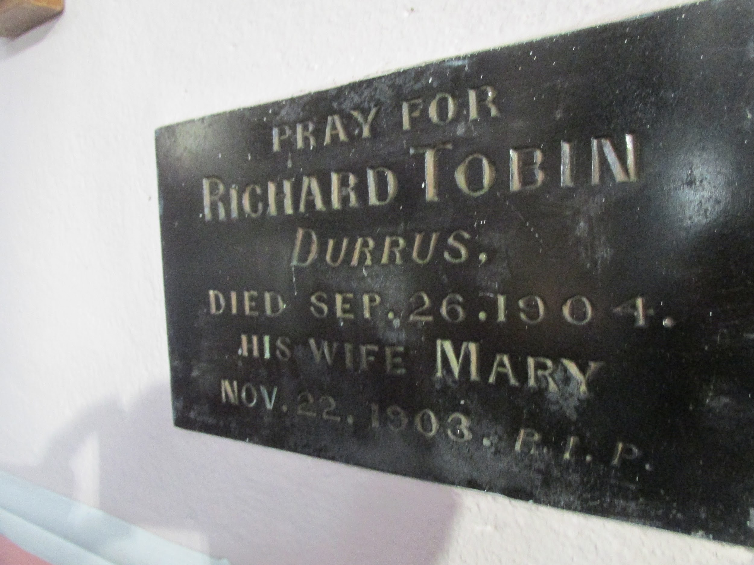
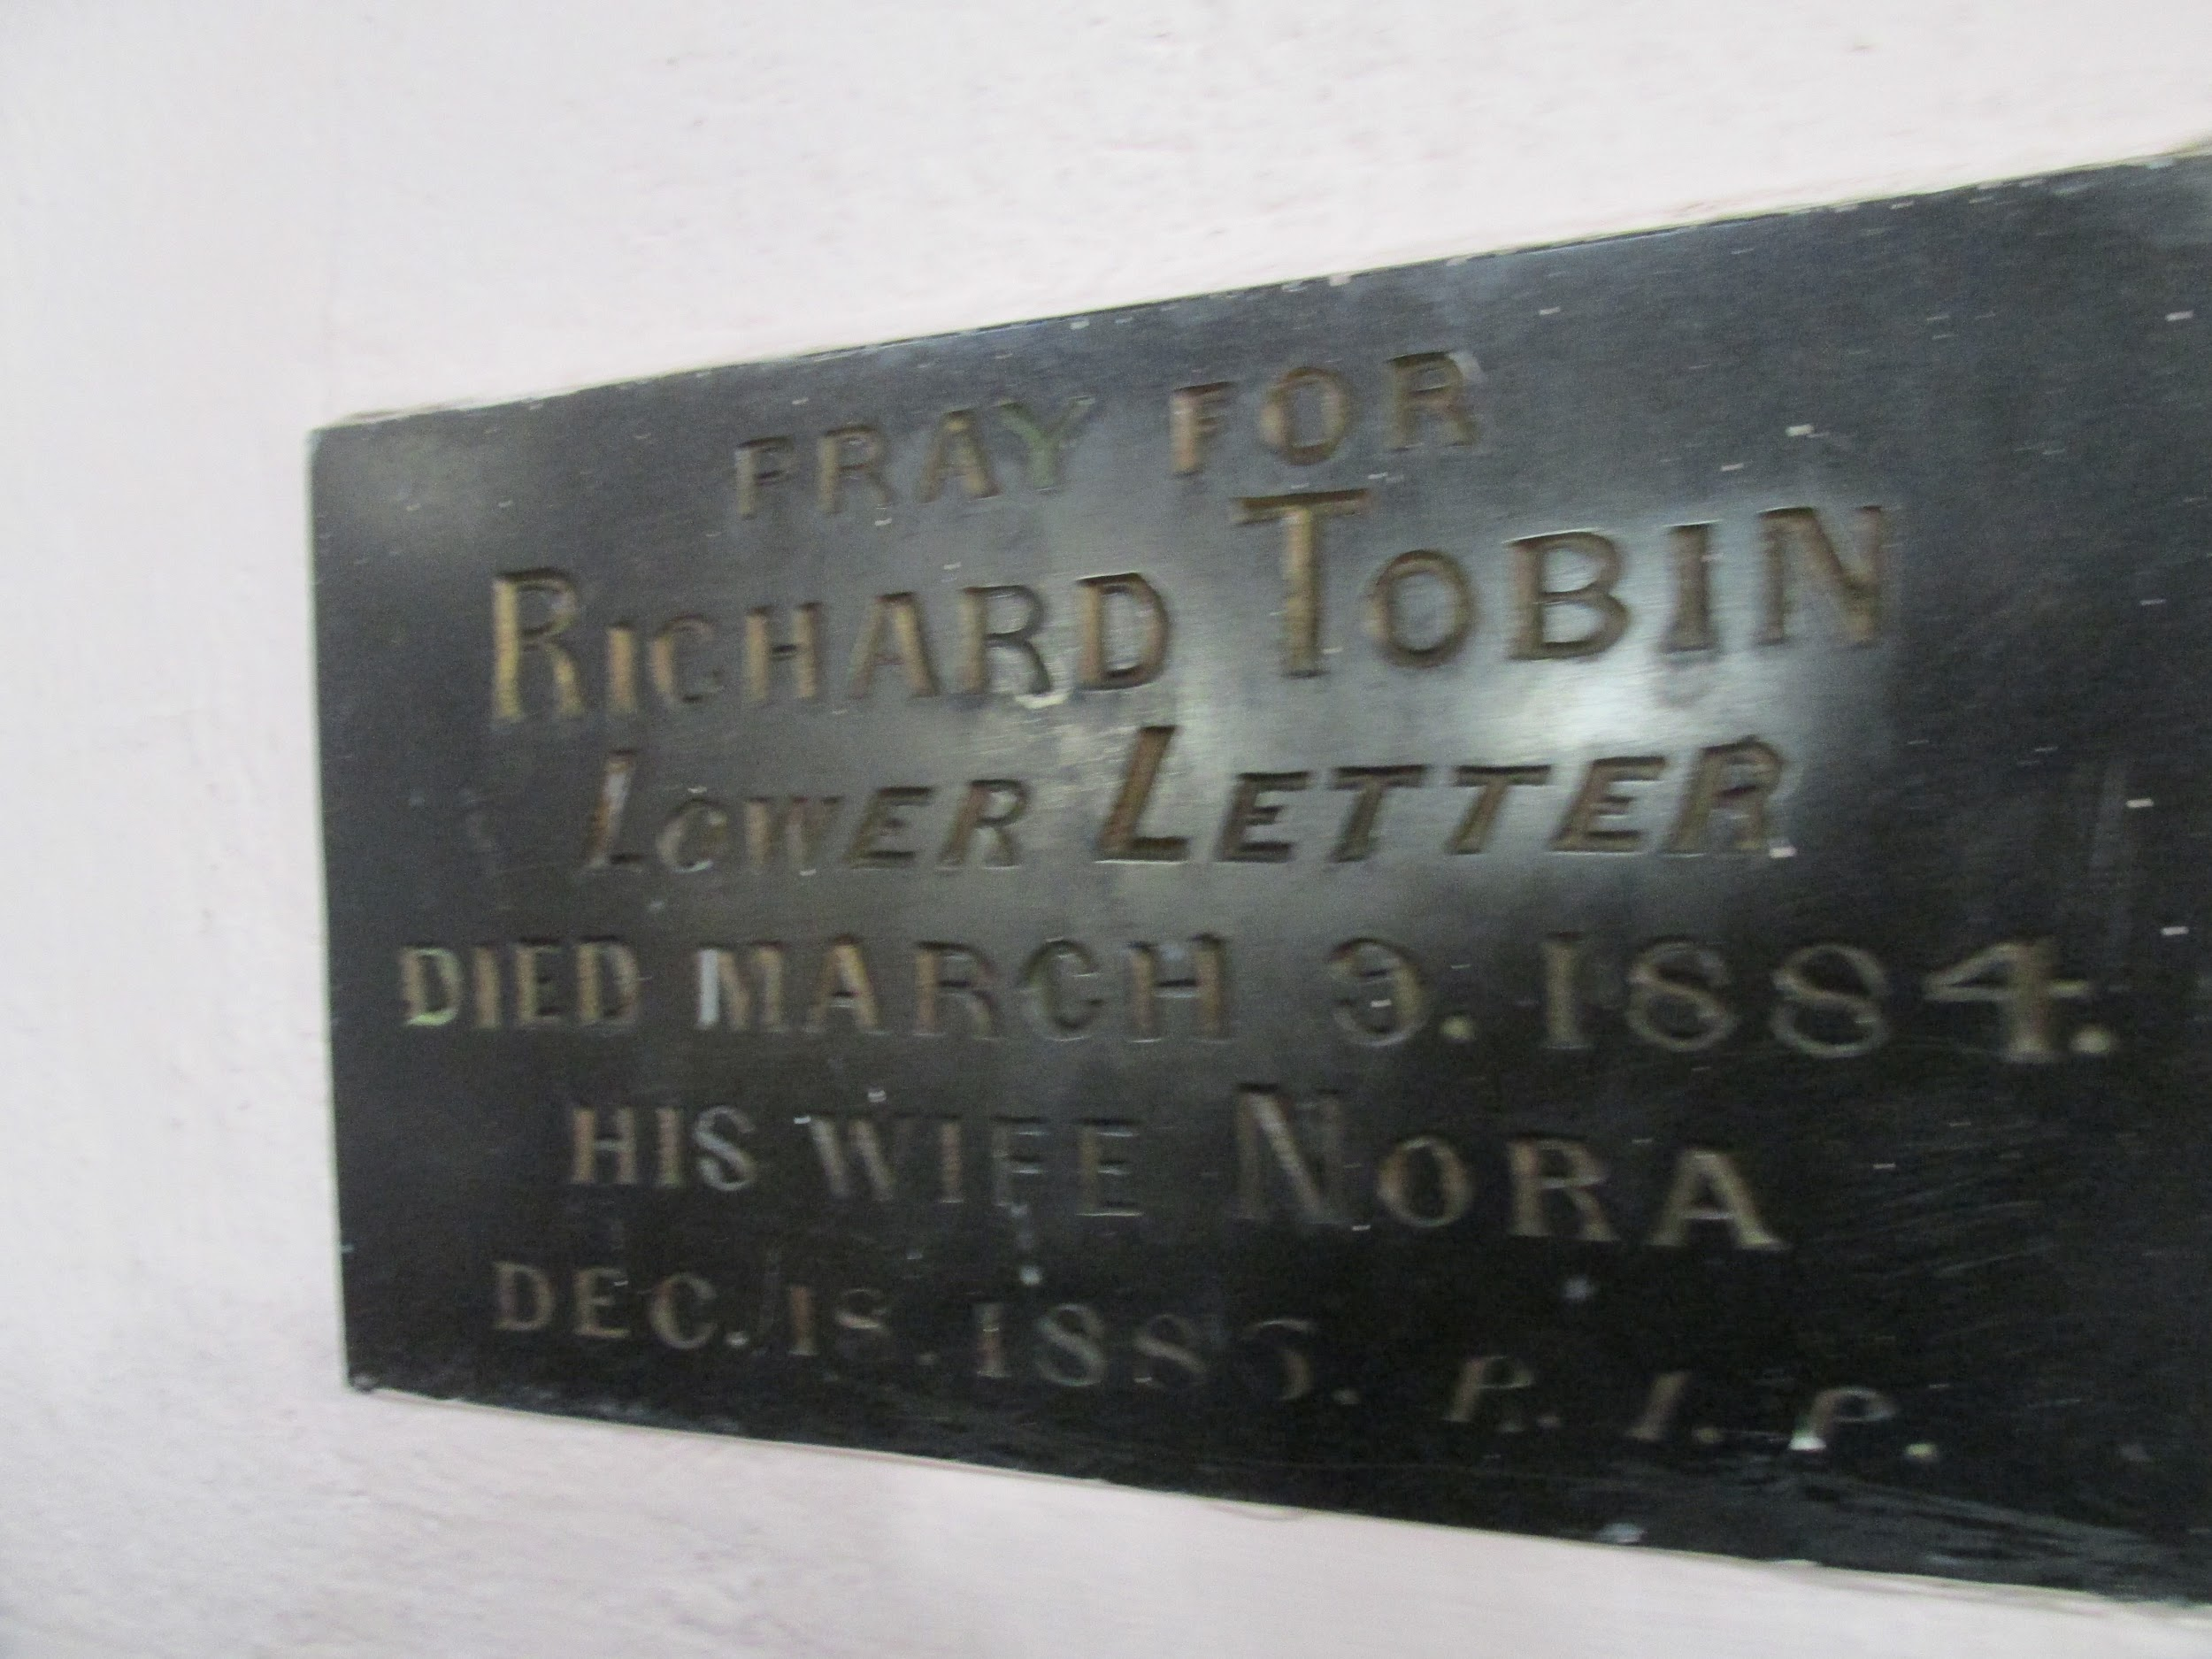
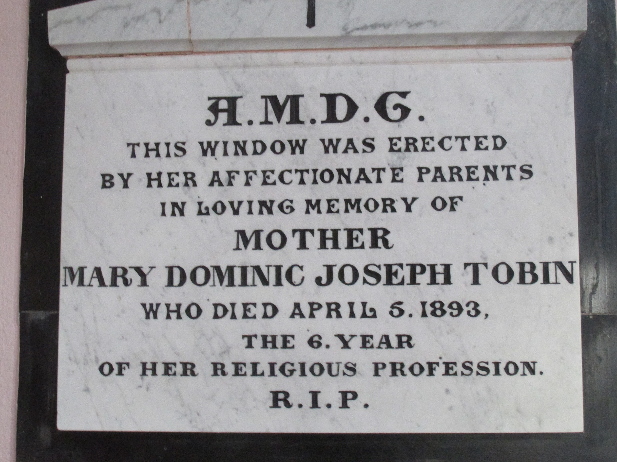
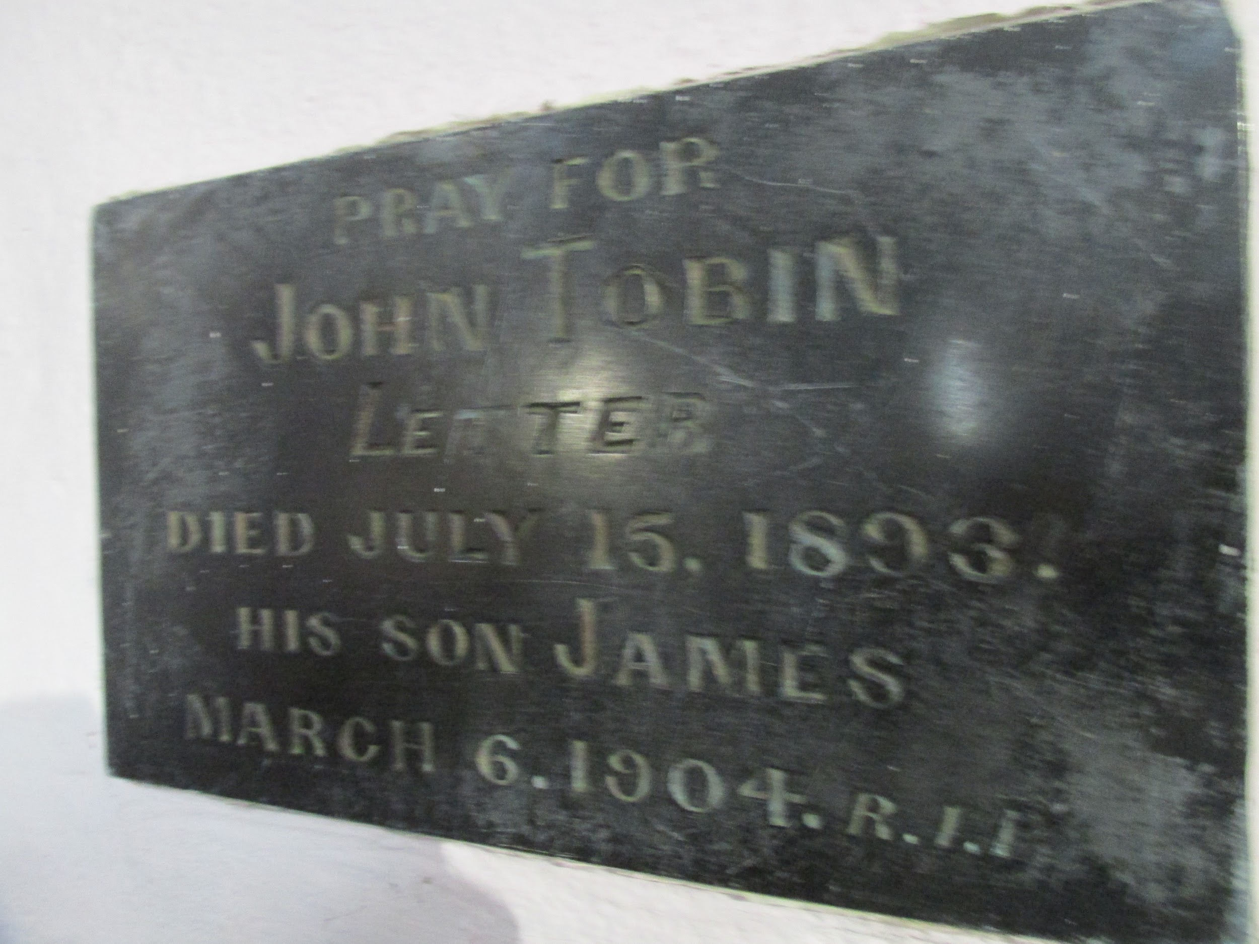
Memorial Plates KIlcrohane Church From 1900

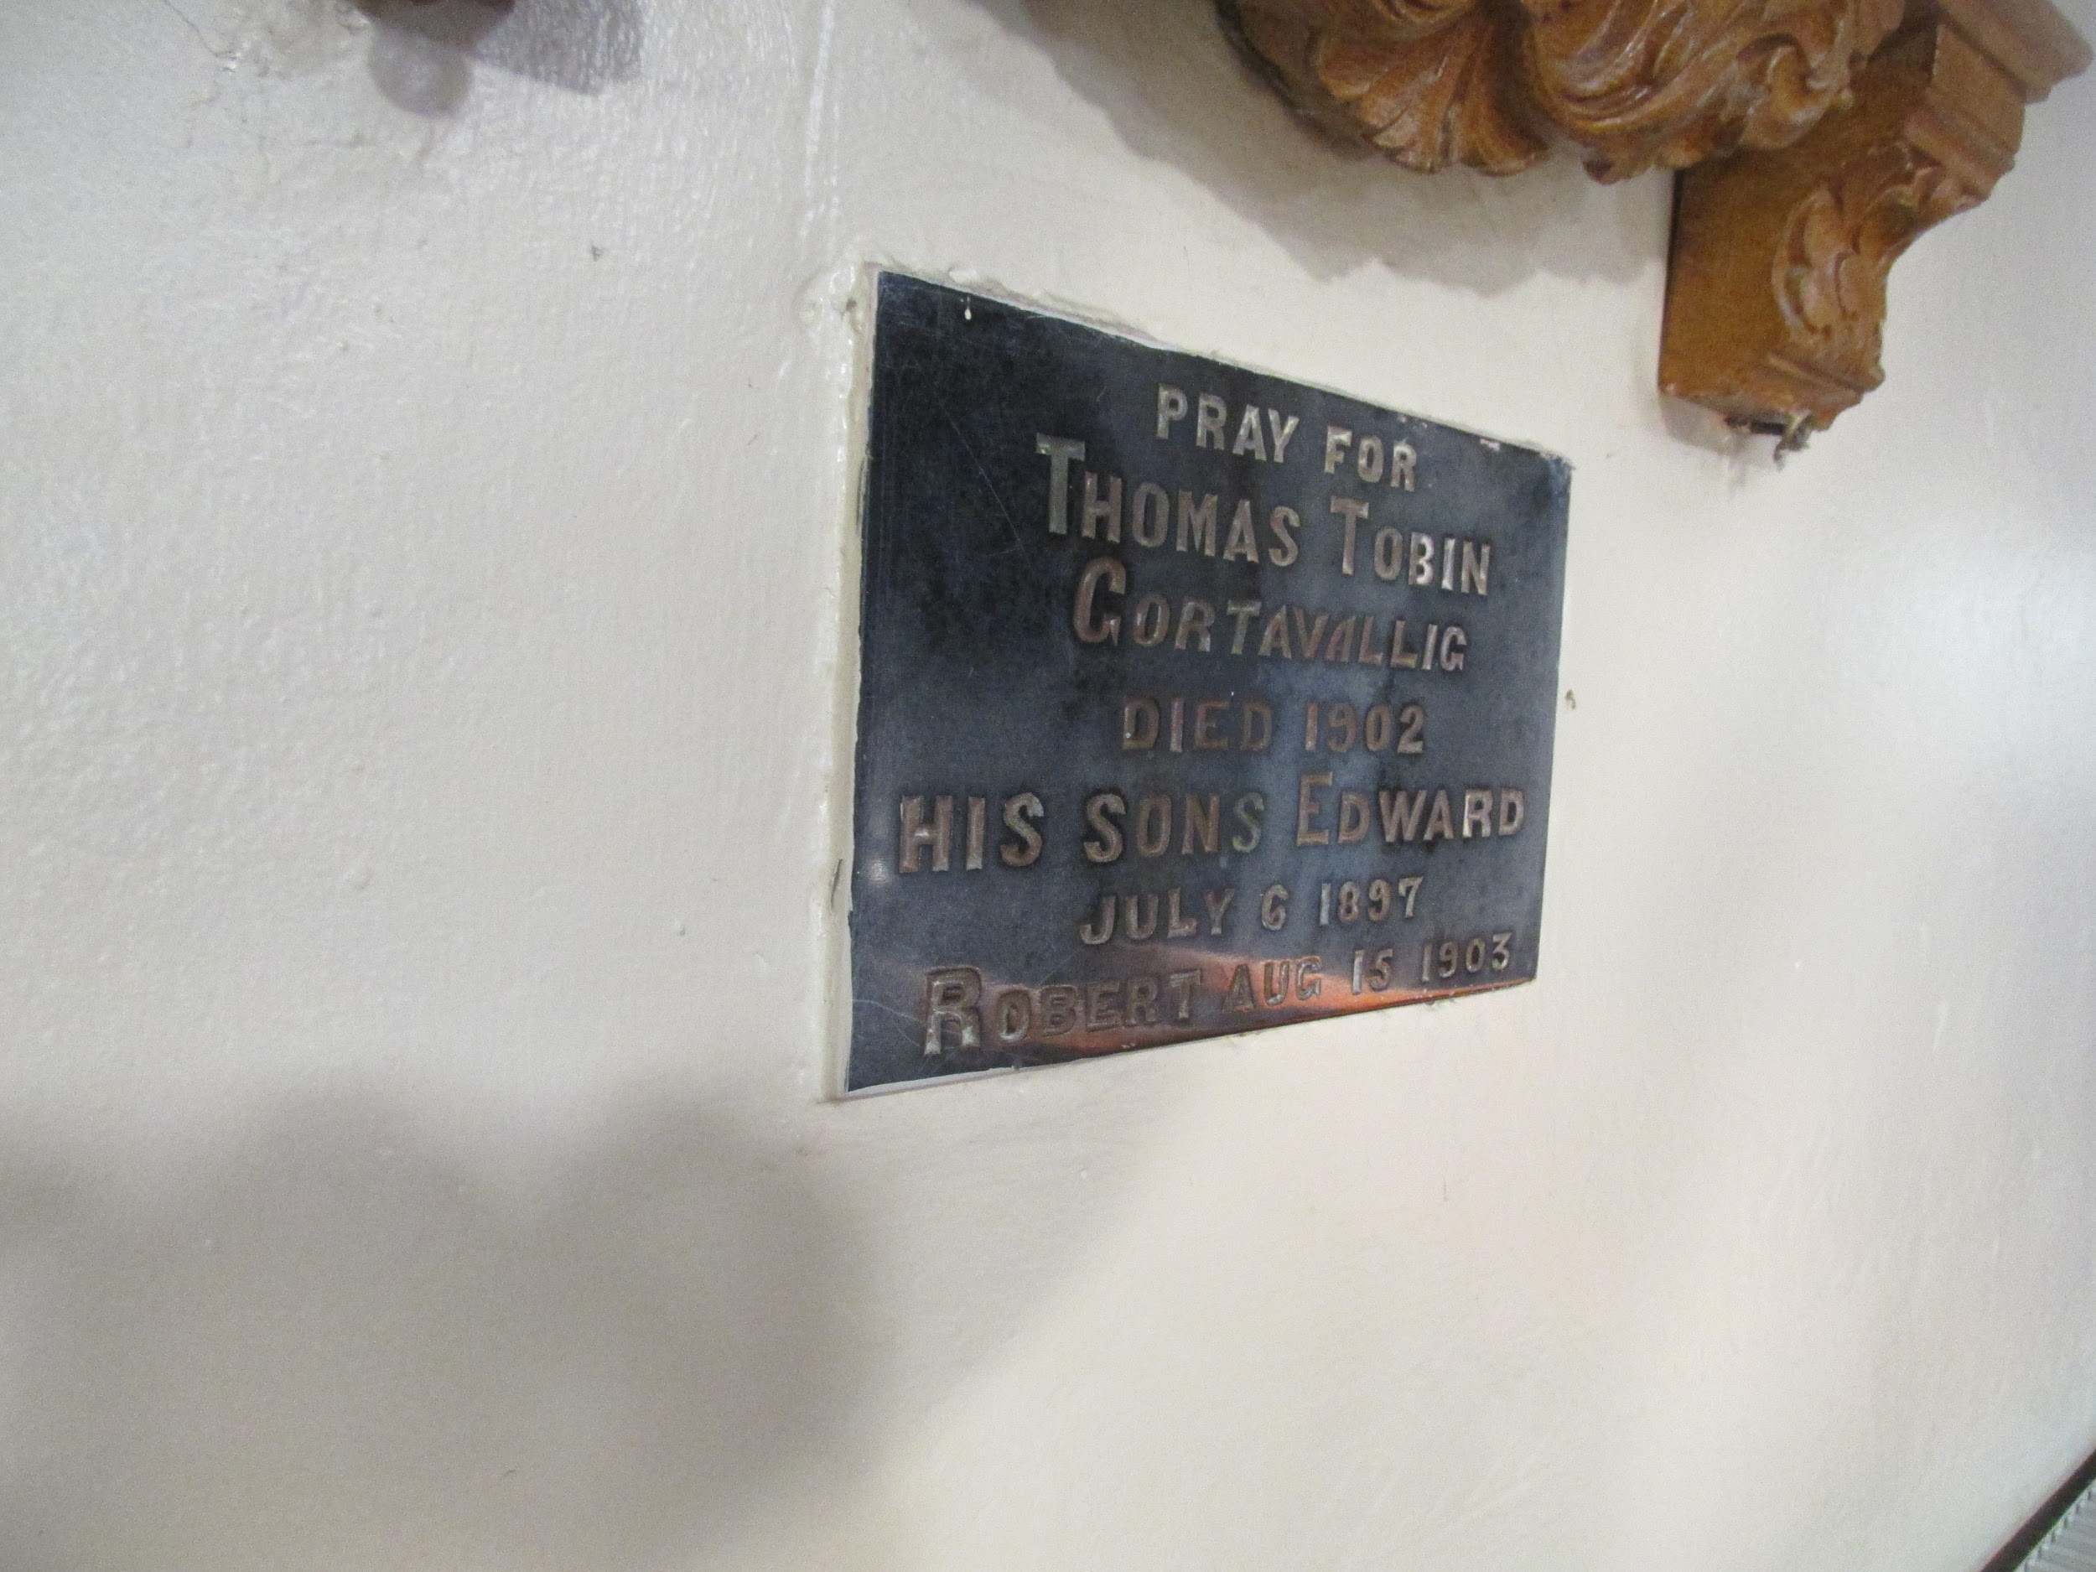
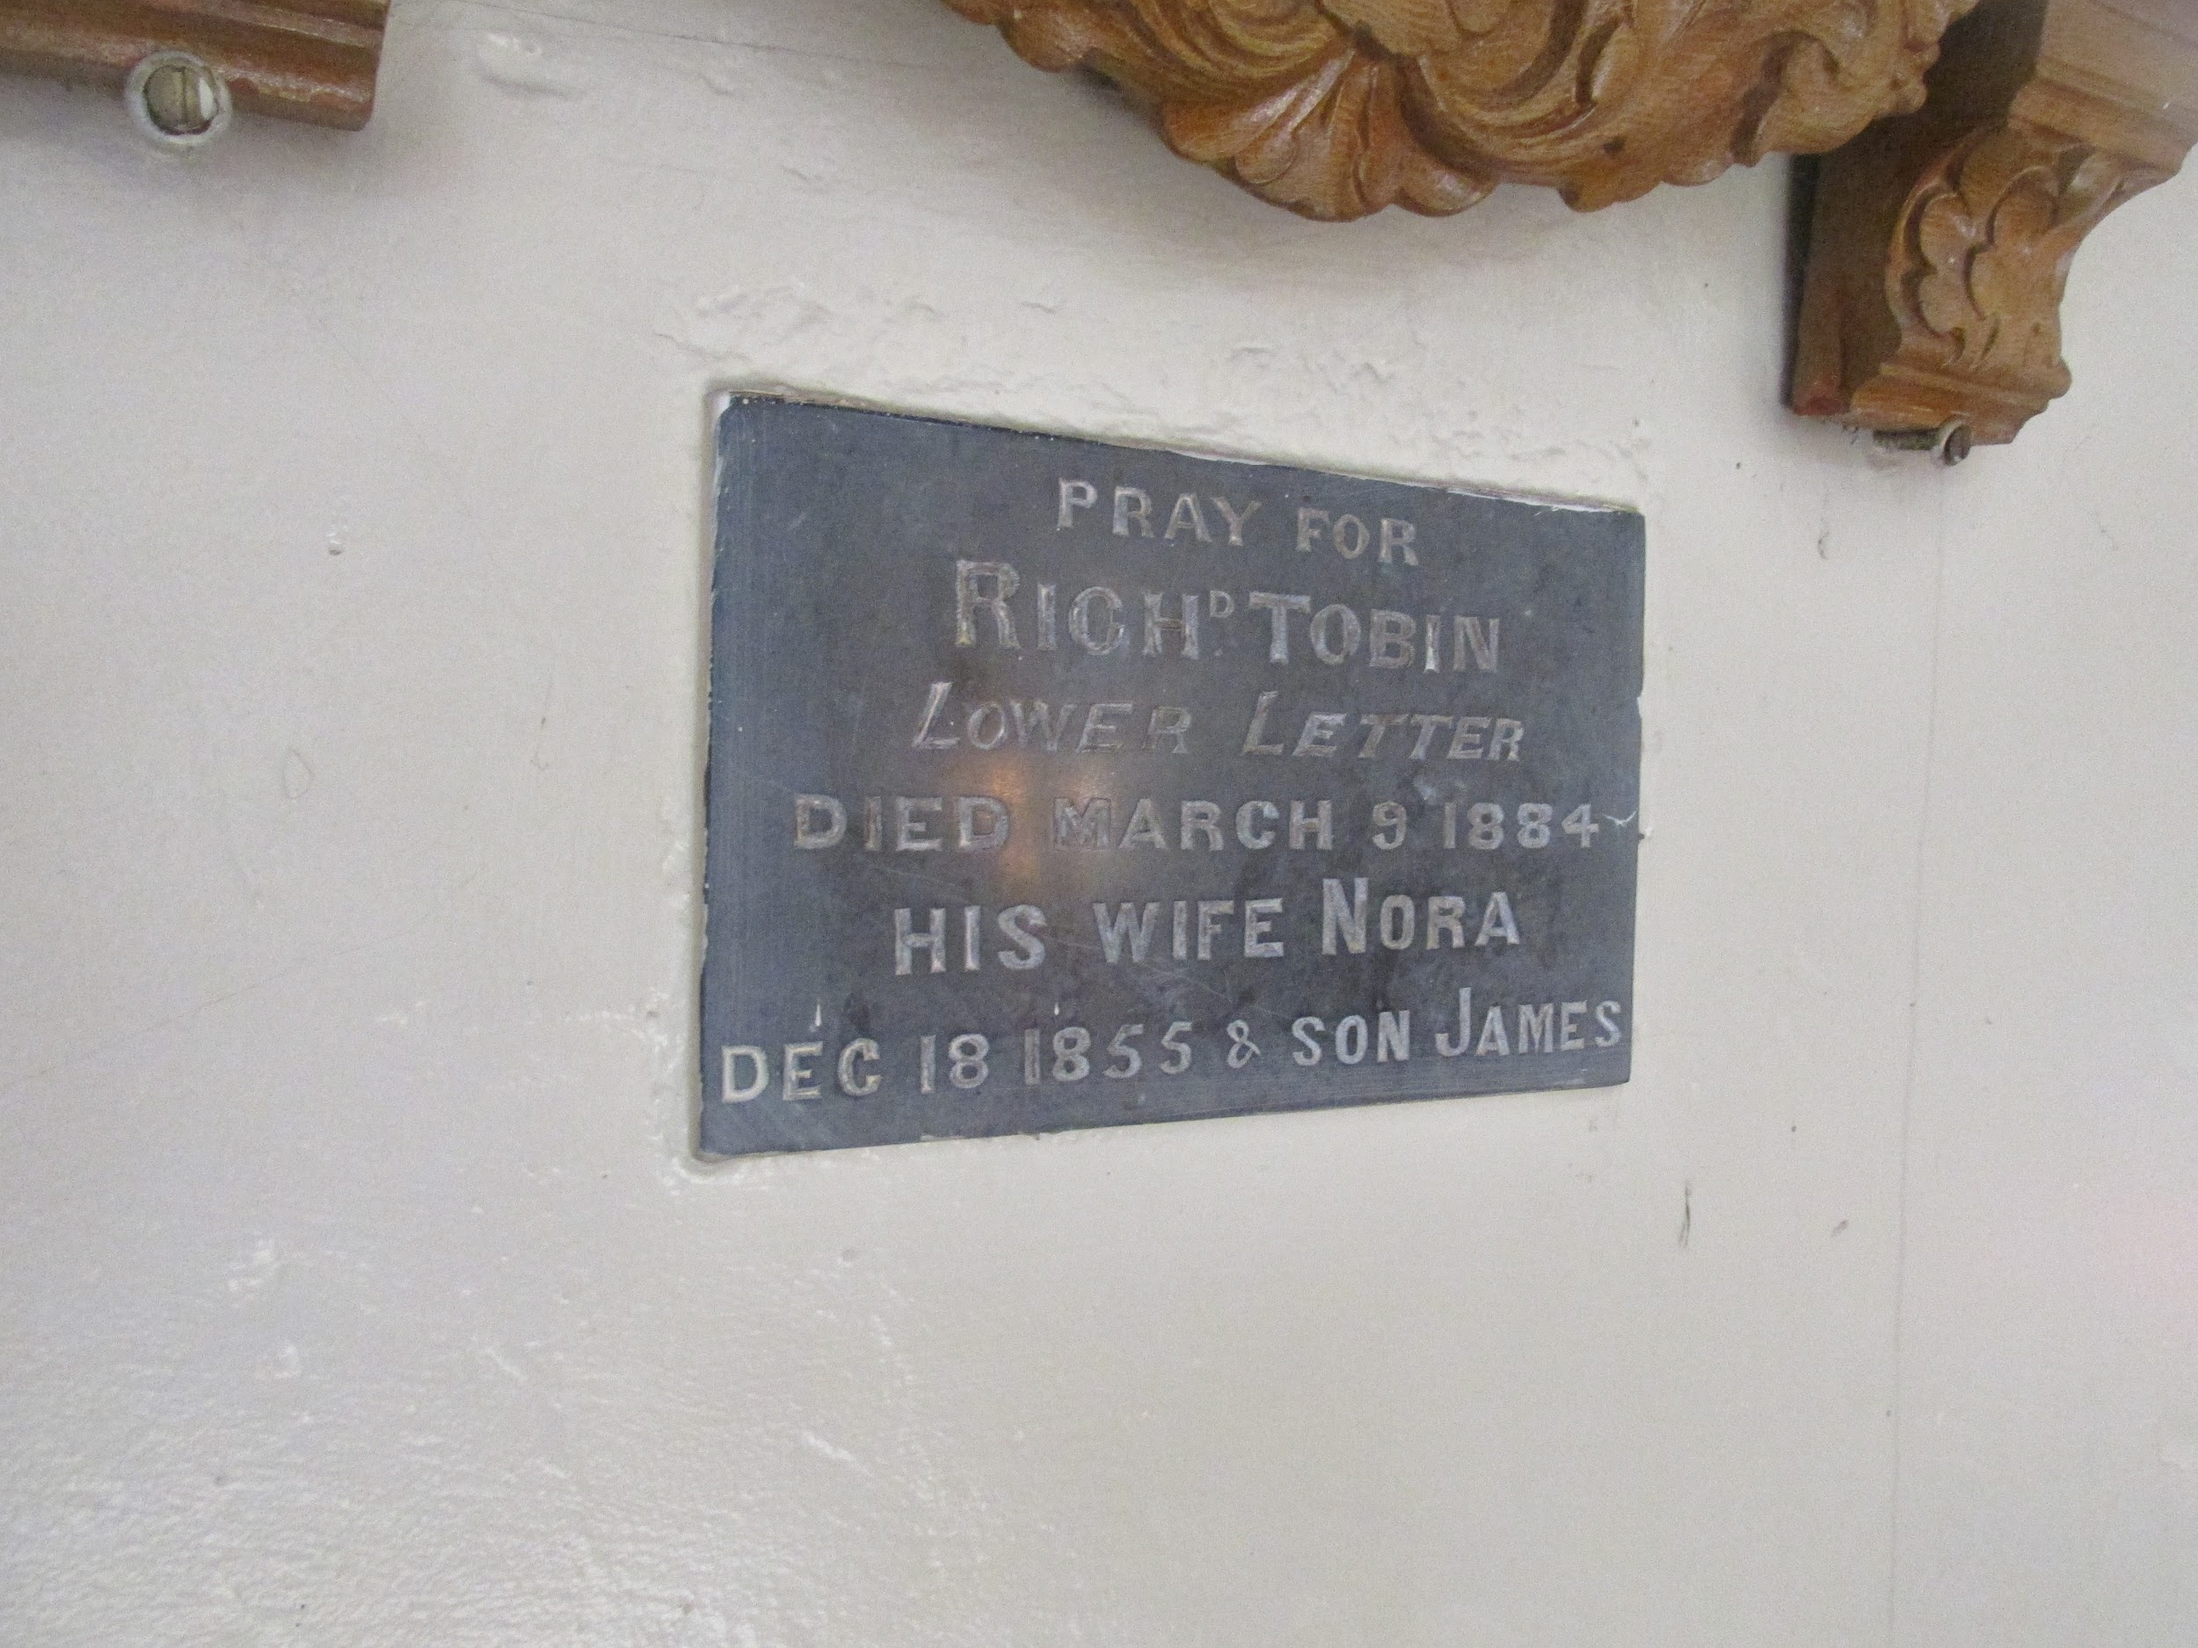
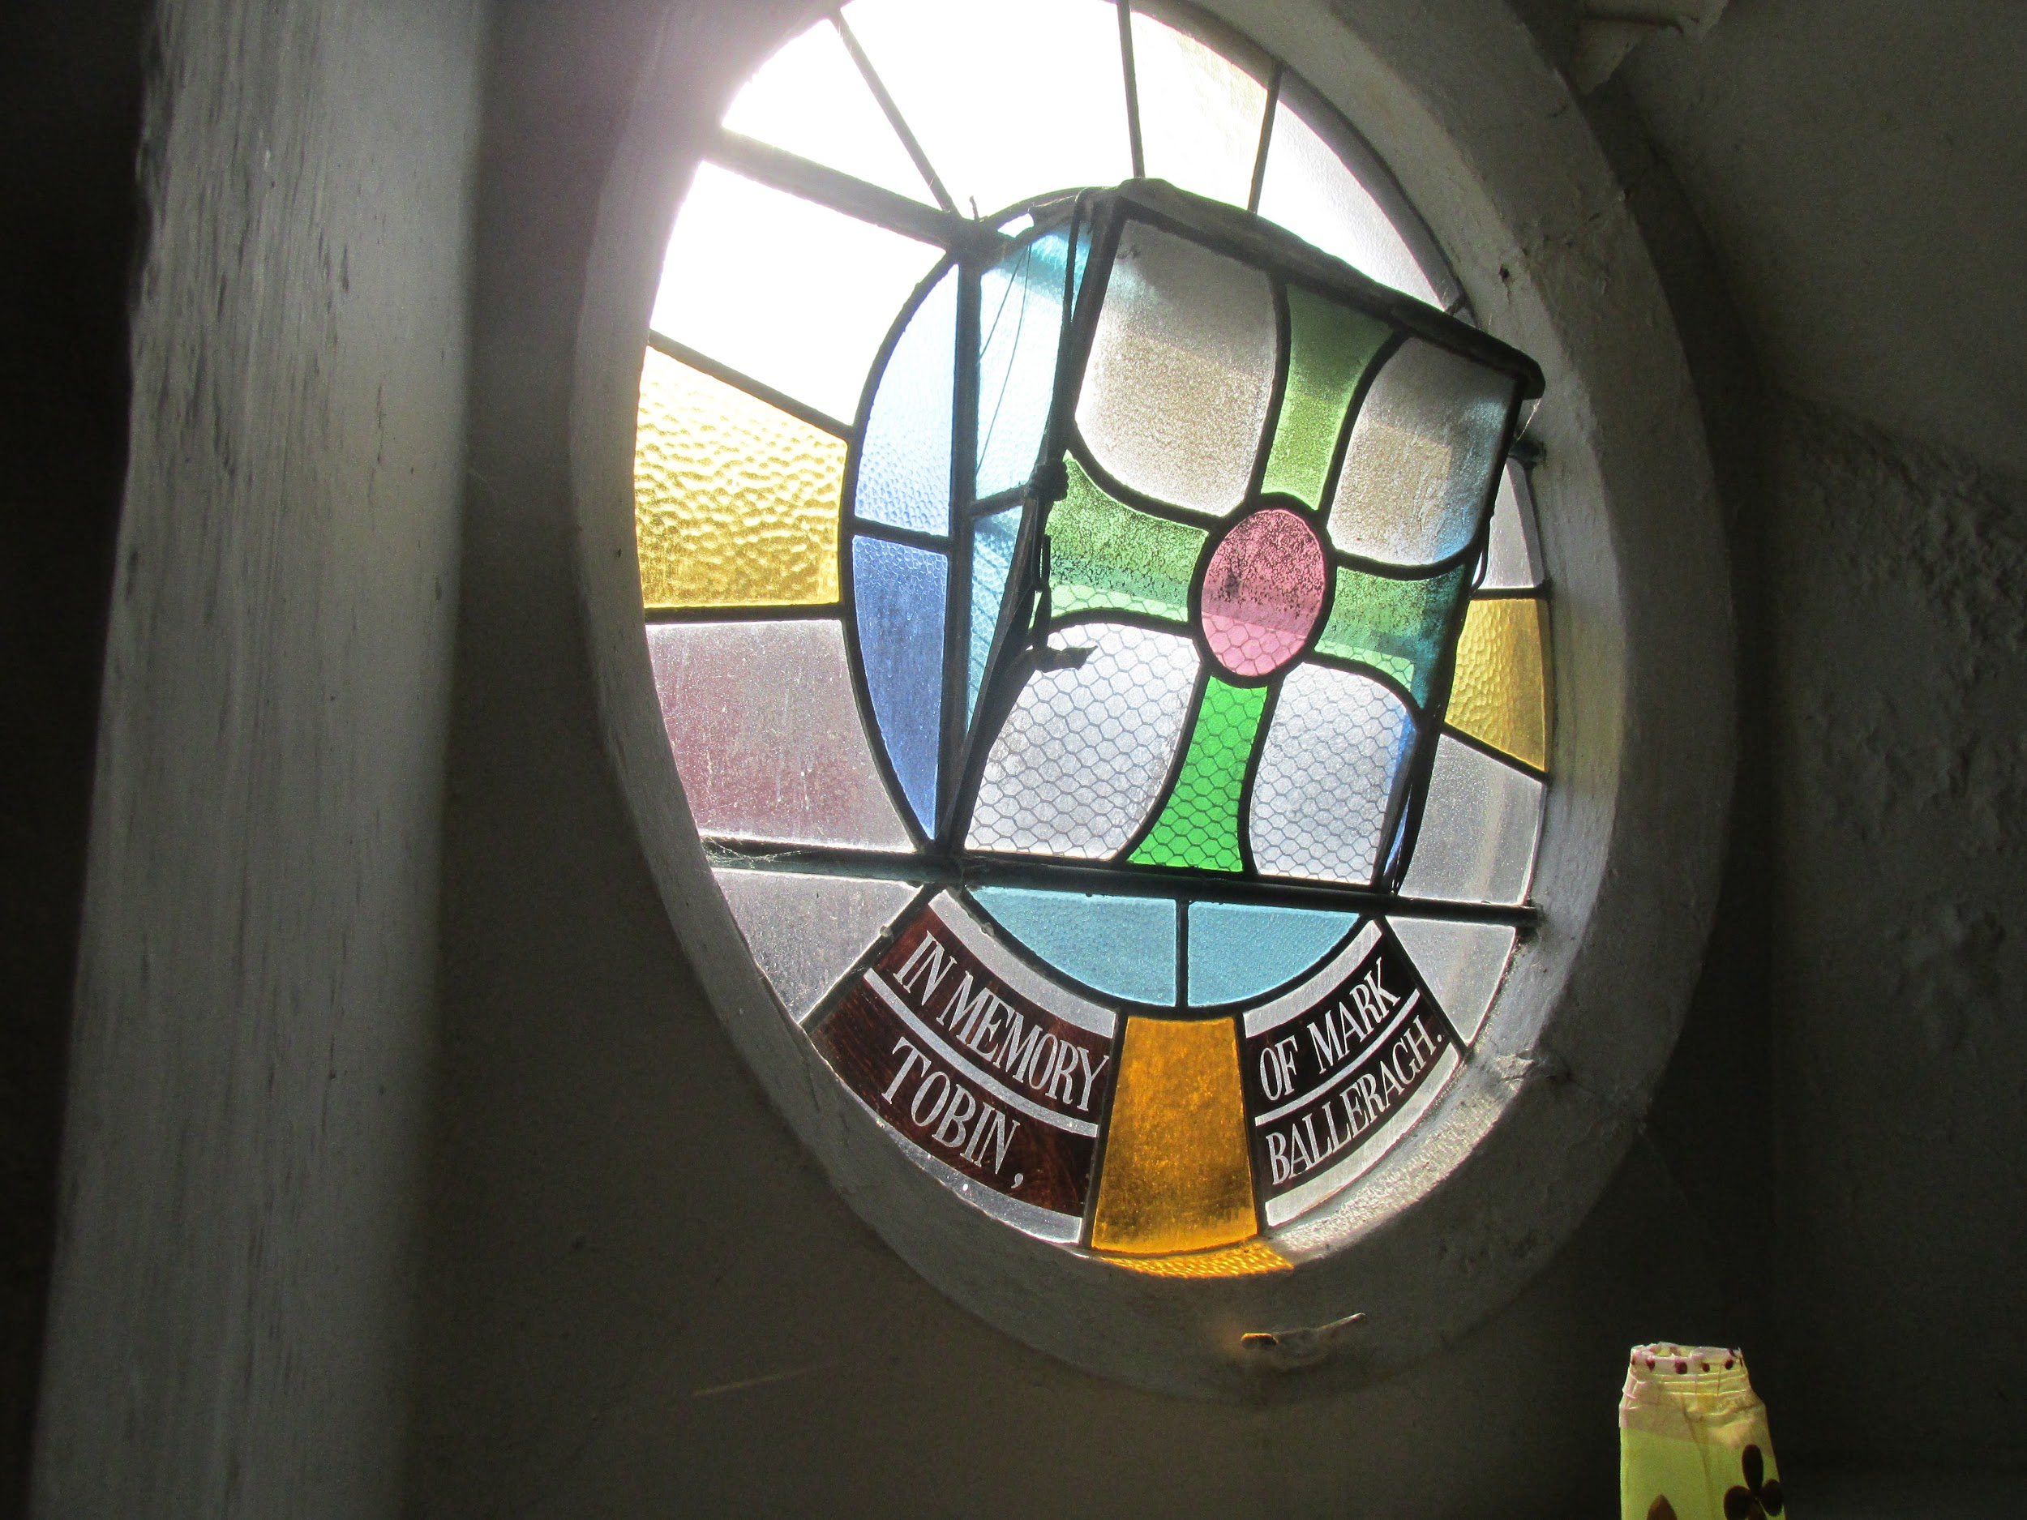
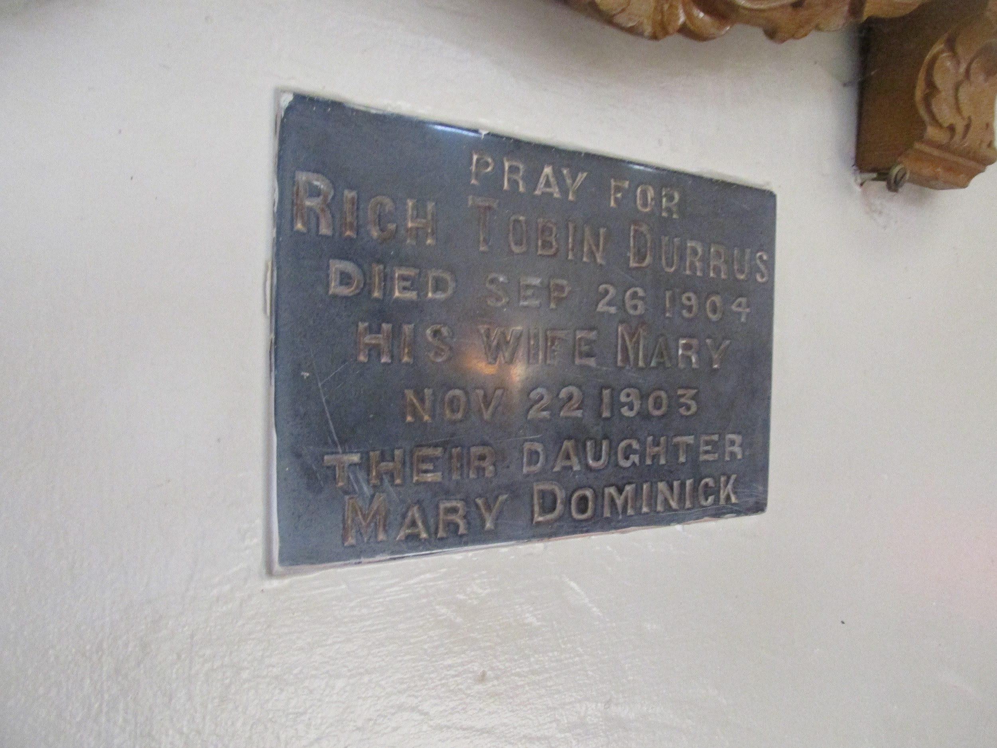
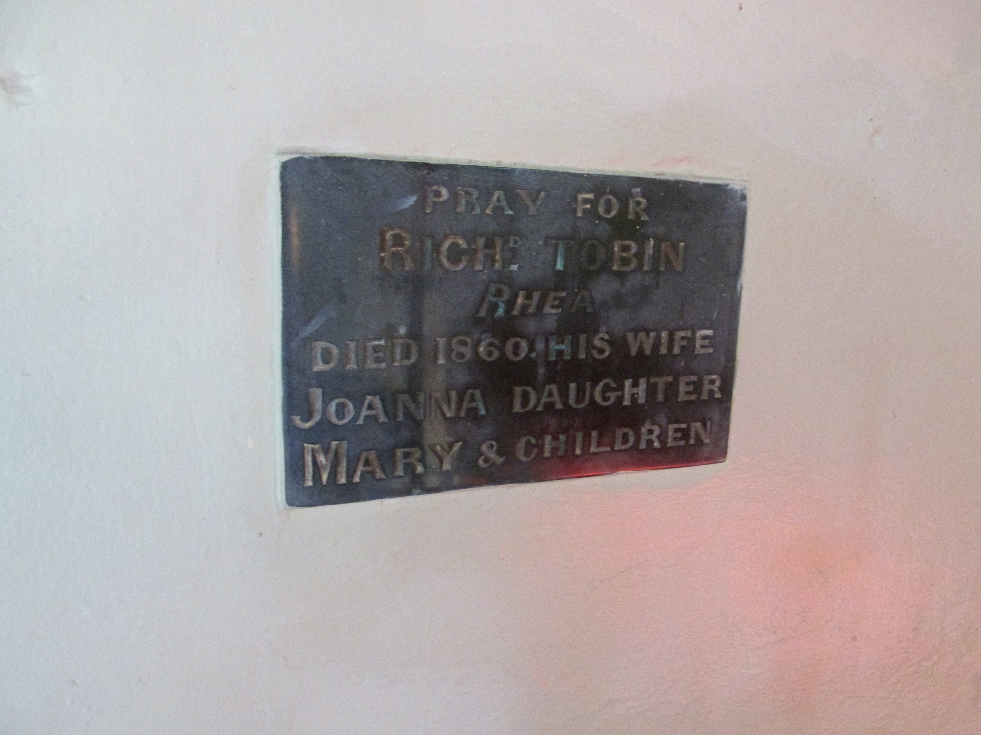
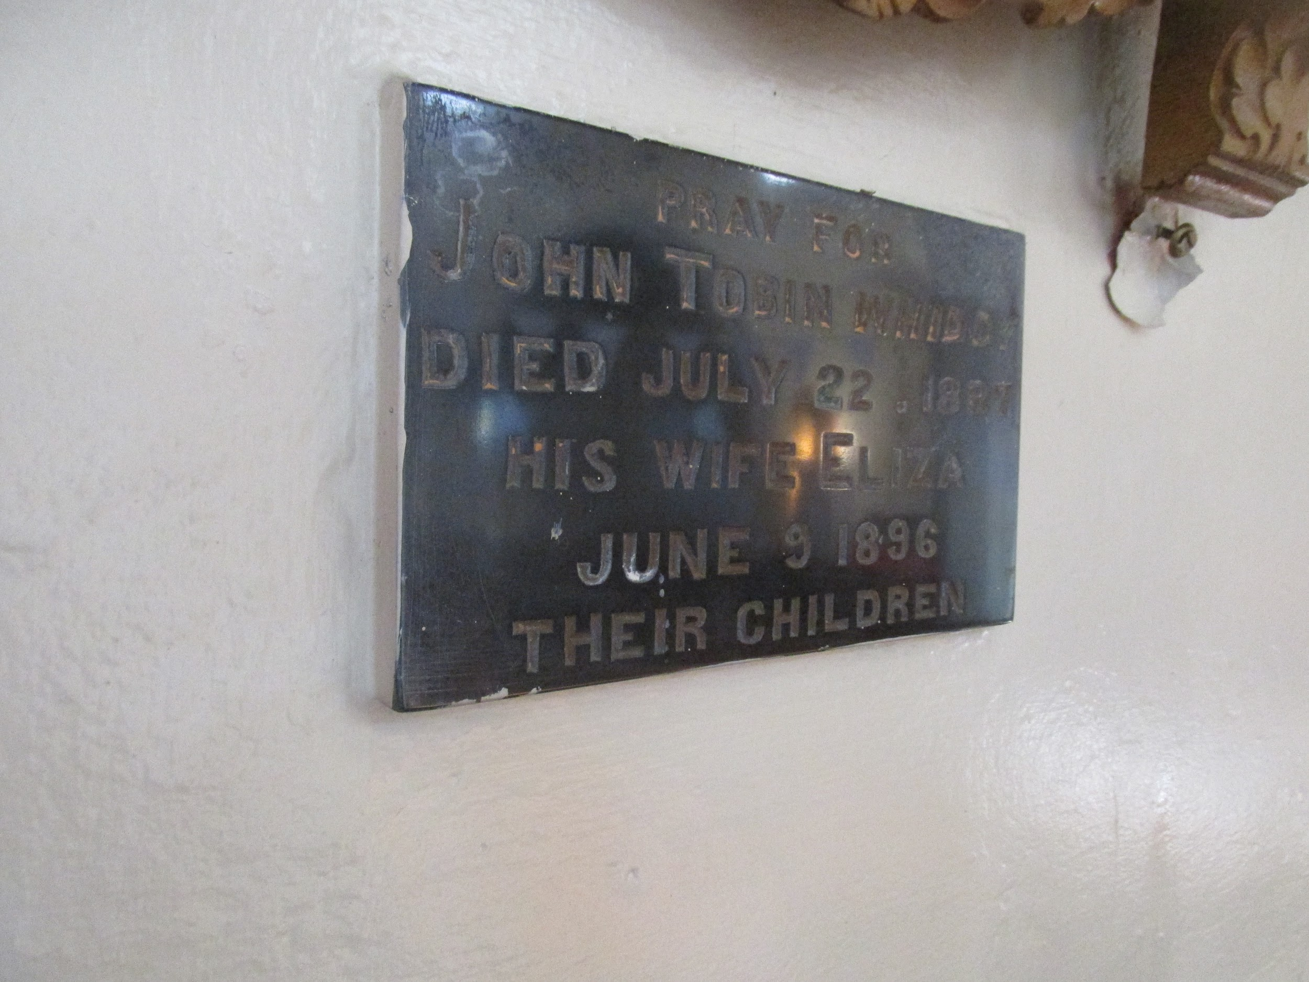

The Whiddy Thomas Tobin’s lease is quoted in a proposed sale of part of the Lord Bantry Estate 1852 and one of the lives mentioned is William born 1827, 2nd son of Timothy O’Donovan JP of the Cove. 1836, Lease of Reenvanagh, part of Whiddy Island of lands at a rental of £73 per annum from Richard White to Thomas Tobin (dead by 1852) lives Emanuel Hutchins (living 1852 son of Samuel Hutchins, Esq., Ballylickey, and William O'Donovan, 2nd son of Timothy O’Donovan, Esq., O’Donovans Cove, Durrus, later additional lease 1841 at a further rent of £60 same parties recited.

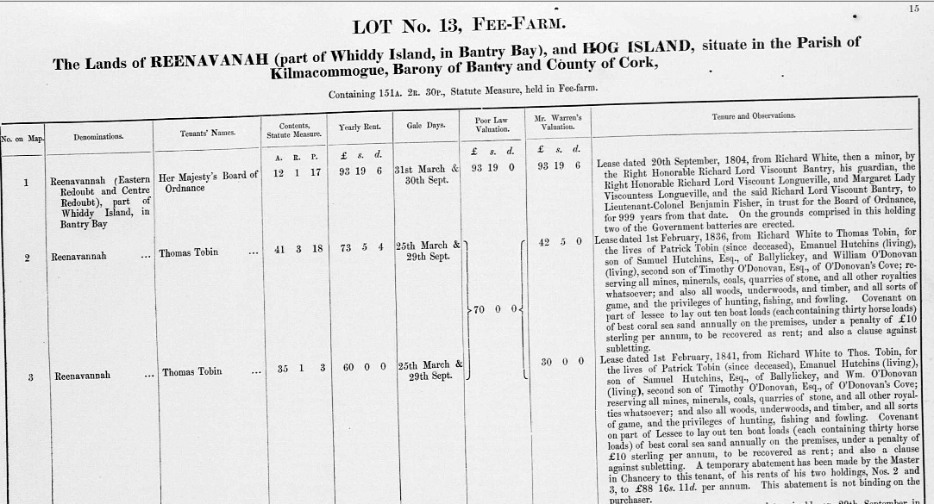

1841 Election Co. Cork, possibly a son of ’King’ Tobin, KIlcrohane. Reenavaugh is Whiddy Island

Subscribers to the New Church at O'Donovan's Cove (Rosnacaheragh Ahakista), West Cork, 1826, including Major contribution from Messrs, Beamish and Crawford, Brewers, Cork, Stained Glass provided later By Arundel Family and Rosnacaheraagh National School 1885. In the photographs, the back windows are in the style of if not the early 19th century windows. Members of the Arundel family associated with the church are buried in the grounds.

Subscribers Co. Cork, Durrus/Kilcrohane, 1846 to the 'O'Connell Tribute': Rev Richard Quinn, Parish Priest £2, Rev Simon Murphy, Curate, Denis McCarthy, (Possibly Letterlickey may be related to Richard Tobin's wife Nora) £5, Eugene Sullivan (Possibly Merchant/Miller Durrus) £5, Patrick Sheedy £2, Richard 'King' Tobin Senior (Major Local figure agent Lord Bantry, businessman) Senior 5s, Richard Tobin (probably son of 'King' who came to Durrus extensive farmer hotelier and businessman owned present Rosses Hotel large Celtic Cross in Durrus Churchyard with inscription in Irish) Junior 5s, Patrick Tobin Junior 5s, Patrick Tobin Senior 5s, James McCarthy 2s, Tom Donovan 2s 6d, Timothy Daly 2s, other smaller amounts

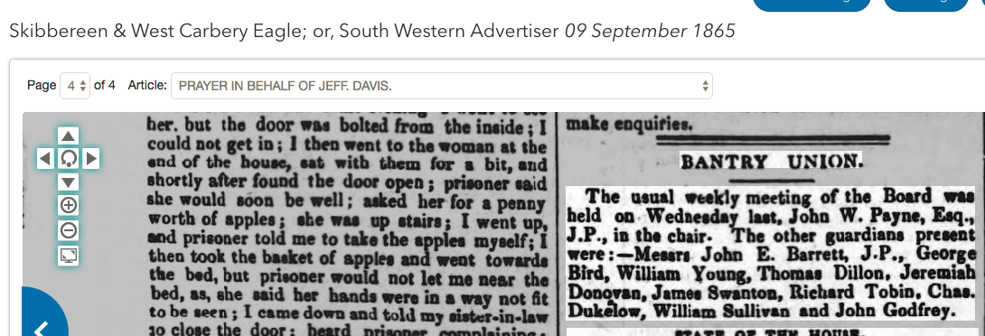

Relief Fund for McCarthy Family, Tullig, Durrus 2 children died in fire, 9th December 1867, house and effects destroyed, Charles McCarthy left to support wife, 4 children mother and father. Facts certified by George Bird, Bantry, probably agent to Lord Bantry, Timothy O’Donovan, O’Donovan’s Cove.

George Bird Bantry £1, Thomas Dillon £1, Dennis McCarthy, £1 The Reverend Pratt, Durrus Glebe, 10 s, John Moss, Carrigboy, 10s, Dennis Sullivan, Carrigboy, 10 s, Thomas Kingston, Dromleavy, 10s, Jeremiah Kingston, Dromleavy, 10s, Jeremiah Lynch, Shandrum £1, Jeremiah Murphy, Dunbeacon, £3, Rev. M O'Flynn, 5s, Reverend Michael O’ Sullivan, Curate, 10s, Philip Shanahan, Dunbeacon 5s, John Cullinane Bantry, £1, The Earl of Bantry, 10s, Thomas Vickery, (Probably Hotel Owner and Operator of Horse Drawn Buggies) Bantry, 1s, Mrs. Jagoe, Bantry, 4s, John Ahern, 1s, John McCarthy, Bantry 1s, Cornelius McCarthy Bantry, 2s, Jeremiah Bryan Kealties, 10s, Thomas Sullivan, Tullig, 10s, Michael Collins, Kealties 6s, Charles McCarthy Kealties 4s, John Leary, Bantry 2s 6d, Timothy McCarthy, Bantry, 5s, William Murphy 5s, Michael Cullinane 2s 6d, Mrs Lannin, (probably from family that originated in Dromreagh) 1s, Mrs Copithorne (Possibly Woolen Mills) 1s, Mr. Pope, Queenstown 5s, John Hurley, (Possibly from family later Members Rural District Council) Ballycomane 3s, Patrick Regan 2s 6d, Henry Donovan M.D. £1, William S Tisdall 5s, (Donemark Mills) McCarthy Downing, (MP and Solicitor) 5s, Eagle Office 5s, Richard O'Donovan (Landlord) Justice of the Peace 10s, Stephen Browne 7s 6d, Richard Tobin Senior, Letter 10s, Patrick Coughlan Killeens, 5s, John Mahony 5s, Richard Tobin Junior, (Probably Durrus) 5s, Timothy Donovan, Laherudota 5s, Michael Goodwin, Kilcrohane 5s, Timothy Lehane 5s,

Subscribers to the New Church at O'Donovan's Cove (Rosnacaheragh Ahakista), West Cork, 1826, including Major contribution from Messrs, Beamish and Crawford, Brewers, Cork, Stained Glass provided later By Arundel Family and Rosnacaheraagh National School 1885. In the photographs, the back windows are in the style of if not the early 19th century windows. Members of the Arundel family associated with the church are buried in the grounds.

Whiddy Island Branch:

Thanks Pat,

Grave pics do fit in with the research I did awhile ago on the family.
I'm in San Francisco, records are back home in Florida. Here"s my best shot:
Thomas Tobin and Cath Donovan connection:
Early records with Thomas Tobin and wife have children born in Bantry, but on original records Whiddy Island is listed on many.
Dympna OMahony Crowley says Whiddy Tobin's were from Gortavalig,Northside Sheepshead.
Whiddy Land grant records 1820s-1840s with details that you have posted.
Then family with Whiddy Margaret Tobin b. 1835 going to USA, marrying a Dennis McCarthy; @ Oswego NY around 1850. Then out to Wisconsin. Contact + Details are on kateeliz king's ancestry, ftdna + gedmatch; with tree. This is our DNA match. But she lists Whiddy father as a Richard Tobin NOT Thomas Tobin. Margaret nee Tobin McCarty + Dennis McCarty raise large family. One son is Charles Tobin McCarthy b. 1857 Feb 24 @ Green Bay WI, USA.
Mother Mgt dies 1893 25 Cec. @ Kaukauma, Outagamie, WI. Brian Hendricks, ADM on gedmatch too.
Sources tell me there was only 1 Tobin family on Whiddy. (Plus later descendants.)I did go online yesterday to review some descendants:
1901 Census #4, Reenavanny, Whiddy, Cork: Single sibs
Thos Tobin 28, Norah Tobin 24, Lizzy 25 (think it said).
1911 Census: Denis Driscoll 47, Ellen 38 Irish & English, married couple; children Chrissy 15 male, Hannah 13,Tim 12, MCL 10, Denis 9, Mary Emily, Patrick 8, John 6, Nellie 5, Annie 3, Mgt 2
Remember seeing a Dublin marriage with 2 sibs present. On this family abt 1900.
Saw a record of a Sullivan of Bantry I think marrying a descendant.
Ferry guy Tim O'Leary said lore is that Tobin family members left in the 1940's for Australia. Earlier 1920's rules on land tracts required owners farming own land created an issue for the family. When we saw ruins of Thomas Tobin's large house on Whiddy, wondered if it was the original owners...estate owners?
My Jim's cousin, Freddie Coleman's wife Carol, near Dympna + Johnny Crowley's Dromcloc B&B has info on Driscolls of Whiddy.
Sorry to be so disjointed...
Bye for now
Dot Allen Sweeney

Dot,

I wasn't aware of my link to the Whiddy Tobins until you gave me the DNA link. I see a reference to Richard Tobin and the Whiddy Tobins having a large house.

Whiddy was part of the Lord Bantry (White) Estate as probably also was Gortavaillig. Reputedly Richard (The King) Tobin was a local agent of sorts for Lord Bantry working wiht the Birds of Bantry.

The Donovan/Tobin connection would be my line. My father's grandmother O'Donovan/Donovan c 1860c 1930, her mother Tobin.

By the way at least one Protestant Tobin family at Fahane north side of Muintervara peninsula. Don't know what became of them will make enquiries.

Look at naming pattern of children. Oldest boy after paternal grandfather, nest boy maternal grandfather, nest boy after father and same for girls

Pat

Tobins of Muintirvara
Tithe Applotments Year 1831 (Courtesy John Tobin)
001 | Richard Tobin | Reagh | 1
009 | Richard Tobin | Lacknagulky | 2
016 | Edward Tobin | Rearour | 3
017 | Richard Tobin | Rearour | 4
023 | Edward Tobin | Gortavallig | 5
025 | Patt Tobin | Gortavallig | 6
026 | Edward Tobin | Cahirgal | 7
029 | Mark Tobin | Ballyieragh | 8
042 | Richard Tobin | Ballyroon | 9
050 | Richard Tobin | Cora | 10
066 | John Tobin | Letter East | 11
067 | Richard Tobin | Letter East | 12
103 | Richard Tobin | Knockroe | 13
216 | Richard Tobin | Farranamanagh | 14
241 | John Tobin | Gortnakilly | 15
245 | James Tobin | Gortnakilly | 16
249 | James Tobin | Gouladoo | 17
250 | Widow Tobin | Gouladoo | 18
298 | William Tobin | Reenmore | 19
314 | William Tobin | Rosskerrig | 20
358 | Richard Tobin | Ardnanenig | 21
365 | Mary Tobin | Knockeens | 22
370 | Thomas Tobin | Knockeens | 23

1892 Elections:

...

….

…..

1909, Richard Tobin Owner Premier Bull, Blairs Cove.

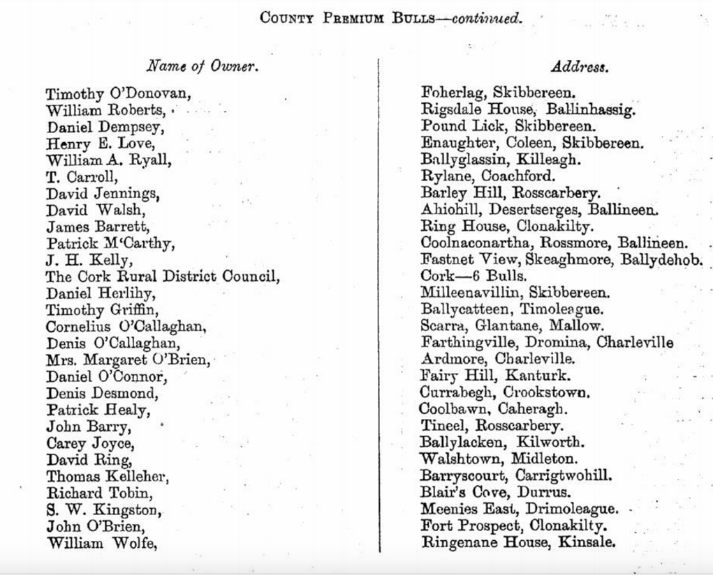

It has been suggested as a result of DNA testing that the Tobins of Bandon who are related to the Regans came from Muintervarea in the early 19th century.

..
John Tobin aged 65, Bantry (Kilcrohane?) discharged 1797 various military services British Army.

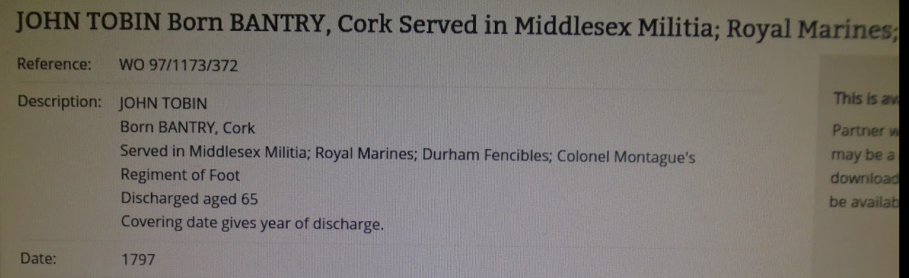
...

https://wordpress.com/post/28206803/10618

http://durrushistory.com/2014/02/23/applications-to-set-up-national-schools-durrus-and-drimoleague-west-cork-1830/

<a href="https://durrushistory.files.wordpress.com/2015/06/4-img_0106.jpg"><img src="https://durrushistory.files.wordpress.com/2015/06/4-img_0106.jpg?w=300" alt="4-IMG_0106" width="300" height="225" class="alignnone size-medium wp-image-12458" /></a>

<a href="https://durrushistory.files.wordpress.com/2015/06/3-img_0111.jpg"><img src="https://durrushistory.files.wordpress.com/2015/06/3-img_0111.jpg?w=300" alt="3-IMG_0111" width="300" height="225" class="alignnone size-medium wp-image-12459" /></a>

<a href="https://durrushistory.files.wordpress.com/2015/06/2-img_0105.jpg"><img src="https://durrushistory.files.wordpress.com/2015/06/2-img_0105.jpg?w=300" alt="2-IMG_0105" width="300" height="225" class="alignnone size-medium wp-image-12460" /></a>

<a href="https://durrushistory.files.wordpress.com/2015/06/1-img_0104.jpg"><img src="https://durrushistory.files.wordpress.com/2015/06/1-img_0104.jpg?w=300" alt="1-IMG_0104" width="300" height="225" class="alignnone size-medium wp-image-12461" /></a> Tobins and related O'Mahony major fish merchants at the time.

<a href="http://durrushistory.files.wordpress.com/2015/10/wpid-img_20151004_101031160.jpg"><img title="IMG_20151004_101031160.jpg" class="alignnone size-full" alt="image" src="http://durrushistory.files.wordpress.com/2015/10/wpid-img_20151004_101031160.jpg" /></a>

http://durrushistory.com/2015/07/20/kilcrohane-church-muintervara-inscriptions-and-stained-glass-to-members-of-mccarthy-omahony-tobin-odonovan-and-murphy-families/

http://durrushistory.com/2015/06/08/distribution-of-tobin-families-in-kilcrohane-townlands-west-cork-1831/
http://durrushistory.com/2015/06/05/the-tobins-of-kilcrohane-west-cork-the-seven-sisters-of-gloun-early-19th-century-and-john-f-kennedy-connection-1740s-lease-of-donmark-mills-1820s-lease-of-part-of-whiddy-island-king-tobon-and/

Census Return 1901, unusually his daughter is an Art Student, his wife is probably of the McCarthy Letterlickey family, substantial farmers:

<a href="https://durrushistory.files.wordpress.com/2015/10/screen-shot-2015-10-05-at-22-59-30.png"><img src="https://durrushistory.files.wordpress.com/2015/10/screen-shot-2015-10-05-at-22-59-30.png?w=300" alt="Screen Shot 2015-10-05 at 22.59.30" width="300" height="108" class="alignnone size-medium wp-image-15608" /></a>

https://docs.google.com/spreadsheets/d/1LVgcai4i4QWpyLFvKhEgQAMjtdhjI6VhRrBr2XMWC2U/edit#gid=0

<a href="https://durrushistory.files.wordpress.com/2015/10/27-img_20151004_101041522.jpg"><img src="https://durrushistory.files.wordpress.com/2015/10/27-img_20151004_101041522.jpg?w=225" alt="27-IMG_20151004_101041522" width="225" height="300" class="alignnone size-medium wp-image-15574" /></a>

<a href="https://durrushistory.files.wordpress.com/2015/10/26-img_20151004_101038342.jpg"><img src="https://durrushistory.files.wordpress.com/2015/10/26-img_20151004_101038342.jpg?w=225" alt="26-IMG_20151004_101038342" width="225" height="300" class="alignnone size-medium wp-image-15575" /></a>

<a href="https://durrushistory.files.wordpress.com/2015/10/25-img_20151004_101035842.jpg"><img src="https://durrushistory.files.wordpress.com/2015/10/25-img_20151004_101035842.jpg?w=225" alt="25-IMG_20151004_101035842" width="225" height="300" class="alignnone size-medium wp-image-15576" /></a>

<a href="https://durrushistory.files.wordpress.com/2015/10/24-img_20151004_101031160.jpg"><img src="https://durrushistory.files.wordpress.com/2015/10/24-img_20151004_101031160.jpg?w=300" alt="24-IMG_20151004_101031160" width="300" height="225" class="alignnone size-medium wp-image-15577" /></a>

<a href="https://durrushistory.files.wordpress.com/2015/10/23-img_20151004_101021670.jpg"><img src="https://durrushistory.files.wordpress.com/2015/10/23-img_20151004_101021670.jpg?w=225" alt="23-IMG_20151004_101021670" width="225" height="300" class="alignnone size-medium wp-image-15578" /></a>

<a href="https://durrushistory.files.wordpress.com/2015/10/22-img_20151004_101019465.jpg"><img src="https://durrushistory.files.wordpress.com/2015/10/22-img_20151004_101019465.jpg?w=225" alt="22-IMG_20151004_101019465" width="225" height="300" class="alignnone size-medium wp-image-15579" /></a>

<a href="https://durrushistory.files.wordpress.com/2015/10/21-img_20151004_101017271.jpg"><img src="https://durrushistory.files.wordpress.com/2015/10/21-img_20151004_101017271.jpg?w=225" alt="21-IMG_20151004_101017271" width="225" height="300" class="alignnone size-medium wp-image-15580" /></a>

<a href="https://durrushistory.files.wordpress.com/2015/10/20-img_20151004_101006198.jpg"><img src="https://durrushistory.files.wordpress.com/2015/10/20-img_20151004_101006198.jpg?w=225" alt="20-IMG_20151004_101006198" width="225" height="300" class="alignnone size-medium wp-image-15581" /></a>

<a href="https://durrushistory.files.wordpress.com/2015/10/19-img_20151004_101003144.jpg"><img src="https://durrushistory.files.wordpress.com/2015/10/19-img_20151004_101003144.jpg?w=225" alt="19-IMG_20151004_101003144" width="225" height="300" class="alignnone size-medium wp-image-15582" /></a>

<a href="https://durrushistory.files.wordpress.com/2015/10/18-img_20151004_101000538.jpg"><img src="https://durrushistory.files.wordpress.com/2015/10/18-img_20151004_101000538.jpg?w=225" alt="18-IMG_20151004_101000538" width="225" height="300" class="alignnone size-medium wp-image-15583" /></a>

<a href="https://durrushistory.files.wordpress.com/2015/10/17-img_20151004_100958172.jpg"><img src="https://durrushistory.files.wordpress.com/2015/10/17-img_20151004_100958172.jpg?w=225" alt="17-IMG_20151004_100958172" width="225" height="300" class="alignnone size-medium wp-image-15584" /></a>

<a href="https://durrushistory.files.wordpress.com/2015/10/16-img_20151004_100952257.jpg"><img src="https://durrushistory.files.wordpress.com/2015/10/16-img_20151004_100952257.jpg?w=300" alt="16-IMG_20151004_100952257" width="300" height="225" class="alignnone size-medium wp-image-15585" /></a>

<a href="https://durrushistory.files.wordpress.com/2015/10/15-img_20151004_100949212.jpg"><img src="https://durrushistory.files.wordpress.com/2015/10/15-img_20151004_100949212.jpg?w=225" alt="15-IMG_20151004_100949212" width="225" height="300" class="alignnone size-medium wp-image-15586" /></a>

<a href="https://durrushistory.files.wordpress.com/2015/10/14-img_20151004_100946589.jpg"><img src="https://durrushistory.files.wordpress.com/2015/10/14-img_20151004_100946589.jpg?w=225" alt="14-IMG_20151004_100946589" width="225" height="300" class="alignnone size-medium wp-image-15587" /></a>

<a href="https://durrushistory.files.wordpress.com/2015/10/13-img_20151004_100944211.jpg"><img src="https://durrushistory.files.wordpress.com/2015/10/13-img_20151004_100944211.jpg?w=225" alt="13-IMG_20151004_100944211" width="225" height="300" class="alignnone size-medium wp-image-15588" /></a>

<a href="https://durrushistory.files.wordpress.com/2015/10/12-img_20151004_100940542.jpg"><img src="https://durrushistory.files.wordpress.com/2015/10/12-img_20151004_100940542.jpg?w=300" alt="12-IMG_20151004_100940542" width="300" height="225" class="alignnone size-medium wp-image-15589" /></a>

<a href="https://durrushistory.files.wordpress.com/2015/10/11-img_20151004_100930585.jpg"><img src="https://durrushistory.files.wordpress.com/2015/10/11-img_20151004_100930585.jpg?w=300" alt="11-IMG_20151004_100930585" width="300" height="225" class="alignnone size-medium wp-image-15590" /></a>

<a href="https://durrushistory.files.wordpress.com/2015/10/10-img_20151004_100918770.jpg"><img src="https://durrushistory.files.wordpress.com/2015/10/10-img_20151004_100918770.jpg?w=225" alt="10-IMG_20151004_100918770" width="225" height="300" class="alignnone size-medium wp-image-15591" /></a>

<a href="https://durrushistory.files.wordpress.com/2015/10/09-img_20151004_100913766.jpg"><img src="https://durrushistory.files.wordpress.com/2015/10/09-img_20151004_100913766.jpg?w=300" alt="09-IMG_20151004_100913766" width="300" height="225" class="alignnone size-medium wp-image-15592" /></a>

<a href="https://durrushistory.files.wordpress.com/2015/10/08-img_20151004_100908002.jpg"><img src="https://durrushistory.files.wordpress.com/2015/10/08-img_20151004_100908002.jpg?w=300" alt="08-IMG_20151004_100908002" width="300" height="225" class="alignnone size-medium wp-image-15593" /></a>

<a href="https://durrushistory.files.wordpress.com/2015/10/07-img_20151004_100902080.jpg"><img src="https://durrushistory.files.wordpress.com/2015/10/07-img_20151004_100902080.jpg?w=225" alt="07-IMG_20151004_100902080" width="225" height="300" class="alignnone size-medium wp-image-15594" /></a>

<a href="https://durrushistory.files.wordpress.com/2015/10/06-img_20151004_100845628.jpg"><img src="https://durrushistory.files.wordpress.com/2015/10/06-img_20151004_100845628.jpg?w=225" alt="06-IMG_20151004_100845628" width="225" height="300" class="alignnone size-medium wp-image-15595" /></a>

He features in the Bandon Estate records for Durrus as a substa

Guy's Directory 1875

Richard Tobin Junior, Carrigboy

..
Died 1930. "O’MAHONY, Nora, (c.1896-died 1930), from Letterlowes, father Florence O’Mahony, farmer. Religion Catholic. Matriculated at QCC in 1916/17, graduated M.B. B.CH B.A.O. in 1924. Address but no post in Letterlowes in 1929, then not listed." Kilcrohane, grave Kilcrohane died 1930 ahed 34 same stone sister Kathleen died 1970. This was the daughter of the Florence O'Mahony of Lowerletter Kilcrohane. This man was the kingpin of the Fishing Industry on the Sheep's Head Peninsula with fish processing facilities located below the homestead at Traweim (last pier on the peninsula). They have an interesting history linked back to King Tobin (whose daughter married O'Mahony from Kilcrohane)

…
Sorry..Followup...that Catherine Donovan may be the next generation up. I don't have the records in front of me.

Sent from my Verizon Wireless 4G LTE smartphone

-------- Original message --------
From: Dorothy Sweeney
Date:07/02/2019 7:27 AM (GMT-05:00)
To: Dorothy Sweeney
Cc: Kathy Scheg , pat25a
Subject: Mccarthy and Tobin marriage born c1850 of a Tobin daughter of Whiddy Island

Kathy,
Can you help? Some of us share a match to kateeliz on ancestry & gedmatch. Sheepshead roots that I believe include a Thomas Tobin & Catherine Donovan. See graveyard pic.

Denis McCarthy (1820-1910) & Margaret Tobin (1835-1895) marry c. 1850 Oswego, Oswego NY.

Margaret was born Whiddy Island.

May be Gortavalig or Gortnakilla.

Her Tobin female of is born @ Whiddy Island, across from Bantry. I think father is Thomas Tobin, though she has a Richard Tobin.

Pat Crowley researched Thomas Tobin Whiddy Island land tract lease, so we have been circling this family for awhile.

Daughter from Whiddy goes to USA and Marriage Denis McCarthy c. 1850 Oswego. Although Thomas had Kilcrohane links, I was surprised to spot Thomas Tobin's grave in Kilcrohane cemetery. Kerry Driscoll helped me scrape off the moss and we read the transcription.

"John Tobin Whiddy. In memory of his beloved father, mother and brother. Thomas died May 1869. Aged 84 years. Wife Catherine died 11 Nov 1849. Age 49 years. Brother Pat died 24 Nov 1845 age 22 years. May they rest in peace. Amen."
Can you locate the Oswego NY marriage record? Family moves on to WI.
Dot

..

Speakers of Irish and English, 1901 Census Durrus.

Durrus Village, Tobins – Richard (Born Kilcrohane, 1834) 67, May (born Letterlickey), 67, Nora 38, and Jane 34 (both born Kilcrohane), Timothy, 75 Mary 52 (Tobin?),

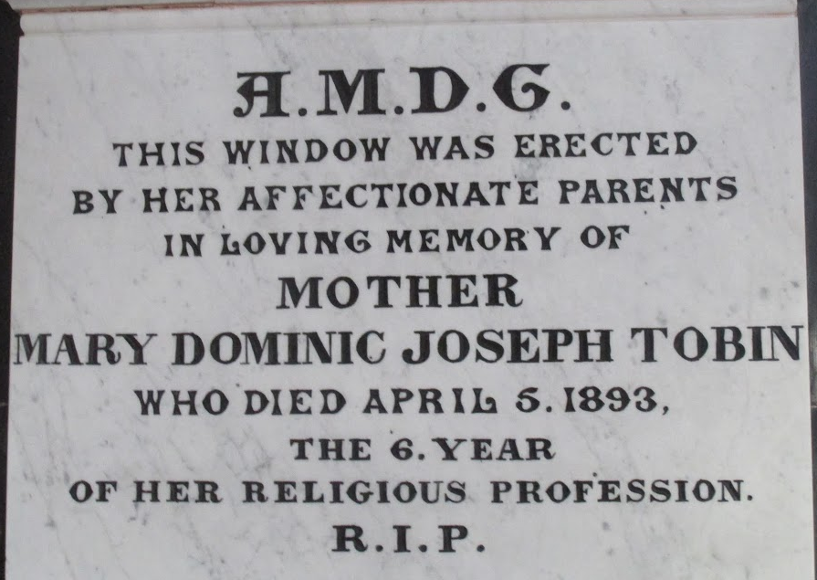

Sheeps Head Company Blog: From a series of articles that appeared in The West Cork Eagle (the Skibbereen Eagle) in 1872
Richard Tobin.
Joan O’Sullivan nee Gallagher, Bantry maternal side Tobin, Gortafahane, July 2017.
UK National Archives.
Quoted in 1852 landed estate sale of White lands
Courtesy John Tobin
Cork Archives GJ CO/PR/5 (1)

