This is a very early working draft pagination and layout will change…

In view of the near total loss of original records any items gratefully received, Pat Crowley

pat25a@gmail.com

Prehistory
Legislative Framework
Cork Records
Health Roads,
1731 Road Presentments, p. 17
Griffith, Nimmo, p.6
Advances from Central Funds
Cess Rates
Dispensaries p.8
Baronial Constables p. 73
Gaol p. 9
Timeline p. 10
Heart Tax Collection p.18
1720 Sample Valuation, Skiddy’s Castle Lane including Minister’s Money, p. 20
County Cess and collection p 23
Cork City Constables for Collection of Taxes on Assizes Presentments 1744. P. 26
Chief Secretary Papers
Grand Jurors p 40
1780-1860 Grand Jury Returns
1780-1803 Grand Jury Returns
1793-Expenditure including Military p. 2
1815 Sample part Presentment Cork City
1827 Legislation Obliging Grand Jury to set up Petty Session Courts p. 23
Sample 1829 Central Approved Funds, p. 24
1830 Budget, breakdown by sector p. 30
Grand Jury Cess p. 25
Cess workhouses, 1840s
Grand Juror Attendance major 1833-1897
Report of Robert Cotter, Secretary 1832
Evidence and Recommendation of Robert de la Coer, Treasurer 1815, p.30
Grand Jury Act 1836 p. 36
1866 Breakdown of County Cess
1786 Resolution re Servants Tips
1840 Provision of Medical Services, p. 42
Grand Jury Attendances 1837-1899, p. 43
Staffing, Secretary, Treasurer, p. 80-92
Surveyors p.
Baronial Constables p. 50
County Council 1899, p. 52
1812 Grand Jury Map Cork, p.
Listing of Baronial Constables 1863 p.Proctors, Drivers, Pounds Enforcement
Local Cess Payer Representatives 1834, p 54
Baronial Committees p. 58
Cess payer Representatives, p. 59
Hearth Tax p. 56
1592 Composition of Cess, Appendix 1, p.63
Assizes and Grand Juror Listing. P. 68
Bibliography, p. 65
Grand Jury Assizes Listings, p. 73
Irish Parliament Legislation, Roads and Bridges from 1731 p.109
18th century Legislation Database Irish parliament including Unenacted Acts re Bridges, Roads. P109
1867, Complete Volume of Cork Grand Jury Presentments. P 113
Appendix p.110
Appendix 2, County Louth Grand Jury presentments etc 1806, p.67
Sample presentment Book 1712, Co. Antrim
Presentments Cork 1807, p. 109-125

Presentments,Cork 1818
Charitable Allocations, 1828 Sessions: 156
Turnpike Legislation, Cork Roads, p. 148.

Some Legislative provision re Jurors.

…

1812 rates of heart tax, window and miscellaneous tax...

…

….

Prehistory

The Bridge Act of 1634 made it legal to raise taxes specifically to build or maintain bridges. Up until this period the road systems in Ireland remained a basic network and somewhat neglected. In 1615 the Highway Act introduced a statutory labour system where each parish was required to appoint two parishioners to act as surveyors and each farmer was to send two able bodied men, a team of horses and tools to work on the roads for 6 days a year. While the system worked on the repair of roads its impact was limited. By 1634 the administration passed to County level and was abolished with the introduction of the Grand Jury‟s in 1765.

It was not until the seventeenth century that the grand juries were given power to execute public works and levy rates. An unsuccessful attempt was made by an Act of 1612 to introduce the English system of statute labour for the repair of roads. Under this system every parish was required to furnish free labour and materials. The Irish Act directed the parish constables and churchwardens to appoint two surveyors and the owner of every ploughland was to work for six days a year and supply a cart and two men to work eight hours a day. After a lapse of twenty two years the justices of assizes and the justices in quarter sessions were authorised to make a levy with the consent of the grand jury of the sums required for the execution of public works. This was the origin of the cess levied on baronies and counties, including counties of cities and towns, which lasted until the Act of 1898 merged it in the new poor rate. The assent of the grand jury was required to levy the cess. The practice grew up of the grand jury taking the initiative in proposing the work to be done or presenting for the work as it was called. This practice was legalised in 1705. The grand jury were authorised in 1727 to enforce the Act regarding statute labour but in 1759 it was provided that payment be made for work done.

The Grand Jury Act of 1634 spurred major infrastructure including bridge building in the period 1660 to 1690. Unfortunately many of the structures were damaged or destroyed in the wars of the 1690s.
During the eighteenth century the grand juries were authorised to make presentments for new purposes and the making of presentments was regulated by law. An Act of 1 765 directed that presentments were to be made on baronies for making and widening old and new roads and for stopping old roads. The right given in the Act of 1612 to remove gravel and other material from private land was re-enacted.

Under the Act of 1836 the grand jury consisted of twenty-three men appointed for each assizes by the high sheriff, an officer who was himself appointed annually by the Lord Lieutenant from a list submitted by the judges of assizes. A resident £5 0 freeholder or £10 0 leaseholder was selected by the sheriff from each barony and the remainder were men with like qualifications from any part of the county. Meetings were summoned twice a year when the Assize Judges visited usually two. Usually the jurors dined together. As a tribunal for presenting crimes their duty was to consider cases to go before the petty jury and find in each case either a true bill or no bill. On the first day of the assizes the secretary having announced that the presentments for the baronies were about to be fiated by the judge invited objections. Objections were rare because very few knew what works were going to be done and unless there was some flagrant piece of jobbery the presentments were fiated by the judge without question.

The Act of 1836 limited the power of the grand jury as such in relation to presentments. They were given no power to initiate expenditure; this was reserved to presentment sessions, which were of two kinds, baronial and county-at-large. The baronial sessions dealt with expenditure for the benefit of the barony and was composed of justices and baronial cesspayers not less than five or more than twelve selected according to a complicated system. The attendance at the sessions of cesspayers who were not Magistrates was slack because no cesspayer could be sure of being selected. The county-at-large presentment sessions dealt with expenditure for the benefit of the entire county and was also the sessions for the barony in which the court house was situated. One cesspayer selected by each baronial session was entitled to act with the Magistrates in the county-at-large sessions.

More than half the amount of the presentments were for roads, paths and bridges. Other items were the maintenance of lunatic asylums, the cost of extra police, the upkeep of courthouses and the conveyance of prisoners, the salaries of county officers, contributions towards county infirmaries and fever hospitals, loan repayments and compensation for malicious injuries. From one-quarter to one-third of the expenditure was imperative, that is it was regulated by statute and the grand jury had no discretion with regard 44 ADMINISTRATION to it. The total amount of the presentments of the grand juries in 1895 was approximately a million and a half pounds for all Ireland.

…
Cork Records

Most of Cork early records were destroyed in a fire at the Courthouse on Good Friday, March 27th, 1891 and with it much of the City’s official records which were stored in the City Treasure and Sheriff’s office.

Some County Grand Jury records survived the fire and were placed in the Public Records Office but were destroyed in the 4 Courts complex in 1922. These included the Query Books for 1779-1850, The Presentment Books from 1768-1870 (1st series), 1800-1870 (2nd series), 1869-95 (3rd series). Others were destroyed by the County Council in the 1960s on the move to the new County Hall. In Northern Ireland the PRO has a significant amount of exten records including County Presentent Books for Co. Down. This shows each presentment approved by the Grand Jury and certified such items as the building a new bridges of road works are included. The survival of indictment and presentment books make rather dull reading. The former consist only of the names of prosecutors and defendants in criminal cases, along with the alleged crime and the verdict of the Grand Jury.

The latter give rather more details. These include details of public works and other projects that received funds from the juries, the sums expended, and the names of those charged with overseeing the work. Occasional entries also record political pronouncements, or highlight local preoccupations with social or economic circumstances.

In both cases the records for each meeting of the court are accompanied by an invaluable list of the names of the grand juror. These can be supplemented by contemporary newspaper reports some of which have now been digitised. Occasionally the 19th century Irish parliamentary records which the University of Southampton have digitalise (eppe project) refer to 18th century Grand Jury records. These lists of grand jurors in combination with other surviving contemporary material, such as estate correspondence and published pamphlets, can give us new insight into both the functions and composition of Ireland's assize grand juries during a crucial period in the country's development.

Local government in early 18th Ireland it is important to acknowledge that those arms of central government which reached directly into the provinces were not conspicuously strong. After the Battle of Boyne in 1690 a faction in Britain proposed to abolish the Army being fearful of the potential threat to Parliament of a strong army. A compromise reached was that a large segment would be garrisoned in Ireland and the cost would be charge on the irish Exchequer. Accordingly a building programme of barracks commenced. would be paid for by the the British Army,

Although the Army largest arm of government, could be seen as essentially a small and often isolated force. Despite having an official establishment of 2,000 men, its effective strength was probably never more than half that, and the implementation of a barrack building programme from 1699 left what troops there were largely confined to the dozen or so garrison towns and a few isolated outposts. While the importance of the military to local economies and the potential influence of the force in disseminating culture modes and values should not be underestimated, it should also be remembered that the official duties they undertook on behalf of the state were limited. Even during major crises, such as the emergence of the Hougher agrarian protest movement in 1712-1713, the actual employment of the military in support of the civil power could be regarded as very much a last resort.he Revenue Service was the

The Revenue Service was the largest civil department. Despite its undoubted importance as a source of patronage and its vital role in filling the Dublin coffers, it employed barely more than I,000 men, and in I715 the salaries of its officers totalled less than £650. Until the Civil Service reforms of the mid 19th century positions such as the Revenue wee in the gift of the powerful political families in the staffing is often the relations or dependant of these families. Often the senior position of these public bodies were sinecures.

Under such circumstances, it was perhaps inevitable that the control and management of provincial Ireland largely devolved on to a number of unpaid local officials and bodies. In urban centres a disparate array of corporate bodies managed affairs In the countryside, some duties were delegated to bodies such as manor courts and parish vestries.

Justices of the peace, appointed by the central government, were charged with various key tasks, but even by mid-century there were fewer than 2,000 magistrates in Ireland, assisted primarily by only unarmed constables. The provision of pension for these constables were a source of frequent representation by the Cork Grand Jury to the Chief Secretary. However, even the powers of Irish justices of the peace were comparatively limited. They never acquired the same powers of summary jurisdiction as their English counterparts, nor did they establish regular petty sessions to deal formally with the minutiae of local business. Nor, apparently, did they exercise the same measure of moral authority.

In Cork an understanding of local administration must be looked at in conjunction with the Magistry. After the consolidation of the British interest in Ireland the control of central authority particularly in remote areas rested with the magistrates generally drawn from the ranks of Planted Landlord families. Even houses built in the early 18th century had defensive features an there is a recurring theme of the threat of insurrection of revolt, revolution.

In 1760 the Lord Chief Baron of the Irish Exchequer could write to his English patron, with some apparent justification, that the vast majority of Ireland's population saw 'very little of government but what they see at the assize. The assizes came to Cork twice yearly a tradition which still continues. Their importance can be gauged at the number of Justices who appear in the Roll of Cork Freemen being made by the City Council from the early 18th century. Until before Independence the procedure adopted on the arrival of the assizes judges was for them to be led into the City from the northern liberties by a dressed military escort. In pre railway days this was a cavalcade of Judges, Barristers and a Coach which operated as a mobile Law Library.

Turnpikes

The Turnpike Trust was set up in 1729 and eventually Ireland had 1,500 miles of turnpike road. These were either new or improved existing roads and were managed by trustees and paid for by users. A listing of the legislation passed by the Irish Parliament and UK parliament is enclosed at Appendix .. All turnpike roads abolished with effect from 5th April 1858.

Roads

In England and in the the European countries forming part of the Roman Empire had for their time a superb network of roads. Ireland did not and this was composed by the Wars of the 17th century, with its wholescale destruction of the limited number of bridges, such as Fermoy in the earlier 1690s, it had been built in pre 1787 at a cost of £1,500. Mallow bridge was destroyed in 1690. It was estimated that in 17-- the island had … of roads and by 1800 tis had increased to …..

In 1739 (13 Geo. II, 20 c. 10) Grand Juries were given the power of acquiring any land, other than built-up areas or private gardens, avenues and orchards, that was needed for new roads, and though damages were payable it was the jury itself that assessed them. In fact there was little objection to finding room for new roads in a country where land was owned in large blocks and used extensively rather than intensively, and indeed in the last analysis it was the Irish tradition of low yielding husbandry that made many middle-class tenants and small gentry so assiduous in their efforts to secure road contracts as a supplementary source of income

Up to 1760 the local parish had responsibility for roads. Even before the establishment of the 'presentment system' of road maintenance in 1765, which vested almost the entire responsibility for the country's roads in the county authorities, grand juries also wielded considerable fiscal and administrative powers. From the middle of the seventeenth century, provision had been made in law for grand juries to levy money to supplement the system of involuntary labour that was intended to keep up the roads. This mirrored many covenants in contemporary lease which obliged the tenant to provide a certain amount of day labor or for large tenants to provide men and horses on designated days. By the middle of the eighteenth century, as the 'six days labour' was proving increasingly ineffective, and the inhabitants of some areas actually opted to pay sums of money in lieu of the work, the amounts raised for this purpose increased dramatically.

Or Ireland generally it is only in 1710 that we reach firm ground with the first of the many eighteenth-century Grand Jury road acts (9 Anne, c.9). Thenceforth there is a growing body of evidence from legislation, maps and topographical literature to show that new roads, like other landscape improvements, were rapidly increasing in number. Many statements to this effect come from the regional descriptions written between the 1730s and the 1750s,7 and the rate of progress seems to have accelerated after 1759, when unpaid statute labour was abolished and the system of authorising county roads improved, until by the middle nineteenth century the network in well-populated lowland areas had reached saturation point, though more remained to be done in sparsely peopled regions and in the far west. The resulting road density naturally varied from place to place, being generally greatest in districts of small farms and dispersed settlement like the drumlin belt, and so did the ratio of new roads to old. But even in a district of well-developed early roads, like the portion of Co. Meath, planned roads could amount to as much as thirty per cent of the total mid-nineteenth century mileage.

Castletownsend 1799. Richard Townsend Esq., Overseer of Parish and Overseer of Highway. Harding Rountree, Overseer of Parish, T. S. Triphook, Overseer of Parish ﻿

Before very long, in any case, the railways were beginning to distract attention from the problem of the trunk roads. In 1857 all the surviving turnpike trusts were liquidated on the ground that, since long distance traffic was now virtually monopolised by the railways, the roads could reasonably revert to county charge. Four years later the mail coaches, now reduced to a mere 238 miles, made their last appearance in the postal section of Thorn's annual directory.

The 1830s Grand Jury returns showed that the local Surveyors the Leahys built a considerable amount of new road. However these were of their nature piecemeal. Local interest in the Grand Jury could determine the line of road to avoid estates or to run to the gates of estates.

These shortcoming eventually led to Dublin Castle calling on Richard Griffith in the 1820s. It was a mantra of Dublin Castle when in trouble call on Mr. Griffith. His Cork projects known as the ‘Wellesley Roads’ included Skibbereen to Crookhaven with a branch to Bantry, 46 km. built between 1826 and 1829 and costing £13,466, Bantry to Skibbereen, Crookhaven to Bantry and the road to north Cork to Banteer. HIs works are characterised by a high degree of engineering excellence. It was said that in building bridges he insisted on going to bed rock for foundations, the Grand Jury contractors would be happy with building on gravel resulting in so many were washed away in floods. HIs schemes highlights the deficiencies of the Grand Jury system and might be looked at like the recently completed motorway schemes in Ireland. The effects were dramatic, on the Mizen Peninsula they first wheeled carts made their appearance. Alexander Nimmo (1783-1832), the Scots Engineer who was also involved said the North Cork Road opened up the entire area to commerce with a beneficial result.

1824, Evidence of Sir Richard Griffith Esq., Road Engineer, to House of Commons Select Committee, on Harmony in West Cork between Protestant and Catholics, Distress of 1822, Evidence of Alexander Nimmo, Scots Road Engineer on Building of 19 miles on the Northern side of Bantry Bay under Joint Supervision of Captain O'Sullivan most of his workers are his tenants not paid in cash but in rent abatement.
Elsewhere Nimmo's evidence of enormous economic benefits of road building. He was involved in the 1820s in extensive road works in North Cork and credited the roads with opening up the area to the butter trade and the huge improvements that benefited the local area.

Bridges.

….

…
1639. It was agreed by the Mayor, &c., that the North Bridge shall be substantially built with sound and good timber, and that the same shall be well paved over with stone, gravel, and sand, according as the best bridge.& . , ' '" SHERIFFS ARE ENFORCED TO PASS THEIR ACCOUNTS IN THE EXCHEQUER. 197 'Of that nature and quality within this kingdom of Ireland be or have been erected heretofore, and that likewise the South Bridge shall be well repaired with the like pavement, and the same shall be so paved and made up substantially, and the river South and North well and sufficiently cleared of the rubbish and stones therein contained and occasioned by the fall of our late Castles and Bridges. Then the residue of the moneys collected to be converted to the most commodious use of the said City, and especially towards the building of both the Castles, north and south, and that the overseers of said work shall use all their best endeavours to expedite that work. Tho. Goolde, Maior; Steph. Coppinger, Vic.; John Roche, Vic.; John Gallwey, Speaker; Tho. Ronayne, Will. Roche, Richard Roche.

…

1660 The Grand Jury were in the process of erecting the bridge at Innishannon. The surviving records of Kinsale Corporation state that the town was to be levied for part of the cost which was initially resisted and eventually agreed to.

….

1784. This is from the records of Cork Corporation the process is likely to be similar to that adopted by the Grand Jury: 16 Jan., 1784. Whereas this Board has been applied to, and a paper laid before them containing heads of an Act of Parliament for making wide and convenient streets, ways, and passages in the City of Corke and suburbs thereof, and erecting a Bridge or Bridges in said suburbs when the same shall be thought necessary. And the concurrence of this Board, with the approbation of the C. D. H., has been requested to join the application to Parliament for obtaining a law agreeable to said heads. Ordered, that a C. D. H. be held at the Guildhall, 24 Jan. inst., to lay said paper before the Court, to determine whether the Board shall join in such application. Present-Mr. Mayor, Sher. Shaw and Waggett; Alden. Wetherall, May lor, Webb, Travers, Butler, Owgan, Harding, Carleton, Kent, Morrison, Baker . Mr. Morrison, Allen, C. S., ' and Browne. 23 Sep., 1784. Ordered, that .the Mayor and Sheriffs for the time being,, be a committee to compare the heads of the bill for building bridges in said City and suburbs, and report.

1823 Comments by Richard Griffith on Standard of Grand Jury Road Construction:
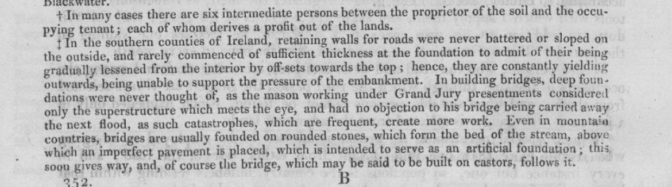
..
..

1827 Select Committee on Grand Jury Presentments (Ireland).
Compiled by Lord Doneraile, Joseph Deane Freeman, W. H. W. Newenham, W. W. Hoare, Robert de La Coer .

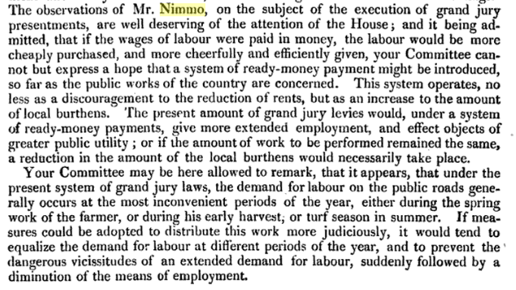
.
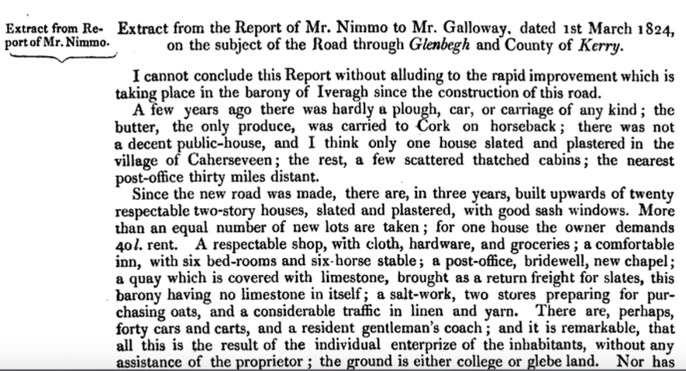

It was not entirely altruism or the promotion of local economic welfare that prompted the Dublin Castle authority to sanction the work of Griffith and Nimmo. The North Cork area had been riddled with Whiteboy activity, the Crookhaven area had been near the scene of an attempted French invasion at Bantry Bay in 1796 and was still the subject of local smuggling. This would asos have been a feature in the construction of the back road to Bantry from Cork over Cousane Gap. Clearly a relatively modern road network will facilitate military activity if perceived to be necessary.

By the late 18th century the area within a radius of 30 miles of Cork had a relatively good system of roads, harbours and the City had a piped water supply. In more remote areas basic provision was rudimentary. When the telegraph came to Dunmanway in 1860 an old man addressed the crowd to give is personal history of local developments. ‘An Old Man Recounts: The First Time I visited Dunmanway c 1790, The Roads were Bad, My Sister and I were in Two Panniers at Each Side of A Horse My Mother on A Saddle in Between, Then Cars with Block Wheels Sawn off of a Thick Tree Bound Round With Iron, Then They Got What They Called Scotch Cars With Spokes and Felloes at Opening of The Office of The Electric and International Telegraph Company, Dunmanway, Co.Cork, 1865. Messages from Cork, London and Crookhaven’.

…

…

….
Health Provision

A network of county infirmaries and fever hospitals was established to serve rural areas in 1765. There were 39 infirmaries by 1839 and about 75 fever hospitals throughout Ireland. These were funded by Grand Jury grants and public subscriptions. Each infirmary was staffed by a surgeon (who usually had a private practice) and was run by a committee who decided who could be admitted. Sick paupers and people with fevers were institutionalised not so much for their own good, as for the benefit of the rest of society.

The county infirmaries which had been under the Grand Jury came under the control of the Cork County Council in 1898 following the the Local Government (Ireland) Act 1898.

Dispensaries

An earlier system of dispensaries that had been partly paid for by the Grand Jury from the 1820s was replaced by the Poor Law Unions which provided for a dispensary system introduced in 1851. This was the Poor law infirmaries which were established by the introduction of the Irish Poor Law in 1838. The primary objective of the Poor Law was to provide relief to people who were destitute. Following the Poor Law Act, Ireland was divided into 130 Poor Law Unions (although this rose to 163 in 1850 Each Union was run by a Board of Guardians, who were able to raise funds from rates levied on property owners. Members of the Board of Guardians were elected by property owners. This electoral process was a further reduction in the power of the Grand Jury and marked the creation of a new class of local politician. The Poor Law Unions built 163 workhouses in Ireland between 1838 and 1851 to house destitute people from their own area. Most workhouses included an infirmary.

The workhouse infirmaries were opened in 1862 to sick people who were not destitute. The Poor Law workhouses consequently became the nearest to a general hospital system outside Dublin. The workhouses always remained very unpopular both with inmates and with
ratepayers who resented having to pay to support a system which many regarded as inefficient.

Gaol
….

…..

1757
Whereas a Memorial was presented to the Council of Cork, signed: by some of the Inhabitants, praying that the present Bridewell should be converted to a Fish market, and that a Bridewell should be built on the ground taken from Ald. Reily, It appears to the Council that said Bridewell was built by presentment of the Grand Jury of the Co. of said City, and that the money was levied on the Inhabitants of this City, and therefore the Corporation hath no property therein, and further, that the ground taken from Ald. Reily is expressly mentioned in the lease to be for building a Fish Market, ordered, that the former plan be carried into execution.

1790. [Advertisement] - NEW COUNTY GAOL - THE Commissioners for Building a NEW GAOL for the County of CORK, give notice that the Site now fixed on for said Gaol, is the piece of Ground at Gill Abbey, known by the name of Mrs. Moore's Fields, and that Proposals and Estimates for Building an insulating or surrounding Wall, agreeable to the Plan now lying in their Treasurer's Office, in the County Court Yard, will be received by him there, or at Mr. Curry's, on Batchelor's-quay, before the 21st instant. Dated May 6,1790 - J. W. DE LA COUR, Treasurer

…
Advances from Central (Consolidated) Funds

The Grand Jury received advances from central funds towards major projects over and above that raises sin cess. This is a sample from 1829:

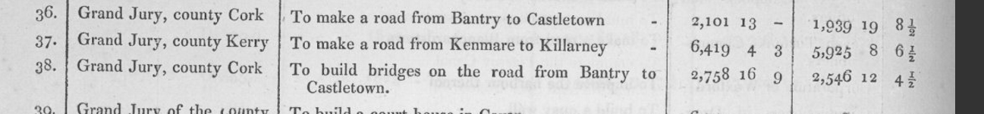

….
When Arthur Young toured Ireland in the I770s he described Irish grand juries as being composed of 'the resident gentlemen, their agents, clergy and respectable tenantry'. For the most part he seems to have been right.

Appointment as a justice of the peace had become, by the 1730s, a mark of prestige in Ireland. It was also seen in later years as a necessary prerequisite effectively to administer and manage an estate.Yet being a magistrate did not guarantee a man a place on a grand jury, nor were grand juries composed wholly of magistrates. As in England, though, justices of the peace were to become increasingly numerous among grand jurors. In Antrim in July 1716 only three grand jurors were in the commission of the peace for the county. By I769 more than half of the County Cork grand jury were Magistrates

…

Timeline
..

1615. Sale of wine in Cork raising £37 towards repair of city bridges.
1617. Freeman of Cork in consideration of erecting penthouse at North gate bridge proceeds to go to bridge maintenance.
1635. Cork Jury empowered to raise tax for bridge and three overseers appointed.

…

…

1660 Tt. That the 30s. charged by the Commissions of assessment of the County of Corke upon the town of Kinsale, being its proportion of 304li. 4s. 10d. charged on the county for insolvencies, mistakes, overcharges, &c., shall be paid out of the town rents.

1664 Kinsale Corporation. Resolved, as formerly, to oppose the payment of the money towards Innishannon bridge. 1665 that a rate be made on the Inhabitants for 15li. 13s. 7d., due to Mr. Rovell, one of the Church Wardens, for repair of the Church. Also, tlmt 15l·£. charged on this towne and liberties for Innishannon Bridge shall be raised by way of rate, 12li. on the town and 8li. on the liberties.

1668, Kinsale. The Grand Jury of the co. of Corke having judged it requisite that the highways leading to this place should be mended for the ease of the travellers, have formerly levied some money for the doing of it, which falling short to do what was intended, and an account being given in how it was disposed of, they are intended by another presentment to have more money raised to perfect what is yet undone. And because Sir Richard Keirle told me it was your desire to him to be left to applot amongst yourselves what sum or sums you shall judge fit to be given by your Corporation towards that work, as a president to be left out of the presentment of the county at large, I have sent this to desire you, that what sum or sums you shall think fit to give from your Corporation towards the mending of those highways may be forthwith paid unto Walter Cooper and Will. FitzGerrald, Esqrs., who are to' receive and pay the same to the doers of the worke, and account for the same. I remain.) Gent"., your very affecte• friend, Charleville, 9 May, 1668. Lord ORRERY. For my respected friends, the Soveraigne, Burgesses, and Freemen of Kinsale. It. That upon the Lord President's letter 8li. be given to the work, and for the present paid out of such moneys as remain in the Chamberlain's hands, and at next Sessions referred to the Jury how like sum shall be applotted on the town and liberties.

672. Kinsale. Agreed that the 25li. charged by the last Grand Jury of the Co. Corke on this town, towards erecting the County Court Hall, shall be raised by a rate on the Inhabitants, in case the Sovereign be advised by 'counsel that the payment cannot be avoided, and that for prevention of further damage the Sovereign. shall draw out of the town stock £25. to carry with him to Corke and pay sa

…

1674, Mayor of Youghal delegated to go to next Assizes at Cork in relation to charges at earlier Assizes towards building Fermoy bridge in the 1670s.

…

1682. County Assizes authorise bridge at Century Youghal among other towns to contribute.
1695. Approval for aarch over river Lee to be financed by Alderman Rogers in consideration from fees from appointing Freemen.

1695. Youghal, Legal Opinion re contribution to public charges Co. cork. ‘We are to join with the said County i defraying charges of bridges and toghers only’.The Mayor was directed to write to the treasure of Co, Cork, stating that the Corporation was willing to pay when the same charge were abstracted from other charges

1696 Cork City and County Grand Jury:

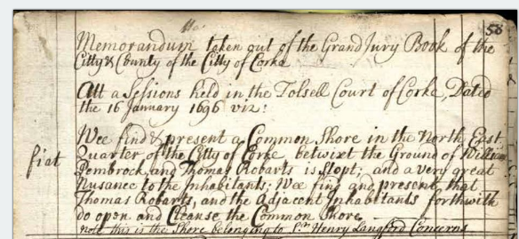

….
1707 Cork City Summer Assizes, Cork Corporation approve contribution towards cost of buckets and engines for extinguishing fires

1709 Cork City Grand Jury, remonstrance re export of corn

…
1712. KInsale Council books records the erection of stone bridge at Mallow to replace existing structure, Law Clayton £200.
1713. Cork to Limerick Turnpike
….

…

…
1720. That the underwritten be sent by two of the members of the Council to the Grand Jury of this County- " 26 Aug. 1720. GENTLEMEN, " The Corporation are always desirous to preserve the best understanding with the County, and are therefore willing to keep the roof and windows of the County Court House in good repair for the future, unless before the last day of the next assizes the Corporation shall be able to make it appear that by a former agreement between the County and City the Corporation was discharged from any further charge or expense on account . of the said Court House. But if the City subject themselves to this expense, they think it reasonable, that the care of the Courthouse should, between the assizes, be left to some person employed by them." Present-Mr. Mayor, Mayor Elect, Mr. Recorder, Sher. Mansell; Alden. Delahoid, Ab. French, Phillips, Hoare; Mr. Masters, Wilson

…

County Warrants, Presentments of Grand Jury at Assizes, Co. Cork, Kings Old Castle, 10th April 1731.

Peter Smith and Henry Harrington, finishing bride at Fotey (Fota, Midleton). £30

Hon. Henry Hayes St. Ledger and Charles Butler finishing little bridge on road from Mallow to Kerry. £4

Robert Wrixon and Charles Keeffe repairing Blackwater Bridge on road to Kerry. £10

Thomas Bond, finishing of Ballarosheen. £2.?

Patrick Bellew and Daniel Pope repairing old bridge over River Oumnagh. £7

Moses Burn and Maurice White repairing bridge of Eightmilewater in the great road leading from Cork to Dublin. £??

Denis O’Hea and Cornelius Sullevan repairing bridge over River Rivoge. £??

William Taylor, repairing bridge of Grinane. £4

2nd August 1731.

Robert Wrixon, repairing Blackwater Bridge. £3

Colonel Anthony Jephson, repairing Mallow Bridge. £15

David Power and Thomas Gibbins finishing Milford bridge. £10.

William Honors (Connor?) and Thomas Owgan finishing Ballinascarthy Bridge. £24

William Taylor and Richard Purcell completing repairs bridge of Grinane. £15.

Moses Burn and Maurice White repairing bridge of Eightmilewater. 9 shillings.

David and Standish Barry, bridge at Douneen (Repairs?). £3

John Lysaght and William Taylor erecting arch and making 1630 yards pavement on land at Knockanah and Lisrobin. £30.
….

..

27 Jan., 174~. Whereas a petition hath been laid before the· House of Commons of Ireland by one John Murphy, in order to bring the turnpike of the Kerry road, to the mile house. in the North Liberties of this City and Blarney Cross, and whereas we apprehend that if a Turnpike should be erected in pursuance thereof, it would be highly disadvantageous to the City of Corke and the Liberties, also to the County of Corke. Ordered, that the Clerk of the Council lay before the recorder instructions to draw a memorial to the . House of Commons and the Privy Council to oppose said Petition

…

….
1754 That John and Solomon Newsome have liberty to turn half an arch to join the North Arch of the North Bridge,Cork, in aid of a presentment granted at the assizes for repairing and widening the passage t'l the North Abbey, and that said persons have liberty to widen the quay before the houses of Anthony Deeves, the late Jam~s U,Epington, James Morrough, and Moses Newsome, leaving a slip ten feet wide for the watering of cattle at the west end.

20 Aug., 1755. £1 10. 8. to Kane Mahony, for services last Assizes as interpreter

…
1757 Castlehaven, (Skibbereen), Select Vestry Records, shows interaction of parishes in road building: Cullane, Daniel, app. Director of the High Way in CTend 37. VM 4 OCT 1757.

…

..
1762, That Cork Corporation to Mr. Edw. Browning, £17 13s. 7 !d. Newspapers and votes of the House of Commons.

…
…
1770 £83 8s. to Henry Wrixon, Esq., on his promissory note, to enable the overseers appointed by the Grand jury at the last assizes for repairing Glaunamought Bridge to proceed on said repairs, as it is apprehended that by delay the public would considerably suffer and the expenses increased.

…..

…..

……
1772. We (Cork Corporation) are informed that a clause has been introduced into the Act for this City, empowering the Grand Jury at each Assizes to raise certain sums for additional salaries for the Clerk of the Crown and Peace, or Town Clerk and Treasurer, without any directions from this Board ; ordered, that the Prime Sargeant be requested next Sessions to apply to have said clauses repealed, and that Mr. Lane do wait on him with a copy of this order.
…..
…
1773. Ordered, by Cork Corporation, that Mr. Snowe (Law Agent) do prepare a memorial to the House of Commons praying an act for local duties for 21 years to be applied as follows : one third for the use of the Workhouse, one third for building a Bridge across the North channel of the river Lee, one third for opening ways and passages and erecting public Buildings, and after the Bridge be completed, said third to be for the use of the Workhouse to be paid the Governors, the part for building the Bridge to be paid to Saml. Maylor,.John Webb, Kingsmill Berry, Esq., Stephen Denroch, Kevan lzod, Greatrakes Smyth, Paul Benson, Willm. Jameson, Humphry Crowley, and Thomas Trant, merchts., the part for erecting public buildings, &c., to be paid to the Mayor, Sheriffs, &c., with the third part for building the Bridge after the completion thereof.

…

1824. Letter from Richard B Cotter, secretary, Grand Jury, County Cork, to William H Gregory, Under Secretary of Ireland, Dublin Castle, enclosing memorial from the grand jury of County Cork to Richard Wellesley, 1st Marquis Wellesley, Lord Lieutenant, Dublin Castle, requesting advance of half moiety of £1,351 13s 6d to enable construction of a bridge and causeway over the River Bandon at Baxter’s fjord on the mail coach road from Cork to Bantry.
…

,,,,,

Kinsale Lighthouse. Early in 1854 Lord Bernard of Castle Bernard, Bandon, Co. Cork enquired why, since the new light was established, Courtmacsherry Bay was without a light. Inspector Halpin explained in his report to the Board that the new light was a sea light and was not intended to guide vessels through the rocks and shoals of Courtmacsherry Bay; also if the latter was required a local light on Land Point would suffice. Lord Bernard also directed his enquiry to the Board of Trade in London as a memorial from the Grand Jury of the County of Cork.

…….

Baronies as Administrative Units.
In Ireland, a barony (Irish: barúntacht, plural barúntachtaí^{[1]}) is a historical subdivision of a county, analogous to the hundreds into which the counties of England were divided. Baronies were created during the Tudor reconquest of Ireland, replacing the earlier cantreds formed after the original Norman invasion.^{[2]} Some early baronies were later subdivided into half baronies with the same standing as full baronies.
With the coming of the Normans to Ireland in the 12th century the Barony emerged as a unit of administration. Each county was divided into Baronies Cork haveing by 23 of various sizes.
Baronies were mainly cadastral rather than administrative units. They acquired modest local taxation and spending functions in the nineteenth century before being superseded by the Local Government (Ireland) Act 1898.

The County Rates levied by the Cork Grand Jury were levied on a Baronial basis. Under the Grand Jury (Ireland) Act 1836 power was given to amend the Baronies for administrative purposes. The Baronies of Carbery and Muskerry were divided into West and East and the Carberies was further sub divided into East and West Riding reflecting the local topography..

The Baronies of Condon and Clangibon were united as well as Orrery and Kilmore and Ibane and Barryroe.
…

Hearth Tax Collection

From 1662 to end of the 18th century. It was levied half yearly by the Sheriff of each county on the basis of lists of the names of householders compiled by local Magistrates.
The list of the households required to pay the Hearth Tax became known as the Hearth Money Rolls, which were arranged by county, barony, parish, and townland. The tax was sometimes collected over an area known as a 'walk', which was based on both the town and a large rural area outside the town.
Several attempts were made in Parliament to abolish or at least limit the proportion of households obliged to pay the tax, which was widely regarded as “a shameful infliction upon the poor peasant, to whom even two or three shillings in the year for such a tax was a burden and a wrong”.
Major reform of the hearth tax was finally carried out in 1793 whereby one-hearth households with less than £10 in personal property, or with houses and land worth £5 or less, were henceforth deemed exempt from the tax. The measure was apparently a consequence of parliamentary pressure in the previous session; the modification of the window tax in Britain giving total relief to poorer householders had led to calls in the Irish Parliament for similar "liberality" in the light of Ireland's healthy finances. The Chancellor of the Exchequer (William Pitt) had refused, but a parliamentary committee was established under the de facto chairmanship of Mr G.P. Bushe who successfully proposed that one-hearth householders should be divided into two groups: those above and those below £5 in annual valuation. Subsequently, in 1795, freedom from hearth tax was extended to all one-hearth householders, as the opposition had earlier demanded; at the same time the tax on multiple-hearth houses was raised.^{[9][11]} The number of persons exempted from the hearth tax was estimated at between a million and a half to two million.^{[12]}
The original Hearth Money Rolls are not extant. The records were housed in the Four Courts in Dublin, the repository for the Public Records Office, but during the Irish Civil War in 1922 the building was destroyed by fire, which also destroyed the Rolls (along with the Irish census records for 1821, 1831, 1841, and 1851), but copies of some of the Rolls have survived.

Hearth Tax ResearchEdit

It is unclear as to what use the tax was applied

1714, Crookhaven, Mr. Downes (may be Dowe), The Hearth Money Man.
1732, Henry King, heart tax collector in Castletownbere with Thomas Lucas, Customs Surveyor, re O’Sullivan smuggling. Richard Tonson Surveyor for Bantry area searched O’Sullivan boat and then came in Bumper with cargo of smuggled Brandy. O’Sullivan probably in collusion with John and Henry Puxley.

1743. Command from Custom House, Dublin re Hearth Tax Collection:

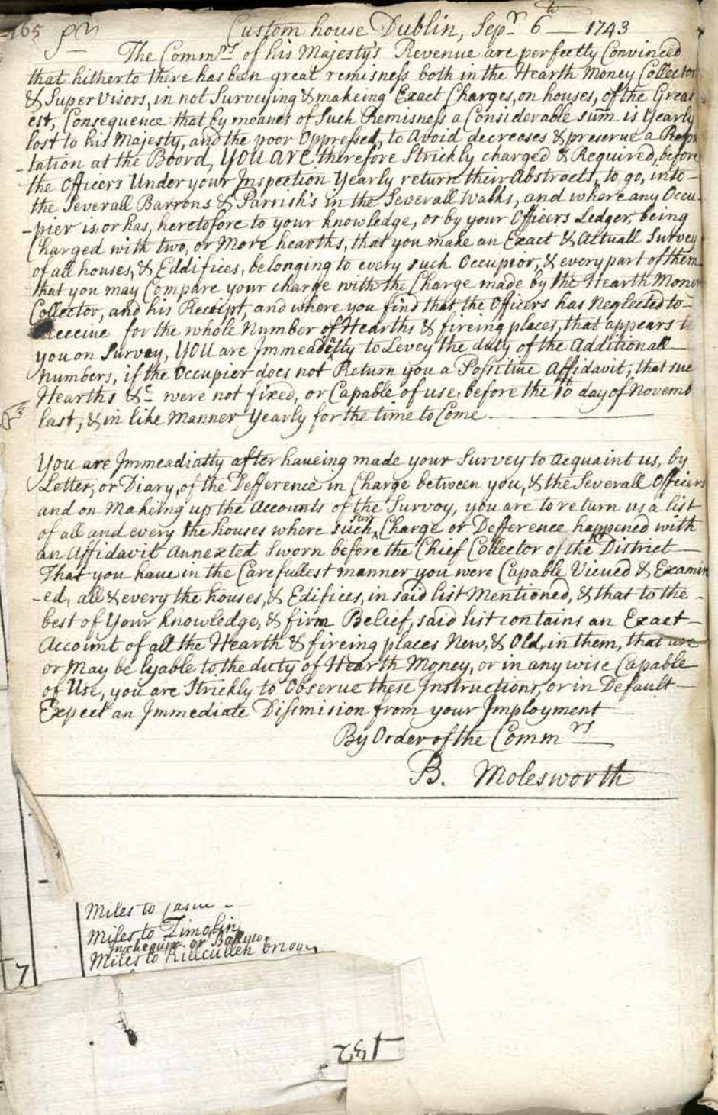........

1769, John Pearce, Mallow Lane, Cork, hearth money collector.

Michael Sullivan (Hurrig), Bantry 1770 allegedly a descendant of O’Sullivan Bere other O’Sullivans later baronial Constables for Bantry and Bere.

1783. John Wood, hearth money collector. May also be merchant related to Chattertons, voting in Cork 1783 election.

1784, Lord Shannon's recommendation to Lord Lieutenant, for appointment, 2 Revenue Boatmen, 1 heartmoney collector, 1 coast officer, 1 mate, surveyor Port of Cobh to William Colthurst at £200 per annum.

C 1800 one of the Bantry Warners describes as Baronial Constable.
1804 Robert Maxwell, Cork may be related to Limerick family

….
1720 Sample Valuation, Skiddy’s Castle Lane including Minister’s Money:

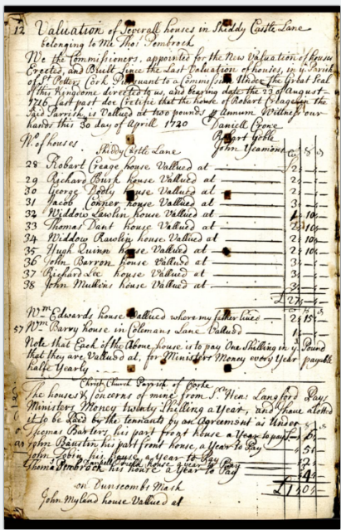
...

…
…

1737 Fragment Hearth Tax Roll..
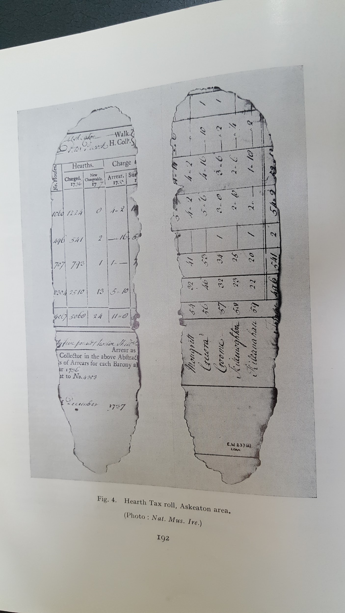
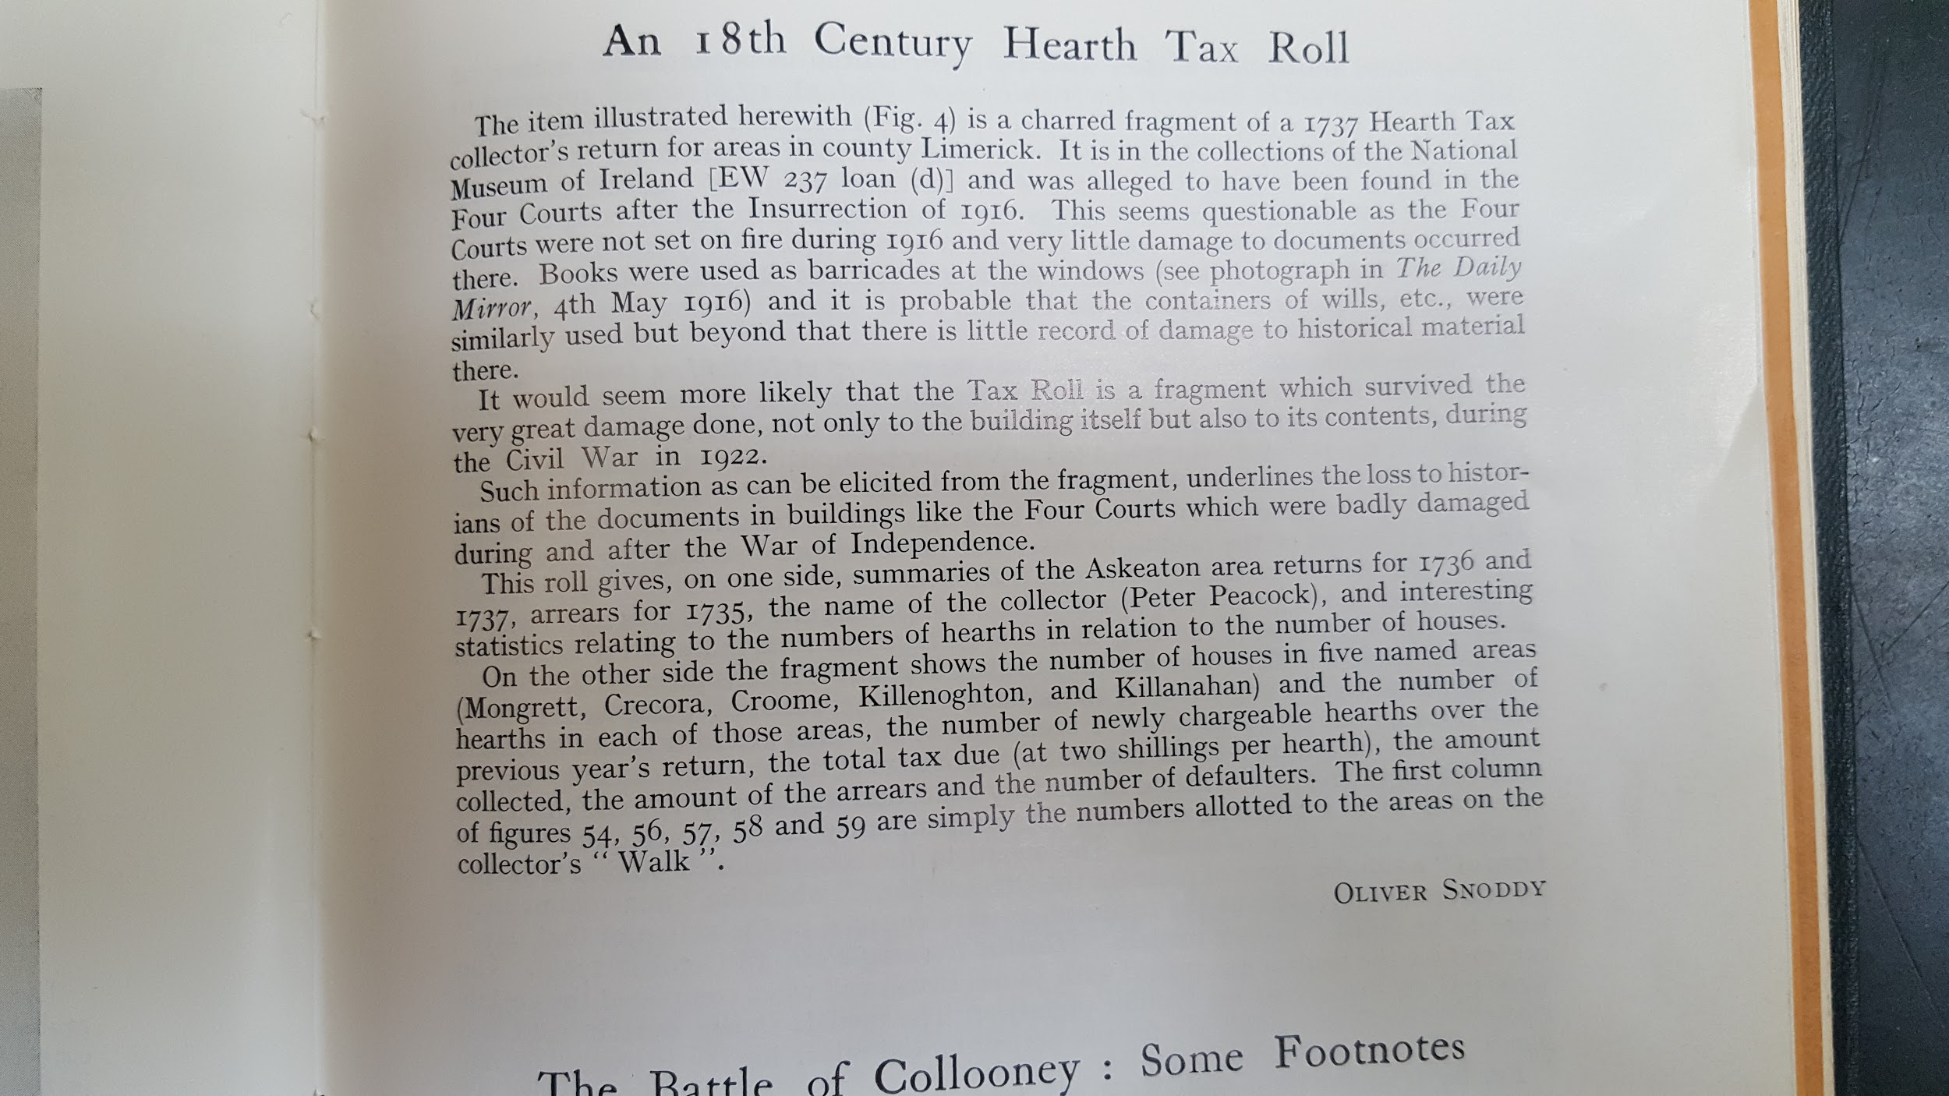
..
From Co. Kilkenny copied pre 1922.

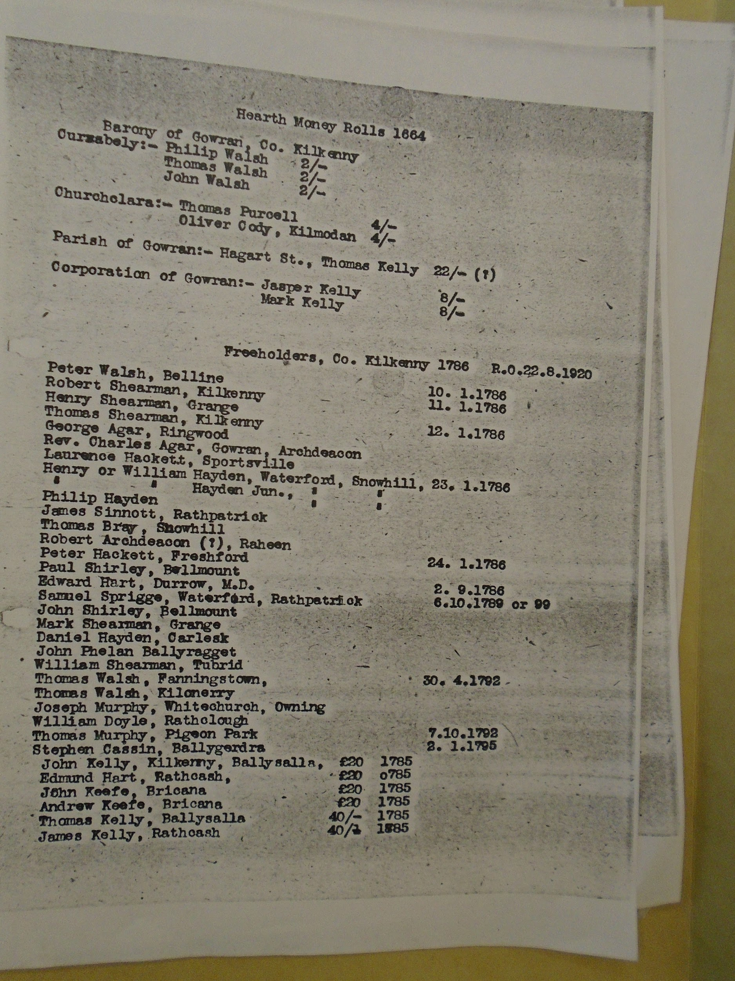

...
Constables for Collection of Taxes on Assizes Presentments 1744.

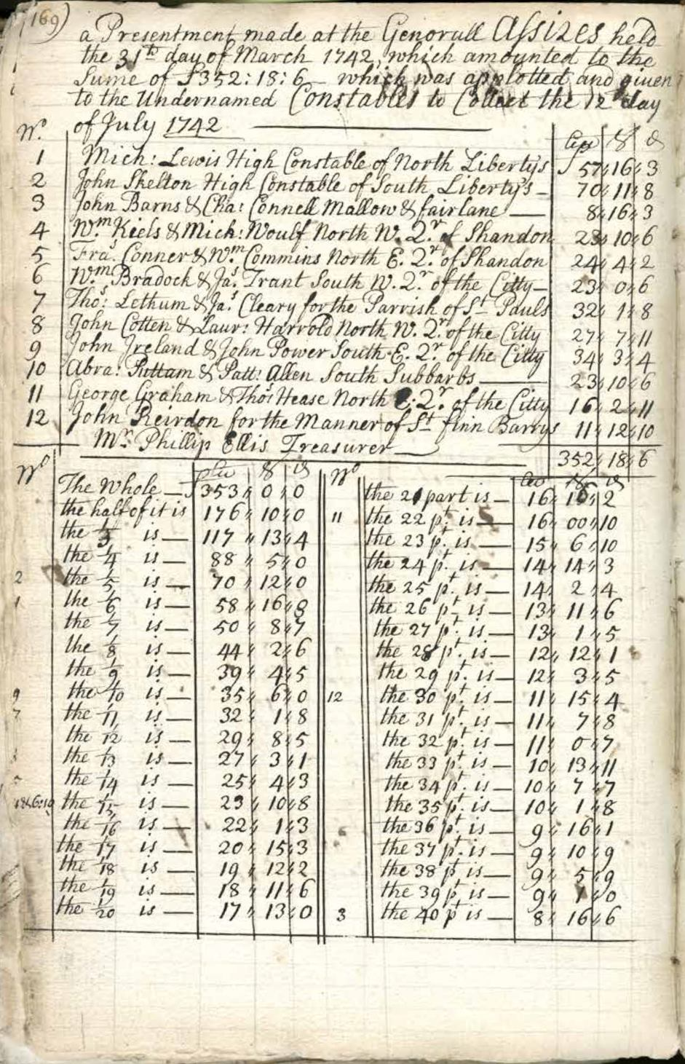.
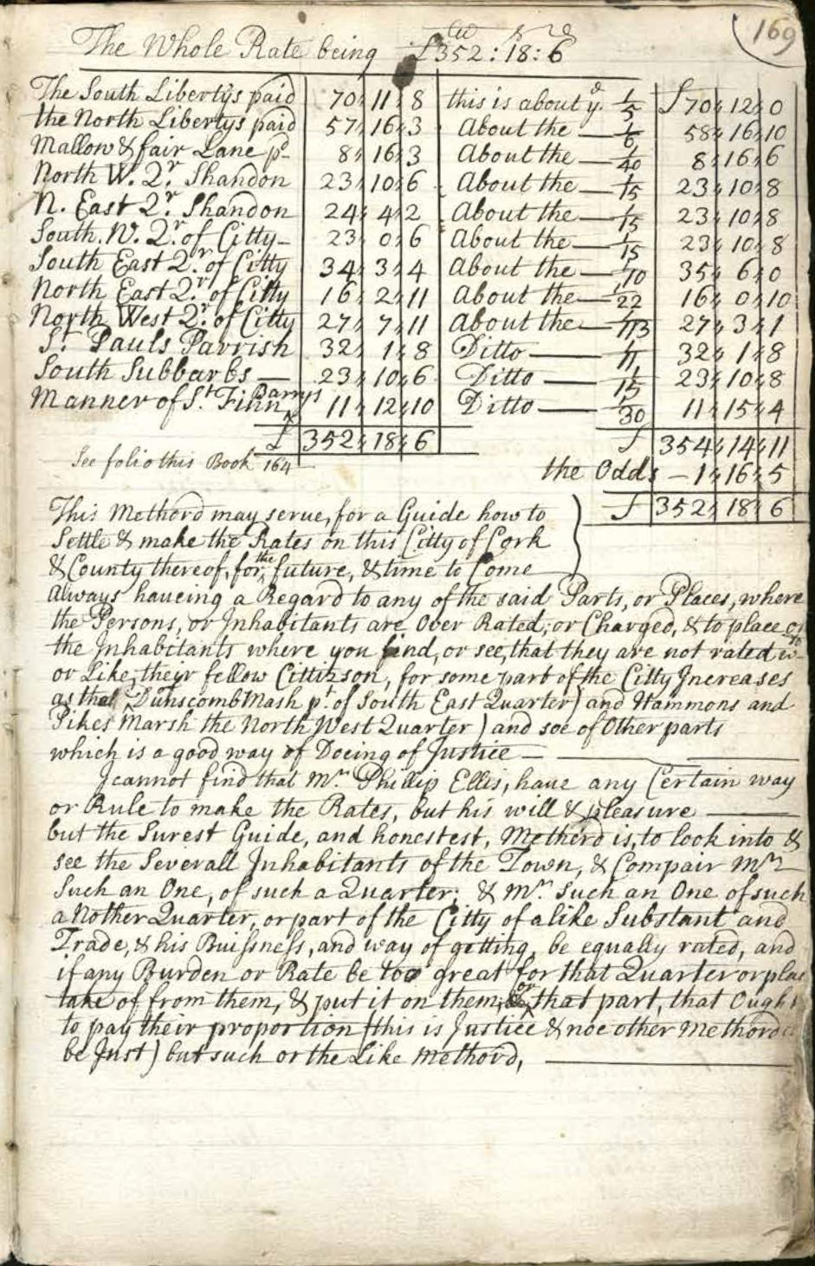..
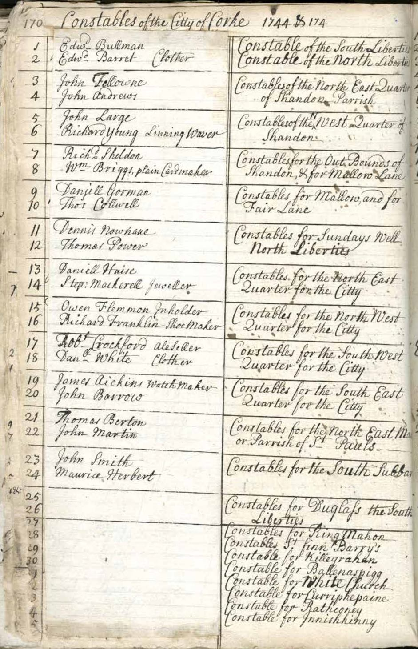..
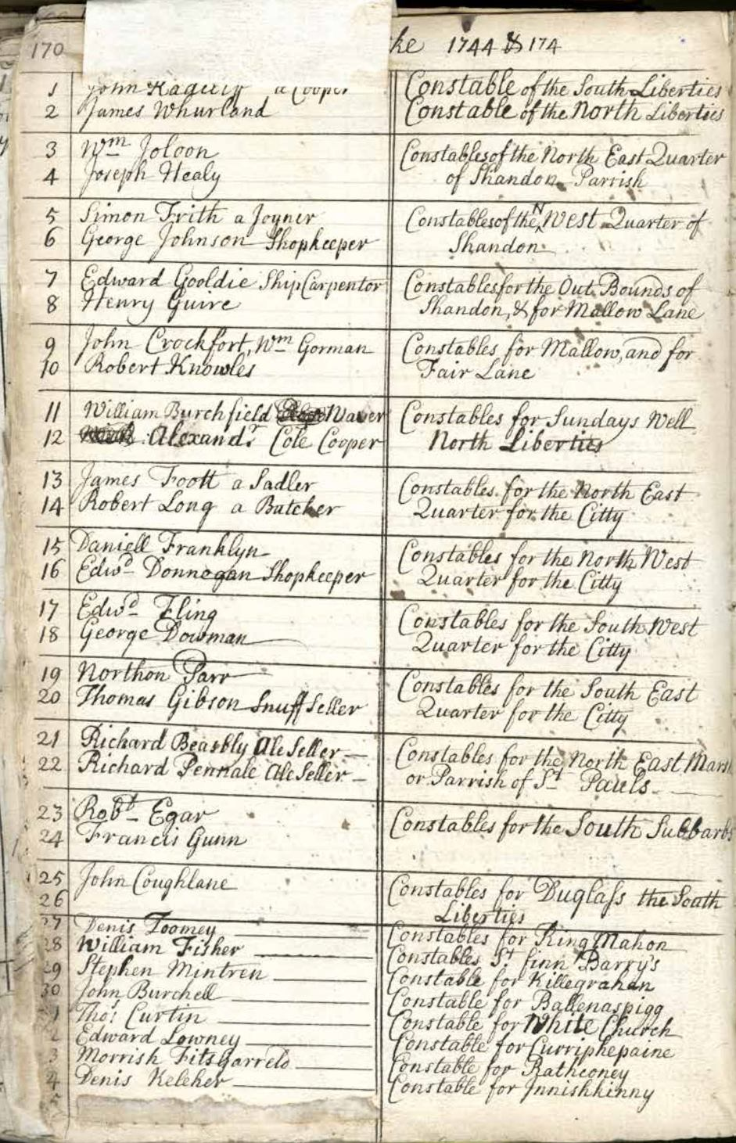..
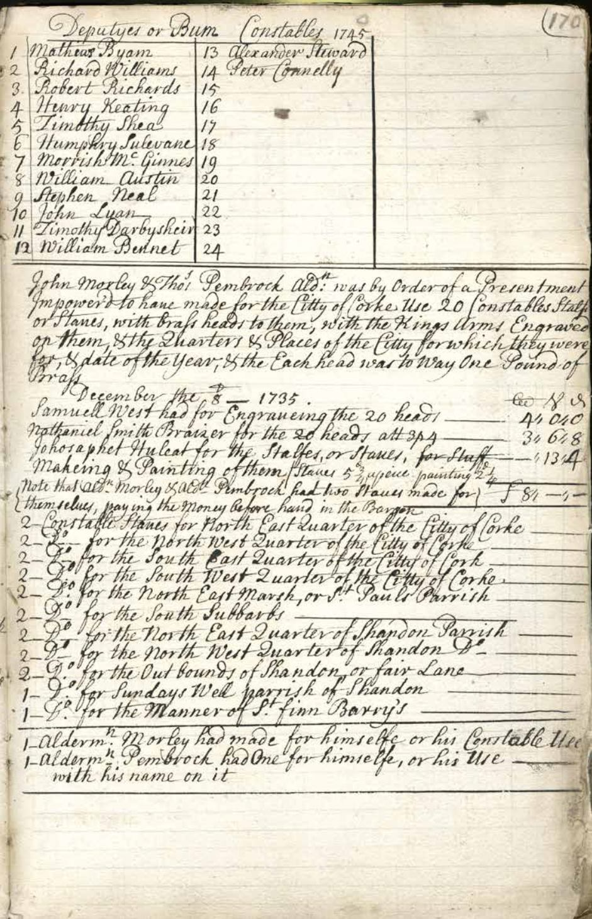

County Rates/Cess

The local charge was known as the Cess which amounted to around 12% of the gross rent on land.

1576, Fiant 2862. Commission to William Drury, Knight, Lord President of Council of Province of Munster .. James Dowdall, Esq., Second Justice of the chief place, Nicholas Walshe, Andrew Skiddy, Esq., John Myagh, Esq., Henry Davells and William Aspley Esquires to the Commissioners for the whole Province of Munster, and in it crosses and marches, adn in the counties of Carbery, Bantry and Desmod, and all places south and east of the River Shenon (Shannon). To muster and array the inhabitants; to cess them for defence of the country, fining and imprisoning those who may be disobedients, to treat with enemies and rebels of the Province, grant safe conducts and conclude terms at discretion and compel the observance of such terms.. To raise the inhabitants and punish rebels and enemies with fire and sword, the Lord President to command the forces in the field in the absence of Deputy, and do all things as contained in instructions to Deputy dated 1573

The Cess had a long history in County Cork, Appendix 1 details some of the surviving records from 1592.

1576. Appointment of Commission for Province of Munster, William Drury, Esq., Lord President of Province of Munster, James Dowdall, 2nd Justice, Province of Munster, Nicholas Walsh, Andrew Skiddy, John Myagh, Henry Davells, William Aspley, to cess the whole Province. Fiant 1862 of Elizabeth 1.

1736 William Bateman, Ballygrasson, Carrigaline, Church Warden, extended to 1737 not having collected rates James Power of Coolmain to succeed

1753, Alleyn Carthy (McCarthy), Freeman of Bandon, Proctor and tithe collector.

March 1798. Rosscarbery Select Vestry meeting to Levy a Rate to provide Four Men to Serve in Militia and to Levy Seven and a Half Pence Per Gneeve. Further meeting August 1803 to levy £1-6-o per ploughland to raise 5 men for Militia and £5-13-9 on town of Rosscarbery.

Apart from the cess other taxes applies as in KInsale in 1831: There are also Assessments for Minister's Money, Church Rate and Foundling Tax. The Houses assessed for these purposes are 96 1; and the amount raised last year was, for Minister's Money ,£. 87.; Church Rate, £. 95·; and Foundling.

Tax, £45.

The cess to pay for roads, bridges, and other public works was set in the Baronial ‘Presentment sessions’, where petitioners applied for funding for such works, were originally held as part of the county assizes, though the costs were paid from the barony cess if the work was of local benefit only. The county grand jury was supposed to have included jurors from each barony, though this did not always happen.^{[28]} From 1819,^{[29]} significantly modified in 1836,^{[30]} baronial presentment sessions were held for these purposes, with a local jury picked by the county grand jury from among the Barony's highest rate-payers, according to a complicated formula.^{[31]} The baronial presentment sessions were a convoluted process, lacking public confidence and marred by allegations of corruption and favouritism.^{[31]} Special emergency sessions were held during the Famine of the 1840s for the make-work schemes.^{[31]}

In the 1840s enquiry into land, the evidence was, that the cess amounted to 12% of the Baronial rental income. Thomas Townsend a landlord of Sunville, Skibbereen stated that since tithes were abolished in 1832 the cess in his area had gone from 2s or 3s to 20s and 30s. If fell on occupying tenants and non resident Landlords who escaped paying anything.

1825. Spare acres: Letter from G Fitzgerald, magistrate, chairman of petty sessions, Clonmel, County Tipperary, to Henry Goulburn, Chief Secretary, Dublin Castle, drawing attention to a case of abuse in the collection of county tax [cess] on the townland of Monksgrange in the barony of Iffa and Offa East in County Tipperary. States a complaint was made by John Maher of that place against William Connors, a collector employed under Patrick Keating, high constable of the barony of Iffa and Offa East. Indicates on the property in question an over collection of cess took place and a horse belonging to Maher was seized in lieu of an alleged outstanding tax on 12½ acres. Following a full investigation, however, the magistrates were unable to support a charge of fraud against the collector or high constable. He observes that tracts of land or ‘surplus acres’ in most counties are not included in the Down Survey and these constitute ‘a source of private and illicit emolument to the collectors’. He recommends making a new and accurate survey of Ireland in order to guard against such malpractice.

1824. Petition of William Swanton, high constable and collector, Gortnagrough, County Cork, to Richard Wellesley, 1st Marquis Wellesley, Lord Lieutenant, Dublin Castle, requesting extension of financial aid due to personal losses incurred through devaluation of currency received as ‘Collector of the Public Money for the West Division of the Barony of West Carbery’. Refers to the collection of notes issued by the banking houses of Messrs Leslie and of Stephen and James Roche, who later declared bankruptcy, and counts the refusal of same by the county treasurer as ‘a fatality which he could not foresee’. Asserts he was obliged to make up the losses out of his own fund; with character reference on foot signed by Lord Bantry [Richard White, 1st Earl of Bantry] and 6 others. Also second signed memorial from Swanton to Wellesley, plus certificate from James Delacour, treasurer, County of Cork, describing Swanton as ‘a highly meritorious public officer’.

Notification, July 1828, by William Swanton, Baronial High Constable, Gortnagrough, Ballydehob, West Cork to Parties Aggrieved by Posting of Cess Levies at Church Doors West Carbery, West Division to Appear in Carrigboy (Durrus) Courthouse.

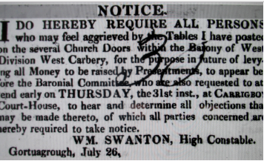

Thomas Ware Esq., Pre 1831, Woodford, Mallow, Sitting Mallow, 1835. Attending Cork Grand Jury 11 times. Thomas Ware, Landlord, Vice Chairman Board of Guardians. Complained about the operation of the County Cess. The HIgh Constable furnishes to the Church Wardens a certificate stating the amount of the Cess to be levied against the Parish, manor or denomination. However he may give a Certificate only to the amount to be levied against the entire Parish. If he does that it is impossible to applot the Cess and he can make an individual liable for the Cess of the entire ploughland and make him collect on his behalf. If he defaults he may distrain him. The system has given rise to great oppressions. He was aware of an example where the Constable had collected more than justified by the Treasurer's warrant, he brought the matter before the Grand Jury and the Constable was dismissed.

1844. Evidence of Alexander O'Donovan, Petty Session Clerk, Bantry into Percolation of Local Cess Collectors. This evidence was given in Bantry to The Inquiry re Land Occupation on the 9th September 1844. He said that every Collectors of County Cess were dismissed around 1840. Hutchins (local Magistrate) swore that the Grand Jury appointed the dismissed man's son to the job. He also said that every collector in his time for about the previous 20 years had been dismissed for percolation. The actual deputy collector was dismissed and fled to America. Hutchins and the authorities selected a policeman to go to Clonakilty on his return he said he was dead which Hutchins doubted.

Thomas Ware, Woodford, Mallow, Landlord, Vice Chairman Board of Guardians. Complained about the operation of the County Cess. The HIgh Constable furnishes to the Church Wardens a certificate stating the amount of the Cess to be levied against the Parish, manor or denomination. However he may give a Certificate only to the amount to be levied against the entire Parish. If he does that it is impossible to applot the Cess and he can make an individual liable for the Cess of the entire ploughland and make him collect on his behalf. If he defaults he may distrain him. The system has given rise to great oppressions. He was aware of an example where the Constable had collected more than justified by the Treasurer's warrant, he brought the matter before the Grand Jury and the Constable was dismissed.

Collection of Cess

The Baronial Constables had an array of staff to enforce the collection of cess. Their teams often collected other local charges such as tithes at differential poundages for collection. The enforcers included proctors and drivers who would often seize cattle late and night bring the to the pound and auction them later. In contentions cases the police and sometimes military were called i by the Magistrates.

The first Ordnance Survey Maps show village pounds for most villages of any size. Enclosed is an example:

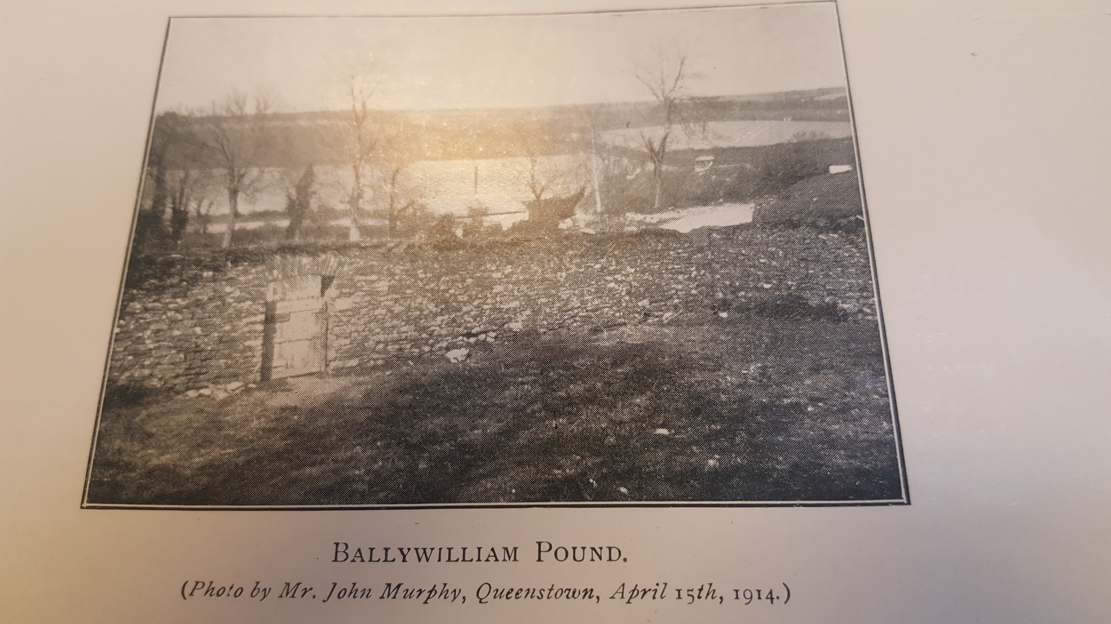

In evidence from the Macroom area to the Parliamentary Enquiry re landin 1841 Father Michael Lane,Parish priest alleged that the County Cess was collected by the Baronial constable four months before it was due to the County Treasurer. In the interim the Constable had the benefit of placing the money on deposit.

Sample from East Muskerry 1889

1889-1891 Valuation of the Barony of East Muskerry for the Grand Jury of County Cork. Collector of the county cess William H. Beamish. Lists by parish and townland all occupiers of townlands and tenements, giving annual valuation, amounts due at the Summer Assize 1889, Spring Assize 1890, Summer Assize 1890 and Spring Assize 1891. This is in e Preston Collection, Cork Archives.

Chief Secretary Dublin Castle papers.

The papers of the Chief Secretary for 1818 to 1822 have been digitalised and among the is a an application 1822 from Richard B. Cotter, Secretary of the Cork Grand Jury calling for a suspension of the levy. It is not clear if this was in addition to the cess.

1807 Militia Bounty:
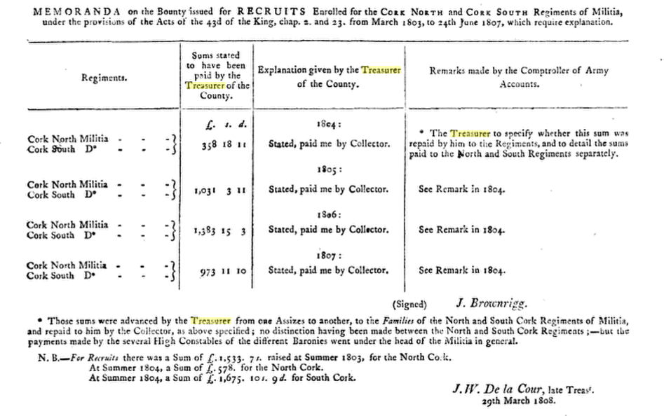

There are frequent applications to the Chief Secretary for employment as Baronial Constables backed up by affidavits from Magistrates and MPs and professions of Loyalty of prior military service in the recent wars. Some of the correspondence suggest pretty drastic methods by the Baronial Constables of collecting the cess through the employment of ‘drivers’ to seize cattle and impound them in local pounds and sell. There are pleas for short term loans for the Grand Jurys and requests to suspend the cess in Tipperary and the collection would lead to ruin because of the local great distress. A recurring theme is the severity of the Cess and its unfairness.

The Grand Jury submitted a list of the jurors for the County for 1815 to 1819 and the City for 1817 to 1819 which is still available. There is correspondence concerning the proposed House of Industry on the Gaol grounds and objections from 40 prisoners who would lose their gardens. The Gaol was overcrowded and there were application by way of Memorials from the Grand Jury submitted by the High Sheriff, Jammet Browne, to move convicts due to transportation to Van Diemen's Land to another depot.

Before the establishment of the RIC the Grand Jury had a jurisdiction in policing which is reflected in the correspondence concerning pensions for constables in some cases for up to 30 years service. The allocation of addition judicial sitting was a matter for Dublin Castle and there are frequent requests from Cork to extend quarter session and the sitting towns in this regard. 1821 Richard Hare Viscount ennismore writing in this regard.

In the general correspondence a move to improve public health can be discerned with application for fever hospitals and to open new dispensaries.

Letter 1820 from William Jones Clerk of the Crown and Peace (State Solicitor) re new draft legislation which he says will make Clerks of Crown entirety dependant on Grand Jury.
…

David Nolan, ‘The County Cork Grand Jury 1836-1898’, unpublished 1974 MA Thesis Boole Library, UCC gives a backdrop to the Cork Grand Jury. As he says in his introduction most of the early records were lost in the fire of the Court Courthouse in 188 and many of the surviving records were destroyed by Cork County Council at the time to the move to the new County Hall in the 1960s. Mr. Nolan relied heavily on back issues of the Cork Constitution for his thesis.

….

1827 Petty Session Court Legislation:

Petty Sessions were the precursor of the modern District Court. The courts ordinarily dealt with minor misdemeanours. The Court’s register books represent a hugely significant resource for family and local history research. The bound registers were arranged by court location giving a schematised account of criminal offences. The system governing how Petty Sessions worked was only set out by statute (despite centuries of operation) in 1827 with the ‘Act for the better Administration of Justice at the holding of Petty Sessions by Justices of the Peace in Ireland, 2 July 1827’ (7 & 8 George IV c.67). This specified that the Grand Jury in each county (the forerunners of modern county councils) should set out petty sessions districts in a formal manner. It also required proper registers to be kept, trained clerks, and regular courts. The system was overhauled again in 1851 with another act, ‘The Petty Sessions (Ireland) Act’ which sought tighter regulation of the keeping of records and meeting of courts. Registers which pre-date 1851 are extremely rare. There are none for Dublin city, Dun Laoghaire (Kingstown), and some other districts either because they were excluded from the provisions of the 1851 act, or because the records did not survive the destruction of the Irish Public Record Office during the Four Courts bombardment of June 1922. Most of the surviving Petty Session records for the Republic are held by the National Archives of Ireland. There is a possibility that this County Cork Register was retrieved from the Public Records Office in the aftermath of its destruction and was deposited in the adjacent Capuchin Friary on Church Street for safekeeping.

Grand Jurors.

Richard White of Bantry giving evidence to a Parliamentary enquiry in 1840 stated that the County needed to raise between £90-100,000 a year. This as done by a twelve Grand Jury of twenty intelligent men who sit for five days at the twice yeary Assizes todo the county’s fiscal business. They break down into sets of two or three men who constitute the Grand Jury. The allocations are made out in two levies. He did not consider this sufficient to do justice to the administration for a County as la as Cork.

He was scathing in the application of the county cess mentioning bungling, of a ploughland left out and the balance falling disproportionately elsewhere. He was echoing a common contemporary complaint about the operation of the cess.

He said that every Magistrate had a vote on the raos session which he thought was wrong he should not be involved in his own district. He said there were a great many evils complained of at the road sessions.
…

…

…

…

…

….

Letter 1821 from Francis Woodley, Frankfort, County Cork, near Tallow, County Waterford, magistrate, to William Gregory, Under Secretary, Dublin Castle, concerning a threatening notice posted in village of Conna, County Cork, warning anyone who pays or collects tithes, and threatening any landlord who does not reduce rents by sixty percent. States that he has advised his son, Francis George, a high constable of the barony of Kinnatalloon, to collect the county cess immediately. Expresses hope that the majority of farmers remain 'well affected'.

1840 G. Standish Barry M.P. in a Submission to the Commissioners appointed by the British Parliament maintained that the level of surety provided by the Baronial Constables was poor, ‘very tottery if not insolvent’.
The Commissioners recommended that collection be put into the hands of poor law collectors who would do so at a lower poundage than the Baronial Constables

1870 Bandon: Poole Horatio T. Esq, Baronial High Constable.

1881 Clonakilty: Baronial High Constable’s Office, The Square – W. Hungerford, High Constable

1780-1860 Grand Jury Returns.

.
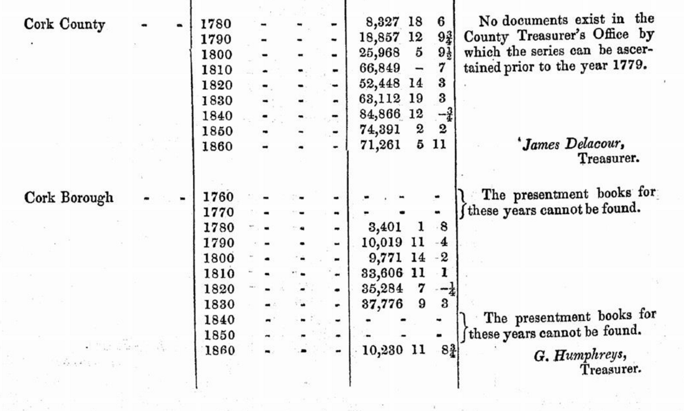

….
1793-1803. Cork Grand Jury Returns including provision for Militia from 1795.

The Military Levy was raised through parishes by the Churchwardens, the parishes were subject to a levy or a bounty to be paid in lieu. the surviving records of Drimoleague and Castlehaven Select Vestries confirm this.

The Military Levy predated the attempted French Invasion at Bantry Bay 1796 and the United Irishmen Rebellion 1798 but was at a time of the French wars.

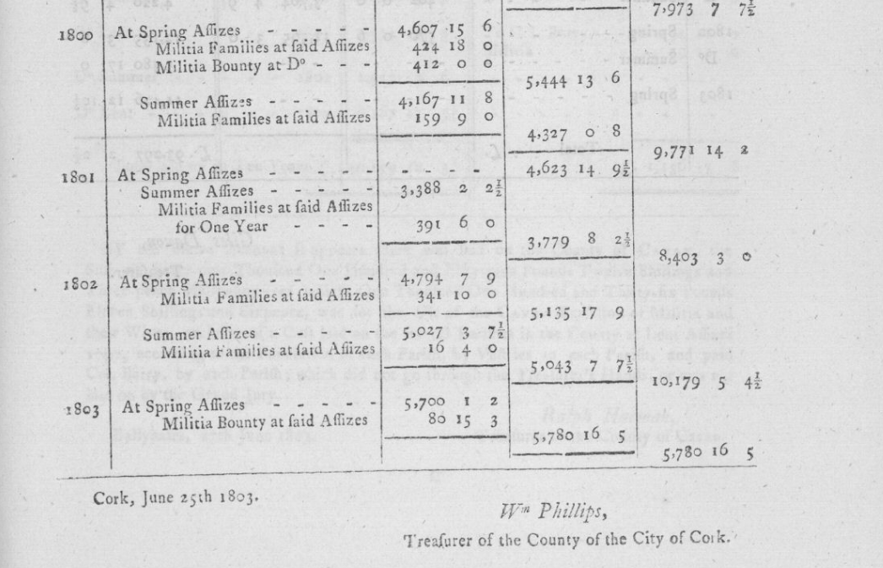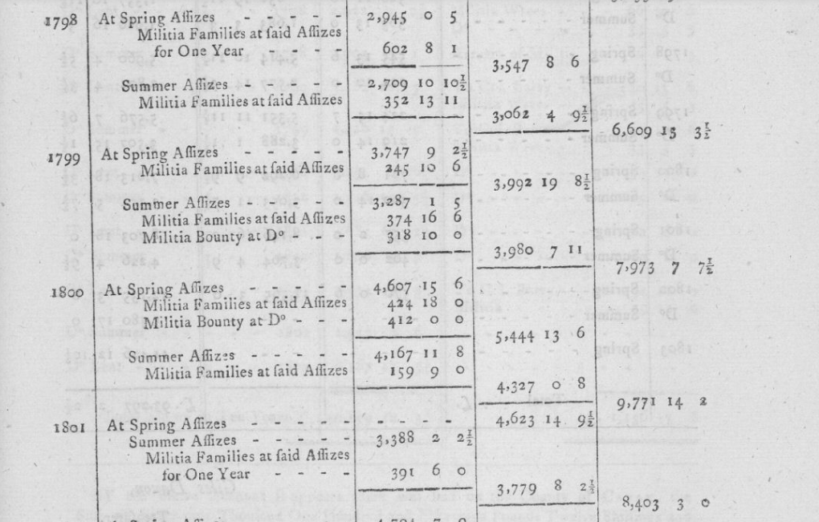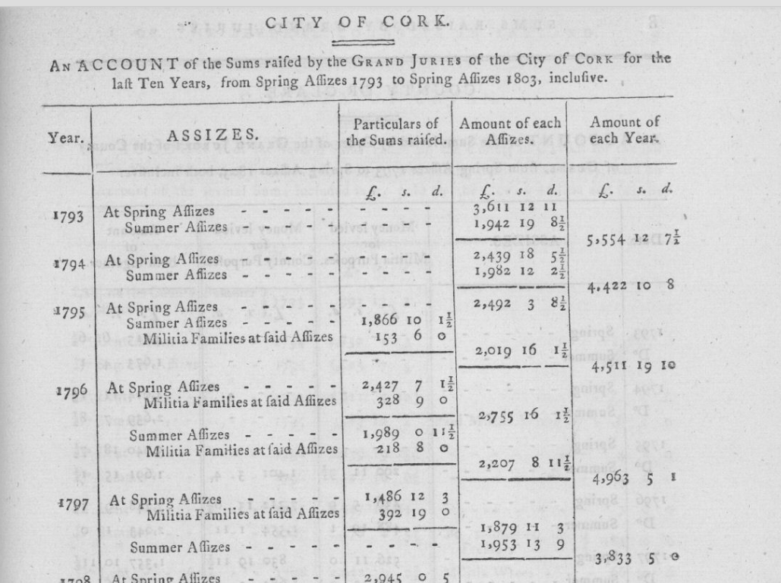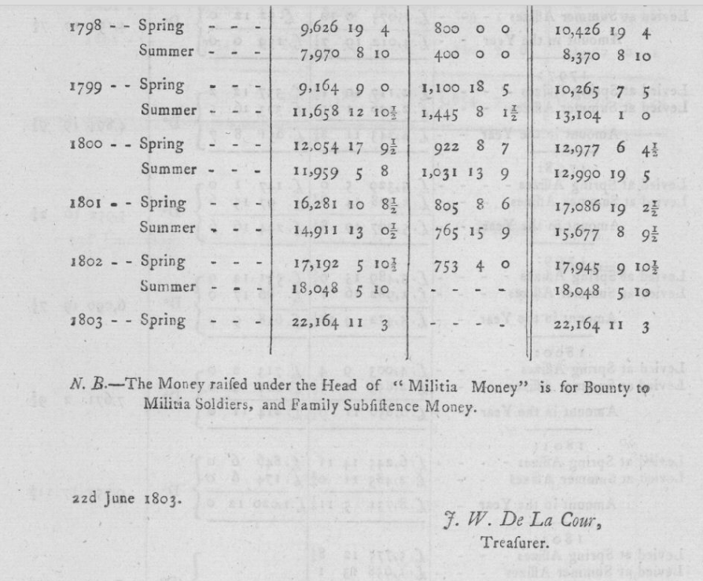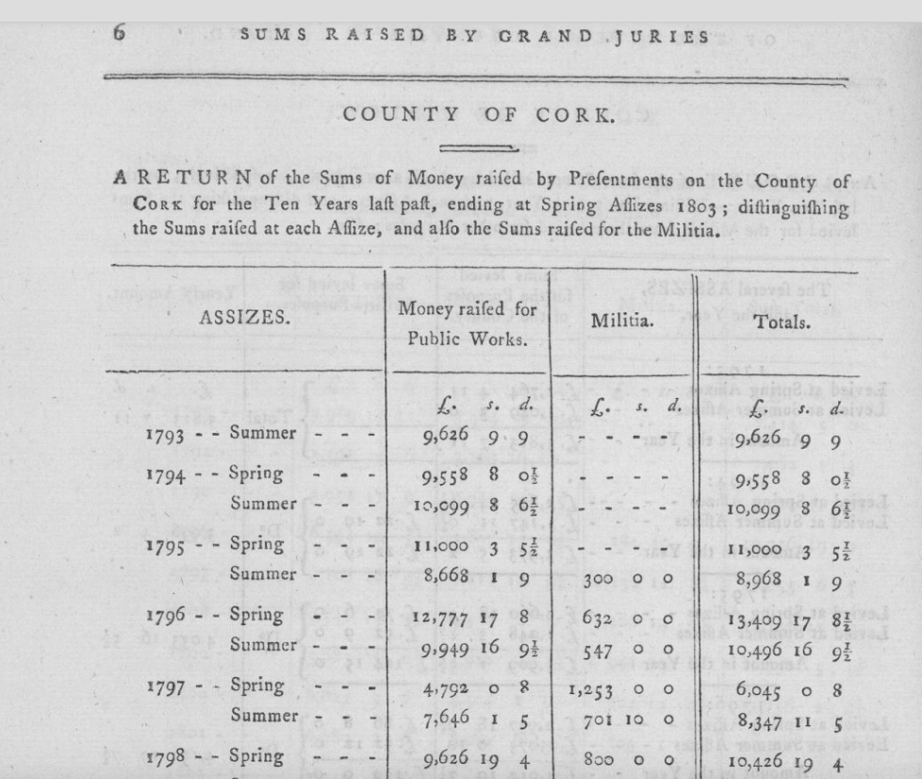..

…..

Grand Jury presentments from 1676.

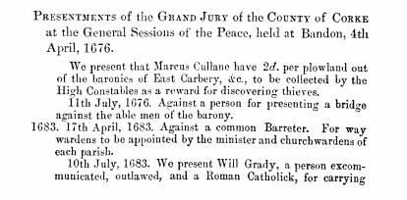.
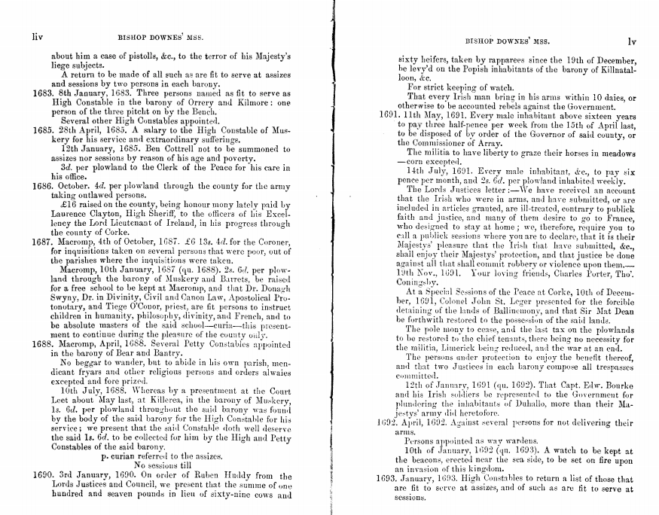.
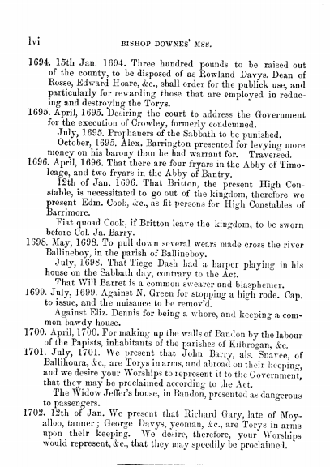

…..

..

..

1793-1803 Grand Jury Expenditure including on Militia

…
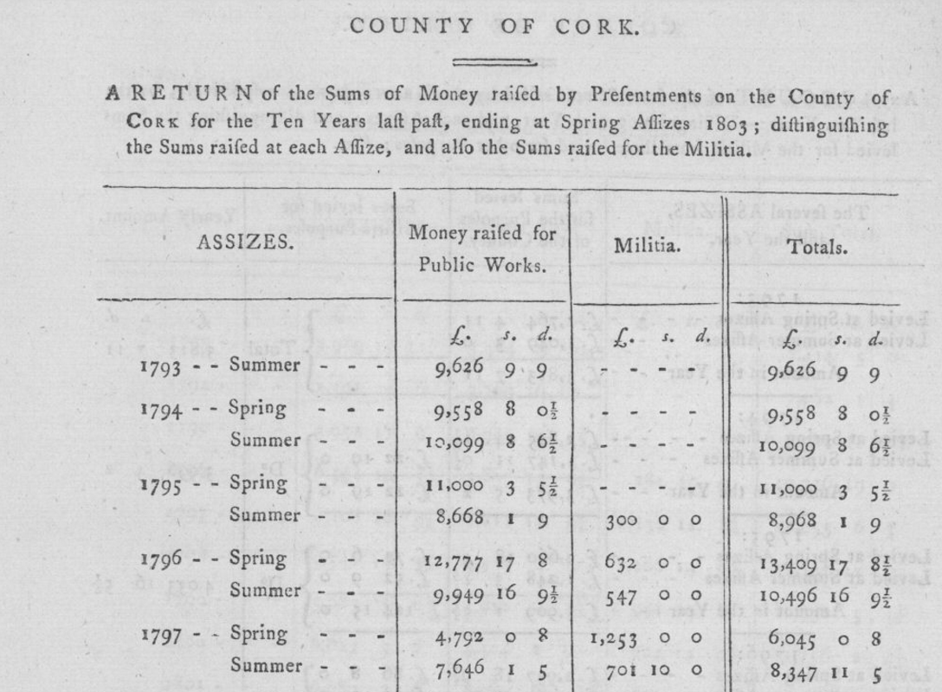
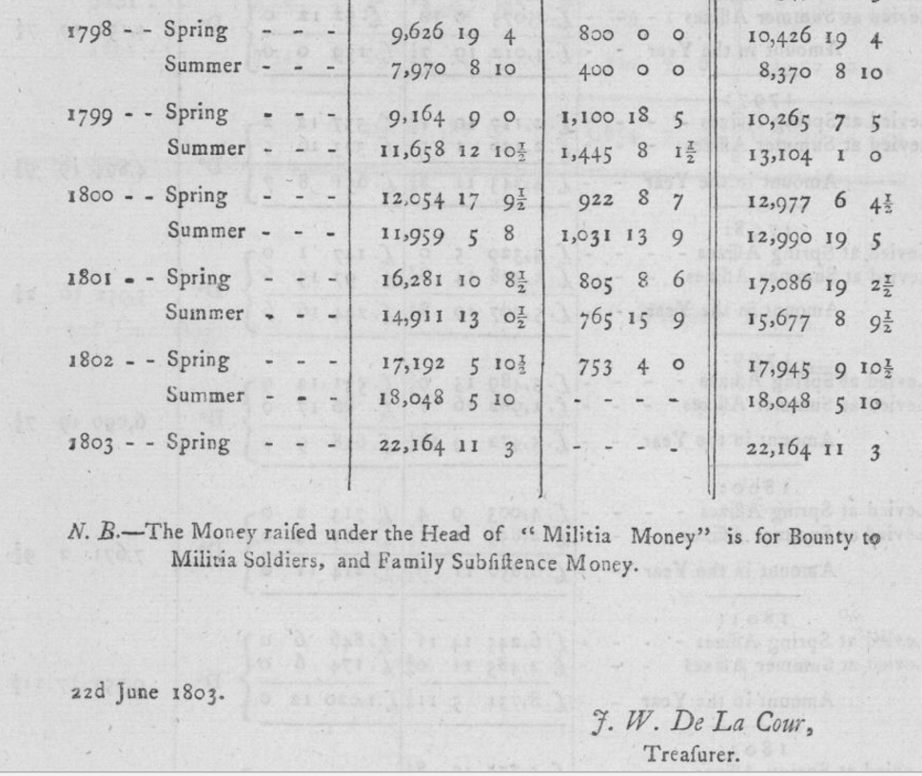
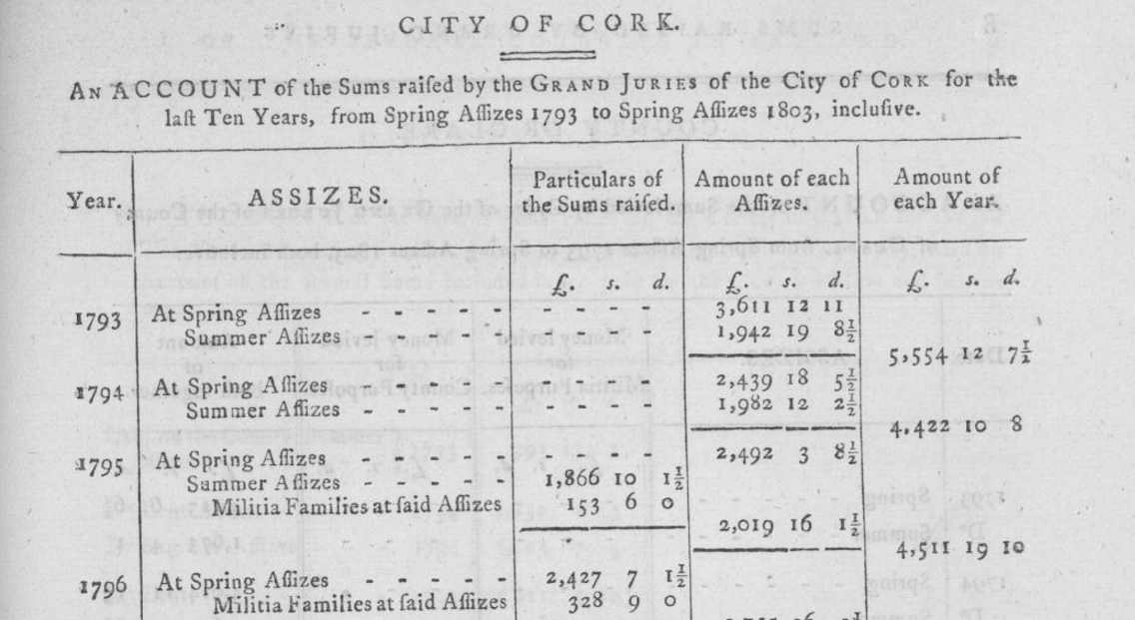
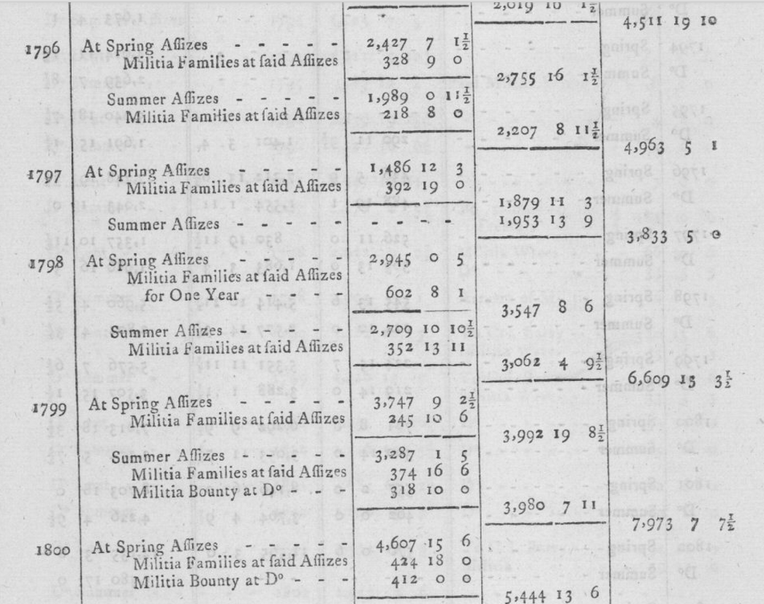
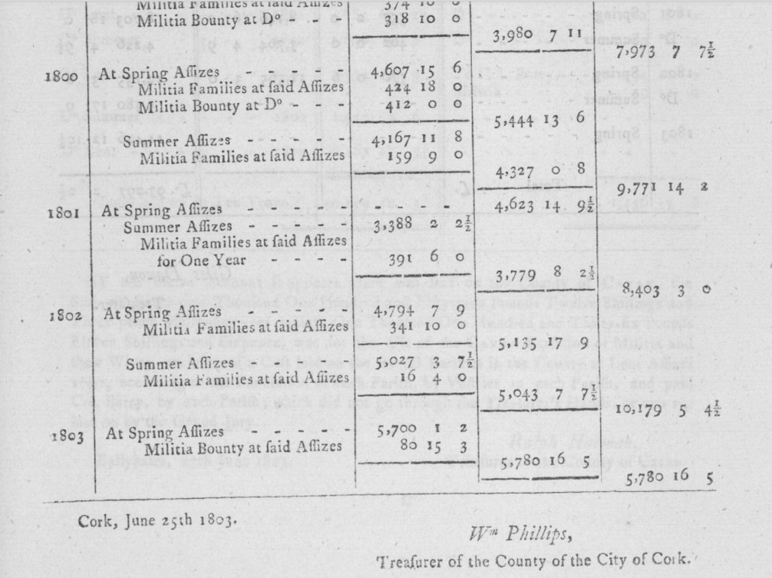
..
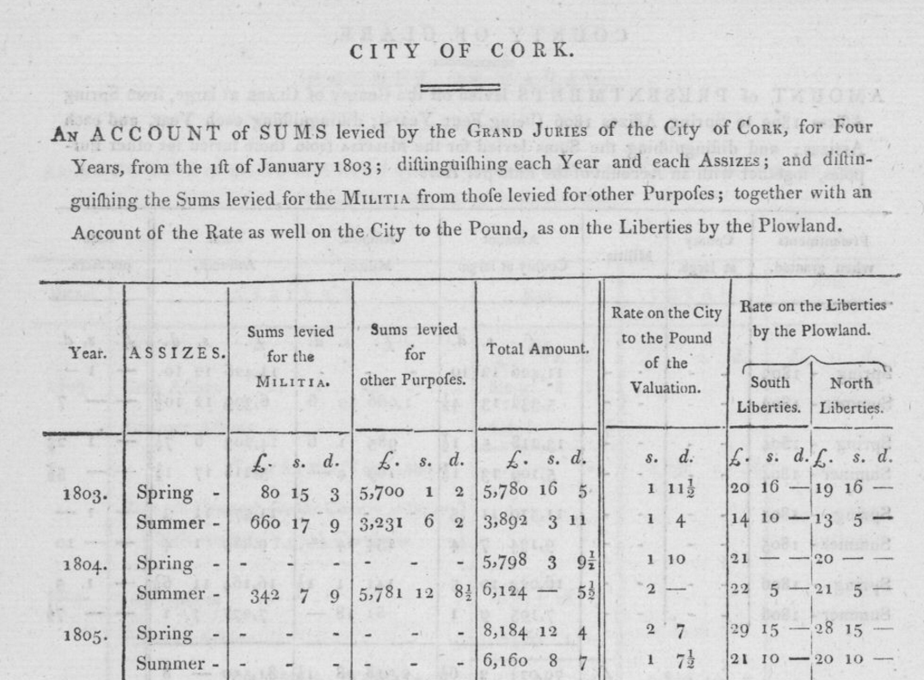
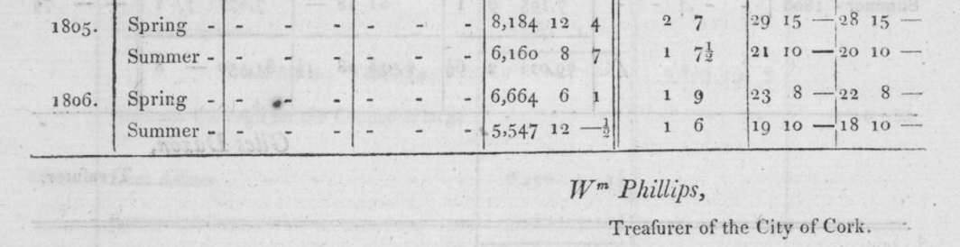
..
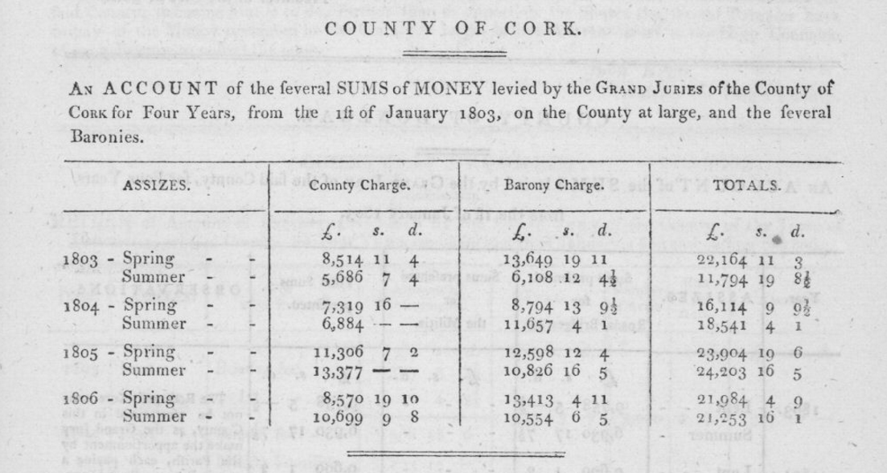..

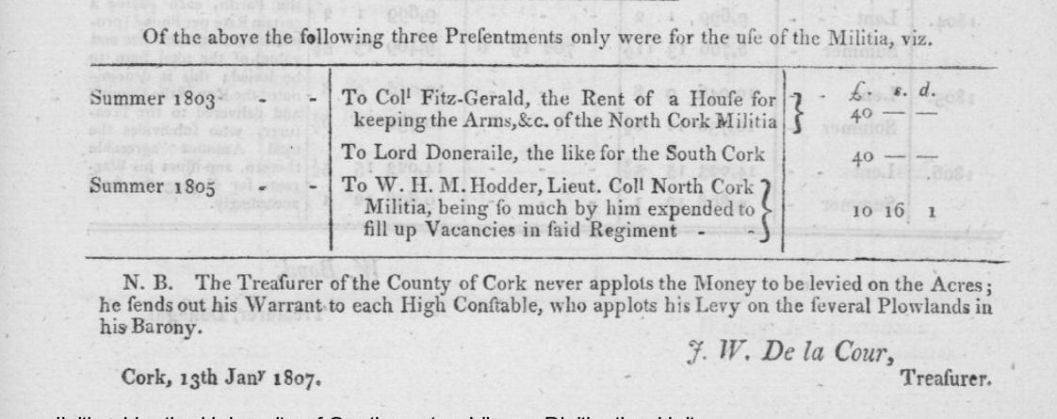
..

1827 Return of Arrears of Levy for Bandon.

Bandon had not paid a levy since and by 1815 arrears of £1,800 had built up. The County had incurred legal charges of £1,000 seeking to recover the arrears. Bandon relied on the argument that the County had no statutory entitlement to recover the charge.

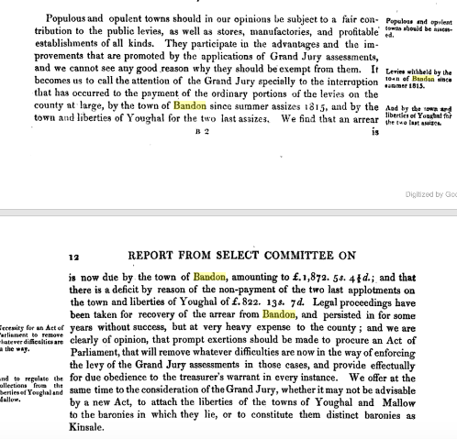

…\\
Cork Prison:

NEW COUNTY GAOL - THE Commissioners for Building a NEW GAOL for the County of Cork, give notice that the Site now fixed on for said Gaol, is the piece of Ground at Gill Abby, known by the name of Mrs. Moore's Fields, and that Proposals and Estimates for Building an insulating or surrounding Wall, agreeable to the Plan now lying in their Treasurer's Office, in the County Court Yard, will be received by him there, or at Mr. Curry's, on Batchelor's-quay, before the 21st instant. Dated May 6,1790 - J. W. DE LA COUR, Treasurer

…
Sample Presentment 1815 Cork City.

It is interesting later in the presentments there is provision for compensation for property owners affected by roadworks.

….
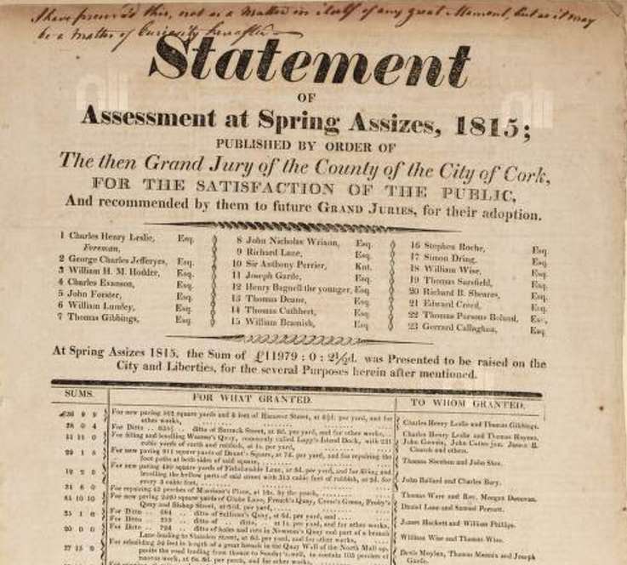

..
1829 Sample Funds Centrally Approved

To make Cork Western Road, £8,000
Cork WIde Street Commissioners street widening, £10,000, £7,000 and £5,500
Trustees for erecting Cork Market House, £7,000
Trustees of Cork/Ballyhooley Road, £10,000
Bridewells, Bandon, Macroom, Mallow, Kanturk, Skibbereen, Clonakilty, Bantry, Dunmanway, Charleville, £7,400
Nicholas P. Leader, to improve colliery, Newmarket area, £10,000
Buttevant/Croom road, £5,500
Grand Jury, Cork, bridge at Glanmire, £2,100
Bantry/Castletown road, £2,600
Lord Audley, copper mine, Clonakilty, £6,000
Lord Bantry and Michael Murphy, Newtown, to employ poor of Bantry, £2,000

...
Grand Jury Cess 1837-1897

Year | Grand Jury County Gross Cess in £ rounded
1837 | 68
1848 | 106
1867 | 85
1877 | 91
1887 | 106
1897 | 120

…..

Report of Richard B. Cotter, Secretary to Cork Grand Jury 20th October 1822:

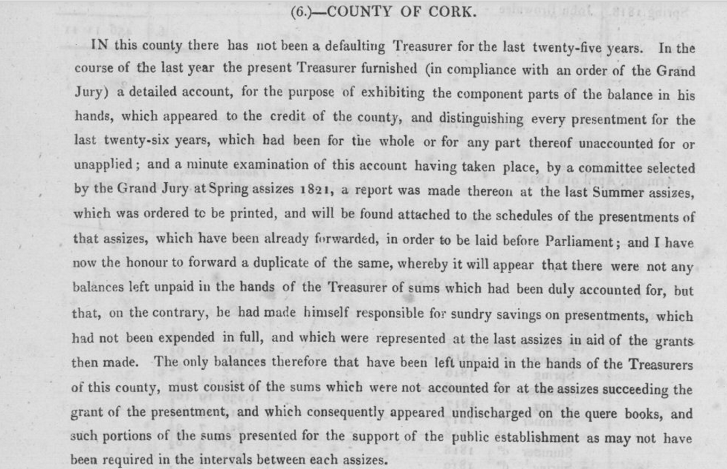
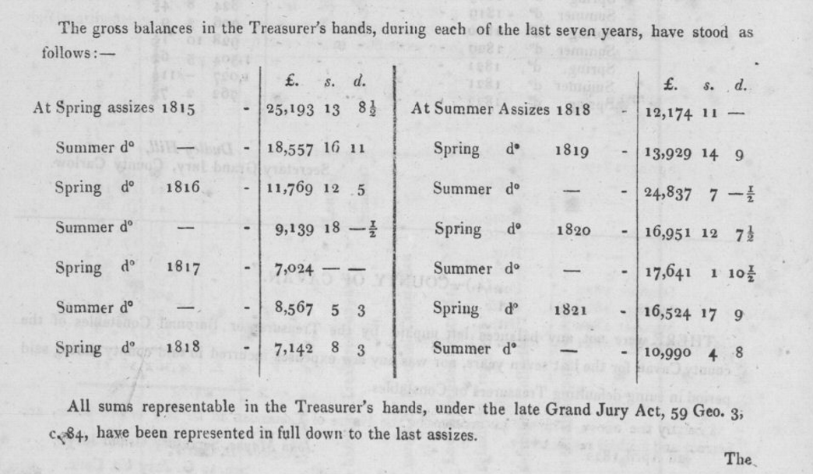
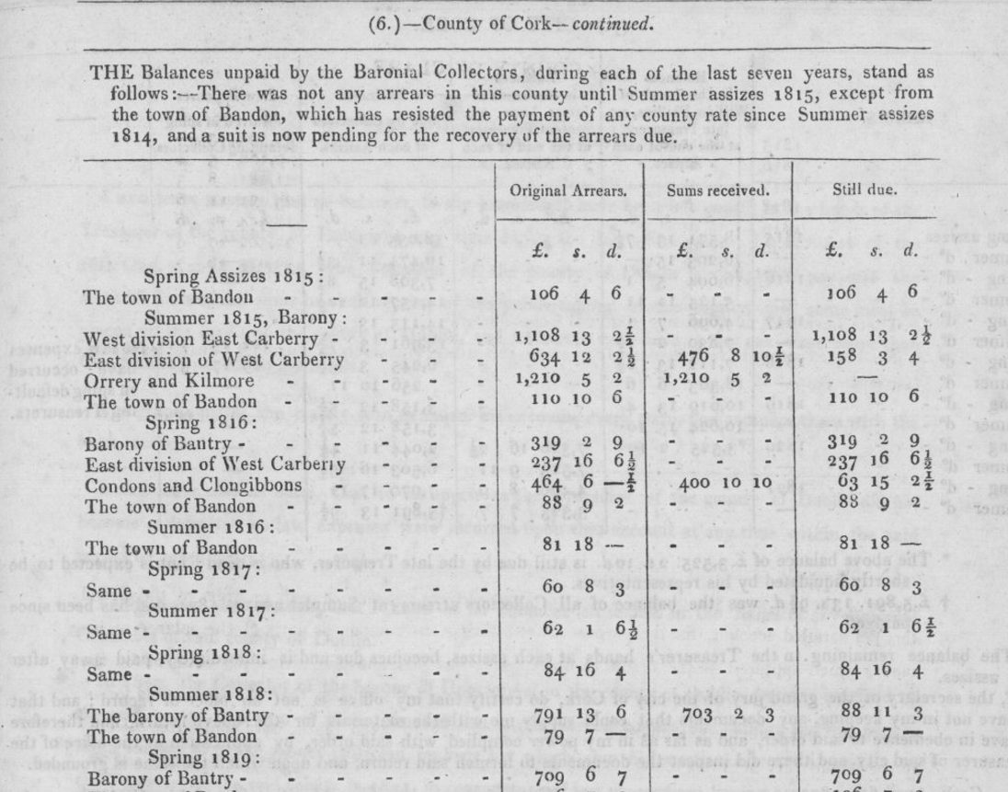
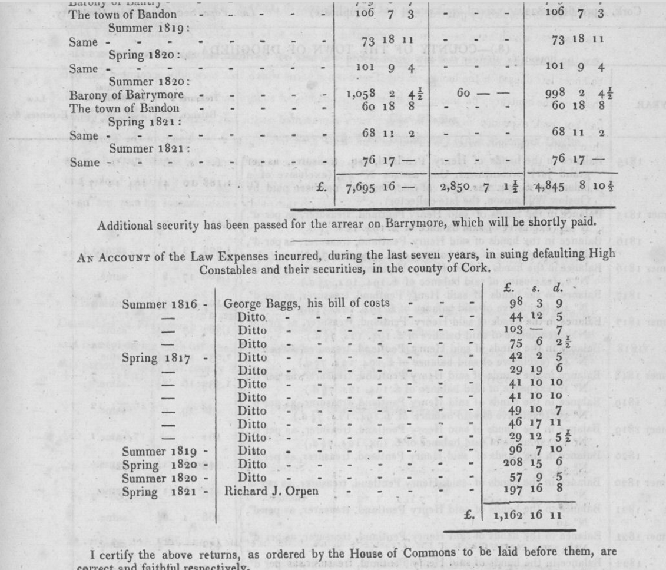

…..

1822 Financial Statement for Co. Cork

This is a good example of the scope and extend to the responsibilities of the Grand Jury.

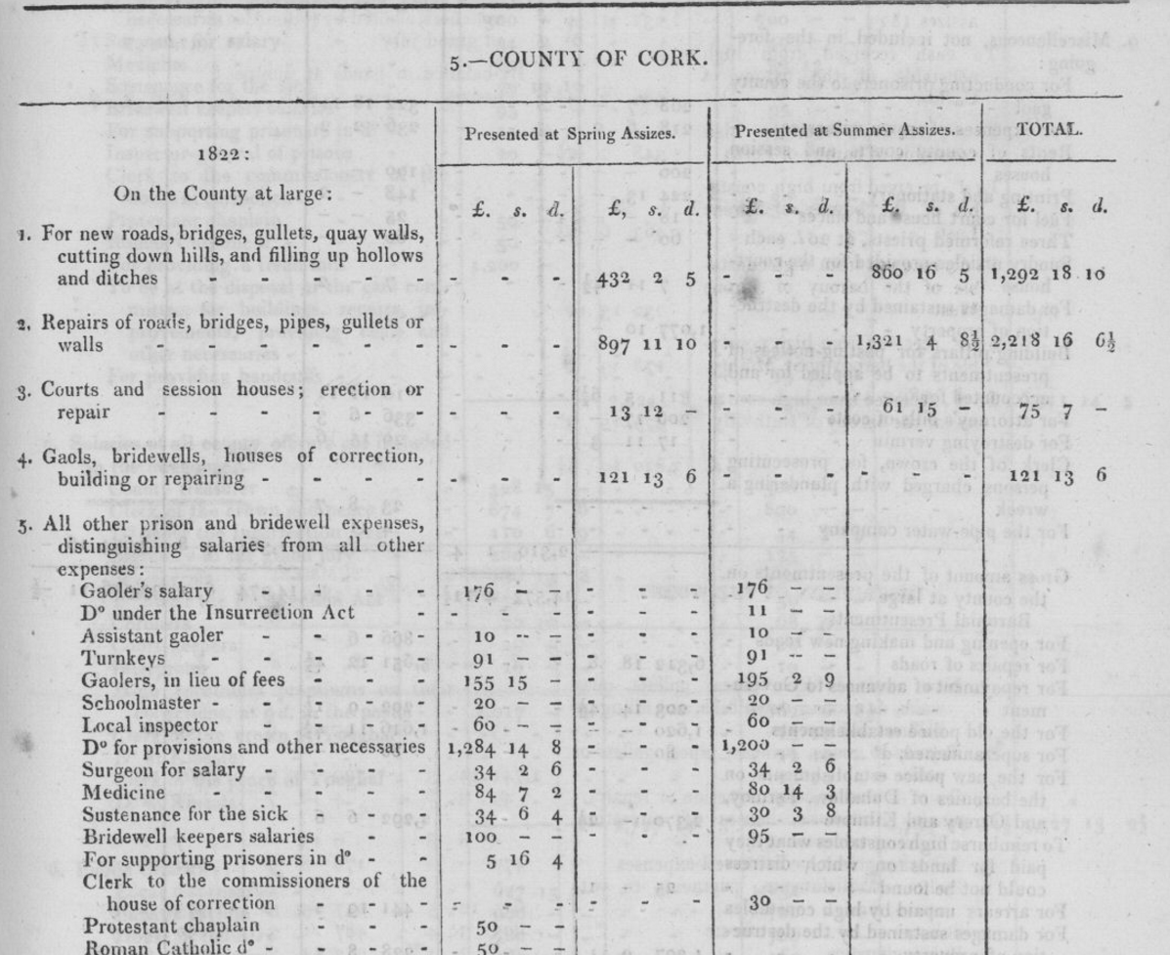

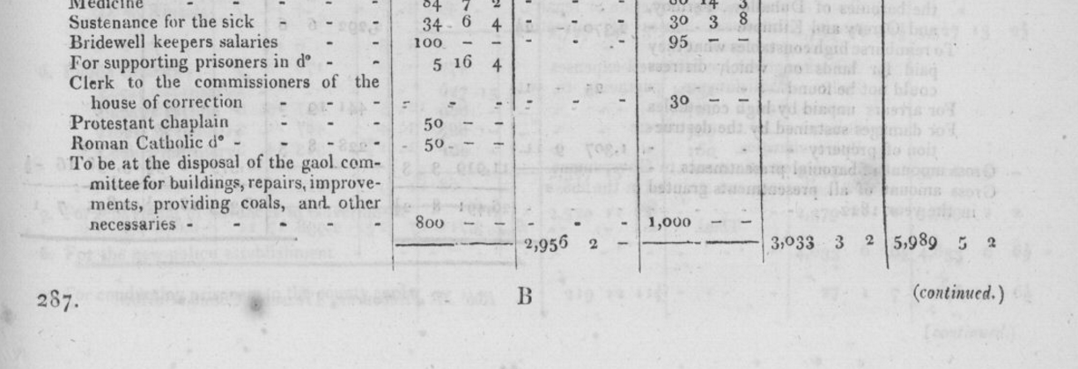
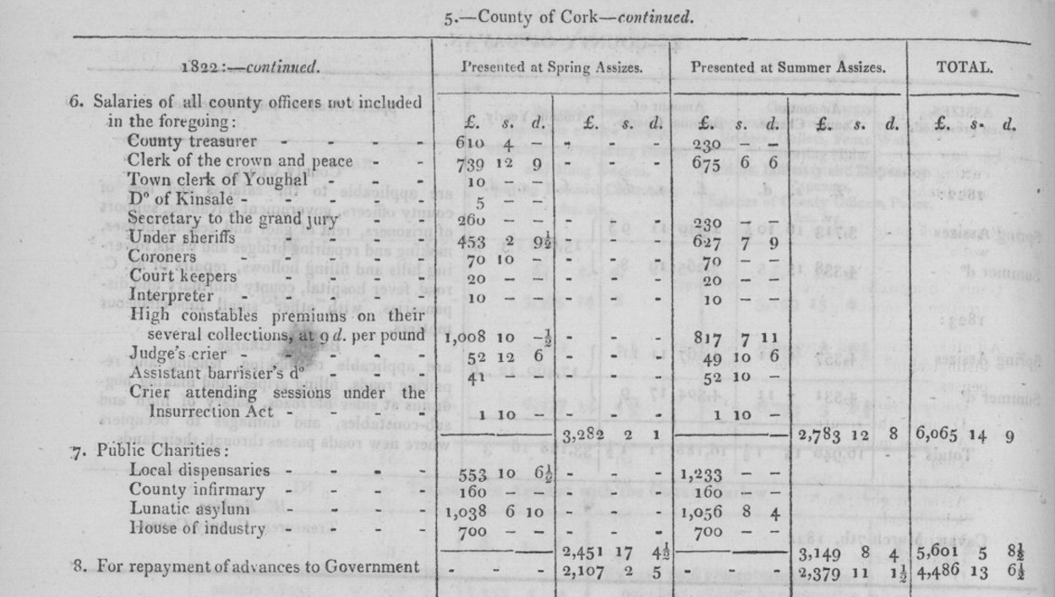
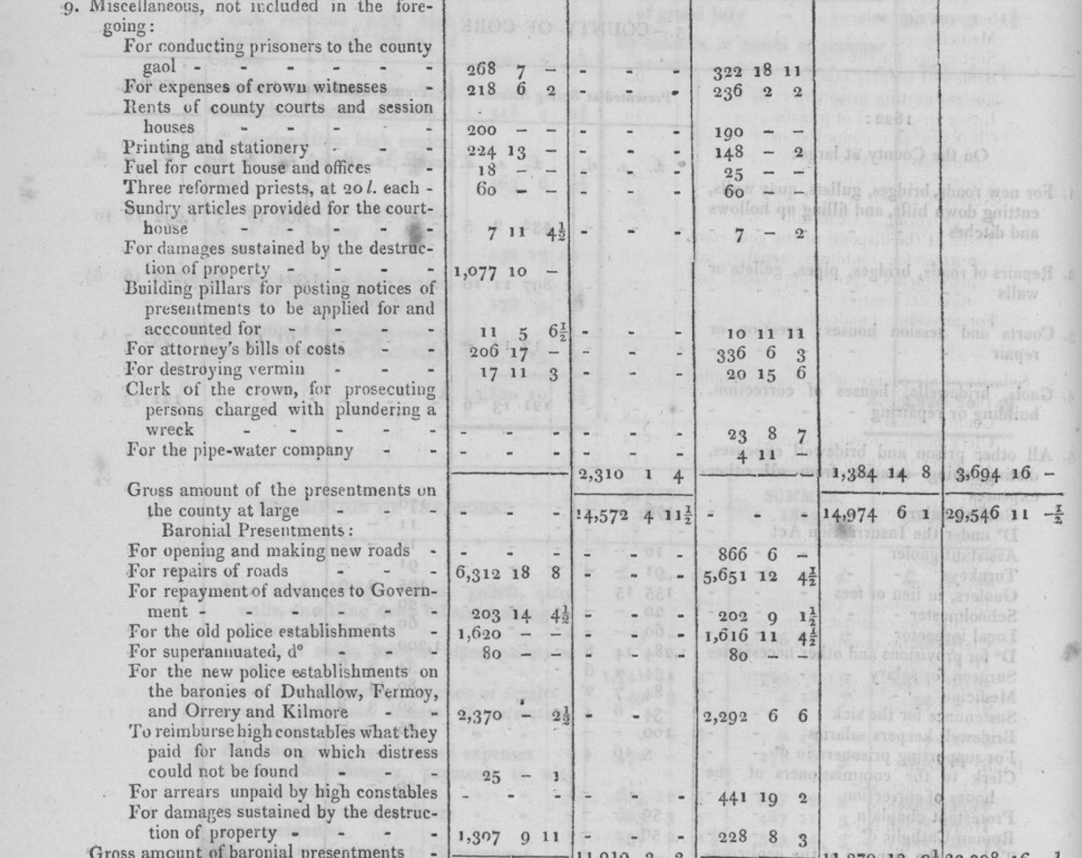
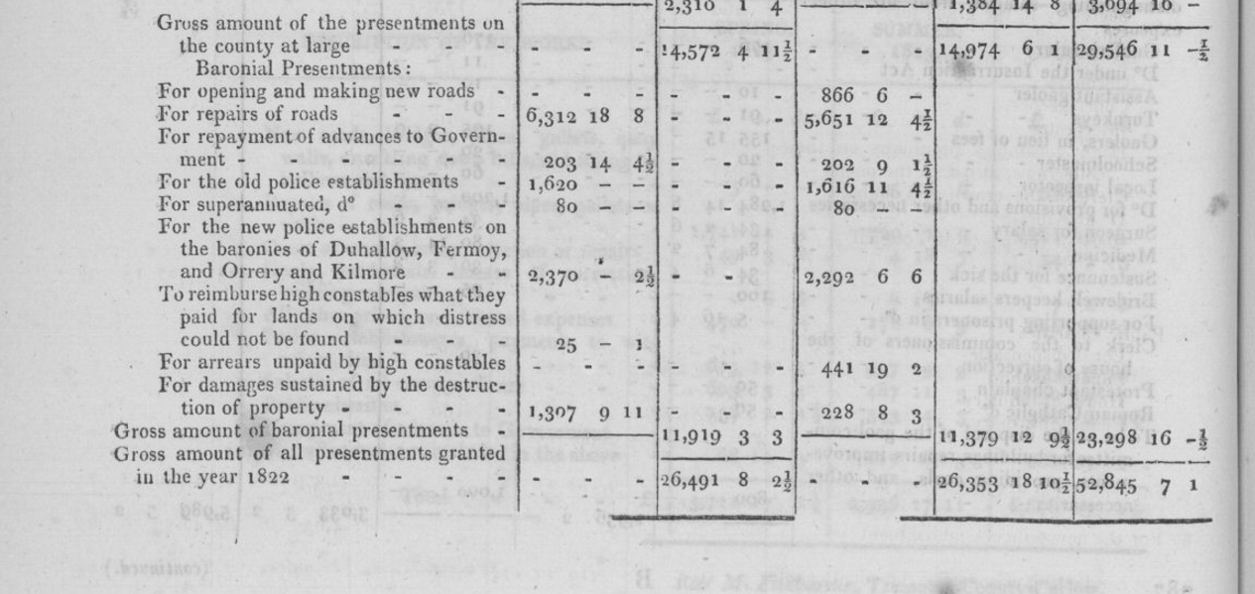
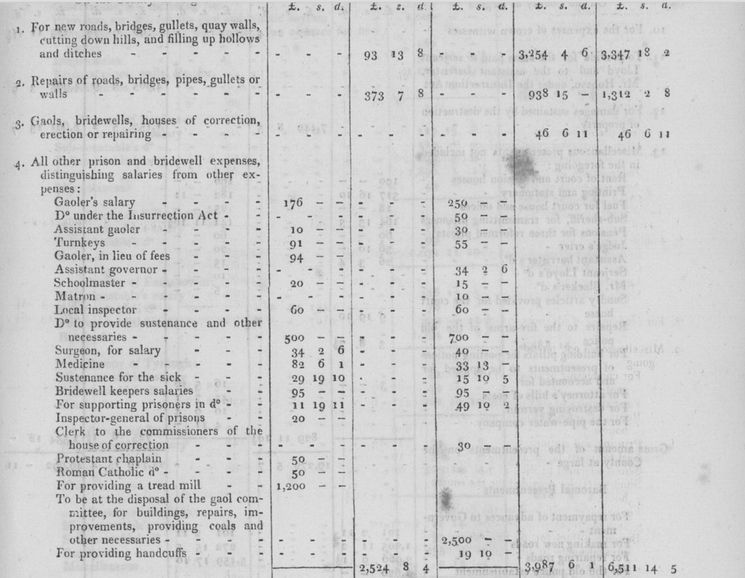
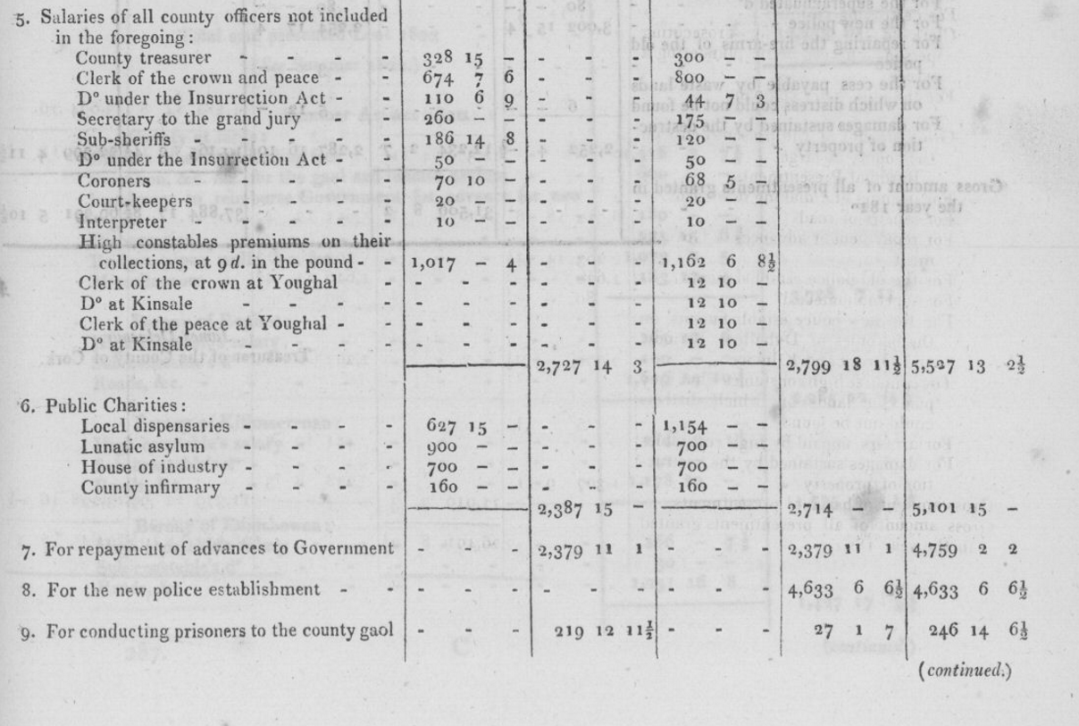
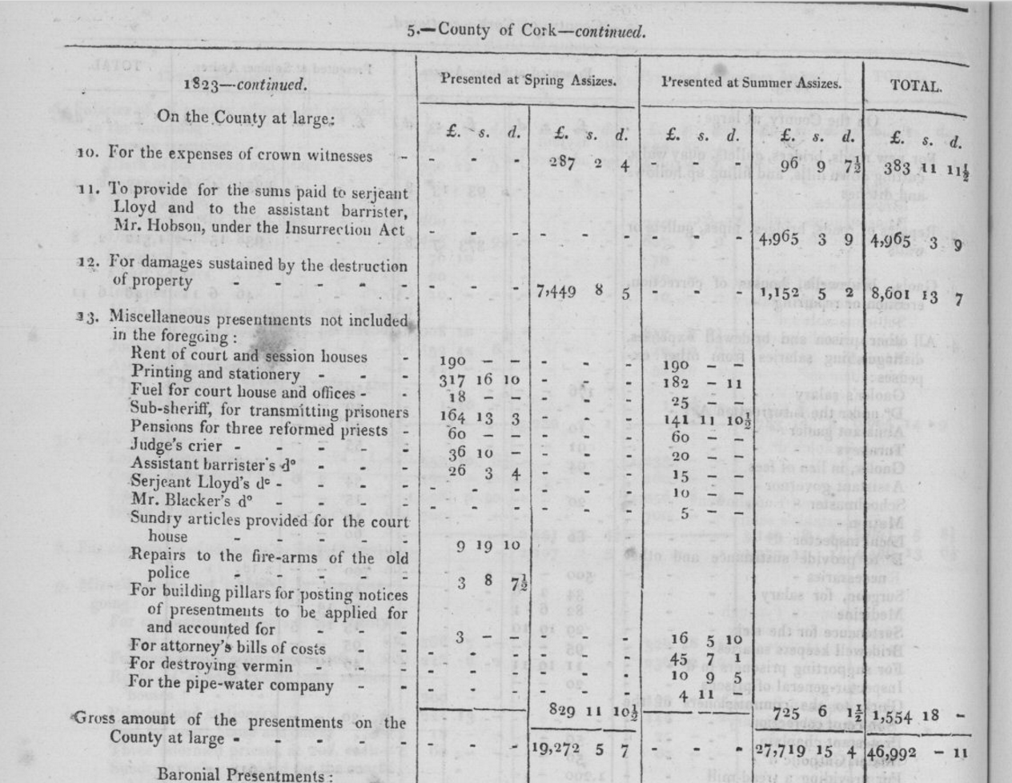
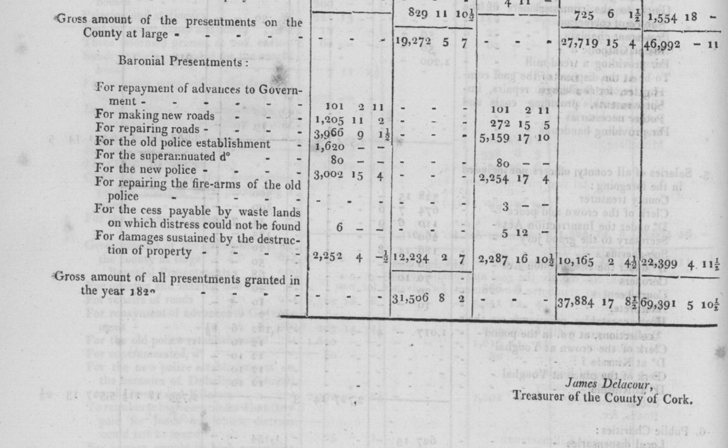

‘’’
Lord Carbery pamphlet and description of 1830 Budget

1830 Cork Grand Jury Budget in thousands | 63 | Percentage
Public Charities, dispensaries | 8.4 | 13%
Salaries, attendances at sessions, poundage of Baronial Constables | 5 | 8%
County Gaol | 5 | 8%
Malicious Damage | 3.6 | 6%
Repayment of central Government advances by installment | 5.6 | 9%
Road repairs | 13.4 | 21%
County Court building fund | .75 | 1%
Discretionary expenditure roads and bridges | 18.7 | 30%

….

…

Report from the Select Committee on Grand Jury Presentments, Ireland By Great Britain. Parliament. House of Commons. Select Committee on Grand Jury Presentments (Ireland). Evidence of Treasurer Robert De La Cour on Evils of Existing System 1815:..
.
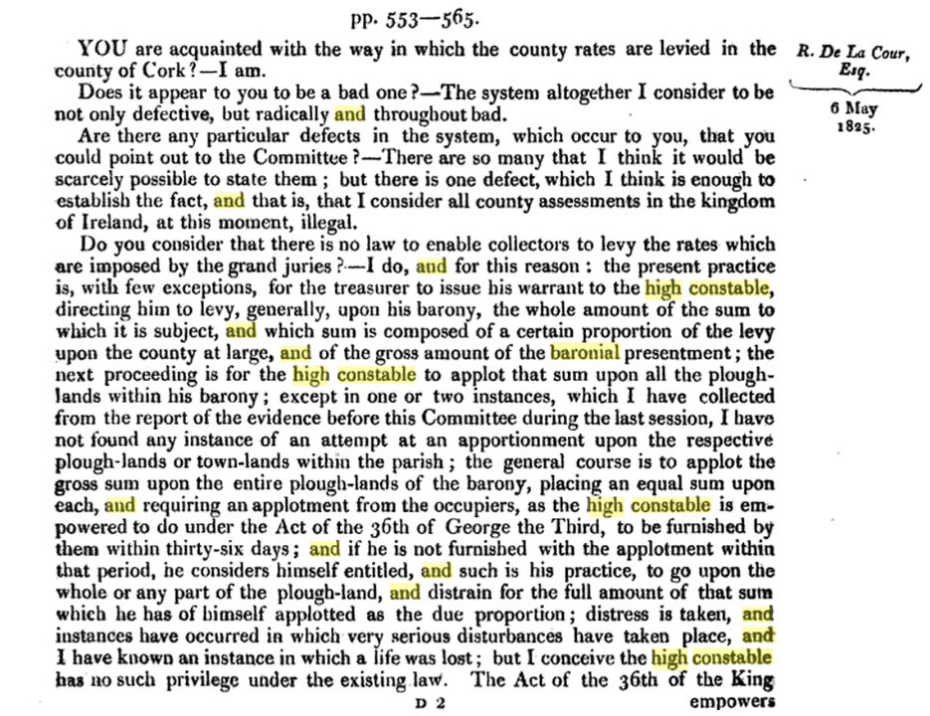
.
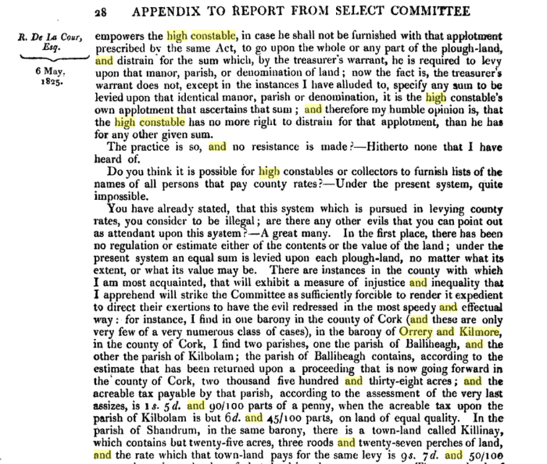
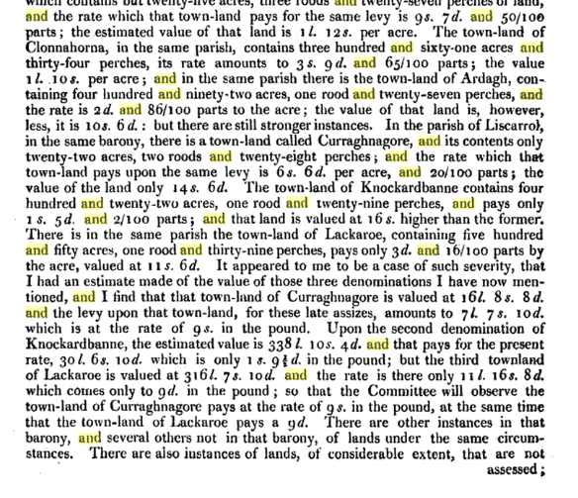
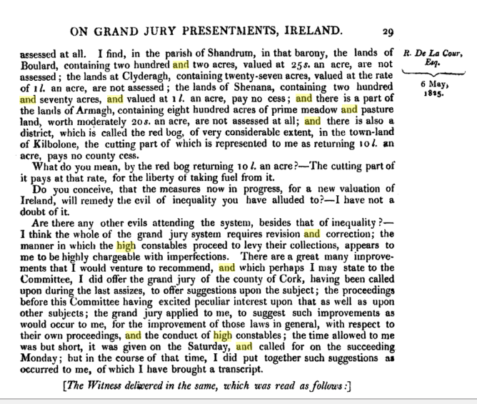

His evidence continued can be followed here:

https://books.google.ie/books?id=LmY1AQAAMAAJ&pg=PA28&lpg=PA28&dq=Orrery+and+Kilmore+baronial+high+constable&source=bl&ots=YB5jGMFkes&sig=a0Ei2wOIsgcca9z4YfT2Ch2HLFE&hl=en&sa=X&ved=0ahUKEwjElvnt8NjQAhWDOsAKHYV9DYoQ6AEIOTAG#v=onepage&q=Orrery%20and%20Kilmore%20baronial%20high%20constable&f=false

- Suggests that labourers be paid weekly suspect they have an account with their overseer or contractor
- Parish inspectors of roadworks leave an amount to be desired
- Recommends independent county engineers appointed by Lord Lieutenant

Evidence of Alexander O'Driscoll, unhappy that out of 23 possible Grand Jurors none for Baronies of Carbery:
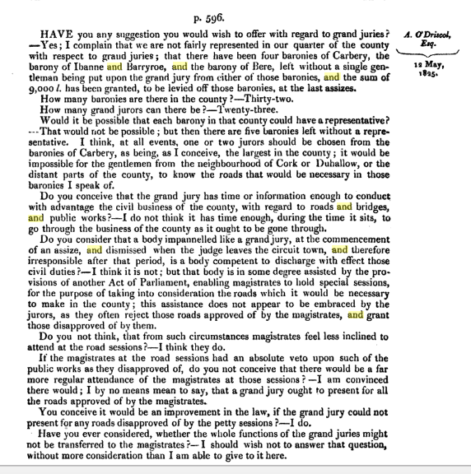
..

...

THE GRAND JURY Act 1836.

The Act of 1836 limited the power of the grand jury as such in relation to presentments. They were given no power to initiate expenditure; this was reserved to presentment sessions, which were of two kinds, baronial and county-at-large. The baronial sessions dealt with expenditure for the benefit of the barony and was composed of justices and baronial cesspayers not less than five or more than twelve selected according to a complicated system. The attendance at the sessions of cesspayers who were not Magistrates was slack because no cesspayer could be sure of being selected. The county-at-large presentment sessions dealt with expenditure for the benefit of the entire county and was also the sessions for the barony in which the court house was situated. One cesspayer selected by each baronial session was entitled to act with the Magistrates in the county-at-large sessions.

1844 Evidence of Jobbery, General Dissatisfaction

Thomas Townsend, a retired half pay Lieutenant Royal Navy managed his aunts estates in Skibbereen. In 1844 he gave the following evidence re the cess and nature of road contracting:

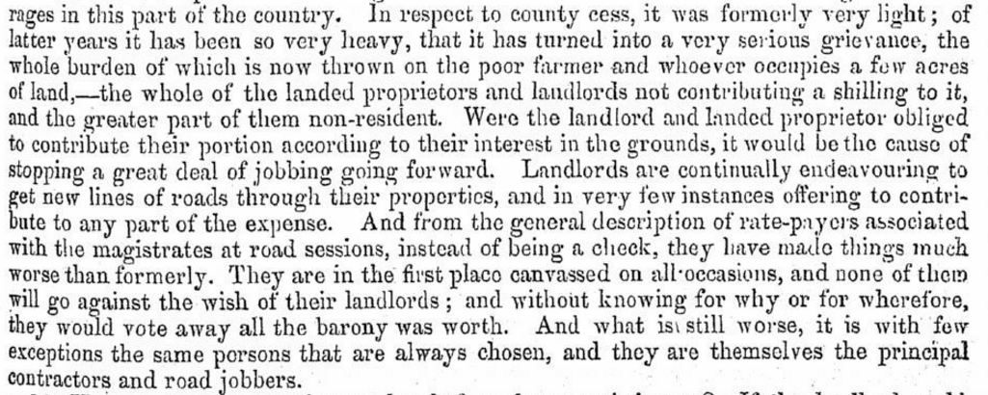

1866 Breakdown for Cork City and County of County Cess:

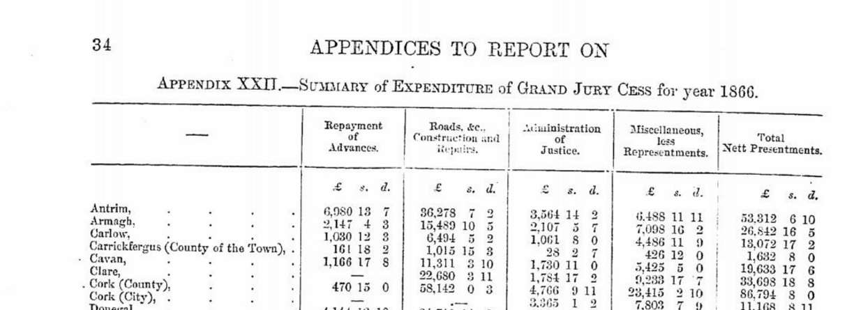
…….
..

….

Grand Jurors

Cork Corporation Court of D'Oyer Hundred, Selection of Grand Jurors from 1656

Cork Corporation Court of D'Oyer Hundred, Copy of Transcript by Richard Caulfield. Ref. IE CCCA/U127 Date: 23 May 1656 - 6 Jul 1730 Level: item Extent: 130pp Scope and Content: Photocopy of [a transcript] of Richard Caulfield's 1875 MS. transcript of volume 1 of the books of the Cork Corporation relating to Court of D'Oyer Hundred. The Court of D'Oyer Hundred was a civic assembly made up of all Freemen/Burgesses of Cork City and within which all officials of Cork Corporation were elected and sworn in Cork City and County Archives Index to Listed Collections with Scope and Content April 2016 Page 44 of 185 including the Speaker of the Common Council, Mayor, Aldermen, Sheriffs, Constables, etc. The Jurors for the Grand Jury were also selected from the ranks of the Freemen/Burgesses sitting in the Court. Valuable as a reference for the history of the trades and guilds of Cork, mayors and officials of Cork Corporation, and the history of individuals. Includes: Lists names of those Freemen elected or sworn in as Common Council members, swordbearers, sergeants at mace, high constables of the Southern suburbs, Northern and Southern Liberties, Whitechurch, Rathcoursey, Carrigrohane, Douglas, Currakippane, and other areas, constables of each Quarter in the City, water bailiff, Grand Jurors, Mayors, Sheriffs, Aldermen, Chamberlain, Common Clerk and Clerk of the Crown and Peace. Also swearing in of masters and wardens of various Guilds, including; Freemasons, Tanners, Cordwainers, Butchers, Goldsmiths, Carpenters and Joiners, Porters, Clothiers, Merchant Tailors, Barber Chirurgeons, Blacksmiths, Whittawers, Coopers, Tallow Chandlers, Bakers.
(21 Jun 1685) Edward Hoare merchant, elected as Common Speaker of the City of Cork for the ensuing year (p68) (22 May 1729) Panel of all persons declared to be Freemen at large of the City Corporation including officials, Burgesses of the [Common] Council and other Burgesses (pp121-127) In a note at the end of the transcript , Richard. Caulfield writes; ''Finished this MS. on...July 29th 1875 exactly as Shandon clock was striking 10pm in my study in Royal Cork Institution. This is the first volume of the Court of D'Oyer Hundred Book and contains entries from 23 May 1656 to 6 July 1730. I have omitted all the entries that occur in the Council Books of the Corporation of Cork which I am now printing for publication. This MS. will be found valuable as a reference, for the history of many of the trades of Cork. . . Also for tracing the history of individuals.'' Also, photocopy of MS. transcript of record of trustees appointed by a Court of D'Oyer Hundred 27 Jun 1810 for distributing the sum of £200 paid by former Mayor Paul Maylor and others in lieu of annual dinners to the Freemen at Large on election and swearing-in days. (2pp)

The composition of the Grand Jury and its staff from the late 17th century reflect the background of Cork’s ruling elite of County Landed families and City Merchants, Protestant. In this it mirrors the composition of the Magistrates. Within the State Church until 1870, the Church of Ireland the majority of the Jurors came from an English Planter background from the 1580s, the early North Cork families tended to marry into local Gaelic and Norman Aristocracy Barry, Fitzgerald, O’Callaghan Families with similar backgrounds such as the Dalys, Drings, Meades, O’Donovans, McCarthy, O’Briens, Roches, Ronaynes or the Hiberno-Norse Cotters and Coppingers, converted because of the penal Laws or Marriage such as the Mccarty heiress who brought 10,000 acres into Shouldham ownership in the 1710s and appears in the Convert Rolls. In a sense the Shouldhams are a sub sept of the McCarthys. There are slightly more exotic backgrounds sun as the German Cramer, Notter, the Huguenot Besnard, De la Coers, Madras, Perrier, Teulon. Due to extensive marriage over time the elite is in fact much more diverse ethnically than is generally supposed.

In the Magistry the last Catholics appointed wee in the 1680s until a small number for Co. Cork in the late 18th century. By around 1800 the balance of economic advantage had shifted to the Catholics ironically aided by the Penal Laws which locked the out of the land market and ensured that they embraced commerce. In evidence to a Parliamentary enquiry in 1828 some months before he took his seat in the British Parliament Daniel O'Connell was complaining that the Bank of Ireland only hd four clerkships occupied by Catholics despite having most of the cash on deposit and the shares in the joint stock company. Similar evidence was given to another Parliamentary enquiry in the early 1820s by the parish priest of Bantry Fr. Barry who said that half pay officers from the Napoleonic Wars were preferred on £40 a year as jurors that assizes to Catholic on £1,500 per annum.

From the early 19th century the wealthy Catholics slowly make their way into the Grand Jury.

…

…
1782 At the Spring Assizes the Grand Jury of Cork, Colonel Richard Townsend was the Foreman, passed the following resolution; “Resolved that we think it necessary to declare no power has a right to make laws for this Kingdom save only the King, Lords and Commoners of Ireland and that we will with our lives and fortunes maintain and defend the Irish Parliament in such a declaration of rights and in any measure they may think proper to defend it.

…
1799 City Grand Jury Spring Assizes, approve of the contemplated act of Legislative Union.
….

1814. John Anderson of Fermoy presented petition against Catholics being Foremen of Grand Jury alleged by Daniel O’Connell this got him Knightship from Duke of Rutland
1840. September Cork High Sheriff invited G.S. Barry M.P. to act as Foreman Cork Grand Jury first Catholic since Gould in 1680s
1865. Richard W. Goold Adams, Esq., of Jamesbrook, has accepted the invitation of Henry Lavallen Puxley, Esq., High Sheriff, to act as Foreman of the Grand Jury at the coming Spring Assizes for the County of Cork.
…

…..

….
1840 Provision for Medical Services
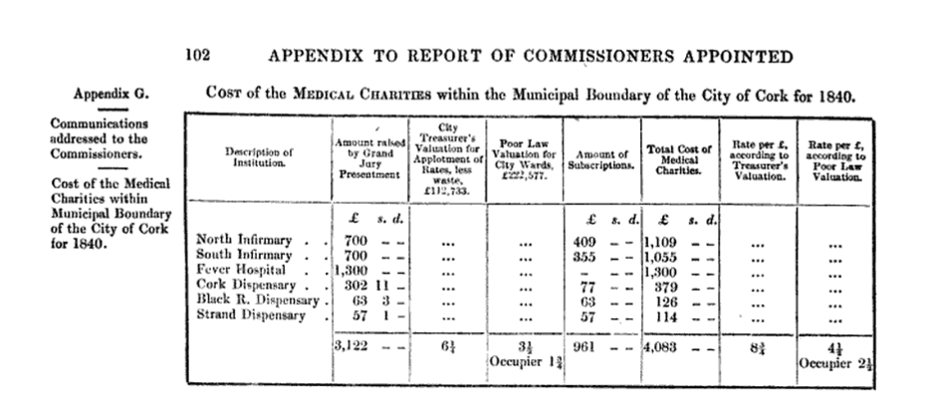
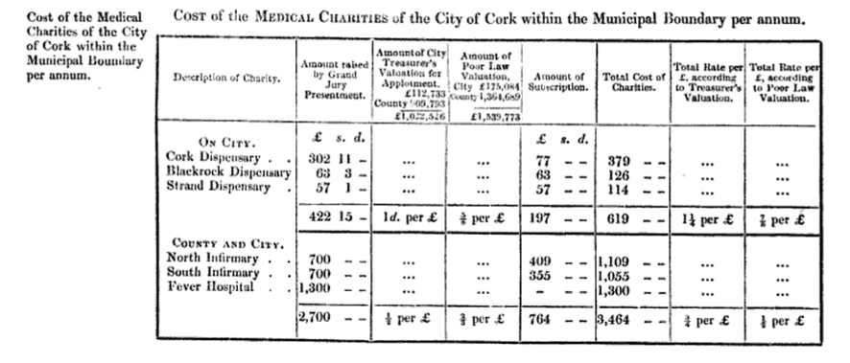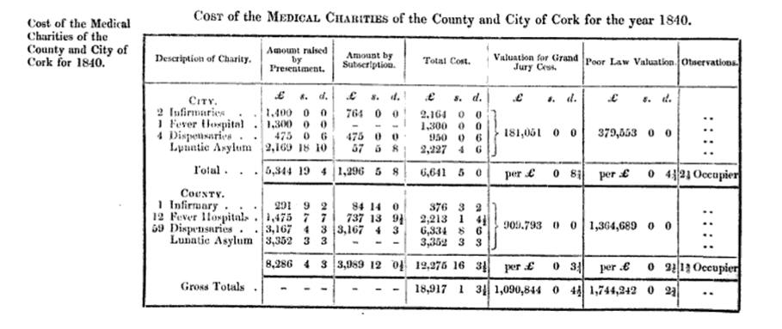
….

….

….

….

Grand Juror Attendances 1837-1899

In Nolan’s thesis of Cork Grand Jury he provides a detailed table of attendances this listing has been abstracted with the more frequent attendees.

Name | Address | Attendance at Presentment Sessions 1837-1899
Richard Willis Goold Adams | Jamesboro | 14
Richard Oliver Aldworth | Upper Dromore/Newmarket Court | 24
Colonel Richard William Aldworth | Newmarket Court | 13
John Edward Barrett | Carriganass Castle, Bantry | 36
Captain James Barry | Ballyclough, Mallow | 15
John Harold Barry | Ballyvorane, Buttevant | 30
Thomas Beamish | KIlmaloda, Clonakilty | 12
John Wrixon Becher Bart. | Ballygiblin and Castlehyde | 11
Sir William Wrixon Becher Bart. | Ballygiblin, Mallow | 12
Henry Bernard Boyle Bernard | Castle Bernard and Coolmain Castle | 20
Lieutenant Colonel Thomas F. Bourke | Prospectville (Passage west?) | 19
Henry Bradder | Modeligo, Fermoy | 16
Jonathan Bruce | Prothurst, Kanturk | 10
Major Bruce, later described as Phineas | Little Island | 10
William Cooke Collis | Castlecollis | 15
Sir George St. J. Colthurst | Blarney Castle | 14
George Conway Colthurst | Blarney Castle 16
Daniel Conner | Manch, Dunmanway | 13
Daniel Conner | Manch, Dunmanway | 41

Charles Purdon Cooke | Ballyclough Castle, Mallow | 20
William Coppinger | Coppinger’s Court (Barryscourt Midleton?) | 10
Sir James Laurence Cotter | Rockforest, Mallow | 11
John Courtenay | Ballydesmond, MIdleton | 15
Marmaduke Cramer | Rathmore, KInsale | 32
Edward Daly | Kinsale | 19
Colonel William Daly | Knockrobin, Kinsale | 13
Simon Dring | Rockgrove | 18?
Nicholas Dunscombe | Mount Desert, Cork | 31
R.V.P. Fitzgerald | Corkbeg, Whitegate, Midleton | 16
Lionel John Fleming | Newcourt, Skibbereen | 12
Abraham John Forster | Garretstown Kinsale | 11?
Savage French | Cuskinny, Cobh | 11
Thomas George French | Marino, Cobh | 14
Thomas St. John Grant | Kilmurray, Kilworth | 16
Stephen Grehan | Clonmeen, Kanturk | 13
Richard John Maxwell Gumbleton | Glenatore, Tallow, Co, Waterford | 24
John Isaac Heard | Pallastown, KInsale | 24
Robert Heard | Pallastown, KInsale | 32
Thomas Bousefield Herrick | Scilly, KInsale | 18

Thomas Arthur Ludlow Herrick | Clancoole, Bandon | 10
William Henry Moore Hodder | Hoddersfield, Carrigaline | 13
William Henry Moore Hodder possibly Junior | Hoddersfield, carrigaline | 12
Thomas Hungerford | Cahirmore, Clonakilty | 11?
Thomas Hungerford | The Island, Inchydoney, Clonakilty | 18
Samuel Hutchins | Ardnagashel, Bantry | 13
William Johnson | Castlelyons | 28
Thomas Watson Knowles | Oatlands, KInsale | 18
Henry Eustace Leader | Mount Leader, Millstreet | 11
Daniel Francis Leahy | Shanakiel, Cork | 12
Thomas Leahy | Derryniha | 16
Thomas John Leahy | Derryniha | 28
William Burton Leslie | Courtmacsherry | 31
Mountifort Longfield | Castlemartyr, Midleton | 18
Richard Longfield | Longueville, Mallow | 15
Richard Edward Longfield | Longueville, Mallow and Waterloo | 14
George Montgomery | Killea, Mitchelstown | 12
Captain Anthony Hackman Morgan | Bunaulin, Caheragh, Skibbereen | 144? For 1866 to 1898
William Richard Meade | Ballymartle, KInsale | 51
James Morrogh | Old Court, Doneraile | 23

James McCarthy | Laurentium and Currymount, Buttevant | 16
John Nason | Newtown Lodge, Fermoy | 12
Robert Nettles | Nettleville Macroom | 21
William Worth Newenham | Coolmore, Carrigaline | 11
John Richard Newman | Dromore House, Mallow | 18
William Norwood | Ballyhalwick, Dunmanway | 11
Thomas O’Brien | Ballyhalwick?, Dunmanway | 11
Thomas O’Brien | Monteagle, KIldorrery | 14
The O’Donovan, Henry Winthrop O’Donovan | Lissard, Skibbereen | 17
The O’Donovan Morgan William O’Donovan | Lissard, Skibbereen | 10
Timothy O’Donovan, pivotal figure with Deasys of Clonakilty early Catholic Magistrate | O’Donovan’s Cove, Durrus, Bantry | 8
Alexander O’Driscoll | Norton Cottage, Skibbereen | 12 (1838-1840)
Standish O’Grady | Aghamart, Carrigaline | 14
John McCarthy O’Leary | Coomlogane, Millstreet | 34
James Henry Payne | Beechmount, Upton, Bandon | 12
John Warren Payne | Beach House, Bantry | 30, 1867-1899
William Symms Bird | Bantry | 3, (1889-1894)
George E. Barrett | Carriganass Castle, Bantry | 7, (1861-1871)
Maskelyne Alcock | Bandon | 3, (1837-1841)
Hewitt Powell | Cahermore | 21

Hewitt Poole | Mayfield, Bandon | 10
Richard Roberts | Ardmore, Passage West | 16
Richard Tonson Rye | Ryemount, Macroom | 37
Robert Massey Dawson Sanders | Sandes Park, Charleville | 11
Dominic Patrick Ronayne | Doughcloyne, Cork | 22
Edmond Anderson Shouldham | Coolkelure, Dunmanway | 31
Captain Somerville | The Prairie, Schull | 13
William Alcock Jones Stawell | KIlbrittain Castle, Kinsale | 10
George Beamish Teulon | Bandon | 14
Horace Townsend | Derry Clonakilty and Woodside | 12
Richard Townsend | Myross wood Skibbereen and Garrycloyne | 20
James Travers | Butlerstown, Clonakilty | 15
Lieutenant Colonel Robert Travers | Timoleague | 50
Henry Wallis | Drishane, Millstreet | 16
Thomas Ware | Woodford, Mallow | 11
Sir Augustus Riversdale Warren | Warrenscourt, Lissarda, Macroom | 16
John Borlase Warren | Ryemount, Crookstown, Macroom | 17
John Hamilton White | Drombroe, Bantry | 14
Robert Hedges Eyre White | Glengariff Castle, Bantry | 25
Henry Young Lindsay | Leemount, Cork | 10

…

…
Enforcement

1845 paid Bryan Galwey, Attorney, £30 taxed bill of costs for prosecuting defaulting contractors.

….

Staff

Location
From John Windle’s History of Cork:

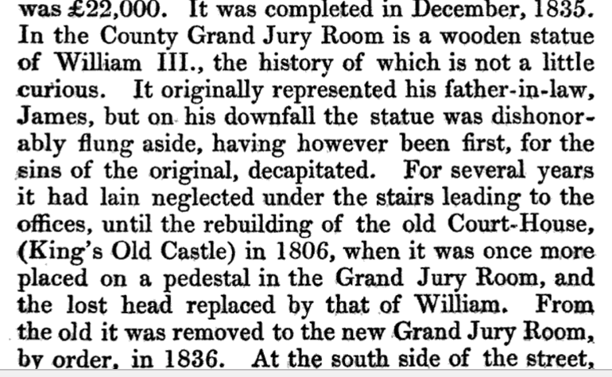

Secretaries

County
1765 John Parker
1819 Davys Tuckey, also Clerk to Commissioner for Building House of Correction Commissioner Court of Exchequer, Proctor Consistory Court.
1821 Thomas Pope, 1818 Under Sheriff
1820, 1822, 1838, Richard B(ailey?) Cotter, Freeman of Cork, had been Attorney pe 1795 to Grand Jury, appointed 1820 serves under pleasure of Grand Jury. Office in Courthouse two clerks three during Assizes, £324 per annum has previously (to 1840) other fees as Secretary to building House of Correction and Bridewell.
1840-1888, William Johnson, Vosterburg, Cork.
1868 evidence of William Johnson that Grand Jury operate through four committees, all financial matters went through finance committee.
1888-1899, Captain Noble N. Johnson, Deputy to father Secretary 188-1899 then Secretary to County Council to 1900.

City

1643, died, John Bayly, Clerk of the City, 1643 wife Ellinor died.
…
1730 William Lane. 1730 elected Clerk of Crown and Public Notary, died 1732

…

8 May, 1745. Whereas it appears that the Town Clerk's office is not sufficient for keeping the Records thereof, ordered, that a floor be made over the Petty Jury Room, and that a passage into the same be made from the Musick Gallery, the upper part to be made fit for keeping the said Records, and that Jehoshaphat Huleatt, overseer of the public works of this City, do oversee said work. That £450 be borrowed from Adam Newman, at £5 for one

1765 William Crofts
1807, Grand Jury Presentments provided for half year £20 and £5 rent
1807, 1818, 1822, Thomas Pope, Secretary.
1832 Denham Franklin, probably attorney, appointed after contested election 1832 serves subject to Grand Jury satisfaction. £120 salary does not permit employment of clerks, continues as Solicitor for private businesses.

Descriptions 1840 of Messrs Delacour and Lane of Duties

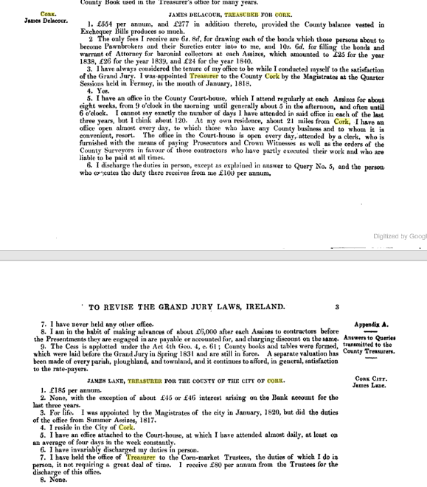

…

Treasurer County.

1712, John Sullivan.

1731. County Warrants, Presentments of Grand Jury at Assizes, Co. Cork, Kings Old Castle, 10th April 1731. James Harnett, County Treasurer’ for prosecuting High Constables and other good services done this country’. £40

1734. Salary of County Treasurer increased from £20 to £100 per annum.

1790 Jackson? Walsh Delacour described as late 1808. May have been an attorney Dublin, Simpson’s Court c 1770. Jackson De La Cour died pre 1816.
1808, 1815, Robert Delacour, Robert De La Cour Junior, Baronial Constable Duhallow 1827.
1818 James Delacour, appointed at Fermoy Sessions. Has office in Courthouse staffed by a clerk (£100 pa) who arranges payments to prosecutors and crown witnesses. He also pays contractors on foot of County Surveyor’s orders. At Assizes he spends 8 weeks in the Cork Office from 9 to 5 otherwise he has a office at this Mallow house. Remuneration, 1840, £554 and £277 provided the County balance in Exchequer Bills reaches this amount, pays for clerk. Small sundry income i.e. from Bonds and Warrants fro Baronial Collectors, £24 in 1840.

1822, no financial default by Treasurer in previous 25 years.1823 William De la Cour
1818,1836, 1861 James Delacour, Sunnyhill, Mallow, appointed 1818 by Magistrates at Mallow Quarter Sessions, salary £554 and fees of £277,

County Security

Presumably this reflects bonds entered into to ensure that in the event of a Treasurer default the Grand Jury had comeback. The Treasures appears to have personally controlled the funds coming from the Baronial Constables until remitted into the account of the Grand Jury.

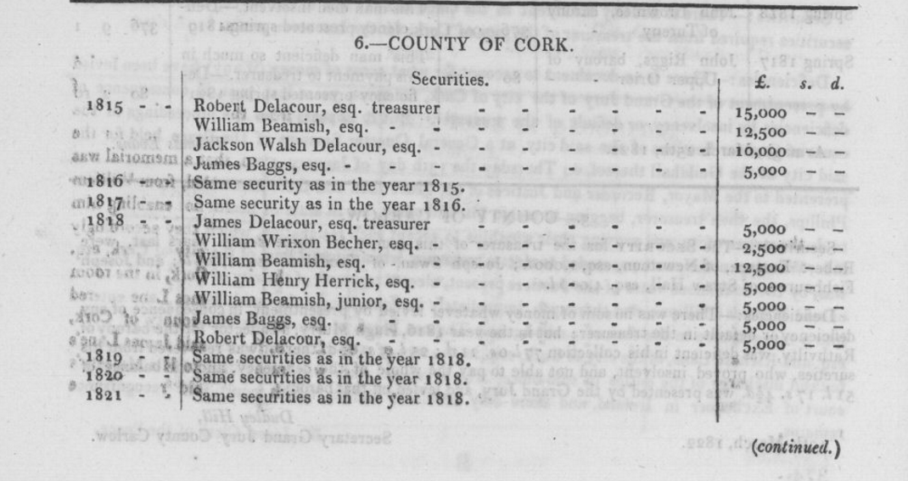

1830 Report of Treasurer James Delacour on procedure

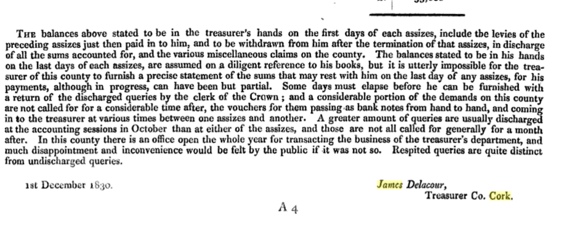
Treasurer City

1732 Grand Jury displeased with Daniell Engan replaced by Phillip Ellis as Treasurer of City and County of Cork., there in 1742.

1791 Robert Travers.

1807, William Phillips, Grand Jury Summer Presentments provided for half year £40 1807, ill 1821 replaced by Lane on his death sum owing to Grand Jury of £3,525 which was expected to be recovered in full from his representatives.
James Brett
1817, James Lane, appointed for life from 1820 by Cork Magistrates by unanimous vote doing position since. Sureties in 1822 recognisances £4,000 Thomas Biggs, Bandon, Richard Lane £2,00 Cork. 1817, salary £185, fee from interest £45 and fee of £80 from Corn Market Trustees.
1840. Late treasurer defaulted to the extent of £460
1861 G. Humphries
1870s, John George McCarthy
1872, John Long Reeves, Borough Auditor died aged 61, Protestant, Grand Parade.

County Surveyors 1834-1944.

The post of county surveyor in Ireland was the first (not just one of the first) in the United Kingdom (not just in Ireland) to be filled on the basis of a competitive examination and an objective assessment of merit. The post of County Surveyor was amalgamated into the post of County Engineer, which was created after the abolition of the county boards of health in 1942 and came into effect in the various counties under as series of ministerial orders in 1943-44.

Office New Court house, Washington St. from 1836 previous two years ‘ miserably situated’.

1834, Edmund Leahy, West Riding, resides Cork. Appointed 1834 holds under will of Lord Lieutenant, full time, £300 per annum with £50 for clerk and expenses. Three assistants at a total cost of £150. 143 miles of new road at 1840 and 971 maintained since appointment Office at courthouse, spends two thirds of time internally the balance at road works. `Private practice but very little.

Patrick Leahy, Associate of Institute of Civil engineers, London. East Riding and County of the City of Cork. Glanmire demesne of Glenville. Appointed 1834 holds under will of Lord Lieutenant, full time, £300 per annum with £50 for clerk and expenses assisted at no cost to county by son qualified engineer. During is tenure at 1840 had erected 120 miles of new road 1,904 miles under maintenance. Four assistants at a total cost of £200 pa. Office at courthouse, spends two thirds of time internally the balance at road works. 1834 Report to Grand Jury under 40th Section, Act of 3rd and 4th William, 4th, Chapter 78. 1834. In 1835 and 1836 also acted as Architect for Ecclesiastical Commissioners for Munster at £200 pa declined due to pressure of work.

1840 presented 13th report to Cork Summer Assizes reporting on road and other road work progresses
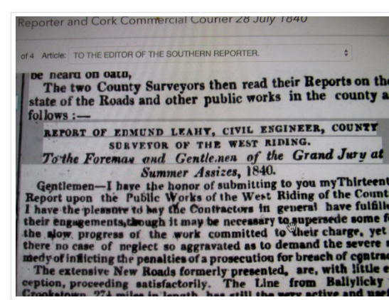.

1853, County Surveyor reported to Grand Jurors after catastrophic flooding which destroyed bridges at St Patrick's Cork (1793), Carrigadrohid, Macroom Bridge, New Bridge over Lee,
1861, East Riding , W. A. Tracey, Cork

1861, West Riding, Nathaniel Jackson, South Mall, Cork
1865, A.O.Lyons

….

Clerk of Crown (State Solicitor Equivalent)

City

1694, Thomas Farren, Middle Temple 1671, deputy previously

…
New Offices at Courthouse 1891 after Fire

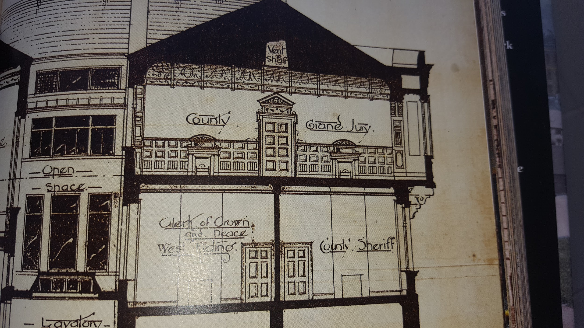
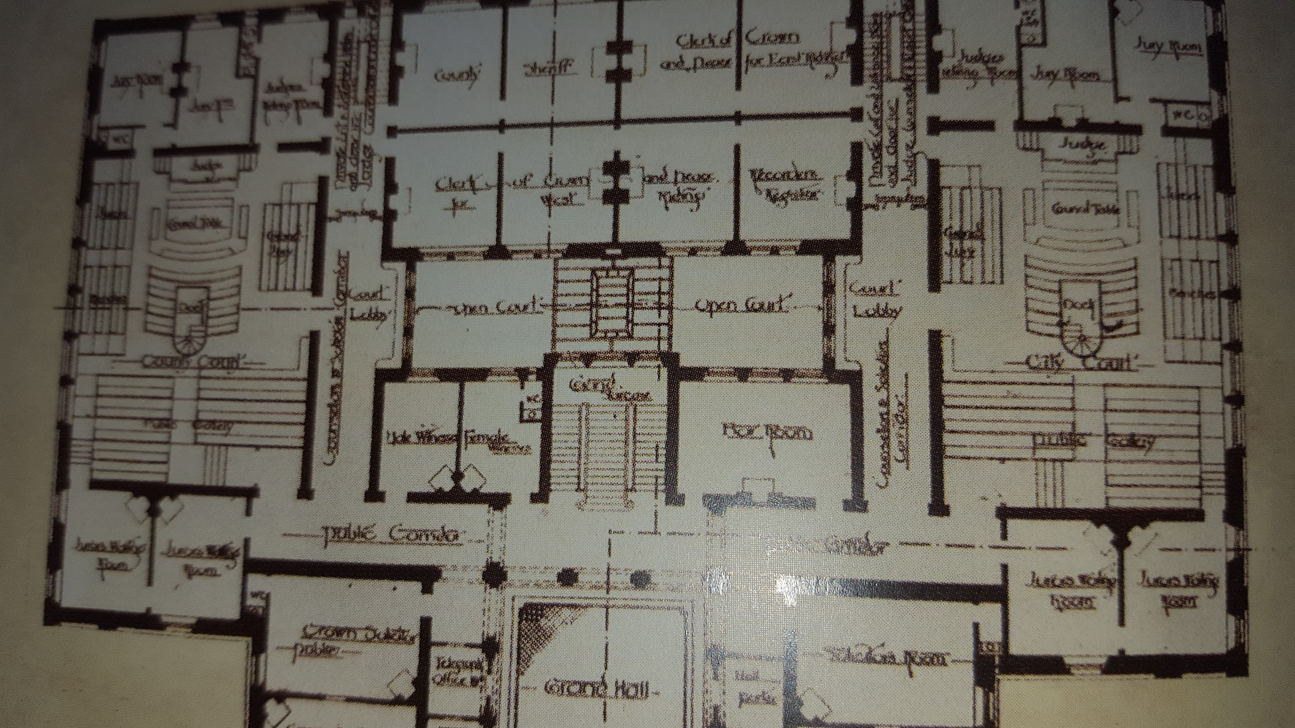
...
…
1714, Edward Webber, Appointment confirmed by Lords Justices as Town Clerk and Clerk of the Crown and Peace sworn in at Tholsel Court 1714.
‘’’

..
1729 (listed also for 1743), John Purdon, Clerk of the Crown and peace for Co. Cork and Waterford.

1730. William Lane, Town Clerk. Clerk of Crown for City and County of Cork and Public Notary elected. Died 1732.

1732. Robert Hoare elected by Court D’Oyer of 100 against Alderman Atkins and Walter Goold. Clerk of Crown and Peace Cork County and City. Town Clerk.

24 June, 1732. The question being put whether this Council should require any sum of money for the office of Town Clerk, resolved, that each candidate shall deposit the sum of £400, either in money or banker's good notes payable on demand into the hands of the Mayor, and that said sum deposited by the Candidate who shall be chosen by the Government shall be granted for ever to the use of the Mayor, Sheriffs, and Commons of this City, and after he shall be sworn, said sum shall be paid into the hands of the Chamberlain and the other deposits returned to their owners, the money received to be applied towards the discharge of the incumbrances which this Corpora- ELECTION~ OF CLERK OF THE COUNCIL.resolution lies under for money advanced towards building and rebuilding several churches in this City. That £5 ls. 6d. expended

28 Sep., 1732. Russell Wood, gent., was approved of Deputy Clerk of the Crown, Clerk of the Peace, Not. Public, and Com. Clerk, or Town Clerk, to Mr. Robt. Hoare, subject to an order made 10 June, 1732, viz., "That no deputy shall practice as an attorney in the Tholsel Court."
….

…..
Died 1748, Richard Morgan, Clerk of the Crown, Co. Cork in King James Time. Born Castlepooky near Doneraile. Aged 107 at death buried Abbey, Buttevant. JCHAS

….
Valentine Greatrak (1629-1683). ‘The Governour made me Clerk of the Peace of the County of Cork, and Register for Transplantation, and Justice of the Peace: In which Employment I studied so to acquit myself before God and Man in singleness and integrity of heart, that to the comfort of my Soul, and praise of God that directed me, I can with confidence say, I never took Bribe nor Reward

1761-1776. Counties of Cork and Waterford and the City of Waterford.

John Sullivan, listed as Clerk of the Crown with his father Benjamin Sullivan and Benjamin Junior for Co. Cork and Waterford.

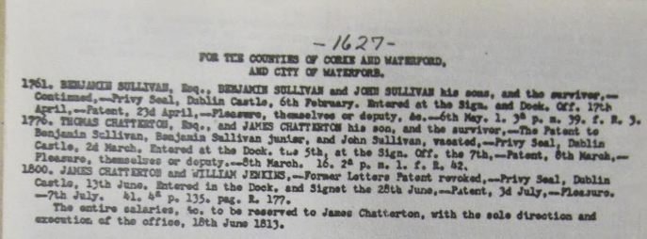

…..

1768. Will. Snowe, Esq., was elected Pub. Not., Clerk or the Crown and Peace for the City and Co. of the City of Corke, in the room of Anthony Lane, dec.; also Clerk of the Council vice Anth. Lane, dec. Ordered, that a C. D. H. be held 20 Sep. to elect a Town Clerk in the room of Anthony Lane, dec. It., a pension of .£20 a year be paid the widow of Anthony Lane, Esq., dec.

….

1776-1800, Counties of Cork and Waterford and the City of Waterford.
Thomas Chatterton and Thomas Chatterton his son

….
1782 That a pension of £20 a year be paid to the widow of the late Wm. Snowe, Esq., in testimony of his m:1ny services in the offices of Town Clerk and Clerk of the Crown and Peace; It., that a C. D. H. be held on 25 Nov., to elect a Town Clerk for this City and County thereof in the room of the late Willm. Snowe, Esq., the person elected to hold the same during his good behaviour, and no longer.

1782 William Jones, Esq., is unanimously elected Clerk of the Council, and Notary Public for the City of Cork, and that said Jones be paid £50 yearly for his trouble

…...
1800. Counties of Cork and Waterford and the City of Waterford.
James Chatterton and William Jenkins.

1807 Miscellaneous fees to Clerk of Crown, £3 Turnpike Road Act, licenses for sale of spirits, for registering bakers, under Civil Bill Act £20, under Militia Act £20

1815 entire salary to be reserved to James Chatterton.

1816. William Jenkins, Clerk of Crown Co.Cork with James Chatterson

1838, Sample advertisement of forthcoming General presentment Sessions, 2nd July 1838 at Clonakilty. Details J. Chatterton, Clerk of the Peace, Co. cork, peace Office, Cork.

1884, Francis Hodder, Solicitor, Solicitor to Admiralty and to County Grand Jury, 36 South Mall

1884, William O’Keeffe, 1825 sworn in as member Kings Inns, Attorney Kings Bench. 1845, 21 Cook St. Solicitor, Partner O'Keeffe and Lynch, Clerk of the Crown and Peace for Cork

1894, William J. Fitzgerald, Bank Place, Mallow, Solicitor listed as Clerk of Crown, Co. Cork

…..
Mr. Alfred Harmer (b.1861-d.1942) was Law Advisor to the County Cork Grand Jury and later to Cork County Council for 40 years.

1917, Henry T. Wright, Clerk of Crown and Peace of East Riding and Cork City, Court House May be of Clonakilty legal family having Protestant Sullivan Dunmanway ancestors. Law Directory

Baronial High Constables

They were appointed by the Grand Jury. In some Baronies percolation and arrears in discharging monies to the County Treasurer Developed.

1812 John Cotter, Tithe proctor Castlelyons. The same people often acted in the recovery of various taxes and tithes.

1820. Memorial to Lord Lieutenant by William Swanton, Gortnagrough, Ballydehob, West Cork. High Constable (Rate and Tax Collector), Barony of West Carbery For Relief on Losses Caused to Him in Banking Collapse when He had transmitted Due Amount to County Treasurer, Leslies, Stephen and Roches Bank, Supported by Lord Bantry and Magistrates Timothy O’Donovan (Durrus), William Hull (Schull), Richard Townsend (Skibbereen), Rev. Edward Jones Alcock (Durrus), Nathaniel Evanson (Durrus), Robert Kenny (Bantry). In 1823 he applied for relief of poor of Ballydehob, which he had founded.

..

1821. Francis George Woodley, HIgh Constable, Barony Kinnatalloon, son of george Woodley Magistrate, Frankford, near Tallow, Co. Waterford. Major disaffection in collection cess.
….

…

…..
1821, In County arrears from 1815-1822 of money not paid over by Baronial Constables, extreme West Division, West Riding £1,108, Barrymore £998, Bantry £707. Legal bills from Richard J. Orpen of £197 and George Bagas? for 1816-7 incurred in attempts to recover. In City accumulated arrears of £5,891 written off.

1838. George Baines Easley, Youghal, Cork County Cess Collector and Gas Cess

1839. Election of Galwey as HIgh Constable by Magistrates:

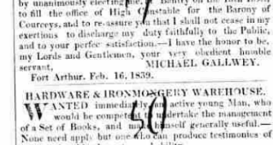

…..
C 1840. COUNTY CESS COLLECTORS

West Riding

Bere
John O'Sullivan, Millcove, Berehaven

Bantry
John O'Sullivan, Millcove, Berehaven

E. D. of E. Carberry
Geo. Sandes, Dunowen,Clonakilty

W. D. of E. Carberry
Adam N. Meade, River View, Enniskeane

E. D. of W. Carberry
J. W. Levis, Skibbereen, (1827-1893), Kilmacabea and Clover Hill, Skibbereen

W. D. of W. Carberry
J. Fleming, Ballydehob

Kinsale and Courceys
Mich. Gallwey, Kinsale

Kinalmeaky,
H. T. Poole, Mayfield, Bandon

Ibane and Barryroe
D. M'C. Gallwey, Greenmount, Clonakilty

Muskerry, West
Devonsher Hawkes, Macroom

….
1843 Baronial Constables. Bantry and Bere, John O’Sullivan. Bandon Town, Horace Poole. Barretts, Thomas E. Coole. Barrymore, Edward H. Wilson. Cork, John Roberts. East Division East Carbery, Thomas Hungerford. West Division East Carbery, A. M. Meade. East Division, West Carbery, Samuel Levis. West Division West Carbery, William Swanton. Condons and Clongibbon, Robert Briscoe Junior. Courcies, Michael Galway. Duhallow, B. De La Cour Junior. Fermoy, Edward D. Freeman. Ibane and Barryroe, Henry Galway. Imokilly, Robert Boles. Kerricurrihy, William Daunt, Springhill, Carrigaline. Kinalea, John Robert. Kinnalmeaky, H.T. Poole. Kinnattalloon, William Woodley. Kinsale, Samuel Heard. Mallow Town, Andrew Mahony. East Muskerry, Thomas E. Crooke. West Muskerry, St. George Browne. Orrery and Kilmore, Hugh De La Cour. Youghal, George B. Heazley

…...

1862 COUNTY CESS COLLECTORS, E. R.
Barretts, George Stawell Ware, Woodfort, Mallow
Barrymore, Henry Barry, Ballyadam, Carrigtuohill
Condons and Clongibbons, John Terry, Springvale
Cork Barony, John Wakeham, Springhill, Glanmire
Duhallow, R. Delacour, Fairy hill, Mallow
Fermoy, Arthur Williamson, Summerhill, Mallow
Imokilly, Henry Welland, Killeigh, Midleton
Kerricurrihy, W. Daunt, Springhill, Carrigaline
Kinnalea, Simon Newenham, Maryboro', Douglas
Kinnataloon, Robert Boles, Ahern
Kinsale, Michael Gallwey Kinsale
Muskerry, E., Horace Townsend, Woodside, Blarney
Orrery & Kilmore, Samuel Uppington, Mallow
COUNTY CESS COLLECTORS, W. R.
Bere, John O'Sullivan, Millcove, Berehaven
Bantry, John O'Sullivan, Millcove, Berehaven
E. D. of E. Carberry, Geo. Sandes, Dunowen,Clonakilty
W. D. of E. Carberry, Adam N. Meade, River View, Enniskean
E. D. of W. Carberry, J. W. Levis, Skibbereen
W. D. of W. Carberry, J. Fleming, Ballydehob
Kinsale and Courceys, Mich. Gallwey, Kinsale
Kinalmeaky, H. T. Poole, Mayfield, Bandon
Ibane and Barryroe, D. M'C. Gallwey, Greenmount, Clonakilty
Muskerry, west, Devonsher Hawkes, Macroom

…...

1863 Baronial High Constables (County Cess Collectors) | Barony
Bantry and Bere | John O’Sullivan, Mill Cove, Castletownbere
Barretts | George Stawell Ware, Woodfort, Mallow
Barrymore | Henry Barry, Ballyadam, Carrigtwohill
Condons and Clongibbons | John J. Therry/Terry, Springville
Cork | John Thomas Wakeham, Springhill, Glanmire
East Division East Carbery | George Sandes, Dunowen, Clonakilty
West Division East Carbery | Adam N. Meade, River View, Enniskeane
East Division West Carbery | James W. Levis, Skibbereen
West Division West Carbery | John B. Fleming, Ballydehob
Courceys and Kinsale | Michael Gallwey, Kinsale
Duhallow | Robert De la Cour, Fairy Hill. Mallow
Fermoy | Arthur Williamson, Summerhill, Mallow
Ibane and Barryroe | D. McCarthy Gallwey
Imokilly | Henry Weiland/Welland, Killeagh, Midleton
Kerrycuuihy | William Daunt, Springhill,Carrigaline
Kinalea | Simon Newenham, Maryboro’, Douglas
Kinnalmeaky | Horatio T. Poole, Mayfield, Bandon
Kinnattaloon | William R. Bowles, 1861 Robert Boles, Ahern.
East Muskerry | Horace H. Townsend, Woodside, Blarney

West Muskerry | Devonsher P. Hawkes, Macroom
Orrery and Kilmore | Samuel Uppington, Mallow

…

1875, Deputy Cess Collector, Mallow, John Wynne

….

Local Government (Ireland) Act 1898.

Local government was totally reformed under the Local Government (Ireland) Act in 1898. The power of the County Grand Juries, and the poor law guardians was eventually replaced by more representative local authorities. Counties, as opposed to poor law unions, were re-established as the main unit of local government, except now they were controlled by elected councils. Cork became a county boroughs, controlled by an elected corporation.

In Cork the County Council took over the offices and personnel of the Grand Jury.

A third tier of government was introduced at the sub- county level. Towns with a population of 1,500 became urban districts with their own town council. The rest of each county was divided into rural districts (largely based on the poor law unions). Urban and rural districts had designated local powers, but were subservient to the counties. This system of local government has remained more or less intact for over 100 years. The only significant change was the abolition of rural districts in 1925.

…..

….

….

Baronial Committees.

Baronial Constables (Collectors of County Cess)

The collection was entrusted to Baronial Constables. Financial control sees to have been lax. There were a number of examples of Constables being in arrears and allegation of fraud. An attempt was made but not continued to dismiss the Baronial Constable for Beara Patrick O'Sullivan of Millcove, Castletownbere for allege fraud but was not proceeded with. HIs career gives an example of the various political interconnections at the time

‘Big’ Patrick O’Sullivan, Millcove: Castletownbere. Died 1863. Lord Bantry Estate appointed as Seneschal Not legally qualified. Parliamentary Report 1837, Eppi. Baronial collector since 1825 deputy Denis Murphy (Irish speaking) as collector. This entailed the collection of the County Cess for the Grand Jury for the barony of Bere. The Cess amounted to 12% of gross rent. An attempt was proposed but not proceed with to dismiss him for alleged fraud in the collection of the Cess. He was a fit and proper person to conduct 1831 Census with Mr. W. Murphy. Seneschal of Altham, Mill Cove, Berehaven, Bantry and Donemark from 1843. 1841 organising voters from Beara in Conservative interest. Sitting as Grand Juror, Cork 1842, 1844, Cork County Agriculture Society Dinner 1842. Distributing in Beara New England Famine Relief 1847. Millcove. leased by Patrick O'Sullivan from the Earl of Bantry's estate in 1852 when it was valued at £14. O'Sullivan worked as an agent for the White estate. A deeply unpopular Landlord local tradition has it that he used to blow his bugle outside the Church after Sunday Mass to summon his tenants to draw hay or turf or whatever other task he designated. 1856 Chairman Berehaven Board of Guardians.

The house has been demolished though traces of the stone work can still be seen in the gardens which are now part of an art gallery and sculpture display. He was agent for the Beara part of the Bantry estate working with receivers and banks to Lord Bantry while Augustus Payne from the Upton family operated the rest of the estate. His daughter Christina, who emigrated to the Unites States and became the matriarch of a very rich New York family, before ending her days sadly in a mental home. Ellen O'Sullivan, Convent of Faithful Companions of Jesus, Limerick Chronicle died 6/06/1857, dau of Patrick O'Sullivan of Mill Cove, Berehaven, Laurel Hill. Died Peshwar India 1881 Edward O’Sulllivan, Queen's Regiment, youngest son of Patrick O'Sullivan, Esq., Millove, Castletownbere, agent to Lord Bantry and Seneschal.

Patrick O’Sullivan was nephew to Captain Paddy O’Sullivan of Faha also Agent to Lord Bantry whose sister was the mother of Peter McSweeney. 1857 Peter McSwiney, the last lineal descendant of the Mac Finin Dubh O’Sullivans (a 400 year old title), after his eviction from Dereen in Kenmare by the Lansdowne Estate, spent his last days in Ahakista Cottage. Patrick O'Sullivan, Lord Bantry's Agent in Beara, Millcove Castletownbere, Agent to Lord Bantry brought the following to Cork 1841, to vote for Longfield/Leader in a Schooner, 'Sophia' via Adrigole and Bantry. Longfield paid expenses. Jeremiah O'Sullivan, Murtagh O'Sullivan, Daniel Florence O'Sullivan, Daniel Jeremiah O'Sullivan, Timothy O'Sullivan, Roger O'Sullivan, Timothy O'Sullivan, Simms (Protestant), Denis O'Sullivan, From Adrigole, Daniel Murphy (his deputy Irish speaking), Richard O'Sullivan (Protestant), Daniel Michael O'Sullivan, James Neill, William Murphy, Murtagh Kelly.
Another family who were Baronial Constables were the Swantons of Ballydehob. They had a reputation for industry and probity. Their position as Baronial Constables may account for them become major middlemen on various estates in Carbery from the late 18th century.

1828, William M. Swanton, Gortnagrough, Ballydehob, West Division West Carbery, requested attendance of people aggrieved and Baronial Committee at Carrigboy (Durrus) Courthouse.

……

1844 Baron Richard at Assizes fined Baronial Constables one quarter of salary for not having Jury lists properly prepared.
…

Hearth Tax

Ireland
Unlike in England, which abolished the Hearth Tax in 1689, it continued in the Kingdom of Ireland till the early 19th century although it underwent major reform at end of the 18th century. It was levied half yearly by the Sheriff of each county on the basis of lists of the names of householders compiled by local Justices of the Peace. The list of the households required to pay the Hearth Tax became known as the Hearth Money Rolls, which were arranged by county, barony, parish, and townland. The tax was sometimes collected over an area known as a 'walk', which was based on both the town and a large rural area outside the town.
Several attempts were made in Parliament to abolish or at least limit the proportion of households obliged to pay the tax, which was widely regarded as “a shameful infliction upon the poor peasant, to whom even two or three shillings in the year for such a tax was a burden and a wrong”.^{[8]} The chief proposers of a radical change were Thomas Conolly and John O'Neill. In 1788, for example, they argued that for a substantial portion of those having to pay the tax, the yearly cash demand was an unreasonable burden.^{[9][10]} Henry Grattan developed the same point: "I am convinced, that the man who has but five pounds in the world, and pays thirty shillings for his house, ought not to pay hearth-money; the strongest argument for his relief is the bare statement of his condition….The wretchedness of their living, and the misery of their consumption, is the reason why they scarcely pay any tax but the hearth-money, and is likewise a reason why they should not even pay hearth-money.^{[10]}
Major reform of the hearth tax was finally carried out in 1793 whereby one-hearth households with less than £10 in personal property, or with houses and land worth £5 or less, were henceforth deemed exempt from the tax. The measure was apparently a consequence of parliamentary pressure in the previous session; the modification of the window tax in Britain giving total relief to poorer householders had led to calls in the Irish Parliament for similar "liberality" in the light of Ireland's healthy finances. The Chancellor of the Exchequer (William Pitt) had refused, but a parliamentary committee was established under the de facto chairmanship of Mr G.P. Bushe who successfully proposed that one-hearth householders should be divided into two groups: those above and those below £5 in annual valuation. Subsequently, in 1795, freedom from hearth tax was extended to all one-hearth householders, as the opposition had earlier demanded; at the same time the tax on multiple-hearth houses was raised.^{[9][11]} The number of persons exempted from the hearth tax was estimated at between a million and a half to two million.^{[12]}
The original Hearth Money Rolls are not extant. The records were housed in the Four Courts in Dublin, the repository for the Public Records Office, but during the Irish Civil War in 1922 the building was destroyed by fire, which also destroyed the Rolls (along with the Ireland census records for 1821, 1831, 1841, and 1851), but copies of some of the Rolls have survived.
Each Barony had a Heart Tax collector. It seems likely that the Cess replaced the Hearth Tax at the end of the 18th century dn the families from whom the heart tax collectors came continued as barnial Constables.

Interestingly in Bantry in 1770 the Heart Tax collector for the Barony not clear if Bantry or Beare was Michael Sullivan/O’Sullivan, a Catholic he married Mary Vickery of Whiddy island and the children were raised in the Church of Ireland. There is an enormous extended family (of the Tedagh Sullivns/O’Sullivans) world wide from that union. Later the baronial constables of Beare were O’Sullivan who also feature as Cess Payer Representatives and a Grand Juror Morty O’Sullivan.

The tyranny of the Heavy Taxes as Seen in Poetry.

1822, The Troubles of a Struggling Farmer, Mud Cabin, Heavy Taxes, Tithes, Cess, and Rack Rents, Wintry Wind, by Poet Mícheál Óg Ó Longáin (1766-1837), Caheragh, (lived later Glanmire), Co. Cork.
Fuacht na scailpe-se, deathach is gaoth gheimhridh,
Cruas na leapsa-sa’s easpa braith lae’s oíche,
Muarcuid teascnna, deachmaithe’s glaoch cíosa,
Tug buartha cáthach mé, easpaitheach éagaoinaointeach.
The cold of the mud cabin, smoke and wintry wind,
The hardness of this bed and the lack of a mantle day or night,
Heavy taxes, tithes, and rack-rent demands,
Have made me troubled, in want, and lamenting.

Cess Payers.

1834. NAMES and PLACES of RESIDENCE of the CESS PAYERS nominated by the County Grand Jury at the last Assizes, to be associated with the Magistrates at Special Road Sessions to be holden in and for the several Baronies within the County, preparatory to the next Assizes, pursuant to Act 3 and 4 Wm. 4, ch. 78.

Barony of Bere | John O’Sullivan Cameatringane | David Kinnigan, Bawn | Edward Puxley, Oaklodge | William Trenwith, Droumdir
James Downing, Castletown | Daniel Sullivan, Dramguiven | Roger O’Sullivan, Seapoint | John Harrington, Killmacowen | Timothy O’Sullivan, Connahanavoe
Richard Martin, Clonee | John Harrington, Grenane | Timothy O’Sullivan, Castletown | William Murphy, Inchintaaglin | William Trenwith, Droumdir
Timothy O’Sullivan, Castletown

Barony of Bantry | William O’Sullivan Carriganass, Kealkil | Michael Sullivan, Droumlickeerue | John O’Connell, Bantry | Richard Levis, Rooska
William Pearson, Droumclough, Bantry | Daniel O’Sullivan, Reedonegan | Jeremiah O’Sullivan, Droumadureen | John Cotter, Lisheens, | James Vickery, Mullagh, Bantry
Rec. Henry Sadler, The Glebe | John Godson, Bantry | Richard Pattison, Cappanabowl, Bantry | John Kingston, Bantry | Samuel Vickery, Franchagh
William Pearson, Cahirdaniel, Bantry | Robert Vickery, Dunbittern, Bantry | Daniel Mellifont, Donemark | John Hamilton White, Droumbroe | Samuel Daly, Droumkeal
John S. Bird, Bantry | William Warren, Reendesert | William Vickery, Rooska | Denis Lehane, Trenmadry | John Brien Corkery, Bantry

Barony of Barretts | Richard H. Purcell, Burnfoot | Daniel Swiney, Coolroe | Philip Rubie, Knocknamarruv | Nicholas Kirby, Carhue. Coachford
Richard Donovan, Lisheen, Ballincollig | John Denlay, Kilnagloree | Jeremiah Coakley, Pluckanes, Donaghmore | Henry Lindsey, Meeshal, Coachford | John Swiney, Classes, Ballincollig
James Goolden, Gurrane | Henry Rubie, Knockane | Peter Galwey, Lisnahoundrum | Edmund Murphy, Currylea | Rev. Mr. Stopford, Knocknalier
Cornelius Hogan, Grenaghbeg, | Timothy Murphy, Old Abbey | William H. Low, Ballyfeareen | William Callaghan, Classes, Ballincollig | James Kelly, Newcastle
John Hennessy, Kilblaffar | William Haynes, Temple Hill | John Swiney, Manglin | Cornelius O’Leary | Thomas Batten

Barony of East Division East Carbery | Jonas Stawell, KIlbrittain | Edward G. Good, Phale | William Daunt, Willsgrove | Hibernicus Scott, Coolemain
Andrew Poole, Kilrush | John Beechinor, Knockscagh | Michael Crowley, Farranasheshires | Peter Neill, reenroe | Edward Cottrell, Ballinadee
George Dunne, KInsale | James Hayes, Castleview | Major Scott, Farrangark | John Beamish, Carhur | Richard Wheeler, Fort Prospect
John Tresilian, Cuttowrane | William Daun, Kilcaskin | Thomas Bailie, Ballybackeen | George Cornwall, Bandon | Winspear Toye, Clonakilty
Henry Cornwall, Bandon | John Howe, Glounavirane | Rev. W. Connor, Doundaniel | Major Broderick, Maryborough | William Austen, Skeafe

Barony of West Division East Carbery | William Scott, East Drinagh | William Norwood, Ballihalwick, Dunmanway | Herbert Gillman, Clounties, Dunmanway | Alexander J. Cox, Kilbarry, Dunmanway
Nicholas B. Jagoe, Kilronan, Dunmanway | Benjamin Holmes, Dunmanway | John Gillman Mylane | James Redmond Barry, Glandore House | John Ranclaud, Kilfinan
Richard Baylie, Ballivoreen, Glandore | Robert Starkie, Cregane, Rosscarbery | Walter Starkie, Burgatia, Rosscarbery | Abraham Beamish, Kilmacabea, Leap | John Wolfe, Coolcraheen, Dunmanway
Rev. Jones? Jones, Drumbeg, Leap | Thomas Hungerford, Farley Cottage, Clonakilty | Richard Wolfe, Caherkirky, Clonakilty | Rev. Joshua Wood, Ross | William Clarke, Clounties, Dunmanway
John Brien, Mohony | James Hayes, Frehanes, Rosscarbery | George Sealy, Kinneigh, Bandon | Arthur Burchill, Kilnscroonagh | Thomas Bradfield, Manch, Dunmanway
 | Abraham Beamish, Kilmacabea, Leap

Barony of East Division West Carbery | Rev. John Wright, Killinah | Gibbs Ross, Smorane, Skibbereen | Alexander McCarthy, Laherdaly | Philip Somerville, Union Hall
John Swanton, Killinagh | George Long, Paddock, Skibbereen | Philip Attridge, Carrigfada | John Sweetnam, Clover Hill, Skibbereen | Robert Evans, Ardraly, Skibbereen
George Beamish, Lakemount, Skibbereen | Richard Swanton, Hollyhill, Aughadown, Skibbereen | Nathaniel Lannon (Lannin), Gortnaclohy, Skibbereen | Henry Newman, Gurtnamuckla, Caheragh | Henry Right (Wright?), Skibbereen
Hugh Jagoe, Lahina | Arthur Attridge, Riverview | Francis Beamish, Skibbereen | Robert Ellis, Carrihaliccca | William Young, Letter Scanlan, Skibbereen
William Louth, Glandore House | John Levis, Leighluinn | George Evans, Drimindad, | William Taylor, Drimindah

Barony of West Division West Carbery | Thomas Roberts, Quolah | Robert Swanton, Ratruane, Schull | Alexander O'Driscoll, Gurtnascrena, Drimoleague | Alexander Evans, Lisangle, Caheragh
Philip Somerville, Maulavodera, Ballyehob | Charles Dukelow, Durrus | William C. Browne, Crowe | William Long, Greenmount, Ballydehob | Richard Swanton, Ratruane, Ballydehob
Rev. Edward Alcock, Clashadoo Glebe, Durrus | Murty Houlahane, Clahane, Caheragh | George Vickery Inchegerig, Caheragh | William Vickery, Ballycomane, Durrus | James McCarthy, Ballydevlin, Goleen
James Swanton, Marsh, Skibbereen | Timothy O’Donovan, O’Donovan’s Cove, Durrus | Andrew Caverly, Ardentenant, Schull | William Newman, Woodlands, Schull | Joseph Wolfe, Ballycumisk, Schull

Barony of Condons and Clongibbons | John Anderson, Ashfield, Fermoy | John Martin, Castlehyde | George Johnson, Duntahon | William Austen, Fermoy
Henry Wigmore, Kilbarry, Fermoy | Cornelius O’Brien, Manning, Fermoy | George Ryal. Cornhill, Glanworth | George Luckey, Clondulane, Fermoy | Edward Creed, Leitrim, Fermoy
Thomas Carroll, Kilmagner, Fermoy | Henry Decie, Douglas, | Henry Baylie, Ardglare, Fermoy | William Hill, Kiltrusnan, Fermoy | Thomas Casey, Gurrane, Fermoy
William Connell. Ballyfana, Fermoy | Patrick O’Mara, Ballykendley, Fermoy | Michael O’Brien, Kilaclog | Joseph Carey, Straw Hall, Fermoy
Garrett May, Modeliga, Conna, Fermoy | Thomas Campion, Leitrim, Fermoy | Andrew Sullivan, Fermoy | Maurice Donegan, Macroney, KIlworth | John Hyde, Castlehyde Cottage, Fermoy

Barony of Courceys | John Bullen, Ballyhandle, Timoleague | James B. Gibbons, Ballinspittle | Thomas Tresilian, Currahaly, Barryroe | John Collins Senior, Gortnacrusha, Ballinspittle
George Sealy, Lispatrick, KIlbrittain | Daniel Sullivan, Kilmore | Daniel Dempsey, Lispatrick | Joseph Hourihane, South Gortnacrusha, Ballinspittle | John Collins, North Gortnacrusha, Ballinspittle
William Connell, Drumdirigh | William Galway, Ballinora | John Sullivan, Coolbawn, Barryroe | Denis Griffin, Ballincurrig, Barryroe | Denis Griffin Junior, Ballincurrig,
Laurence Donovan Ballincurrig, Courtmacsherry | Jeremiah Bohane, Old Court, Courtmacsherry | David Manning, Old Court, Courtmacsherry | David Manning, Ballymackner | John Dempsey, Ballymackner
John Mansfield, Ballymackner | Michael Dempsey, Dooneen, Ardfield, Clonakilty | William Quinn, Crohane (Creghane), Barryroe | Patrick Connell, Bogstown | Edward Long, Knockgurrum

Barony of Duhallow | Charles D. Purcell, Mallow | Patrick McCarthy, Kanturk | Richard Smith, Newmarket | Timothy Shine, Corbally
Cornelius Sheehan, Clonmeen, Banteer | Rowland Burke, Bantyre | Richard O’Callaghan, Killenligh | ---Lloyd, Milliew | Richard Terry, Bettyville, Mallow
Matthew Fitzpatrick, Freemount, Kanturk | Nicholas Philpot Leader, Nashville, Kanturk | William Sharpe, Glenmount, Kanturk | John Philpot, Clonribbon, Kanturk | Francis Burton, Curras, Kanturk
George Bolster, Curraghbower, Lombartstown | John Twomey, Dysart, Dripsey? | Timothy Guinee (Guiney), Knockaclarig, Rockchapel | Henry Newman, Droumoneen | James Nunan (Noonan), Curraheen, Kanturk
Daniel McAuliffe, Fortgraddy, Millstreet | William Sullivan, Tullylease, Kanturk | Timothy Croning, Assolas, Kanturk | ---Sherlock, Ballyheen, Kanturk | Jeremiah Lane, Coonahane

Barony Imokilly | Crofton Uniacke, Ballyre | Patrick Lawlor, Mount Uniacke | William Hall, Garranjames, Castlemartyr | Thomas Welsh, Dromada
James Hanning, Kilcone | James Gleeson, Lisquinlan, Castlemartyr | Jonas Smyth, Ballyshane, Cloyne | John Canny, Ballyglashine, Castlemartyr | John Carden, Midleton
Richard Hall, Gathnagark | Rec. C. Harte, Lisquinlan | Rev. William Boles, Springfield, Castlemartyr | Walter Atkin, Careystown | Daniel Hamhreys,  Midleton
James Fitzgerald, Carrigacrump, Cloyne | Patrick Smiddy, Carrigshehan | William Abbott, Shangarry | R.P. Fitzgerald, Corkbeg, Whitegate | Christopher Upton, Cloyne
Edward Roche, Trabolgan, Cloyne | Jonas Smith, Inch, Cloyne | John Connor, Ballymacandrick, Cloyne | Rev. R. Longfield, Castlemary | R. Travers, Mosastown, Midleton

Barony of Kerricurrihy | Thomas Barter, Myrtle Hill, Carrigaline | John Martin, Knockmore, Carrigaline | Edmund Hutchins, Ballea, Carrigaline | Robert Warren, Barnahely, Passage
Robert Shaw, Monkstown | Robert Hedges Eyre White, Raffeen, Monkstown | Osborne Savage, Kilnaglery, Carrigaline | John Sainthill, Rathaneering | Joseph Coghlan, Ballygarvan
Gersham Herrick, Adamstown, Ballinhassig | Jeremiah Eugene McCarthy, Kilmoney, Carrigaline | William Travers, Cumineen, Carrigaline | Robert Bible, Crosshaven | George Rice, Rerower
Daniel Kelleher, Tulligmore, Ballinhassig | Nicholas G. Seymour, Carrigaline | David Cagney, Parkgariffe, Monkstown | Daniel Callaghan, MP, Monkstown | Hatton Conron, Ballinameta, possibly Grange
Thomas Sullivan, Kilnopane | Andrew Windale, Laurel Hill, Monkstown | De Courcey O’Grady, Carrigmahon House, Monkstown | Thomas Drinan, Tulligbeg, Ballinhassig | John Anderson, Rahankard

‘’’

Barony of Kinnalmeaky | Bradshaw Popham, Coolfadda, Bandon | Henry Baldwin, Mount Pleasant, Bandon | John Woods, Cottage | Herbert Gillman, Oldpark, Mount Pleasant, Bandon
Samuel Baldwin, Lisnagat, Bandon | William Whiting Lissybrother, Brinny, Innishannon | Doctor Beamish, Coolfadda, Bandon | Henry Herrick, Farrenlough, Innishannon | John Ottley, Roughgrove
Thomas Poole Poole, Gurteen, Bandon | Richard Splaine, Mormeen | William Gash, Mishells, Innishannon | Jaque Nash, Lissybrother, Brinny, Innishannon | Henry Cornwall, Knockbrogan, Bandon
Adderley Beamish, Kilcoleman, Bandon | Francis Sweeney, East Gulley, Ballymoden, Bandon | Thomas Beamish, Bandon | John Beamish Junior, Cashelmore | John Swanton, Lauragh, Bandon
William Bansfield, (probably Banfield, Shinnagh) L...noh | John Popham, Bandon | Edward McCarthy, Kilcoleman, Bandon

..
Barony of Kinnalea | Charles Busted, Knocknalurrign | George N. Dunn, Glenny, Kinsale | Thomas Biggs, Garryhankard, Bandon | Henry Bastable, Heathfield, Kinsale
George Daunt, Bromley | James Deane, Dunkereen, Innishannon | Peter Downey, Lybe, Belgooly | Walter Fitzsimmons, Reagrove, Minane Bridge | Robert Jeffords, Coolculitha, Ballinhassig
John Gallwey, Kilowen, Bandon | John Lane, Arangstown | John Nash, Brinny, Innishannon | Richard Kennefick, Ballindeasig, Kinsale | Francis Sealy, Innishannon
Nicholas Haynes, Ballynoluha, | Francis Sealy, Innishannon | Thomas Roberts, Ballinacourty | William Barber, Ballymurphy | William Daunt, Springhill, Minane Bridge
Matthew Hornibrook, Dunkereen | William Seymour, Ballinling, Butlerstown | John Hornibrook, Beechmount, Bandon | Newenham Crone, Knocklea, Belgooly | Major Wescott, Frankfort, Innishannon

Barony of Killannattaloon | John O’Neill, Fermoy | Spotswood Bowles, Ahern/Aghern, Fermoy | Walter Croker, Lisnabrin, Mogeely, Fermoy | Richard Gumbleton, Castleview, Knockmourne, Fermoy
James Brown, Coole Lower, Castlelyons | James O’Neill, Gunnerribeen | Daniel O’Neill, Killclare, Conna, Fermoy | Miles O’Neill, Bouladerragh | Richard Neville, Mogeely, Midleton
Daniel Hanning, Carragun | William Day, Killnmaclow | Richard Power, Carrigmore, Fermoy | Daniel Mahony, Garryduff | Hugh Keeffe, Bridepark, Fermoy
Bartholomew Sheehan, Ballymountain | John Griffin, Ballybride, Fermoy | John Harris, Cullenagh, Fermoy | John Nason, Newtown, Fermoy | Jerry McNamara, Glengoura, Fermoy
John Parker, Ballyclough | John Kirby, Garryentaggart | John Kirby Junior, Glanballycullane

Barony of Kinsale | John Walton, Ardbrack | George N. Dunn, Kinsale | John C. Hartnett, Kinsale | John Bullen, Kinsale
Thomas Markham. Kinsale | William B. Dorman, Kinsale | Robert Brickford, Kinsale | William Newman, Kinsale, | Sir. Thomas Browne, Knockduffe, Kinsale
John Beazhy, Ballinacurra, Kinsale | John Cummins, Tisaxon, Kinsale | William Barter, Ballywilliam, Kinsale | Thomas Murphy, Coolvallanane Beg, KInsale | Thomas Kenefick, Gortnalusheen, Kinsale
Captain Gallwey, Fort Arthur, Kinsale | Edward Bolton, Knockrobbin, KInsale | Samuel P. Townsend, Palacetown, Kinsale | John Gillman, Sandycove | John Purcell, Dunderrow, Kinsale
Daniel Sullivan, Coolvallanane Beg, KInsale | Patrick Donovan, Castlepark, Kinsale | Robert Roberts, Ballinamona, Kinsale | Cornelius Kelly, Mullendunny, Kinsale

Barony of East Muskerry | Robert Harnett, Deelish, Macroom | John Good, Carhue, Coachford | John Bowen, Oakgrove, Carrignadrohid | Cornelius Murphy, Garryhesta, Ballincollig
Edund Kinnealy, Marshinaglass | Daniel Mullane, Dawstown, Blarney | John Hawkes, Kilcrea, Bandon/Macroom | Samuel McCarthy, Castleinch, Ovens | John Pyne, Clonmoyle, Macroom
John H. Colthurst, Dripsey | Henry O'Callaghan, Nadrid, Macroom | John Horgan, Knocknagour | Francis Woodley, Deelish, Macroom | Andy Forrest, Bannifinn
Charles Colthurst, Clonmoyle, Macroom | John Hennessy, Cloghroe | Timothy Coleman, Cloughphilip, Blarney | Michael Hayes, Ardamiclane | Denis Horgan, Clogheenmilcan
Timothy Lyhane?Lehane, Carrigadrohid | John Hornibrook, Corrin, Bandon | John Dunley, Ballyrosheem | Timothy Keily, Dawstown, Blarney | William Barter, Aherlebeg, Bandon/Macroom

Barony of West Muskerry | Robert Hedges Eyre, Macroom Castle | Rev. Benjamin Gash. Ballytrasna, Macroom | John Leader, Glounleagh, Millstreet | Thomas Gollock, Dummarklam, Macroom
Henry Good, Crossmahon, Bandon | Denis O’Sullivan, Liscahane, Millstreet | Benjamin Swete, Greenville, Macroom | Richard Ashe, Ashe Grove, Macroom | Herbert Baldwin O’Donnell, Coole, Millstreet
John Williams, Carrigafooha | Mccarthy O’Leary, Coomlegane, Millstreet | Edward Ashe, Codrum, Macroom | Jeremiah Eugene McCarthy, Rathduhane, Millstreet | John Warren, Codrum, Macroom
Denis Donoghue, Drishanebeg | Walter Lane, Clonmoyle, Macroom | Denis Kelleher, Millstreet | Daniel Readron, Hanover Hall, Macroom | Andrew Kelly, Killowen, Bandon
Richard O’Leary, Milleen, Inchigeela | Stephen Ambrose, Kilcorney, Millstreet | John Grainger, Curriclogh, Bandon | Thomas M. Brown, Rockborough, Macroom | Cornelius Shea, Caherbrane, Clondrohid, Macroom

Barony of Orrery and Kilmore | William Purcell, Altimira, Buttevant | Thomas L. Crofts, Velvetstown, Buttevant | John O’Leary, Templemary, Buttevant | Jonathan Bruce Junior, Charleville
Rev. F. Crofts, Churchtown | Charles Daly, Ballygraddy | Standish Harrison, Castle Harrison, Charleville | Richard Gibbings, Gibbings Grove, Kanturk | George Gould, Aughrim, Kanturk
William Barry, Charleville | Timothy Cronin, Barna | Garrett Nagle, Mount North, Ballyclough | James Norcott, Springfield, Buttevant | William Rogers, Buttevant
Pierce Gould, Curryglass, Mogeely | William James McCormack, KIlpatrick | Thomas Heffernan, danbarry | Richard Bear, Cork | William Bullen, Rathclare, Buttevant
R. Purcell M.D., HIghfort, Mallow | William Rogers, Buttevant | James Cowhy, Imogawn | Francis Barry, Garryduff, Midleton? | Edward Brown, Kilmackennan
..

….

Cess payers, West Carbery, West Division, 1894,1895, George Vickery Ballycomane, Durrus, J. Mahony, Goleen, F. Mccarthy, Crookhaven, J. Murphy, Rhea, Kilcrohane, T P Somerville, Lisacaha, Schull, R or Y. Swanton, Rathrevane, Schull, S. Woulfe, Stouke, Ballydehob, .

….
1828, William M. Swanton, Gortnagrough, Ballydehob, West Division West Carbery, requested attendance of people aggrieved and Baronial Committee at Carrigboy (Durrus) Courthouse.

1873, John B. Fleming, BNH, WDW Carbery, Lowertown, Schull
1875, William Hungerford Baronial High Constable, East Division East Carbery, The Square, Clonakilty. Denis McCarthy Galwey, Ibane and Barryroe, Greenfield, Clonakilty
….

…

Grand Jurors as per Assizes

…

….

…..

1711, Kings Old Castle, Lord Chief Baron Rockford, John Nutley.
….
..

March 1719, Munster Circuit at the Tholsel, Lord Chief Baron Gilbert and Mr. Baron Pockington.

1723 March County Kings Old Castle

….
1725 Assizes Summer, Lord Chief Justice Whitehead, Prime Sergeant Bernard, City Tholse, County Kings Old Castle

1726, Spring, Lord Chief Justice Wyndham, Justice Parnell.
Sumer Assizes, Lord Chief Justice Dawson, Baron Pockington, County Kings Old Castle, City Tholsel
…..

…
28 Aug., 1730. That Mr. Justice Ward, of the King's Bench and Judge of Assize, be presented with his freedom in a Silver box.

…

…
20 July, 1734.That Robt. Lindsey, Esq., one of the Justices of Common Pleas, be presented with his freedom in a Silver box, being one of the coming Judges of Assize.

….

…

…
19 May, 1735. -- That Baron Wainwright be presented with his freedom in a silver box, being one of the Judges of this Circuit.
…

..
1739 That £6 16s. 6d. be paid Mr. James Crooke for lodging Arthur Blennerhassett, Esq., one of the Justices of Assize on last circuit in 1739.

…

…

March 1743 Arthur Dawson, Esq., one of the Barons of Court of Exchequer, one of the Judges the present Assizes, be with his freedom in a Silver Box. 11 March, 1743. That the Rt. Hon. Wm. York, Esq., one of the Justices of the Common Pleas and Justice of Assize for this Circuit, be presented by the Town Clerk with his freedom in a Silver box.

…

18 Aug., 1743. That Richard Mountney, Esq., 2nd Baron of his MajJS. Court of Excheq., .. and one of the Justices of Assize for the Munster Circuit, be presented with his freedom in a silver box usual on such occasions.

…

18 March, 1747. That the Honl. Robt. French, one of the Lords Justices of this present Assize, be presented with his Freedom in a Silver Box.

….
20 March, 1748. That Robt. Marshall, Esq., Serjt at Law, one of the Judges of Assize, be presented with his freedom in a Silver box.
….
Spring 1749 Justice Yorke, Sergeant Marshall, City Tholsel, County Kings Old Castle. Summer 1749, Sitting Saturday City Tholsel, County Kings Old castle Baron Dawson, Justice Hassett.
..

…

….

…
20 .Aug., 1750. Ordered, that the Freedom of this City be presented to the Hon. St. George Caulfield, in a Silver box, as he is one of the Judges of Assize and His Maj. Attorney-General

….
1753 Spring. Mr. Justice Arthur Blennerhassett Judge Court of King's bench 1745 subscriber to Ancient and Present State of Cork, Smith., Summer Mr Lord Chief Justice Caulfield.
….

1756, September, Baron Mountney, Judge Smith.

..

1759 Summer Tholsel for City, KIngs Old Castle County, : Lord Chief Justice Caulfield, French, Clerks, Samuel Owens Esq., Whitefriars St., William Knox Esq., Loughboy.

1 Aug., 1759. That the Right Hon. Edwd. Willis, Lord Chief Baron of His Maj. Court of Exchequer, and the Hon. Wm. Scott, one of the Justices of the King's Bench for the Munster Circuit,

…
1760 Spring, County Kings Old Castle, City Tholsel, Baron Dawson, Justice Marshall, Registrars: Charles Mears Esq., Mary St, John Wolverton Esq.,Georges Lane.

July 1760. That Edmd. Malone, Esq., one of the Justices of Assize for the Munster Circuit, be presented on his arrival with his freedom in a Silver box.

…

…

..
9 March, 1761. Ordered, that the Right Hon. Warden Flood, Chief Justice of his Maj. Court of Queen's Bench, and one of the Justices of the Munster Circuit, bo presented by the Town Clerk with his freedom in a Silver box.
..

3 July, 1761. That Thomas Tenison, Esq., His Maj. Prime Sergeant and one of the Justices of Assize, be presented with his freedom in a Silver box.

…
..

10 March, 1762. Ordered, that the Right Ron. Rich d. Ashton, Lord Chief Justice, and one of the Justices of Assize, be presented with his freedom in a Silver box.

…

...

…

…
10 March, 1762. Ordered, that the Right Ron. Rich d. Ashton, Lord Chief Justice, and one of the Justices of Assize, be presented with his freedom in a Silver box.

….

..
30 March, 1764.That Marcus Patterson, Esq., one of the Lords Justices of Assize for the Munster Circuit, be presented with his freedom in a Silver box.

…

..

1765 Resolution not to give servant tips on being entertained at their master's house | John Conway Colthurst | John Hyde | Robert Uniacke Fitzgerald | Richard Townsend
Richard Longfield | Robert Rogers | William Conner | Abraham Devonsher | Samuel Hutchinson
Richard Fitzgerald | Riggs Faulkiner | John Rye | Abraham Morris | Roger Bernard
John Bernard | Boyle Aldworth | Francis Kearney | Walker Izod | George Pigot
Godfrey Baker | Luke Grant | Usher Philpot | William Parks | Henry Bullen
Thomas Poles | Christopher Conran | William Coles | Stephen Denroche | Hugh Lautin (Lawton?)
Humphrey Crowley | John Parker on behalf of County Grand Jury | William Crofts on behalf of County of City of Cork Grand Jury | Walker Colthurst | John Colthurst
Emanuel Moore | Thomas Wran (Owgan?) | John Lapp | Joseph Wetherall | Andrew Franklin
Francis Rowlat | Henry N. Nixon | Walter Traverse | Kevin Moore | John Bullen
From the Freeman 04/04/1765
Whereas it has been a custom for Gentlemen to give money to servants after
being entertained at dinner by their masters, and as such a custom is
contrary to hospitality, and generally attended with many mischief's to men
servants, We the Grand Jury of the County of Corke, being thoroughly
persuaded that an immediate stop ought to put to such a practice, have
unanimously resolved to suppress it for the future, by neither giving money
ourselves, not suffering our servants to take it from others. April 1st
1865.
John Conway Colthurst,
Richard Townsend,
William Connor,
Richard Fitzgerald,
John Hyde,
Richard Longfield,
Abraham Devonsher.
Riggs Falkiner.
Robert Uniake Fitzgerald,
Robert Rogers,
Samuel Hutchinson,
John Rye,
Abraham Morris,
Boyle Aldworth,
Wallis Colthurst,
John Colthurst,
Roger Bernard,
Francis Kearney,
Emanuel Moore,
Henry H. Wrixon,
John Bernard,
Thomas Boles,
John Parker.
We the Grand Jury of the County of the City of Cork, do agree to the above
resolution or the Grand Jury of the County.
Walter Traverse,
Usher Philpot,
Joseph Witherall,
Andrew Franklin,
John Wrixon,
Stephen Denroch,
Kevan Izod,
Godfrey Baker,
William Parks,
Thomas Owgan,
Francis Rowland,
William Coles,
Hugh Lawton,
George Pigott,
Luke Grant,
Henry Moore,
John Lapp,
John Wrixon the younger,
John Bullen,
Christopher Conron,
Humphry Crowley,
Wills Crofts.

….

…..

March 1768, Judge Clay, Baron Scott.
1769 March Justices Clay and Baron Scott

…

…
Spring 1770 Mr. Justice Henn 29 ltl a1·clt, 1770. That the Rt. Hon. Rich d. Clayton, Esq., Lo. C. J. C. P., and Justice of Assize; also Will. Henn, Esq., one of the Justice of Assize, be presented with their freedoms in Silver boxes.

…

1787 Address Cork Grand Jury:

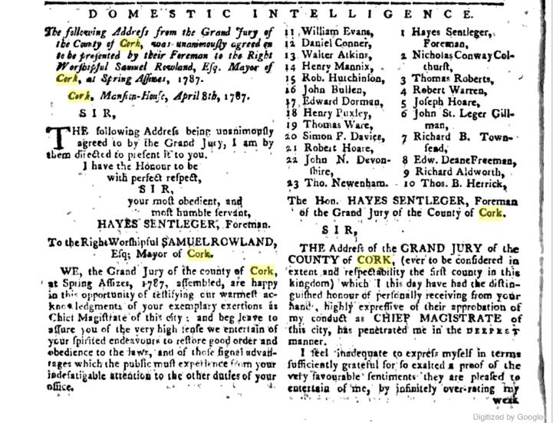

…

….
Burgh Rt. Hon. Walter Hussey Lord Chief Baron. (1783) 1/4/1783 Freedom.

…

Cork Summer Assizes, 1785 | John Pedder | P. Allen | Frauds Cray | Richard Longfield
William Hann | Francis Rowland | Christopher John Harding | William Cormack | William Lumley
Henry Shears | William Coles | B. Hayes | Samuel Rowland | Edmund Regan
Benjamin.. | ? | ? | ? | ?
…

Cork Grand Jury Autumn 1785 | William Hare | Rowland Marm Peacock | John Christopher Waggett | Henry Shears | Rowland
Bonsfield | Edmund Regan | Christopher Allen | Peter Carey | John Lapp | Rowland Morrison
Richard.. | To be verified

….

….

……

……

….

….

1790 APRIL 1 1790 - [Advertisement] - TRUE BLUE TAVERN – BARKER’S ROOMS In Brown-street, open during the Assizes as usual.

….

….

Cork Grand Jury, Spring Assizes, 1792 | Francis Busteed | John Erskine | Edward Allen | John Travers, Cork
Richard Lawton | John Barry | Rowland Smyth | Edward Deane Freeman | Robert Uniacke
Morgan Donovan | Abraham Richard Meade | To Be Verified

….

1793: Lord Chief Baron Yelverton, Baron Hamilton, Serjeant Chatterton.

…

……

….
1 Sep., 1793. That the Rt. Hon. Thos. Kelly, one of the.Justices of the C. P., and Justice of Assize, be presented with his freedom in a Silver Box; also the Hon. Will. Downes, one of the Justices of K. B., and Justice of Assize, in a Silver Box

…..

….

Spring Assizes 1807

Spring Assizes, County of the City of Cork, King's Old Castle | Foreman, Honourable Abraham Hely Hutchinson | Rowland Morrison | M. R. Westropp | Charles Evanson
John Foster | Thomas Gibbings | Robert Harding | John Cuthbert Junior | Abraham Lane
Christopher Cole | R. Neville Parker | Richard Maguire | Joseph Leycester | G.C. Jeffereys
Charles H. Leslie | Samuel R. Perry | Stephen Roche | Edward Jameson | Thomas Rochford
J. Fuller Harnett | Daniel Lane | Daniel Callaghan | Edward Pope

Summer Assizes 1807

1807 Summer Assizes, County of the City of Cork | Foreman, Richard Longfield | George Waters | M. R. Westropp | Henry Bagnall
John Foster | Thomas Gibbings | Strettle Jackson | John Cuthbert | James Lane
John Cole | T. Dunscombe | William Busteed | John Dennis | G.C. Jeffereys
Charles H. Leslie | Thomas Cuthbert | William A. Kellet | William R. Hare | William Roberts
Daniel Goold | Henry Hewett | Thomas Harding | George Waggett | Anthony Perrier

…..

…

1809 Record Jury, Cork City Summer Assizes.
Foreman, John Cotter Junior.
….

…..

…..

1815 Grand Jury Co. Cork, 23 in Number | Charles Henry Leslie, Foreman | George Henry Jeffreys | William H. M. Hodder
Charles Evanson | John Forster | William Lumley | Thomas Gibbings
John Nicholas Wrixon | Richard Lane | Sir Anthony Perrier | Joseph Garde
Henry Bagnell, The Younger | Thomas Deane | Thomas Cuthbert | William Beamish
Stephen Roche | Simon Dring | William Wise | Thomas Sarsfield
Richard B. Shears | Edward Creed | Thomas Parsons Boland | Gerard Callaghan

…..

1817 August Baron Smith.

…

…..
1821 Spring Assizes

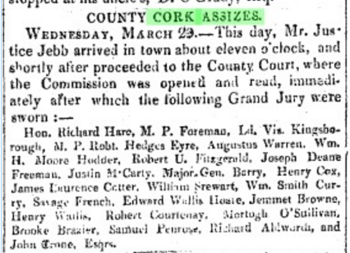

‘’’

‘’’’
Cork County October Assizes 1821
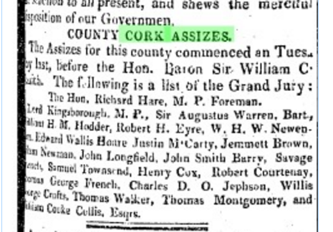

….
…

….

…
1823, Court of Special Sessions under Insurrection Act

County sessions resumed under Assistant Barrister Following sworn onto Grand Jury, Cornelius O’Callaghan, Joseph Austen, John Parker, Thomas Parker Parker, William Sheehy, Richard Hoare Junior, William Blearby, Wiliam Lysaght, William Travers, James Davies, John Pratt, Richard Ashe, Robert Warren Senior, James Wide, Richard Coppinger, John Byrne, Corliss Hawkes, Robert Martin, Philip Donovan, Richard Donovan, Shaw Busteed, Abel Orpen.
…

…
1823 Spring Assizes, Hon Justice Burton, Baron Pennyfeather, Registers Samuel S. Reeves and Samuel Delap Esq.

….

...
1825 Spring. Special Commission
….
….
1826 Spring Assizes Baron Pennyfeather (County), Justice Torrens (City),
1828, Lent Assizes Justices Vandeleur and Torrens Registrars: John Lambert and Andrew Torrens Esqs.,
1829 Baron Pennyfeather, Judge Torrens, Registrars Andrew Esq., Samuel Delap Esq., 1829 City Assizes August Lord Chief Baron O'Grady

…..
1830 Spring County and City Assizes

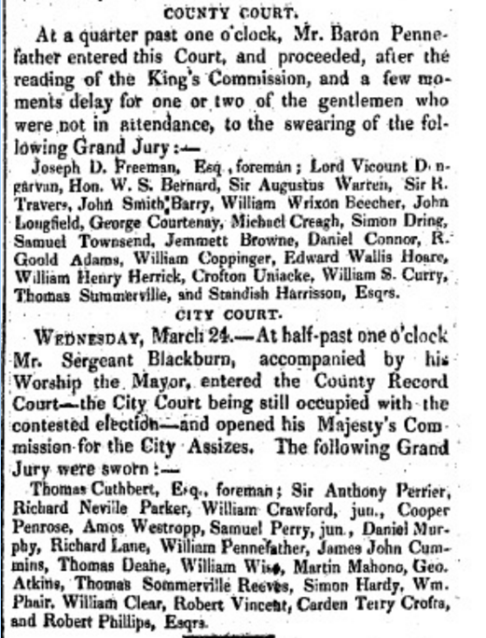
‘

…
1830 Doneraile Conspiracy Case Jury

…

..

….

…
1837 County Record Grand Jury:
Sir William W Beecher Bart., Ballygiblin, Robert McCarthy Esq., Carrignavar, George Bruce, Milltown Castle, William Harrington Junior, Crosshaven Cottage, Daniel O'Callaghan Cahirduggan, Benjamin Bousfield Creagh, Doneraile, Sampson French, Cosquinn, Henry Brazier Mitchell, Mitchelsfort, Henry Herrick, Farrenlough, Innishannon, Charles Connell, Cloverhill, Henry Cole Bowen, (Elizabeth Bowen family) Bowens Court, Francis Woodley, Deelish, Richard H Gumbleton, Curryglass, George Daunt, Newborough, St. Augustus Clerke, Overton (Bandon), Thomas Hungerford, Somers Payne, (Land Agent for Lord Bantry among others) Upton (up to recently the property of Rosminian Fathers), Thomas Somerville, Drishane (Skibbereen), Pierce Power Clonmult, Jonas Travers, Butlerstown, Achilles Daunt, Kinsale, Edward Supple, Kinsale, Thomas Knowley, Killeagh, Bartholomew Barry, Kilbolane House, Adderley Beamish, Kilcolman, Samuel P. Townsend, Palace Town, Richard Hill, Doneraile, John Molony, (Possibly Surveying family) Ballinaboy, William Cooke Collis Junior, Castle Cook, John O'Sullivan, Coumatringane (Beara), John Hawkes, Kilcrea, John Leader Junior, Keale, Edward Bedha Thornhill, Castle Kevin, John Nason Junior, Newtown, Simon Davis Crook, Oldtown, Philip Harding, Firgrove (Macroom), Henry Baldwin, Mount Pleasant (Bandon), George Cooper Stawell, (Old Kinsale Family) Old Court, William Barry, Charleville, Thomas Lloyd Williamson, Castleview, Arthur Gethin Creagh, Ballyellis, Richard Donovan, Lisheens (Either Skibbereen or Ballincollig), Joseph Coughlan, (Family originally from Carrigmanus Protestant from 1600 allied to Hulls and Boyle) Ballygarvan, Timothy O'Donovan, O'Donovan's Cove, Durrus, Benjamin Sweete, Grenville, Herbert Gillman, Bennett's Grove, Cornelius O'Brien, Kilcur, Samuel Townsend, Whitehall (Skibbereen), Standish Harrison, Castle Harrison, John Allen, Glandore, Jonas Morris Townsend, Shepperton (Skibbereen).

…

….
1839 County Cork Record Jury. Summer Assizes.

Sir William Abraham Chatterton, Castlemahon, Cork,Thomas Hungerford, Cahirmore, Clonakilty, Thomas Somerville, Drishane, Skibbereen, Edward Townsend, Whitehall, Skibbereen, Standish Harrison Castle Harrison, Charleville, Daniel Connor, Manch, Dunmanway, Thomas Perrott, Fermoy, James Joseph Roche, Aghada House, Midleton, Henry M. Mitchell, Mitchelsfort, Watergrasshill, Charles Connell, Cloverhill, Blackrock, Cork, Samuel P. Townsend, Garrycloyne, Watergrasshill, Edward J. Morrogh, Glanmire House, Charles Colthurst, Clonmoyle, Coachford, St. John A. Clarke, Overton, Bandon, Henry Cole Bowen, Bowen’s Court, Doneraile, Jeremiah Eugene McCarthy, Cork, Denis O’Callaghan, Cahirduggan, Midleton, John McCarthy O’Leary, Millstreet, William Cooke Collis Junior, Castlecook, KIlworth, Timothy O’Donovan, O’Donovan’s Cove, Durrus, Henry Leader, Mount Leader, Charleville, Pierce Power, Clonmult, Fermoy, herbert Gillman, Bennetts Grove, Clonakilty, Benjamin Sweet, Greenville, Bandon, George Bruce, Milltown Castle, Charleville, William MInhear, Raleigh, Macroom, William Harrington junior, Crosshaven, William Brown, Coolcower, Macroom, Jonas Travers, Butlers town, Gerard Barry, Ballinahina, Cork, John Molony, Ballinaboy, Ballinhassig, George Cooper Stawell, Oldcourt, Bandon, Edward Barrett, Carrigbuee, Macroom, Simon Cook, Oldtown, Henry Baldwin, Mount Pleasant, Bandon, John O’Sullivan, Coomatringane, Castletownbere, Benjamin B. Creagh, Doneraile, Edward Supple, Kinsale, John Leade, Junior, Keale, Millstreet, Richard Donovan, Lisheens, Henry Herrick Woodlands, Bandon, Philip Harding, Firville, Macroom, Thomas Lloyd Williamson, Castleview, Fermoy, William Barry, Charleville, John Nason Newtown, Fermoy, Jonas Morris Townsend, Shepperton, Skibbereen, Christopher Crofts, Ballyhoura, John Howe, Glanavirane, Kinsale, Patrick Coleman, KInsale, Edward Purcell Junior, Bawnishal?,

...

…..

Bantry, West Cork, Quarter Sessions, February 1842.

Chaired by Mr. Moody, Assistant Barrister, East Riding, Magistrates, Mr. Little Resident Magistrate, Dr. Gillman, Richard White (Lord Bantry family), Michael Warren, Alexander O'Driscoll (Middle Man, Caheragh, married to Miss Evans, Lissangle). Juries: William Lannin (Possibly later Master Workhouse may be from Dromreague), Elias Roycroft (Rooska), William Roycroft, Robert Warren, Samuel Daly, George Vickery, Edward Barry, Michael Sullivan (Possibly Tedagh), John Warner, Cornelius O'Leary, Alexander O'Donovan Possibly Clerk Petty Sessions), Robert Vickery, Daniel Sullivan, George O'Connor (Landowner Bantry/Skibbereen), Thomas Dukelow (Durrus possibly Clashadoo), Michael Sullivan, Thomas Kingston, Michael Foley, Jeremiah Sullivan, T Williamson (Durrus), James Sullivan, Thomas Vickery.
….

….

County of Cork Record Jury, Summer Assizes 1843, All Jurors Esq. | Sir William Abraham Chatterton, Bart, Castlemahon, Blackrock, Cork | Samuel Allen, Midleton | Henry Allen, Cloyne House | John Thomas Atkins, Ledington, Youghal | John Harold Barry, Ballyvorane, Mallow
Henry Standish Barry, Reencoulig, Midleton? | William G. Browne, Coolcower, Macroom | Gerard Barry, Ballinahina, Fermoy | Michael Alleyn Becher, Ballydivane, Clonakilty |  | Henry Barry, Barry’s Lodge, Midleton
Henry Baldwin, Mount Pleasant, Bandon | James Bouge, Laragh, Bandon | Thomas Crofts, Velvetstown, Buttevant | Hatton Couran, Grange | Alfred Callaghan, New Castle, Limerick? | Patrick Coleman, Kinsale
Richard Donovan, Lisheens, Ballincollig | Thomas Garde Durdin, Shanagarry | Ralph Evans, Carker, Doneraile | Sampson Twogood French, Cusquinny, Cobh | Henry Baldwin Foot, Carrigacunna, Mallow | James Foott, Springfort, Mallow
Richard Fitzgerald, Muckridge House | William Hume Franks, Carrig, Mallow | William Fagan, Feltrim | Walter Giles, Frogmore, Youghal | Michael Gallwey, Gurtnascreena, Skibbereen | Thomas Gollock, Leemoun, Cork
Thomas Murdoch Green, Ahadoe | Richard Gumbleton, Castleview | William Hennessy, Fortwilliam, Doneraile | Standish Harrison, Castle Harrison, Buttevant | Edward Heard, Ballintubber, Kinsale | Thomas Knowles, Oatlands, KInsale
Thomas Limrick, Union Hall, Thomas Hingston Limrick who was the rate collector for the Skibbereen Union a few years later. One of Col. Limrick's four sons.  Started badly in life by being committed for burglary and robbery aged 14 in 1831 (as noted in Irish Prison Registers 1790-1924). | William Henry Lysaght, Clogheen | William Leader, Nashville, Kanturk | Henry B. Mitchell, Mitchelsfort, Watergrasshill | Edward Morrogh, Glanmire | Michael Murphy, Newtown, Bantry
Denis McCartie, Woodview | Arthur Norcott, Park, Doneraile | James Murphy Junior, Midleton | Patrick O’Sullivan, Millcove, Castletownbere | Robert J. O’Donoghue, Killanerdrish, Macroom | Timothy O’Donovan, O’Donovan’s Cove, Durrus
John O’Sullivan, Keamatringane, Castletownbere | Abraham Morris Oliver, Tourmore, Goleeen? | Cornelius O’Callaghan, Brookville, Cork | Pierce Power, Clonmult, Midleton | Jasper Pyne  Ballyvolane, Fermoy | James Joseph Roche, Ahada House, Midleton
Philip Sarsfield, Ducloyne, Togher, Cork | George Cooper Stawell, Old Court, KInsale | Joseph Luke Shea, Rennies, Kinsale | Richard Welstead, Ballywalter, Mallow | Probably at least 15 Catholics out of 57

…

….
1862 Quarter Sessions Bantry.

In Lord Carbery’s 1830 pamphlet he says there were two primary Assizes supplemented with six in each of the two Cork County Ridings West and East. This is one of them where criminal as well as presentment business was done.

Bantry, West Cork, Quarter Sessions July 1862 Chaired by Robert Johnstone Esq., Chairman, Magistrates: J H Townsend, F Davies Resident Magistrate, F Bennett, R. H. Notter (Crookhaven), J. W.Payne (Land Agent), William Beamish Baldwin, George Robinson (Possibly Skibbereen Landlord). Jurors: Patrick O'Sullivan (Foreman), Daniel McCarthy, C. and H. Thomas (Possibly Mines), Alexander Blair (Blair's Cove, Coolculaghta, Durrus, The Cottage, Schull, Landlord), Samuel Baily, Daniel O'Conner, (Possibly Landlord, Bantry), William Young (Merchant), William Jagoe (Merchant), Richard Hungerford Evanson (Ardgoena, Durrus, Landlord), George Swanton (Possibly Fortlodge, Ballydehob), William Bennett, Thomas T Curtayne, Denis W Murphy, Cornelius O'Leary, William Tisdall (Donemark), Stephen Browne, William Ross (Possibly Drimoleague), John Ross, Timothy Downing, Samuel Jagoe, William Morris (Friendly Cove, Durrus, Landlord), T. D. Notter (Crookhaven, Landlord).

…..

Grand Jury Cork Spring Assizes, 1863. The High Sheriff, Thomas Somerville, Drishane Esq., Foreman The Right Honourable Henry Boyle Bernard Esq., Coolmaine Castle, Bandon, M.P., Sir George Conway, Colhurst, Ardum, Bart., Richard Oliver Aldworth, Newmarket House, Esq., Mountifort Longfield, Castlemartyr, Esq., Nicholas Dunscomb, Mountdesert, Esq., Thomas St. John Conat.,, Kilmurray House, Esq., Henry John Townsend, Castletownsend, Esq., Robert Heard, Kinsale, Esq, Thomas French Simpson, William S Meade, Ballymartle, Esq., Edward Daly., Kinsale, Esq., Thomas Parsons Belaird, Pembroke, Esq., Timothy O’Donovan, O’Donovan’s Cove, Durrus Esq., Horace Townsend, Derry, Esq., George B Treselian?, Bandon, Esq., Freeman Crofts, Cloughfadda House, Blarney, Esq., Thomas Leahy, South Terrace, Esq., William B Leslie, Lislee, Esq., Henry Hardy, Firmount?, Esq., John William Payne, Beach House, Bantry, Esq., Jonathan Bruce, Milltown Castle, Esq., Maxwell Gumbelton, Kilmaturin Esq.
.

….

…..
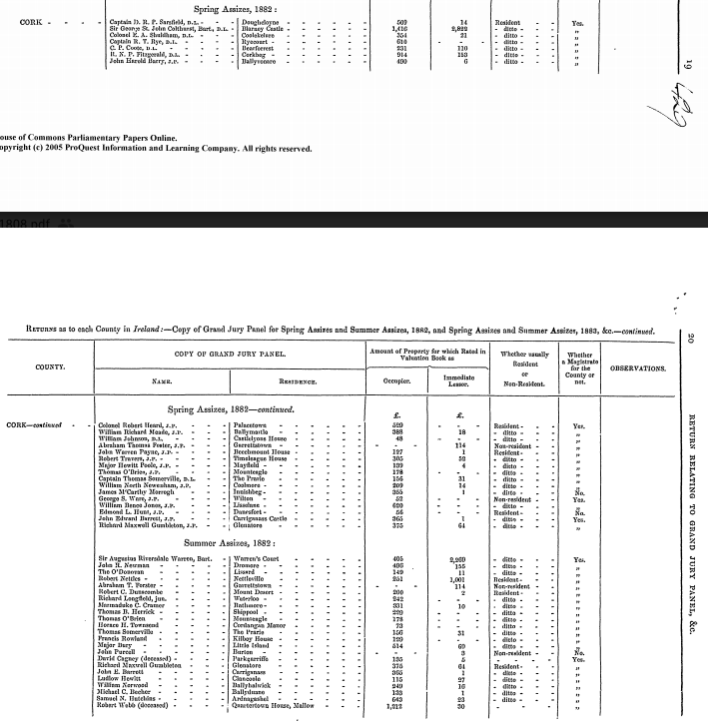
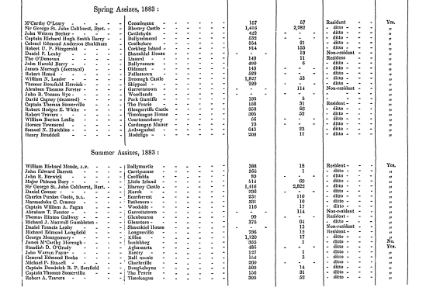
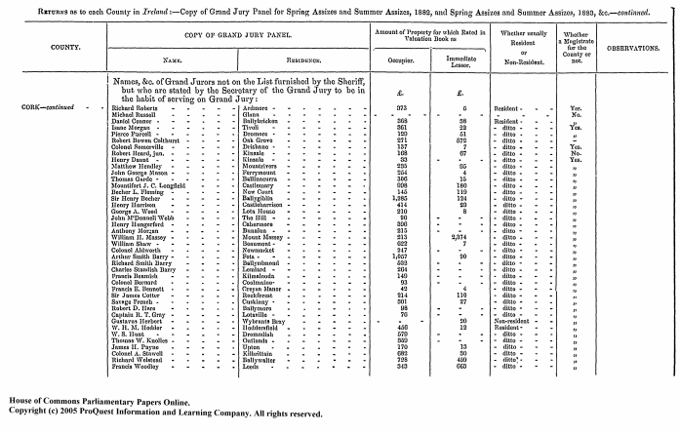

…
1867, Complete Volume of Cork Grand Jury Presentments.

The Cork Archives has a complete volume of the 1887 presentments. By Barony it schedules all presentments approved, with the cost, and contractors .It also shows the allocation of expenditure in the County to appropriate hospitals, industrial schools. The structure and names of staff is given, together with salaries. Cleary Cork County Council which would come into existence in the period immediately after, is largely based on this structure.
…

1887 Complete Volume of Cork Grand Jury Presentments.

Bibliography:

Lord Carbery, 1830 Pamphlet on Cork Grand Jury:
https://books.google.ie/books?id=9esYAAAAYAAJ&pg=RA3-PA9&lpg=RA3-PA9&dq=cess+collectors+barony+of+west+carbery&source=bl&ots=BEbKSqUWwn&sig=AvXS6iDgqEYckX3wDEY6j-UvV5w&hl=en&sa=X&ved=0ahUKEwj_7qGslvvQAhXELsAKHSk9CGgQ6AEIVjAJ#v=onepage&q=cess%20collectors%20barony%20of%20west%20carbery&f=false

David Dickson, ‘Old World Colony Cork and South Munster 1630-1830’, Cork University Press, 2005

Brendan O Donoghue was formerly Secretary of the Department of the Environment and Director of the National Library and Chief Herald of Ireland. He is the author of In search of fame and fortune: the Leahy family of engineers, 1780–1888 (2006). (Leahy)

Peter O’Keeffe, Tom Simington revised by Rob Goodbody, ‘Irish Stone Bridges’, Irish Academic Press revised 2016 (Bridge)

Nolan, M.A. thesis entitled Grand Jury of County Cork, 1836-99. Dated 1974.

‘’’

‘’’’’

County of Cork Record Jury, Summer Assizes 1843, All Jurors Esq. | Sir William Abraham Chatterton, Bart, Castlemahon, Blackrock, Cork | Samuel Allen, Midleton | Henry Allen, Cloyne House | John Thomas Atkins, Ledington, Youghal | John Harold Barry, Ballyvorane, Mallow
Henry Standish Barry, Reencoulig, Midleton? | William G. Browne, Coolcower, Macroom | Gerard Barry, Ballinahina, Fermoy | Michael Alleyn Becher, Ballydivane, Clonakilty |  | Henry Barry, Barry’s Lodge, Midleton
Henry Baldwin, Mount Pleasant, Bandon | James Bouge, Laragh, Bandon | Thomas Crofts, Velvetstown, Buttevant | Hatton Couran, Grange | Alfred Callaghan, New Castle, Limerick? | Patrick Coleman, Kinsale
Richard Donovan, Lisheens, Ballincollig | Thomas Garde Durdin, Shanagarry | Ralph Evans, Carker, Doneraile | Sampson Twogood French, Cusquinny, Cobh | Henry Baldwin Foot, Carrigacunna, Mallow | James Foott, Springfort, Mallow
Richard Fitzgerald, Muckridge House | William Hume Franks, Carrig, mallow | William Fagan, Feltrim | Walter Giles, Frogmore, Youghal | Michael Gallwey, Gurtnascreena, Skibbereen | Thomas Golloc, Leemount, Cork
Thomas Murdoch Green, Ahadoe | Richard Gumbleton, Castleview | William Hennessy, Fortwilliam, Doneraile | Standish Harrison, Castle Harrison, Buttevant | Edward Heard, Ballintubber, Kinsale | Thomas Knowles, Oatlands, KInsale
Thomas Limrick, Union Hall | William Henry Lysaght, Clogheen | William Leader, Nashville, Kanturk | Henry B. Mitchell, Mitchelsfort, Watergrasshill | Edward Morrogh, Glanmire | Michael Murphy, Newtown, Bantry
Denis McCartie, Woodview | Arthur Norcott, Park, Doneraile | James Murphy Junior, Midleton | Patrick O’Sullivan, Millcove, Castletownbere | Robert J. O’Donoghue, Killanerdrish, Macroom | Timothy O’Donovan, O’Donovan’s Cove, Durrus
John O’Sullivan, Keamatringane, Castletownbere | Abraham Morris Oliver, Tourmore, Goleen? | Cornelius O’Callaghan, Brookville, Cork | Pierce Power, Clonmult, Midleton | Jasper Pyne  Ballyvolane, Fermoy | James Joseph Roche, Ahada House, Midleton
Philip Sarsfield, Ducloyne, Togher, Cork | George Cooper Stawell, Old Court, KInsale | Joseph Luke Shea, Rennies, Kinsale | Richard Welstead, Ballywalter, Mallow | Probably at least 15 Catholics out of 57

….

,.

Grand Jury Assizes….

…
1807, Cork Spring Assizes, King's Old Castle, 23 Jurors.
1807, Summer Assizes, King's Old Castle

…..

…..1883

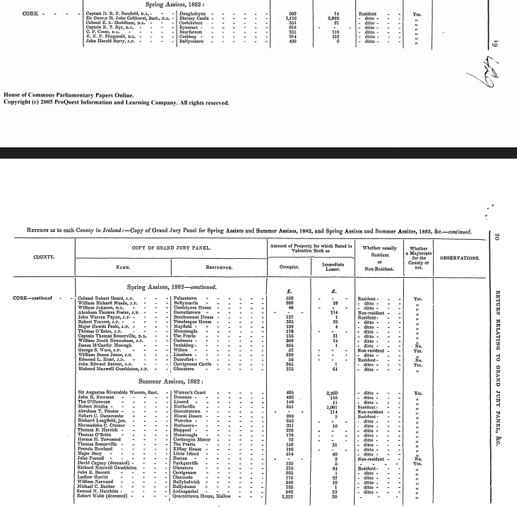
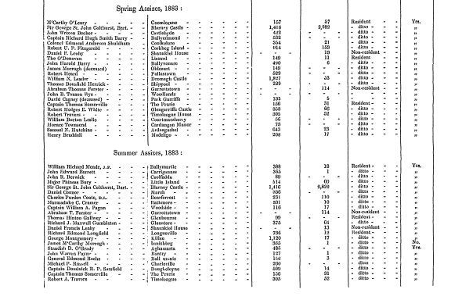
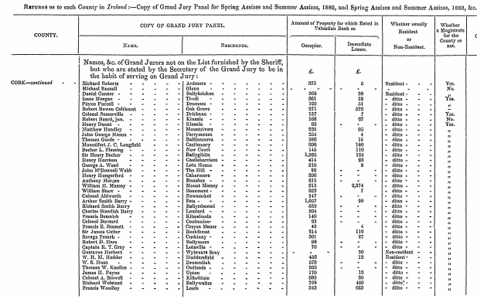
1

….

Irish Parliament Legislation re Roads and Bridges:

Early legislation is largely confined to the areas within the Pale and as english rule spread Cork and its environs are included in legislation. It is part of a pattern affecting other counties and there are periods of legislative activity followed by none.

18th century Legislation Database Irish parliament including unenacted Acts re Bridges, Roads:
http://www.qub.ac.uk/ild/?func=simple_search&search_type=name&search=true&search_string=1001&&session_from=1692&session_to=1800

1731 (5 George 2) s. 20. Repair of Road Cork City to Kilkenny Border.
1733 (7 George 2) s. 20. Repair of Road Cork City to Kilworth Mountain.
1739 (13 George 2) s. 15. Repair of Road Tipperary to Cork City.
1743 (17 George 2) s. 19. Road Limerick to Cork.
1755 (29 George 2) s. 19. Road Cork/Limerick/Kilkenny.
1755 (29 George 2) s. 20. Road Tipperary/Cork.
1761 (1 George 3) s. 19. Bridges in Cork.
1765 (5 George 3) s. 113. Roads Cork County.
1767 (7 George 3) s. 10. Roads in Cork/Kilkenny.
1773/4 (13, 14, George 3) s. 193, 14. Roads in Cork.
1779/80 (19, 20, George 3) s. 48 , 49, Roads in Cork.
1786 (25, George 3) Repair of Cork City Bridge.
1790 (30, George 3) s. 47, 14. Roads in Limerick/Cork.

1730 Cork Dublin Road Journey:

..
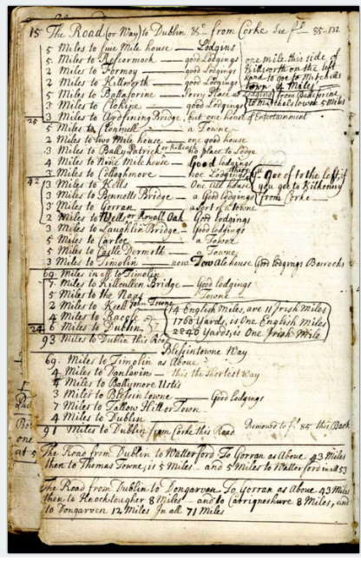

...Appendix

Presentment of the grand jury of Co. Cork of lands, tenements, services, etc. concealed in the said county, 1584. Presentment of lands held in capite in Co. Cork, 1584. Location London: Lambeth Palace Library, Ms. 617: (Extracts) Other The National Library of Ireland holds a microfilm copy (n.2800, p.1702).

The names of such as were in relation with the Earl of Desmond and what lands they held in Co. Cork, presented by a Grand Jury of Corke, 1The names of such as were in relation with the Earl of Desmond and what lands they held in Co. Cork, presented by a Grand Jury of Corke, 1584. Lambeth Palace Library, Ms. 627: (Extract). The National Library of Ireland holds a microfilm copy (n.2802, p.1704).

Grand Jury Valuation of the Barony of East Muskerry, 1889. Cork Archives Council, U.195 [Part]

Draft of petition by Philip Ronayne begging exemption from jury and assize service on grounds of age, with his certificate of exemption; Jan., 1752. National Library of Ireland, D. 25,858-9

Grove-White Mss. Copy jury list, Co. Cork, 1814. Extracts from a Book of Survey and Distribution for Co. Cork. Extracts from a 1659 census, Co. Cork. Extracts from O'Donovan letter-book and from Windele and Du Noyer Mss. in the Royal Irish Academy relating to Co. Cork. Public Record Office, M. 2637-9; 2641-2

Cork City Grand Jury, South Liberties Rate Collector's Summary Book c 1820, IE CCCA/SM797 Descriptive List Cork City and County Archives

Robert De la Coer, Treasurer Cork County Grand Jury 1825, proposals for reform:

https://books.google.ie/books?id=-jJbAAAAQAAJ&pg=PA90&lpg=PA90&dq=presentment+books+cork&source=bl&ots=acHxXzGlvc&sig=ua4p5my_KbP5Hd1k8fKm0h_SpJA&hl=en&sa=X&ved=0ahUKEwiGwunV5u_QAhVMK8AKHQ82CyY4ChDoAQg_MAk#v=onepage&q=presentment%20books%20cork&f=false

Appendix 1, Co. Louth Grand Jury Records 1896:

http://www.louthcoco.ie/en/Services/Archives/Online-Digital-Archives/GJ-5-37-Query-book-of-spring-summer-assizes-1896-1897.pdf

Appendix 2:

Presentment made at the General Assizes for Co.Cork that the ancient road and great highway from Clonturke, on the lands of Curknenagh to Tralee and Killarney ought to be repaired at the charge of the Barony of Duhallow. With depositions on the same. July 27, Sept. 9, 1676. Egmont Manuscripts.

Appendix 3

1592 Imposition of Cess.

COMPOSITIONS for CESSE and other IMPOSTS. MS 631 5 Aug-11 Oct 1592
These documents are held at Lambeth Palace Library, reference: MS 631
49 Pages.
Supplementary information: Calendar of the Carew Manuscripts preserved in the Archiepiscopal Library at Lambeth, ed. J. S. Brewer & W. Bullen (6 vols., 1867-73), vol. III, document 130.
Contents:
Articles indented betwixt the Queen’s Commissioners and the gentlemen, freeholders, and inhabitants of the country of Orrerie in co. Cork, touching a composition in lieu of cesse; at Cork, 17 September 1592.
Whereas her Majesty by letters patents dated at Dublin 12th July last, and by instructions annexed to the said commission, authorized the said Commissioners to deal with the lords and freeholders and all other possessioners in Munster for a composition in lieu of cesse, such as is in Connaught; the said freeholders and possessioners of Orrerie, acknowledging her Majesty’s care and great masses of treasure spent within this province for the suppression of the late traitor Desmond and his complices, have submitted willingly to a composition, and do by these presents offer her a yearly composition out of the said country of 20l. sterling for three years. And the said Commissioners promise and agree that the said inhabitants shall be exonerated of all cesse, and of all victualling of her Majesty’s army and garrison, and of all provision of the household and stable of the Lord Deputy, the Lord President, and Vice-Presidents, and of all provision of horsemen, soldiers, galloglas, horses, horseboys, and all other impositions, except in case of any invasion or sudden rebellion. This country or barony shall appoint a collector to receive the same, without fee.
Mem.–“The chargeable lands of Liskarroll, lands of Ballimckowa, Ballehustie, and Kilmclenye, if any part thereof be chargeable, is meant to be subject to the above composition.
Signed: Nicholas Barry alias McShian’s mark, James Lumbard, Eily Barry of Bregoge, P. H. Rirragus (?), John Chillister, John Miz of Lessfricken, James Byrn, Edward Nangle, Cornell Dalie, Rallaghan McOwen.
Mem.–The day and year above said, the gentlemen and freeholders of all Condons’ country have compounded with the Commissioners to pay 6l. yearly for three years.
Signed: Edmond Gangahe, Edmond Og Condon, Piers Gold, Patrick Condon, Richard Condon alias McMaoge, Fynne Monsloe, Walter Condon, William McEdmond Condon, Edmond McJohn Condon.
II. Similar Articles betwixt the Commissioners and the gentlemen, freeholders, and inhabitants of Kinnalea, at Cork, 15 September 1592, in public assembly of the whole county.
A yearly composition of 15l ster.
Signed: Thomas Longe, John Bostock, Henry Barries alias Barricok, Philip Golde, George Robinson, Walter Graunte, Leoffin Meade, E. M. D., Awlie O’Flime, James Sarsfield, Thomas Fleminge, Richard Roche, John Roold, William Cogan, David McShane, Edmond FitzMoris Roche, Edmond White, William Risserd, David FitzWilliam Roche, Piers Golde.
III. Articles betwixt the Commissioners and the freeholders, &c. of Ibaone, at Cork, 17 September 1592.
A yearly composition of 25l. ster.
Signed: Donoghe Oge, Teige O’Hee alias O’Hea, Edmond Arundell, James Hodwett.
IV. Articles betwixt the Commissioners and the freeholders, &c. of Carbrey, at Cork, 15 September 1592.
A yearly composition of 80l. ster.
Signed: Owen Carte, Phenen O’Driscoll, John Slewright, Connour McMahowne, Walter Graunt, Donell Solevan, Donogh Driscoll, Conour McO’Mahowne “de Lenton,” Donell Oge ne Carte, Donell McDermod McCarte, Dermod McTege O’Driscoll, Fana McDonell McCarte, Dermod O’Driscoll, Donell McDonogh McCarte, Donogh McCormocke McCarte, Tege McDermod McFeleme, Tege O’Crole alias Crowle, Tege McCartan alias Tege McMockle, Cormocke Oge McCarte, Phenen O’Driscoll, Davy O’Crole.
V. Articles indented betwixt the Queen’s Commissioners and the gentlemen, freeholders, and inhabitants of the lands of the sixteen toeghes in Connyloughe, charged with shraghe, marte, and other uncertain customs, at Limerick, 8 August 1592, in public assembly.
The said Commissioners having moved them to compound with her Majesty for the said shraughe, &c., all the said freeholders, &c. accepted of the same, and by way of composition do yield to her Majesty out of every quarter of land within the said sixteen toughes, in full satisfaction of all sraghe, marte, cesse, connye, livery, and other such charges, the yearly rent of 25s. ster. And although the said chargeable land was charged to the late Earl of Desmond in every toughe 40 marks and 20 beoffes clearly, besides coyne and livery and other uncertainties, yet in respect that the land wasted paid no portion of that charge during the waste, and no arrearages were at any time demanded, and that the said Earl when it was levied sometimes gave it back again, and that the said sixteen toughes are not yet fully peopled, by reason none dare inhabit the said land for fear of the great burden, the Commissioners do accept of the said offer and composition, to continue during her Majesty’s pleasure, and agree that the said freeholders, &c. shall be discharged of all sraghe, &c., and likewise of the provision of the Lord President, &c. The arrearages are deferred to further consideration.
Signed: Philip Suppell of Ballenetubbred, Thomas McEae (?), Doole McMulmurry, David Lacie, Richard Wale, James Lacie FitzDavid, Patrick Lalor, Morys Cooswill, McHenry, Carhill McGerrott, John FitzThomas McPhillipp, Gerrott Liston, James Nashe, William Oge England, David Barrie, Moriertaghe McMorghe, James Russell.
Supplementary information: Calendar of the Carew Manuscripts preserved in the Archiepiscopal Library at Lambeth, ed. J. S. Brewer & W. Bullen (6 vols., 1867-73), vol. III, document 130.
Contents:
Articles indented betwixt the Queen’s Commissioners and the gentlemen, freeholders, and inhabitants of the country of Orrerie in co. Cork, touching a composition in lieu of cesse; at Cork, 17 September 1592.
Whereas her Majesty by letters patents dated at Dublin 12th July last, and by instructions annexed to the said commission, authorized the said Commissioners to deal with the lords and freeholders and all other possessioners in Munster for a composition in lieu of cesse, such as is in Connaught; the said freeholders and possessioners of Orrerie, acknowledging her Majesty’s care and great masses of treasure spent within this province for the suppression of the late traitor Desmond and his complices, have submitted willingly to a composition, and do by these presents offer her a yearly composition out of the said country of 20l. sterling for three years. And the said Commissioners promise and agree that the said inhabitants shall be exonerated of all cesse, and of all victualling of her Majesty’s army and garrison, and of all provision of the household and stable of the Lord Deputy, the Lord President, and Vice-Presidents, and of all provision of horsemen, soldiers, galloglas, horses, horseboys, and all other impositions, except in case of any invasion or sudden rebellion. This country or barony shall appoint a collector to receive the same, without fee.
Mem.–“The chargeable lands of Liskarroll, lands of Ballimckowa, Ballehustie, and Kilmclenye, if any part thereof be chargeable, is meant to be subject to the above composition.
Signed: Nicholas Barry alias McShian’s mark, James Lumbard, Eily Barry of Bregoge, P. H. Rirragus (?), John Chillister, John Miz of Lessfricken, James Byrn, Edward Nangle, Cornell Dalie, Rallaghan McOwen.
Mem.–The day and year above said, the gentlemen and freeholders of all Condons’ country have compounded with the Commissioners to pay 6l. yearly for three years.
Signed: Edmond Gangahe, Edmond Og Condon, Piers Gold, Patrick Condon, Richard Condon alias McMaoge, Fynne Monsloe, Walter Condon, William McEdmond Condon, Edmond McJohn Condon.
II. Similar Articles betwixt the Commissioners and the gentlemen, freeholders, and inhabitants of Kinnalea, at Cork, 15 September 1592, in public assembly of the whole county.
A yearly composition of 15l ster.
Signed: Thomas Longe, John Bostock, Henry Barries alias Barricok, Philip Golde, George Robinson, Walter Graunte, Leoffin Meade, E. M. D., Awlie O’Flime, James Sarsfield, Thomas Fleminge, Richard Roche, John Roold, William Cogan, David McShane, Edmond FitzMoris Roche, Edmond White, William Risserd, David FitzWilliam Roche, Piers Golde.
III. Articles betwixt the Commissioners and the freeholders, &c. of Ibaone, at Cork, 17 September 1592.
A yearly composition of 25l. ster.
Signed: Donoghe Oge, Teige O’Hee alias O’Hea, Edmond Arundell, James Hodwett.
IV. Articles betwixt the Commissioners and the freeholders, &c. of Carbrey, at Cork, 15 September 1592.
A yearly composition of 80l. ster.
Signed: Owen Carte, Phenen O’Driscoll, John Slewright, Connour McMahowne, Walter Graunt, Donell Solevan, Donogh Driscoll, Conour McO’Mahowne “de Lenton,” Donell Oge ne Carte, Donell McDermod McCarte, Dermod McTege O’Driscoll, Fana McDonell McCarte, Dermod O’Driscoll, Donell McDonogh McCarte, Donogh McCormocke McCarte, Tege McDermod McFeleme, Tege O’Crole alias Crowle, Tege McCartan alias Tege McMockle, Cormocke Oge McCarte, Phenen O’Driscoll, Davy O’Crole.
V. Articles indented betwixt the Queen’s Commissioners and the gentlemen, freeholders, and inhabitants of the lands of the sixteen toeghes in Connyloughe, charged with shraghe, marte, and other uncertain customs, at Limerick, 8 August 1592, in public assembly.
The said Commissioners having moved them to compound with her Majesty for the said shraughe, &c., all the said freeholders, &c. accepted of the same, and by way of composition do yield to her Majesty out of every quarter of land within the said sixteen toughes, in full satisfaction of all sraghe, marte, cesse, connye, livery, and other such charges, the yearly rent of 25s. ster. And although the said chargeable land was charged to the late Earl of Desmond in every toughe 40 marks and 20 beoffes clearly, besides coyne and livery and other uncertainties, yet in respect that the land wasted paid no portion of that charge during the waste, and no arrearages were at any time demanded, and that the said Earl when it was levied sometimes gave it back again, and that the said sixteen toughes are not yet fully peopled, by reason none dare inhabit the said land for fear of the great burden, the Commissioners do accept of the said offer and composition, to continue during her Majesty’s pleasure, and agree that the said freeholders, &c. shall be discharged of all sraghe, &c., and likewise of the provision of the Lord President, &c. The arrearages are deferred to further consideration.
Signed: Philip Suppell of Ballenetubbred, Thomas McEae (?), Doole McMulmurry, David Lacie, Richard Wale, James Lacie FitzDavid, Patrick Lalor, Morys Cooswill, McHenry, Carhill McGerrott, John FitzThomas McPhillipp, Gerrott Liston, James Nashe, William Oge England, David Barrie, Moriertaghe McMorghe, James Russell.
…..
Grand Jury Map Co. Cork.

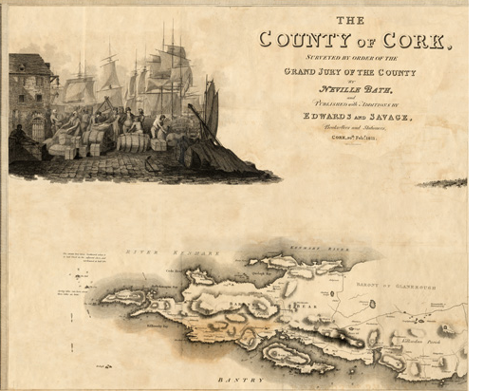....
..
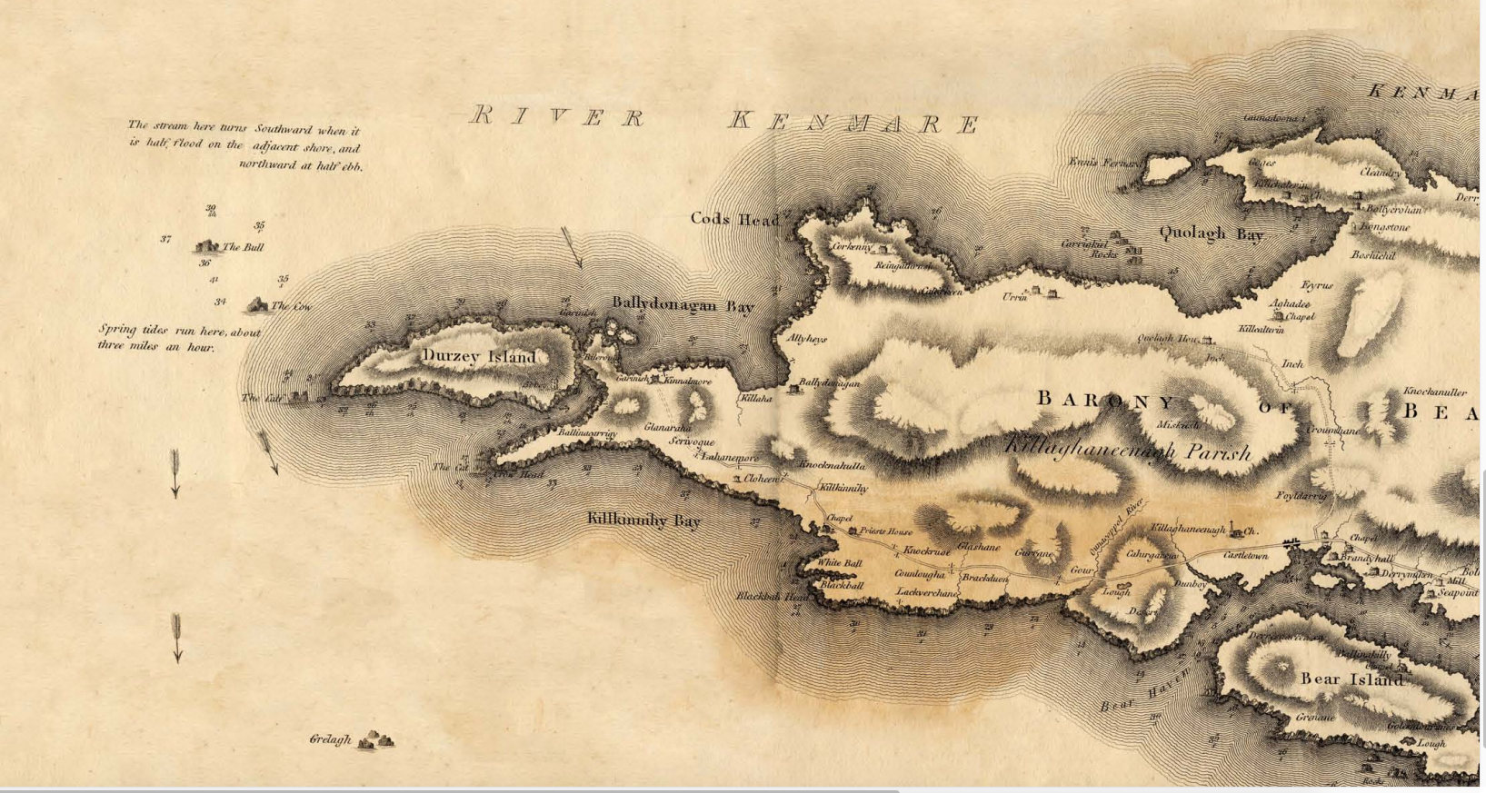
..
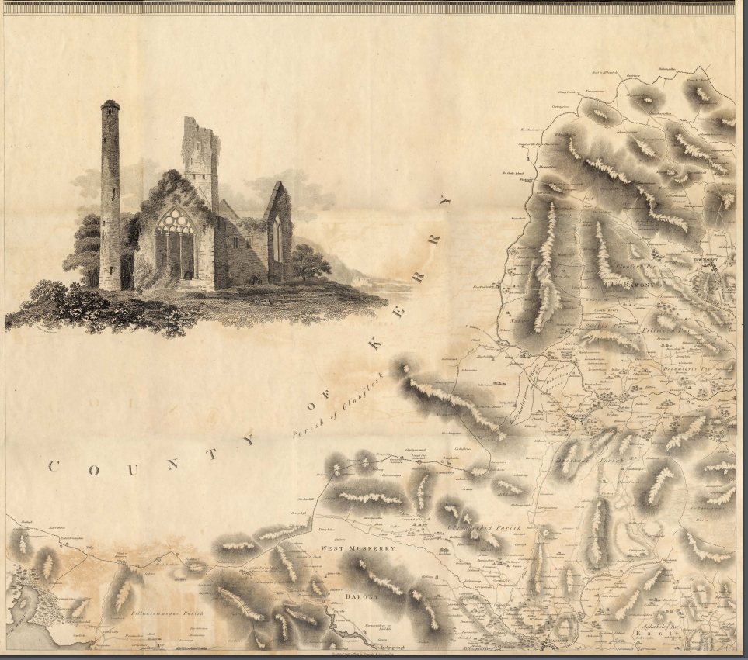
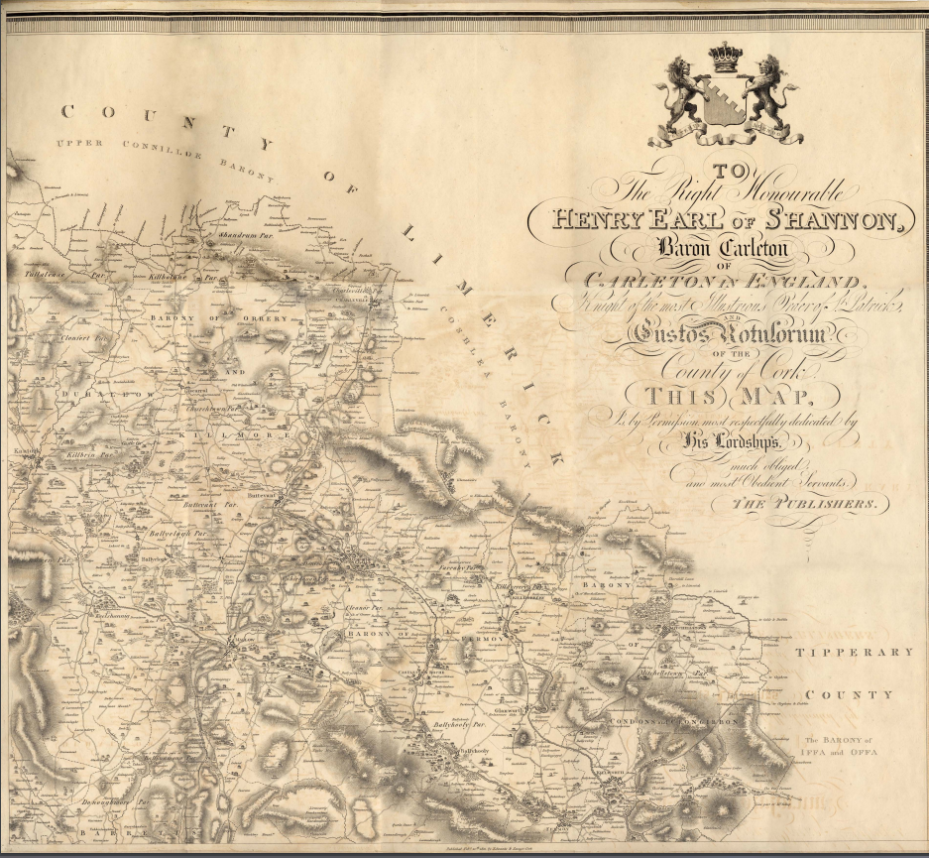

…
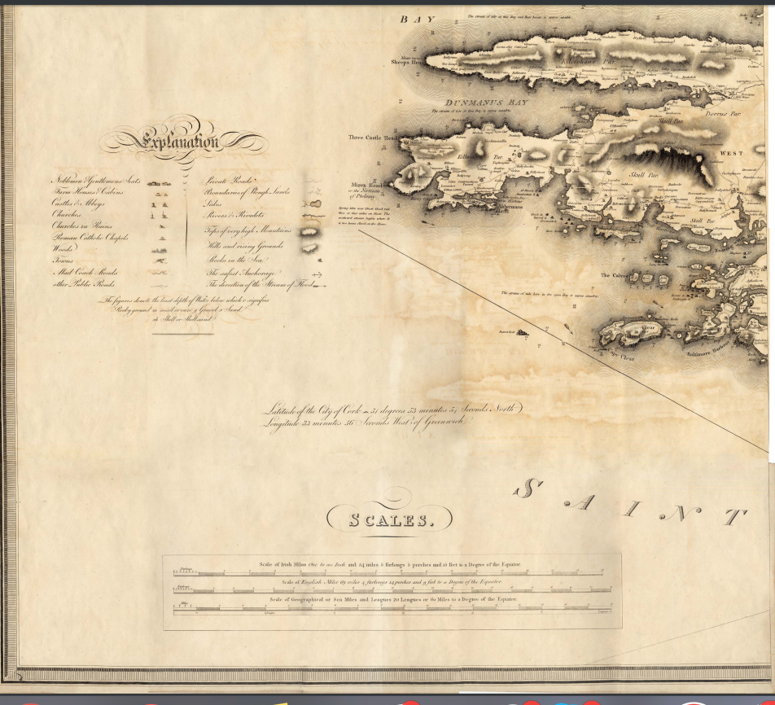
…
..
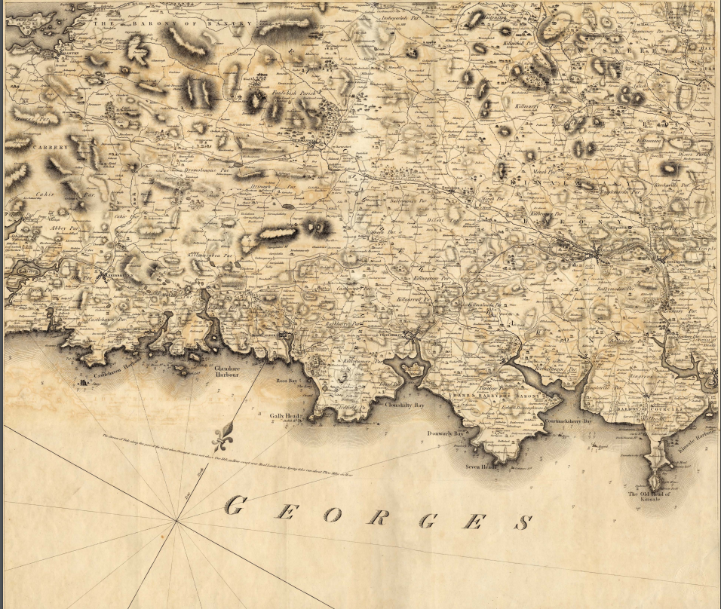
..

.
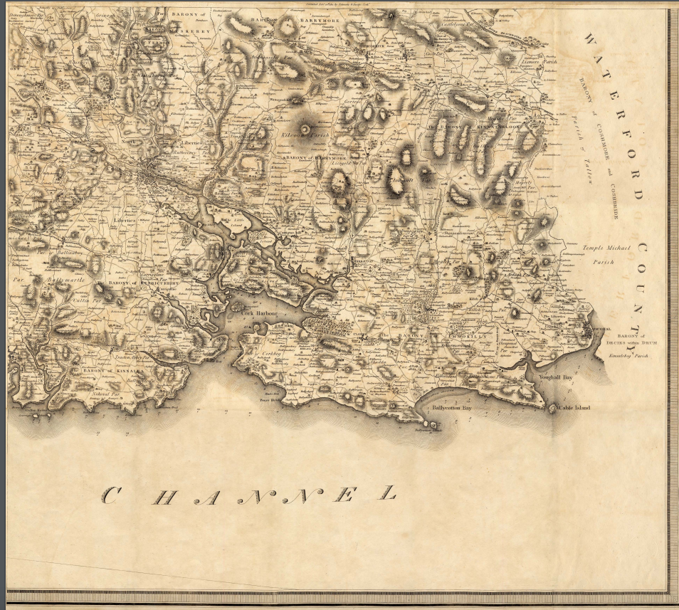
..
….

……

…..

…..

…..

…….

……

……

……..

…..
1695 City Grand Jury.

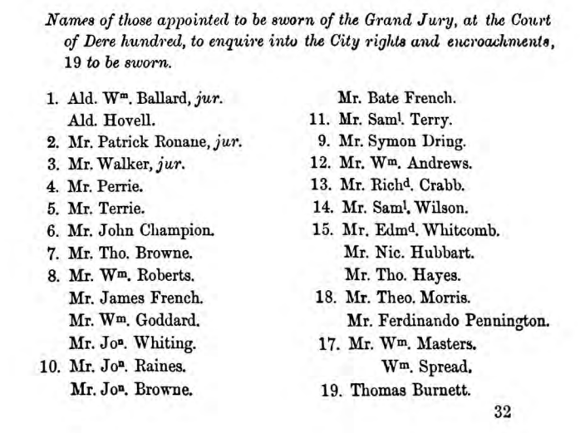

…..
Sample Presentment Book 1712 Co. Antrim

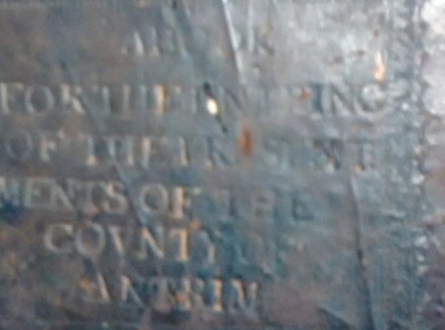
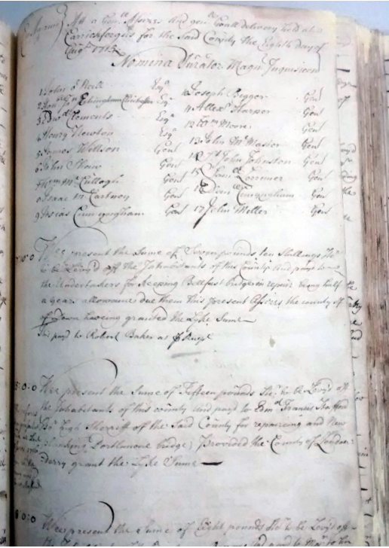
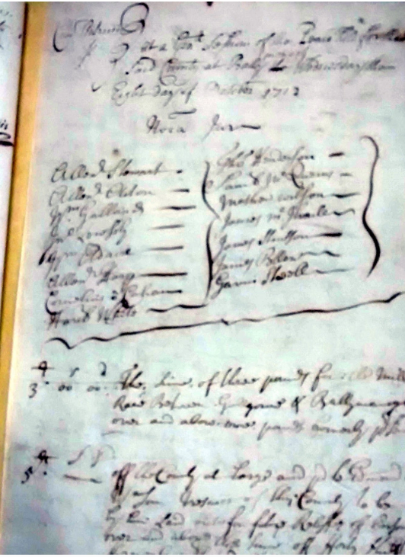

…..

…….

1807
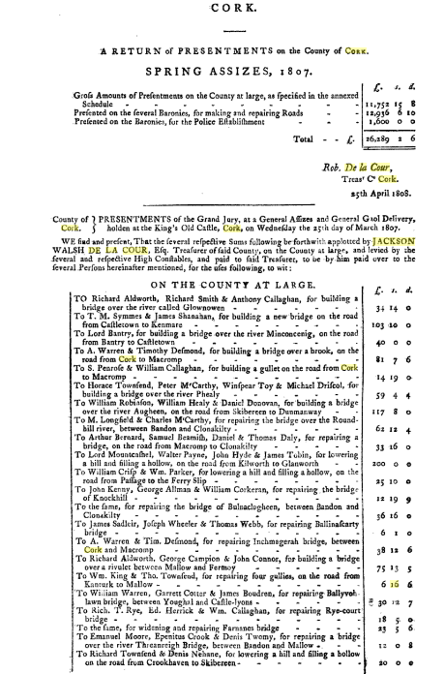
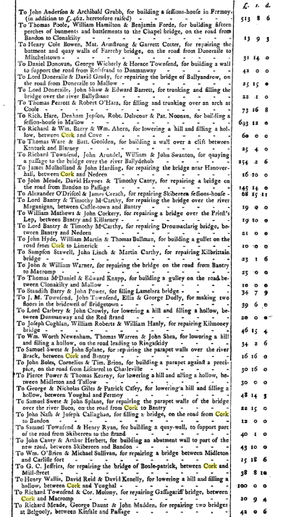
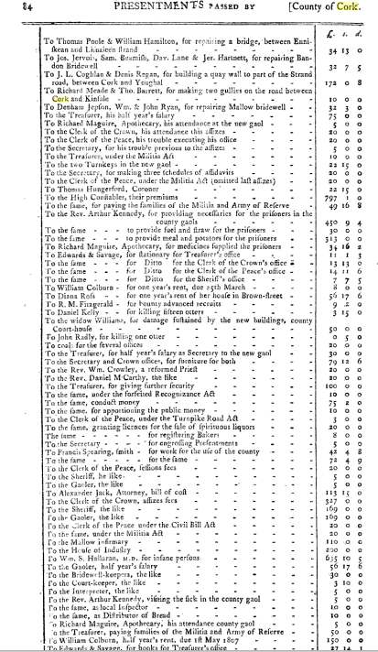
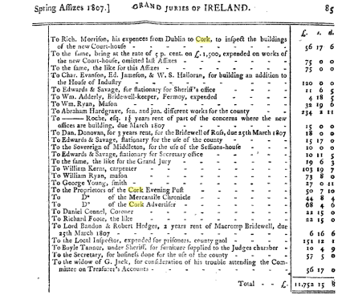
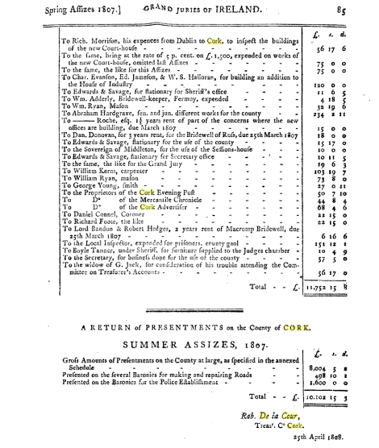
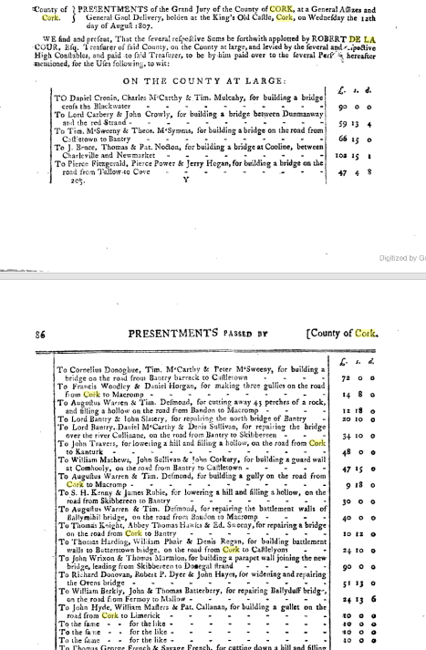
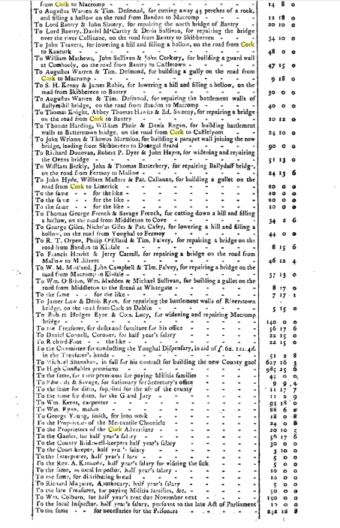
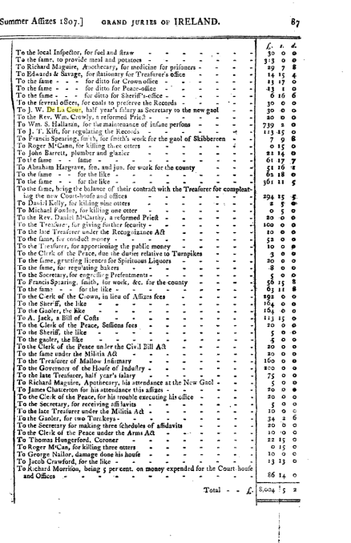
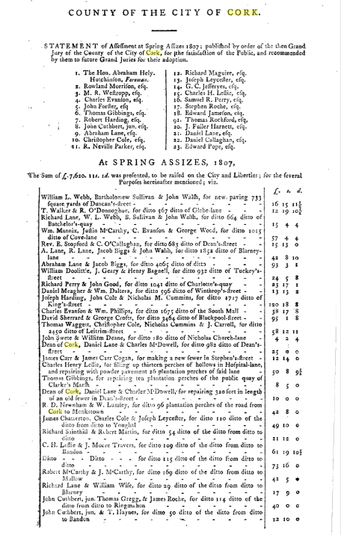
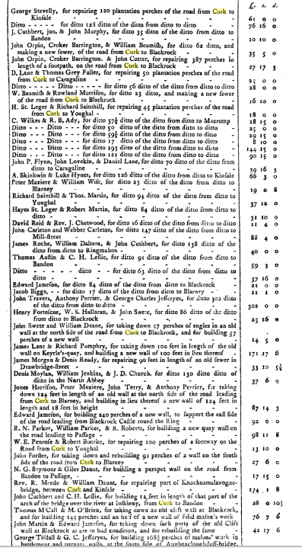
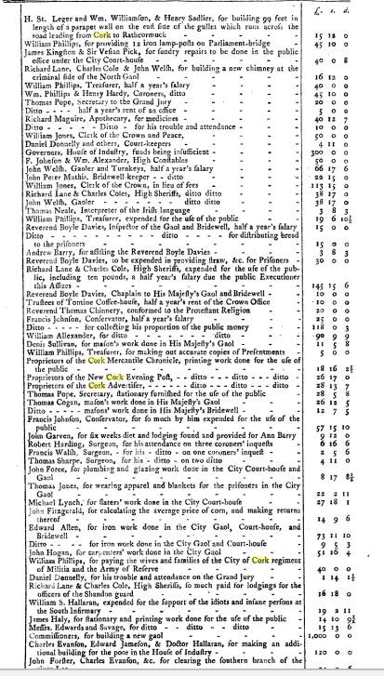
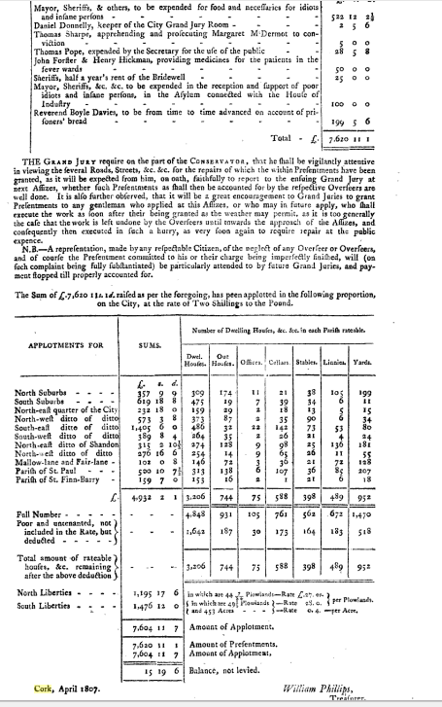
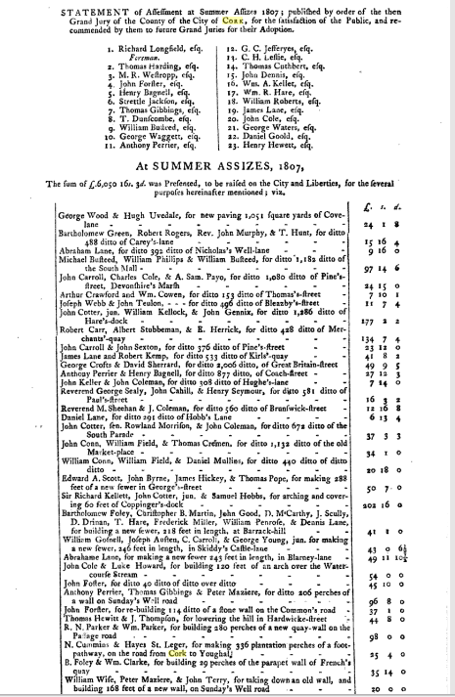
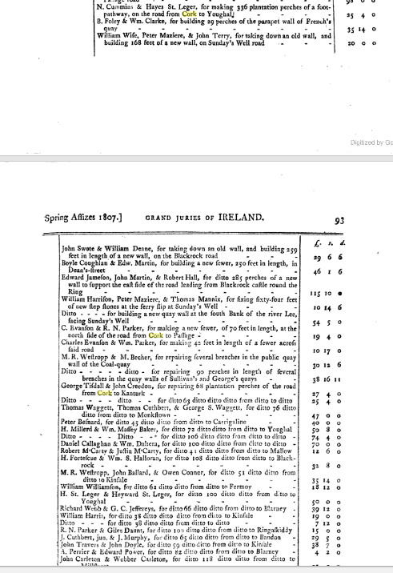
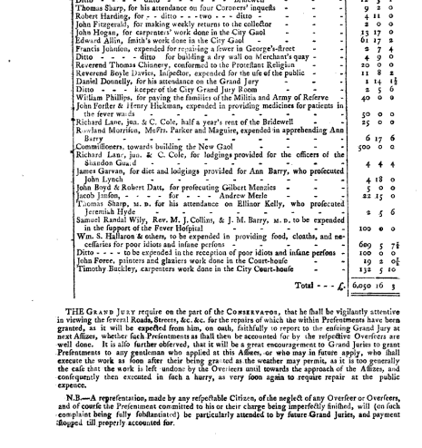
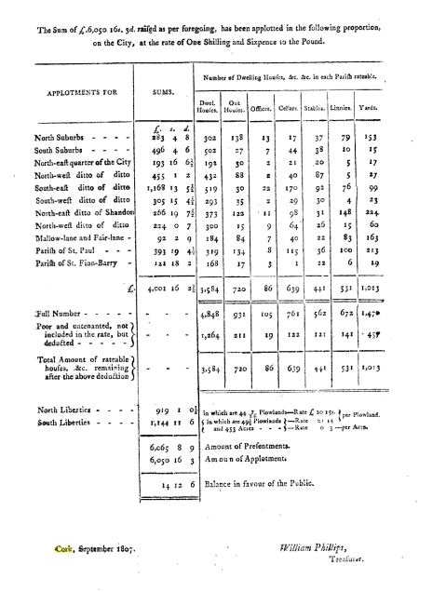

…..

..
Obtained Richard Caulfield prior to Courthouse Fire 1891, Now in Boole Library, UCC

U.83/1/23 Copy of a Schedule of the Several Affidavits to obtain
Presentations at Summer Assizes, 1818, [3 pages].
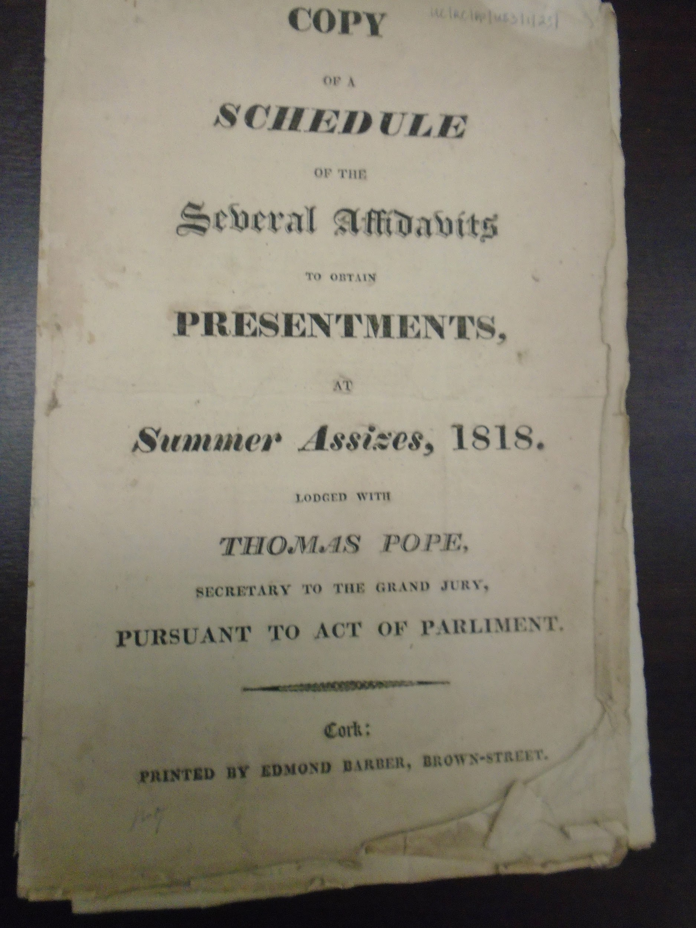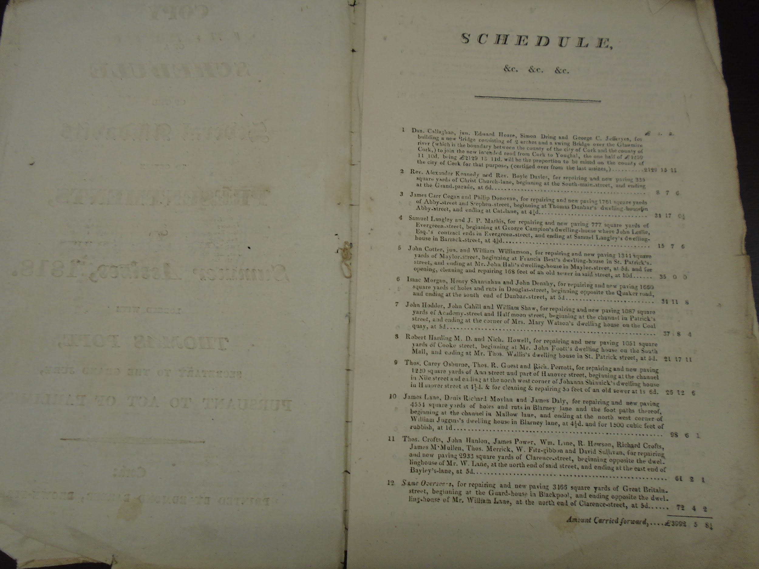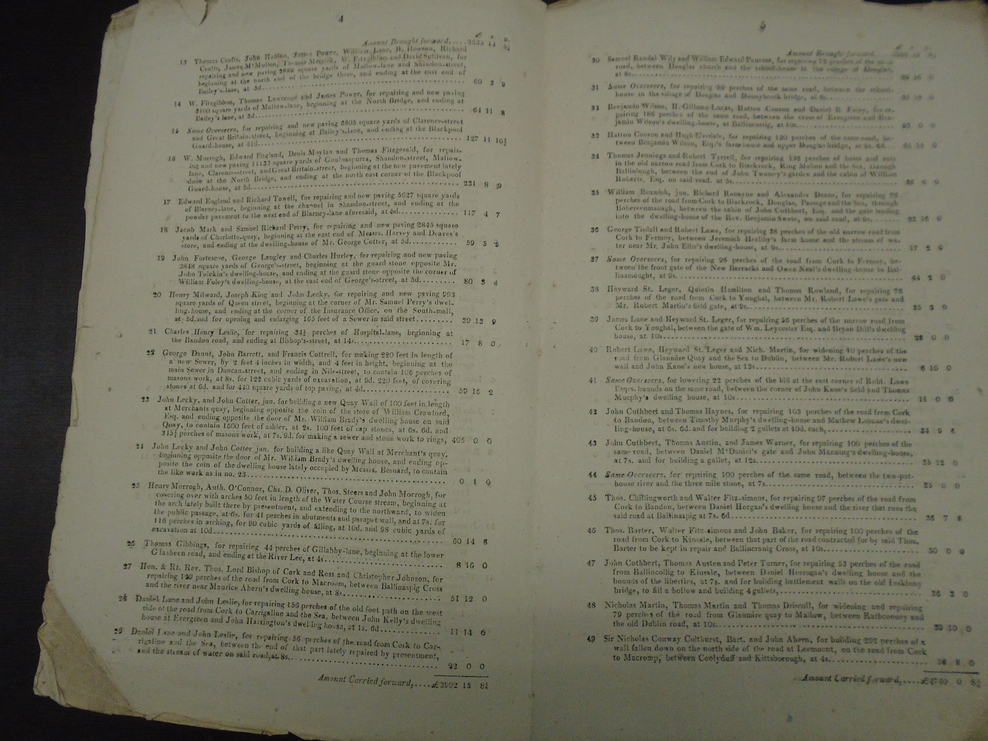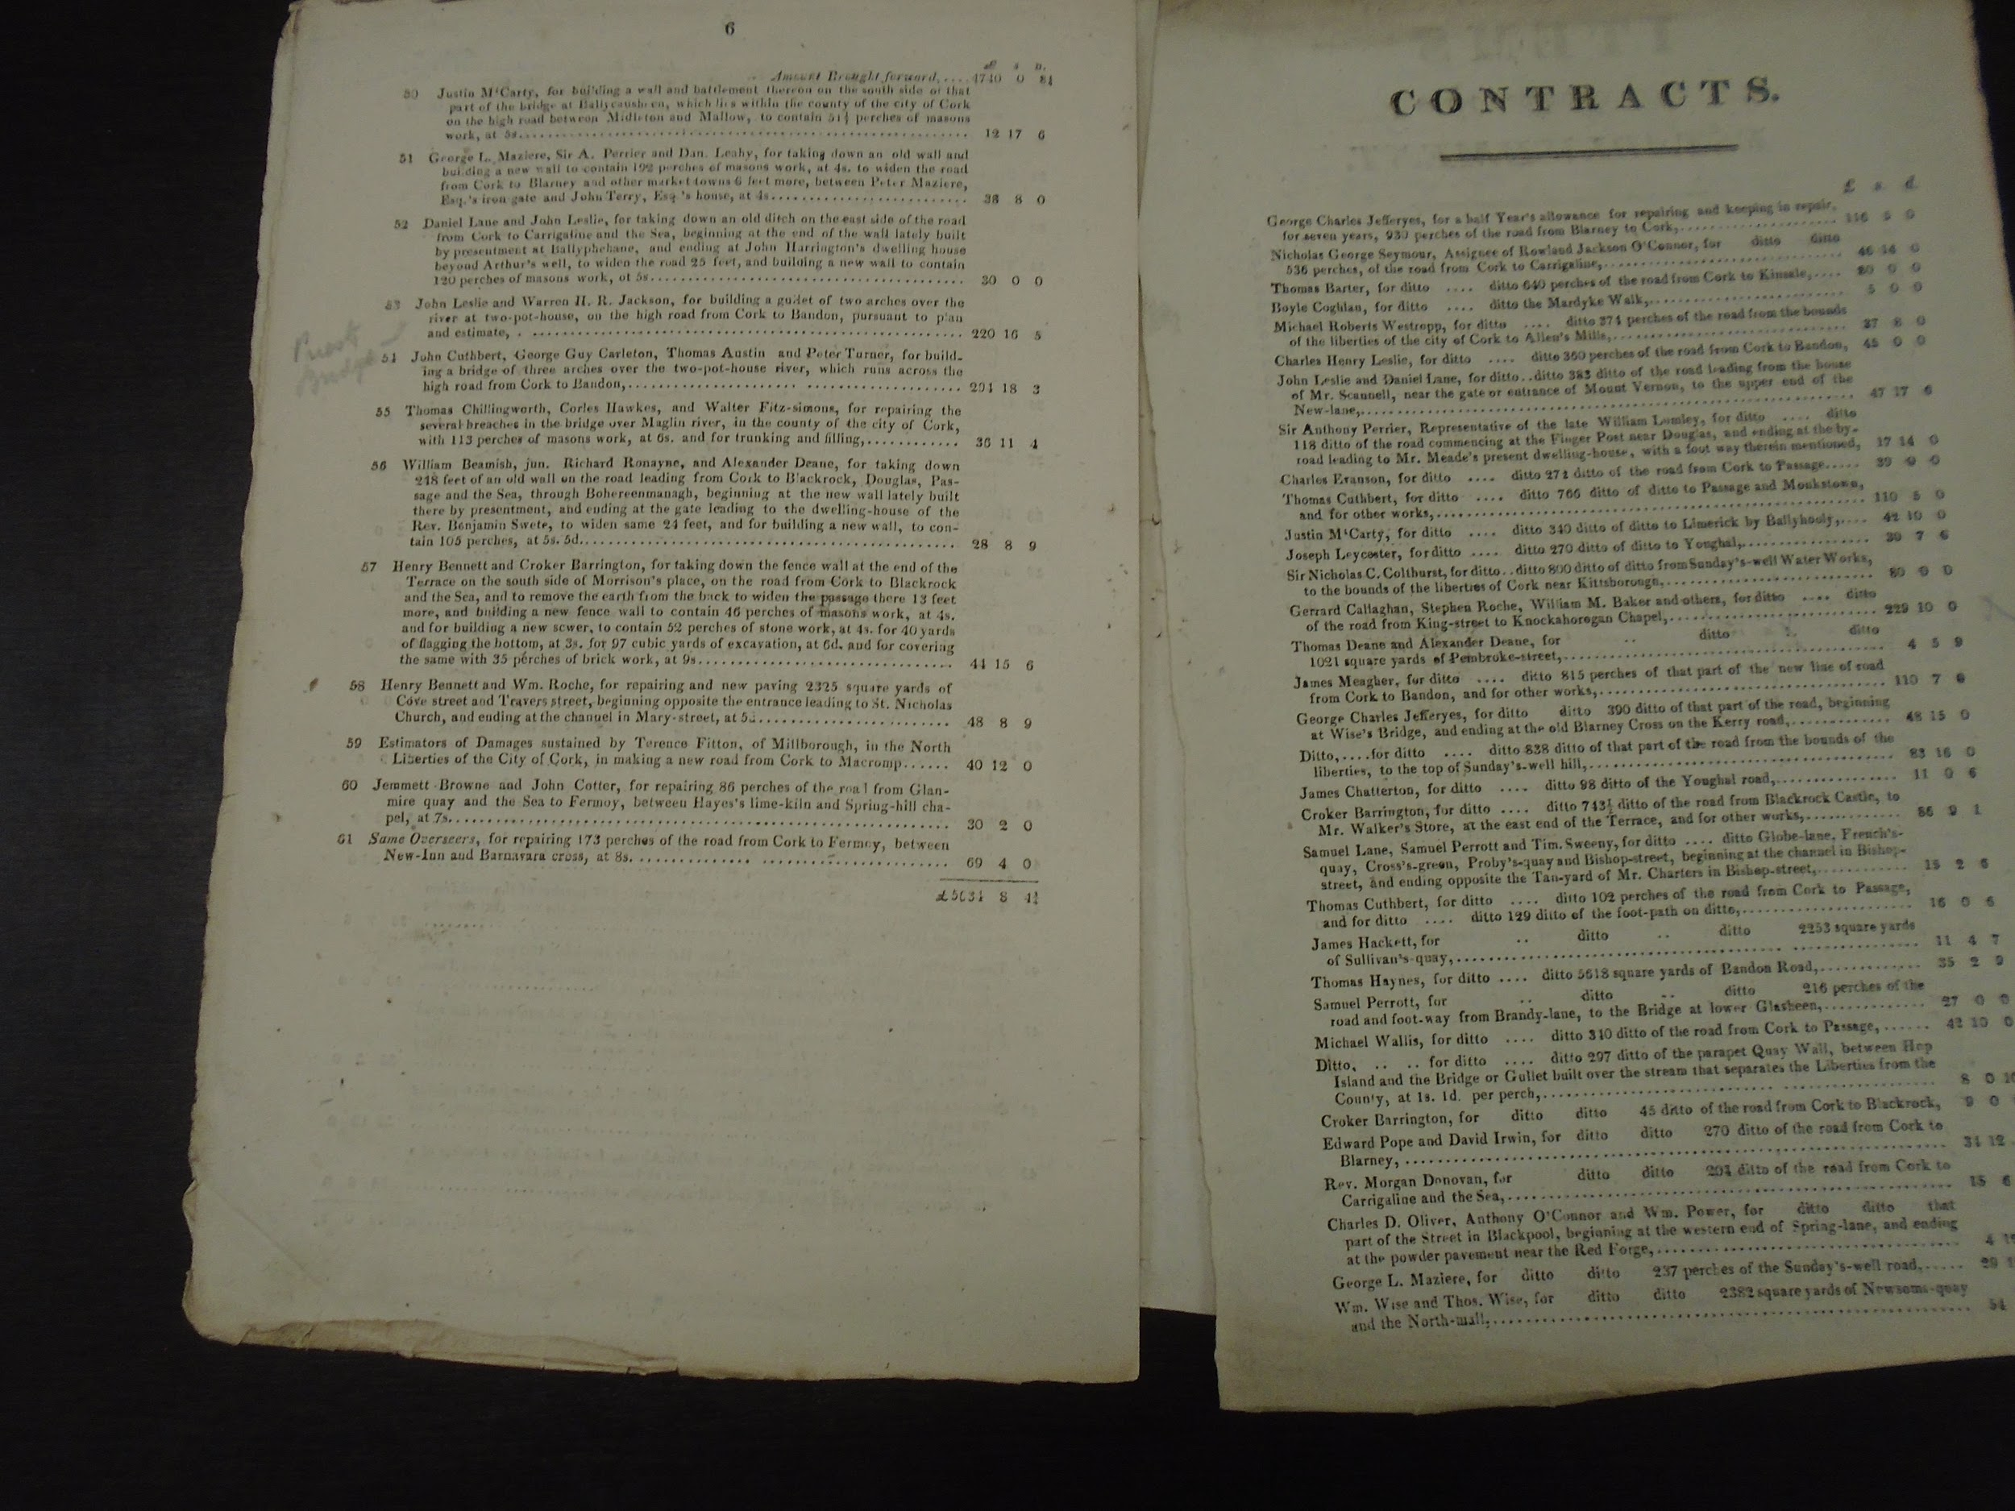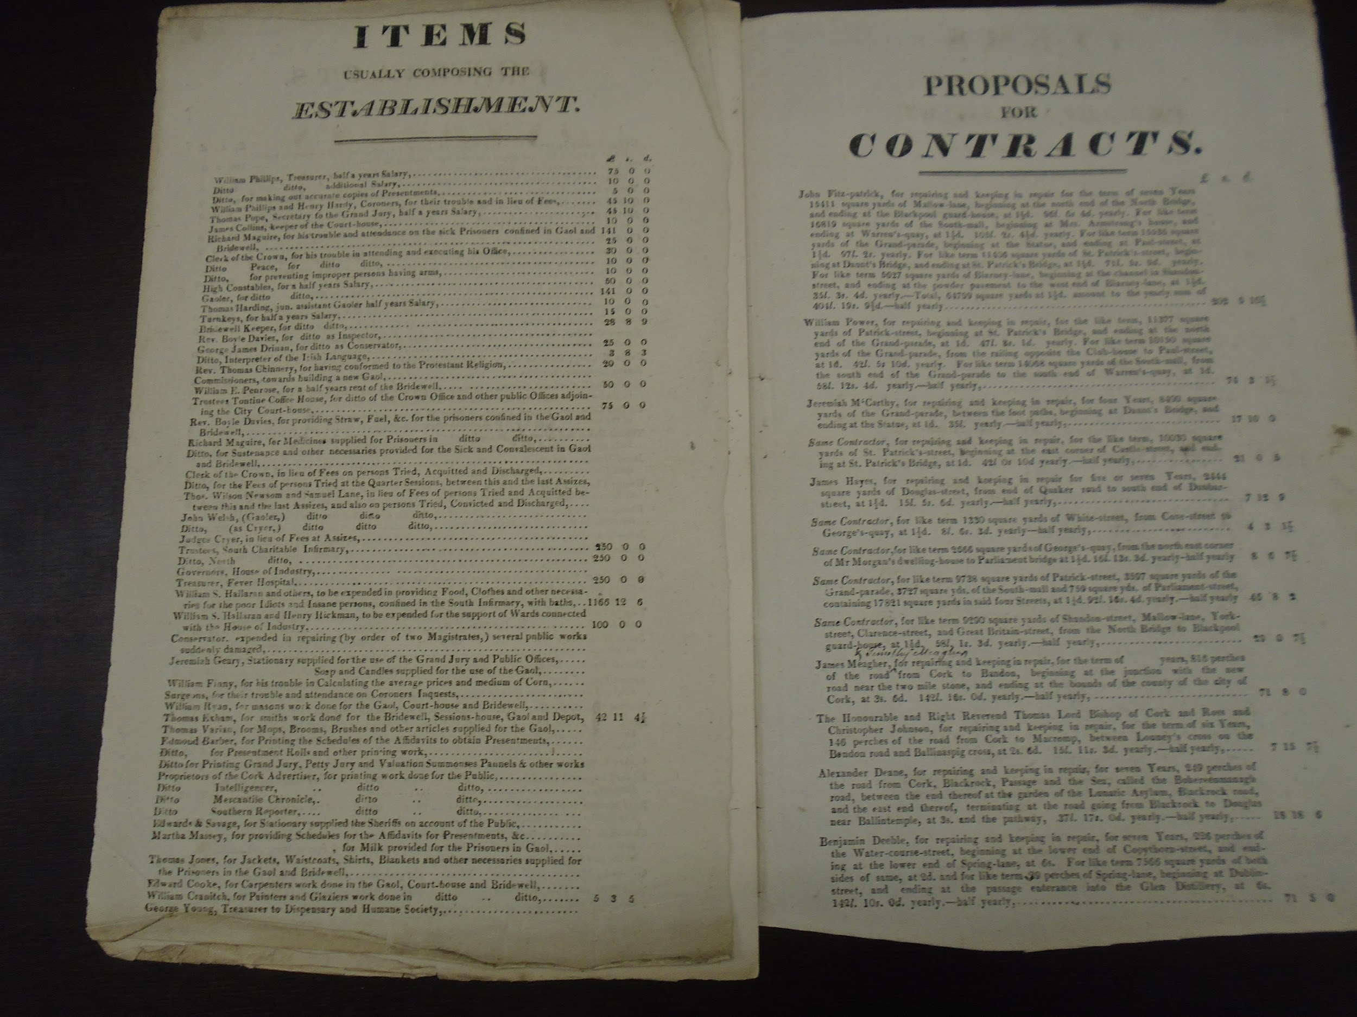
…
1828 Charitable Presentments

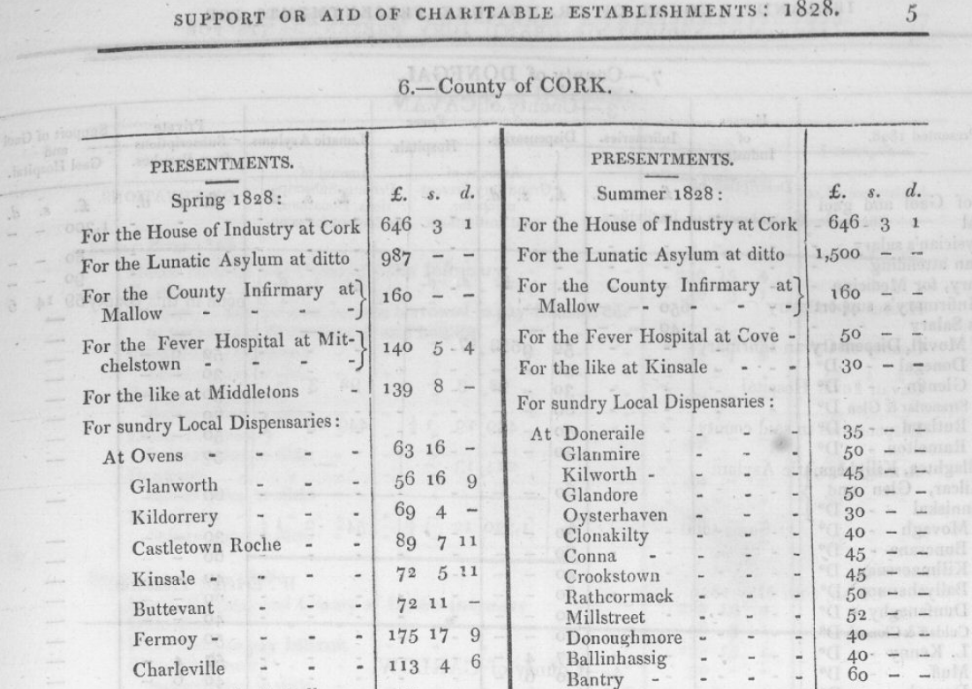
..
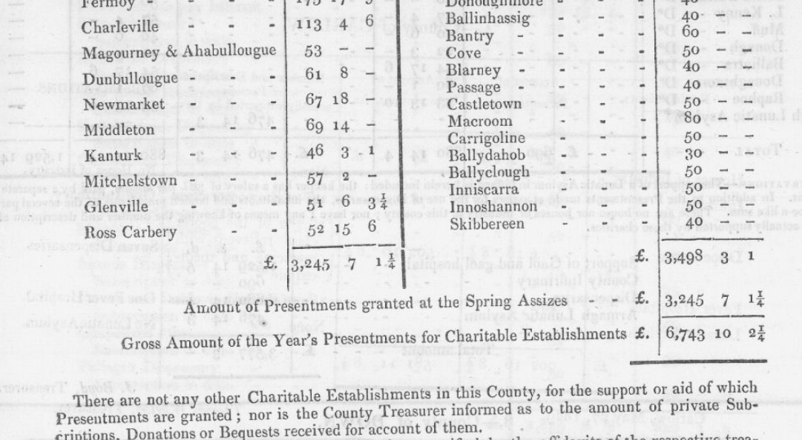
..
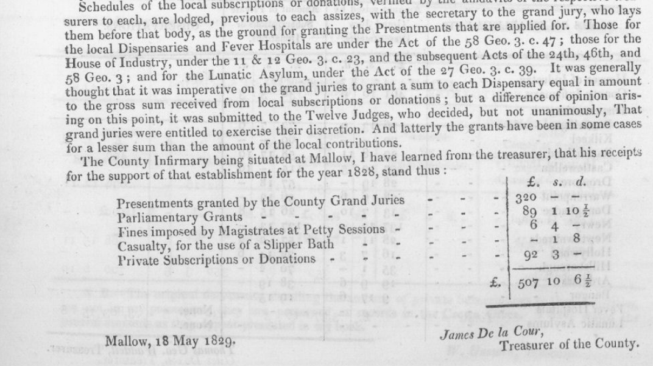
..

…..

….

!830

…..

…

….

1834 Cork Grand Jury presentments

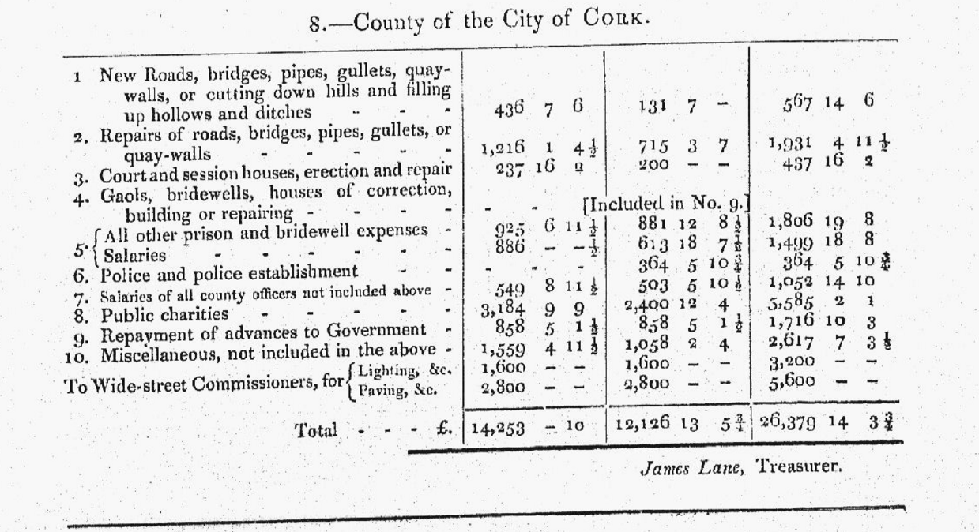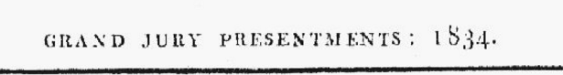

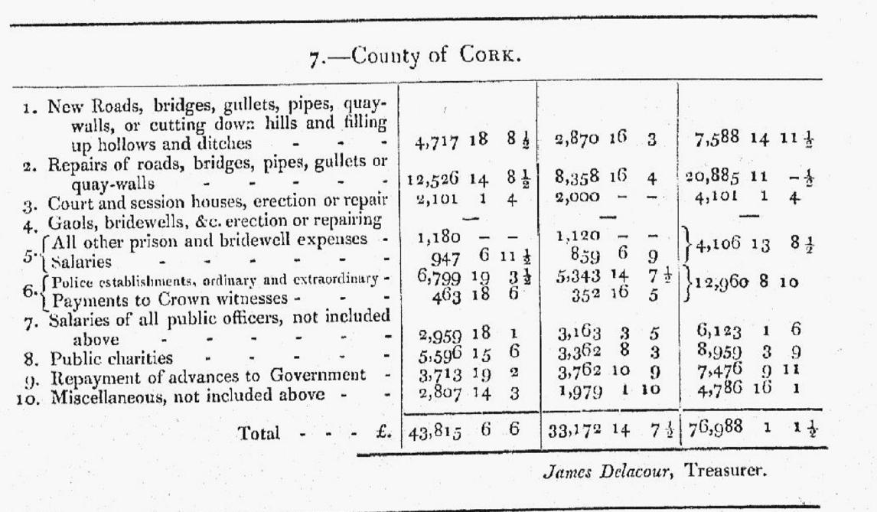

….

Timothy McCarthy Downings Observations 1860
1860 Timothy McCarthy Downing

….

……

….

….

…

Cork Turnpike Road Legislation

1731, Cork-Kilworth Mountain to Co. Tipperary border, tolls intended to last to 1752.
1779-80, tolls increased
1798, road privatised
1798, tolls on stagecoaches doubled
1799, tolls increased.

1731, Newcastle-Limerick-Cork, tolls intended to last to 1753.
1745, tolls increased road to go via Charleville.
1826, new Act.

1747, Listowel-Cork, original tolls to 1809
1767, adjustment of position of turnpike gates

1765, Kanturk-Fair Lane (Cork), tolls intended to continue to 1826 but only short length constructed

1790, Charleville to Cork City

1812, Cork-Tralee, tolls to 1833.

1822, Cork-Skibbereen-Kinsale, tolls to 1843

1825, Cork-Ballyhooly, tolls to 1846.

1830 Extension of Waterford-Cork, provisional only.

1857, all existing turnpike roads in Ireland abolished with effect from 5th April 1858

….

…..

1812 Heart, Chimney and Rates of Miscellaneous Tax. It is unclear when this finishes and whether the cess replaced it.

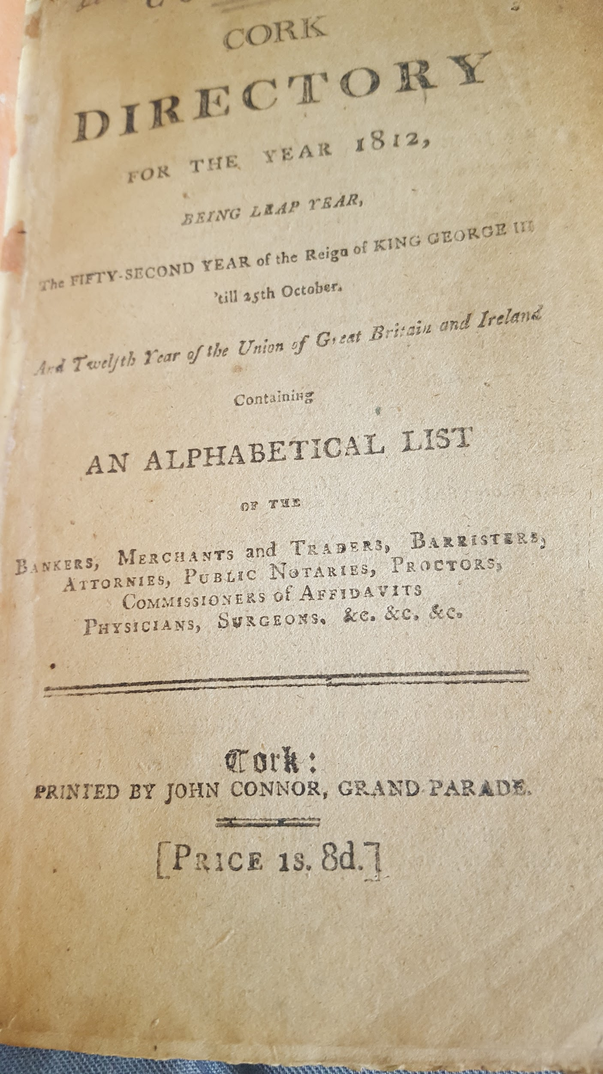
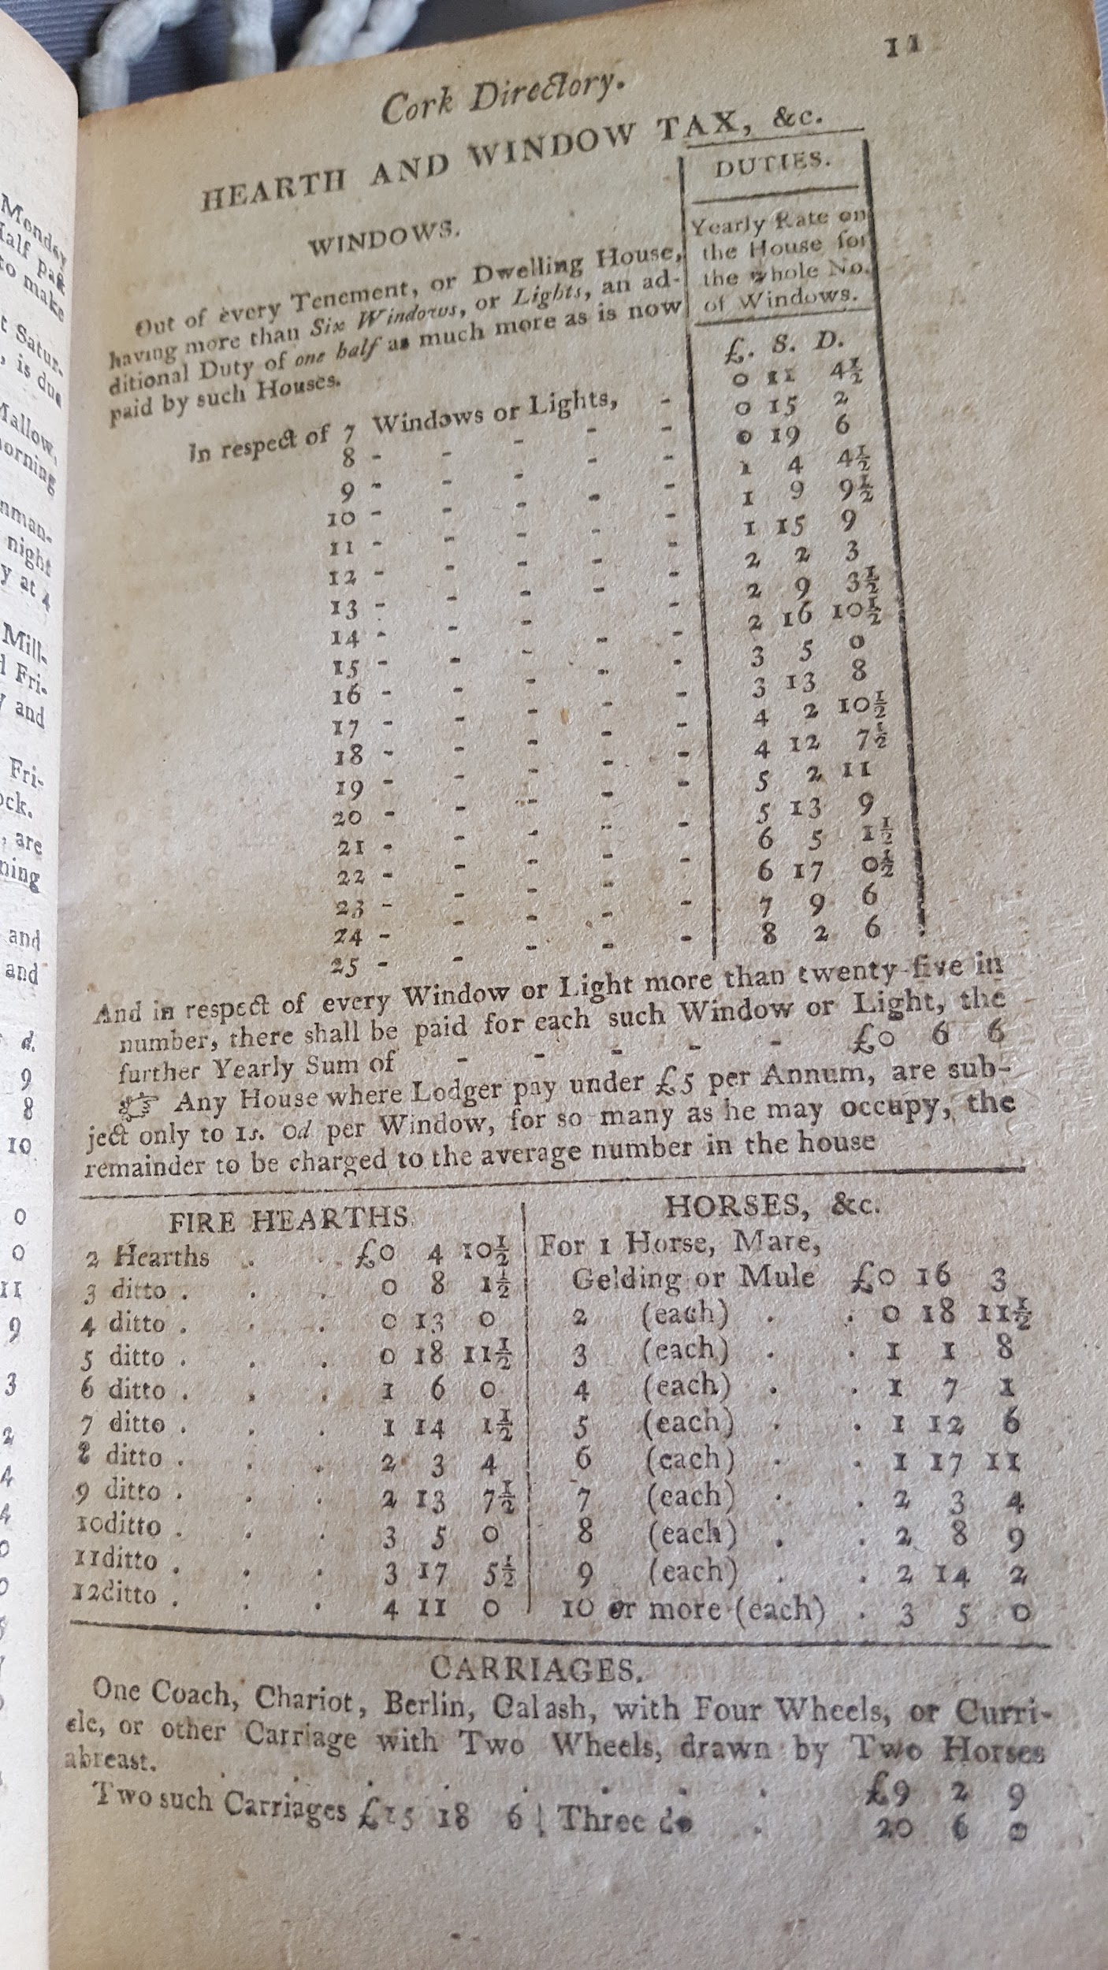
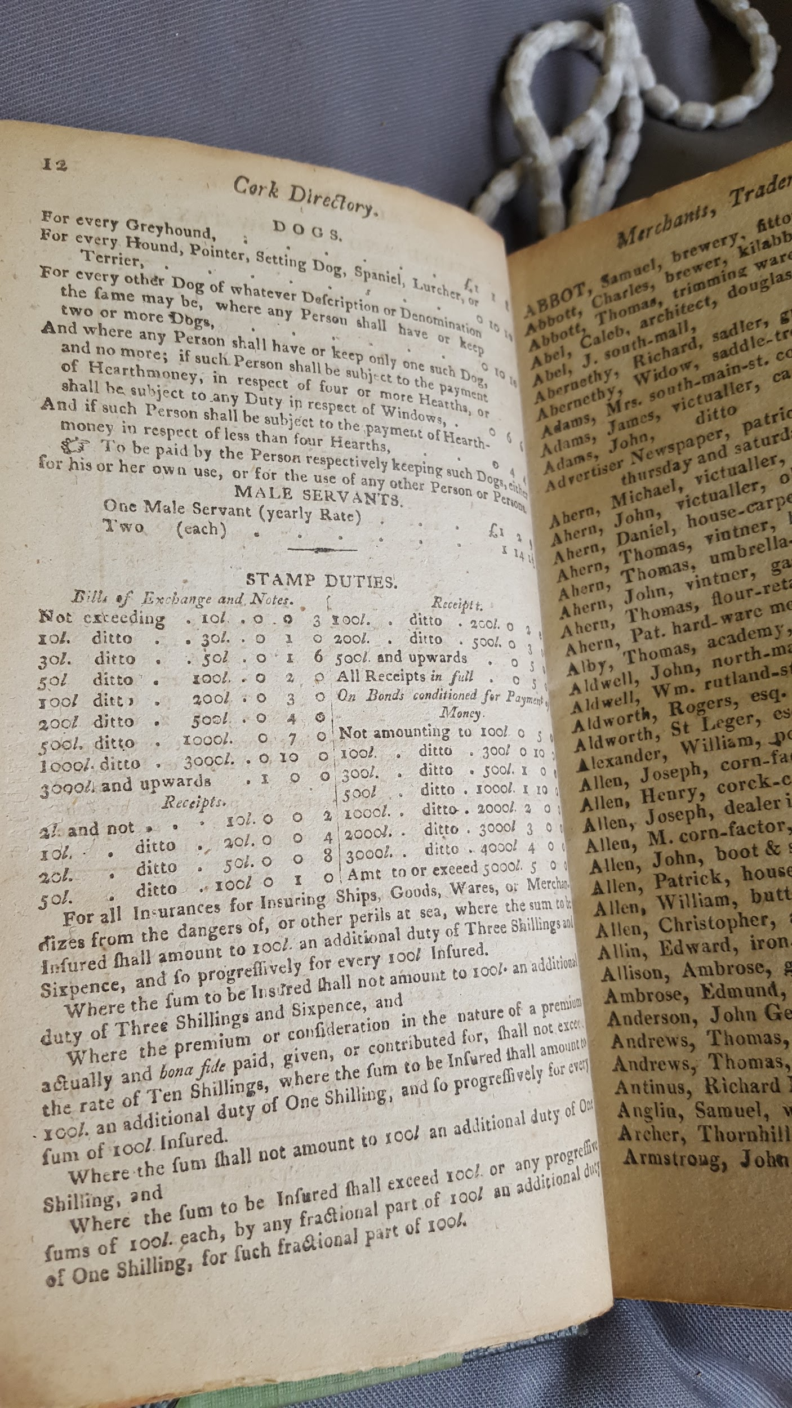...
The Winter family were involved in the administration of Co. Meath as Sheriffs and Magistrates.

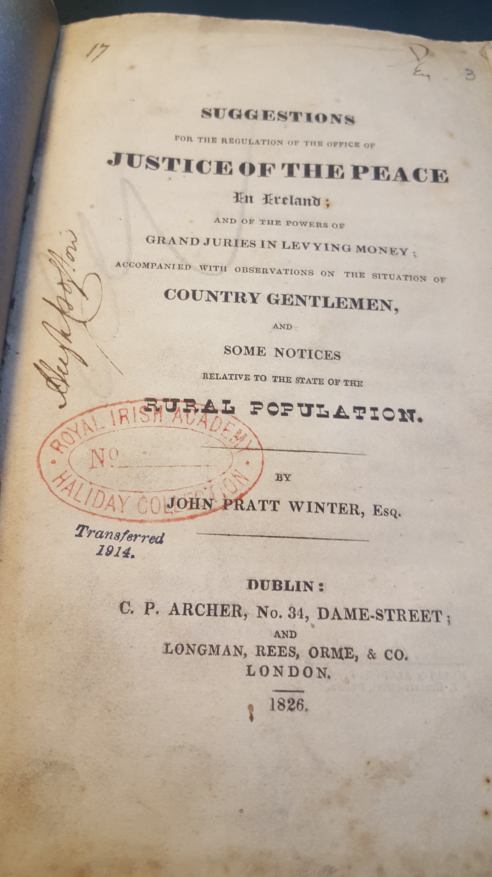
..

Legislative provision re Magistrates, Jurors
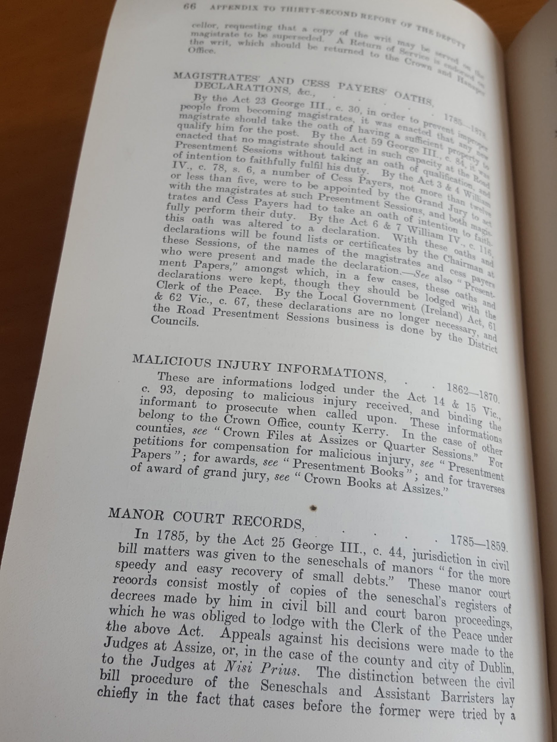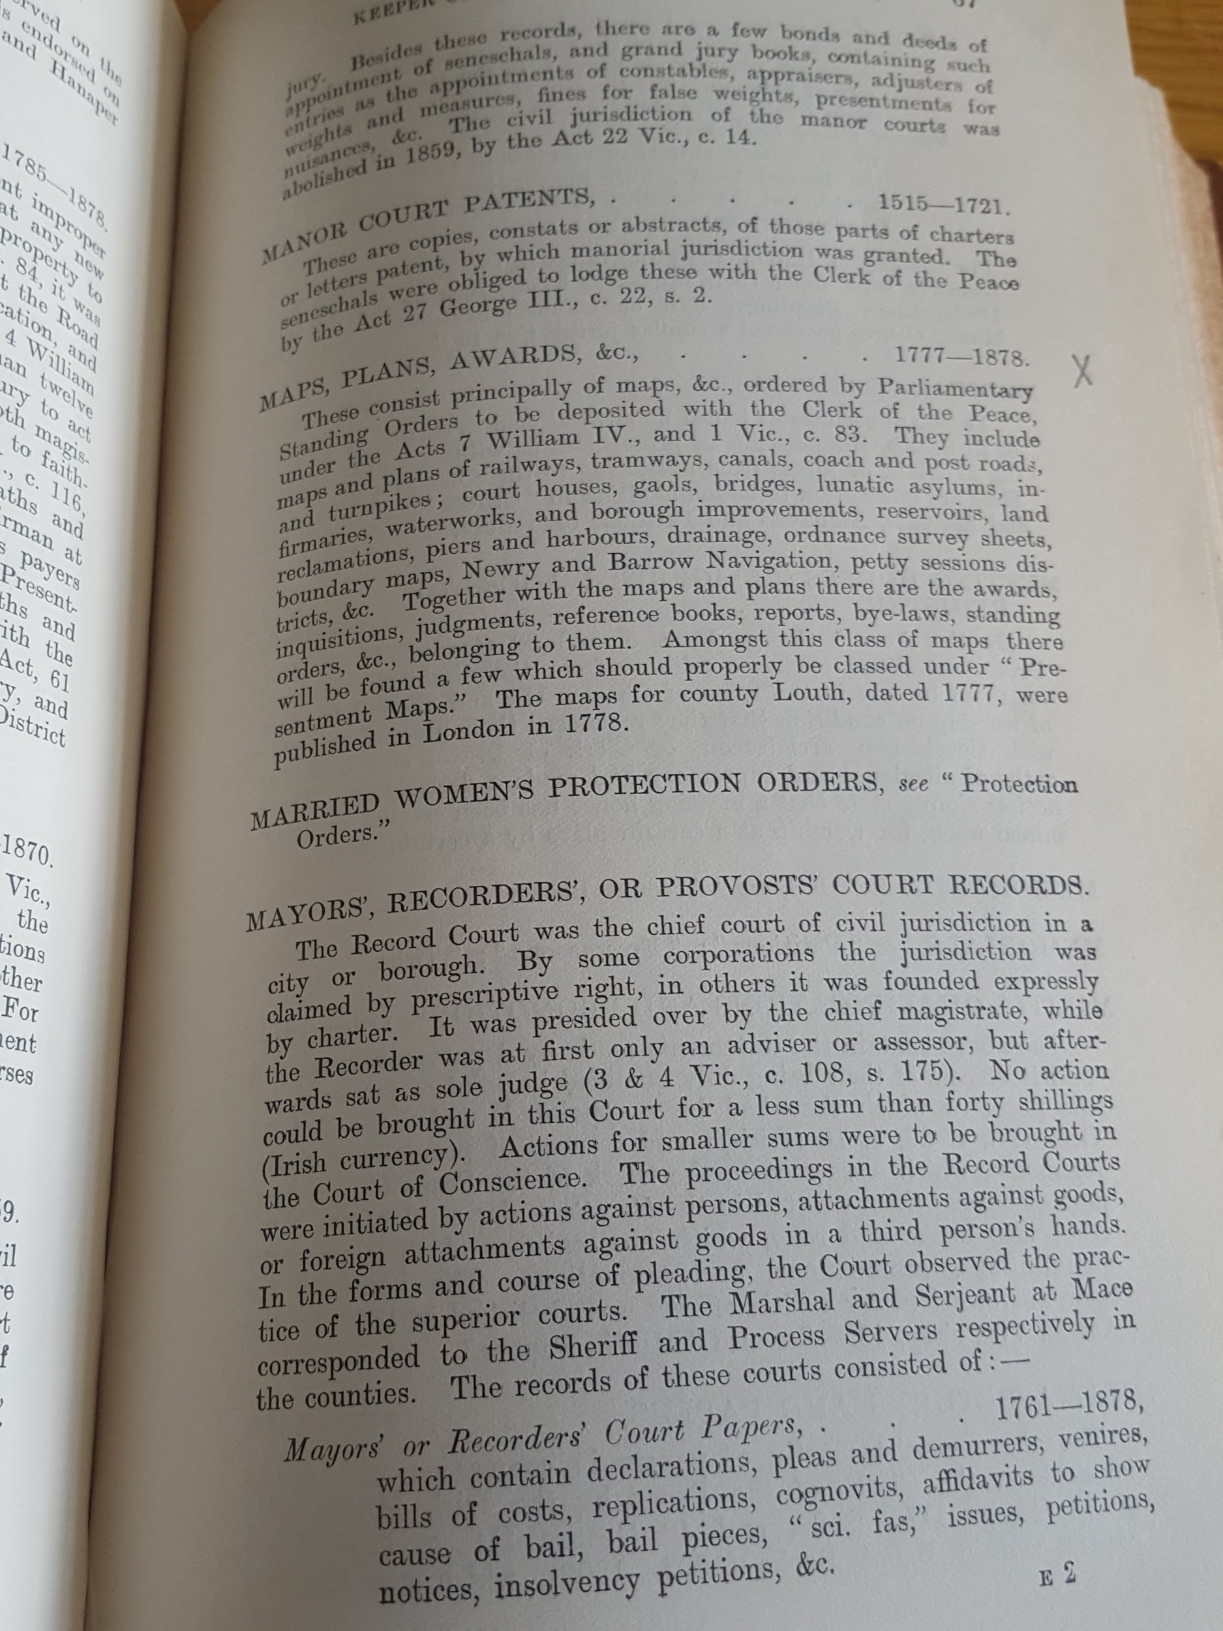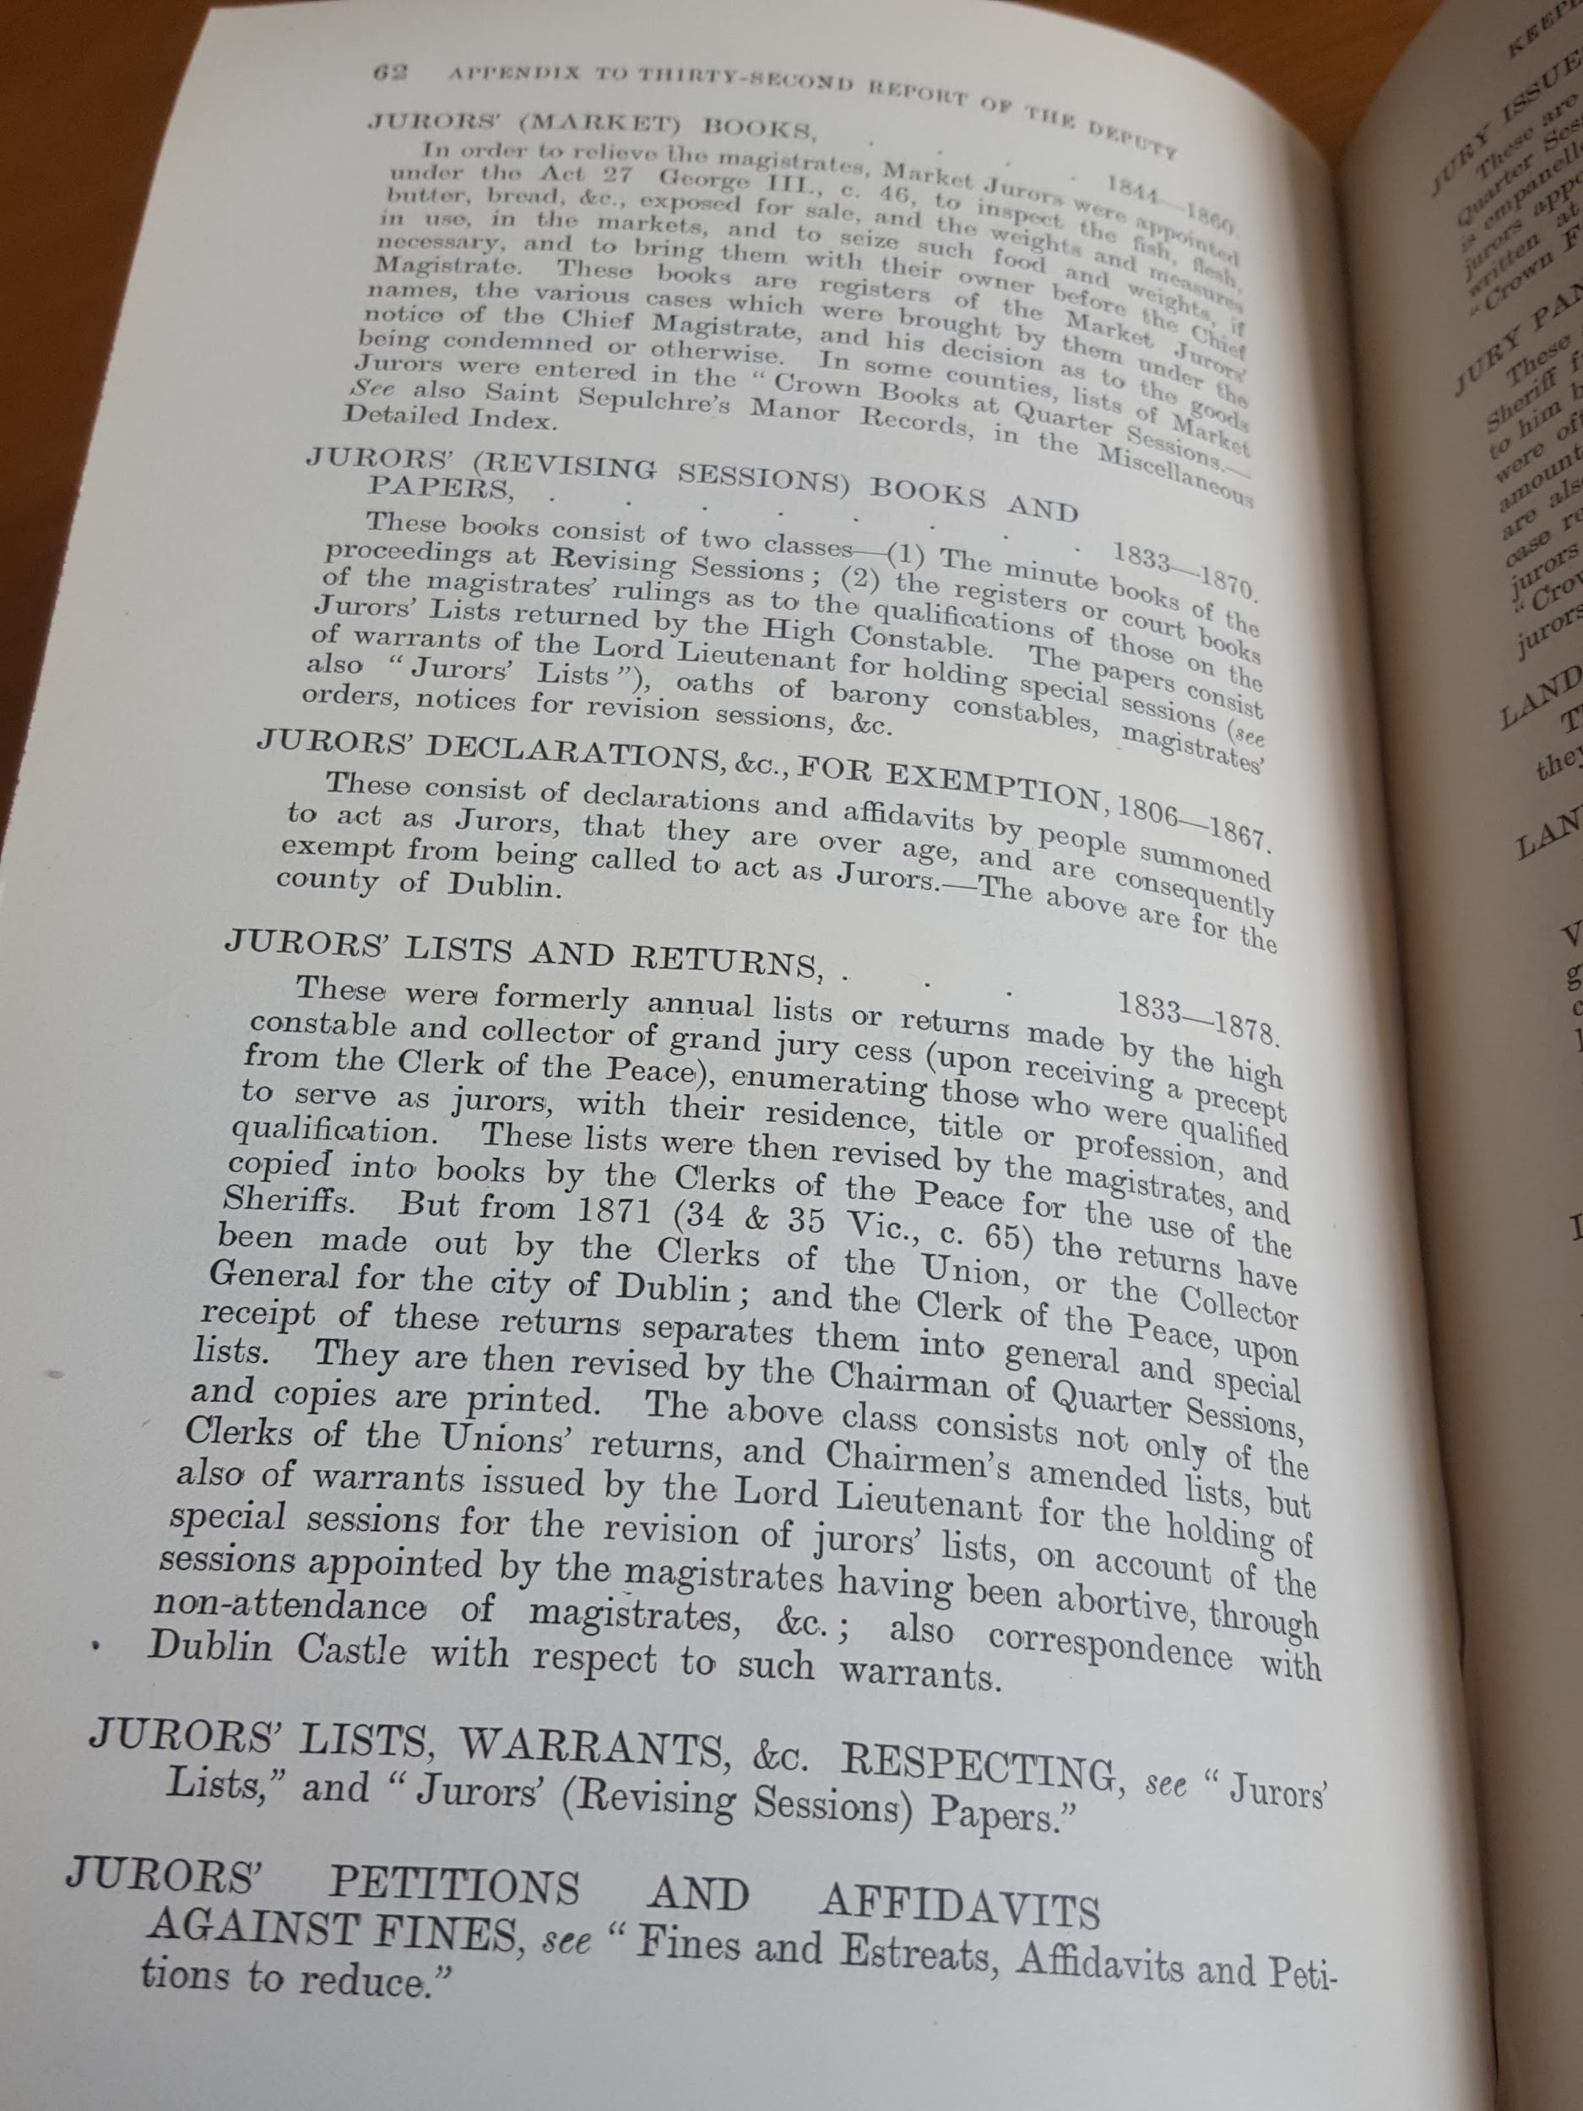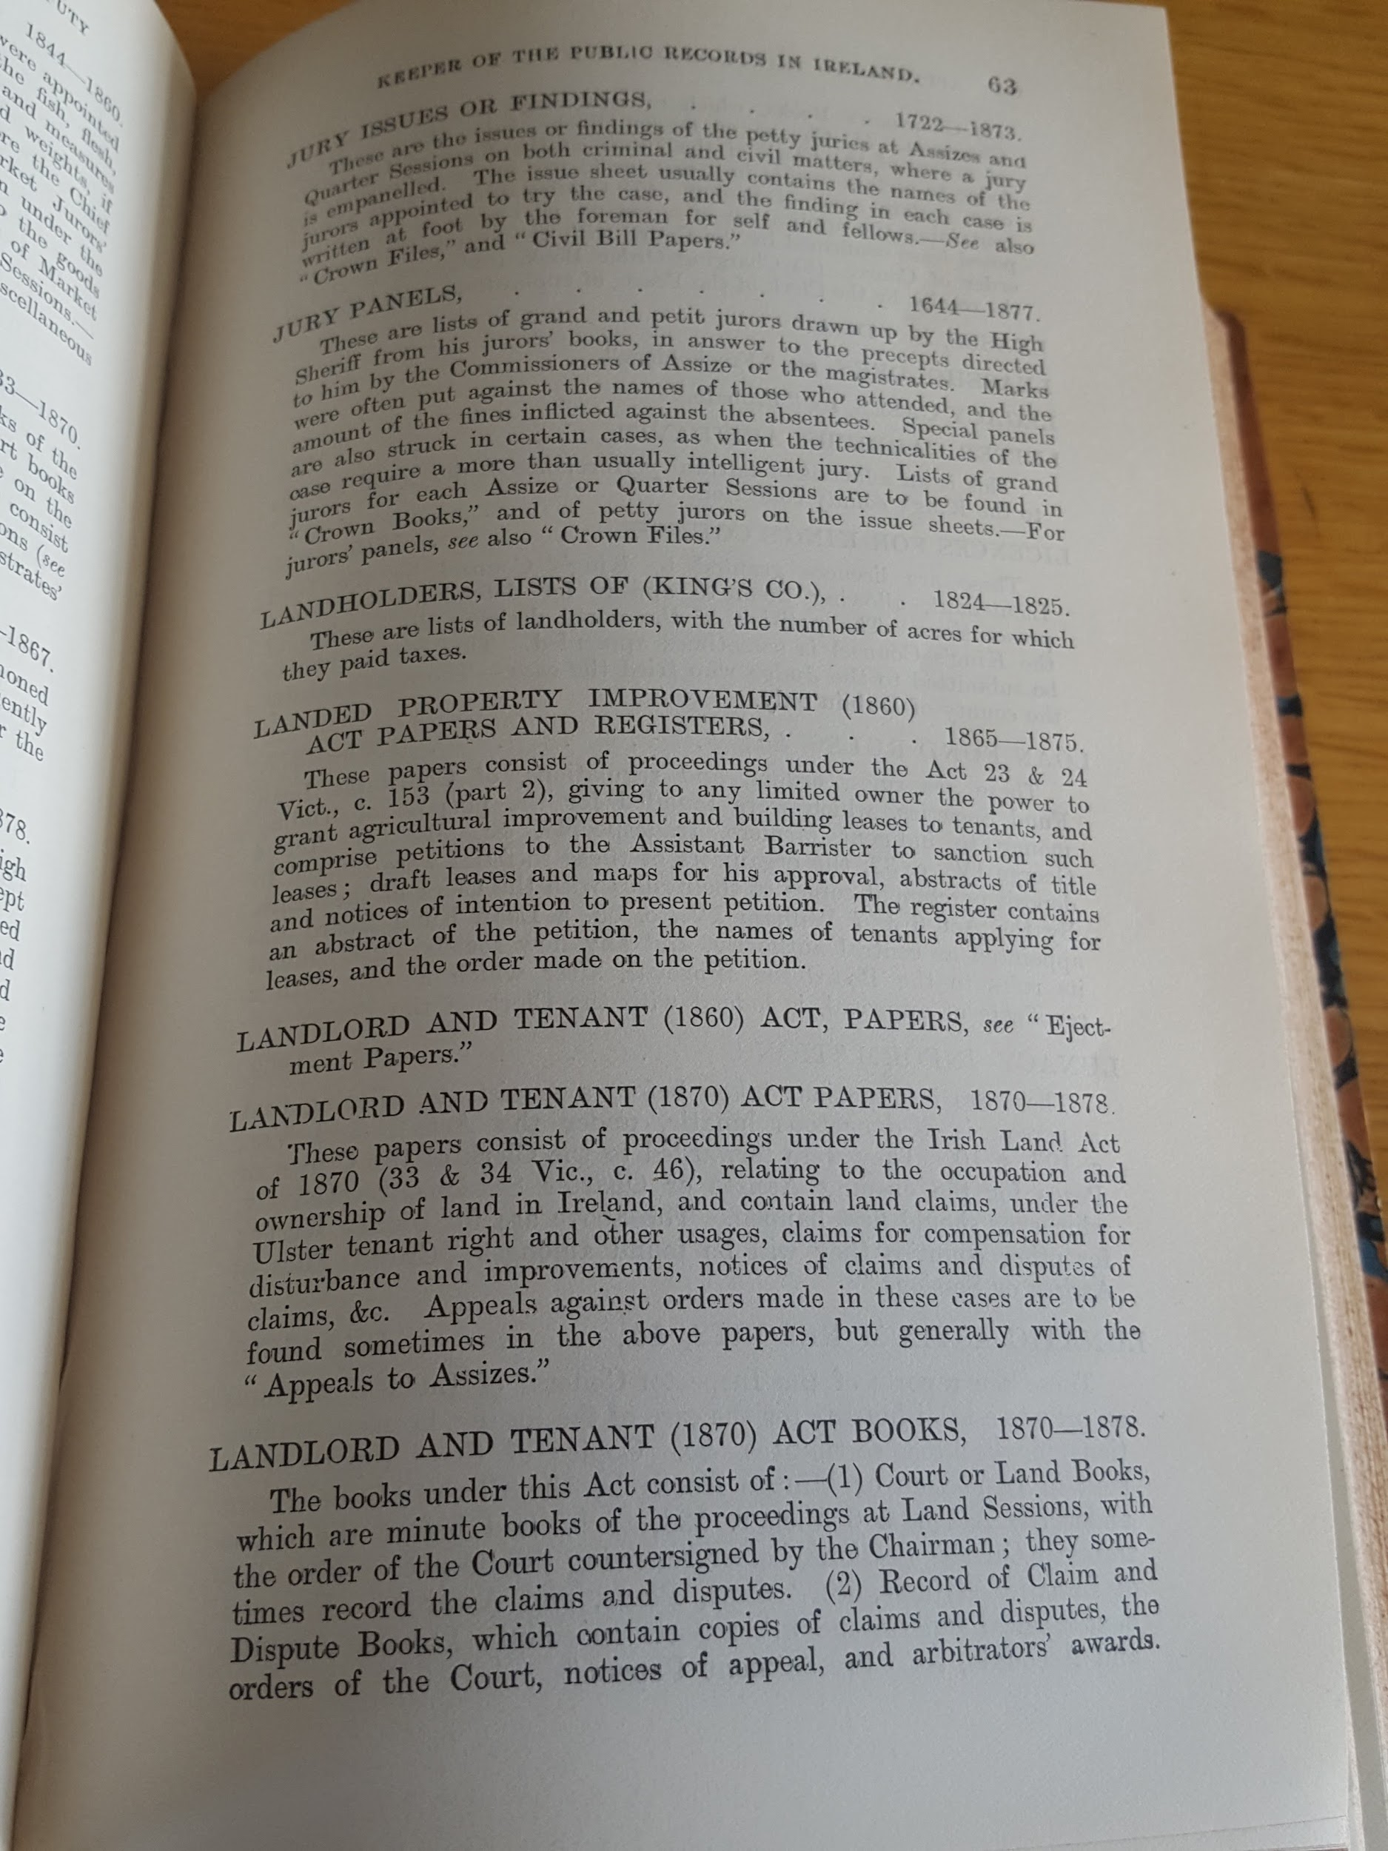

….

….

…..

http://www.dippam.ac.uk/eppi/documents/9835/page/215836
http://www.dippam.ac.uk/eppi/documents/15390/page/399635
http://www.dippam.ac.uk/eppi/documents/9508/page/210267
http://www.dippam.ac.uk/eppi/documents/8322/page/196221
Chief Secretary papers: http://www.csorp.nationalarchives.ie/search/index.php?simpleSearchSbm=true&category=27&searchDescTxt=high+constable&simpleSearchSbm=Search#searchfocus
http://www.csorp.nationalarchives.ie/search/index.php?simpleSearchSbm=Search&category=27&searchDescTxt=high+constable&offset=20&browseresults=true
http://www.dippam.ac.uk/eppi/documents/14301/page/369732
https://books.google.ie/books?id=8iA6AQAAMAAJ&pg=PA823&lpg=PA823&dq=delacour+grand+jury+treasurer&source=bl&ots=Gu7TCzsDXu&sig=WBMqYoN0SS3PMu1ugOF8WeEBTBs&hl=en&sa=X&ved=0ahUKEwik58uO3NvQAhWlBsAKHSo1BKAQ6AEIITAC#v=onepage&q=delacour%20grand%20jury%20treasurer&f=false
https://books.google.ie/books?id=LFQSAAAAYAAJ&pg=RA1-PA2&lpg=RA1-PA2&dq=de+la+cour+treasurer+cork&source=bl&ots=Ib9Lg1PIHq&sig=0NSYvrdoHHbBZFs0sInULGI5hb8&hl=en&sa=X&ved=0ahUKEwiykJXm_tzQAhWlJMAKHbQOBwE4ChDoAQgJMAA#v=onepage&q=de%20la%20cour%20treasurer%20cork&f=false
https://books.google.ie/books?id=LFQSAAAAYAAJ&pg=RA1-PA2&lpg=RA1-PA2&dq=de+la+cour+treasurer+cork&source=bl&ots=Ib9Lg1PIHq&sig=0NSYvrdoHHbBZFs0sInULGI5hb8&hl=en&sa=X&ved=0ahUKEwiykJXm_tzQAhWlJMAKHbQOBwE4ChDoAQgJMAA#v=onepage&q=%20cork&f=false
https://books.google.ie/books?id=LFQSAAAAYAAJ&pg=RA1-PA2&lpg=RA1-PA2&dq=de+la+cour+treasurer+cork&source=bl&ots=Ib9Lg1PIHq&sig=0NSYvrdoHHbBZFs0sInULGI5hb8&hl=en&sa=X&ved=0ahUKEwiykJXm_tzQAhWlJMAKHbQOBwE4ChDoAQgJMAA#v=onepage&q=%20cork&f=false
https://books.google.ie/books?id=LFQSAAAAYAAJ&pg=RA1-PA2&lpg=RA1-PA2&dq=de+la+cour+treasurer+cork&source=bl&ots=Ib9Lg1PIHq&sig=0NSYvrdoHHbBZFs0sInULGI5hb8&hl=en&sa=X&ved=0ahUKEwiykJXm_tzQAhWlJMAKHbQOBwE4ChDoAQgJMAA#v=onepage&q=%20cork&f=false
Cork Examiner 2nd March 1865.
http://www.astro.wisc.edu/~townsend/tree/record.php?ref=213
http://www.academicroom.com/article/local-elite-creation-early-hanoverian-ireland-case-county-grand-jury
Neal Garham: http://www.academicroom.com/article/local-elite-creation-early-hanoverian-ireland-case-county-grand-jury
http://www.dippam.ac.uk/eppi/documents/10229/page/226454
Skibbereen & West Carbery Eagle; or, South Western Advertiser 07 January 1865
Heritage Bridges of County Cork. Published by Heritage Unit of Cork County Council 2013
The Beginnings of County Administration by J. COLLINS
Grand Jury Valuation of the Barony of East Muskerry, 1889—1891 (1 item), 188. Preston Collection Collection Ref: IE CCCA / U195 Descriptive List Cork City and County Archives
http://www.dippam.ac.uk/eppi/documents/11941/page/282470
Stone Bridges p. 30-31
Laings Directory: http://www.corkpastandpresent.ie/places/streetandtradedirectories/1863laingdirectory/files/assets/basic-html/page105.html
Chatterton, Clerk of Crown 1922 return to British Parliament
Dr. Casey Collection, item 2389, John T. Collins newspaper extracts originally from Kearney family Garretstown House.
Dublin Evening Post 27th September 1785
Dublin Evening Post 2nd February 1792,
Dublin evening Post, 24th September 1785
Connected to a place name in Blackrock called Factory Lane. His factory seems to have been a 17th century enterprise - what he did is unknown. The site of the Dunlocha housing was Jameson's Field. Jamesons seemed to have a lot of leases locally and a fair bit of land - Richard Longfield Jameson seems to have inherited the lot.
Southern Reporter and Cork Commercial Courier 11 June 1831
Robert Scoble. Author of O'Sullivan piece was published as Chapter 7 of book Raven: The Turbulent World of Baron Corvo (Strange Attractor Press, London, 2013).
Freeman’s Journal 8th April 1821.
6th October 1821, Freeman’s Journal
27th March 1830 Freeman’s Journal
1st April 1830, Freeman’s Journal
THE SOUTHERN REPORTER & CORK COMMERCIAL COURIER : TUESDAY 8 APRIL 1834, County Cork
Enquiry of Law and practise into Conditio of Land, http://www.dippam.ac.uk/eppi/documents/11941/page/282508
Thank to Wikipedia
Southern Reporter Cork Commercial Courier 19th July 1862.
Southern Reporter and Cork Commercial Courier 16th January 1823.
Southern Reporter and Cork Commercial Courier 17th February 1845.
Cork Examiner, 11th November 1853 quoted in Bridges p.239
Bridges, p. 345
C.C.C. 2nd August 1834.
Bridges p. 267
Bridges
http://www.dippam.ac.uk/eppi/documents/11608/page/271640
https://books.google.ie/books?id=ADFbAAAAQAAJ&pg=PA82&lpg=PA82&dq=jackson+de+la+cour+cork&source=bl&ots=jNG7wpu819&sig=QAygCKkQUiASTYm3AdzUslTGtRM&hl=en&sa=X&ved=0ahUKEwitoeb2oY3RAhUpJMAKHUSoDAUQ6AEIQDAG#v=onepage&q=jackson%20de%20la%20cour%20cork&f=false
Public Record Office Northern Ireland.
Richard Caulfield: http://www.corkpastandpresent.ie/history/caulfield_complete.pdf
http://www.corkpastandpresent.ie/history/caulfield_complete.pdf
http://www.corkpastandpresent.ie/history/caulfield_complete.pdf
http://www.corkpastandpresent.ie/history/caulfield_complete.pdf
https://books.google.ie/books?id=Dw0UAAAAQAAJ&pg=PA80&lpg=PA80&dq=john+rogerson+1715+cork+attorney&source=bl&ots=DMEvSjMoLT&sig=AbNu1TyLgrhMP8Rd2YXdRY95i44&hl=en&sa=X&ved=0ahUKEwiVzZHYoJLRAhUBDsAKHb2sBQ44ChDoAQggMAE#v=onepage&q=cork&f=false
http://www.corkpastandpresent.ie/history/caulfield_complete.pdf
http://www.corkpastandpresent.ie/history/caulfield_complete.pdf
http://www.corkpastandpresent.ie/history/caulfield_complete.pdf
Bridge p. 196
http://www.corkpastandpresent.ie/history/caulfield_complete.pdf
http://www.corkpastandpresent.ie/places/southcorkcounty/kinsalecouncilbook/courtbookofthetownofkinsalepages1-300/court_book_Part3.pdf
http://www.corkpastandpresent.ie/places/southcorkcounty/kinsalecouncilbook/courtbookofthetownofkinsalepages1-300/court_book_Part5.pdf
http://www.corkpastandpresent.ie/places/southcorkcounty/kinsalecouncilbook/courtbookofthetownofkinsalepages1-300/court_book_Part6.pdf
http://www.irishlights.ie/tourism/our-lighthouses/old-head-of-kinsale.aspx
https://mail.google.com/mail/u/0/#inbox/15961ab80a78f433?projector=1
http://www.corkpastandpresent.ie/history/caulfield_complete.pdf
Caulfield
Dr. Casey Collection.
Andrews, ROAD PLANNING IN IRELAND BEFORE THE RAILWAY AGE By J. H. ANDREWS Trinity College, Dublin
Bridges p.196.
The First Toll-Roads, Ireland's Turnpike Roads 1729-1858, by David Broderick, Collins Press.
The First Toll-Roads, Ireland's Turnpike Roads 1729-1858, by David Broderick, Collins Press.
Consolidated legislation: chrome-extension://klbibkeccnjlkjkiokjodocebajanakg/suspended.html#uri=http://www.oireachtas.ie/documents/bills28/bills/2007/0507/b5a07d.pdf
https://books.google.ie/books?id=T7oRAAAAYAAJ&pg=PA167&lpg=PA167&dq=dr.+william+walker+cork+1740&source=bl&ots=HGXVkiyYZs&sig=gayk6-v7Mupg1tRj0dZNoJmXmT8&hl=en&sa=X&ved=0ahUKEwjD9uTvkNHUAhULJMAKHYSRBGE4ChDoAQg9MAQ#v=onepage&q=cork&f=false
Capuchins, surviving books: Registry of proceedings in criminal matters at petty sessions courts held for the County of Cork at Rathcormac’. The following columns are extant for each court record: ‘Number; date of information; informant’s name; offence; name of persons charged and residence; witnesses sworn; determination’. The offences recorded ranged from minor crimes such as theft (foodstuffs, clothes and turf), destruction of property, embezzlement and forgery to more serious incidents including violent assaults, rape and in some (rare) instances murder. The remainder of the volume is made up of a series of registers and schedules of fines compiled (in different hands) probably by the court’s clerks. https://www.facebook.com/CapuchinArchivesIreland/photos/a.335577569866375.75431.212596548831145/335577599866372/
https://books.google.ie/books?id=LmY1AQAAMAAJ&pg=PA11&lpg=PA11&dq=petty+session+clerk+bandon&source=bl&ots=YCZjEDEo8x&sig=nTCNyuOJaSFsAfWFIsHWJEwUi60&hl=en&sa=X&ved=0ahUKEwjp8pryv5bVAhXkD8AKHT2ZD2M4ChDoAQgfMAI#v=onepage&q=bandon&f=false
North Munster Antiquarian Journal 1965.
Pamphlet in the National LIbrary. Halliday Collection 650.
Mentioned In a military report from Governor Bantry, re activities of O'Mahony family Irish Papist, openly carrying arms allegedly terrorising local population, privateers. If Downes may be related to Protestant Bishop if Dowe small landlords in Crookhaven and Bantry area, papers in Marsh's Library Dublin.
Abstracted by Cork Historian, John T. Collins, 1930s
http://www.dippam.ac.uk/eppi/documents/11941/page/282484
chrome-extension://klbibkeccnjlkjkiokjodocebajanakg/suspended.html#ttl=Enhanced%20British%20Parliamentary%20Papers%20On%20Ireland&uri=http://www.dippam.ac.uk/eppi/documents/11941/page/282792
http://www.dippam.ac.uk/eppi/documents/11941/page/282823
Southern Reporter and Cork Commercial Courier - Saturday 16 February 1839
Chief Secretary papers: CSO/RP/1824/958
Chief Secretary Papers: CSO/RP/1824/958
Rev. Wallace Clare abstracts of Hibernian Chronicle, 1769-70
http://www.csorp.nationalarchives.ie/search/index.php?simpleSearchSbm=true&category=27&searchDescTxt=swanton&simpleSearchSbm=Search#searchfocus
https://books.google.ie/books?id=HLIzAQAAMAAJ&pg=PA211&lpg=PA211&dq=Deputy+Cess+Collector,++cork&source=bl&ots=fEBOQHyHto&sig=CYK1CFhoex3zTYpAhh3pCD5H0XE&hl=ga&sa=X&ved=0ahUKEwi4wLvF9Y7WAhUMCcAKHY8NBPw4ChDoAQguMAI#v=onepage&q=Deputy%20Cess%20Collector%2C%20%20cork&f=false
http://www.dippam.ac.uk/eppi/documents/11941/page/282823
Ross Cathedral Records, National Archives.
O’Keeffe and Simmington on brides
http://www.dippam.ac.uk/eppi/documents/10227/page/226423
Diary Mayor Pembrock, page 40: http://www.corkpastandpresent.ie/history/ye%20mayoral%20booke%20of%20thomas%20pembrock/
Diary Mayor Pembrock, page 40: http://www.corkpastandpresent.ie/history/ye%20mayoral%20booke%20of%20thomas%20pembrock/
Mayor Pembrock Doary, p. 46. http://www.corkpastandpresent.ie/history/ye%20mayoral%20booke%20of%20thomas%20pembrock/
Mayor Pembrock Diary: http://www.corkpastandpresent.ie/history/ye%20mayoral%20booke%20of%20thomas%20pembrock/
Deed.
http://www.corkpastandpresent.ie/history/Mayoral%20Book%20of%20Thomas%20Pembrock/files/assets/basic-html/page-420.html
http://www.corkpastandpresent.ie/history/Mayoral%20Book%20of%20Thomas%20Pembrock/files/assets/basic-html/page-420.html
http://www.corkpastandpresent.ie/history/Mayoral%20Book%20of%20Thomas%20Pembrock/files/assets/basic-html/page-445.html
http://www.corkpastandpresent.ie/history/ye%20mayoral%20booke%20of%20thomas%20pembrock/
https://play.spotify.com/user/guardianmusic/playlist/0u6gu9xmohGdb2KpZo34NG
Lord Shannon’s letters to son, PRONI, p. 228
Maziere Brady: http://www.corkpastandpresent.ie/history/batch2/brady_vol1_cropped.pdf
Transcribed 1944 by Dr. Edward McLysaght from bundles of old documents in a chest in the Town Clerk's Office, Kinsale.
McLysaght Analecta Hibernia, No. 14, 1944, Transcriptions, Conor Papers, Herbert papers, Manch, Kinsale Corporation from 1594.
McLysaght Analecta Hibernia, No. 14, 1944, Transcriptions, Conor Papers, Herbert papers, Manch, Kinsale Corporation from 1594.
McLysaght Analecta Hibernia, No. 14, 1944, Transcriptions, Conor Papers, Herbert papers, Manch, Kinsale Corporation from 1594.
https://quod.lib.umich.edu/e/eebo/A41955.0001.001/1:4?rgn=div1;view=fulltext
chrome-extension://klbibkeccnjlkjkiokjodocebajanakg/suspended.html#ttl=Enhanced%20British%20Parliamentary%20Papers%20On%20Ireland&uri=http://www.dippam.ac.uk/eppi/documents/9822/page/215004
https://books.google.ie/books?id=OLj0D0vnbJ8C&pg=PA47&lpg=PA47&dq=stephen+bernard+bandon+1740&source=bl&ots=gXlc9HgkCN&sig=U0CnPLfJlv2XkxadClSxMVra4Qw&hl=en&sa=X&ved=0ahUKEwjr56vP6u_bAhVIeMAKHcChD8oQ6AEIRjAE#v=onepage&q=cork&f=false
Buried Aughadown Upper Graveyard, Lisheen, Skibbereen.
http://www.corkpastandpresent.ie/places/streetandtradedirectories/1884guyscitycountyalmanacanddirectory/1884pages84to125/CorkCity&County1884Pages84%20to%2089.pdf
Member Royal Society of Antiquaries 1894. https://ia801406.us.archive.org/19/items/journalroyalsoc00irelgoog/journalroyalsoc00irelgoog.pdf
http://www.corkarchives.ie/media/CP-CY-FI-1-web(Surname-Order).pdf
http://www.corkgen.org/publicgenealogy/cork/potpourri/corkancestors.com/Castlehaven.htm
National Archives special accessions 999/486.
From Public Records Report to British Parliament c 1909
Richard S. Harrison, Story of Ballymacowen
Wealthy farmer, businessman O’Connell supporter, Bantry
Cork Southern Reporter.
Parish Vestry Records.
Register of the Parish of Christ Church Edited Dr. Susan Hood, RCB
http://www.corkarchives.ie/media/Index%20to%20Listed%20Collections%20with%20Scope%20and%20Content%2020160420.pdf
Richard Caulfield papers, Boole Library, UCC
Married into Dorman family of that address.
Pamphlet in National Library of collection of Freemen he came after meeting and asked to be allowed dine.
Cork Grand Jury Presentments, 1845 Assizes. Cork Archives: GJ/CO/PR
CSO/RP/1825/1284. Letter from G Fitzgerald, magistrate, County Tipperary, concerning a case of abuse in the collection of county tax on the townland of Monksgrange in County Tipperary
http://www.dippam.ac.uk/eppi/documents/8322/page/196182

