Rossmore:

https://www.google.ie/maps/place/Rossmore,+Co.+Cork/@51.615579,-9.5778136,15z/data=!3m1!4b1!4m2!3m1!1s0x48459e159ee4ee71:0x2600c7a7bb4beee2

Jack Dukelow 1866-1953

Diocesan Magazine July 1953

During the last month one of our oldest parishioners passed on to Higher Service. Mr. Jack Dukelow, Jack, the name by which the farmer was familiarly known was an extremely popular figure in the district. Apart from his entertaining value he possessed a prodigious memory. We believe he could have told us, were it not for his untimely passing, something about the quarter Billion of Gold lying in the bottom of Bantry Bay in a Spanish Galleon.

From the late Mrs. Mary Dukelow’s family history 1990

John (Jack) was the only member of the Brahalish family whom we hear and believe met up with the fairies. He was a man of immense intelligence, a musician, strong in character and feared little.

In the evening of his life he had time to mingle and converse with all and sundry. To a child he suspected had not answered his question truthfully he said and I quote ‘Little boy I will not ask you anymore or put you to the painful necessity of telling lies’. To a foreigner passing by and remarking on the view he replied, ‘To see a sunset on that harbour of a summer’s evening would cast a ray of light upon one’s bosom that would make it like a pathway to heaven’.

To a Solicitor who said to him that he should have been one, on hearing him quote law so correctly, John answered , ‘God forbid’, when asked why not he replied ‘Well my parents always wanted me to be something but never a Solicitor’. Why not?. ‘They will have a hard time hereafter because all a Solicitor’s life he is trying to make wrong right and right wrong’, to that there was no reply.

There was an old quarry behind his house with others at Sea Lodge and a stone quarry at Fahies, Clashadoo. He used to describe the ‘slaters’ who were not slaters in the ordinary sense but dressed stone in the quarry for slate use.

It was his custom to go to Durrus Village regularly, on this particular night he visited Mr. John Croston in his home (the Crostons long back had been weavers), he had not been to a vintners premises but gave Mr. Croston’s son cash to purchase 6 small bottles of stout which he shared with Mr. Croston, they had 3 each. That quantity was just about enough to whet John’s appetite. No way could he be under the influence of the liquor. Close to midnight he was homeward bound when he saw coming from the Sand Quay and continuing towards the Public Road towards St. James’s Church what appeared to him a throng of little people. He did not continue his homeward route but returned to the Village and spent the remainder of the night in a loft of Phillips making his journey home as the new day dawned.

In Jack's younger days a body was washed ashore at Rossmore. The corpse was clutching a walking stick with a very elaborated knob. When the undertaker arrived to put the body into the coffin he grabbed the stick and tossed it into the rocks. Jack feld it was a pity and after the undertaker departed he recovered the stick, took it home and place it with the other sticks in the area under the joists. He was uncomfortable as there was a pisheóg (old superstition) that troubled him. Some months later a beggar called to the house with a walking stick in poor condition. Jack took the opportunity to get him to swop and the tramp went off happy.

Back in the days when Intoxicating liquor was two pence a pint equivalent to slightly less the 1p in today’s currency, John had perhaps several drinks too many on a particular occasion, walking home he did not realise where he was until he found himself waist deep in Coosheen

His father William died returning from Durrus Races 26th December 1896. He had been walking around Coísín, near the bridge in Bahalish when he was struck by a man with a horse. At that time there was no wall and he fell into the sea. The family were searching for him. On the beach Tánna (Tra na gCailiní/Women’s Beach), a Shannon man and Alf Attridge found the body. The Shannon was from Lower Rossmore.

He is assumed to have had an accident near St. James Church, inquest accidental death. His wife Margaret nee O’Sullivan, Tedagh, (married 7th March 1848?) outlived him by 10 years in fine weather she would sit out counting her sovereigns.

Mrs. Nancy Peters nee Sarah Dukelow

Sarah Dukelow is still alive as Mrs. Nancy Peters, former teacher, August 2018, 93 later in the month. The teacher in her school Líam Blennerhassett, from Tralee was particularly inspiring. Part of the School folklore collection has now gone online the rest in phases will happen. The collection is the most extensive in the world.

She said that two of her informants were Jack Dukelow and Mick Bohane the Parish Priest's manservant.

From Mick she got a poem in Irish which she transcribed. He did not speak Irish but this was by his grandmother, who was from the Northside, in the style of the lament composed by Eibhlín Ni Chonaill on the death of her husband, 'Caoineadh Art Uí Laoighre'. The lament was the young fishermen drowned from Gearhies. She wrote it in the jotter supplied but the teacher did not send all the jotters to Dublin. She said that went to Dublin was only a fraction of what she collected.

Jack told her a story that during distress perhaps late 1880s or early 1890s the Grain Store at Sea Lodge was used to distribute yellow meal (maize) which may have come from America. The distribution was by townland at an allotted time. The overseer called out the townland name and the people then queued to get their ration. One man missed his slot. The phrase as recalled by Jack ‘Call the Land Bewest the Tower that haven't ate meal for a week’ the Tower (Tooreen/KIlcrohane) .

Jack Dukelow died in around 1954 and was from Rossmore, grandfather of the late Eric Dukelow. On his mother's side he was Sullivan one of the Hurrigs who claim descent from O'Sullivan Bere. He told her that during the Famine (probably later) boats from America used to come with meal to the pier near her house at Seaview, Gearhameen. On one occasion the meal landed it the man in charge called out names from a list. One man from Kilcrohane was in a terrible condition but as his name was not on the list he got nothing.

Jack’s usual greeting to people was 'T'anam an diabhal.

She mentioned that in the long hot summer of 1940 Tuna arrived in Dumnanus Bay and the pilchards and tuna returned. Apparently there was no rain from May until September. Her father used to cure them on slabs on the pier.

From Betty Dukelow, Kilkenny, Granddaughter.

When he was a boy in the 1870s at the rock of the road in Upper Brahalish near David Shannon’s house there was a little hut where an old man lived. Jack looked in and was shouted at by the old man. He came back later and the man said that he had his eye on a rat that he hoped to kill and eat for his dinner but Jack frightened him away. Jack got four potatoes from his father which the old man put into a black pot boiling over the fire.

Canon Pratt and Father McSweeney were having dinner and after they went to look at the Canon’s vegetable garden. Fr. McSweeney was admiring the cabbages and the Canon asked him if he would like ahead. He said yes and as the Canon bent down to cut it he said I’m surprised you would eat Protestant cabbage. Father McSweeney said Oh! No!, but I’d boil the Devil out of it.

He thought that Hetty’s Rock incorporated into the present pier got its name from a young lady who used to sun herself there, a family name mentioned was Phillips. He used to related how the Slate Quarry behind his house used to take out the salted by horse and cart through a narrow passageway near his yard. The powder store is still intact and visible from the public road.

In later life he was still in the habit of rising early. A neighbour said ‘Jack would you think of staying on in bed in the morning’. He replied ‘If I stayed there and started to think, I would start to think the unthinkable’.

Jack Dukelow, Rossmore, 1866-1953, grandfather of the late Eric played the fiddle. He may have been playing at an amateur concert in Durrus in March 1895. He often went by boat across the bay to Moulroe on the Mizen Peninsula to thrashings and meithels. After injuring his hand in an accident with a horse he gave his fiddle to a travelling man and never played thereafter. A note on his death in the Diocesan magazine in July 1953 said ‘that apart from his entertaining value he possessed a prodigious memory. We believe he could have told us, were it not for his untimely passing, something about the quarter billion of Gold lying in the bottom of Bantry Bay in a Spanish Galleon’.

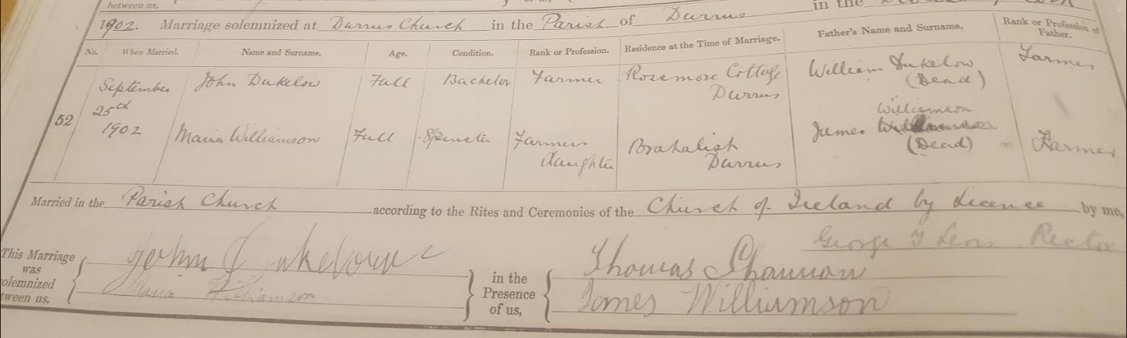

Jim Dukelow, Coomkeen Jan 2014, died 2017 aged 90.

Jack took over the farm when his brother James died. Before that he was free. He played the fiddle and would often play in Durrus and after a few drinks would go to Bantry then proceed to Ballylickey to Glengarriff and onto Castletown Bere, walking all the time. He could be gone for a few days. His mother was from Castletown and he was on her side descended from O’Sullivan Bere (this may not be correct).

Jim Dukelow himself had a turn of wit, some years ago addressing an IFA cavalcade of tractors assembled at the Bantry Tyre Centre he denounced Larry Goodman the ‘Beef Baron’, in the following terms. ‘Is a pity Larry Goodman’s mother did not had a banbh (Piglet) instead of him. If she had it would have been slaughtered after birth’

When JIm was young in the 1930s a number of Shannon children died from diphtheria the condition of the school at Clashadoo was suspected. Another school was built, the first Church of Ireland in the Free State. The Department of Education grant only covered about two thirds of the cost and the parish had to come up with the balance. The parishioners were levied according to their rateable valuation and in Jim Dukelow case the levy was £8. His father, Bob, had to sell the best cow in the middle of the economic war with Britain. He recalled getting up at 2 am and walking the cow over the hill from Coolculahta with his father to Ballydehob fair where it was sold later in the day.

Jack was fiery, full of temper and fire, very loud you would hear him a mile off.

On his death on the 13th May 1953 there was an article in the Diocesan Magazine

He had a sidecar which the family did not use after his death. In earlier years he would have a horse racing at Durrus Races on Stephen’s Day

He told Nancy Peters that there was a mass grave in Rossmore and another West of Attridges. He also told her that women from Kilcrohane would walk barefoot to Cork with a pannier of butter wrapped in cabbage leaves. 10 miles before Cork they stopped at a particular rock and out on boots.

His granddaughter recalls in the 1950s his pension was 17/6 and from that he would buy big bars of Cadbury’s chocolate for her and her the late brother Eric.

His daughter Sarah had two sons, one Ernest Dukelow was adopted by a US couple in 1954 and grew up in Louisiana. His adopted name is Frank Snellings. He became a lawyer and married Mary Landrieu. Her father was Governor of Louisiana and her brother currently is. She was a US Senator from 18996 to 2014. Another son Percy Dukelow was born in 1947 and for the last 30 years had been the right hand man to Joe Costello, a TD and Junior Minister for Dublin North Inner City.

He was on the scene of Durrus RIC Barracks on the morning following the raid October 1920 and found blood stained clothing and surmised that there had been serious injures.

Jack came across the RIC barracks after the raid. The raid was reported in the Cork County Eagle on Saturday 3rd April 1920 and according to Gibbs Ross RIP Publican Durrus and nephew of Gibbs Ross who was involved in the raid, the article is inaccurate in a number of respects according to what he told Mrs Hickey whose house is built on the site of the Barracks. The numbers involved is grossly exaggerated. Jack Dukelow Rossmore was one of the the first on the scene the following day and found blood stained clothing and surmised there had been serious injuries Richie Dukelow, Brahalish, August 2008.

From Ron Price Belfast:

Between 1981 and 1990 I made notes immediately after speaking to various Co Cork people about my Cork ancestry. I now wish to make those notes available to anyone interested. Any clarification comments added at this stage are in square brackets. I would welcome any questions or comments.

Source: Anne (Nan) Dungen (nee Bryan) (1900 – 1985) then of St Luke’s Home, Cork City

My great Aunt Nan had previously written to me that the mothers of her grandparents were Deane, Jagoe, Shannon & Sweetnam.

Notes from conversation on 28 Jan 1981

- Margaret Sullivan’s family [her great grandmother] came from Tadagh near Bantry. They were Roman Catholics, Margaret changed to Church of Ireland [see below for correction].
- The Shannons came from Brahalish she thinks, but was not sure.
- She did not know where the Sweetnams came from.
- She stated that the Bryans of Cunnickeenbuee [Knockeenboy] were once wealthy, but deteriorated.

Notes from conversation on 31 Jan 1981

- William Dukelow (Father of Jack Dukelow) fell off his horse when it shied, coming home from Durrus Races. He had been drinking.
- Margaret Sullivans [family] was Protestant before she married William Dukelow, however they may have been Roman Catholics originally.

Notes from conversation on 1 May 1983

- Our Sullivans were O’Sullivan Beare.
- She said her mother had told her of a Sullivan who married a Vickery and she had forced him to change his religion. She promised him “a boot of gold or a revolver” (I can’t say I understand this!)

Bob Dukelow, Coomkeen talking with Pat Crowley 1970s The Jewish packmen used to come around to houses selling holy picture and trinkets. They would go back to Cork on Saturdays? for synagogue It is prophesied in the Bible that when they go back to Israel the end of the world is coming and this is now happening.

His brother with many other family members went to America to California. He came back to Ireland during Prohibition. He was fond of a sup and went onto Bantry on Fair Day and ended up coming back on the horse and cart.
Bob would often spend Sunday afternoon down with his neighbour Bridget Crowley nee O’Sullivan, Ceohanach, and Paul Shannon ex Clashadoo until her death in 1966 in her 90s. Families and neighbours would be traced, cattle sales and prices compared old stories recited by the fire.
Bob’s son the late Jim says that he as an elder citizen now gets more in Pension then his father Bob whose starting pension at 15 shillings a week in 1955 would get in nine years.

Connolly?

He was the Minister’s man lived on the back Gearhameen Road where the Burkes are now. He was partial to a sup of drink. One morning he arrived with no shoes and socks the Minister asked why and he said he had no money. The Minister gave him some and he skedaddled to the village. Later he appeared again with no shoes or socks the Minister asked did you get socks Yes he said with black tops (pints of stout).

Another time he was in Jacky Cronin’s store on the Lower Lane (Jackie was from the Cove) his family place was where the O’Donovan Cove House was, during the War he used to go on his truck to Cork for bread and saved people from starvation.

Connolly was sitting on a butter box when George Hegarty, Rossmore, (Father of Jimmy) came rushing in all fluster. There is a blight warning in the paper I want bluestone Says Connolly aren’t you lucky it is not in the stalks.

Joe O’Driscoll grew up in the 30s and has done a list of Irish words in ordinary use while he was young. Before he would go to school he would check his rabbit snares usually getting around 10. There was a man who used to buy them at the creamery. Nancy Peter’s father Tom at Sea Lodge used also buy them and they were collected by a man with a lorry who used to send them to England.

George Swanton, Molloch.

George was fond of shooting in the early years of the 20th century with the Warners. The Warners were well to do and dressed well for the outings. George in contract wore his oldest of clothes on the basis that were less likely to frighten the birds.

Sam Ross

For upwards of 200 years the Durrus River was fished of salmon without the benefit of a licence. Many of the most prominent local families ahd member who fell foul of the fishery regulations. Methods of poaching included strokelauling (Gaffs), dazzling, nets, and the use of hay forks under the creamery bridge. In the 1940s one of the local nocturnal group was headed by Sam Ross. He was single and lived in the end room over his brother’s public house in Durrus. HIs difficulty was waking ap at 4 am when his group would be ready. In exasperation they came up with a solution. A string was tied his his big toe and let out the window to dangle in the street. At the appointed tie they would give a tug to wake him and they would all then go about their business.

Shannon, Rossmore

In the early years of the 20th century one of the family used to go barefoot to school in Clashadoo. It must have been by preference as the family were in reasonable circumstances. On cold morning he would follow a horse hoping to step onto warm dung to heat his feet.

Batt the Fiddler

1880s born Gloundala, Dunmanway an old lame man who played the concertina, wrote a satire on Fr. Kearney, the curate in Kilcrohane later Parish Priest of Durrus. Fr. Kearney (from Manch by the River Bandon) was very anti-dancing Batt played the concertina at cross roads and Fr. Kearney condemned Batt from the altar.

And like wise Father Kearney
I don't want to praise you failte
For I played in Muintir Baire
Before you knew your creed.

Another version is given in ‘Under the Shadow of Seefin’

‘Well as for Fr. Kearney, I don’t wish him good or harmy,
I was playing in Muintir Varra before he knew the creed,
Tis well I know his father, he lived by the Bandon water
And his second eldest daughter ran away with Luther’s breed’

Durrus history (from the children accounts in the folklore project 1937-1939, Durrus schools (St. James, Carrigbui, Dunbeacon)
Poet; Charles Dennis, died 1961 aged 82 years

Oh! Durrus, you were often fleeced,
In the good old days gone by
And only for Mr. MacManaway
You should lie down and die
He's out to help industry
Give every man fair play,
His enterprising capitalist
Will surely win the day
(He can use a pick and shovel
As any man desired,
To hear him preach on Sunday
You think he was inspired)
His latest stunt is to build a road
Through the fair valley of Coomkeen
It starts at Crocawadra
An ends in Gearameen
(Tis a very hilly country
Often fed a horny ram
Where myself and Mick the postman
Often ate our badger ham)
We'll make of him a Bishop
And that without a doubt,
And he'll remove the Border,
Between North and South.

There are two versions of this poem from Carrigboy and St James’s school and they have been unified here. More of his works are in the Paddy O’Keeffe papers.

Poet; Kearney
I don't want to praise you failte
For I played in Muintir Baire
Before you knew your creed.

Another version is given in ‘Under the Shadow of Seefin’

Batt the Fiddler

1880s born Gloundala, Dunmanway an old lame man who played the concertina, wrote a satire on Fr. Kearney, the curate in Kilcrohane later Parish Priest of Durrus. Fr. Kearney (from Manch by the River Bandon) was very anti-dancing. Batt played the concertina at cross roads and Fr. Kearney condemned Batt from the altar.

And like wise Father
‘Well as for Fr. Kearney, I don’t wish him good or harmy,
I was playing in Muintir Varra before he knew the creed,
Tis well I know his father, he lived by the Bandon water
And his second eldest daughter ran away with Luther’s breed’

Charlie Dennis died 5th June 1961.

Paddy O’Keeffe, Bantry Antiquarian attended the funeral and has a note, ‘Met Edwin Hurst recorded a ditty of Charles. Edwin brought me the following scraps in his handwriting the property of Mrs. Richard Swanton?. I returned the originals 9th December 1961

Here lies the body of Charles Dennis
He loved the brew of Arthur Guinness
Like all great men who lived before
He’s off the brew for evermore

Her lies a man that was no good
And if he lived he never would
Wherever he is and however he fares
There is nobody knows
And nobody cares

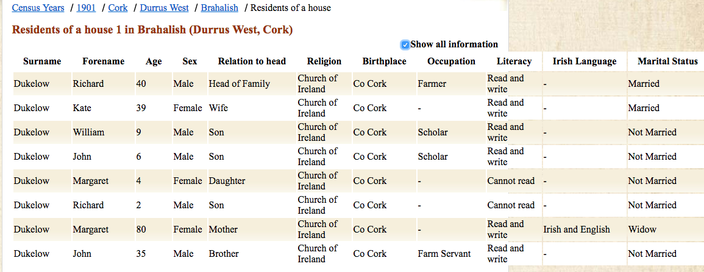
….

…
1902, Jack Dukelow Deed:

 |  |  | Type of deed | Date of current deed |  | 12 May 1902 | Vol | Page | Memorial
 |  |  | Indenture | Date of earlier deed |  | 5 Nov 1879 | 190237 | 19 | 190237019
No | Role(s) in earlier deed(s) | Role in current deed(s) | Family name | Forename |  | Place |  | Occ or title |  | A
A |  | P1 | DUKELOW | James | of | Rossmore [Durrus], Co Cork |  | farmer; son of William Dukelow [B] & Margaret Dukelow [C] |  | A
B | P4 | mentioned | DUKELOW | William | of | late of Rossmore [Durrus], Co Cork |  | farmer; died 26 Dec 1896 intestate
C |  | P2 | DUKELOW | Margaret | of |  |  | widow of William Dukelow [B] |  | A
D |  | P2 | DUKELOW | Charles | of | Dunbittern West, Co Cork |  | farmer; son of William Dukelow [B] & Margaret Dukelow [C] |  | A
E |  | P2 | WRIGHT | Margaret | of | Castlelane [Cashelfean, Co Cork |  | wife of Michael Wright [F]; daughter of William Dukelow [B] & Margaret Dukelow [C] |  | A
F |  | mentioned | WRIGHT | Michael | of | Castlelane [Cashelfean, Co Cork
G |  | P2 | DUKELOW | William | of | Brahalish [Durrus], Co Cork |  | farmer; son of William Dukelow [B] & Margaret Dukelow [C] |  | A
H |  | P2 | DUKELOW | Richard | of | Brahalish [Durrus], Co Cork |  | farmer; son of William Dukelow [B] & Margaret Dukelow [C] |  | A
I |  | P2 | BRIEN[BRYAN] | Anne | of |  |  | wife of Henry Brien [J]; daughter of William Dukelow [B] & Margaret Dukelow [C]
J |  | mentioned | BRIEN[BRYAN] | Henry | of
K |  | P3 | DUKELOW | John | of | Rossmore [Durrus], Co Cork |  | farmer; son of William Dukelow [B] & Margaret Dukelow [C] |  | A
L | P1 |  | JAMES | Charles Henry | of | Merchants Quay, City of Dublin |  | Official Assignee of the Court of Bankruptcy in Ireland
M | P1 |  | DEERING | Lucius Henry | of | Merchants Quay, City of Dublin |  | Official Assignee of the Court of Bankruptcy in Ireland
N | P1 |  | O'DRISCOLL | Cornelius | of | Kilthomane[?], Co Cork |  | farmer; creditor of George Henry Rawlings [O]
O | P2 |  | RAWLINGS | George Henry | of | Rossmore [Durrus], Co Cork |  | farmer & shopkeeper; bankrupt
P | P3 |  | SUTTON | Thomas | of | North Mall, City of Dublin |  | Butter Merchant; mortgagee of George Henry Rawlings
Q | P3 |  | ATKINS | John | of | Dunmanway, Co Cork |  | Merchant; mortgagee of George Henry Rawlings
R |  | WD WM | FLYNN | James | of | Bantry, Co Cork |  | Solicitor |  | A
S |  | WD WM | BUCKLEY | Patrick D | of | Bantry, Co Cork |  | Solicitor's Assistant |  | A
Abstract |  | Recites that B had obtained a lease of 46 acres of Rossmore & Brahalish in 1879 formerly held by O, a bankrupt. B had verbally transferred this land to A on his marriage. A now sold the land, its stock & implements, to K, with the formal agreement of his siblings.
MS |  |  | Date registered | 17 May 1902 |  | Date abstract added |  | 20180913

Abstract made by: RonPrice

Go to film
..

..

...

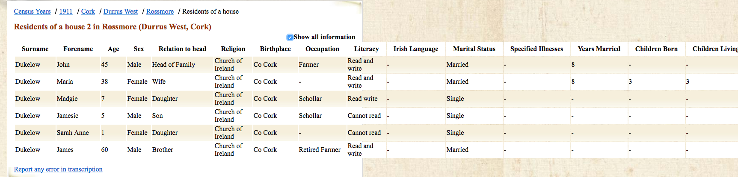

Used to be held from the Creamery to the Holly Bush in Ballycomane in the past on St. Stephen’s day now New Year’s Day
From Jimmy Swanton, Clonee, aged 78 in 2016.
Progressive farmer, Beach House, Bantry promoter agricultural shows Bantry and Durrus. Family mid 19th century coastguards from North of England. Married Shannon from Clashadoo, Durrus father of Hazel Vickery Bantry historian.
From David Shannon Brahalish wester October 2016.
Jimmy (Bens) Swanton, Clonee, October 2016
Michael O’Sullivan who was in school in the 1940s
Part of old Townsend Estate house recently refurbished.
Corroborated by Father Kelleher, CC Durrus evidence to Devon Commission c 1835 of local girls walking to Cork 10 times a year with baskets of eggs earning £4 a year.
Mary nee Fuller died 2017 in her 80s. Like her father she had an immense knowledge of genealogy and compiled books on the Dukelow, Swanton and Sullivan/O'Sullivan families.
Told August 2018, Nancy 93 this August.
The Grain Store may have been built by Lord Bandon at the time he rebuilt mid 1850s Durrus it was let to a London Fishing Company in the 1880s
Sarah Dulelow (now Mrs Peters) said that her teacher Mr Blennerhassett was enthusiastic and had good Irish, she remembers filling 24 copybooks but when she checked at the Folkore Commission there were only 4.
The Kearneys were a wealthy family of large farmers, one of the daughters married a Protestant.

