Pilchard

Baltimore

Bantry and Durrus, p.4

Ballydehob/Crookhaven/Skibbereen, p. 20

Courtmacsherry, p.22

Kinsale,p. 25

Grand Jury Presentments Seasand roads, 26

Lloyds Agents

Ropemakers, Nets

Smuggling,p. 33

Wrecks, p. 38
Pilchard Palaces, p.44

Maps

Among the families involved in the Fishing Business in Bantry in the 18th century were the Jagoes. Families of that name were active in the Pilchard Business in Cornwall in the 17th century.

It is now believed that Sir William Hull active in the West Cork fishery also had an operation in what is now Atlantic Canada in the early 17th century.

..
Harvest of the Sea Herring and Pilchards
.
What is termed the Medieval Warm period commenced in the North Atlantic around 1330 and this coincided with the start of the fishing industry in Ireland. From 1375 onwards the herring fishery in the South West was well established. The herring had migrated from the Baltic to the South West coast of Ireland and this was the major economic event of the period 1300-1500. Tribute was paid by the French and Iberian fleets to the O'Mahony, O'Driscoll and McCarthy families. This conferred on them the right to fish, and also to build on-shore bases to salt their catch, as herring had to be processed within 24 hours. This prosperity gave rise to significant building of religious and tower houses in the overall area, in the first half of the 15th Century. The O’Mahonys alone built twelve castles of which a number at Dunmanus, Rossmore (later taken by the McCarthy Muclaghs), Dunbeacon and Ballydevlin are in the area. They have minimal defense features, suggesting this was a time of peace and prosperity. It is believed that these tower houses served as centers of the fishing industry and were surrounded by more comfortable houses. Recent excavations in the front lawn of Bantry House (formerly Blackrock) suggest the presence of a creat, a one roomed wattle-built structure; may have been in use around the various Tower Houses including Rossmore. Some years ago the Shannon family whose house is in the vicinity of Rossmore Castle was doing farm work in the general area of the castle and came across cobbled surfaces some distance away. This may suggest that the curtilage of the Castle contained farmyards and other areas of activity. Michael Carroll, Marine Historian, Bantry considered that there may have been a fish palace on the site. The 15th Clan Gathering of the O’Mahony family was held there in July 1969. The O’Mahonys ruled the Western lands including the western parts of Durrus on the Ivagha (Mizen) Peninsula such as Dunbeacon for over four centuries with a succession of 20 O’Mahony chieftains. Of the 56 castles built in Co Cork by Gaelic chiefs. 14 were built by the O’Mahonys.

The South Western peninsulas have a long tradition of trade with continental Europe. The Roman writer, Tacitus, circa 90 A.D. stated that the harbours of Ireland were better known in Rome than those of Britain. Aethicus of Istria would have a wine trade with the south west of Ireland, circa 100 A.D

In the medieval period, wines and such luxuries as leather from Spain, and other exotic items arrived by sea, and were exchanged for wool, fish and hides. Recent excavations at Dunboy Castle have yielded pottery from France, Spain, Portugal, Italy, Germany the Netherlands and China from the late 15th to the early 17th centuries. Circa 1190, the author in Irish of Acallam Sean Ó Rach (Colloquyfry) referred to seas teeming with fish, and in a letter circa 1449 mentioned the value of the fishing dues to Lord Carew of £2,200 sterling. In March 1569, in a report to the Secretary, Cecil, in relation to the South West, stated that it was fruitful to the Spaniards that “every year 200 vessels sail to fysh there”.

The English administration was alarmed at the loss of revenue by the use of the fishery by the Continental fleets, and in 1430 there was a complaint that the King was losing 300-6—marks because of ‘illegal’ exports of fish. There were further decrees in 1450 and 1465 directed against “foreign fishermen without license fishing among the king’s Irish enemies.” A query was put in 1586 to the English authorities as to whether the fishing customs at Baltimore, Bere and Bantry belonged to the English Queen. The reply in 1592 stated that since the time of Edward 111 (1327-1377) and Henry 1V (1399-1413) the Irishry prevailed and expelled many English gentlemen from their possessions and in effect there is no record of a royal entitlement to the customs.

William Hull (the Vice President of Munster) had established pilchard palaces (basic processing buildings where the pilchard oil was extracted) at Dunmanus and Dunbeacon. In the rising of December 1641 these were attacked by ‘800 rebels in all’ according to Hull and the entire industry was wiped out. He identified O’Mahonys from Leamcon and O’Dalys from Kilcrohane as being part of the raid. His claim later for compensation gives good detail on the workings of the industry. His claim included 16 seine boats allegedly lost; each would have a crew of twelve and a further 80 would be needed. Hull himself was implicated for his involvement and for help given to pirates.

There is historical evidence to document the pilchard industry in the South West coast from Rathmolin, Waterford, to Ballinskelligs in Kerry, from approximately 1600 to about 1750. This was an important industry with Bantry as the primary centre, together with outlying curing stations called “Palaces” of which there were a number in Dunmanus and Bantry Bay areas. In a deed of 1778 between the O’Donovan family of Tullig there is a reference to Timothy O’Donovan late of Pilchard Point, which may have been in this area. The point nearby is known as point na mbad. Fish was caught by means of the seine, which together with the curing at the fish palaces had been introduced by English settlers from the west country in the period. Interestingly Timothy O’Donovan, Landlord and Magistrate of O’donovan’s Cove, Durrus, gave a written submission to the Fishing Enquiry 1836.

Two boats, the seine boat and the so-called “follower” were used. The seine boat, a large boat pulled by perhaps a dozen or more oars, carried the net, which was often 300-400 yards long. An experienced fisherman acted as a “huer” by directing fishing operations from suitable points of vantage. From high land, the huer could see the shoals of pilchards clearly, and he directed the skipper of the seine boat by suitable signs to the location of a likely shoal. On a given signal, the net was shot around the shoal by the seine boat, and in the meantime, the free end of the net was picked up by the “follower”, with a crew of perhaps five or six, and the two ends of the net were brought together. Weighted pieces of timber were placed to prevent the fish from escaping. The escaping footropes of the net were gradually drawn up until the fish were completely enclosed by means of baskets the fish were transferred from the net to the boat, and fishing continued until no more fish could be managed, or if catches were poor. The pilchards were preserved with salt in the “palaces” or occasionally smoked. Smith, in his history of Cork, states that “the extreme point of this tract was called Ballyogy Head, between which and the opposite Cape called Missen Head (anciently called notium promontorium of Ptolemy is a great Bay; and another between that and Three Castles Head, so called from the three square Towers built on it by the Mahonys, and then comes the larger Bay of Dunmanus, which has its name from Dunmanus Castle, erected on the East banks thereof, by that sept which was fortified with walls or flankers. Near it is a good house of Mr. Donovan, with adjacent fish palaces”.

James Fontaine (Huguenot owner of fishery Beara) said that you couldn’t enter the pilchard industry unless you had a large farm with many tenants on it obliged to fish for you.

Up to the late 1940s there were a number of seine boats operating in Dunmanus Bay. A field on the farm of Mr. Mark Mehigan, of Drisheen, Dunbeacon, was known as the “Palace Field”, a name which probably records the existence of a pilchard press. The townland of Paddock in Kilcrohane is sometimes described in deeds as Palace.
..

1588. Historical notes on Bandon River Fishery, Co. Cork, (formerly known as Glashlinn: Green River), Salmon Weirs, Oysters, Pearls, methods of Fishing, Legal Title commencing with Grant in September 1588 of 'Castle of O'Mahony' and a Moiety of the Cantred of Kilnamecky to Phane Beecher. The author Dr. Went was London born and a long time advisor to various Irish Government Departments. He lived in Sandycove in Dublin. He was the author of many articles on fisheries which are characterised by a very high degree of scholarship and research. He was a long time member of the Cork Historical and Archaeological Society.

..
Baltimore:

Francis Jobson's Map (at back) of West Cork, 1589 including Cape Clear (Iniskyran), Baltimore, O'Driscolls, Rosbrin, Crookhaven, Bantry, Muintervara land of Rymers (O'Daly's Bardic School), O'Sullivan Bere, Priest's Leap.

Early Map of Baltimore, West Cork (Between 1605-1640), showing English Settlement, Dunasead Castle, Loo Rocks, Storehouse for Preserved Fish, 12 Fishing Boats, Seine Pilchards, 5 Possible Royal Navy Boats.

Some time after the Port was raided by Algerian Pirates.
http://en.wikipedia.org/wiki/Sack_of_Baltimore
The Baltimore Fishery was part of a larger fishery including Leamcon, in Schull controlled by Sir William Hull, that of Whiddy Island rented by Davenant from O’Sullivan Bere and that of Cornwall. Hull may have had another fishery in Newfoundland. The fisheries were financed by London merchants.
..

…
Bantry

Pre 1500. Kilcrohane, Farnamanagh Strand, which roughly translates to 'land of the monks'. A monastery was built here in early christian times and was a center of refuge for persons of substance from the Iberian peninsula which came under attack approx mid 700's from the Moorish invasion. According to legend, 2 of the sons of the king of Spain drowned there when one got into difficulties while swimming and the other went to help him. We know from history of the Umayyad conquest of Hispania and in particular the northern Iberian Peninsula during the mid 700's AD, some of the smaller Spanish kingdoms came under intense pressure and sent their families abroad for safe-keeping during these turbulent times. The Basques and the Galician's had been coming north to Irish waters for centuries to fish during the Summer and in the process establishing trade and religious links, so it is reasonable to assume that some of these families established places of refuge for their families here.

1531 Dermot O'Sullivan, 'Prince of Bere and Bantry' hangs English Captain that seized Spanish ship, 1572 Spanish and Basque fleets at Baltimore, 1586, O'Sullivan Bere and O'Driscoll 'extortionate dealings' with English fishermen, 1683 Herring fishery between Baltimore and Bantry Bay.

1591. Sir Owen O’Sullivan and his son Owen lease Whiddy island to Hugh Brioghley and James Derbyshire.

2 Votes

1584. Edward Davenant (1568-1639), Record of Cambridge University, England Entry 1584 of ‘Whiddy Island’, Bantry, Co. Cork. Later owner fishery. This corroborates the Fishery at the time being financed from London Merchants He is son of John, brothers John 1587, William 1590, George 1602.

1608. Lease of Whiddy to Edward Davenant for fishery from widow of Sir Owen O'Sullivan. Further Davenant papers 1621, 1622, 1631, 1637. Public Records Office. London.
1622. Question of levies on fishery at Whiddy Island referred to english Privy Council for a determination.

c 1608. Rebecca Barnham. Her father Nicholas Barham Commissioner for Conservation of Peace, Clonakilty mother Rebecca he (John Snelling) a partner with Edward Devenant in Whiddy Fishery leased from O'Sullivans 1608. Sister Mary m William Slader Crookhaven
1630. Will of Richard Steventol, Gent., Whiddy island.

1639. Will of Edward Davenant, Whiddy Island

1641. Frank O’Mahony’s book ‘Losses sustained by William Hull’ arising from the raid on his pilchard fishery at Dunmanus and Dunbeacon by natives of Kilcrohane in 1641. He identified then as the former O’Mahonys of Leamcon, Schull and from KIlcrohane, Daniel O’Daly of Raffergreen, Charles Daly of caher, Tim O’Daly and the ‘widow’ Daly of Rossnacaheragh.

1648. Petition from John Winspeare, c 1648, Shipwright, living near Bantry Bay, West Cork, Timber for Staves, Propositions for Felling, and Deed of 1724 Robert Winispeare probably Durrus. Petition from John Winspeare to [?]. Writer, a shipwright living near Bantry Bay, co. Cork, now makes his livelihood `upon the fishing trade’. He has found in neighbouring woods much `knee timber, standards and ripe staves’ which would be useful for shipbuilding. He asks `your worships’ for permission to fell timber, and to build `any lighter or boats for the carriage’ to the eventual port for transportation [? to England], and gives details of suggested payment for himself for delivering the timber, prepared for use, `on board in the river of Kilmarr [? Kenmare] in Bantry Bay’; he also calculates freight charges. Endorsed (different hand): `John Winspeare his proposition touching felling, squaring etc. of timber and of woods in Ireland’.
Date: [? 1648-1660]
The name appears in the Durrus area from the late 17th century and as witnesses to documents Bantry area mid 18th century. A John Winspeare married a widow Rachel Anglin in 1738. Some of the family later married Church of Ireland McCarthys from whom a long line descend. Robert Winispeare probably Carrigbui (Durrus), Deed 1724, names Beversham Harman, Lahern (near Ballylickey), Hutchins also probably involved in timber trade and fishing.

1672 and following years, pilchard curing hose at Dursey Island.

1699. The record of Bishop Dives Downs’ visit to Bantry in 1699 referred to ‘a lack of pilchards’. He also referred to scallop beds off Horse Island. Ships up to 1.00 tons come within Whiddy Island, In 1689 up to 20 French men-of war came to Bantry Bay engaged with British between Bere Island and Muintervara.

1700s. Davy Crocket’s ancestor James Crockett born c 1674 (may be later) was the child of one of the 13 Huguenots who worked with James Fontaine in a short lived fishing enterprise around the late 17th century to the early 1700s. He was Louise de Sax Crocketagne (Anglicised to Crockett) mother Antoine. The fishery was in the Castletown/Dursey area. Rev. James Fountain/Fontine -1728), 1702, Beara, Huguenot Minister, established a fishing colony including an ancestor of Davy Crockett, his own descendant include US Hydrographer Matthew Fontaine Maury (1806-1873). Left France 1685 and turned up in Cork. Mentioned as a Magistrate, Cork 1694 as broadcloth manufacturer, Freeman of City, eventually moved to Castletownbere set up a fishery. As a Justice of the Peace claimed that he at the hands of ‘Irish Robbers’ and French Privateers. His house was besieged by the French he was kidnapped and a ransom paid. Secured a pension of 1705 from Queen Anne of five shilling a day for protecting shipping from his fort in Beara. Moved to Dublin and secured damages of £800 from Cork Grand Jury.

1726. In an article by the Archbishop of Dublin in the 1726 Edition of ‘Boates Natural History’ it was stated that prior to 1688 there was good fishing of pilchards in the South coast, but since the fight in Bantry Bay the pilchards have not been seen on the coast.

C 1730. Rev. Richard Davies b 1682, TCD, son of Dean Davies, Bishop of Cork, Vicar of Bantry multiple businesses, pilchards, iron, timber, used stones from old Franciscan Abbey to build fish palaces. He was an associate of the Galweys of whom he took their renounctions against Popery. His daughter Martha married Richard White of Bantry.

1735. There is however reference in 1735 by Mr. Jenkins, giving evidence before a Commission on the state of Irish fisheries. He had seen the books of Mr. Meade who was involved in the fisheries in Bantry Bay from 1730 to 1745, and exported enormous quantities of pilchards. In 1749 Nicholas Meade of Bantry obtained a premium from the Royal Dublin Society for having caught and cured 380,000 fish.

1730s, Kilcrohane. Duneen Pier. This is a substantial stone construction and was built to enable sailing ships engaged in coastal trade to dock in relative safety. In its time it was a significant port for the export of salted fish and there is also a legend that it was used as a port by brandy smugglers. The O’Donovan, KIlcrohane, Ardahill family may have been involved in this very wealthy no visible means of support. There is a well hidden cave here which is only accessible during very low tides. The entrance is very small necessitating a person to crawl on their hands and knees which in turn leads to a large chamber which was used for the storage of the contraband. Further west, the last pier on the south side of Dunmanus Bay is Tra Ruaim. This also played a significant part in the substantial Pilchard and Mackerel fishery of the Bay.

1730s and 1740s Richard White the ‘Counsellor’ kept an account book detailing his involvement in the pilchard trade, Pilchard oil, oak staves, oak bark, iron ore.

1742 the Durrus lands were purchased from Charles Moore of Tipperary by Stephen Bernard in trust for Francis Bernard. The lands included a fish palace at Mannions Island, Rossmore.

1767. Mackerel were plentiful, in 1767 there were complaints that 50 French boats were fishing for mackerel off Bantry Bay with no hindrance from the Customs.

1770. In 1770 the complaint went that 500 French boats were involved some as large as 200 tons. This activity yielded no benefit to the area.

1798. 200,000 herings caught in one haul in Bantry.

Pre 1800. Bantry. Samuel Vickery, trammel owner, Richard Young and John Jagoe seine owner Samuel Young Port Surveyor, John Young probably over 90 in 1828, fish merchant, Richard Young, John Sandy Bird fish merchants. Evidence to Parliamentary Enquiry on Fishing Bantry 1828 Eppi

1810. Horatio Townsend 1810 writes of the disappearance of the pilchards and the gradual disappearance of herring and sprats. He says that by Smiths time 1750 the pilchards had disappeared.

1819, Michael Dealy, Gent, conveyed to Paul Kingston, shopkeeper, Bantry and William Dealy, his brother, then of H.M. boat Kedal?, part of lands at Dromkeal, Bantry, together with farming and fishing and fish curing utensils.

1836 in evidence to a Parliamentary Enquiry Mr Young then still active in the fishery in his 90s remarked that one of his predecessors lost a fortune in the collapse of a Spanish Finance House. This was probably Bilbao in 1641.

The record of Bishop Dives Downs’ visits to Bantry in 1699 referred to ‘a lack of pilchards’. In an article by the Archbishop of Dublin in the 1726 Edition of ‘Boates Natural History’ it was stated that prior to 1688 there was good fishing of pilchards in the South coast, but since the fight in Bantry Bay the pilchards have not been seen on the coast. There is however reference in 1735 by Mr. Jenkins, giving evidence before a Commission on the state of Irish fisheries. He had seen the books of Mr. Meade who was involved in the fisheries in Bantry Bay from 1730 to 1745, and exported enormous quantities of pilchards. In 1749 Meade of Bantry obtained a premium from the Royal Dublin Society for having caught and cured 380,000 fish. The previous year 1748, James Young landed 231 barrels of sprats and 482,000 herrings. Horatio Townsend 1810 writes of the disappearance of the pilchards and the gradual disappearance of herring and sprats. He says that by Smith's time 1750 the pilchards had disappeared.

Bishop Downes commenting on Castletownbere in 1699, stated that in the coming season 20 seines were expected to be operational, with 2 boats and 15 men on each boat.

Regulations made in 1735 Between The Owners of Seine Boats in Bantry Bay, Dispute to be Determined by Mr Nicholas Mead at His House 'Spread Eagle'. Presented to Fishery Enquiry 1836 by Mr. R. Young and 1749 Bounty from Royal Dublin Society to Mr. Meade and Young for Fish Landings at Bantry.
..
C 1730s. Reen Strand, Durrus

Opposite former demolished house of Timothy O’Donovan, Landlord and Magistrate. Had kennels, stables, glasshouses growing grapes, pineapples. The late Barry Cronin’s family built house and yard from stones. Walls and gates remain. His brother Richard O’Donovan, Landlord and Magistrate lived at The Fort a few hundred metres east now owner by Mr, Ryan of village shop and for sale. In Reen strand area reputed ‘palace’ press for extracting pilchards.

The reference to “Spread Eagle’ presumably a licensed premises. The Meades were given: 1615. Patent 15 of King James 1 of England, David Meade to Sell Liquor in Carbery, and to James Roche and Richard Liquor Licenses at Crookhaven and Berehaven

1748 Nicholas Meade landed

Nicholas Meade Bantry Merchant. 1750 affidavit before Richard White, JP, that Marcus Downey, Timothy Sullivan and 16 hands involved in rescue of Hampton Court, Captain Moyson and Prince Frederick UK Archives: ADM 106/1080/261

The Young family were involved in the Bantry Fishery since at least 1600. The Youngs lived at Young's Point possibly Rearour. The location of the present Maritime Hotel is probably on the site of fish palaces which seems to have been abandoned around 1750 when they were leased to the Young family. This was build on stores which were once Young property. There are descendants in the Dunmanway area.

Nicholas Meade active in Bantry pilchar industry 1730-1745 turns up c 1755 in deeds as a merchant in Bandon.

The pilchard fishery was run in the early 18th century by the Galwey, Meade, Bird, Young, Vickery and Davies families. 16 seins owned 1730s by Young, Meade, Gawey families and pastor Davies one shipment of 6,000 barrels.

1740 deed of Cork City property Richard White, Bantry, Captain Andrew Ross, Edward Shipsey. The Shipseys were quasi-partners with Richard White in shipping boat loads of staves from Bantry to Cork and appear in the Bantry estate Records c 1750. The Shipsey were Quakers from Bandon/Rosscarbery/Cork and associated with Cork mercantile families. A branch in the 19th century became Catholic and were fish merchants in Schull and Dunmore East.

1750. Charles Smith (author of ‘The ancient and present state of the county of Cork’, 1750) further says that before that, in many creeks around Bantry, there were several fish palaces for saving, preserving and salting pilchards, which were sent to Spain, Portugal and Italy. He says that the fishery ‘generally began around St James’s Day or the 1st day of July, and for the first three months they were large, fat and full of oyle, and were saved with difficulty, being darker and worse coloured than those taken in the Winter months, and less prized in foreign markets, notwithstanding they were afforded more profit, having a much greater quantity of oyle’. W. G. Biggs office in the Square in Bantry is built on the site of a fish palace. The Fishery held until the end of the year; 600 barrels of these fish, having been enclosed together in one net. When the pilchards were cured they were known as “fumados”. The fishery would have given great employment for coopers, carpenters, clerks in the overall area.

1760s, Lease renewal to Richard Mellefont, Esq., by Kenmare Estate of Donemark, Bantry, West Cork for Three Lives Mellefonts Father had Vastly Improved and Enclosed Fields of a Proper Size with Well Planted Ditches and Had Fish Palaces Redundant Due to Flight of Pilchards.

In 1788 the French traveller Daniel Augustus Beauford was in Bantry and reported that after some pilchard catches there was some hope of a return but this did not happen.

Bantry Chandlers and Associated Trades:

1756, Plumer Young, chandler obtained lease from Richard White decd by 1841.

1759. Donemark remarks by Lord Kenmare, the farm lies on Bantry Bay, it has large palaces or receptacles for carrying on fishery which the tenant, Richard Mellifont’s father carried out while the pilchards wee in the bay. There is a good harbour for shipping or boats.

1773, Thady Sullivan, Subscriber Manual on Mercantile Law most are leading merchant or lawyers in Ireland. Lex Mercatoria Rediviva: Or, The Merchant's Directory: Being a Complete … By Wyndham Beawes, Jacques Savary des Brûlons

1781, Letter Richard Wright, Port Surveyor, Skibbereen Enclosing Letter from Philip Townsend, Tide Surveyor, Berehaven, re Naval Movements Privateers, Dutch and French Boats

1812, Thomas Clarke, probably related to Young family. 1814, chandler.

1812, American Edward Wakefield, Travels in Bantry. ‘Miserable Hogs, Long Legged, Narrow Backed Ill Shaped Level of Animals, Lord Bantry Introducing Devonshire Cattle, Marine Sand Coral and Manure.

1816, Plumer Young

1816, Jeremih Donovan, rope maker.

1818, Thomas Clarke, Chandler. William Young leased premises to him.

1824, Bantry House Map (at rear appendix) of projected road to Bantry house shows the clustering of fish related businesses and the names mentioned all of whom are interrelated follow the classic economic model of a cluster and specialisation. There is nowhere west of Cork that had so many fishery specialised businesses, Kinsale had many but more ship repair or provisioning.
.

..
1824.

Robert John Bird, fish merchant, North st.
R. N. Bird, fish curer, North st.
John Boyce, Inspector of Fisheries, Main St.,
Clerk and Levers (Levis), fish curers, Main St.
Morgan Connell, salt dealer,
J. Donovan and Son, rope makers and fish curers,
John Slattery, fish curer, Main St.,
Thomas Young, fish curer, Main St.

..
..
1833. Castletownbere.
- 4 Decked boats of 20 ton or more
- 12 hookers of 12 tons or ore
- 51 Yawls of 4 ton or more
- 400 fishermen employed
..

Banking Collapse Bilbao Evidence of John Young aged 87 and Richard Young 1837 Fishery Commission, Bantry:

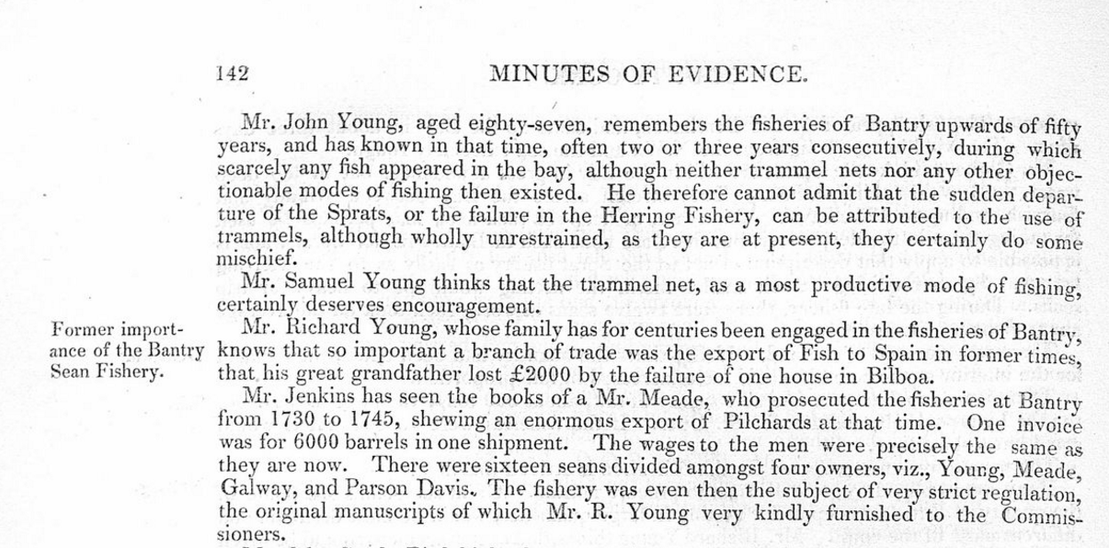

..

…

Letter William J. Dealy, 1798- Shipowner, Bantry, Co. Cork re trade, fishing business to his son in Canada 1840, and the Dealy Brig

They had intermarried with the powerful political Gore clan whose Dublin base was in Dominic Street, then the fashionable upper class Georgian Street of Parliamentarians and Legal Luminaries on the Northside of Dublin.
They were probably in Bantry by mid 18th century at the fishing business with the Jagoes, Meades, Galweys, Murphys, Youngs and Vickeries.
There was a migration of many of these Bantry families to St. Johns, New Brunswick from the late 18th century. Family memoirs of the Dealy family in New Brunswick suggest political influence in preferment. Many of the Dealys ended up in New Brunswick as Fishery Inspectors and Customs officials.
The Bantry Estate records have a William Dealy eldest son of Michael and his brothers Samuel b 1800, Michael 1803 names as lives in a lease.
It is possible that the Bantry Dealys/Dalys are connected with the Landowning East Galway family of the 18th century powerful in politics as were the Gores with whom they were intermarried. This could account how many of the Bantry Dealys ended up in State positions as Customs and Fisheries in St. Johns, New Brunswick in the early 19th century.

Bantry Sep. 17, 1840
My Dear Michael,
I have inst. rec 3 newspapers from you. (The last date 22nd Augt. 1840.) I wrote several times to you, and to W. Burns since the “Dealy’s” return on the 2nd July 1840. My letters were forwarded (I understood) by Steven Vessels and I am therefore surprised that they did not reach you before the S 22nd August. I also wrote per the “Dealy” which sailed from here on the 1st August 1840 for Quebec, both to W. Burns and yourself & hope, before the present date, that these letters have reached their destination. I was rather lucky, considering the slack state of trade here this season, to secure a Charter from my neighbour W. Riordan of Kenmare for a cargo of Timber & deals from Quebec – as the delivery there is next thing to being at home with me. sales at Bantry of Timber & deals have been nearly nonexistent I hope the prospect of a good harvest will cause a general improvement. Please to present my Compts to W. Burns & inform him that I paid his bill for the “Dealy’s” cargo on the 5th Inst- at the present moment I have nothing worth perusing to communicate but will shortly write to him. I purpose, with God’s assistance, to send the “Dealy” to St John’s very early next season with passengers – but as we have now a greater facility of sending letters. I will communicate frequently with on the subject during the Winter. We have strong rumors of a general war, but I hope it will not take place.
From the number of vessels which took out immigrants last year all our Irish markets are overstocked with American timber and the prices are consequently very low – with an additional duty layed on – that with an impoverished population tenders sales bad and remuneration indifferent.
Private. I wrote you some disponding letters in April last. at that time I was hard pressed to meet some bills – and I was preparing to remove my boys from Rosscarbery School (Diocesan Secondary School) which would have been a severe blow to your aunt. but thank Providence I met more kind and good friends and if I can rub over another season I am in hopes that I will not owe any a man a shilling particularly if I can effect good sales & to encourage which I am offering goods on low terms. The fisheries have nearly failed here as yet this season & I hold a large stock of salt __ has improved the English market & I am a considerable holder.
When you write next please to inform me particularly as to quality and price etc generally as to how barreled herrings & American tar could be shipped & whether the deck load law would prevent barrels being brought on deck. The failure of the fishing here causes me to make this inquiry although I fear there will be no chance of my getting any of these articles this year in both ____.
As soon as I receive your expected letter I will write to you at all events I will do so shortly. Your mother and all your family are quite well. The new road to Bantry is nearly completed & will certainly enhance the value of Drumkeal (on road from Bantry to Ballylickey/Glengariff/Kenmare) very much.
Our Dunmanway friends are all in the enjoyment of health but the___ doing very little good.
Our Bantry Postmistress has been detected in forgery__ of money from letters – She made ___& was apprehended near Bristol. She is now in Gaol at Cork & will be tried at __ the next assizes.
Mr and Mrs Gastry are here with us on a visit this month and they request to be particularly remembered to you, Our little family are quite well Thank God and your Aunt unites with me in kindest wishes to Isabella & yourself and we hope that your little ones enjoy good health – present our kind wishes to Wm and his family to Eliza and her family and to Paul who I hope is maintaining his place with credit.
I am dear Michael yours affectionately
Wm J Dealy

..
Will of Joseph Austin 21st May 1768, Cork, son John in Amherst, Nova Scotia and son-in-law James Brown, Halifax and Cork Canadian links. The Austins were prominent merchants, lawyers and landowners in Cork.

This is from the Welply collection of wills he transcribed before they were destroyed in 1922.

They show the extent of movement between Cork and the Maritime provinces of Canada around 1750. Later Canada was attractive for emigration being shorter than the USA which also then levied a poll tax on entry. The witness William Callanan may be from the family of Doctors and Apothecaries of Mallow Lane (present Shandon Street). One of the extended Callanan family the poet J.J. Callanan stayed with Dr. Burke in Bantry at the Square on and off for a number of years in the late 1810s.

1836, Reenvanagh, Whiddy Island, ‘Covenant to lay out by Lessee (Tobin) Ten Boat Loads (each containing thirty horse loads) of Best Coral Sea Sand Annually of Premises under a penalty of £10. Until guano from Chile and late chemical fertilisers came in the late 19th century Bantry Bay coral was prized as a fertiliser.

1836, To Be Let by Daniel O'Sullivan Esq., Reendungan, For the Year or Summer Season, HOUSE OF GURTEENROE, Grass of One Cow or More can be Given and the use of a Six-oar Barge. The barge sounds like a sand boat.

1846, Dunmnus Bay, ‘The Bay forms an important fishery ground and soe years ago had
- 1 decked fishing vessel with six men
- 1 half-decked vessel with sis men
- 9 open sail boats with 45 men
- 219 row boats with 1,095 men

1846, Jeremiah Donovan, ropemaker disposes of rope manufacturing premises on lease from 1816 to 1830 to William Jagoe, shopkeeper.

1848, Richard Tonson Evanson (also Magistrate) makes an application to the Sessions House at Carrigboy (Durrus) Courthouse to place oyster bed on the shores between his lands at Murragh between Blair’s Cove and Durrus Glebe.

1849. An application was received and approved by the Board of Works in 1849 for liberty to place oyster beds in Dunmanus Bay.

1849. Meeting Carrigbui Schoolhouse, Durrus, West Cork, November 1849 to Consider Harbour Developments and Lights In Attendance; Lord Viscount Bernard, M.P., Chaired in the chair with the following gentlemen: The Honourable Henry Boyle, Castlebernard (Bandon), Timothy O’Donovan Esq, J.P. O’Donovan, Cove, Daniel O’Donovan Esq MD, Reverend Alleyn Evanson JP Four Mile Water Court, Richard O’Donovan JP, J. Somerville Esq JP, Reverend W. M. Crosthwaite Minister, Durrus, Reverend C. Evanson, George Boward Esq, R. O’Donovan Esq, R.J. Evanson Esq, Thomas Gloss Esq, Lieutenant Royal Navy, J. Swanton Esq, the Messrs Power, General Collins Esq, Reverend Richard Quin, Parish Priest, O’Callaghan Esq, J.H. Townsend Esq, John Staunton, Reverend E. Bell, Kilcrohane, W.E. Wright Esq. and Mrs. Fitzgerald, Reverend Charles O’Donovan Minister Schull etc. etc.

c.1848-1852. Experimental curing station established at Castletownbere probably at Laurence Cove with store at by Society of Friends (Quakers) with the support of Redmond Barry, Fishery Commissioner, Glandore.

C 1850, John Jagoe, B.L., son of John Jagoe and O’Connor, Bantry father fish merchant later Fishery Inspector.

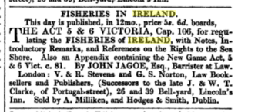

C 1850. Sale of Carbery, Cold, Furze, Horse Islands, Dunmanus Bay, West Cork, part of Becher estate 19th century, Horse and Cold Island no cultivation value consists of right to sea-weed to be had to a considerable extent, Carbery and Furze particularly suited as salt marshes for feeding horses and black cattle, Wintering Place for Horses of Marmions of Skibbereen, Coaching Establishment.

1854. Dummanack House. Gorteenroe House. July 1854; The old salt house Gurteen Roe near Bantry and Gurtnaroe House | George Victor Du Noyer. Sketch at back.

1861. Salmon fishing was licensed and those with licences for Four Mile Water Lower or Tidal were invited to attend a meeting in Bantry in November 1861 to elect a Conservator

1861. There was steam trawlers fishing from Bantry financed by Pikes a Merchant family of Cork, managed by Messrs. Tisdall and Murphy Donemark in 1861, as well as trawlers owned by Messrs. Biggs early 20th century. Paddy O’Keefe the owner of G.W. Biggs sold the operation in the 1950s.

1862 the Bandon estate was receiving rent for a fishery and oyster beds lately from Dawly.

1862. Lighter (Small cargo Vessel) for Sale, Charles McCarthy, (Father of John McCarthy, Nebraska Politician) Tullig, Durrus, West Cork, 1862.

1862. Henry Hurst fish stores mentioned in Grand Jury Presentment meeting. It was located at site of W.G. Biggs offices in the Square, Bantry. Hurst of coast guard background ancestor of Bantry historian Hazel Vickery..
Before the advent of modern roads in the 1830s and 1840s many goods were moved by sea using lighters flat bottom type boats. They were able to operate in the absence of proper piers.
The McCarthy mentioned may have been active in Land Agitation and related to John Mccarthy born Tullig, Nebraska, USA, politician.

1860s. There were occasional tensions between the smaller fishermen using traditional methods and the trawlers. In the 1860s there was up to 400 trammel fishermen, some operating from the Northside of the Sheepshead Peninsula.

1862 Mr Henry Hurst's fish store. That would be where Biggs office now stands. He would have been my (Hazel Vickery) g-grandfather - didn't know he had a fish store but we knew he was a seine owner so that follows! He died in 1864.

1866. The start of the Communication Revolution, Picture of 'The Atlantic Telegraph Cable Fleet' at Berehaven, Bantry Bay, 28th July 1866, held at Cable and Wireless Archive.

1879. In March 1880 a number of fishermen on the northside were prosecuted for riotous behaviour; this arose from an altercation over the fishermen’s trammel nets being damaged by the trawlers. Father Bowen and the Rev. Pratt gave evidence on behalf of the fishermenThere was ongoing tension between the trammel fishermen and the owners of the steam trawlers and this is referred to a in the 1879 reports onwards of the Resident Magistrate Warburton.

1870s an early 1880s at Gearhies. Pilchards landed and cured in a store near the pier for a Bantry Fish Merchant.
1877, First small freighter ‘Lily Mies’ put into service by young G.W. Biggs, more substantial vessels put into service later.

1880. There was a prosecution of a number of alleged poachers from Clonee and Ballycomane for fishing salmon in the Durrus (of Four Mile) River with poles having sharp ends by Sergeant Uriah Piper in 1880?; this failed due to a lack of evidence.

In the 1880s the old Grain Store and pier at Gearameen, Durrus on Dunmanus Bay was leased by Lord Bandon to the Wright Fishing Company of London.

1888. Mackerel fishery at Castletownbere, 30 yawls operating out of Bere Island, catches worth £2,000 per annum.

1892, following years in Castletownbere, 174 fishing boats of whom 69 French, 18 Manx, 87 Irish (75 from Arklow), 194 boats.
- 7 1st deep sea vessels
- 32, 2nd class yawls, seine boats
- 165, 3rd class line vessels
- 1,024 employed
.
Died 1930. "O’MAHONY, Nora, (c.1896-died 1930), from Letterlowes, father Florence O’Mahony, farmer. Religion Catholic. Matriculated at QCC in 1916/17, graduated M.B. B.CH B.A.O. in 1924. Address but no post in Letterlowes in 1929, then not listed." Kilcrohane, grave Kilcrohane died 1930 ahed 34 same stone sister Kathleen died 1970. This was the daughter of the Florence O'Mahony of Lowerletter Kilcrohane. This man was the kingpin of the Fishing Industry on the Sheep's Head Peninsula with fish processing facilities located below the homestead at Traweim (last pier on the peninsula). They have an interesting history linked back to King Tobin (whose daughter married O'Mahony from Kilcrohane)

1940s. Joe O'Boyle is a ship broker based in Dingle and is often in Vigo in Spain. Some years ago he was with Juan Ferra the founder of a major international machinery company. In his young days (he is now in his 90s) he was a deckhand and later skipper of one of the trawlers which used to call to Bantry. The fishermen bartered ling for flour which given the poverty of Spain at the time was prized. Of more interest were the flour bags which were used as bedding and dyed and made into trousers. See also Michael Carroll's book 'the Second Armada'.

1942. Tsunami, December 1942, Dunmanus Bay, Kilcrohane, Ahakista, West Cork, Devastates Remaining Seine Boats and evidence of earlier 1755 Tsunami uncovered in 1968 building of Barley Cove Hotel, Swimming Pool.

1968, First supertanker arrives at Whiddy island, The development was prompted by the closure of the Suez Canal following the Arab Israeli War of 1967. Gulf Oil built six, Universe Ireland at 326,000 deadweight tons at the time the largest ship in the world followed by Universe Iran, Japan, Kuwait, Portugal, Korea.

..
Ballydehob/Carrigmanus/Crookhaven/Skibbereen:

C1590. Dear Sir,

I hope you will excuse me for this paper the ink is very sharp. Now I must tell you how that celebrated man Sir Florence O’Driscoll ended his life. At the time the Spanish Galleon was wrecked on the east point of Sherkin Island which was at that time Sir Fineen’s property. He took charge of that ship's cargo into his stores that? supplied the Queen's Soldiers during that ...time and after all his exertions on that business he made over accomplishment for that reason her Majesty Sent for him to go over to England then the grant of honour was conferred on him with as much of the Southwest part of ireland as he cold ride over in a day his companion was his nephew Sir Walter Coppinger.

1605. Early Map of Baltimore, West Cork (Between 1605-1640), showing English Settlement, Dunasead Castle, Loo Rocks, Storehouse for Preserved Fish, 12 Fishing Boats, Seine Pilchards, 5 Possible Royal Navy Boats.

1609. Sir William Hull, appointed Vice Admiral of Munster in 1609. Hull’s ancestry is unknown but he may well have been the same William Hull, son of a former Mayor of Exeter, pardoned for piracy in Devon in 1608. If that is the case, his appointment had a certain poacher-turned-gamekeeper irony for it entrusted him with protecting the Munster coastline against piracy. Admiral Hull aroused considerable suspicion by his ambivalent relationship to the pirates who effectively had their Atlantic base right beside Hull’s castle at Leamcon, ten miles west by sea from Baltimore. Instead, the crafty Admiral concentrated on establishing a series of pilchard fisheries along the south-west coast of Cork, particularly along Roaringwater Bay and Dunmanus Bay. He was particularly active at Crookhaven where he had a major fishery in operation by 1616. His business partner was Richard Boyle, the Great Earl of Cork, who would subsequently lease his interest in Clonakilty to the Hull family. When the Earl’s elder brother John Boyle, Bishop of Cork and Cloyne, passed away in 1620, his Leicestershire-born widow Elizabeth took the freshly knighted Sir William as her second husband.

1613. Borough of Baltimore, West Cork Charter Dated 25th March 1613, 2 MPs, Manor Court and Seneschal, Quayage Payable by Berthing Boats, Duty of Water Bailiff to Keep a Perch on Rock Hidden in the Harbour

1618. A letter from William Hull to Lord Cork from 1618 explains the relationship of the two men. A pirate called Ellis had arrived at Schull and a number of other pirate’s wives, then living on Hull’s estates, had gone to join him. Hull was in a quandary as to whether to arrest the wives or not. The letter ends on a provocative postscript: ‘I hear Ellis has very rich beaver skins out of a Frenchman from Canada’. Like most members of the colonial elite, Hull was knowingly receiving pirate goods at this time. In 1625, however, Hull captured eight pirates at Long Island opposite Leamcon and sent them to Cork where they were executed. Sir William subsequently returned to sea as a privateer, raiding French and Spanish ships with the blessing of Charles I. Among the captains on his ship was a Walter Ellis, perhaps the same Ellis who was at Skull a decade earlier. However, it is at this point that the Irish seas began to experience a new, more violent type of pirate in the form of Algerians. See MacCarthy-Morrogh. Also: Settlers and Pirates in Early 17th Century Ireland: A Profile of Sir William Hull, J.C. Appleby (Studia Hibernica No.25 1989-90).

1624. Seizure of Captain Claes Campane, Dutch Pirate’s Cargo by Sir Sir William Hull, at Leamcon, Schull, West Cork, and his appeal for the King’s mercy, disposition of cargo of Pepper, Tobacco, Camphor, Cheney roots, Elephant’s teeth, Muscovy Hides, 1624 From Doctor Richard Caulfield’s Annals of the Corporation of Cork, and Customs Personnel, Baltimore.

1631. Two days after sack of Baltimore by Algerian Pirates William Hull advises Sir Richard Boyle of present of Turkish Pirates off Mizen Head.

1631. Silver Chalice of Baltimore Church possibly thanksgiving from Captain of ‘Agatha’ 1631, Church of Ireland, Baltimore, West Cork

1641. Henry Becher's Fishing palace, Crookhaven 1641,

1641. Losses of Sir William Hull, Leamcon, Schull, West Cork, 1641 and his Fishery at Newfoundland, part of greater Fishery which suffered from Bank failure in Bilbao in Basque Country 1641, Cornish Mining links.
Hull's fishery at the end of the 16th and early 17th century was part of a larger fishery at Baltimore, Crookhaven and Whiddy/Bantry Bay. It is probably that may involved came from Cornwall going on names Hull, Symms etc. Recent research suggests that Hull also had interests in Newfoundland at the time. Incidentally there were further close Cornish links in the 19th century Mining in West Cork with the Mining Captains and many of the miners in Allihies Copper Mines were Cornish. It is probably that the fisheries were financed from London and the produce exported widely later to Spain where political conditions allowed.
1665 Four Dutch Vessels of ‘Great Force’ hover between Crookhaven and Castlehaven. They burned a Barque. Communication between Coronet Emanuel More to his Kinsman Mr. Hull.

1697. List of Seamen, Fishermen and Boatmen, whereof Papist, Baltimore, West Cork. From Peter J. Clarke's site, Irish Genealogy E Books.

Captain Smith's assessment, 1697.

Baltimore

Seamen 9
Fishermen 188
Boatmen 84
Total 268 Ireland 4428 Baltimore 6%
Whereof Papist 268.

1699/1700. Parish of Schull, tithes on fishing are computed by the Rector and Vicar greeting as well as they can with the fishermen to tithes sometimes 40 shillings a seine sometimes 5 shillings and 20s shillings for a boat using hook fishing Half the tithes paid where the fishermen come from hald whee the fish re landed.

1714. Built at Crookhaven, St. Brendans Church for seafarers, at his own expense by Bishop of Cork Peter Browne. Recently restored.

1752, Pocock’s Tour, West Indian Fleet often call into Crookhaven

1757. Extract from letter ‘Very Bad Mutton and Beef, you Can’t Conceive of the Wretchedness of it’, of Godwin Swift (Customs Man), 16th May 1757 from Crookhaven, West Cork, Ireland.
‘Now with regard to the place and provisions: you are to know that you see nothing here but mountains of rock (not cliffs) and yet those rocks are more dear to poor people or strangers as the lands within 2 miles of Dublin. There is here undoubtedly great plenty of fish, yet the people are so lazy they’d rather live on salt mackerel and potatoes then give themselves the trouble to take fresh fish. There is no garden stuff here, very bad mutton and lamb, and no beef, not a tree or even a shrub within 8 miles of the place….
30th June 1757 ‘…nothing but rocky mountains around us for 20 miles, where not even a slide car can go the road, nor any other cattle than little horses bred and used to this country….you can’t conceive the wretchedness of it. We have neither bread to eat nor malt liquor wine or cider to drink, nor meat except a little mutton and bad lamb. Our liquor a bad toddy, our victuals potatoes and fish and lie in a cottage..
1785. Will of Alexander O’Donovan, Squince, Skibbereen, West Cork, Various Townlands, Farm at Myross, Fishery, Salt Store, Fishing Boat, Possible Grandfather-in-Law of Timothy O’Donovan, Justice of The Peace and Grandfather of Rickard Donovan, First Catholic Clerk of the Peace for Co. Cork 1838 since the 17th Century.
1780-1783, Hake landings, 9,400 to 4,5000 tons.

1788 Kinsale fishermen built huts and cure their fish on Cape Clear and pay a smart rent (to Becher Estate).

1796. Will Captain Jeremiah Coughlan, Royal Navy, 1796-1815, of Carrigmanus, Schull, West Cork Family and William Marcus Coughlan 1884, Proved Canterbury.

1840 Sacred to the Memory of:
ROBERT SWANTON (1764-1840)
Counsellor at Law
One of the Judges of the Marine
Court of the City of New York
Who departed this life
in Ballidahab
On the 15th of February 1840
aged 76
..

..
(Cork Examiner 29/5/1843) - SKIBBEREEN PETTY SESSIONS - SEA-WEED - PROCEEDINGS UNDER THE MALICIOUS TRESPASS ACT (Summary)

The names of the claimants and defendants are not given. ‘A great number of persons were summoned on informations sworn by different persons for cutting and carrying away sea-weed on the Skeam Rocks, and on Hare Island.' Messrs. Downing and Fitzmaurice, Attorneys for the Complainants. Mr. Jagoe, Counsel for the Defendants.

There was a market for carrageen moss which sold in Skibbereen market priced by the ton in the 1860s.

1863. Julius Reuter and William Siemens and the South-Western of Ireland Telegraph Company, Linking Cork to Crookhaven by Telegraph and British & Irish Magnetic Telegraph Company, Cork to Cape Clear

1864. For Sale A First Class Whaleboat, Apply H. Justice, Ballydehob, West Cork.

Prior to World War I large fleets of French trawlers fished for mackerel and used Schull harbour.

Courtmacsherry
Sir Vincent Goodkin of Courtmacsherry made his will in 1637. HIs manager John Burrowes was directed to forward his fishing and other businesses including my fishing houses, presses, and all other implements presumably in connection with his pilchard fishery. Burrows was hanged in 1642 accused of send information in 1641 Rising to British Forces.

Jonas Travers, Butlerstown, had several commercial maritime interests as well as the development of the fishing industry on the Cork coast.

Kinsale:

Dr. Richard Caulfield’s transcription of the Annals of Kinsale contain from c 1300 a huge number of marine related entries such as 1673, 20 East India ships waiting for convoy. Also 21 East India men and 40 rich mercantile vessels

1611, Kinsale, A poor town ruined by the last rebellion. One of the best harbours in the Kingdom. Depends on fishing of pilchards, herring and hake which are taken in the Harbour.
1617, pilchards exported.
1630. Sir Thomas Putton refers to importance of pilchards as a reason for keeping in repair Kinsale Fort.
1642 10] EXAMINATION OF JOHN DALY OF KINSALE, AGED 45, 10 APRIL 1642, ff 4r–5v.1 As for 7 and 9. The examinant is the master of the Unity. John Preston of Weymouth and Thomas Morgan own the vessel. Adam Gould and Thomas Lavallyn hired the ship and laded it at Blackbrick in the river at Cork to go to Jersey and to return to Cork.2 The Unity sailed to St Malo and Gould and Lavallyn laded the ship there. On the return voyage to Cork contrary winds forced the ship into Salcombe in Devon. The examinant, six sailors and merchants were imprisoned there. The merchants and mariners are not rebels and had no hand in the rebellion in Ireland. The governor of St Malo threatened to imprison the examinant if he refused to carry the Irish officers. He also compelled the examinant to enter into a bond for £300 to ship the officers. The governor also sent an officer to prevent the Unity from sailing without the passengers. 1 The master of the Unity is given in all the other examinations as Daniel Daly. In this examination his name is given as John at the start on fol. 4r and end on fol. 5v. However his mark is the letters DD on fol. 5v. 2 Possibly Blackrock, County Cork.

1665-181. Southwell family restore pilchard fishery after Cromwellian period. 1665 Sir Robert Southwell Southwells trial pilchard for Duke of Ormond same year one haul of sperma ceti valued at over £1,000 by apothecaries. One haul valued at £1,300.
1671, major harbour works involving dredging, quay wall building by Isaac Calfe of Kinsale approved by Lord Lieutenant cost £1,000 he to have right to sea sand for 21 years.

1780-1783, Hake landings, 48,700 to 48,600 tons.
1788 Kinsale fishermen built huts and cure their fish on Cape Clear and pay a smart rent (to Becher Estate).

Sea Sand

1861. 16th October 1861, Donemark, Bantry, 16 acres to let prime land suitable for potatoes or corn, four Boats of Sea Sand Will be Given.

1838, 1845, 1863 Grand Jury Presentment Sand Quays, Strands

1838 Presentents

Kinsale

Belgooly Sand Quays
Brown’s Mills Sand quays to Macroom
White Castle Sand Quays

Beara

Trahalane Sand Quay

Ballydonegan Strand

Bantry:

Ballylickey Sand Quay

Strand:

Kileenovogue

East Division, East Carbery

Ballinadee Sand Quay
Burrane Sand Quay to Enniskeane
Clonakilty Sand Quay
Gurraneragh Sand Quat
Innishannon Sand Quay to Macroom

Strands:

Coolmain
Flaxford
Garretstown (Multiple Entries)
Grounviran to Bandon
Lisnaleen to Bandon

West Division, East Carbery

Strands:

Red Strand multiple entries major centre of extraction
Rosscarbery Harbour and Strand
Tralong, multiple entries

Sand Quays:

Ballylickey road to
Leap Sand Quay

East Division, West Carbery:

Roaring Water Bay and Seacloyne Sand Quay

Strand:

Corrigillihy at Clontaff
Troughlough Sand Banks

West Division, West Carbery:

Ballydehob Sand Quays
Dunbeacon Castle Sand Quays
Lowertown Sand Quays

Courceys:

Garretstown Strand

Ibne and Barryroe:

Timoleague Sand Quay

Strands

Broad
Dunowen
Harbour Mouth
Red (multiple entries)

..

1845 Presentments:

Kinsale:

Ardkilly Sand Quays
Brown’s Mills Sand Quays
Belgooly Sand Quays

White Castle strand.

Beara:

Sandbanks:

Faha
Palace
Trafask
Tralaha
Ballydonegan strand

Bantry

Ballylickey Strand to Dunmanway

East Division East Carbery:

Sand Quays:

Burrin/Burrane
Clonakilty Innishannon Sand Quay to Macroom
Kilbrittain
Ballinadee
Broomfield Bridge Quay
Leap Strand and Sand Quay

Strands:

Coolmain
Flaxford
Garretstown
Glounnvirane
Gurtnefeen
LishnaleeLittle Island to Dunmanway
Tranalong Strand

East Division, West Carbery:

Ballyrizard Sand Quay
Keelfadda Sand Quay
Roaring Water Bay Sand Quay

Strands

Abbey Strand road to Cape Clear to Baltimore
Dough Strand
Trahina strand to Crookhaven

Ibane and Barryroe

Strands

Ballinglass
Ballycosheen
Blind
Broad
Donoghmore
Dunmorley
Dunmore
Dunmore Sand Cove
Dunowen
Garretstown and Quay
Harbour Mouth
Island
KIlmore
Long
Red (multiple entries)

Kinnalmeaky (Bandon area)

Burrane Sand Quar road to Enniskeane
Lisnaleen strand to Enniskeane

West Division East Carbery:

Mr. Mahony’s Quay
Mr. Smyth’s Quay, Doneen

Red Strand

1863 Grand Jury Presentments, Spring Assizes

Following references:

Ardtennant Sand Quay
Greenmount (Ballydehob) Sand Quay
Ballydehob Sand Quay
Ballydehob Sand Quay/store
Lowertown Sand Quay
Roaring Water Bay Sand Quay
Rossbrin Sand Quay

Ibane and Barryroe

Strands

Ahavoda
Ballinhalin
Ballybana
Broadstrnd
Donoghmore
Dooneen
Dunworley
Island
Lirah
Red

Barony Kinnalmeaky:

Inchy Bridge Sand Quys

Harbours transferred from the Commissioner of Public Works to Cork Grand Jury

Baltimore
Cape Clear
Castletown Berehaven
Coulagh Pier
Courtmacsherry
Cove at Kinsale
Glandore
Kinsale Land’s End
Laurence's Cove, Beara
Schull

1863 Grand Jury Presentments, Spring Assizes

Following references:

Ardtennant Sand Quay
Greenmount (Ballydehob) Sand Quay
Ballydehob Sand Quay
Ballydehob Sand Quay/store
Lowertown Sand Quay
Roaring Water Bay Sand Quay
Rossbrin Sand Quay

Strands Ibane and Barryroe

Ahavoda
Ballinhalin
Ballybana
Broadstrnd
Donoghmore
Dooneen
Dunworley
Island
Lirah
Red

Barony Kinnalmeaky:

Inchy Bridge Sand Quys

Harbours transferred from the Commissioner of Public Works to Cork Grand Jury

Baltimore
Cape Clear
Castletownberehaven
Coulagh Pier
Courtmacsherry
Cove at Kinsale
Glandore
Kinsale Land’s End
Laurence's Cove, Beara
Schull

Sand Quay, Durrus.

1890s. Appears in Bandon estate records, Richard Tobin, ex Kilcrohane, owner of what is now Rosses then Hotel paying dues to estate for sand boats. Sand landed until 1940s remains of quay walls.

Shipping:

1766, Seizure by Mob of Disorderly Fishermen at Kinsale, Co. Cork of Sloop Laden with Potatoes Bound for Gibraltar. From Dr. Richard Caulfield's Annals of Kinsale:
:
Attridges, Glandore

Richard Henry (Henry R) Marmion, 1869, Rineen, Castletownsend, Skibbereen, Resident, £150, m Grace Elizabeth d Herbert Moore, Tipperary, runs coaching business with brother, agent Townsend and local estates. His father ran vessels which rendered good service during Famine.

Dealy (Daly), Bantry timber boats to St. Johns, New Brunswick and emigrants.

Deasys, Clonakilty running boats to France.

24th February 1794, Richard Notter, Crookhaven. Master and owner of Fanny of Crookhaven lost with two crewmen

James O’Sullivan, Esq., Roaring Water House, Aughadown, ran potato boats to Cork and had property in Cork earlier involved in smuggling which he testified at trial of Long a neighbour accused of smuggling. c 1810.

Swantons, Ballydehob

Smuggling.

1624, Dec. 10. The Lord Deputy of Ireland to Sir William Hull one of the Council of Munster, protection for 30 days for Captain Claes Campane a Dutch pirate who desires to submit himself, his ship and goods to the King’s mercy.1625, Feb. The names of those that bought goods of the Pirate Claes Campane at Lymecon in the west of Ireland involving the Lord Deputy and others.
Martin Harman bought of this pirate to the value of 200li. Justice Bradye as was thought was partner with him in the disbursements. The pepper cost 6-ld. per pound the wax cost 6d.-Thomas Neale of Bandon Bridge bought 2 bales of pepper containing 700 weight at 8d. per pound and 100 of Barbary hides wet in the hair.A chest of cheney roots was bought of Campane 150 weight at 5s. per pound. Sir Will. Hull knows who had them. Joshua Boyle of Waterford bought one cheat of camphor .000 weight at least, tobacco 14 rolls, pepper 1000 weight, cloves 212 li. weight. Elephants teeth 3, red Muscovy hides 5 dozen.
The two Whites of Cork carriers, there dwelling can discover much for they carried for most men, and bought much themselves. Mr. Jeremye Roston near Kinsale bought tobacco and pepper as he confesseth to me himself. Mr. Luxtone near Bandon Bridge bought 300 weight of pepper. Mr. Newcomen of the bridge bought 800 weight of pepper and as he told me himself. Sir Will. Hull sent 40 horseloads of pepper to Kinsale. Mr. Richardson of Plymouth sent 500 weight of pepper from Baltimore which he bought of Campane
Witness
James Stanley searcher there.
Mr. Nicholas.
The Galwey family whose estates were forfeit in the Baltimore area feature as smugglers. As late as 1952 there were the remains of a tunnel through the rocks linking the beach to Dunworley Cottage near Clonakilty. The branch at Enniskeane, land agents to the Shouldham Estate (McCarthy by marriage) were involved in a fatal fracas in a customs raid for illicit spirits mid 18th century.
1732, Henry King, heart tax collector in Castletownbere with Thomas Lucas, Customs Surveyor, re O’Sullivan smuggling. Richard Tonson Surveyor for Bantry area searched O’Sullivan boat and then came in Bumper with cargo of smuggled Brandy. O’Sullivan probably in collusion with John and Henry Puxley.

Thomas Hutchins, Appointed magistrate 1776, Ballylickey, Bantry. 1758 leases for Ballylickey renewed, major trade in herring, cod, ling, oysters, father a major smuggler. Captain Robert Man, the Lauceston, Bantry. Has drawn a bill in favour of Thomas Hutchins for the cost of impressing seamen. Date: 1746 Feb 23

1769, Probably smuggled and seized. For Sale by Public Cant 'PER INCH OF CANDLE" A Parcel of Roll Bale of Tobacco at Cork Custom House. This gave the purchased time to consider while an inch of candle burned. Public Cant is Public Auction and a term generally used in the 18th century. From Dr. Caulfield extraction of notices in Cork Evening Post.

1740. a Memorial of Several Gentlemen Residing at or near Berehaven in West Cork, setting forth the necessity of having a Barrack built for one company and half of foot to prevent running of Goods and the Shipping Off of Men to Foreign Service

1765 - WHEREAS a riotous Mob did assemble after Night on the 18th of November last in the Town of Bantry, and rescued a Horse with two Ankers of Brandy, seized by … Revenue-Officers…[usual rewards, etc, offered for information on the perpetrators ]

1772. About three o clock this morning, the house of Thomas Hungerford, esquire, and the King's stores at Glandore, were attacked by a great number of armed men, in order to rescue a cargo of tobacco; they were however beaten off by Mr. Hungerford, assisted by a party from the Thunderbolt cutter. Several of the persons who made the attack were wounded.

1775. 18 cwt of leaf tobacco was seized by Mr. Potter and his men near Enniskeane, (probably at a Galwey house)when a great mob arose and stoned him and his party in so violent a manner as obliged him in his own defence to fire upon them, by which two of the smugglers were killed and another was dangerously wounded; upon this the smugglers desisted, and the tobacco was brought off and lodged in the custom house of Kinsale.

1781. Son of Samuel Townsend Wright Esq. married at Christchurch Cork to Miss Louisa Digby, 30th July 1790. 1781, Letter Richard Wright, Port Surveyor, Skibbereen re Naval Movements Privateers, Dutch and French Boats

1785. Alexander Donovan, Squince, Myross, bequeaths his Cork lands of Rinogreny, Keamore & Saravelly to his son Dr. James Donovan, M.D., and to his son Alexander his farm at Myross with the fisheries, salt house & large boat thereto and lands at Manhelare and Cusronan, Filmuck, and Carhngariff (Cahhugariff).

James O’Sullivan, Esq., Roaring Water House, Aughadown, ran potato boats to Cork and had property in Cork earlier involved in smuggling which he testified at trial of Long a neighbour accused of smuggling. c 1810.

1820. Petition of James Donovan, preventative officer and waiter, Ballygarteen [Ballingurteen], Dunmanway, parish of Kilmeen, County Cork, to Richard Wellesley, 1st Marquis Wellesley, Lord Lieutenant, Dublin Castle, requesting promotion to a situation in the water guards. Observes that by acting in support of government he ‘ran the risk of his life and disrepute of his neighbours’. Claims in 1820, the year he secured his post, he made seizure of ‘fifty Bales of Contraband tobacco’ and through his exertions the smugglers were found guilty and transported for a period of 7 years; adds that during his term in office he also lodged other quantities of tobacco and tea with Richard Hungerford, the port surveyor of Clonakilty.

1822. Lord Bantry not renewing lease of any of his Tenantry involved in Smuggling.

1822. From Diary of Richard O’Donovan, of Bawnlahan, Skibbereen, Co. Cork, Ireland, said the Whiteboys had been caught in a pitched battle with police and troops on January 25th nine had been found guilty of Insurrection Act and hanged. This was prompted by an Excise raid on a Poteen Making Operation which developed into a running battle with the Whiteboys.. Quoted p. 50in Donald McKay, ‘Flight from Famine’ The coming of the Irish to Canada’, Natural Heritage Books, Toronto, 2009.

1826. SMUGGLING - On the 3d inst. MR. O GRADY, Excise Officer, accompanied by MR. TOWNS, Supervisor of Skibbereen, and a party of the 11th Foot, commanded by Lieutenant GARDINER, proceeded by information from Clonakilty to the Parish of Kenah, and detected at work Five extensive Distilleries, seized forty gallons of spirits, a horse load of malt, and two prisoners – the people having a knowledge of the approach of the party removed the stills and the other apparatus before their arrival. For the want of assistance or any possible means of breaking the vessels, they were obliged to commit to the flames those of the Distilleries, with all the utensils; the spirits, malt and prisoners, were brought to Clonakilty, by the party, who deserve much credit for their exertions, having performed a journey of forty miles in fourteen hours.

Harbours/LIghthouses:

On 18 November 1703 a petition from the Sovereign Burgesses and commonalty of Kinsale was presented to the House of Commons looking for the reinstatement of the light which had been unreasonably discontinued for upwards of 20 years. One can presume the petition was successful because of the existence of a lease between Lord Kinsale and Mr J. Steele, Collector of the Port of Kinsale, covering the lighthouse and one acre of land (Irish plantation measure or 1.6 acres statute).

1818, Cape Clear lighthouse

1841. Paddy O'Keeffe, Bantry Historian has a note dated 1961 that he had been conversing with Mary Barrett then RIP. She said that the Bantry House additions were built by Murphy and immediately after he built the old pier. Paddy dated the Bantry House works to 1840-1 and the pier to 1842.

1847 Report on memorial presented to the Lords of the Admiralty with regard to the Harbours and Lighthouses of Co. Cork mentioning the catchment of the River Bandon, Innishannon, Kinsale Fishery and Harbour, Courtmacsherry, Ilen Skibbereen, Baltimore, Schull, Carrig-na-Melia off Castle Island, the Cosheen Fishing and Mining Company rescue of East India Man 'Charlotte' by Cosheen fishermen.

1849, Carrigavadra, hill overlooking Bantry Bay on eastern Muintervara mast bound with chains to solid chain

1849. Meeting Carrigbui Schoolhouse, Durrus, West Cork, November 1849 to Consider Harbour Developments and Lights In Attendance; Lord Viscount Bernard, M.P., Chaired in the chair with the following gentlemen: The Honourable Henry Boyle, Castlebernard (Bandon), Timothy O’Donovan Esq, J.P. O’Donovan, Cove, Daniel O’Donovan Esq MD, Reverend Alleyn Evanson JP Four Mile Water Court, Richard O’Donovan JP, J. Somerville Esq JP, Reverend W. M. Crosthwaite, Minister, Durrus, Reverend C. Evanson, George Boward Esq, R. O’Donovan Esq, R.J. Evanson Esq, Thomas Gloss Esq, Lieutenant Royal Navy, J. Swanton Esq, the Messrs Power, General Collins Esq, Reverend Richard Quinn, Parish Priest, O’Callaghan Esq, J.H. Townsend Esq, John Staunton, Reverend E. Bell, Kilcrohane, W. E. Wright Esq and Mrs. Fitzgerald, Reverend Charles O’Donovan, Minister Schull etc. etc.

1849. A Traveller in a letter to the Cork Examiner 1849 refers to a rumour that Lord Bandon is building a lighthouse on Carbery Island in Dunmanus Bay, stressings its potential from a Naval viewpoint and Carrigboy made a packet station.

1847. Steve Whitney lost off Mizen with many hands prompted building of first Fastnet Rock Lighthouse iron tower not able to withstand storms.

1854. Kinsale Lighthouse. Early in 1854 Lord Bernard of Castle Bernard, Bandon, Co. Cork enquired why, since the new light was established, Courtmacsherry Bay was without a light. Inspector Halpin explained in his report to the Board that the new light was a sea light and was not intended to guide vessels through the rocks and shoals of Courtmacsherry Bay; also if the latter was required a local light on Land Point would suffice. Lord Bernard also directed his enquiry to the Board of Trade in London as a memorial from the Grand Jury of the County of Cork.

1862. Meeting Urging the Building of Pier At Bantry at a cost of £2,000, November 1862.

1891. Fastnet Lighthouse 176 feet of Cornish granite.

Ropemakers/Nets.

1757. Stephen Scott, Kinsale ropemaker

1820. Donovan ropemaker Bantry, ropewalk still extant behind bantry House.

..
Wrecks/Lloyd’s Agents:

The ports used by the wrecked boats and the composition of their cargos give good idea of the changing world economy. The district was until the building of the road from Skibbereen to Crookhaven ad from Bantry to Kilcrohane and from Bantry to Castletown by Richard Griffith isolated. However in maritime terms it was at the centre of world trade the first land fall from North America and a provisioning center for the Royal Navy and East India Company vessels.

There is a comprehensive online listing of Cork wrecks: http://www.irishwrecksonline.net/Lists/CorkListA.htm

1697, HMS Loo, Sherkin.

1714. Agatha of Amsterdam Probably Saved at Baltimore, Church Plate Presented to Parish of Tullagh by Captain Keissbergh, A Dutch Man, Commander of the Ship Agatha.

1762. Tarlton, lost at Crookhaven from Jamaica to Liverpool.

1763, Casks of Madeira Wine and Boxes of Fruit from Shipwreck, Bantry Bay.

1767. Elizabeth, lost Crookhaven

1780. La Solidada. Sunk Crookhaven. Taken as prize by Liverpool Privateer.

1794. Richard Edward Hull and brother salvaged wreck of Lady Harriet.

1794. Richard Notter, Master of Fanny of Crookhaven lost

1794 WRECKED GOODS - To be sold by Auction, for ready Money, on Monday the 5th day of January, 1795, at Crookhaven, by Richard Wright, Esq; Collector of the Port of Baltimore, the following Articles, being part of the Cargo of the Brig Eliza, Sweeny Wilson Master, bound from Hamburgh to New York, and Stranded at Crookhaven the 26th November last: - Corderoys, Velverets, Thickset, …, Baffetys, Counterpanes and other Manchester Goods, Woollen Goods, Yarn and Ragging Stuff, Sheeting Linens white and grey, Coarse linen in seven-yard pieces, Waxed painted Linens in nine-yard pieces, English Check in twelve-yard pieces, Stockings; Duck, Canvas. - December 18, 1794.

1796. L’Impatiente, loss of 563 excepting 7 and several hundred horses. Lost south side of Mizen Head. Part of 43 ship French fleet attempting to invade

1804, Loss of Nabby, En Route from Liverpool to Bandon on South Shore of Bantry Bay. Contents Pillaged by Two Hundred Men and Women. Crew Sheltered by Richard Donovan, Esq., David Mellifont, Esq., Magistrate, Donemark, Bantry, with Captain Scott and Lieutenant Griffin and 40 Soldiers went to Bantry to Search for Stolen Property, assisted by Jonas Baldwin, Esq.

1806. Friends 18 Feb 1806, Caroline all in Dunmanus Bay, Shipwreck Index of Ireland, Lloyd's Register 2002, Bridget Teresa and Richard Larn.

1807, ‘Good Rech’, of Pool (Poole), Shipwrecked off Crookhaven, Co. Cork, with Loss of Seven Lives, En Route from Newfoundland with a Cargo of Oil and Dried Fish to Messrs Penrose, Waterford (Family who Founded Waterford Glass) Some of the Cargo Exciting The Brutal Rapacity of the Surrounding Multitude.
The Waterford Penrose family were Quakers related to the Cork Penrose/Fitzgerald family. They were active 18th century developers of Cork, Shipping Merchants whose property straddled the North Main Street area and the location of the present railway station.
1814. Arum, transport damaged at Crookhaven.

1817. Providence, struck rocks off Crookhaven, bound for St. Michaels from Plymouth.
…
1822. Thalia lost at Crookhaven. From Savannah to Liverpool.
..
1822. Confiance, 393 Brigbetween Mizen and Three Castle Head all 100 lost. Carried 36 guns.

..

1822. Albion of Black Ball Line Packet en route from New York to Liverpool. Wrecked west of Old Head of Kinsale near Courtmacsherry Bay all lost bar one. Included in those lost well known Yale Professor Alexander Metcalf Fisher.
.
1823. Loss of 'The Hope of Newry' at Ballyisard, Crookhaven, West Cork, February 1823. Captain and Six persons Perished. Voyaging from Newry to New York for Refit with Three Passengers.
..
.

1824. Leander, wrecked on rocks off Mizen, en route New Orleans to Liverpool all saved.

1825, Salvage Award by Baron Pennyfeather at Cork Assizes from Rescue at Crookhaven, West Cork, of Clio of St. John's New Brunswick en Route to Cork abandoned in a Storm Boarded with 34 Salvage claims Awards to Daniel Coughlan, Esq. £220, Joseph Baker Esq. £80, F. (Thomas) Raycraft (Roycroft) Esq.£50, Francis Gillies Esq. £60, A.O'Driscoll Esq. £60, John Notter Esq. £60, Florence McCarthy Esq. £100, Richard Medway £100. 1825 Sergeant (Law Officer) Goold. In the case of the Clio salvaged Crookhaven. The underwriters objected to the level of awards made by the local magistrates and reduced the eventual awards. From the Southern Reporter and Cork Commercial Courier 31 March 1825

1827. Trio, lost Dunlough Bay from Derry.

1828. Try Again, Crookhaven to Quebec contents auctioned.

1829. Barbara, lost Crookhaven

1831. John Campbell, wrecked off Crookhaven en route to Cork from Quebec crew saved.

1833. Mary, 191 ton of Dublin lost off Crookhaven.

1834. Daniel Galwey, Kilkeran, Clonakilty, Under Agent for Lloyd's Marine Insurance, Assaulted by Mob, Cape Clear, February 1834, Attempting to Recover Proceeds of Ship wreck. Earlier Wreck of Europe off Rosscarbery.

1837, Shipwreck Orelia of Plymount, on Bere Island. Efforts of Edward Puxley, Lloyd’s Agent and Patrick O’Sullivan.

..
1845, John Coughlan of Crookhaven, West Cork Owner of Whaler 'The Wild Irish Girl' Rescues Schooner British America (Canada) 'Exile'. Somewhat surprising to see a whaler operating out of Crookhaven. The extended Coughlan/Coghlan family were active mariners, Royal Navy personnel.

..
1847. Steve Whitney lost off Mizen with many hands prompted building of first Fastnet Rock Lighthouse

1849. Marchioness Abercorn, wrecked off Mizen bound to Cardiff from Quebec.
1850 Rescue in Dunmanus Bay, West Cork of Mountaineer, 869 Tonnes, 35 Days out of Quebec and later 1862 Sale of Salvage by Receiver of Wreck, Thomas H. Love, Skibbereen.
..

C 1850 MFV Bombay of Rosscarbery. Timbers used in reconstruction of Church of Ireland Deanery. Lloyd have no record of this loss.
..
1850. Ranger, carrying Egyptian wheat to Cork total loss Dunmanus Bay. To Cobh from Malta.

1852. Whim, bound from Ayr to Cardiff lost off Mizen.
..
1852. Broad Oak, lost off Dunlough Bay. Cotton and sugar from Pernambuco, Brazil Captian and 15 crew lost.

1862. Sale at Blue Hill, Bantry, March 1862 of Wreck of 'Frederic Brunning' of Rostock, Sails, Rigging, Etc apply Thomas H Love, Receiver of Wrecks, Skibbereen.

1862. 3rd July sale at Dunbeacon large oak 46 feet by 2 square inches contact Coastguard Station, Station Heights, Dunbeacon or Thomas H. Love, Receiver of Wrecks, Customs, Skibbereen.

1862. March sale of Frederick Brunner, Bantry. Thomas H. Love, Receiver of Wrecks, Customs, Skibbereen.

1862. Loss of Angelita, Dunmanus Bay near Dunmanus Bay and appointment of James Hutchinson Swanton as Agent of Lloyds Of London, January 1862. From Skibbereen Eagle.

1867. Wolverine, wrecked near Crookhaven lighthouse, 485 ton barque had put in for provisions. All saved.
1874, Cardross, Castletownbere, crew had mutinied in Cork magistrates compelled them to re enlist. Captain, his wife and all crew but two drowned.
1874. Sailor Prince, 445 ton built St. Johns, New Brunswick, as well as loss cargo of 2,000 Havana Sugar Boxes.

1877. Liberty, 10 ton smack lost off Mizen Head, owned by Roans of Arklow.

1881. Prudence. 148 ton schooner lost off South west Coast. Carrying oats from Limerick to London. Master Thomas and crew lost.

1881. Bohemian, en route from Boston to Liverpool carrying cotton, flour, apples, struck a rock off Dunlough Bay a number of hands sperished vessel lost.
1885. Iberian. Total wreck off Three Castle Head.
1886. Augusta 136 ft. iron steamer of 54 tons lost in Dunmanus Bay. Total wreck.
1886. Caroline 15th Oct 1886, Augusta 3rd Dec 1886 all in Dunmanus Bay, Shipwreck Index of Ireland, Lloyd's Register 2002, Bridget Teresa and Richard Larn.

Possibly Trá na gCloch (Stony Strand). Opposite late Eric Dukelows. On Eric lands, grave of 8 sailors drowned when flour boat lost. Flour washed up and a cake former over flower once broken flour edible. James O’Mahony aware of graves possible interest for Sheeps Head Way. Further on on Eric’s land remains of stone Powder House used in Rossmore Slate Quarry, visible from road.

1888. Cherwell. Iron Barque 1,000 tons register. Lost of Three Castle Head.

1889. Bohemian. Baltimore to Liverpool 900 cattle on board, 2,000 bales of cotton, 60,000 bushels of wheat. Struck rock off Three Castle Head. Cargo lost no loss of human life.

1896. Memphis. 3,191 tons gross Montreal to Bristol. 380 head of cattle and general cargo. Struck rocks Three Castle Head. 9 crew lost.

1899. Oswestry. 2,419 ton Lost at Mizen Head. En route from Newport News to Manchester with cotton, deal, iron bars. India Corn.

1889. Cherwell. 1,129 ton struck rocks off Three Castle Head. Carrying coal from Newport to Mauritius and had loaded nitrate in ile bound to Cork. 17 of 19 crew escaped.

1889. Queensmore carrying 900 cattle, 1,000 tons wheat, 2,000 bales of cotton, 850 tons of copper from baltimore to liverpool. Cotton ignited off Dunlough

1906. Ribble. 71 ton steam trawler stuck rock near Mizen crew saved.

1908. Manaos, 82 ton trawler, mate lost, struck Clohane Island off Mizen

1908. Loss of Irada, crew member buried Schull, 1909. Sailing from Galveston, Texas cotton for Liverpool. 5 lost as well as cargo worth £250,000. Boat insured for £896,000.

1918. There was a major tragedy in 1918 when a seine boat from Gearhies was lost with all eight crew drowned.

..
Palaces

Allihies
Ballynaule, Goleen.
Baltimore several palaces some pre 1631 Algerian raid, other Cornish Company 1876.
Bantry, Rev Davies c 1730 removing stone from Franciscan Abbey to build Fish Palaces.
Castlehaven, threescore and five tons of fumados exported probably by Edward Hunt a customer of Cork Harbour. All papers destroyed in 1922.
Courtmacsherry pre 1750 several palaces.
Drishane, Goleen.
Dunbecon.
Hursts, Bantry W.G. Biggs office in Square built on site.
Eyries
Garnish, Beara, western end not Garnish island
Kinsale, World’s End (also for train oil) and Scilly.
Leenane, Goleen.
O’Donovan’s Cove (Pilchard Point), Durrus.
Manions Island, Dunmanus Bay.
Near Toormore beach as ‘The Palaice Strand’ pilchards cured for export.

Early Maps

..
With 1958 detailed commentary by Bantry Historian Paddy O’Keeffe:

https://plus.google.com/photos/100968344231272482288/album/6106480034418356305/6106480199472986658
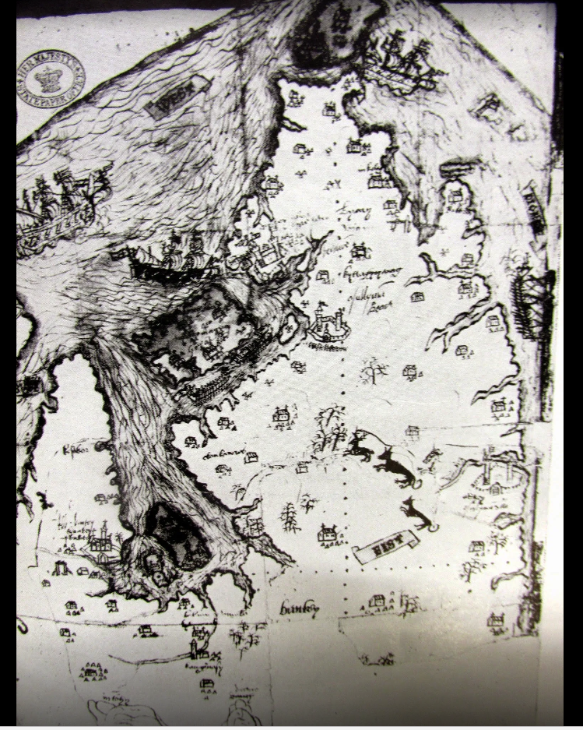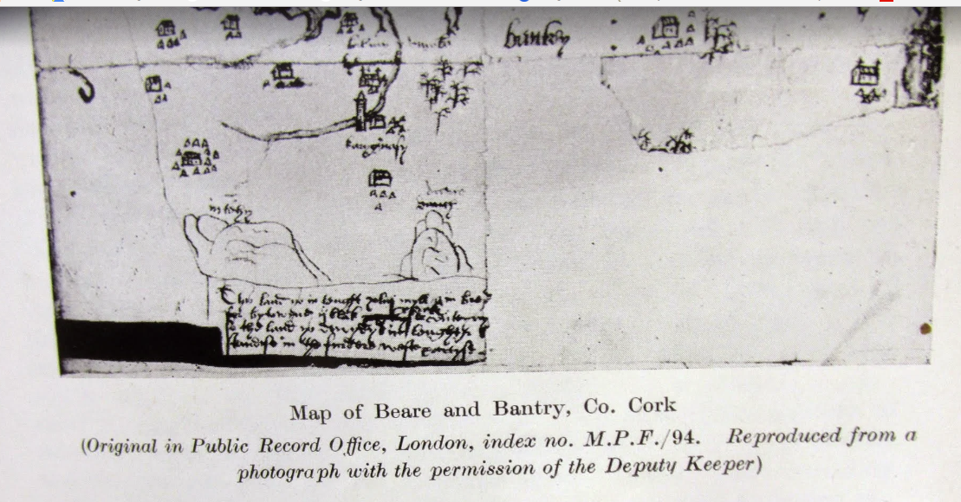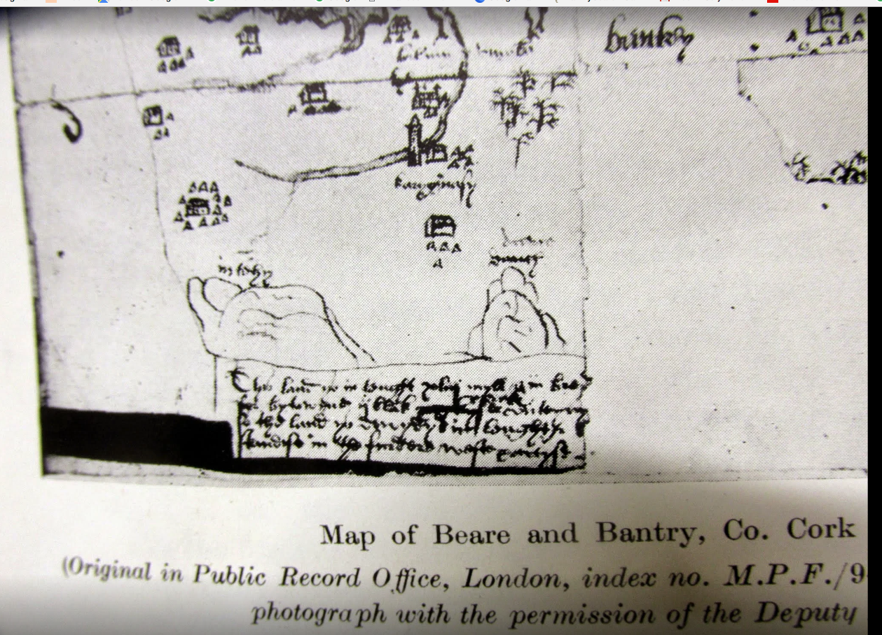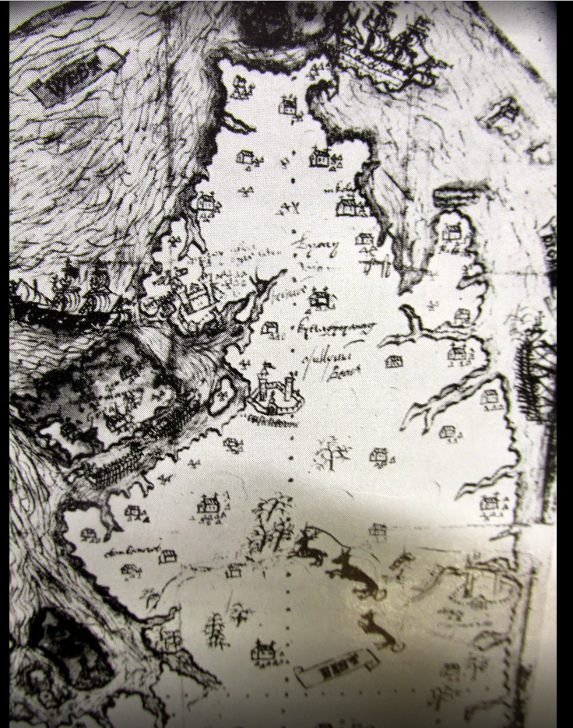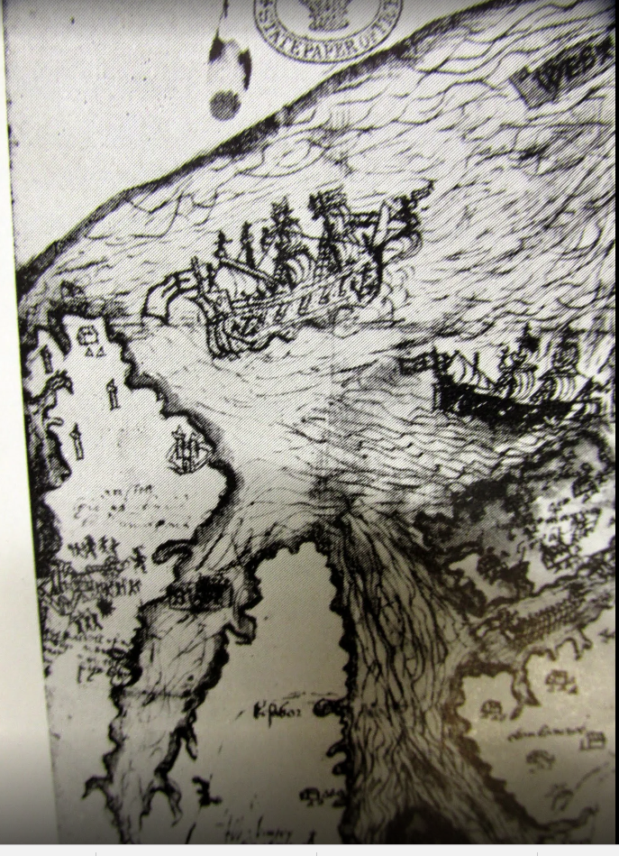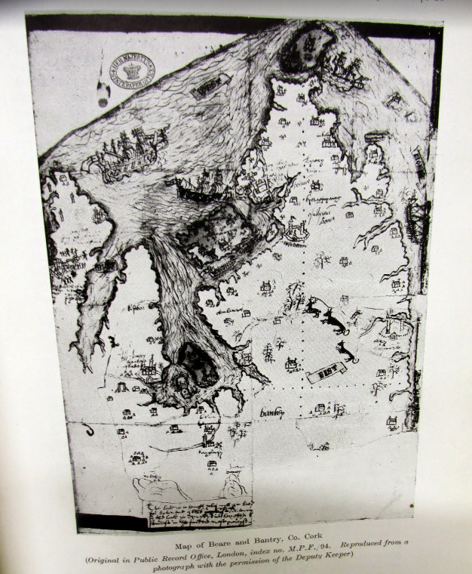
https://plus.google.com/photos/100968344231272482288/album/6106480034418356305/6106480199472986658.
..

...
Dummanack House. Gorteenroe House. July 1854; The old salt house Gurteen Roe near Bantry and Gurtnaroe House | George Victor Du Noyer.

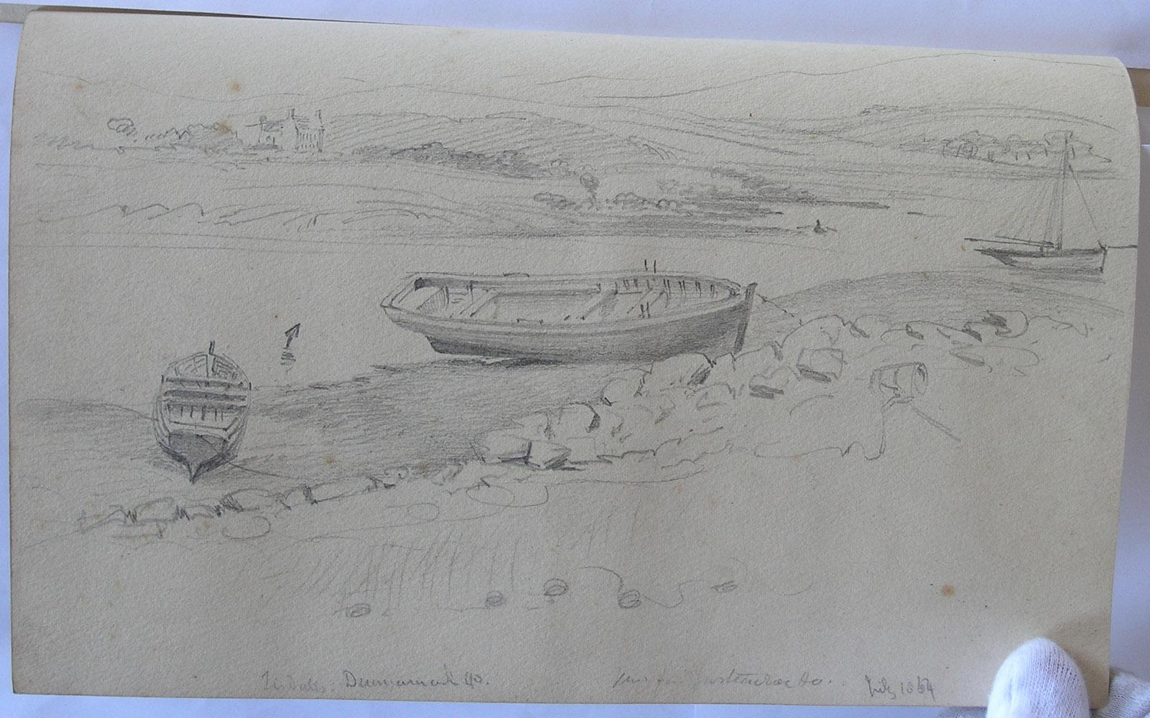..

..

….

….

..
..

…

Francis Jobson's Map (at back) of West Cork, 1589 including Cape Clear (Iniskyran), Baltimore, O'Driscolls, Rosbrin, Crookhaven, Bantry, Muintervara land of Rymers (O'Daly's Bardic School), O'Sullivan Bere, Priest's Leap.

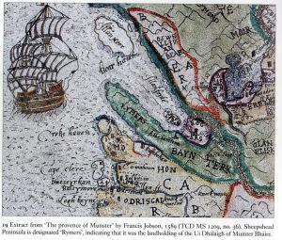
..
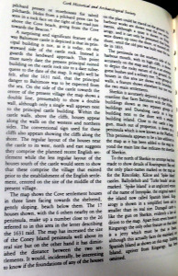 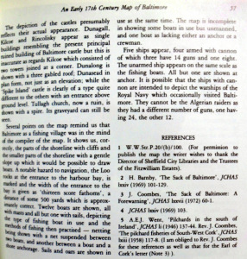 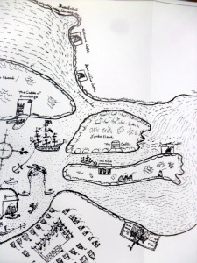 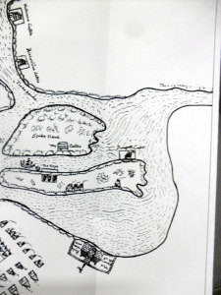 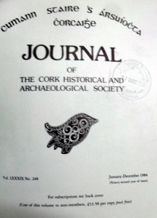 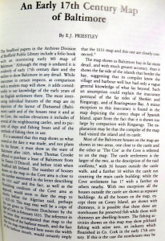 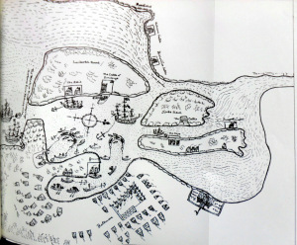 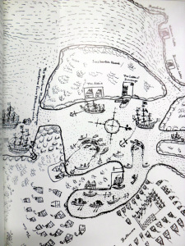..

.
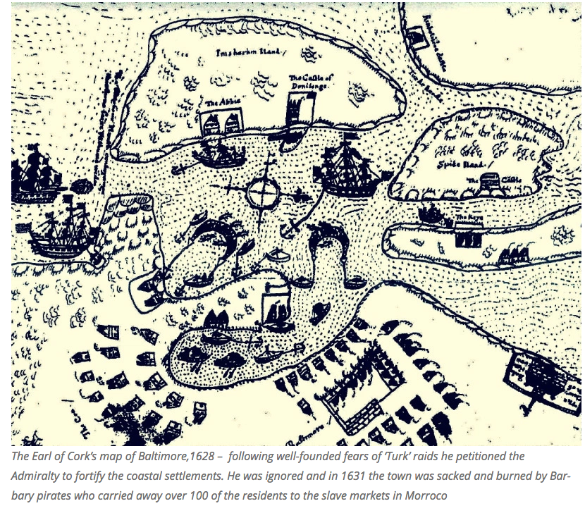..

..

..
1824 map projected road to Bantry House

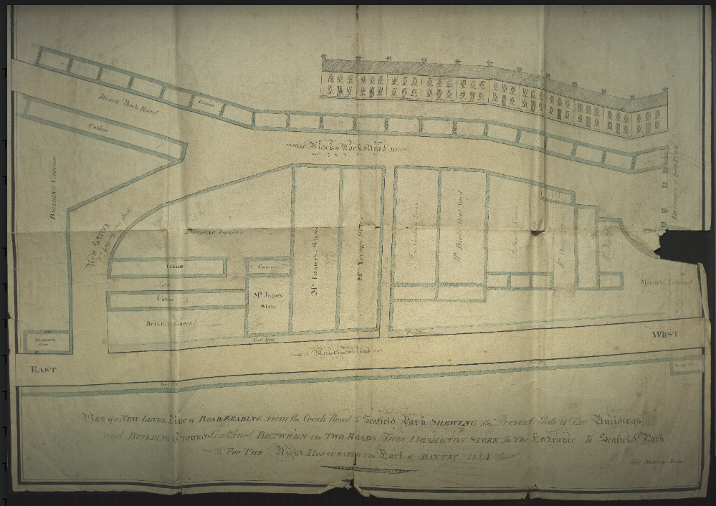
..

‘’

..

Dummanack (Donemark) House. Gorteenroe House. July 1854; The old salt house Gurteen Roe near Bantry and Gurtnaroe House | George Victor Du Noyer

.

….

…
1685. ‘Portable vessel of wicker, ordinarily used by the wild Irish’ by Thomas Phillips c 1685 and Gold boat from First Century BC. From Peter Harbison’s book, Pilgrimage in Ireland
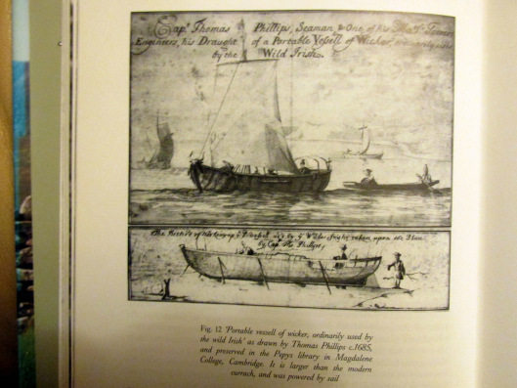
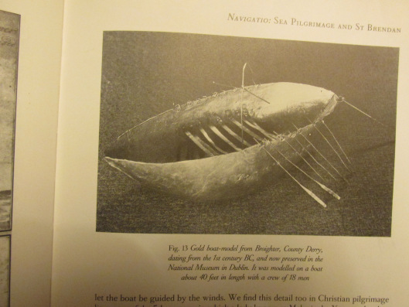

..
…

…
1822. Local Fishery Committees, Kinsale, Clonakilty, Glandore, Baltimore, Crookhaven For Bantry Timothy O'Donovan JP, O'Donovan's Cove, Durrus, Michael O'Sullivan, Rev. Edward Jones Alcock, Rector Durrus, John Jagoe later Fishery Commissioner, Michael Murphy, Newtown, Bantry, Rev. M McChean, Bantry, John Sandys Bird.

https://books.google.ie/books?id=8XISAAAAIAAJ&pg=PA39&lpg=PA39&dq=rev+edward+jones+alcock+cork&source=bl&ots=N31NFDoRWZ&sig=ZG8DwEPlBHEeaHJ87JNQDu0xm9g&hl=en&sa=X&ved=0ahUKEwjP5-qS-c3OAhViIcAKHdyODoIQ6AEIOjAF#v=onepage&q=cork&f=false

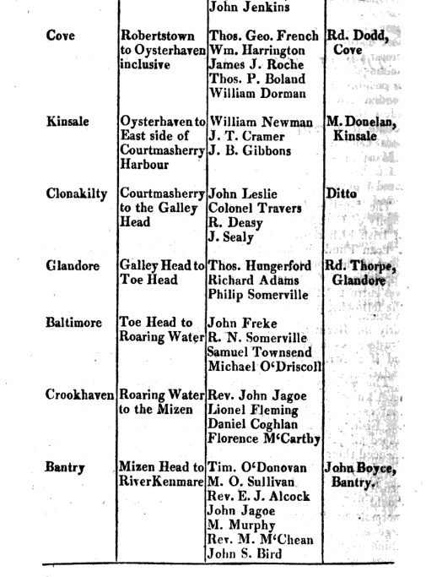

..
1825. The case of the Clio. The underwriters objected to the level of awards made by the local magistrates and reduced the eventual awards. From the Southern Reporter and Cork Commercial Courier 31 March 1825

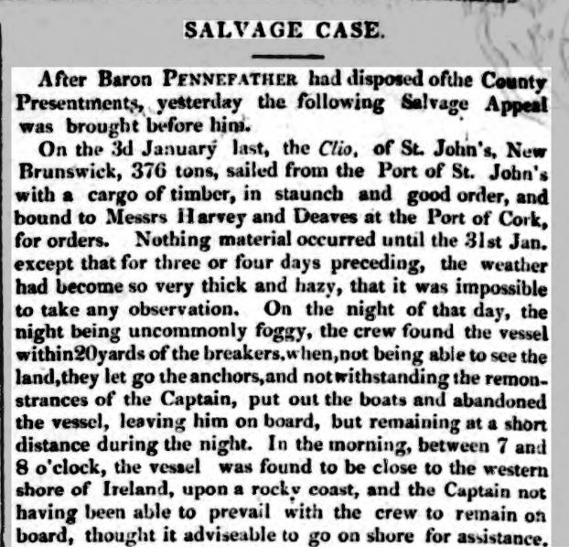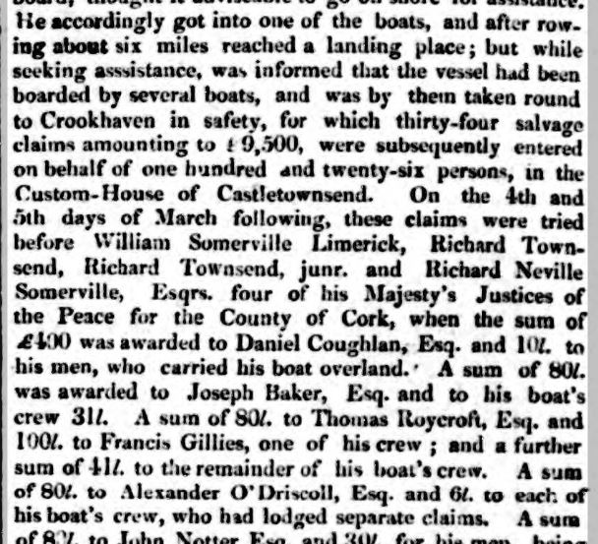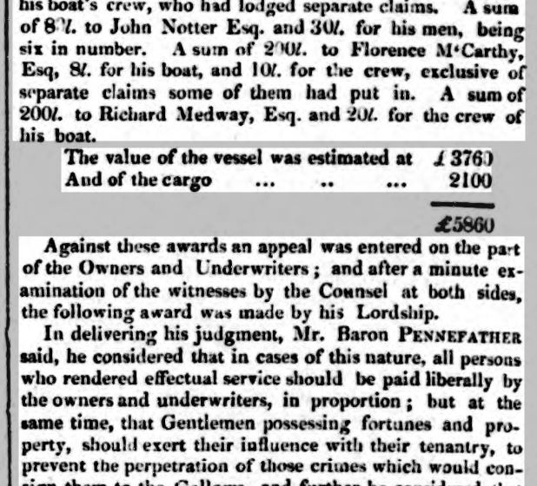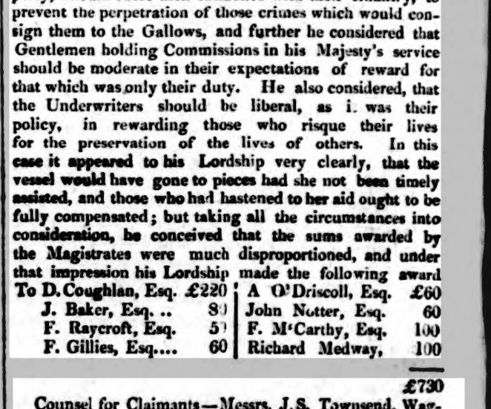

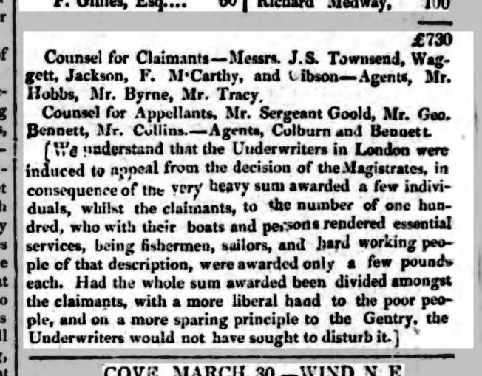..

..
1788, Hake Landings, Baltimore, Kinsale

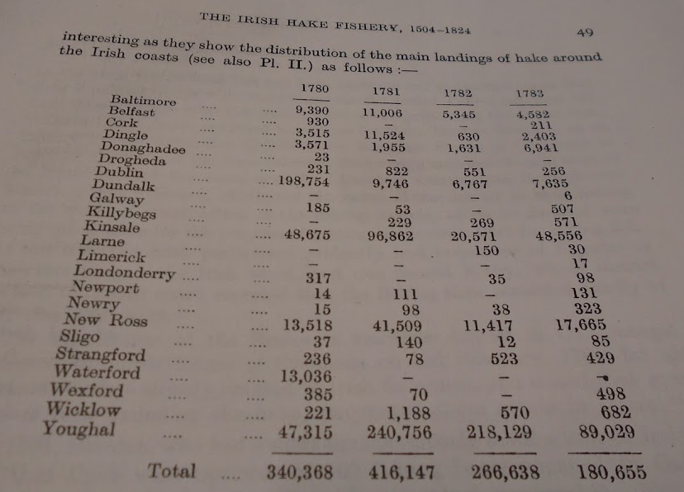
..

..

….
1837. Fisheries of Co.Cork, 2,631 Boats, 13,738 Fishermen, with Listing of Coast Guard Stations and Named Coastguards.

From Commission on Industry.

http://www.dippam.ac.uk/eppi/documents/11292/page/152014

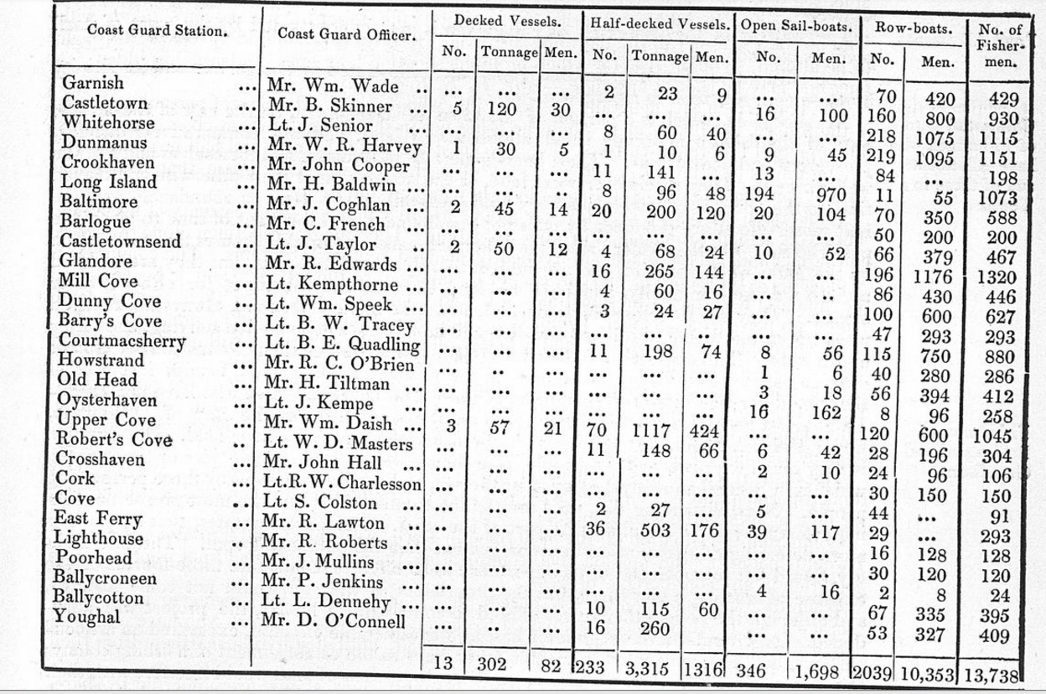
...
..
Jack Attridge, Gearhameen, Durrus, West Cork, c 1920-50 with Skeleton of his Boat on Dunmanus Bay and Homemade Threshing Machine. Courtesy St. James History. The boat was built with timbers felled from around the Grain Store at Friendly Cove across the bay. They were then floated across the bay to the Priest's Gate, Gearhameen. The boat was probably a sand boat. The winch was installed but not the engine so it never went into service but would be representative of that type of craft.

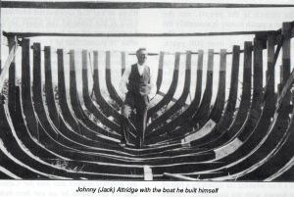
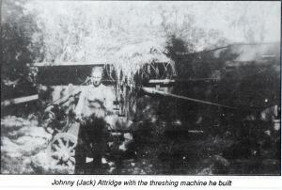
..

...
..
Lighthouses

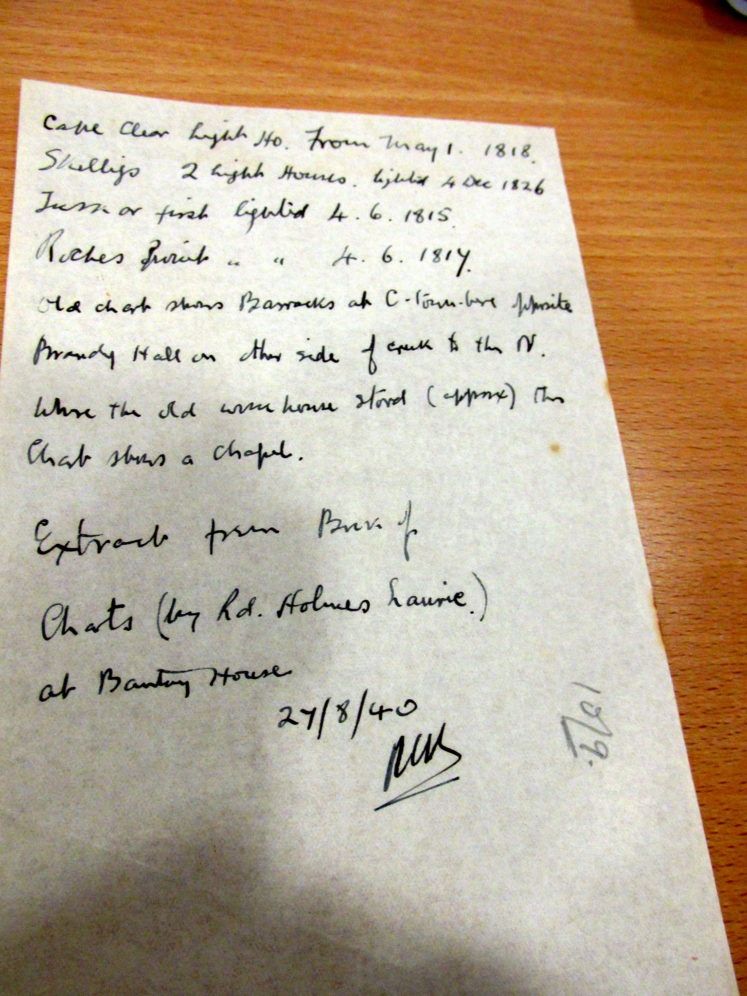...

...
1777 Bantry Map
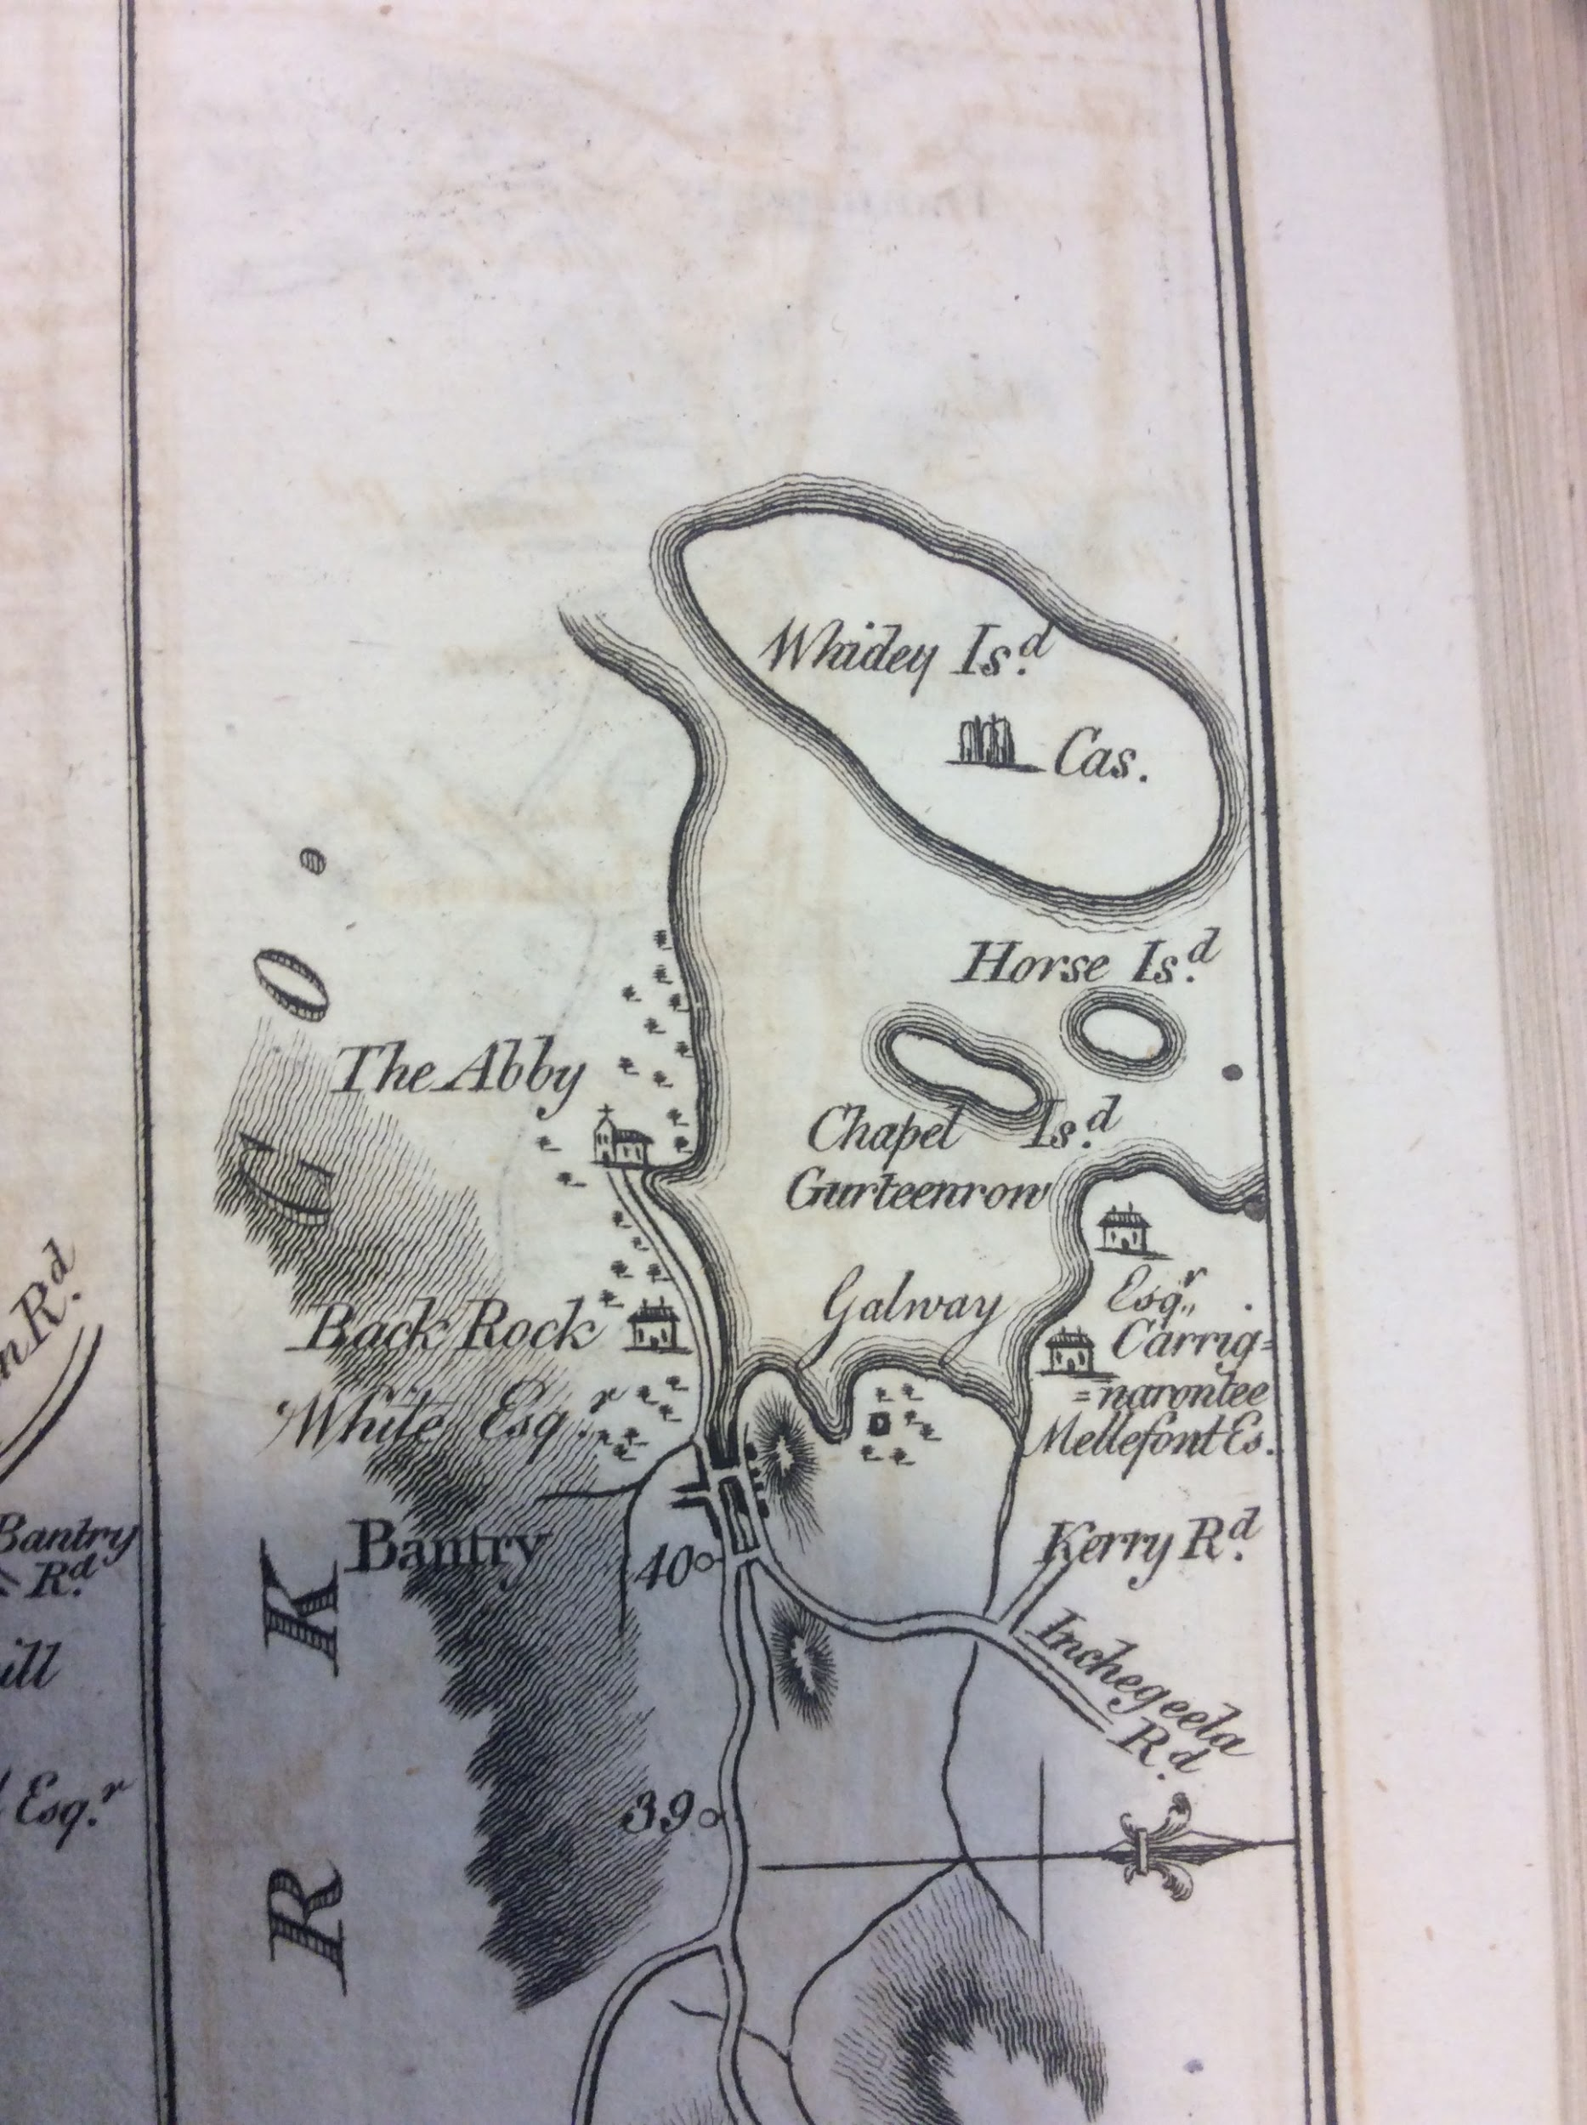
..

..

….
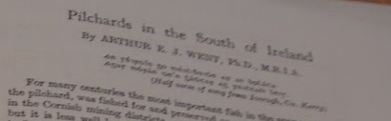..
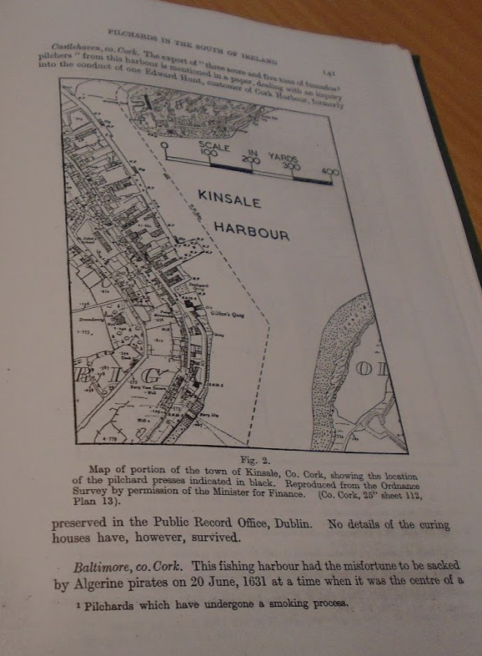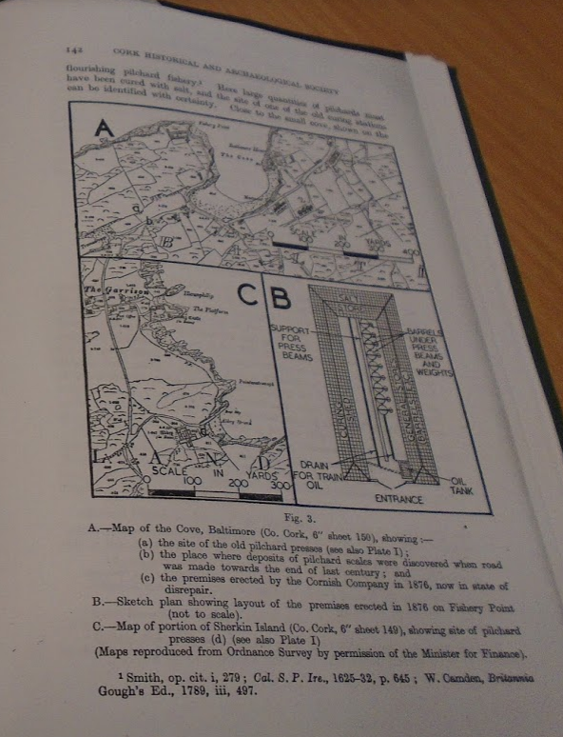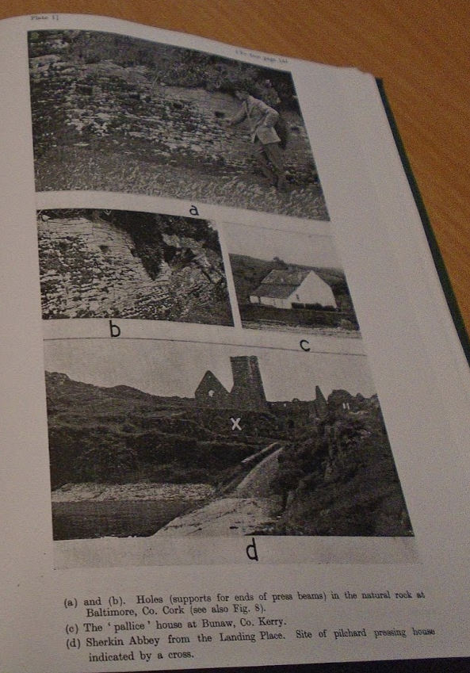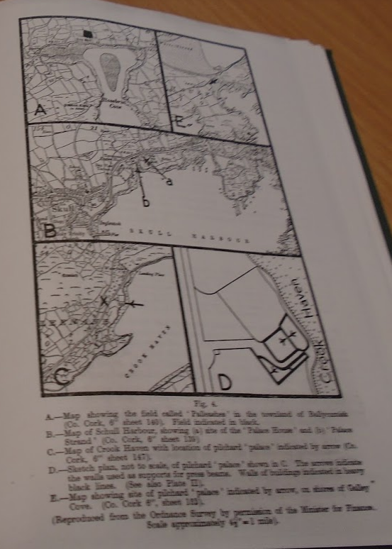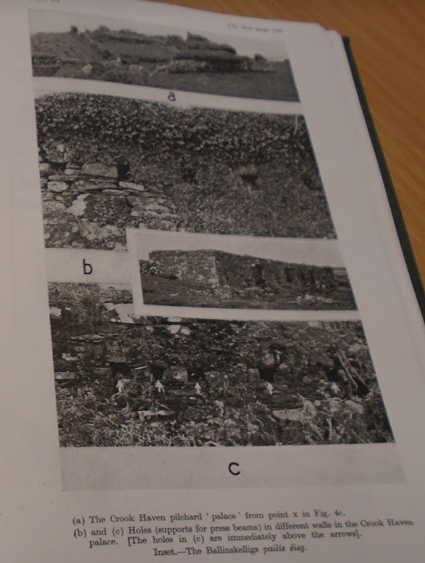...

…

...
Parliamentary Gazateer, Bantry, 1845

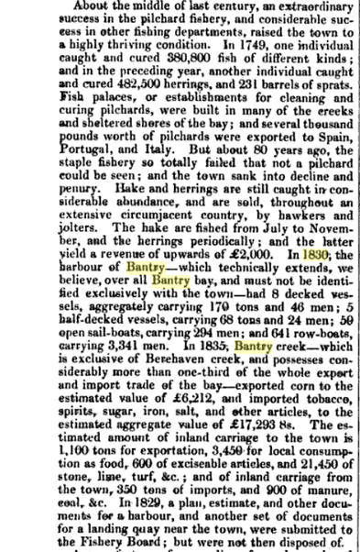

….

….

Pilchard Fishery, Bantry 1740s:

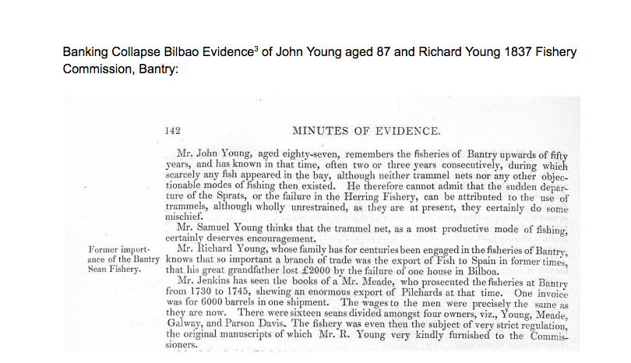

..

….

...

…

..

..

Digital JCHAS: Index contents

Ardmore, curing of pilchards at, LI (1946), 140
Ballinskellig's, curing of pilchards in, LI (1946), 151
Baltimore, curing of pilchards in, holes for press beams, (illustr.), LI (1946), f. 144
Baltimore, curing of pilchards in, LI (1946), 141-3
Baltimore, pilchard fishing in, LXXXIX (1984), 55-6
Bantry Bay, pilchard fishery, 92 (1987), 118-19 [N]
Bantry, bay, curing of pilchards at, LI (1946), 146-9
Bantry, pilchard fishery at, LXVI (1961), 67-9
Beare peninsula, curing of pilchards in, LI (1946), 149-51
Castlehaven, curing of pilchards at, LI (1946), 141
Clear island, curing of pilchards in, LI (1946), 144
Cork, south-west, pilchard fisheries of, LXIII (1958), 117-18
Courtmacsherry bay, curing of pilchards at, LI (1946), 140
Crookhaven, curing of pilchards at, LI (1946), 146
Crookhaven, pilchard palace at, (illustr.), LI (1946), f. 146
Crookhaven, pilchard palace at, holes for press beams in, (illustr.), LI (1946), f. 146
Crookhaven, plan of pilchard 'palace' in, LI (1946), 145
Dunmanus bay, curing of pilchards at, LI (1946), 146
Dursey island, curing of pilchards in, LI (1946), 149
Fishing and fisheries, pilchard fishery (Cork coast), 92 (1987) 118-119 [N]

reland, South of, pilchards in, LI (1946), 137-57
Kenmare bay, curing of pilchards around, LI (1946), 149-51
Kinsale, curing of pilchards in, LI (1946), 140
Leamcon, pilchard fishing at, LII (1947), 67
Long island, Co. Cork, curing of pilchards at, LI (1946), 144
Pilchard fishery, 92 (1987), 118-19 [N]
Pilchard fishing, Baltimore, LXXXIX (1984), 55-6
Pilchards, alternative names for, LI (1946), 156
Pilchards, Bantry fishery, LXVI (1961), 67-9
Pilchards, Cornish seine net for, (illustr.), LII (1947), 67
Pilchards, Cornish seine net for, method of working, LII (1947), 67
Pilchards, curing of, LII (1947), 59n.
Pilchards, curing stations for, LI (1946), 140-51,
Pilchards, folk tales concerning, LI (1946), 156-7
Pilchards, holes for press beams. (illustr.). LI (1946), f. 144; f. 146
Pilchards, identification of, LI (1946), 156
Pilchards, method of curing of, LI (1946), 151-4; LII (1947), 68
Pilchards, method of curing of, plan and elevation of press, LI (1946), 154
Pilchards, method of packing, LI (1946), 150
Pilchards, methods of fishing for, diagrams illustrating, LI (1946), 138

Pilchards, methods of fishing for, LI (1946), 137-9; 149n.; LII (1947), 60n.; 61n.; 67
Pilchards, questionnaire re, LI (1946), 88-9
Pilchards, South of Ireland, in, LI (1946), 137-57
Pilchards, South-west Cork fisheries of, LXIII (1958), 117 -18
Pilchards, train oil from, LI (1946), 154-5; LII (1947), 61n.
Pilchards, use of, as food, LI (1946), 155
Rossbrin cove, Co. Cork, curing of pilchards at, LI (1946), 144
Schull harbour, curing of pilchards at, LI (1946), 146
Sherkin Island, curing of pilchards in, LI (1946), 143-4
Sherkin Island, curing of pilchards in, site of pressing house for, (illustr.), LI (1946), f. 144
Went, Arthur E. J., 'Negotiations for the establishment of a pilchard fishery at Bantry in 1875,' LXVI (1961), 67-9
Went, Arthur E. J., 'Pilchards in the South of Ireland,' LI (1946), 137-57
Whiddy Island, curing of pilchards at, LI (1946), 148.
..

...

https://books.google.ie/books?id=VIsJAAAAIAAJ&pg=PA393&lpg=PA393&dq=meade+bantry&source=bl&ots=LiS5TpVAR9&sig=NPVsneILMs2kFV8SlDzrAfau7mo&hl=en&sa=X&ved=0CCUQ6AEwAjgKahUKEwj6nqSOyLzIAhXJOj4KHQ8iCwo#v=onepage&q=meade%20bantry&f=false
https://durrushistory.com/2017/09/12/1615-patent-15-of-king-james-1-of-england-david-meade-to-sell-liquor-in-carbery-and-to-james-roche-and-richard-liquor-licenses-at-crookhaven-and-berehaven/
https://durrushistory.com/2017/01/22/1760s-lease-renewal-to-richard-mellefont-esq-by-kenmare-estate-of-donemark-bantry-west-cork-for-three-lives-mellefonts-father-had-vastly-improved-and-enclosed-fields-of-a-proper-size-with-well-p/
https://books.google.ie/books?id=EnBbAAAAQAAJ&pg=RA1-PA43&lpg=RA1-PA43&dq=map+baronies+west+cork&source=bl&ots=QeOEw2nd9S&sig=_8mz9xzBOuzb6hCUgh4MNWWiAP4&hl=ga&sa=X&ved=0ahUKEwjoh8jqs97YAhWHh7QKHRXXBsw4KBDoAQg1MAQ#v=snippet&q=pilchard&f=false
https://irishdeedsindex.net/mem.php?memorial=184109224
https://books.google.ie/books?id=VYJHAAAAYAAJ&pg=PR3&lpg=PR3&dq=warden+flood+barrister+donovan&source=bl&ots=AYyeBsG1kw&sig=qjINmWLh70HTQbPEsmpMBELlk_A&hl=en&sa=X&ved=0ahUKEwjwtoSPj4_RAhViIMAKHQGfDuoQ6AEILDAD#v=onepage&q=warden%20flood%20barrister%20donovan&f=false
https://irishdeedsindex.net/mem.php?memorial=480868
1998 addendum by Emery C. Daly: In the book Irish Immigration to New England through the Port of Saint John New Brunswick Canada 1841-1849″ by Daniel F. Johnson I found the following arrival dates for the Brig Dealy. All voyages originated in Bantry co Cork Ireland. May 16, 1841, Sept 15, 1841, May 27, 1842, Sept 4, 1845, May 12, 1846, May 27, 1847, June 21, 1848. I don’t know where the Dealy was during 1843 and 1844 but the June 1848 voyage from Bantry to Saint John was obviously the last one across the Atlantic. https://durrushistory.com/2013/04/08/letter-william-j-dealy-shipowner-bantry-co-cork-re-trade-fishing-business-to-his-son-in-canada-1840-and-the-dealy-brig/
https://wordpress.com/post/durrushistory.com/12005
https://durrushistory.com/2014/11/27/will-of-joseph-austin-21st-may-1768-cork-son-john-in-amherst-nova-scotia-and-son-in-law-james-brown-halifax-and-cork-canadian-links/
Cork Reporter and Cork Commercial Courier, 27th May 1834. https://durrushistory.com/2015/07/12/daniel-galwey-under-agent-for-lloyds-assaulted-by-mob-cape-clear-february-1834-attempting-to-recover-proceeds-of-ship-wreck/
https://durrushistory.com/2015/03/31/loss-of-angelita-dunmanus-bay-near-dunmanus-bay-and-appointment-of-james-hutchinson-swanton-as-agent-of-lloyds-of-london-january-1862/
https://durrushistory.com/2017/03/20/1850-rescue-in-dunmanus-bay-west-cork-of-mountaineer-869-tonnes-35-days-out-of-quebec-and-later-sale-of-salvage/
http://www.dippam.ac.uk/eppi/documents/12615/page/316582
https://durrushistory.com/2016/05/07/1845-john-coughlan-of-crookhaven-west-cork-owner-of-whaler-the-wild-irish-girl-rescues-schooner-british-america-canada-exile/
https://durrushistory.com/2015/09/23/will-captain-jeremiah-coughlan-royal-navy-1796-1815-of-carrigmanus-schull-west-cork-family-and-william-marcus-coughlan-1884-proved-canterbury/
https://durrushistory.com/2016/07/06/1837-shipwreck-orelia-of-plymount-on-bere-island-efforts-of-edward-puxley-lloyds-agent-and-patrick-osullivan/ Southern Reporter and Cork Commercial Courier 02 December 1837
Saunders Newsletter, 12th July 1808
Dublin Courier 18th March 1763.
https://durrushistory.com/2015/03/12/sale-at-blue-hill-bantry-march-1862-of-wreck-of-frederich-brunning-of-rostock-sails-rigging-etc-apply-thomas-h-love-receiver-of-wrecks-skibbereen/
https://wordpress.com/post/durrushistory.com/25508
Skibbereen & West Carbery Eagle; or, South Western Advertiser 19 November 1864
Courtesy: Toby Bernard, Mizen Journal 2004
Two forgotten Ballydehob patriots are linked in a memorial in the old Protestant cemetery in Skibbereen. On the obelisk which surmounts the memorial there is a draped urn with the single word ROBERT inscribed on it. One of the four panels had the following inscription:
Cork Reporter and Cork Commercial Courier, 13th February 1823.
https://durrushistory.com/2015/01/04/losses-of-sir-william-hull-leamcon-schull-west-cork-1641-and-his-fishery-at-newfoundland-part-of-greater-fishery-which-suffered-from-bank-failure-in-bilbao-in-basque-country-1641-cornish-mining-l/
https://durrushistory.com/2015/01/04/losses-of-sir-william-hull-leamcon-schull-west-cork-1641-and-his-fishery-at-newfoundland-part-of-greater-fishery-which-suffered-from-bank-failure-in-bilbao-in-basque-country-1641-cornish-mining-l/
http://www.turtlebunbury.com/history/history_irish/history_irish_boyle_and_smyths.htm
Breen. p 114. Details evidence of climate change affecting fisheries over 5,500 years from Norwegian fjord core.
Father James Coombes, the O’Mahonys of Ivagha, O’Mahony Journal.
See 22 below, Breen p 85
Iscach mara muiridi deep sea fishing, a crichaib Bai is Beire from the regions of Dursey and Beare, Medbhan Faide firghlaine laver of clean and fresh Whiddy, Duileasc a cuanuibh Cleire Dulse from the harbours of Clere Island , Breen p 114
O.Mahony Journal, No 17, 1994
Breen p 120.
See 75
A.E.J.Went, Pilchards in the South of Ireland, JCHAS 1946
Francis Tuckey’s remberancer, Cork, 1767, 1770.
This is dealt with in Michael Carroll’s book and took place on the 25th September 1918. Those lost were Ned Griffin, Henry Driscoll, Johnny Leary, William Donovan, Jeremiah O’Neill, Christy Neill, Denis McCarthy, and Jeremiah McCarthy. An earlier tragedy in 1899 outside Kilcrohane resulted in the loss of 6 lives, 2 McCarthys from Letter, A McCarthy, Donovan and Tom Spillane Charles Coughlan father of 12 children. In the 1930s Father McSweeny’s manservant was Mick Bohane who was friendly with Nancy Dukelow (Mrs Peters), she remembers that he said his grandmother from the Northside was a native Irish speaker and composed a ‘Caoin’ for lost fishermen. Even though Mick had no Irish he was able to recite the Caoin and she transcribed it for the school folklore project but it does not appear to have been used.
The Fisheries Commissioners Report for the Bantry District 1865 showed 216 vessels 658 men, some old curing establishments but fish generally sold fresh and sold locally except sole? Sent to Dublin, 206 boats engaged in seine line and trammel fishing. Want of energy chief impediment to progress. SE 14thJuly 1866
Cork Examiner 24 Dec. 1861.
Richard S. Harrison Bantry in Olden Days, p 46 this was the Cork Spring Assizes and they were defended by TD Sullivan originally from Durrus Cross.
Chief Secretary Papers reports of Resident Magistrate Warburton, 1879 onwards.
SE Oct 1861
Doherty Papers Cork Archives, U137 and 024, rental registers.
https://www.europeana.eu/portal/en/record/2058619/object_DP_7921453.html?q=bantry
https://www.europeana.eu/portal/en/record/2058619/object_DP_7921453.html?q=bantry
John Windle papers, Royal irish Academy, Correspondence between Owen (Eugene) McCarthy, Kilcrohane, Co. Cork and [Rev] James O'Driscoll, Kilmichael, Co. Cork, in which O'Driscoll furnishes queries concerning the O'Driscoll family of Baltimore and Carbery. The queries are answered by McCarthy, making direct reference to Royal honours bestowed on Fynen (Fineen) O'Driscoll and his association with Sir Walter Coppinger. O'Driscoll, James; McCarthy, Eugene (Owen) 29 December 1850 27 December 1850 12 L 11/104
Thanks to John Tobin.
Thanks John Tobin
Cork Gazette, 27th December 1794.
Cork Gazette, 8th March 1794.
Hibernian Chronicle 29/12/1794
Registry of Deeds, 1741, Book 105, p. 159, 73005. The lands were described as lands at Coolnalong 6 ploughlands a ploughland and half at Broghreeis, half ploughland of Rossmore with the Island and fishing palice and the half ploughland of Gerrymeen in which the house of Jn O Mucky, the half ploughland of Cappamonagh (this may have been above the old rectory in Clashadoo) and the half ploughland of Coolenchorny the ploughland of Comkeen and ploughland of Carrigbui. The deed was from Charles Moore of Hamerton Tipperary who was probably of the Tullamore Moores who had estates adjoining the Bernards and who later intermarried with them. There was a property transfer involving Kilcrohane lands in 1711 from William Hull to Elizabeth Tonson who transferred her interest in 1715 to Emanuel Moore among others, there may be a connection. There is a further deed (Book 789 p. 218 538954), including Four Mile Water over the same lands in 1824 where Viscount Hayes Doneraile in consideration of £6,665.13 from Frances Bernard releases onerous covenants in the earlier deeds.
(Tuckey's Cork Remembrancer) - AD 1775
Corke Journal, Feb. 1765
Cork Constitution 6/5/1826)
http://www.csorp.nationalarchives.ie/search/index.php?simpleSearchSbm=Search&category=27&searchDescTxt=dunmanway&offset=30&browseresults=true
Dublin Weekly Register 03 August 1822
http://www.corkpastandpresent.ie/history/caulfield_complete.pdf
The above is in the UK National Archives, Kew. SP 46/130/70
https://durrushistory.com/2015/01/30/early-map-of-baltimore-west-cork-between-1605-1640-showing-english-settlement-dunasead-castle-lo-rocks-storehouse-for-preserved-fish-12-fishing-boats-seine-pilchards-5-possible-royal-navy-bo/
https://durrushistory.com/2016/02/11/1785-will-of-alexander-odonovan-squince-skibbereen-west-cork-various-townlands-farm-at-myross-fishery-salt-store-fishing-boat-possible-father-in-law-of-timothy-odonovan-justice-of-the-pe/
https://books.google.es/books?id=ZUcxAQAAMAAJ&printsec=frontcover&dq=inauthor:%22Great+Britain.+Commissioners+on+Municipal+Corporations+in+Ireland%22&hl=en&sa=X&ved=0CBsQ6AEwAGoVChMIjKXBl6WXyQIVQ7MUCh3d8QhF#v=onepage&q&f=false
https://durrushistory.com/2015/09/09/1781-letter-richard-wright-port-surveyor-skibbereen-re-naval-movements-privateers-dutch-and-french-boats/
https://durrushistory.com/2015/04/13/tsunami-december-1942-kilcrohane-west-cork-devastates-remaining-seine-boats/
https://durrushistory.com/2015/03/14/16th-october1861-donemark-bantry-16-acres-to-let-prime-land-suitable-for-potatoes-or-corn-four-boats-of-sea-sand-will-be-given/
https://wordpress.com/post/durrushistory.com/34140
https://wordpress.com/post/durrushistory.com/14729
https://wordpress.com/post/durrushistory.com/14517
https://books.google.ie/books?id=250TAAAAYAAJ&pg=PA395&lpg=PA395&dq=bantry+proctor&source=bl&ots=9Oshd62Q58&sig=Ms23mkUZi1sGgyoVBAQ4HMMWXIg&hl=ga&sa=X&ved=0ahUKEwj6wtWE0JbLAhXFcRQKHRBZBVgQ6AEIOjAG#v=onepage&q=bantry%20&f=false
https://durrushistory.com/2015/02/04/historical-notes-on-bandon-river-fishery-co-cork-formerly-known-as-glashlinn-green-river-salmon-weirs-oysters-pearls-methods-of-fishing-legal-title-commencing-with-grant-in-september-1588/
https://durrushistory.com/2014/12/05/from-foreign-fishing-fleets-in-ireland-1531-dermot-osullivan-prince-of-bere-and-bantry-hangs-english-captain-that-seized-spanish-ship-1572-spanish-and-basque-fleets-at-baltimore-1586-osul/
https://durrushistory.com/2015/03/11/carbery-coldfurze-horse-islands-dunmanus-bay-west-cork-part-of-becher-estate-19th-century-horse-and-cold-island-no-cultivation-value-consists-of-right-to-sea-weed-to-be-had-to-a-considerable-e/
https://wordpress.com/post/durrushistory.com/5280
https://wordpress.com/post/durrushistory.com/6093
https://durrushistory.com/2015/12/28/meeting-urging-the-building-of-pier-at-bantry-at-a-cost-of-2000-november-1862/
Thanks to Brian Limrick
Hurst originally coast guard stock married into Shannons of Clashdoo, Durrus (Coughlan, Carrigmanus descendants
Dublin Evening Post, 1st February 1849.
Dublin Evening Post, 1st February 1849.
Cork Examiner 3rd December 1849
https://wordpress.com/post/durrushistory.com/21650
.https://wordpress.com/post/durrushistory.com/20050
https://durrushistory.com/2015/11/09/october-1766-seizure-by-mob-of-disorderly-fishermen-at-kinsale-co-cork-of-sloop-laden-with-potatoes-bound-for-gibraltar/
https://durrushistory.com/2014/12/08/silver-chalice-of-baltimore-church-possibly-thanksgiving-from-captain-of-agatha-1631-church-of-ireland-baltimore-west-cork/
Bishop Dives Downes visitation quoted in Maziere Brady.
Boole Library UCC.
Boole Library, UCC.
http://www.corkgen.org/publicgenealogy/cork/potpourri/corkancestors.com/Aughadown.htm
Royal Commission of inquiry into the state of the Irish Fisheries: first report http://www.dippam.ac.uk/eppi/documents/11292/page/151988
Pigotts Directory
https://irishdeedsindex.net/mem.php?memorial=578443
https://irishdeedsindex.net/mem.php?memorial=481950
https://irishdeedsindex.net/mem.php?memorial=184205157
https://irishdeedsindex.net/mem.php?memorial=345908
https://irishdeedsindex.net/mem.php?memorial=467284
Irish Manuscripts Digital online edition of Kenmare papers
Paddy O’Keeffe papers
The Story of Kilcrohane, Frank O’Mahony, Bantry, 2000
Tuckey.
1846 Parliamentary Gazetteer, Fullerton and Co.
https://durrushistory.files.wordpress.com/2012/08/history-of-whiddy-island-bantry-bay-from-paddy-okeeffe-papers.pdf
http://discovery.nationalarchives.gov.uk/details/r/D851588, PROB 11/181/2
http://discovery.nationalarchives.gov.uk/results/r?_q=whiddy
Many of the wrecks listed here are outlined by Denis Downey in ‘Goleen Past and Present’,
Harrisson, Rosmacowen
Harrison
W. O’Halloran, Story of West Cork 1916
Congested District Board, baseline reports, Mr. Rche, no. 79, 63
Richard S. Harrison, Story of Ballymacowen
http://www.corkgen.org/publicgenealogy/cork/potpourri/corkancestors.com/Castlehaven.htm
Cork Constitution, 9th June 1862.
http://www.irishlights.ie/tourism/our-lighthouses/old-head-of-kinsale.aspx
http://www.corkhist.ie/index-results.php?pageNum_rsSearchi=2&totalRows_rsSearchi=53&indexSearch=pilchard&search=Search
https://irishdeedsindex.net/mem.php?memorial=143223
http://landedestates.ie/LandedEstates/jsp/estate-show.jsp?id=2382
Kenmare Estate Records.
Thanks to Colum Hourihane for locating in British Library.
1946, JCHAS. Vol 2, In turn this is from Cogan survey of Irish Customs and Excise. From Dr. Went’s history of Irish Fisheries:
Smiths History of Cork
Smiths History of Cork
Dr. Went, JCHAS, Vol 2, 1946
Dr. Went, JCHAS, Vol 2, 1946
Dr. Went, JCHAS, Vol 2, 1946
Carew Ms., 1603-1624, p. 177 quoted in Dr. Went.
School Folklore Collection, Daithi De Barra, Tracton
Smith History of Cork, W. W. Seward, Topica Hibernica, 1795.
https://durrushistory.com/2018/07/17/1665-four-dutch-vessels-of-great-force-hover-between-crookhaven-and-castlehaven-they-burned-a-barque-communication-between-coronet-emanuel-more-to-his-kinsman-mr-hull/
https://irishdeedsindex.net/mem.php?memorial=507786
Dr. Went advised 1945 by Mr. MIchael Harrington which he recalled in his youth.
Dr. Went
https://books.google.ie/books?id=9rblf03SdkYC&pg=PA222&lpg=PA222&dq=bantry+dispensary+1830&source=bl&ots=tmlK9RAjB_&sig=v1gysFCUOAiUWUzu1O2Eazo7CjM&hl=en&sa=X&ved=2ahUKEwj35rC5qo7eAhVKK8AKHQrHBckQ6AEwBHoECAUQAQ#v=onepage&q=bantry%20dispensary%201830&f=falsehttps://books.google.ie/books?id=9rblf03SdkYC&pg=PA222&lpg=PA222&dq=bantry+dispensary+1830&source=bl&ots=tmlK9RAjB_&sig=v1gysFCUOAiUWUzu1O2Eazo7CjM&hl=en&sa=X&ved=2ahUKEwj35rC5qo7eAhVKK8AKHQrHBckQ6AEwBHoECAUQAQ#v=onepage&q=bantry%20dispensary%201830&f=false
Cork Gazette 8th March 1794
http://www.irishmanuscripts.ie/pdf/products/117/Reduced%20size%20Calendar%20of%20the%20HCA%20Preview.pdf
Huguenot ran fishery in Beara among followers ancestor of Davy Crockett
Robert Wyse Jackson, Life in the Church of Ireland, 1600-1800
In 1968 Paddy O’Keefe in contact with A. C. Holliday, Burgeta, Rosscarbery. O’Keeffe was shown location of wreck by John E. Donovan of Union Hall. Box 5, Paddy O’Keeffe papers, Cork Archive,
Dr. Charles Webster, Plate of Dioceses of Cork.
John T. Collins, http://www.corkhist.ie/wp-content/uploads/jfiles/1947/b1947-033.pdf
1863 Cork Grand Jury Presentments, Spring Assizes. Cork Archives: GJ/CO/PR/23 (1).
Cork Archives 1838, GJ CO/PR/5 (1)
1863 Cork Grand Jury Presentments, Spring Assizes. Cork Archives: GJ/CO/PR/23 (1).
http://www.corkpastandpresent.ie/history/august27/kinsale_council_book_reduced_cropped.pdf
http://www.corkpastandpresent.ie/history/august27/kinsale_council_book_reduced_cropped.pdf

