.

…..

….

Baronies of West Cork.

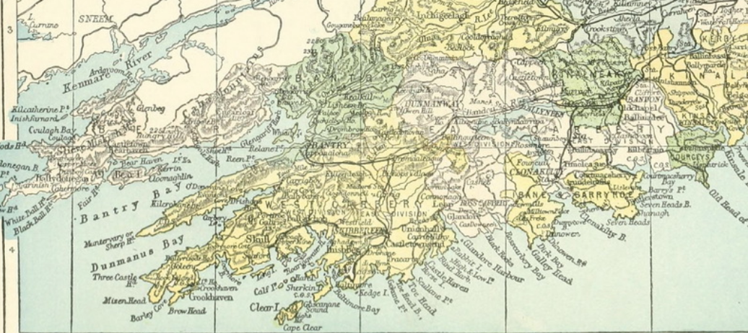

...

Freedom of the City

Roll of the Honorary Burgesses of The City of Cork -Freedom of the City

The custom of awarding the "Freedom of the City" whereby persons distinguished for public service become Honorary Burgesses of a City dates from the 14th century. Prior to the reform of the Cork Corporation in 1841 the City was generous in awarding the distinction to prominent representatives, of those thus honoured may be mentioned Dean Swift and Captain Richard Roberts who navigated the "Sirius" the first steamship to cross the Atlantic from Europe Cobh to New York in 1838. Due to recent acquisitions by the Cork City Library a complete list of the Freemen of the City of Cork including Honorary Freemen for the period 1609-1841 is now available. Owing to the destruction of municipal documents by fire in the Courthouse in 1891 very few early municipal documents are available except some few items that have recently come to light. Previous to 1887 the Municipal Privileges Act, 1875, was passed under which Charles S. Parnell and William E. Gladstone were elected Honorary Burgesses, and on August 22nd, 1884, William O'Brien.

From Cork Archives Freemen 1710 to 1841.

Transcribed from existing collection (Ref. U.11) ‘Index/Digest to Council Books of the Corporation of Cork With alphabetical list of Freemen’. Original and typescript by John O'Shea. Date of freemen admission from the 31st October 1710, to the 25th October 1841, the last assembly of the old Corporation as constituted previous to the coming into operation of the Municipal Corporations (Ireland )Act 1840, which introduced local democratic elections. The power of admitting Freemen only by birth or right also ceased in 1841.

This list is not exhaustive, there are frequent mention of Freemen in relation to election petitions in the early 19th century who are not mentioned. Often the same name appears multiple time with no address or date. It is a challenge to try and ascertain from other sources who the person is. Sometime by looking at lists of Magistrates or deeds it is possible to establish their identity but of necessity this list is not complete nor does it attempt to be definitive.

Cork City Constituency

Pre Act of Union 1800.

The electorate comprised the freemen of the city (including non-residents), and the Forty Shilling Freeholders of the county of the city. It returned two members to the Parliament of Ireland to 1800.

Post 1800 election to Imperil Parliament in London, England

The right of election was vested in the freemen of the city, and in the 40s. freeholders and £50 leaseholders of the county of the city, of whom the freemen, in 1831, amounted in number to 2331, and the freeholders to 1545, making a total of 3876; but by the act of the 2nd of Wm. IV., cap. 88 (under which the city, from its distinguished importance, retains its privilege of returning two representatives to the Imperial parliament, and the limits of the franchise, comprising the entire county of the city, remain unaltered), the non-resident freemen, except within seven miles, have been disenfranchised, and the privilege of voting at elections has been extended to the £10 householders, and the £20 and £10 leaseholders for the respective terms of 14 and 20 years. The number of voters registered up to Jan. 2nd, 1836, amounted to 4791, of whom 1065 were freemen; 2727 £10 householders; 105 £50, 152 £20, and 608 forty-shilling freeholders; 3 £50, 7 £20, and 2 £10 rent-chargers; and 1 £50, 26 £20, and 95 £10 leaseholders: the sheriffs are the returning officers.

Sheriff and Mayor of Cork City
In Ireland, a sheriff (Irish: sirriam) is a court officer in both Dublin City and County and Cork City and County who earn their fees from poundage (commission). Before 1842 two sheriffs (and the Mayor) were voted into office annually by the freemen of the borough. After that time the power of appointment of a single sheriff per year was vested in the crown

Freemen of Youghal

In 1353 the Freemen of Youghal were allowed freedom of trade for their wool, woolfells, leather and lead in different staples throughout England and Wales.

1827 Election, John Hely Hutchinson, Esq., Gerard Callaghan, Esq., List of Voters including West Cork Freemen.

Francis Allman, Cotton Manufacturer, Bandon family later had brewery and distillery.
Francis Allman, Cotton Manufacturer, Bandon 2nd Francis.

James Allman, Cotton Manufacturer, Bandon family later had brewery and distillery. Probably Invitation by Henry Townsend DL, 1839, on behalf of The Reformers of the West Riding of Cork to Daniel O'Connell MP to Dinner in Bandon, Co Cork, with 200 Liberals in attendance including, Francis Bernard Beamish MP (1802-1868), Rickard Deasy (1766-1852) Brewer Clonakilty, James Clugston Allman Distiller Bandon, James Redmond Barry J.P., Commissioner for Fisheries, Edward O'Brien, Masonic Lodge Bandon, John Hurley Brewer., Major E. Broderick, Henry Owen Beecher Townsend (1775-1847), Major Mathew Scott J.P. (1779-1844), Philip Harding, Carrigafooka, Macroom, Richard Dowden (1794-1861) Unitarian, Frances Coppinger Esq., Parkview, Bandon.

William Allman, Cotton Manufacturer, Bandon family later had brewery and distillery.

Rev. George Armstrong, Diocesan Schoolmaster (St. Faunans) Rosscarbery, 1825.

Dr. Philip Armstrong, M.D., later dispensary Doctor, Castletownbere. Attending Great Meeting re Poor Law in 1840, Bantry. Mentioned at protest meeting Cork 1842 re Medical Charities Bill and effect on fever hospital. Son George William Frederick Armstrong MD, d 1893. Brother for a while 1842 Dispensary Doctor. Timothy Collins, Attorney Cork may be related: Killingley (Ballygarven) father Timothy Margaret O'Leary both decd, affidavit of brother-in-law George Armstrong, wife Mary Armstrong, son 2nd Thomas King's Inns B. 1821. National Library has book on Cork 1783 election, published by Bennett, Cork c 1820, with his name. Wife Charlotte Louise d 1904 aged 80. Subscribers:1822 An Inquiry Concerning the Primitive Inhabitants of Ireland - Thomas WOOD (M.D.)

Arthur Bernard Baldwin, Bandon?, possibly father of Magistrate Captain Thomas Baldwin Esq (1795-1871), 1819, Mardyke/North St., Skibbereen, son of Arthur. Present at enquiry Skibbereen 1823 into enquiry into fatal affray at Castlehaven caused by Rev. Morritt’s tithe extraction.

Franklin Baldwin, Bandon. Attorney, Coroner. 1832 registered to vote for Bantry probably Rusheeninaska, Durrus by Sampson Beamish probably through Evanson renting from Lord Bandon. Non resident in Cork City, voted as County Freeman of Cork election 1837.

Henry Baldwin, Magistrate, 1750, Curravady, , Skibbereen or Bandon. Probably Freeman 1765. Richard Foott,, Millford, M 1771 Mary d Henry Baldwin of Curryvody and Mount Pleasant and wife Alice sister of Sir Robert Warren. Member 1751 Rath Club presented gallery to poor of Aherla, Church of Ireland.

Henry Baldwin, Esq. 1769

Henry Baldwin, Esq., 1794, likely Henry Baldwin, Lisardah, Crookstown, Possibly 1812 election voted Hutchinson, listed 1843. Member Commission on Magistrates 1838, listed Mountpleasant.

Henry Baldwin, Esq., Mount Pleasant, Bandon, 1767.
Henry Baldwin, Esq., Barrister,

Henry Baldwin, Esq. multiple Henry Baldwins one likely father of Hungerford Baldwin, Woollen Draper, 1797, probably related to Hungerfords of The Island, Rosscarbery. He was one of the younger children of Henry Baldwin who in 1730 was assigned poughlands at Farranmareen, Bandon, Hungerford deceased by 1860

Henry Baldwin, Esq.
Henry Baldwin, Junior, Esq., 1761
Henry Baldwin, Esq.

Hewett Poole Baldwin, Woollen Draper, Bandon. Non resident in Cork City, County Freeman of Cork election 1837.

Hungerford Baldwin, Woollen Draper, 1797, probably related to Hungerfords of The Island, Rosscarbery. One of the younger children of Henry Baldwin who in 1730 was assigned poughlands at Farranmareen, Bandon, deceased by 1860.

John Baldwin, Gentleman, 1768.
John Baldwin, 1728.
John Augustus Baldwin, Gentleman.
John Baldwin, Junior, Gentleman, 1788.
Solomon Baldwin, 1768.

Walter Baldwin, Esq., 1775. Magistrate 1772, Mount Pleasant/Curravordie, Bandon. Member 1751 Rath Club presented gallery to poor of Aherla, Church of Ireland.

William B. Baldwin, Lissard, Kinsale. Non resident in Cork City, voted as County Freeman of Cork election 1837. Magistrate Pre 1831, Lissard, 1842, (William B.). 1842 Subscriber Jacksons County and City Directory. Bantry Quarter Sessions, 1862, Jane widow, married 1865, M.C. Vallance Whiteway. May be Kinsale in 1830s. Winthrop Baldwin, Esq., 1769.
Robert Stawell Ball, may be related to Kinsale Stawell family.

Dr. John Milner Barry (1768-1822), M.D., born Kilgobbin, Bandon introduced vaccination to Cork 1800, Freedom for services in founding Fever Hospitals. Married Mary Phair, Brooklodge, family had Dunmanway connections.

Thomas Barter, Esq., Cooldaniels, Kilmichael, Bandon 1798. Non resident in Cork City, voted as County Freeman of Cork election 1837.

Adderely Beamish Esq., Kilcoleman, Bandon, may be related to Innishannon Adderleys. Non resident in Cork City, County Freeman of Cork election 1837.

Benjamin Swayne Beamish, Gentleman. Aghada may have Bandon connections.
Francis Beamish, Esq., 1776

Francis Bernard Beamish, Esq. Invitation by Henry Townsend DL, 1839, on behalf of The Reformers of the West Riding of Cork to Daniel O'Connell MP to Dinner in Bandon, Co Cork, with 200 Liberals in attendance including, Francis Bernard Beamish MP (1802-1868), Rickard Deasy (1766-1852) Brewer Clonakilty, James Clugston Allman Distiller Bandon, James Redmond Barry J.P., Commissioner for Fisheries, Edward O'Brien, Masonic Lodge Bandon, John Hurley Brewer., Major E. Broderick, Henry Owen Beecher Townsend (1775-1847), Major Mathew Scott J.P. (1779-1844), Philip Harding, Carrigafooka, Macroom, Richard Dowden (1794-1861) Unitarian, Frances Coppinger Esq., Parkview, Bandon.

Rev. Henry Beamish

Dr. John Beamish, M.D., may be Bandon, 1832 election did not vote, possibly father of Samuel, TCD, 1823, aged 18 and Peter Teulon, TCD 1841, aged 18. 1828 seeking reform of House of Commons. 1830 subscriber House of Industry. Member Western Medical Society Bandon 1834.

John Fleming Beamish, Esq.
John Beamish, Junior, Gentleman.

Lord Richard Viscount Berehaven, 2nd Earl of Bantry. (White/Bantry), (1800-1868). 1821 Freeman of Cork. Bantry, Magistrate.Pre 1831. 41 Belgrave Square, London. Bearhaven Lord “In a Silver Box, as a testimony of their High Esteem for this highly respected young Nobleman”. (1821) Subscriber 1821 Dr Thomas Wood’s ‘Primitive Inhabitants of Ireland. Notified as Magistrate of Catholic Meeting on Loyalty to King 1825. 13th January 1816. Viscount Bantry Created Earl of Berehaven and a New Viscount. Deputy Lieutenant 1832. Member Commission on Magistrates 1838. Attending Protestant Conservative Society meeting 1832. Protestant Protest Meeting Bandon 1834. He enjoyed an income of £9,000 per annum. He also married well in 1836 in London ; his wife’s Lady Mary O’Brien’s (a descendant of Brian Boru) dowry was £30,000. At Bantry Vote Registration Session 1840 with Augustus Payne J.P. (His Land Agent), Revs Sadler and Triphook. Probably focus of perceived ’Orange’ faction in Bantry by Liberals. 1842 Subscriber Jacksons County and City Directory. On death of his father became Earl of Bantry in 1851 following 3 years abroad. He amassed Bantry House Art Collection. Member provisional Committee projected Bandon to Bantry Railway 1845. Resolved, by Castletownbere Board of Guardian: ‘that the offer made on the part of Lord Berehaven of the house and offices at Cametringane as a temporary workhouse until the 1st August Castletown Board of Guardians 1850 be accepted’. Beara Estate sold to Lord Clinton c 1850 subject to scathing criticism of him and agent Patrick O’Sullivan, Millcove by Dublin Barrister Prendergast of treatment of tenants and recovery of arrears.

Edward Beecher, Esq., 1761 possibly Skibbereen.
Edward Beecher, Esq., possibly Skibbereen.

Henry Beecher, Gentleman, possibly Skibbereen. Henry Beecher, (1759-1790), 1779, Creagh/Creaford, Skibbereen. 1765 11 July Cork City Newspapers. “To be Let, part of the estate of Henry Becher (aged 5) during his minority. Lands of Gortadrohid, Ardnagreena on harbour of Baltimore etc. contact Michael Becher guardian. 1779 Hibernian Magazine Dec 1779 “Henry Becher of Creaghtford to be a J.P. of the Peace for the Co of Cork”. 1780 Hibernian Chronicle 25 Dec 1780 “Died Thursday last, Henry Becher at Creagh near Baltimore.”

Lionel Beecher, Esq., 1783 Skibbereen.

Michael Beecher, Esq., Gentleman, Skibbereen. Possibly Michael Beecher, 1777, Creagh, Skibbereen, member Atlantic Society literary society. Subscriber of 1766 'The History of the Irish Rebellion', Cork, 1766. 1778 Dublin Hibernian Journal Aug 24 1778, “Died-Near Bandon Michael Beecher of Creagh Esq.” 1789 Cork Evening Post 12 Jan 1789, ‘Last Sat George Pigott Rogers Esq. to Mary Twogood Becher, dau of the Late Michael Becher of Creagh, Esq’.

Rev. Michael Beecher, Esq.,
Michael Alleyn Beecher, Esq., Esq., Clonakilty, may be related to Alleys of Ballyduvane, Clonakilty. Non resident in Cork City, County Freeman of Cork election 1837.

Michael Westropp Beecher.

Richard Hedges Beecher, Esq., presumably related to Macroom Hedges Eyre family.

Richard Henry Hedges Becher, Hollybrook, Skibbereen, non resident in Cork City, County Freeman election 1837. Richard Henry Hedges Beecher Esq., Pre 1838, listed 1838, Hollybrook, Skibbereen, sitting Skibbereen, 1835, Came into possession pre 1833 very neglected set about improving. In re organising compensated tenants according to Ulster Custom. Engaged in road building. Abolished rundale system. Subscriber Lewis Topographical Dictionary of Ireland 1837. Attending Protestant Conservative Society meeting 1832. Bandon Brunswick Constitutional Club 1828. Non resident Freeman voting in Cork 1837 election. Anti-Repeal Meeting, Dunmanway 1845. Skibbereen 1847 distress meeting. Presentment sessions Ballydehob 1845. Signed 'No Popery Petition 1851'. 1866 Freemason Skibbereen 15th Lodge. Long litigation with Lord Bandon added to financial woes over townland of Rathooragh near Mount Gabriel. Imprisoned but later freed by his creditors 1848. The Hollybrook estate was sold in the Encumbered Estates Court in 1851, 17,000 acres, 42 townlands, 8 parishes, debts in 52 charges amounting to £52,275. The sale realised £52,080. It was estimated that the rent of £4,500 per annum represent only 25% of the value of market rents but two thirds were given long leases on low rents with a capital sum in the 1794 to families such as the Ballydehob Swantons. 1839 Freeman’s Journal 15 Feb 1839 “Marriages~On Tuesday last, in Cork, Richard H H Becher, Esq of Hollybrook in that County, to Melian, daughter of the Rev M O’Donovan of Montpelier (Ronayne’s Court, Douglas, Cork)

Thomas Alleyn Beecher, Esq., may be related to Alleys of Ballyduvane, Clonakilty.

William Wrixon Beecher, later Sir William 1846, Mallow dn Skibbereen. Sir William Wrixon Becher/Beecher Bart D.L., MP (1756-1847), Magistrate Pre 1831, Ballygiblin, Kanturk/Mallow, sitting Ceciltown 1835, m Elizabeth O’Neill celebrated actress, 2nd son Sir John Wrixon-Becher, Creagh and Ballygiblin, b 1828. 1822 Cork Trustee for The Encouraging Industry in Ireland. Commissioner with Sergeant LLoyd 1822-3 for Insurrection Acts 1822-3 Co. Cork. 1826 member Grand Jury Cork County Assizes. 1828 seeking reform of House of Commons. Member 1832 Cork Friendly Club. Cork Yacht Club 1833. Subscriber Lewis Topographical Dictionary of Ireland 1837. His son John (1828-1914), Inner Temple 1845. 1845 wholesale clearances on Creagh estate.

Dr. David John Berkeley, M.D., Skibbereen. Non resident in Cork City, County Freeman of Cork election 1837.

John Berkeley, Skibbereen. Non resident in Cork City, County Freeman of Cork election 1837.

Arthur Beamish Bernard, two of same name, Bandon

Arthur Beamish Bernard, Pallace Ann, Murragh, Enniskeane. Non resident in Cork City, voted as County Freeman of Cork election 1837. Arthur Beamish Bernard Esq., Palace Anne, Bandon, Pre 1822. Writing 1821 to Chief Secretary seeking appointment of brother Adderley Beamish Bernard half pay Captain 37th Regiment as Chief Constable of Police, severely wounded serving under Duke of Wellington and he himself active in restoring tranquility to local area. 1828 with Sir Augustus Warren proposed Franklin Baldwin attorney Bandon as Coroner. Attending Protestant Conservative Society meeting 1832, Member 1832 Cork Friendly Club. Listed 1854, Subscriber Lewis Topographical Dictionary of Ireland 1837. Member Commission on Magistrates 1838

FRANCIS BERNARD, Junior, Esq., 1777, was elevated to the peerage, in 1793, as Baron Bandon; and advanced to a viscountcy, in 1795, as Viscount Bandon. His lordship was further advanced, in 1800, to the dignities of Viscount Bernard and EARL OF BANDON. He wedded, in 1784, Catherine Henrietta, only daughter of Richard, 2nd Earl of Shannon, Francis Bernard, 1st Earl of Bandon (1755-1830), 1772, Castle Bernard, Bandon, only son James Bernard and Esther Smith d Percy Smith. M Lady Catherine Henrietta Boyle d Richard, 2nd Earl of Shannon. MP Ennis 1778-83, Delegate 1783 to Irish Volunteer convention. Requested to be president of Bandon Brunswick Constitutional Club 1828 donated £50. Bandonbridge in Irish Parliament to 1790. Lady Charlotte Bernard, 2nd daughter married 3rd Viscount Doneraile.

Francis Bernard, Esq., (1698-1783) Bandon, 1731. of Castle Bernard, and Bassingbourne Hall, Essex, espoused, in 1722, the Lady Anne Petty, only daughter of Henry, Earl of Shelburne; but died without surviving issue, when he was succeeded by his nephew James.

Prime Sergeant Bernard (1663-1731), Bandon, Prime Sergeant, Judge of Assizes. Cash purchases of distressed land sale formed nucleus of later Bandon Estate. 1725. , was attained by JAMES II’s parliament, but was restored to his estates by WILLIAM and MARY. He was appointed Solicitor-General for Ireland by QUEEN ANNE, Prime Sergeant, and a judge of the Court of Common Pleas. Mr Bernard represented Bandon and Clonakilty in parliament.

JAMES BERNARD (1729-90), of Castle Bernard, son of North Ludlow Bernard, Member in several parliaments for County Cork, who married, in 1752, Esther, daughter of Percy Smyth, and heiress of her brother, William Smyth, of Headborough, and widow of Robert Gookin. 1768 succeeded uncle FRancis Bernard.

Richard Boyle Bernard (Very Rev), Dean of Leighlin (1787-1830), of Bandon family, died of fever, associated with Church Education Society.

Roger Barnard, Esq., Palace Ann, Ballineen, 1769. Died a young Gentleman 1773.

1st Viscount Bandon and afterwards 1st Earl of Bandon. 1807, CASTLE BERNARD, near Bandon, County Cork, was re-modelled by Francis Bernard. He pulled down the two early 18th century fronts in 1798 and began building a new house alongside the old O'Mahony castle, which was joined by a corridor.

Lieutenant Walter Bernard, Bandon?

William Smith Bernard, The Farm, (Bernard Court), Curravarahane, Castle Bandon. Non resident in Cork City, voted as County Freeman of Cork election 1837. Honourable Captain William Smith/Smyth Bernard, Magistrate Pre 1831, The Farm, Bandon, listed 1824. Chairing Bandon Brunswick Constitutional Club 1828. Subscriber Lewis Directory 1837. Attending Protestant Conservative Society meeting 1832 presiding Magistrate 1845. Attending Landlord Meeting Bandon Courthouse 1846, listed 1854. Member Commission on Magistrates 1838. Country Freeman of Cork voting in Cork City 1837 election.

Abraham Biggs, Gentleman, Bandon, 1792. Merchant. Died in Waterford 1820.

Isaac Biggs, Clothier, Bandon. An Isaac Biggs clothier died 1729. Isaac Biggs/Bicks, Magistrate Pre 1828, Bandon Mills, listed 1843. 1828 member Grand Jury Bandon Quarter Sessions. 1828 seeking reform of House of Commons. Subscriber as Messrs William and Jacob and John Biggs to Lewis Directory 1837. Member Commission on Magistrates 1838. Jacob, 1840 petition for Catholic Equality.

Jacob Biggs, Clothier, Bandon. 1789.

Jacob Biggs, Gent., Bandon.

James Biggs, Gent., Bandon.

Thomas Biggs, Merchant, Bandon.

Thomas Joseph Biggs, may be Junior, Garyhankardmore, Bandon, large progressive farmer. Non resident in Cork City, County Freeman of Cork election 1837.

William Biggs, Gent., Bandon.

Richard Cox Bowden, Dunmanway. Non resident in Cork City, County Freeman of Cork election 1837. Rev. Richard Cox Bowden, Superseded as Magistrate 1810-30, Dunmanway, writing to Chief Secretary 1821 re local disaffection and requesting presence of a yeomanry corps to keep the peace. Listed supporter of Act of Union, 1799. Non resident Freeman voting in Cork 1837 election.

Rev. Carleton Browne, Glandore. Non resident in Cork City, County Freeman of Cork election 1837.

John Boyle, Esq., 1776. Estates in Bandon, Clonakilty.

Hon. John Boyle, Esq., 1827 Estates in Bandon, Clonakilty. M.P. for Cork, 1827.

Colonel Richard Boyle, 1751.

Right Honourable Viscount Boyle, Esq., 1796. Estates in Bandon, Clonakilty.

Right Honourable Richard, Esq., 1846. Later Viscount Boyle. Estates in Bandon, Clonakilty.

John Bullen, Esq., Kinsale?. 1769.

John Rowland Bullen, Gentleman, Kinsale?.

Joseph Bullen, 1797, Gentleman. Sovereign Kinsale. Listed supporter of Act of Union, 1799.

Robert Bullen, Esq., 1768. Probably Robert Bullen, Magistrate 1765. Monaparsons, Mourne Abbey & formerly Ballynidown, Kinsale.

Rev. Robert Bullen, Kinsale

William Bullen, Gent./Butler?. 1763.

Rev. Charles Bushe, Castlehaven Glebe, Non resident in Cork City, County Freeman of Cork election 1837.

Lieutenant Colonel Thomas Burke, Prospect Villa, Carrigaline. Catholic. Non resident in Cork City, County Freeman of Cork election 1837. Lieutenant Colonel 1846

John Campbell, Aide De Camp to Duke of Devonshire, Lord Lieutenant, 1755.

John Campbell, Coolfadda, Bandon. 1785

John Westropp Carey, Esq., 1813. South Cork Militia. Letter from John Westropp Carey, Cork, County Cork, half pay ensign of 30th regiment of foot, to Charles Grant, Chief Secretary, Dublin Castle, referring to his previous application for government employment. Suggests that his local knowledge would prove useful at present in the districts of Mallow, Kanturk, or Millstreet, County Cork, 9 November 1821. Also letter from Carey to Richard Wellesley, 1st Marquis Wellesley, Lord Lieutenant, Dublin Castle, congratulating Wellesley on his arrival in Ireland, and requesting government employment.

Charles Clarke, Skibbereen,. Non resident in Cork City, voted as County Freeman of Cork election 1837.

Hugh Goggin, Gent., having served Thomas Beamish, Gent., for seven years. 1769. May be a mechanism to get vote for Beamish family.

Rev. Charles Lambert Coghlan, Keen, Adrigole, probably descendant of O’Coughlans/Coughlans of Carrigmanus, Goleen of whom Jeremiah, Attorney and agent of Devonshire Estates 1700s

Lieutenant Royal Navy Jeremiah Coughlan, 1761, sold his interest in Tuckey’s Quay at a discount. May be of Carrigmanus family.

John Coghlan, Gent., Bride Park, probably descendant of O’Coughlans/Coughlans of Carrigmanus, Goleen of whom Jeremiah, Attorney and agent of Devonshire Estates 1700s

Daniel Connor, Junior, Esq., Manch House, Ballineen. Non resident in Cork City, voted as County Freeman of Cork election 1837.

William Connor, Mishels, Bandon.

Earl of Cork (Boyle descendant), 1790

Earl of Cork (Boyle descendant), 1803

Chambre Corker, Gent., Innishannon. Non resident in Cork City, County Freeman of Cork election 1837.

Chambre Corker, Junior, Esq., Innishannon. Non resident in Cork City, voted as County Freeman of Cork election 1837.

Rev. Chambre Corker, 1777, Innishannon.

Frederick Wall Corker.

Thomas Corker, Gent.

George Cornwall, Brewer, Bandon.

George Cornwall, Junior, Brewer, Bandon.

Francis Southwell Cottrell, may be related to Kinsale family. Some of extended Cottrell family Rosminian Priests who played hurling for Cork.

Dr. Boyle Coughlan, M.D., Esq., 1796 probably descendant of Carrigmanus family. Family probably had small Carrigaline estate.

John Bagwell Creagh, Kinsale. Non resident in Cork City, County Freeman of Cork election 1837.

Henry Cox, Esq., Dunmanway, 1787, descendant of Sir Richard Cox, Lord Chancellor, 1703-1707 and Chief Justice, 1711-1714.

James Cox, esq., 1736.

Sir Michael Cox, Baronet, 1766

Rev. Sir Michael cox, Baronet, 1767.

Richard Cox, Esq., 1731.

Richard Cox, Esq., eldest son of last Archbishop of Cashel, 1783.

John Cuthbert now 1846 Cuthbert Kearney, Ballymartle, Barrister. Probably of Kearney, Garretstown line. Freeman 1846

Arthur Henry Daunt, Esq. Originally a Gloucestershire family, the Daunt family appear in County Cork in the early seventeenth century, notably Thomas of Owlpen Manor in Gloucestershire and Tracton Abbey, County Cork. Members of the family owned property in the Kinsale area in the 1870s. These included the representatives of Achilles, who owned over 2,000 acres and George A. who owned over 1,000 acres. George A. Achilles and Arthur Daunt were among the principal lessors in the parishes of Ballyfeard, Ringcurran and Tracton, barony of Kinalea, at the time of Griffith's Valuation.

Francis Daunt, Ballineen, Gentleman. Non resident in Cork City, voted as County Freeman of Cork election 1837.

Thomas Achilles Daunt, Coolnagouge. Non resident in Cork City, voted as County Freeman of Cork election 1837. May be Freeman of Tracton, Esq., 1796.

Thomas Daunt, Baltineen, (Ballineen?), Non resident in Cork City, voted as County Freeman of Cork election 1837.

William Daunt, Gentleman, 1747.

William Daunt, Springhill, Tracton, KInsale. Non resident in Cork City, County Freeman of Cork election 1837.

William Daunt, Enniskeane, Non resident in Cork City, voted as County Freeman of Cork election 1837.

Rev. Boyle Davies

James Dennis, Kinsale? 1724.

James Dennis, Kinsale? Merchant 1742.

James Dennis, Esq., King's Counsel, Kinsale 1760, afterwards Lord Tracton. Son John Dennis timber merchant Anne Bullen, advisor to Henry Boyle, Monk of Screw (with John P Philpot, Father Art O'Leary). MP, Privy Councillor, Lord Chief Baron Exchequer M Elizabeth Pigot Chetwynd (Present Viaduct) no children, monument to him originally at Nicholas Church, Cork by Bacon, then removed to old St. Finbarr's Cathedral.

James Dennis, Esq., Major 49th REgiment, for ‘His Gallant services’ Kinsale?

John Cosley Dennis, Esq.

Joseph Dennis, Barrister, Esq. 1797.

Edward Dogherty, Attorney, Freeman , possibly Edward Doherty, Bandon.

Doherty Edward, Bandon. Attorneys and Land Agents to Lord Bandon and others. Non resident in Cork City, voted as County Freeman of Cork election 1837.

Morgan Donovan, Esquire, probably Montpellier/Ronaynes Court, Douglas, Tat branch assumed Chieftainship of family post 1820. Estates in Caheragh/Drimoleague.

Morgan William Donovan, Esquire, probably Montpellier/Ronaynes Court, Douglas, That branch assumed Chieftainship of family post 1820. Estates in Caheragh/Drimoleague. Possibly Barrister mother Alicia.

Rev. Morgan Donovan, Esquire, 1796, probably Montpellier/Ronaynes Court, Douglas, Tat branch assumed Chieftainship of family post 1820. Estates in Caheragh/Drimoleague

Bishop William Dorman, Kinsale. Non resident in Cork City, voted as County Freeman of Cork election 1837.

George Newman Dunne, Kinsale. Non resident in Cork City, voted as County Freeman of Cork election 1837.

Robert Lander Dunne, Non resident in Cork City, voted as County Freeman of Cork election 1837.

Doherty Edward, Bandon. Attorneys and Land Agents to Lord Bandon and others. Non resident in Cork City, voted as County Freeman of Cork election 1837.

Evanson, the Rev. Alleyn, Four-mile Water, (Durrus), non beneficed clergyman, middle man on Bandon Durrus estate and agent on other estates. Non resident in Cork City, voted as County Freeman of Cork election 1837.

Evanson, Nathaniel, Four-mile Water , Durrus, Landlord. Non resident in Cork City, County Freeman of Cork election 1837.

Isaac Dowden, Gentleman, probably linen draper, Bandon 1787.

Charles Evanson, Woolen Merchant/Draper, 1783, born Durrus maintained presence there married into wealthy Hadry family. Lord Mayor Cork, benefactor of Father Quin Durrus church building 1820s. Either Senior or Junior thanked 1835 the following thanked for their fairness in conducting recent election, James O'Brien, Thomas Parsons Boland, Charles Evanson, Daniel Connellan, George Wade Foot, Richard (Rickard?) Donovan, a delegation was selected to give thanks Rickard Deasy (Chairman), Thomas Coppinger, Esq., J.P., Midleton, Rev. J Barry, P.P., Bantry, Rev. J. Doheny, P.P., Dunmanway, T. Dennehy, Esq., Martin Farrell, Esq., Daniel Clanchey, Esq., Charleville, J.P., Deputy Chairman D. Geran Junior. Fermoy,

Charles Evanson, Esq.

Evanson, Charles, Four-mile Water, (Durrus), probably Charles Evanson Junior, woolen draper, son of Charles one time Lord Mayor of Cork at Ronayne’s Court Douglas, small estate in Ahakista. Non resident in Cork City, County Freeman of Cork election 1837.

Evanson, Abraham M., Four-mile Water (Durrus). Non resident in Cork City, voted as County Freeman of Cork election 1837.

Edward Allen (Alleyn) Evanson, 54th Regiment.

Dr. Henry Baldwin Evanson, (1795-1867), M.D. Four Mile Water (Durrus), Friendly Cove 1828. 1856 2, Camden Quay.

Evanson, William Baldwin, Four-mile Water (Durrus), Bandon Attorney. Non resident in Cork City, voted as County Freeman of Cork election 1837. £20 rent charge, 1835 given by brother Rev. Alleyn over lands at Brahalish, Durrus. Married 1828, Henry Baldwin Evanson MD, Mary (Martha) Murphy. His father Nathaniel Evanson, John Murphy and Elizabeth Jervois, Brade, Skibbereen. At St. Anne Shandon, on the 13th instant, by the Rev. John Murphy, Henry B. Evanson, Esq. M. D., of this City, to Martha, fourth daughter of the late John Murphy, of Newtown, in this County, Esq.’ CC (14/08/1828)

Evanson, Richard Tonson, Gentleman, Ardoguma (Ardgoen), Durrus, Landlord. Non resident in Cork City, voted as County Freeman of Cork election 1837.

Evanson, Richard. Woolen Draper.

Evanson, Nathaniel, Esq., Durrus. Landlord. 1794.

Evanson, Nathaniel, Esq., attorney.

Evanson, Nathaniel, Gentleman, Friendly Cove, Durrus. Landlord. Evanson, Nathaniel Junior, Four-mile Water, Durrus. Non resident in Cork City, County Freeman of Cork election 1837.

Evanson, William Alleyn, Edq.

Evanson, William Baldwin, Four-mile Water (Durrus), Bandon Attorney. King's Inns Admissions. Attorney 1836 Non resident in Cork City, County Freeman of Cork election 1837. Brookfield, also lived at at Durrus Court, 6th son Nathaniel JP, over 16 affidavit father. Related by marriage to Franklin Kirby Baldwin. 1836 attempted to bring criminal libel action against Cork Constitution re his attempt to become Notary Public in the line of his work for the local agent for the Skibbereen Agricultural Bank Mr. D. McCarthy.

Eyre, Robert Hedges, Macroom Castle. Related to Whites/Lord Bantry. Non resident in Cork City, voted as County Freeman of Cork election 1837.

Rev. Peter Foley, Sovereign of Kinsale. 1815

Foley, Robert Yard, Kinsale. May be descendant of Rev. P. Foley who married Miss Yard of Kinsale 1790. Non resident in Cork City, voted as County Freeman of Cork election 1837. Son Edward Green Foley Kings Inns entry 1833.

Franks, various family members listed, attorneys, related to Kearneys of Garretstown and Rochford associated family.

John Dean Freeman Esq., Magistrate Pre 1822, Cottage, Mallow, Clogheen, sitting Liscaroll, Mallow, 1835. Subscriber 1821 Dr Thomas Wood’s ‘Primitive Inhabitants of Ireland. Letter from John Deane Freeman, Castle Cor, Innishannon, County Cork, to William H Gregory, Under Secretary of Ireland, Dublin Castle, enclosing declaration and oaths consented to in preparation for acceptance of post of magistrate of county of Cork, signed in presence of Major Carter [Subscriber Lewis Topographical Dictionary of Ireland 1837. Listed 1843. 1870, listed 243 acres.

Hon. John Freke, Baronet, 1732, Castlefreke, Rosscarbery?

Gillman, Herbert, Junior, Esq.

Gillman, Herbert, Woollen Draper, Esq.

Gillman, Herbert, Junior, Gentleman.Esq. 2nd entry with this name.

Gillman, Sir John, Herbert, Knight in preserving peace during riors, 1793..

Gillman, Richard, Cooper.

Gillman, Robert, Esq.

Gillman, Herbert, Esq.

Good, many of the family originated in Bandon/Clonakilty area.

Allen Good, Merchant.

Good, Charles , Balinvowsig. Ensign, Cork Militia, Non resident in Cork City, County Freeman of Cork election 1837.

Henry Good, Merchant.

John Good, Merchant.

John Good, Esquire.

John Good, Junior, Esquire.

John Dunt Good, Merchant.

Good, John, Rockgrove, Macroom. Non resident in Cork City, voted as County Freeman of Cork election 1837.

Jonathan Morgan Good, Merchant.

Good, Tomas, Merchant, 1745.

Good, Tomas, Royal Navy.

Gosnell, Robert, Apothecary, family may originate in Schull area.

Gosnell, Samuel Esq., family may originate in Schull area.

Gosnell, William, Apothecary, family may originate in Schull area.

George Hales, Gentleman,1728. Possibly Bandon area.

Rev. William Hales, Fellow Trinity College Dublin, 1779. Possibly Bandon area. He was born in Cork, Ireland, the son of Samuel Hales, the curate at the cathedral church there. He went to Trinity College, Dublin in 1764 and became a fellow there, graduating with a BA and DD. He later became professor of oriental languages in the university. In 1778 he published Sonorum doctrina rationalis et experimentalis a study, based on experiments, of Newton's theory of sounds.

Charles Evenson Hardy, Gentleman, other Evenson, Durrus.

Rev. Henry Cox Haris, Rector 1825, KIllaconneagh (Bearhaven Glebe), 1831 wife had son living at Mardyke, Cork

John Pope Heard, Gentleman, Kinsale,

Emanuel Helen, Bantry. Pawnbrokers in Bantry, Cork related to Beara Trenwith family. Non resident in Cork City, County Freeman of Cork election 1837.

Emanuel Helen, Grocer

Roger Helen, Gent.

Benjamin Hutchins, Bullea Castle. Family in Bantry, North Cork and Limerick. Non resident in Cork City, County Freeman of Cork election 1837.

Thomas Hungerford, Cahermore, Clonakilty. Non resident in Cork City, County Freeman of Cork election 1837.

John Crosbie Harnett, Kinsale. Non resident in Cork City, County Freeman of Cork election 1837.

Thomas Harris, Kinsale. Non resident in Cork City, County Freeman of Cork election 1837.

John Isaac Heard, Kinsale. Non resident in Cork City, County Freeman of Cork election 1837.

Arthur Hebert, Esq., Myross, Skibbereen.

Gersham Herrick, Cent., Clonakilty, 1796

John Thomas Hornibrook, Beechmount, Bandon?. Non resident in Cork City, County Freeman of Cork election 1837.

John Hornibrook, Tanner, Bandon?

Thomas Hornibrook, Esq., Bandon?

Thomas Hornibrook, Esq., Bandon?, two of name.

David Howe, Cooper, Bandon? 1782.

George Howe, M.D., Bandon, Voted for Callagan 1826 election. 1837 subscriber Cork and Passage Railway. 1843 Member Committee Cork Medical Society.

Daniel Hungerford, Merchant. Burke indicates that this family traditionally claimed descent from the Hungerford family of Farley in Somerset. Captain Thomas Hungerford settled in west Cork in the later seventeenth century.The Hungerfords married into many other influential families in the area including Beecher, Jones and Daunt.

Richard Hungerford, Esq.

Thomas Hungerford

Thomas Hungerford, three names.

Benjamin Hutchins, Gent., may be Bantry family.

Emmanuel Hutchins, Esq., Ballyleeky (Ballylickey, Bantry), 1791. NUI Galway Home

Richard Hutchins of Blackrock, near Bantry, county Cork, was appointed a Poll Tax Commissioner by William III. In 1759 his great grandson, Thomas Hutchins, married Elinor, daughter of Arthur Hutchins of Cregane Castle, county Limerick, and they had 21 children. Their descendants were residing at Ardnagashel, near Bantry, by the beginning of the 19th century.
Emmanuel Hutchins, Gent.
William Hutchins, Esq.

Thomas Hungerford, The Island, Rosscarbery. Non resident in Cork City, County Freeman of Cork election 1837.

(Colonel) William Hull, Esq., M.P., 1768, probably descendant of Schull family.

Bennett Jagoe, Brewer, 1779

Jonathan Jagoe, Dunmanway. Lieutenant 32nd Regiment. Non resident in Cork City, County Freeman of Cork election 1837.

Rev. James Jervois, 1825 attending Scripture Meeting Cork.

John Townsend Jones, Junior, Gent.

Rev. Jones Travers Jones, probably Jonas Travers, Dromley, Rosscarbery. Jones's family lived at Drombeg near Glandore for nearly two centuries in one of the oldest houses in that part of the country, having been built in 1703 by Henry Jones, a descendant of Henry Jones, a major in Cromwell's army, who settled in Bandon.

James Kearney, Esq., M.P., Kinsale, 1769. The Kearney family were established at Garrettstown, near Kinsale, county Cork, by the end of the 17th century. In the 18th century heads of the family married members of the Roche family of Trabolgan, Sarsfield family of Sarsfield Court and the Roche family of Dunderrow. In 1812, following the death without heirs of James Kearney, the estate passed to his first cousin, Thomas Rochfort of Cork. Rochfort married Anne, daughter of John Cuthbert of Cork, and left his estate to his brother- in-law, Thomas Cuthbert, provided he took the additional surname of Kearney, which he did in 1832. Thomas Cuthbert Kearney had married Jane Franks in 1791 and they had two sons, John and Thomas.

Thomas Patrickson Kemp, Printer, 1832. Mother may be Patrickson prominent Dunmanway area early 18th century.

Rev. Richard Herbert Kenny, 1797, probably Rev. Edward Herbert Kenny, 1799. Present at enquiry Skibbereen 1823 into enquiry into fatal affray at Castlehaven caused by Rev. Morritt’s tithe extraction. 1822 received £50 for distress in Kilmeen from Lord Lieutenant. 1831, Ballineen 1835, 1835 Son of Rev. Dr. John Kenny, rector of Kilbrogan which he spent £3, 104 on, his father had married sister of Emmett Archbishop of Tuam. Family based in Bandon area. Subscriber at Kilmeen Glebe where he was rector for 43 years. Lewis Topographical Dictionary of Ireland 1837. Rector of Durrus for 6 years built Rectory at at his own expense c 1830 occupied to mid 1960s. Edward Herbert Kenney 1793-1799, a Justice of the Peace 28th May 1799. He was later Rector Rosscarbery and his work in organising relief work (in the famine of 1822) and paying the workers in money or meal was praised by the Parish Priest for his 'meritorious conduct'. Family buried at Ballymartle. County Freeman Kilmeen of Cork City voting in Cork City Election 1837.

Robert Kenny, Esq., Barrack Master, Bantry, 1813.

Samuel Kingston, 1788, Merchant, Glandore. He had extensive holdings in the area around Union Hall, Glandore). he was the same family as James, Lord Mayor of Cork and would have been one of Colonel Sam Kingston's descendants (lived in the 1600's)

William Holland Kingston, Bandon. Non resident in Cork City, County Freeman of Cork election 1837. Petitioned 1838, House of Commons in London to insert clause into Grand Jury (Ireland) Bill to repay certain monies to his father on roads.

Thomas Biggs Lane, Gent,1735 probably Bandon.

William Dowding Lane, probably Bandon.

John Lapp, Merchant, 1747, among first settlers in Bandon.

Richard Lavers (Levis).

Peter Leavillan (Lavellin) probably Carrigaline. Old Norman family who converted. One of ancestro families Puxleys of Dunboy Castle and related to Timothy O’Donovan, Magistrate, Durrus through wife.

Robert Travers Lewis, Medical Student, probably relate to Travers of Timoleague.

Littleton Lyster, Glandore Non resident in Cork City, County Freeman of Cork election 1837.

William Lewis, Kinsale. Non resident in Cork City, County Freeman of Cork election 1837.

Hugh Lawton, Lake Marsh, Skibbereen. Non resident in Cork City, County Freeman of Cork election 1837.

Colonel William Somerville Limrick (1757-1831), East India Company, family originate early 18th century Goleen.

Edward Lord, Merchant, Bandon, 1732.

Cornelius Lyne, Barrister qualified 1801. TCD, admitted Grey's Inns, Kings Inns 1801, Barrister Dyke Parade 1824. The Lynes may be a branch of the Beara O’Sullivans. 1834 correspondent with Thomas Moore. 1834, appointed by Lord Lieutenant, for Leinster Circuit under Ireland Reform Act. Paid £173 for 38 sitting days.

George Milner, Lakemount, Dunmanway. Non resident in Cork City, County Freeman of Cork election 1837. Probably largely resident in England

Rev. John Henry Madras. Nohoval Glebe. Married Durrus Evanson family Huguenot via Amsterdam. Granddaughter married grandson of Daniel O'Connell. Non resident in Cork City, County Freeman of Cork election 1837.

Rev. John Madras. Donoughmore. Married Durrus Evanson family Huguenot via Amsterdam. Granddaughter married grandson of Daniel O'Connell. Non resident in Cork City, County Freeman of Cork election 1837. Query

Rev. Richard Meade, Ballymartle, KInsale, 1736. The Ballymyrtle Meades originate from 1682 marriage of Robert Meade, 3rd son of Lt. Colonel William Meade to Francis Courthorpe, d Sir Peter, Courtstown and Little Island. John Meade, M.P. for Cork, 1585, Recorder of Cork, and Queen's Attorney for Munster, the ancestor of the Earls of Clanwilliam and of the Meades of Ballintober, d. in 1626. His will dated 21 Dec, 1626, proved in the Cork Diocesan Court on 21 Feb., 1626-7,

Sir Richard Mead, Bart, 1719, Magistrate 1720, witness to Kinsale deed 128 with William Bowler Sovereign.

Rev. Robert Meade, Pre 1830, Provost of Bandon. Member Hanover Association meeting Cork 1791 re Whiteboys. Possibly Member 1751 Rath Club presented gallery to poor of Aherla, Church of Ireland. Voted in 1812 Cork election for Colonel Longfield. Bandon Brunswick Constitutional Club 1828.

Rev. Robert Meade, 2nd of name.

William Richard Meade, Ballymartle, Ballinhassig/Kinsale, listed 1854, Cork Quarter Sessions 1856, Spring Assizes 1863. Listed 1875-6. 1870 return, 1,188 acres. Attending 51 Grand Jury presentments.
David Mellifont,, Esq, 1761 probably Bantry middle men under Lord Kenmare may be old Gaelic family who converted. Related to Galweys of Bantry.

David Mellifont, Magistrate 1794. Donemark house of Carrignarontha, Bantry, May have freedom of Cork 1761 as Esq. 1779 Lieutenant Bantry Volunteers, Superseded 1810-30, Middleman on Lord Kenmare estate. Game Cert 1802. 1822 his house and those of Pattison, Doyle, McCormack, Kingston attacked by over 400 Whiteboys searching for arms. William O’Sullivan, Esq., Carriganass Castle, native Ahill purchased Carriganass from David Mellifont, Donemark in 1817 for £250 and £50 rent. O’Sullivan prominent in anti tithe, repeal. Died c 1825, significant debts, estate in chancery and litigation.

Gilbert Mellifont, Esq., 1778, probably Dunmanway.

Rev. Charles Mongan, Rector of Skibbereen, 1789. Elected as Rev. J.C. Mongan, to Committee Protestant Conservative Society meeting 1832. Rev. J. C. Mongan, Kilnamartyr Glebe County Freeman of Cork City voting in Cork City Election 1837.

Stephen Moore, Magistrate, 1729. Probably Rosscarbery.

John Morgan, Gentleman, Dunmanway, 1783.

Rev. Robert Morritt, Creagh Glebe, Skibbereen, Pre 1821. Letter 1821 to Chief Secretary re lawlessness in Creagh, lack of military forces and poor calibre of police. Notorious tithe extractor whose actions led to an affray at Castlehaven in which four lives was lost including one policeman. At the subsequent hearing into affray he accepted that the Skibbereen Magistrates were hostile to him. Active in famine relief 1822 with Rev. John Jagoe, ballydehob. 1822 Chaplain to West Cork Yeomanry. Later Rector Castlehaven where he was almost universally hated for tithe extraction. He was reported as having neighbouring magistrates hear 600 summons against his parishioners re tithes owing. Lord Carbery in 1823 said Morritt was English in that year he had extracted £2,300 out of his tithes of £2,700. He seems to have resigned his living some time after. Later Paris 1828 Defamation action while in English Protestant Establishment In Paris against three Anglican Clergymen

William Daunt McCarthy, Esq., Ballineen?

Robert McDonnell, fellow Trinity College Dublin, married to one of Durrus Evansons. Descent claimed from Earls of Antrim.

Michael Murphy, Newtown, Bantry. Non resident in Cork City, County Freeman of Cork election 1837.

R. Newenham, 65th Foot Regiment, Dunmanway. Possibly from Cork family. Non resident in Cork City, County Freeman of Cork election 1837.

Rev. Horace Townsend Newman, Very Rev Horatio Newman took Holy Orders and was appointed Dean of Cork in 1863. He married Charlotte, daughter of Denis Daly of Dunsandle (4) and Lady Harriet Maxwell, his wife. Horatio died without issue in 1864 and Charlotte died in March 1866.

Webb Nash, Kinsale. Earlier Lieutenant City of Cork Militia. Non resident in Cork City, voted as County Freeman of Cork election 1837.

John Spiller Newman, Kinsale.

John Notter, Architect, probably of Crookhaven family of german Protestant origin to West Cork 1640s. The building project of Cork Gaol, Sunday's Well, was carried out by the eminent Cork architectural family firm of Deane and supervised by Richard Notter, a brother-in-law of Sir Thomas Deane, a three-time Mayor of Cork City.[iii] The red sandstone used in the building was quarried from the surrounding hills. Opened 1824.

Arthur O’Connor, Manch, Ballineen, 1791, HIgh Sheriff f Cork, M.P., arrested 1798 reUnited Irishman activities, uncle of Fergus O’Connor.

Alexander O’Driscoll, Shepperton, Skibbereen. Probably Catholic. Non resident in Cork City, County Freeman of Cork election 1837.

Thomas O’Driscoll, Gentleman.

Benjamin OLiffe, Cooper, Bandon?

William Oliffe, Bandon?

Colonel G.. Parker, Deputy Governor of Kinsale, 1726.

Rev. Somers Payne -1857), Pre 1815, Upton, Grand Master Orange Order, Co. Cork. Ordained 1810. Sons Rev. Henry, James, John Warren daughter Mary married Nash. Voted for Hutchinson 1826 election. Bandon Brunswick Constitutional Club 1828, sitting Bantry and Bandon, 1835, Provost of Bandon. Agent to Lord Berehaven since 1820 son Augustus agent to Lord Bantry. 1828 Bandon Quarter Sessions. Parliamentary Commission sitting Bantry 1845 showed sympathy for labourers and cottiers. The Rev. Somers Payne’s mother was sister of John and Henry Shears, Barristers in the City of Cork, who perished on the scaffold for alleged ‘high treason’ at the opening of the ‘present century’. 1835 Subscriber Lewis Topographical Dictionary of Ireland 1837. Probably grandson mentioned in will of Eliza Gethin, Cork, 1801 property for him held in trust by Dr. Boyle Coughlan and Gilbert Henry Fleming, attorney, Dublin. His Upton property became a Reformatory School under the Rosminian Fathers in 1860. Land record, 1870, 653 acres. Sir Augustus Louis Carre Warren succeeded to the baronetcy in 1811. He and his wife Mary had two sons and two daughters. They were Augustus, born on 17th May 1791 and John Borlase, born on the 13th September 1800. The daughters were Esther and Charlotte. Esther married James Colthurst of Dripsey Castle on the 30th July 1808, which linked the family by marriage into two of the most powerful families in Cork: the Bernard’s and the Colthurst’s. Esther died on the 22nd July 1872. Charlotte married Reverend Somers H. Payne of Upton House.[68] Sir Augustus Louis Carre Warren died on the 30th January 1821. Accused in election petition 1830s of abusing Freeman system by enrolling his labourers as apprentices to enable them to vote as freemen.

Rev. Somers Payne, Junior, Upton.

Samuel Richard Perry Esq., 1797, Butlerstown, Kinsale, 1831. Listed supporter of Act of Union, 1799 Member 1832 Cork Friendly Club, listed 1838. Ex-Officio Poor Law Guardian, Cork, 1839. Samuel Richard Perry Junior, attorney freeman of Cork, On 23 April 1790 Samuel Richard Perry, eldest son of Richard Perry, was admitted to the freedom at large of Cork City with about thirty other people.[

(Rev?) Richard Newman Perry, Ballinadee, Clonakilty. Non resident in Cork City, County Freeman of Cork election 1837. Appears in 1835 Chancery Roll.

Bradshaw Popham -1846), Scartnamack, Bandon. Cotton Manufacturer, 1787 Non resident in Cork City, County Freeman of Cork election 1837.

Bradshaw Popham, Gentleman, Bandon.

James Popham, Clothier, Bandon.

John Popham, Bandon. Non resident in Cork City, voted as County Freeman of Cork election 1837.

Joseph Popham, 1737, Bandon.

Robert Popham, Bandon. 2 of same nme.

Robert Popham, Coolfadda, Bandon. Non resident in Cork City, County Freeman of Cork election 1837.

Henry Puxley TCD (1741-1803), 1763, Bantry, son of John Puxley, Customs Official killed by O’Sullivan, dispute over seizure. Barrister 1764. Freeman of Cork 1768. Married Sarah Lavelllin, Carragaline, 1771. Listed supporter of Act of Union, 1799.

Henry Lavallin Puxley, 1796, Dunboy Castle, Castletownbere.

John Lavellin Puxley TCD (1772-1856), Dunboy, Allihies, Copper Mining Magnate. Member Hanover Association meeting Cork 1791 re Whiteboys. Freeman of Cork. Pre 1830. Voted in 1812 Cork election for Hutchinson and Longfield. Member 1832 Cork Friendly Club. Signed public declaration in Skibbereen to Alexander O’Driscoll on his removal as Magistrate 1835 with Lord Bantry, Simon White, Arthur Hutchins, Thomas Baldwin, Samuel Townsend Junior and Senior, Thomas Somerville, Richard Townsend Senior, Rev. Alleyn Evanson, Timothy O’Donovan, Richard Townsend, Lyttleton Lyster. listed 1838, started mines in 1812 at peak employed 1,600 miners. M Sarah Hobbs, da Thomas Bantry. John Puxley, Berehaven qualified as Barrister 1797. Son of Timothy O’Donovan, J.P., Durrus, wife is grand daughter to Daniel O’Connell, the mother of Timothy O’Donovan’s wife was a Miss Lavellan, Co. Limerick, a daughter of Philip Lavellin of Water park in the County of Cork. Her sister was married to Mr. Puxley of Dunboy Branch?. The grandson the present Mr. Puxley is a man of immense wealth the principal owner of the famous Allihies Mines in the Barony of Bere

Francis Carleton Reeves, South Terrace Cork. Non resident in Cork City, County Freeman of Cork election 1837. Related to Somerville and Fleming families of Skibbereen. One of family Dublin Attorney acted for Lord Bandon 1837. Descendant Lionel Fleming wrote the family may have partial O’Dempsey ancestry.

Samuel Spraight Reeves, Attorney, Merrion Square, Dublin. Probably of extended Cork Reeves/Somerville/Fleming with reputed O'Dempsey ancestry. Freeman of Cork. In multiple Cork transactions 1830s for Lord Bandon, Morgan William O'Donovan, BL, disentailing deeds enrolled as Chancery Rolls.

Thomas Somerville Reeves, Merchant. He built Tramore House in 1822, on land leased from William Coppinger. He had become a wealthy merchant and he invested in property around the city, earning a living from ground rents. In the 1850s, he owned 18 properties on Great Georges Street (now Washington Street).

Benjamin Scott, Coolmain, Kinsale, 1784. The family held land in county Cork from the 17th century and gives a detailed description of their family history up to 1852. Benjamin Scott of Coolmain in the early 19th century was the eldest son of Hibernicus Scott of Flaxfort. Benjamin had 8 sons, the youngest Percy settled on the Isle of Wight. Hibernicus Scott held a small amount of land in county Cork in the 1870s Parents Hibernicus Scott and Elizabeth Scott Wife, Persis Scott Father of Hibernicus Scott; Margaret Sullivan; Captain George Scott; Benjamin Scott; Maj. Mathew Scott, J.P. and 9 others Brother of George Scott; Sarah Smyth; Phoebe Stawell; Hannah Patterson and Elizabeth Howe. Half brother of Percy (Scott) Smyth; Lieut. Col. Mathew Scott; Hester Radcliffe; Mary Baldwin and Ann Isabella Spread

John Sealy, Ballymallis, Killarney likely related to Bandon family. Non resident in Cork City, County Freeman of Cork election 1837.

David Howe Scott, Apothecary in Bandon 1828.

Edward Scott, clothier, 1759, probably Bandon.

Edward Scott, Gentleman, 1793.

Edward Alinet Scott, Gentleman.

George Scott, Merchant, 1777.

Hibernicus Scott, Gentleman, Gortaglanna House, Raathclarin, Bandon, son of Benjamin.

James Scott, Merchant. May be James, Cotton Manufacturer, Bandon 1826.

Oliver Scott, Merchant.

William Scott, Esquire.

Rev Armiger Sealy (1740-1855), Unmory, Bandon, sitting Bandon, 1835, 1845, died 1855, aged 95, regarded as Ireland’s oldest magistrate. Freeman of Cork 1788. Son of James, the clothier, of Bandon, grandson of Armiger and great grandson of Robert who married Elizabeth Marsh. Writing to Chief Secretary 1821 re disaffection in Timoleague and improvement to laws on trespass. Provost of Bandon. 1821 request to Chief Secretary with James R Barry John Swete, Thomas Walker that military be sent to Timoleague re Captain Rock disturbances. 1828 Quarter Session Bandon.

Baldwin Sealy, Gortnahowen, Kilbrittain, Gentleman 1784.

George Timothy Sealy, Esquire, Bandon?.

James Sealy, 1774, Tylney, Bandon, possibly the clothier and brother of George 1766 Rev Armiger was the son of James, the clothier, brother of the George Sealy, provost and magistrate. Subscriber of 1766 'The History of the Irish Rebellion', Cork, 1766. Freeman of Cork 1787.

John Sealy, Esq., 1768, Bandon?

Rev. John Sealy, Bandon, 1787.

John Sealy, Gentleman, Bandon?

Jonas Morris Sealy Esq. (1785-, TCD. Barleyfield, Bandon, pre 1831, Gortnahorna, sitting Ballinspittle, Timoleague, 1835, eldest son of Robert of Gortnahorna (who in turn was the eldest son of George, the magistrate 1766). TCD 1801 aged 16 ed Mr. Cooke, son Robert. 1822 petition to Lord Lieutenant with Jonas Stawell, Kilbrittain suggesting public works to improve lot of local poor. 1822 local fishery committee. Gave evidence, re Rathclaren Parish 1835 to enquiry to Poor Law Commission. 1835 Subscriber Lewis Topographical Dictionary of Ireland 1837. County Freeman of Cork City voting in Cork City Election 1837. Freeman of Cork.

Robert Sealy, Merchant, 1777. Bandon?

Robert Sealy, Esq., 1783. Bandon?

Robert Sealy,Gentleman., Bandon?

Robert Sealy, Ironmonger, Bandon? 4 of this name.

Samuel Sealy, Esq., 1746. Bandon?

Samuel Sealy, Gentleman, 1778. Bandon?

Thomas? Morris Sealy Sealy, Barleyfield, Bandon. Non resident in Cork City, County Freeman of Cork election 1837.

John Shaw, Merchant, 1778, Woolen Draper probably partner of Charles Evanson of Durrus later Lord Mayor Cork.

William Snowe, Gentleman, 1757. Family agents to Devonshire estate Bandon

Philip Somerville -1861), Priory (Prairie), Schull, 1850, listed 1850, 1856, 3rd son Thomas, Drishane, and Mary d Philip Townsend, Derry, m 1. daughter Horace Townsend, 2. 1816 Harriet d Richard Townsend, the Point, 3. Isabella d Redmond Uniacke, Old Court, Captain South Cork Militia. 1822 local fishery committee. Freeman of Cork. Donor 1825 to Schull Catholic Church. Listed in 1841 election Longfield/Leader, £50 freeholder North Lisacaha, Schull. Receiver under Court of Chancery for W. H. Hull, a minor turned out 10 from Hull estate at Lowertown 1845. Probate 1861 to John Limrick, Union Hall, £4,000.

Richard Neville Somerville, Esq.

Thomas Townshend Somerville, Esquire, Magistrate 1796, Castlehaven.

Thomas Somerville Esq. (1797-1882), Drishane House, Castletownshend, son of Thomas, m Harriett Townsend of Castle Townsend in 1822, d Richard Boyle Townsend (1756-1827). Pre 1830, listed 1835 Castlehaven. Freeman of Cork. Irish Speaking exhorted calm in notorious affray caused by Rev. Morritt tithe extraction. Signed public declaration in Skibbereen to Alexander O’Driscoll on his removal as Magistrate 1835 with Lord Bantry, Simon White, John Puxley, Arthur Hutchins, Thomas Baldwin, Samuel Townsend Junior and Senior, Richard Townsend Senior, Rev. Alleyn Evanson, Timothy O’Donovan, Richard Townsend, Lyttleton Lyster. 1838, sitting Skibbereen, 1835, 1850. Presentment sessions East Division of West Carbery, Skibbereen 1845. A Thomas Somerville at Bandon Brunswick Constitutional Club 1828, Cork Spring Assizes 1863 HIgh Sheriff as Thomas, Drishane. 1828 application to Dublin Castle re gas supply for Skibbereen. involved with Richard Townsend, Castletownshend and James Redmond Barry, Glandore, in setting up Agricultural and Country Bank in Skibbereen, April 1835. 1835 Subscriber Lewis Topographical Dictionary of Ireland 1837. Chairman Skibbereen Board of Guardians 35 years, 1848-81. Chairing Skibbereen 1847 distress meeting. 1847 distribution for Castletownshend of New England Relief Committee Famine Relief. Small estate 450 acres. Grand father of Edith Somerville (1858-1949).

Thomas Somerville, Gentleman.

Right Honourable Edward Southwell, 1732, Principal Secretary of State for Ireland, May be related to Kinsale family

Emanuel Spiller, 1779, Cooper, probably Rosscarbery.

Ferdinand Spiller, 1783, Merchant, probably Rosscarbery.

John Spiller, 1794, Cooper, probably Rosscarbery.

John Splaine, 1781, Merchant, possibly Bandon.

James Splane, possibly Bandon.

Richard Splane, 1781, Merchant, possibly Bandon.

Philip Splane, 1781, Esquire , possibly Bandon.

Thomas Spraigh, Freedom of Cork 1763, brother-in-law John Hely Hutchinson, MP, Provost Trinity College, Collector of Baltimore

William Spread, Kinsale. Non resident in Cork City, County Freeman of Cork election 1837.

Eustace Stawell, Coolmain, Bandon. Justice of the Peace for the County of Cork on 28 June 1786. He is shown by the "Council Book of the City of Cork" to have been a counselor-at-Law on 27 September 1787, on which date he was admitted as a freeman of the city. He was shown in Watson Stewart's "Gentleman's and Citizen's Almanack for 1809 as having been called to the Irish Bar at Michaelmas 1789, and in Wilson's "Dublin Directory" for 1823 he is shown as a barrister practicing at Bandon. In the "List of Officers of Yeomanry in Ireland" in 1797, Eustace Stawell appears as a First Lieutenant in the Kilbrittain troop of Cavalry, of which Sampson Stawell, of Kilbrittain was the Captain. His commission was dated 31 October 1796. He is mentioned in the will of Sampson Stawell, dated 21 June 1815, as his "kinsman and friend, Eustace Stawell". Sitting 1821, Superseded 1810-30. Enclosing 1821 request from inhabitants of Barony of Courseys to hold a meeting of Loyal Address to King George IV to Chief Secretary.

George Stawell, Crowbeg, KInsale. Freemn 1792 at Ballywilliter. Non resident in Cork City, County Freeman of Cork election 1837.

George Stawell, Esq., possibly Magistrate, 1768, Ballywilliter. Kinsale

George Cooper Stawell, Esq.

Jonas Stawell, 1739, Kilbrittain, freeman of Cork by marriage 1738.

Jonas Stawell, 1796, Esq. possibly , Kilbrittain.

Sampson Stawell (1741-1819), 1768, Kilbrittain, m. Hester Bernard, Castle Bernard, Bandon. Freeman of Cork 1768.

Lieutenant Colonel Sampson Stawell, 1846,

Rev. Edmund Staveley, Drinagh Rectory. Died later of famine fever in Bantry. Cork mercantile family related to Jones. Non resident in Cork City, County Freeman of Cork election 1837.

John Spiller, Clonakilty. Non resident in Cork City, County Freeman of Cork election 1837.

Richard Splaine, Moneen, Templemartin, bandon. Richard Splaine, Moneen

John Swete, Bandon. Non resident in Cork City, County Freeman of Cork election 1837.

Thomas (Tom) Somerville, Drishane, Skibbereen. Non resident in Cork City, County Freeman of Cork election 1837. Irish speaking urging restraint at Rev. Morritt tithe extractor affray, Castlehaven.

Benjamin Sullivan, 1749, Attorney, Cork. Protest against him being appointed Freeman as he allegedly did not serve 7 years as an apprentice, 1742, Memorial 77771. May be related to Laurence Sullivan speculation the Laurence was an illegitimate elder brother, so Lawrence may be variation of Lábhrás a name common among the O'Sullivan Beres, Chairman of East India Company. Parliamentary biography gives his address as Dromeragh. (Dromreagh Durrus?). Notary Public, 1752 Clerk of the Crown (State Solicitor) for Counties Cork and Waterford. Married Bridget Limerick daughter of Dr. Limerick, Rector Kilmoe (Ballydehob), 1742. 1771 listed as Clerk of the Crown with John Sullivan for Co. Cork and Waterford.

Rev. William Sullivan, possibly Courtmacsherry. William Sullivan, Clonakilty. Non resident in Cork City, County Freeman of Cork election 1837.

Benjamin Sweet Esq., Lissarda, Macroom, Esq., 1749. Magistrate 1752, Subscriber of 1766 'The History of the Irish Rebellion', Cork, 1766. 1822 a group of Whiteboys attacked the home of Benjamin Swete (either him or family member) at Greenville, Lissarda, east of Macroom, just three miles from Deshure. The objective of the attack was to secure ammunition.

John Swete, Gentleman, Bandon, 1794.

Jonathan Tanner, 1765, Provost of Bandon.

Captain Charles Teulon, 1815, Gallantry at battle of waterloo, 28th Regiment, Bandon.

George Beamish Teulon (1813-1883), Magistrate 1855, Kilbrogan Hill, Bandon, Resident, £168, son John d 1861 and Catherine Wood lived Kilbrogan House and Catherine. Family Huguenot and noted silver and (his grandparents parents John d 1828, Bandon and Mary Wood) and goldsmiths in Cork. Juror Cork Spring Assizes 1863. 1870, 2,712 acres. Died Glenwood, Fermoy. Executor with Francis Beamish, Killinear of estate of Charles Teulon, 1873, £30,000. His wife Dorcas Jane Teulon he left £15,000 equivalent to €30 million when she died Glenwood and Battersea London she left almost twice that among her executors William F. St. Ledger, 1896. Attending Cork Grand Jury 14 times. Freeman of Cork.

John Teulon, 1775, Merchant family between Bandon and Cork.

John Teulon, Junior, Gentleman, Merchant family between Bandon and Cork.

Rev. Edward Pakenham Thompson, Brade House, Skibbereen. Non resident in Cork City, County Freeman of Cork election 1837.

Abraham Morris Townsend. He inherited the lands at Drishane & Farrnedagh and Glannafoyne on the death of his father in 1810. 'Pigot's Provincial Directory 1824' records "Townsend Abraham Esq, Castle Townsend." Freeman of the City of Cork. Between 1710 and 1841, when the power of admitting Freemen only by birth or right ceased, a total of thirty three members of the Townsend family were admitted as Freemen. Abraham is buried in St Barrahane's Church in Castletownshend. His will is dated 24 February 1826 and was proved on 28 April 1830 in Cork. In it he devised all his freehold lands of Myross to his brother Henry Owen Townsend [223] and after his death these lands were to pass to John FitzHenry Townsend [250]. The lands of Drishane, Farrendagh and Glannafoyne he devised to his sister “Catherine Townsend [226] (Resident of the City of Cork)” and after her death these lands were to pass to John FitzHenry Townsend. Catherine also received all Abraham’s goods, chattels, furniture and plate etc. Abraham left one hundred guineas to “my respected friend and relative Philip Somerville of Laputa Esq” and directed his brother Henry to pay an annuity of £6 to “my servant John Walsh for his faithful and honest servitude”. The executors where Philip Somerville and Jonas Morris of Dunkettle. John subsequently conveyed the Drishane lands to Thomas Somerville, husband of his Aunt Elizabeth Townsend [225]. Lovera Papers 224/1

Abraham Boyle Townsend Esq.

Reverend Abraham Boyle Townsend. Listed as Rev. Boyle Townsend. Father:Richard Boyle Townsend, Mother:Newenham, Henrietta, Lived Easthampstead, England. He was at Christ Church, Oxford at the same time as his brother, Maurice FitzGerald Townsend [231]. His tutor, Mr Frederic Ricketts, wrote (1) to Abraham's mother on 29 June 1810 - "He (Mr Webber the Archdeacon) has however faithfully promised to endeavour in the course of the next term to fix Boyle’s mind more closely to those studies that are worthy of his abilities" and goes on to report that "Both he (Maurice) and Boyle are in high health."

In the summer of 1810, whilst still at Oxford, Abraham and his brother Maurice went out to Portugal to see their brother John Townsend [230] - known to them as Jack, then a Lieutenant in the 14th Light Dragoons serving under the Duke of Wellington during the Peninsula Campaign. Letters (2) home from Maurice describe the good life of Lisbon - "Lisbon is so delightful a place I should like to stay here the rest of the winter"; "The ladies in Lisbon are delightfully pleasant and rather pretty but the men are the most uncultivated stupid, dirty, lazy, ugly bears I ever met." In a letter to his mother from Lisbon dated September 29th 1810 Maurice said that he and 'Boyle' should return to Oxford for the Michaelmas term. However, the good life of Lisbon was clearly too tempting for Maurice later wrote to seek leave of absence for the term which was granted. Other letters to his mother tell of Jack being "in high health and spirits" but very frustrated that he did not yet have his own troop (3). In his last letter from Lisbon dated Saturday December 15th 1810 he wrote "I heard of Jack yesterday from Charles Syng, he is very well and has done one of the most gallant things that has as yet been done in Portugal - namely he with eight of his men surprised and brought home as prisoners fifty French troopers, it has been the talk of the town these last four or five days".

Some ten years later, Abraham was ordained Deacon on 5 December 1819 and Priest on 19 December 1819, both at Cork. See page 257 of Brady's Parochial and Clerical Records Volume 3. Later he was a Senior Fellow of Christ Church, Oxford and later still for many years he was Rector of Easthampstead, Berks, where he is buried.

Rev. Chambre Corker Townsend (348). Date of Death: 1868. Father: Reverend Horatio Thomas Townsend [334]. Mother: Somerville, Agnes

Rev. Chambre Corker Townsend, 2nd listing with name.

Cornelius Townsend, (c1745-1817), Residence: Clogheen & Bridgemount, Macroom. Father: Horatio Townsend [130]. Mother: Richards, Anne. Spouse: Tanner, Mary. Alumni Trinity College Dublin from Co Cork and Kerry 1593-1860 in Dr Casey's Collection records that Cornelius was taught by Mr Foley before he entered Trinity College, Dublin, on 11 May 1762 as a fellow commoner paying double fees and enjoying several privileges. Cornelius Townsend, 1732. Bridgemount. Subscriber of 1766 'The History of the Irish Rebellion', Cork, 1766,

According to 'An Officer of the Long Parliament', he was forced to sell Bridgemount (2) having failed in his attempts at agricultural improvement. The book further states that Arthur Young in his 'Tour in Ireland 1776 - 1779' mentions that about 1778 Cornelius Townsend "fixed two Sussex farmers to improve a stony mountain. These men, Messrs Crampe and Johnson, bought very fine horses and brought over all their implements at great expense. Mr Townsend built the most handsome houses, barns etc for them. The land was so stony that £100 was spent in clearing one field of eight acres. The men were ruined and Mr Townsend suffered considerably". No trace of this quotation can be found in the 'A Tour in Ireland', by Arthur Young and edited by Henry Morley.

Horatio Townsend [5D00] referred to this incident in his book 'Statistical Survey of the County of Cork' (3). On page 682 he wrote - "In another part of the district under consideration occurred also an instance of the unfortunate result of injudicious enterprise. Cornelius Townsend, Esq. of Bridgmount, (a seat situated in a wild and rugged country between Macroom and Millstreet) several years since, induced two Sussex farmers (Cramp and Johnson) to leave their native country, and settle upon a part of his estate in that uncultivated and hardly cultivable region. Mr. Townsend had visited England at an early age, and, struck with the superior excellence of its agriculture, felt a laudable desire of introducing a similar style into his own country. But the difference of circumstances was too striking to escape any person of cool reflection. Youth and inexperience may excuse, but cannot justify transplantation so preposterous as that from the fields of Sussex to the wilds of Muskerry. Attempts, however, were made to assimilate the situations. Houses and barns, wholly unfit for the place, were erected at great expense. The formidable obstructions of rock and bog were endeavoured to be removed at an expense exceeding the fee simple of the ground, which, after all, was a miserable subject for farming operation. Market, as well as manure, was remote and inconvenient, and the roads of the country wholly unfit for the heavy draught of carts and waggons. The result was what might have been expected—ruin to the farmers, and very serious injury to the landlord."

The Registry of Deeds Index Project Ireland records three entries relating to Cornelius. Memorial 281042 dated 9 August 1790 and Memorial 277186 dated 9 September 1790 both record 'Cornelius Townsend of Droumilly' (wherever that may be) as Party 1 in the lease of part of the lands at Cashall to Richard and William Wolfe (Party 2). Memorial 457758 dated 14 August 1813 does not specify where Cornelius was living. The Wolfe family also features in a deed involving Cornelius' uncle, Cornelius Townsend [128] - Memorial Deed 124501 dated 7 January 1752.

Cornelius was admitted a Freeman of the City of Cork on 15 May 1770. The Council Book of the Corporation of the City of Cork 1690-1800 by Richard Caulfield records on page 848 “That ..... Cornelius Townsend, Esq., eldest son of Horatio T., Esq., dec., be admitted freemen at large.”

Cornelius Townsend, Esq., 1783, 2nd entry.

Edward (Splendid Ned) Maunsell Townsend, 1(1727-ca 1806), Magistrate 1762, Whitehall, Skibbereen. Freeman of Cork 1782. Father: Samuel Townsend [400], Mother: Mansel, Dorothea. Spouse: Becher, Helena Baldwin, Anna. He attended Alumni Trinity College Dublin from Co Cork and Kerry 1593-1860 in Dr Casey's Collection records that Edward was taught by Mr Spiller before he entered Trinity College, Dublin, on 3 April 1745 aged 17 as a pensioner who paid a fixed sum annually for his studies. Mr Spiller also tutored Edward's cousin, Richard Townsend [301], before he entered the University in 1742. http://irishdeedsindex.net/mem.phpMarried 1st 1752, Helena Becher (2) was the only daughter of John Becher (2a) of Creagh,(2b) Skibbereen, by his wife Mary Townsend [121]. See 1976 Edn Burke's Irish Family Records - Becher. See also ‘A Guide to Irish Houses’ by M. Bence-Jones, London, 1988 – “SKIBBEREEN cor Creagh. Becher 1820+”. Married 2nd 2 October 1762. Anna Baldwin was the only daughter of Henry Baldwin of Curravordy,(2c) Bandon, Co Cork. Anna's niece, Mercy married Edward's son, Samuel Townsend [405]. See 1958 Edn Burke's Irish Family Records - Baldwin. See also ‘A Guide to Irish Houses’ by M. Bence-Jones, London, 1988 – “BANDON cor Curravordy. Baldwin 1740+. Seat of the Baldwins. Derelict. Later called Mount Pleasant.” According to his great grandson, Samuel Nugent Townsend [432], Edward was commissioned on 15 October 1756 and appointed Adjutant of the County Cork Militia Dragoons, commanded by Colonel Richard Townsend [213] (3). These were troubled times in Co Cork and Samuel records that "he had plenty of work of a non agricultural nature to attend to, as anyone reading the Irish history of that day can easily enough see." Elected a Freeman of Youghal on 28 July 1760 along with his kinsmen Richard Townsend [213], John Townsend [214], Richard Townsend [301], and Philip Townsend [500], Edward was admitted a Freeman of the City of Cork on 9 August 1782 (4). The Council Book of the Corporation of the City of Cork 1690-1800 by Richard Caulfield records on page 975 “9 August 1782. That ….. Edward Mansel Townsend Esq …..be admitted freemen at large”.

Major Edward Townsend, Esq., (1800-dsp 1851)Father: Horatio Townsend [607]. Mother:Elizabeth Trelawney Townsend [410]. Spouse: Townsend, Isabella [5D08]. Edward was born in Upper Wimpole Street, London and his birth is registered in Marylebone. Edward purchased his commission in the 83rd Regt of Foot (Royal Irish Rifles). Ensign 23 May 1816. Lieutenant 28 October 1824. Captain 18 February 1826. Brevet Major 28 June 1838. Major 23 November 1841. Following a tour of duty as Military Secretary to Major General Sir Patrick Ross (2) (Governor?) in Kingston, Ontario, Canada in 1838-39. Edward returned to England in 1840. After a spell of service in Malta he embarked for India at short notice on 6 February 1849 and was stationed at Poona for at least a year. On several occasions whilst there he met his cousin, Edward Hume Townsend [626], who worked for the Indian Civil Service.

Edward was a great writer of letters and many of these to his mother, describing life in Canada and India, survive (3). His letter from Kingston, Canada dated 1st January 1839 is of particular interest for in it he describes the trial and fate of those involved in the Patriot Rebellion of 1837-38. Edward was stationed in Karachi when he died of cholera. In his will he left all the freehold properties in Ireland that he had inherited from his father to his brother Aubrey Townsend [621]. There is evidence in family correspondence (4) of the time that Edward's estate eventually passed to his nephew John Chambre Townsend [629], presumably on the death of Edward's wife Isabella.

Edward Townsend, Esq. 3 entries with Edward, one Dr. Townsend not related to West Cork family.

Captain Henry Townsend (c 1742-1788), Dunbeacon Durrus and Ballintona. Father: Richard Townsend [201]. Mother: Becher, Elizabeth. Henry's father died in 1742 when he was an infant and his mother, Elizabeth, died the following year. Under the terms of his father's will, should Elizabeth die before his brother Richard Townsend [213] came of age then his uncles Samuel Townsend [400], Philip Townsend [500] and Horatio Townsend [600] were appointed guardians of all the children. Under the terms of his mother's will Henry inherited the lands of Dunbeacon, Ardra and Ballintona. His eldest brother Richard inherited the entire Castletownshend estate and his elder brother John Townsend [214] inherited the lands of North and South Aghills (Shepperton), Drishane and Farrendagh, East and West Myross and Glannafoyne (near Loch Ine). Page 285 of The Ancient & Present State of the County and City of Cork published in 1750 records "Towards the bottom of the bay is Dunbeacon, another castle of the Mahonys; it was purchased from Mr Michael Apsley, by Sir Richard Boyle, Dec. 9 1602. Near it is a good house of Mr Driscoll; and it is now the estate of Mr Townsend a minor". This extract is reproduced in Henry's 'Scrapbook'. Nothing is known about Henry other than the fact that he was in the Royal Navy and what can be extrapolated from his will which is listed in Swanage Wills; which does not show him as a Captain. (Scroll down to his entry.)

Henry drew up his will on 30 December 1785 and thus sometime prior to that he moved to Whitecliff, Isle of Purbeck; it is not known whether he was still serving the the navy at this time. Amongst the provisions of the will there is one in which his brother John Townsend [214] was to receive the rents from his properties in Ireland which were to be held in trust for John's children until they reached the age of 21 at which time they were to pass to the children. In fact Henry's estate in Ireland passed 'in toto' to his nephew Richard Townsend [221]. Henry must have known that he was close to death for he drew up a codicil on 19 February 1788 in which his brother John was charged with ensuring that certain people received their due on his death. Amongst these is 'Mary the housekeeper at Whitecliff' (£20), 'Timothy Chinchen, apothecary' (£20), 'John Smith agent in Ireland' (£50) and 'Robert Atkins of Salisbury Street, Westminster' (£50). He must have died a short time after because his will was proved on 29 February 1788. It it is interesting to note that his 'good friend' William Moody was replaced as executor by Henry's distant cousin James Townsend [311] who was a barrister. It would appear Henry was a Freeman of the City of Cork.

Rev. Horace Townsend, Magistrate pre 1824, Derry, Rosscarbery, noted agriculturalist, 13 children of whom Dizzie married Lionel Fleming J.P., Ballydevlin later Newcourt. Managed estates of Lord Shannon in Timoleague until his death. Listed supporter of Act of Union, 1799 1835 Subscriber Lewis Topographical Dictionary of Ireland 1837. Possibly attending Cork Grand Jury 12 times address Derry and Woodside. Freeman of Cork 1788.

Horace Townsend, Junior, Esq.

Rev. Horace Townsend, Junior, Esq.

Rev. Horatio Townsend, (1699-1764), D.L., 1739. Bridgemount, Macroom, Subscriber of 1766 'The History of the Irish Rebellion', Cork, 1766, Freeman of Cork 1730. Parents John FitzCornelius Townsend [122], Bowdler, MargaretNotes for Horatio Townsend JP, Anne Richards was the daughter of John Richards of Cork.
Horatio inherited Bridgemount (Cahirkegan), Macroom from his father in 1736. When he died the estate passed to his only surviving son, Cornelius Townsend [139]. (1)
In 1896 Dorothea Townshend, the wife of Richard Baxter Townshend [5D15], wrote six articles entitled ‘Notes on the Council Book of Clonakilty’ for inclusion in the ‘Journal of the Cork Historical and Archaeological Society’ that year. (2) Thirteen members of the family were elected to serve on the council between 1686, when Colonel Richard Townsend [100] was elected Sovereign (Portreeve) and 1802 when the Rev Horatio Townsend [5D00] was the last Sovereign; of these, seven served as Sovereign. The Council met on average about four times each year with St James’ Day on 25 July and St Luke’s Day on 28 October as regular fixtures. There is a gap in the records between February 1730 and 1802 though it is recorded that Philip Townsend [500] was Sovereign in 1764 and 1765.
Horatio was elected a Freeman of the borough on 17 March 1725 and, as there is no further reference to him in the Council Book, he presumably took no part in the business of the Borough. His father John FitzCornelius Townsend [122], his brother Cornelius Townsend [128], his cousins Francis Townsend [125] & the Rev Butler Townsend [126] and uncles Richard Townsend [201], John Townsend [300], Samuel Townsend [400] & Philip Townsend [500] were all freemen of the Borough.
Appointed JP 1732. Page 310 of Francis G Tuckey's "Tuckey's Cork Remembrancer" records that 'Hor Townsend' was a Sheriff of the City of Cork in 1737, there is a reference to this on page 212 of 'An Officer of the Long Parliament'.
There are several references to Horatio in The Council Book of the Corporation of the City of Cork 1690-1800 by Richard Caulfield - Edited from the Original with Annals and Appendices compiled form Public and Private Records in 1876.
*Page 491. 13 May 1730. "That Mr. James Atkins, Ebenezer Pike, and Horatio Townsend be admitted free (freemen), paying £5 each." See also "Freeman of the City of CorkThe book “The Ancient and Present State of the County and City of Cork” was published in 1749 in Dublin and was dedicated to John, Earl of Orrery. The list of subscriber’s names on page xii includes ‘Horatio Townsend Esq’, ‘Samuel Townsend Esq’ and ‘Cornelius Townsend Esq’. These refer to Cornelius Townsend [128], Horatio Townsend [130] and Samuel Townsend [400]. The list of "Gentlemen now in the Commission of the Peace in this County" on page 69 includes 'Townshend Corn Esq', 'Townshend Horatio Esq' and 'Townshend Revd. Horatio' (Horatio Townsend [600]). The spelling of 'Townsend' varies even in the same book!‘Gleanings from Old Cork Newspapers’ in the Journal of the Cork Historical and Archaeological Society (5) contains the following item from ‘The Corke Journal’ of 18 October 1756 - - “ To let for two lives or 21 years, lands within a mile of Bantry, Keelnaskarty, Caherogillane, Direen, Guenarigh, all part of lands of Skart. Also lands near Macroom called Glaunanarig, part of Gortnalicky, part of Kilgobinet, part of Bawnatanacknock, part of Bridgemount and Cahircagin, all part of estate of Horatio Townsend, Esq. Proposals to said Townsend at his house at Bridgemount (Clondrohid) or at Clogheen near Clonakilty. Will give good encouragement to improving tenants and particularly Protestants, to whom he will grant long leases or make them freeholders.” (6)
Just 17 months later, an advertisement in 'The Corke Journal' (7) of 6 February 1758 reads "To let demesne of Clogheen, near Clonakilty. Mansion house, Brew house, Malt house, kiln and pigeon house. All beautifully situated overlooking an arm of Clonakilty Bay. Apply Horatio Townsend, Bridgemount, Clondrohid, Francis Price or Edward Howell, Clogheen."
An entry in the Church of Ireland Parish Records Ross Cathedral 1690–1823 records on page 29 under the heading 'Christenings' - "1751 June 17th Mary and Jane daughters of Mr Jonas Morris (husband of Mary Townsend [308]). Mr Thomas Hungerford and Reverend Mr John Beamish, Mrs Sarah Morris, Jane Jones, Mrs Butler Townsend ([126]), Mrs Horatio Townsend ([130]) and Richard Townsend ([131]) minor sponsors."

Horatio Townsend, Esq.

John Townsend, 1760, Mardyke (One in Cork one in Skibbereen), in 1777 chasing banditti in Murdering Glen outside Bantry with Samuel Jervois and John Townsend and Daniel Callaghan.

John Townsend, , Recorder of Clonakilty, Married 1st 9 February 1788. Eleanor Townsend [510] was the daughter of Dr Richard Townsend [501] and mother of all John's children. She died of typhus in 1818 (1). Married 2nd 1819. Agnes Somerville (2) was the daughter of Thomas Somerville (3) of Drishane,(4) Castletownshend, Co Cork and his wife Mary Townsend [506]. See Burke's Irish Landed Families 1912 - Somerville. See also ‘A Guide to Irish Houses’ by M. Bence-Jones, London, 1988 – “CASTLETOWNSHEND cor Drishane. Somerville 1790+. Built by Thomas Somerville.”
John entered the Royal Navy circa 1778 and saw much active service during the war against France. Initially he served in Admiral Rodney's fleet, which pursued the French to the West Indies. He was a member of the boarding party that captured the French Flagship, ‘Ville de Paris’, at the Battle of the Saintes 12th April 1782. Two years later he was appointed Captain of the revenue cutter 'Bush' when he was twenty. Shortly after this whilst his ship was anchored at Kingstown (Dun Laoghaire) John was entertaining friends to dinner on board when a signal, warning of a French privateer, went up from the Bailie lighthouse at Howth. Just as the guests were about to be put ashore a second signal went up and John immediately put to sea. The 'Bush' overhauled the privateer, boarded her and after a tough fight received the French captain's sword in surrender. The guests who had witnessed this action and the prize were taken to Kingstown and John was handsomely rewarded in prize-money. Page 189 of Francis Tuckey's "Tuckey's Cork Remembrancer", records that on 7 January 1785 "Eight American vessels which sailed in company for the purpose of smuggling, appeared off the harbour of Castle Townsend, but being pursued by the Bushe cutter, an engagement took place within pistol shot, when the latter was overpowered by numbers; the smugglers then landed all their cargoes". Was this John?
It would appear that John was still commanding the ‘Bush’ in 1798 for in ‘An Officer of the Long Parliament’ there is reference to his "gallant little vessel". When news of the arrival of the French Fleet in Bantry Bay was received in Cork (5) John volunteered to brave the storm that was raging at the time and take the news to Bristol. The ‘Bush’ finally met her end sometime after this when she ran onto rocks in Galway Bay at nine o’clock at night during a snow storm. She partially sank and the crew took refuge in the rigging but in the chaos and darkness a cabin boy was left on deck. John rescued him and wrapped him in his coat only to find that, come daylight, the boy had died of cold during the night.
Account of Officers Superannuated in Customs of Ireland catalogued in the ‘Enhanced British Parliamentary Papers on Ireland’ records “John Townsend Commander of a Cruiser” with a former salary of £163-13s-9d and a pension of £64-4s suffering from “bad health and totally incapable to do duty”. By 1817 he was completely blind.
After leaving the service John settled in Clonakilty and was appointed Recorder and Seneschal of the town in 1801 and this is confirmed by an entry on page 320 of the Cork Historical and Archaeology Society Journal 1896. "As will have been observed, there is a gap in the reports of the Council Meetings of Clonakilty, between the years 1730 and 1801.....till revived in 1802, a few months after the Council had begun to meet once more under Commander Townsend [316] as recorder". John continued in this appointment until at least 1837. His kinsman, Rev Horatio Townsend[5D00], was Sovereign of Clonakilty at the time. Colonel Richard Townsend [100] was elected Sovereign in 1686 and between then and 1802 ten other members of the family were involved with the borough as freemen, burgesses or sovereign. (7)
Until the mid-eighteenth century there was little incentive for tenants to plant trees on the land they leased, for the trees were legally the property of the landlord. However, by 1765, the tenant’s position had changed in that he was entitled to all the trees he had planted, or their value, on the expiry of his lease. To prove ownership tenants had to register the trees they planted and this was eventually published in a register for the particular county in which they lived. Details of the ‘Register of Trees, Co Cork, 1780 - 1860’ are contained inJournal of the Cork Historical and Archaeological Society 1976 Vol. 81, Nos 233-234, pages 39-60 and seven members of the family are shown as part of the scheme. Between them they planted 63,500 trees of which "John Townsend" planted 200 trees in Maulnaskehy in 1810 and 1,900 trees in Skirtagh in 1815. Previously Skirtagh belonged to John's uncle John Townsend [303] and this entry could refer to John Townsend [318] or possibly John Townsend [214]. Other members of the family who subscribed to the scheme include Richard Boyle Townsend [219], Rev Richard Boyle Townsend [332], Samuel Townsend [412], Samuel Philip Townsend [6A03], Samuel Philip Townsend [6B00] and William Townsend [6B02].

Lieutenant Colonel John Townsend, Castletownshend. Like his brother, Maurice Townsend [231], he was educated at Westminster. Parents Richard Boyle Townsend [219],Newenham, Henrietta
Aged 16, John was appointed Cornet in the 14th Light Dragoons on 24 January 1805. The following year he purchased his Lieutenancy on 8 March. (1) Between 1815 and 1841, when the regiment embarked for India, the 14th Light Dragoons served in twenty different places in England, Scotland and Ireland; a summary of these, extracted from the regimental history is given in John’s ‘Scrapbook’.
John was appointed: brevet major on 21 January 1819, as a reward for his services during the Peninsular War; major in the Regiment, by purchase, on 13 September 1821 (London Gazette 17748) and lieutenant-colonel, by purchase, on 16 April 1829 (London Gazette 18577) to succeed in command of his regiment vice Lieutenant Colonel Baker who retired.The Treble Almanac of 1832 incorporating Wilson’s Dublin Directory records on page 161 John as a Lieut Col in the 14th Light Dragoons under the heading ‘The King’s Land Forces’.
It was whilst the 14th Light Dragoons were stationed in Ireland that John joined the Regimental Lodge on 8 March 1819; this originated in 1756 when a Military Lodge was warranted by the Grand Lodge of Ireland and became officially the 14th Dragoons Lodge No. 273. John was installed in the chair of Solomon on 22 June 1825 and served as Master of the lodge until 22 December 1827. The Lodge closed when the Regiment embarked for Liverpool on 26 March 1828. Copies of documents relating to John’s membership of the Lodge are shown in his ‘Scrapbook’ and a Memorial to him can be seen on the Abercorn Lodge II website - the successor Lodge.
In July 1826, when the 14th Light Dragoons were stationed in Portobello Barracks, Dublin, the famous Irish painter and portraitist Daniel Maclise drew two portraits of John; these are reproduced in his 'Scrapbook'. Maclise also drew a number of other officers of the regiment at the same time.
In 1831 he was appointed to the Board of Officers headed by Lord Edward Somerset for revising the formations and movements of cavalry.
In 1836 John gave evidence at the enquiry into the system of punishment in the Army; the details of this can be seen in House of Commons Papers Volume 22 'Report from His Majesty's Commissioners for Inquiring into the System of Military Punishments in the Army'pages 49 to 52.
John embarked at Gravesend for India with the first division of the 14th Light Dragoons on 24 May 1841 in the freight ship "Repulse". They arrived at Bombay on 8 September, from whence they proceeded to Kirkee. The second division of the regiment embarked at Gravesend on board the freight ship "Reliance" on the 14 June, under the command of Major Barton, landed at Bombay on the 5 October and marched to join the regiment at Kirkee, where it arrived on the 13th of that month. Unable to witness the distress of his soldiers whose wives had not been given free passage to India John paid £800 for them and their children to sail with the Regiment.(3b) The regiment remained stationed at Kirkee though two squadrons proceeded on field service to Kolapoor in October 1844.

John inherited the Castletownshend estate in 1827 on the death of his father along with a considerable holding of property in Dingle. Samuel Lewis' Topographical Dictionary of Ireland 1837 records under the entry for Dingle "Lieut.-Col. John Townshend, and Lord Ventry are the principal proprietors of the town; the Earl of Cork has a small portion along the sea-shore."

Appointed aide-de-camp to the Queen Victoria and promoted Colonel on 23 November 1841 (London Gazette 20044), John remained with his Regiment in India until he embarked at Bombay for England in November 1844 in order to recover his health from 'Indian ague'. He landed in England in January 1845 and died unmarried three months later at Castletownshend, where he was buried in St Barrahane's Church. The officers of his Regiment erected a monument to his memory in the church.

John was made a Freeman of Limerick on 6 Aug 1817. He was also a Freeman of the City of Cork. Between 1710 and 1841, when the power of admitting Freemen only by birth or right ceased, a total of thirty-three members of the Townsend family were admitted as Freemen.
Pages 124 and 125 in the book ‘Life as I have found it’ by General Charles Philip de Ainslie (4) provide an interesting insight. “My new Commanding Officer, Colonel Townsend, was well known in the army and had spent the whole of his military life in the 14th, with whom he had served throughout the Peninsula War, in the south of France and in the campaign of New Orleans. He was a pleasant-looking, wiry little man, of good family and fortune, possessing, I have heard, a beautiful place – Castle Townsend, county Cork. He had been well educated according to the lights of those days, being an excellent classic, and at one time, I believe, had been one of the representatives for his own county in Parliament; a kind hearted gentleman, and above all, devoted to the 14th, which no consideration would induce him to leave. Townsend was an excellent officer, after his own fashion, and commanded the regiment in a style which only himself could have done; but he inherited, and unluckily kept up, that failing at one period so prevalent in the army, and which, to say the truth, the old 14th had always been rather in advance of their neighbours. Poor Jack dearly loved good fellowship, in connection with more good liquor than he could safely carry, and the disorders this occasioned in the corps are not to be described. The language also of the worthy colonel was often of a startling nature, and not always appreciated by some of those who had not been accustomed to it, which more than once led to disagreeable consequences.”

Maurice Fitzgerald Townsend, Esq.

Reverend Maurice FitzGerald Stephens Townshend (1791-1872) DL JP Richard Boyle Townsend [219] Newenham, Henrietta. Married 1826. Alice Shute (1) was the only daughter of Henry Richmond Shute (d. 25 Nov 1855) of Iron Acton, Gloucestershire. Three years before her marriage Alice had inherited her uncle Henry Stephens' estate at Chavenage, Tetbury, Gloucestershire, when he died in 1823 without issue (2). Maurice assumed by Royal License the additional name of Stephens on 27 January 1827 as reported in the London Gazette and 'The Gentleman's Magazine' Volume 97 Part 1. Maurice was educated at Westminster and Christ Church Oxford, ."In the summer of 1810, whilst still at Oxford, Maurice and his brother went out to Portugal to see their brother John Townsend [230] - known to them as Jack, then a Lieutenant in the 14th Light Dragoons serving under the Duke of Wellington during the Peninsula Campaign.
Having graduated (6) Maurice spent much of his time in his early years in London. He was a member of Almack's and is reputed to have danced there in the first quadrille ever performed in England. It is not known when he was ordained but he was appointed Vicar of St Mary's Parish Church, Thornbury, Gloucestershire in 1824 and remained there until his death in 1872.
On the death of his brother Colonel John Townsend [230] in 1845 Maurice inherited Castletownshend by which time the disastrous alterations undertaken by his mother had been put right. Sadly the house was burned to the ground in 1852. The blaze was so fierce that the large quantity of silver, which had been stored at the top of the house, ran down in molten streams and Maurice sent a Bristol silversmith to search the ruins to value the silver by the pound. The silversmith did so and promptly disappeared to America!
At some time between his accession to the Castletownshend estate in 1845 and his death in 1872 Maurice raised a substantial mortgage from Mr Robert Stayner Holford of Westonbirt in Gloucestershire using the Chavenage estate as security. It is not known why this was necessary, though it could well have been to repair the house after the fire of 1852. When this encumbrance on the estate was called-in in 1891, Maurice’s daughter, Geraldine Townsend [252], who by then had in equal share with her sister a 'life interest successively' in the Castletownshend estate’ was forced to put the estate up for auction.
According to ‘An Officer of the Long Parliament’, Maurice was a most benevolent landlord for on acquiring the estate from his brother he dismissed £10,000 of arrears hoping thus to give his tenants a fresh start. (2005 equivalent is about £626,500!). He was an accomplished classical scholar with a great wit and, like his father, had a most retentive memory. Along with his brothers, John and Abraham, Maurice was made a Freeman of Limerick on 1817. He was also a Freeman of the City of Cork.

Rev. Chambre C. Townsend, Clonakilty. Non resident in Cork City, County Freeman of Cork election 1837.

Richard Townsend, Clontaff, Union Hall, Skibbereen. Non resident in Cork City, County Freeman of Cork election 1837.
Samuel Townsend, Whitehall, Skibbereen Non resident in Cork City, County Freeman of Cork election 1837.

Boyle Travers, 1738, Ballynamona, Bandon/Clonakilty, possible Freeman of Cork 1743, merchant.

Major Boyle Travers,1796.

Captain Boyle Travers

John Travers, 1782, Merchant, Bandon.

Jonas Travers, 1759, Gentleman, probably Traverstown, Butlerstown decd. 1798.

Jonas Travers, 1790, Gentleman, probably Barrister, made Freeman of Bandon 1797. eldest son of Jonas Travers, Traverstown, Butlerstown decd. 1798.

Jonas Traverse Esq., Magistrate Pre 1830, Butlerstown, Timoleague, 1827 attended dinner given by Jeremiah Murphy, Hyde Park, Cork with Catholic Bishop of Cork, Dr. Murphy, John Cotter, Perriers, Gibsons, Alexander O’Driscoll, J.P., listed 1835, 1838, sitting Timoleague, 1835, 1835 Subscriber Lewis Topographical Dictionary of Ireland 1837, voted for George Travers as High Constable for Ibane and Ballyroe (Clonakilty). High Tory. Jonas Travers held Butlerstown House in fee at the time of Griffith's Valuation, when it was valued at £32. Lewis refers to it as the seat of J.Travers in 1837. Jonas Travers had several commercial maritime interests as well as the development of the fishing industry on the Cork coast. The history of the house indicates that he had commissioned its building sometime in the early nineteenth century. It was still a Travers seat in 1894.

Robert Travers, 1793, Bandon, possible member Hanover Association meeting Cork 1791 re Whiteboys. Possibly Member 1832 Cork Friendly Club. Probably Freeman of Cork 1791.

Robert Travers, 1791, Freeman of Cork 1791.

Major-General Sir Robert Travers. Timoleague. Listed 1835. Attending Cork Grand Jury 50 times as Lieutenant Colonel Robert Travers, Timoleague. Probably Freeman of Cork.

Walter Traverse/Travers, 1758, Pallace Ann. Member 1751 Rath Club presented gallery to poor of Aherla, Church of Ireland. Freeman of Cork 1758.

Thomas Tresilian, Dunworley, Clonakilty. Family major landowners and clothiers Bandon. Non resident in Cork City, County Freeman of Cork election 1837.

Rev. Thomas Tuckey. Drimoleague. Non resident in Cork City, County Freeman of Cork election 1837.

Robert Triphook, Castletownshend. Non resident in Cork City, County Freeman of Cork election 1837.

Amos Varian, Clothier, family also brushmakers may have originated in Rooska Bantry and Drimoleague.

Isaac Stephen Varian, Shopkeeper, family also brushmakers may have originated in Rooska Bantry and Drimoleague.

Agmondisham Vesey., Esq., 1769, M.P., Kinsale. Irish politician and the second husband of Elizabeth Vesey, one of the founders of the Blue Stockings Society. He held the appointment of accountant-general of Ireland, probably from 1767. Agmondesham Vesey died on 3 June 1785, leaving his wife and her companion, Miss Handcock, facing relative poverty, Agmondesham having left them nothing in his will, despite leaving £1,000 to his mistress.^{[1]}

William B. Warren, may be Kinsale, elected a Freeman of Kinsale but only allowed to vote after a House of Parliament enquiry in 1832.

Abraham Wheeler, Clothier, probably Bandon.

Francis Wheeler, merchant, probably Bandon

Greasly Wheeler, Merchant, probably Bandon

John Wheeler,1729, probably Bandon.

John Smithson Wheeler, Bandon. Non resident in Cork City, County Freeman of Cork election 1837.

John? Thomas Wheeler, Bandon. Non resident in Cork City, County Freeman of Cork election 1837.

Joseph Thomas Wheeler, Bandon.

Joseph Wheeler, Junior, Bandon?

Richard Wheeler, Fort Prospect, Bandon. Mercantile and clothier family. Non resident in Cork City, County Freeman of Cork election 1837.

Honourable Simon White (1769-1838), 1789, Glengarriff Castle, Bantry, 1831. Listed supporter of Act of Union, 1799. 1822 Customs and Excise Inspector responsible for Excise trials. 1821 wife seeking payment for him Mrs. J D White at Wickcourt St., Cheltenham. Notified as Magistrate of Catholic meeting in Bantry re loyalty to King 1825. Attending Protestant Conservative Society meeting 1832. Signed public declaration to Alexander O’Driscoll on his removal as Magistrate 1835 with Lord Bantry, Simon White, John Puxley, Arthur Hutchins, Samuel Townsend Junior and Senior, Hugh Lawton, Thomas Somerville, Richard Townsend Senior, Rev.. Alleyn Evanson, Timothy O’Donovan, Richard Townsend, Lyttleton Lyster. 1835 Subscriber Lewis Topographical Dictionary of Ireland 1837. County Freeman of Cork City voting in Cork City Election 1837.

Robert Wheeler, 1816, 1832 apothecary South Main St. Freeman of Cork.

Richard White, Esq.,, Magistrate, 1787, Blackrock, Bantry, 1790.

Robert Hedges Eyre White, Glengariff Castle. Attended Great Meeting in Bantry 1840 re Poor Laws. Grand Jury grant for drainage of 140 acres at Boultenagh and Seskin.

Honourable Simon White, Bantry House. Non resident in Cork City, County Freeman of Cork election 1837.

Richard Wright, 1800, Collector of Baltimore.

Rev. Richard Wright, sitting Skibbereen 1850. May be Rev. Richard Henry Wrighy, died Adrigole, £100 oath of Sarah Long, spinster.

Goodwin Young, Peace Officer preserving Public Peace, may have Bantry connections

1837, Non resident freemen Co/ Cork 385 f whom 184 voted.

Rev. C. Mongan, Kilnamartyra Glebe. Non resident in Cork City, County Freeman of Cork election 1837. Pr

From 1800 to the Irish Reform Act of 1832 the politics of Cork was controlled by the Landed families of The Earls of Bandon/Bernards, Bantry/Whites, Hydes of Fermoy, Shannon (Boyle Descendant), Duke of Devonshire (Boyle descendant)

….

1686, Suggestion of Appropriate oath for Catholics being Freemen, in the event the post Battle of The Boyne Settlement made this a moot point, the quotation continues

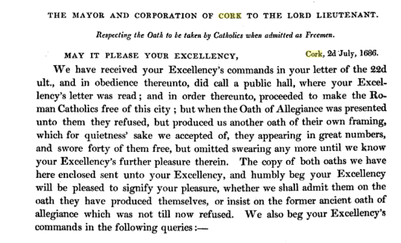

…

Between 1710 and 1841, when the power of admitting Freemen only by birth or right ceased,

Voter Registration:

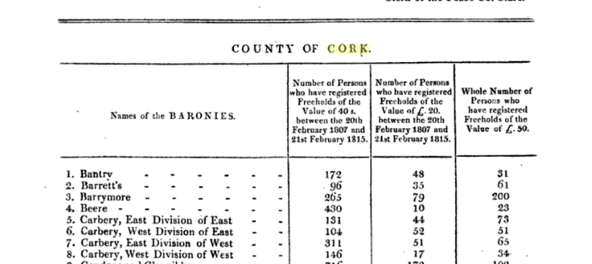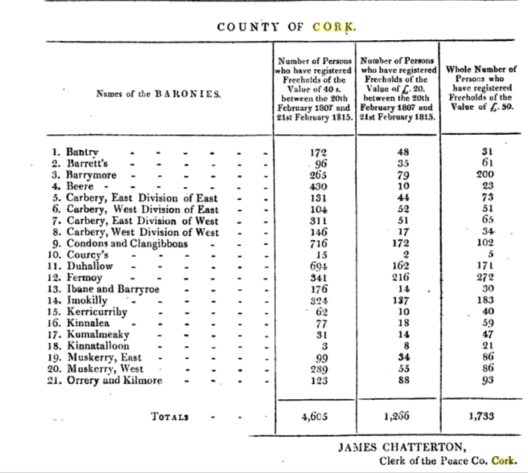

…

Poll in election 1815:

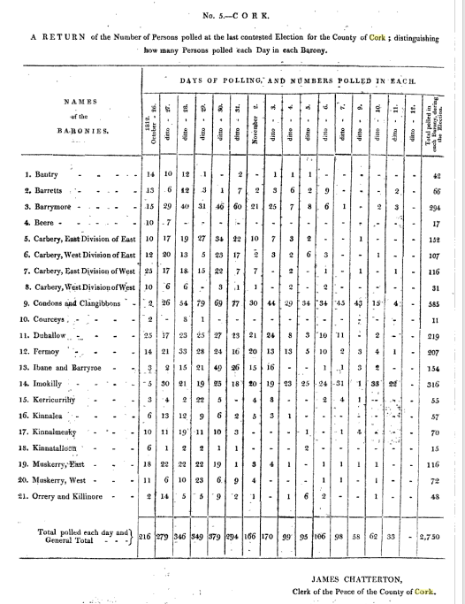
..

1795-1824. Electorate of Co.Cork, Freemen, 40 shillings, £20, £50, Householders, Rentchargers, Bandon Bridge, Kinsale,

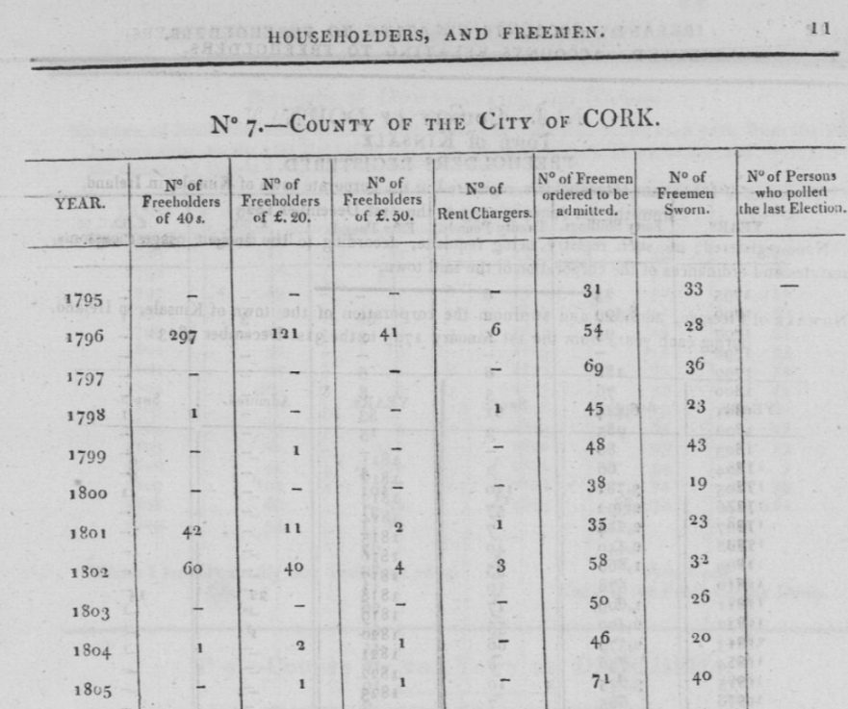
.

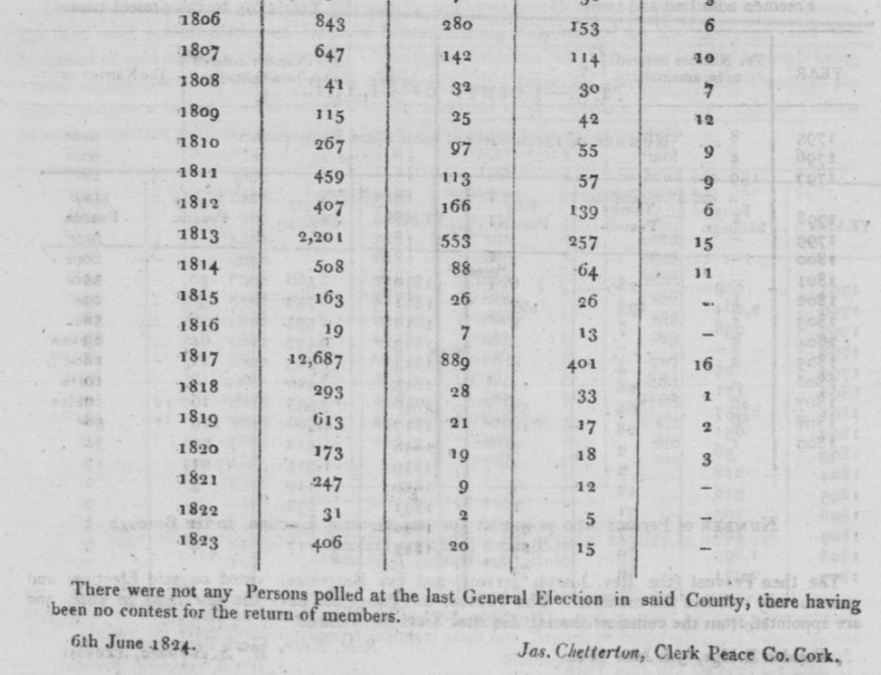
..

Many Freemen non resident appear here but not on the Cork Archive listing.

Excerpted from]
Parliamentary Papers
REPORTS from Committees
Seventeen Volumes
___________________________________________________________________________________________
FICTITIOUS VOTES (IRELAND)
Session: 15 November 1837 - 16 August 1838
______________
Into: "THE SELECT COMMITTEE appointed to inquire how far the intentions of the Reform Bill
are defeated by creating and registering FICTITIOUS and IMPROPER VOTES in IRELAND and
who were empowered to report the MINUTES OF EVIDENCE taken before them, from time to
time, to The House.
Have received several further Documents relating to the City of Cork, in addition to
those already reported; Ordered by The House of Commons, to be printed, 9 April

Session: 15 November 1837 - 16 August 1838
______________
Into: "THE SELECT COMMITTEE appointed to inquire how far the intentions of the Reform Bill
are defeated by creating and registering FICTITIOUS and IMPROPER VOTES in IRELAND and
who were empowered to report the MINUTES OF EVIDENCE taken before them, from time to
time, to The House.
Have received several further Documents relating to the Cty of Cork, in addition to
those already reported; Ordered by The House of Commons, to be printed, 9 April 1838
_________________________________________________________________________________________________________
Appendix 6
___________
CITY OF CORK
Appendix 6 LIST of Non-resident Freemen, County of the City of Cork, with those who Voted at the Election of 1837 marked off.
(p328) NAME Locale Residence Voted 1837
Allen, William Liscongil yes
Ashe, Richard Coolehan no
Austen, Rev. Robert Hadwell Lodge no
Austen, William 97th Regiment of Foot no
Adams, Samuel Wallis Killbree yes
Allen, Samuel Youghall no
Aldworth, R. Oliver Lower Drummore no
Allen, William Shandrum yes
Ashton, Gough Donerail no
Aldworth, Robert Rogers Newmarket no
Aldworth, Rev. John Newmarket yes
Anderson. John William Ushfield no
Armstrong, Rev. Julius Mallow no
Ashe, Richard Ashgrove yes
Ashe, ed ward Castle Hill yes
Annesley, Hon. Arthur Grove Armsgrove no
Atkins, Heyward Carrigalin no
Alleyn, Henry Middleton no
End A's Ashe, Richard Macroom yes
Becher, Richard Henry Hedges Hollybrook no
Barter, Joseph Ballinphelie yes
Beale, Samuel Reddington no
Becher, Michael Allen Clonakilty no
Barter, William Lovekin Ballymurphy yes
Baldwin, Rev. Arthur Bernard Mallow yes
Burke, Thomas, Lieut.-Col. Prospect Villa no
Barry. Henry Green Ballyclough House yes
Bowen, John Oakgrove yes
Bowden, Richard Cox Dunmanway no
Beamish, Adderley Killcoleman yes
Bernard, Arthur B. Pallace Ann yes
Berkeley, David John, M.D. Skibbereen no
Brasier, Kilner Mitchelsfort yes
Bruce, George Milltown Castle no
Briscoe, Robert Fermoy yes
Bernard, Walter Newmarket no
Biggs, Thomas Joseph Garryhankardmore yes
Brown, Rev. Carlton Glandmore no
Ball, Bob Stawell Youghall no
Baldwin, Hewit Pool Bandon no
Baldwin, William Kinsale no
Baldwin, Franklin Bandon yes
Brown, Henry Ballythomas yes
Barter, Thomas Bandon yes
Beale, John Felmyng Reddington no
Braddle, John Armsted Mallow no
Barrett, Richard Mallow no
Bernard, Hon. W.S. the Farm near Bandon yes
Bond, Harmer Crosshaven no
Briscoe, Robert, jun. Fermoy yes
Brown, Thomas Mitchell Rockborough no
Bernard, John, jun. Clareville no
Barrett, Richard, jun. Mallow no
Bruce, Rev. Jonathan Springfort no
Bush, Rev. Charles Castlehaven Glebe no
Bastable, Henry Heathfeld no
Bennett, Samuel Clonakilty no
Bland, Francis Christopher Derrygwinn yes
End B's Bowls, Spottswood Ahern no
Cotter, Nelson Kearney Rochforrest no
Campion, Rev. T. S. Knockamourne Glebe yes
Corbin, Lawrence Kilworth yes
Creagh, John Bagwell Kinsale yes
Crofts, Charles White Point yes
Carden, Robert Corel yes
Chatterton, Sir William Castlemahon no
Cotter, Rev. James Lawrence Buttevant yes
Courtney, John Ballyedmound yes
Courtney, Robert Ballyedmound yes
Courtney, George Dromadda no
Connor, William Mishills no
Colthurst, Charles Clonmoyle no
Crofts, Thomas Lucas Velvetstown yes
Crofts. Christopher Ballyhoura Lodge yes
Crofts, Rev. Freeman Willis Churchtown yes
Cramer, John Thomas Rathmore yes
Crooke, Thomas A. Ahavim no
Crooke, Richard Brown Carrigadwhid yes
Cudmore, Thomas Millstreet yes
Campion, Richard Gifford Bushey Park yes
Chester, Rev. John Ballyclough yes
Cotter, Rev. John Rogerson Templetrine no
Crooke, William Derreen yes
Crone, John Byblox no
Coppinger, John Rye Carkue yes
Creah, B. B.Laverntinim Donerale New no
Creagh, Arthur Gethin Donerale New no
Creagh, Michael Killbrack no
Crofts, James Nelson Concamore yes
Cotter, Rev. John Edmomd yes
Cotter, George Sackville Heathfield no
Connell, Rev. Richard Loane Templebrady no
Collis, William Crooke Castlecooke no
Cowen, John Glanmire Road no
Campion, Rev. R. D. Knockinirvine Glebe yes
Campion, Robert Croomore yes
Clarke, Charles Henry Passage West no
Chute, Rev. Francis Arthur Cahirciveen yes
Clarke, Charles Skibbereen yes
Cleburne, Joseph Bridepark no
Colthurst, John Henry Dripsey Castle no
Connor, Daniel, jun. March House no
Corker, Chambre jun. Innishannon yes
Corker, Chambre Innishannon no
Connor, Daniel Ballybricken yes
Clarke, David Horan Weston yes
Creagh, Arthur Gethin, jun. Bally Ellis yes
Coghlan, John Bride Park yes
Coghlan, Rev. C. L. Keen Adragole yes
END C's Cotter, John Ashton no
Dunscombe, Richard Meade Brookville yes
Daunt, George A. Newborough yes
Daunt, Henry Arthur Newborough yes
Daunt, William Inniskean yes
Daunt, Francis Ballyneen yes
Dunn, George Newman Kinsale yes
Dunn, Robert Lander Kinsale yes
Delany, George Foster Gurtmore yes
Daunt, Achilles Kinsale no
Daunt, John Inniskeen yes
De la Cour, Robert Bearforrest no
Donovan, Philip Castletownsends no
Daunt, Thomas Achilles Coolnagouge yes
Deane, James Roche Dunkerreen no
Daunt, Thomas Baltineen yes
Damas, Peter Claghreen no
Davies, Roger Green Ahadoe yes
(p329) Daunt, William Springhill no
Dorman, Bishop William Kinsale yes
Doherty, Edward Bandon yes
Dunscombe, Richard Child Brookfield no
END D's Delany, Edward Lisnagoorneen yes
Evanson, the Rev. Alleyn Four-mile Water yes
Evanson, Nathaniel Four-mile Water no
Evanson, Charles Four-mile Water no
Elliot, Thomas Kanturk yes
Evanson, Abraham M. Four-mile Water no
Evanson,William B. Four-mile Water yes
Evanson, Richard Tonson Ardoguma yes
Evanson, Nathaniel Friendly Cove no
Edgar, the Rev. John Ware High Purk [Park-?] yes
Evanson, Nathaniel jun. Four-mile Water no
END E's Eyre, Robert Hedges Macrom Castle yes
Forsayth, Thomas Ringuskiddy no
Finlayson, John Bristol no
Foot, Henry Baldwin Carrigacunna Castle no
Freeman, Richard Deane Charlestown yes
Foot, Thomas Wade Springfort no
Foot, James Springfort no
Foley, Robert Yard Kinsale yes
Fitzgerald, Joseph Capel Cloghroe no
Foott, George Carrigacunna Castle no
Foot, James Boyce Carrigaline no
END F's Furlong, Charles Convamore no
Green, Rev. William Middleton yes
Gambleton, Rev. George Mount Rivers yes
Gumbleton, John B. Lismore yes
Gumbleton, Richard Castleview no
Galway, St. John Mallow no
Garde, Thomas William Ballindynis yes
Garde, Charles Ballindynis no
Gollock, Rev. James Cloghroe yes
Garde, Henry Ballincurra yes
Gardiner, John Mallow no
Gibbings, Robert Kilcrea yes
Good, John Rockgrove yes
Good, Charles Balinvowsig no
Gibson, Lewis Kilboy no
Gollock, Thomas Leemount yes
Gollock, Lewis Crusins Classes no
Green, Roger Youghall yes
Gaggin, Rev. Richard Dungourney Glebe no
Glover, James Drumcorbett no
Green, James Ellis Youghall no
Gumbleton, Henry Curryglass House no
Gumbleton, Richard Curryglass House no
END G's Galwey, William Mallow no
_________________________________

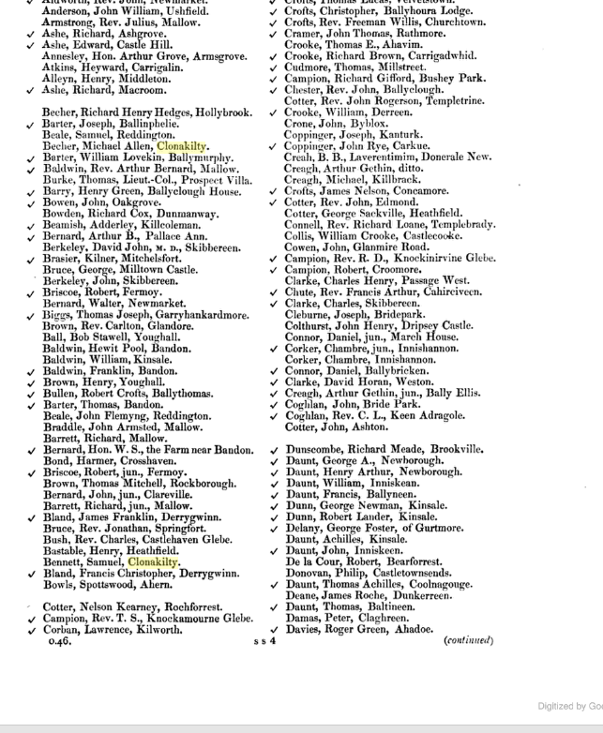.
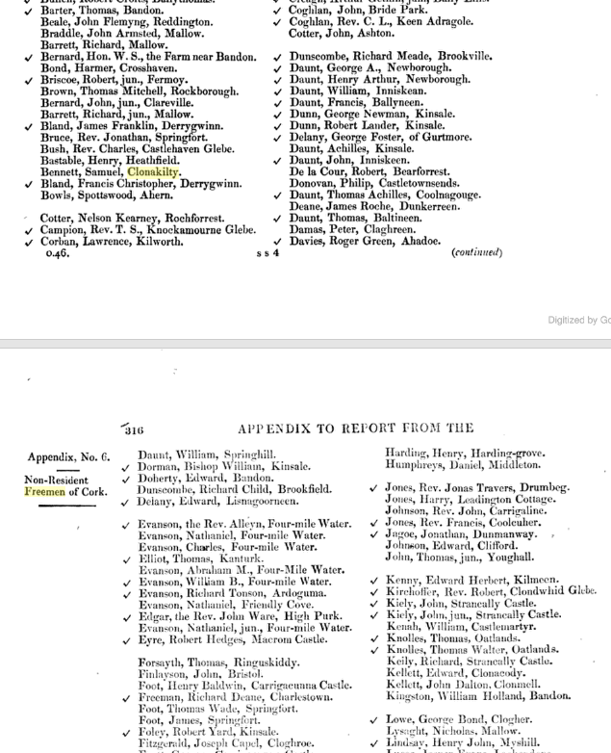.
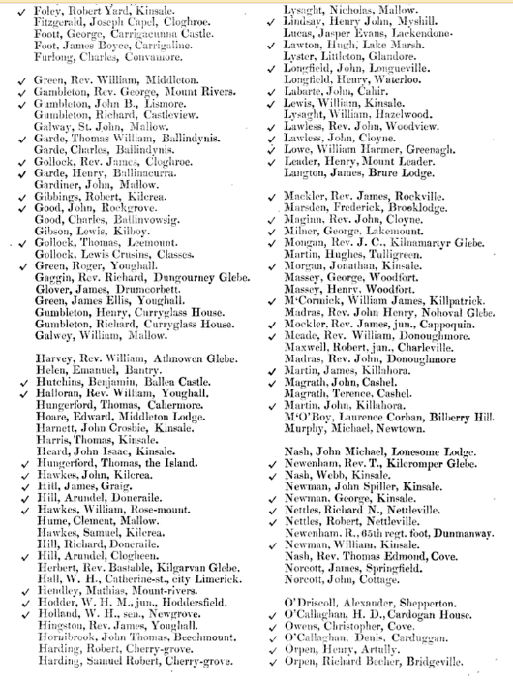.
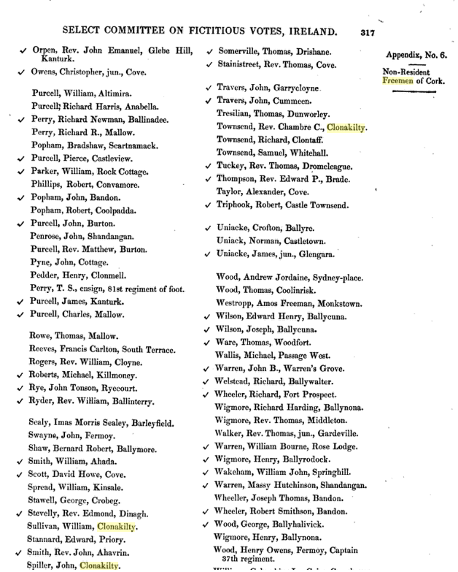.
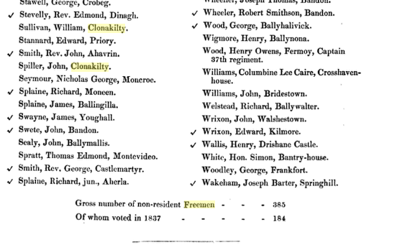
SOURCE: Seventh Volume Part 1 [Excerpted from SECOND REPORT] Parliamentary Papers REPORTS from Committees
[Online Google Books-p328 to p330]

..

1838

...
…
Bandon Freemen:

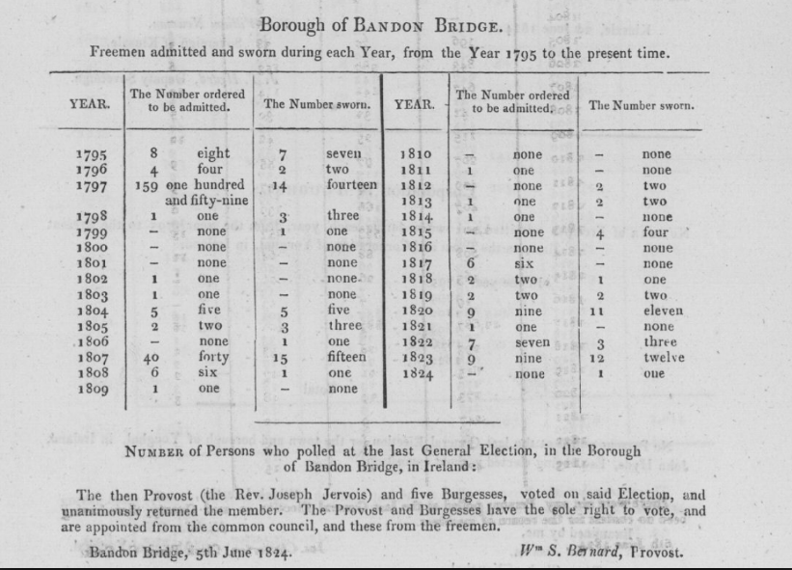.

BANDON CORPORATION – At a Court of D’Oyer Hundred held at the Town Clerk’s Office, Bandon on Wednesday the 27th of December instant [1826], the following persons were proposed by the Honourable W.S. BERNARD, seconded by RICHARD HARRIS Esq. MD, and unanimously admitted Freemen of that ancient and loyal Corporation, in addition to those lately admitted, and added to the list of the Noblemen and Gentlemen composing the Freemen of that Borough:-

Surname | Forename/s | Residence/Occupation
AICKEN | Rev James | Dublin
BALDWIN | Hewitt P Esq | Bandon
BEAUFORT | Rev William Lewis | Glanmire
BENNETT | George | Dublin, King’s Counsel
CALLAGHAN | Gerard Esq | Sydney House, Cork
CHATTERTON | Lieutenant Thomas | Cork
CROFTS | Rev William | Velvetstown
DEANE | Robert | Cork, Barrister at Law
ELLIS | Thomas | Dublin, Master in Chancery
HARRIS | Rev Henry Cox | Beerhaven (Berehaven?)
HARRIS | Lieutenant Thomas | RN (Royal Navy)
HERRICK | Captain W H | RN
JACKSON | Joseph D Esq | Dublin, Barrister at Law
JAGOE | Lieutenant Jonathan | 32nd Regiment, Half Pay
JONES | Rev Jonas J | Drombeg
KEILY | Arthur Esq | Ballysaggartmore
KENNEDY | Rev Alexander | Cork
KIELY | John Esq | Strancally
LONGFIELD | Rev Mountiford | Church Hill
LUCAS | Lieutenant Jasper | 32nd Regiment, Half Pay
LUCAS | Thomas MD Esq | Richfordstown
PARKER | William Esq | Passage West
PERRY | Charles Esq | Cork
POPE | Rev Richard T P | Cork
RYE | George Esq | Forrest
RYE | John Tonson Esq | Rye Court
SMITH | Rev John R | Castle Downeen
ST LAWRANCE | Rev Robert | Murragh Glebe
SWETE | Rev Benjamin | Cork
TEULON | Major Charles | Late 28th Regiment
WEBB | Rev R F | Cahara
WESTROPP | Michael Roberts Esq | Cork
WHEELER | Richard Esq | Fort Prospect

FREEMEN ADMITTED SINCE 1831
NAME/RESIDENCE/DESCRIPTION STATEMENT OF RIGHT UNDER WHICH ADMITTED*

Surname | Forename/s | Residence | Statement of Right under which admitted
BALDWIN | Francklin Esq | Bandon | Court d’Oyer *
BARTER | Thomas Esq | Bandon | Court d’Oyer
BEAMISH | Bernard Esq | Palace Anne | Court d’Oyer
BEAMISH | George Esq | Palace Anne | Court d’Oyer
BEAMISH | Samuel Bernard Esq | Maumore | Court d’Oyer
DOHERTY | Edward James Esq | Bandon | Son of Freeman
EDWARDS | Robert (Gent.) | Bandon | Court d’Oyer
ELMS | Thomas Esq A B | Bandon | Court d’Oyer
GILLMAN | Captain George | Clancoole | Court d’Oyer
HINGSTON | Francis Bernard Esq |  | Son of Freeman
JERVOIS | Sampson Esq | Tullyland | Court d’Oyer
LOVELL | John (Gent.) | Bandon | Court d’Oyer
M’CLINTOCK | Rev Henry (Clerk) | Bandon | Court d’Oyer
PAYNE | Somers Esq | Upton | Birthright
SHERLOCK | Thomas (Gent.) | Bandon | Court d’Oyer
STEWART | Rev John (Clerk) | Bandon | Court d’Oyer

(From Cork Constitution 28/12/1826)

Excerpt from Lucas Topographical Directory 1837 – “The freemen are chosen at the court of D'Oyer Hundred, but must be proposed by the mayor; no qualification on the part of the candidate is required. The court of D'Oyer Hundred is an assemblage of all the members of the corporation, and exercises the right of admitting freemen, disposing of the corporation property, and performing all other corporate acts except the election of officers.” Acknowledgments to Jean Prendergast for original transcription – Cork Ancestors

Residents in and near Bandon who were non resident freemen of Cork City in 1837
Bernard Arthur B Palace Anne, Murragh
Beamish Adderley Kilcoleman
Baldwin Hewit Pool Bandon
Baldwin Franklin Bandon
Barter Thomas Bandon
Bernard Hon W.S. Bandon
Connor William Mishels
Corker Chambre, Jun Innishannon
Corker Chambre Innishannon
Doherty Edward Bandon
Kingston William Holland Bandon
Perry Richard Newman Ballinadee
Popham Bradshaw Scartnamuck
Popham John Bandon
Popham Robert Coolfadda
Sealy Jonas Morris Barleyfield
Swete John Bandon
Wheeler Joseph Thomas Bandon
Wheeler Robert Smithson Bandon
…
…
Clonakilty Charter 1613
In 1613 King James I created 40 boroughs, each returning two MPs to Parliament. One of the main purposes was to create a Protestant majority in Parliament Some of the towns given charters in 1613 were: County Cork: Baltimore, Bandon, Clonakilty, Mallow

Clonakilty Corporation was established in 1613 The town of Clonakilty was founded by Earl of Cork (Richard Boyle) The Charter was issued on 5th May 1613
Earl of Cork was made Lord of the town. Corporation created a Sovereign (mayor) a Town Council of 13-24 members (burgesses) and Freemen were chosen by Council (none after 1794).

….

..
Kinsale Constituency, Freemen
Admission of Freemen not made by birth, marriage or servitude but by courtesy. The elections were by a Council and the swearing in at a Court of D’Oyer Hundred.

It is not known exactly at what time the borough first exercised the elective franchise, but it returned two members to parliament long prior to 1652, and continued to do so without interruption till the Union, since which time it has returned only one to the Imperial parliament. The right of election, previously vested in the corporation, was, by the act of the 2nd of Wm. IV., cap. 88 (1831), extended to the £10 householders and limited to the resident freemen; the total number of registered electors up to June 1st, 1837, was 224, of whom 192 were £10 householders, and 32 freemen; the sovereign is the returning officer. The borough and liberties comprise an area of 11,000 acres, within the jurisdiction of the borough magistrates; a new electoral boundary has been drawn close round the town, including the village of Scilly, and comprising an area of 273 acres.

1747 Newtown Act Kinsale.

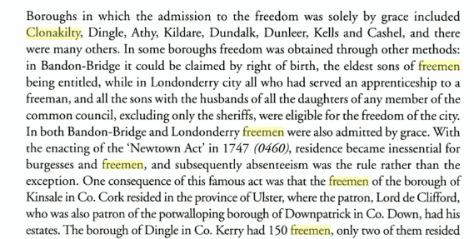.
..

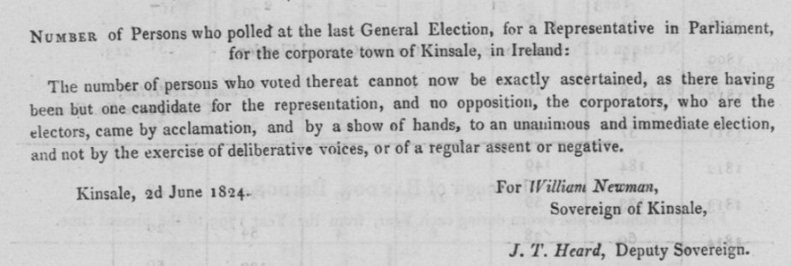.
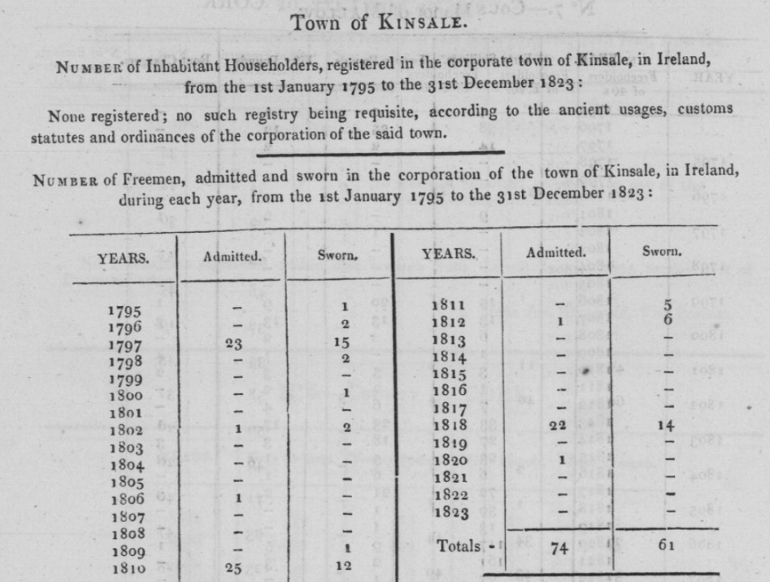.

.

BOROUGH OF KINSALE
TRANSCRIPTIONS FROM THE PARLIAMENTARY PAPERS 1837/8 - REPORTS FROM COMMITTEES - FICTITIOUS VOTES (IRELAND) Session 15 November 1837 – 16 August 1838 - VOL. XIII – Part II

FREEMEN ADMITTED SINCE 1831

NAME/RESIDENCE/DESCRIPTION
Murphy, John, Kinsale, Woollen-draper
Donovan, John, Kinsale, leather-cutter
Black, James, Kinsale, yeoman STATEMENT OF RIGHT UNDER WHICH ADMITTED
All Ex-gratia.
..

…

...
….

….

...

https://books.google.ie/books?id=w14SAAAAYAAJ&pg=PA301&lpg=PA301&dq=nathaniel+belcher+cooper+bandon&source=bl&ots=ZJ5vsCgxa6&sig=W-jZaJ1_j0JNmye2gRFBBLOQclY&hl=ga&sa=X&ved=0ahUKEwituaPus7zYAhVXOMAKHS69CuwQ6AEIVTAM#v=onepage&q=nathaniel%20belcher%20cooper%20bandon&f=false
https://books.google.ie/books?id=aOo5AQAAMAAJ&pg=PA576&lpg=PA576&dq=Foley,+Robert+Yard,+Kinsale.&source=bl&ots=gqSgtvnx1f&sig=A0ozoFUPE2aRkohWEXbT1bBwce0&hl=ga&sa=X&ved=0ahUKEwjplq2E47zYAhVIJMAKHXHwCn84ChDoAQgiMAA#v=onepage&q=Foley%2C%20Robert%20Yard%2C%20Kinsale.&f=false
http://landedestates.nuigalway.ie/LandedEstates/jsp/estate-show.jsp?id=2572
(CE 18/1/1843) - RENT - CHARGE - THE several Persons liable to the Payment of RENT-CHARGE in the Parishes of KILNAMARTERY, DRISHANE, and NOHOVAL DALY, are requested to forward the Amount of their NOVEMBER ACCOUNTS and ARREARS to Herbert E. O Donnell, Solicitor, Macroom, and 21 North Cumberland Street, Dublin, whom I have appointed my Agent, with full authority to Collect and Receive the same - Dated this 16th day of January, 1843 - JOHN CHARLES MONGAN, Clerk, Rector of Kilnamartery, &c., &c.
https://books.google.ie/books?id=sNG5V5KPY_4C&pg=PA72&lpg=PA72&dq=Richard+Newman+Perry,+Ballinadee,&source=bl&ots=xqjdro9UH9&sig=GaZkfFel7sDiQ5ho8w8VEPR4yrE&hl=ga&sa=X&ved=0ahUKEwjMpKjNrr7YAhWHDMAKHeoPDxYQ6AEINTAH#v=onepage&q=Richard%20Newman%20Perry%2C%20Ballinadee%2C&f=false
https://www.tribalpages.com/tribe/familytree?uid=mydadroy&surname=Popham
Lionel Fleming, ‘Head or Harp’.
Edith Somerville 1940 family history.
http://www.bandon-genealogy.com/newspapers_bandon.htm
Thanks to Bullen researcher, Pat Bullen.
Belfast Newsletter, 30th July 1799
http://www.csorp.nationalarchives.ie/search/index.php?browse=true&category=27&subcategory=178&offset=1630&browseresults=true
https://books.google.ie/books?id=XipcAAAAQAAJ&pg=PA103&lpg=PA103&dq=Rev.+James+Jervois+cork&source=bl&ots=2eLbU89v_E&sig=PbujGMwq9M0vHNjh0KoXoKFU8jE&hl=ga&sa=X&ved=0ahUKEwjsrdP859DYAhVIF8AKHR-HBIYQ6AEIPDAE#v=onepage&q=Rev.%20James%20Jervois%20cork&f=false
/books.google.ie/books?id=CjpMAAAAYAAJ&pg=PA97&lpg=PA97&dq=Rev.+James+Jervois+cork&source=bl&ots=VVU3tgUpbo&sig=NFUTcTsFTvrlv1OLxb3gi6QLPmQ&hl=ga&sa=X&ved=0ahUKEwihqtLG6dDYAhVrJsAKHSpjAyU4ChDoAQgoMAI#v=onepage&q=Rev.%20James%20Jervois%20cork&f=false
http://www.dippam.ac.uk/eppi/documents/11284/page/261264
Lord Bantry to Golburn, Dublin Castle.
Supplement to the Trials of the Rev. Robert Morritt, A.M. Prebendary of Ross, Rector and Vicar of Castlehaven, and Domestic Chaplin to Field Marshal Lord Beresford, Duke of Elvas. By an Anti-Conspirator. Cork: Printed by John Connor, Grand-Parade, 1819. pp. 36. COPAC locates the BL copy only. Not in NLI
http://www.astro.wisc.edu/~townsend/tree/record.php?ref=605
http://www.turtlebunbury.com/published/published_features/pub_feats_corkcitygaol.html
Belfast Newsletter, 30th July 1799
https://niallbrn.wordpress.com/category/waterford-history/
Belfast Newsletter, 30th July 1799
Possibly, Puxley, Mrs. Pallaskenry Glebe, Limerick Chronicle 04/11/1857, d. at res of son-in law, Rev. John Thomas Waller; widow of late John Puxley, Co. Cork
Letter from Timothy O’Donovan J.P. to D. John O’Donovan scholar in Grove collection Royal Irish Acdemy.
https://books.google.ie/books?id=fy5bAAAAQAAJ&pg=RA1-PA72&lpg=RA1-PA72&dq=Abraham+E+Orpen+M.D.+cork&source=bl&ots=66x5alhOi1&sig=ZKOhIIM_r7YFGbISLoTj92w1JAQ&hl=ga&sa=X&ved=0ahUKEwipvdPx_tbYAhVhBsAKHeIuDrcQ6AEIPzAI#v=onepage&q=cork&f=false
http://douglastidytowns.ie/heritage-trail-tramore-house/
https://www.geni.com/people/Benjamin-Scott/6000000031957924787
National Archives of Ireland: Baker, Ringwood & Gordon, solicitors' collection, includes plain copy will of Jonas Morris Sealy [of Barleyfield], 3 Aug 1836. Small Accs. Index 105, T.12,028
http://www.dippam.ac.uk/eppi/documents/10931/page/246009
14th April 1835, Southern Reporter and Cork Commercial Courier.
Huguenot background owned 2,714 acres.
Courtesy Colonel John Townsend for Townsend entries, http://www.astro.wisc.edu/~townsend/tree/record.php?ref=224
Belfast Newsletter, 30th July 1799
This is from the Cork Examiner of the 8th November 1846.
Belfast Newsletter, 30th July 1799
Curravally (modern spelling) Creagh, Skibbereen. A Henry Baldwin Esq was living nearby in Creagh Parish in the early 1800’s.
https://irishdeedsindex.net/mem.php?memorial=186004291
https://irishdeedsindex.net/mem.php?memorial=186004291
http://www.corkarchives.ie/media/freemen1710-1841.pdf
Wikipedia, https://en.wikipedia.org/wiki/Cork_City_(Parliament_of_Ireland_constituency)
http://www.corkcity.ie/yourcouncil/freedomofthecity/
http://irishgeography.ie/index.php/irishgeography/article/viewFile/1018/880
Courtesy Catherine Fitzmaurice, http://www.bandon-genealogy.com/corporation-1826.htm
https://en.wikipedia.org/wiki/Kinsale_(UK_Parliament_constituency)
https://books.google.ie/books?id=_nADAAAAQAAJ&pg=PA343&lpg=PA343&dq=kinsale+freemen&source=bl&ots=RGcGTW9gMY&sig=9IeEnglP1QOh1m9-G9Is2B-T5f8&hl=ga&sa=X&ved=0ahUKEwi7zdWXuNzYAhXEAcAKHV3JCXI4ChDoAQgpMAE#v=onepage&q=kinsale%20freemen&f=false
books.google.ie/books?id=_nADAAAAQAAJ&pg=PA343&lpg=PA343&dq=kinsale+freemen&source=bl&ots=RGcGTW9gMY&sig=9IeEnglP1QOh1m9-G9Is2B-T5f8&hl=ga&sa=X&ved=0ahUKEwi7zdWXuNzYAhXEAcAKHV3JCXI4ChDoAQgpMAE#v=onepage&q=kinsale%20freemen&f=false
http://www.dippam.ac.uk/eppi/documents/9819/page/214964
https://books.google.ie/books?id=lqMLAAAAYAAJ&pg=PA473&lpg=PA473&dq=kinsale+freemen&source=bl&ots=OUFLwc9n3v&sig=7p-WRZCGwv_Tlx-K6M7DFYB1RQY&hl=ga&sa=X&ved=0ahUKEwjopvmG1tzYAhUnIMAKHToiC244MhDoAQgiMAA#v=onepage&q=cork&f=false
https://books.google.ie/books?id=w14SAAAAYAAJ&pg=PA317&lpg=PA317&dq=clonakilty+++freemen&source=bl&ots=ZJ5wtEgAc9&sig=L0pqmcEbXU2xQ7dt9x0ptMxZvQM&hl=ga&sa=X&ved=0ahUKEwiP2_-xgd3YAhWIAMAKHb0eBLMQ6AEIYDAN#v=onepage&q=clonakilty%20%20%20freemen&f=false
https://books.google.ie/books?id=jitdluWSybIC&pg=PA188&lpg=PA188&dq=clonakilty+++freemen&source=bl&ots=OXUBX99kZN&sig=sQZn_aeHqCjK7GtBxAeA7eeEegg&hl=ga&sa=X&ved=0ahUKEwj48NiUhd3YAhUKK8AKHeg9B904ChDoAQgzMAM#v=onepage&q=clonakilty%20%20%20freemen&f=false
http://www.corkarchives.ie/media/BG59web.pdf
1779 Hibernian Magazine Dec 1779 “ Henry Becher of Creaghtford to be a J.P. of the Peace for the Co of Cork”
http://landedestates.nuigalway.ie/LandedEstates/jsp/family-show.jsp?id=2442
Father Hickey, famine in West Cork, p 301.
1872 The Belfast News-Letter Thursday 31 October 1872, “ Death of Lady Becher-We have to record the death, at a very advanced age of Lady Becher, widow of the late Sir William Becher, of Ballygiblin, Co Cork. She was the celebrated Actress Miss O’Neill, who from 1814 for many years held the highest possible position on the tragic stage. Miss O’Neill was of ancient Irish descent, and her husband Sir William Becher was head of an old Irish family. Miss O’Neill’s first appearance was as Juliet, in Covent Garden Theatre as early as 1814. She adorned the stage & both in her professional and private life merited and obtained the very highest respect and esteem. Her death, even at her advanced age, will be deeply lamented by a very large circle of friends.” [other papers add that she was 82, died on the 29th October & was interred at Castlemartyr on Nov 1.]
Belfast Newsletter, 30th July 1799
https://books.google.ie/books?id=PD3byHyDVuMC&pg=PA51&lpg=PA51&dq=Thomas+Honner+attorney&source=bl&ots=JCVMyjZ20z&sig=OUmjKBO7rgHosVuapghqTic9Cb8&hl=ga&sa=X&ved=0ahUKEwj3oKjU6tnaAhXLI8AKHaZsD74Q6AEINzAD#v=snippet&q=blair&f=false..

