1823, Proposed Bridge Dunmanway/Inchigeela

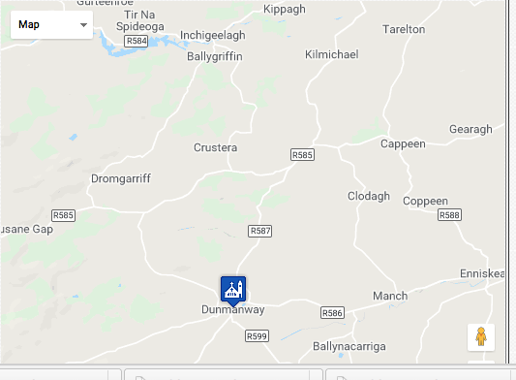

CSO/RP/1822/3322

To His Excellency The Marquis Wellesley, Lord Lieutenant General and General Governor of Ireland:

In these times when Government has thought it prudent and advisable to set on foot such work as are considered useful and advantageous to the Country as well as to create Employment for the Poor and distressed in those districts where distress is prevalent. We the undersigned in such circumstances beg leave to submit to the consideration of Your Excellency not only the propriety but the necessity of erecting a bridge across the Cahan River on the direct line of road leading from the town of Dunmanway In the County of Cork leading to Incheegeelagh being a mile and a half North East of Dunmanway. This Bridge would afford great great facility for a considerable portion of the Parishes of Dunmanway, Incheegeelagh and Kilmichael to a communication with the market town of Dunmanway and the Markets of Cork and Bandon. It would open and complete a direct communication to the Mountains on the North of Dunmanway as there have this Summer been about four miles of road repaired in that line in the Parish of Dunmanway and about three miles miles in the paris of Iveleary leading to Incheegeelagh. We are the more convinced of the necessity and importance of this bridge as it frequently occurs in the Winter that all communication between the Town of Dunmanway and these places is intercepted by the overflow of the River which is frequently in these seasons impassable. We further beg leave to observe that it may be considered extraordinary that so useful and necessary work has not heretofore proceeded on by presentment. The only reason we conceive can account for want of attention to the convenience of the country that the Chief Landed Proprietors of the District are Absentees: - and for the verification of our statement and the utility of the work, we hope, that your excellency will be pleased to refer this Statement to Mr. Griffith the Government Engineer in the South of Ireland, who will on examination make a report as he think proper: - We Beg leave to enclose Maps, Plans and Estimate of the Intended work.

Signed:

Joshua H. Cox

David H. Cox, Justice of the Peace

Herbert Gillman, Justice of the Peace

Joseph McMullan

William? McMullan

Benjamin Hayes Holmes

Father M. Barry

Edward St. Lawrence, Vicar of Fanlobus

Henry H. Jagoe, (might be Henry Hayes Jagoe, flour factor)

Rev. Richard Cox Bowden, Justice of the Peace, Co. Cork

James Doheny. Parish Priest of Fanlobus

Cornelius Corkeran

..

..

..

NAI REFERENCE: | CSO/RP/1822/3322
TITLE: | Petition of magistrates and gentlemen of Dunmanway, County Cork, requesting funds to build bridge
SCOPE & CONTENT: | Petition of the magistrates and gentleman of Dunmanway, County Cork, to Richard Wellesley, 1st marquis Wellesley, Lord Lieutenant, Dublin Castle, requesting to avail of government's grants for public works, for the construction of a bridge over the Cahan [Caha] river, on the line of road leading from Dunmanway to Incheegeela [Inchigeela], County Cork. Details the benefits of such a bridge, including improved communications with the mountains to the north of Dunmanway, especially in the winter months. Petition signed by 12 individuals, 9 August 1822. Encloses a map, plan and estimate for the proposed work: details cost of the work, and includes a map of the area, marking the location of the proposed bridge, and also an elevation drawing of the bridge, both in black ink with colour washes.
EXTENT: | 2 items; 4pp
DATE(S): | 9 Aug 1822
DATE EARLY: | 1822
DATE LATE: | 1822
ORIGINAL REFERENCE:
..

..

Rev. Richard Cox Bowden, Superseded 1810-30, Dunmanway, writing to Chief Secretary 1821 re local disaffection. Listed supporter of Act of Union, 1799. 1822 signed Memorial for new road Crookstown to Bantry an 1822 for bridge over River Cahan. Non resident Freeman voting in Cork 1837 election.

David Cox, 1822, Dunmanway, Petition of John White, late sub constable, Dunmanway, County Cork, to Richard Wellesley, 1st Marquis Wellesley, Lord Lieutenant, Dublin Castle, requesting grant of financial support due to cessation of payment of one third of salary which became due to him as a result of incapacity arising from injury: recalls that he was deployed by a magistrate at a riot in Dunmanaway on 17 July and ‘when on his duty, in quelling such Riot, was assaulted in the most Violent, and desperate manner, by a large mob, who Knocked him down, with sticks and stones, deprived him of his Sword, with which they Cut and maimed him, in a most Cruel manner, and left him Lifeless on the Ground’, signed by David Cox, justice of the peace, and 6 other persons.Petition of John White, late sub constable, Dunmanway, County Cork, to Richard Wellesley, 1st Marquis Wellesley, Lord Lieutenant, Dublin Castle, requesting grant of financial support due to cessation of payment of one third of salary which became due to him as a result of incapacity arising from injury: recalls that he was deployed by a magistrate at a riot in Dunmanaway on 17 July and ‘when on his duty, in quelling such Riot, was assaulted in the most Violent, and desperate manner, by a large mob, who Knocked him down, with sticks and stones, deprived him of his Sword, with which they Cut and maimed him, in a most Cruel manner, and left him Lifeless on the Ground’, signed by David Cox, justice of the peace, and 6 other persons. Signed memorial with others for bridge Dunmanway/Inchigeela 1822.

Joshua H Cox, magistrate, Manor House, Dunmanway, County Cork, to Henry Letter 1823, from Goulburn, Chief Secretary, Dublin Castle, requesting a copy of the parliamentary statutes for use of the magistrates of Dunmanway. Complains of the need of the statutes as a reference source for ordinary proceedings and remarks his late father, Henry Cox, had a copy as did Edward Hayes, a magistrate who has recently retired from service due to age. 182l? Joshua eldest son of late Henry Cox Esq, died of fever. Signed memorial with others for bridge Dunmanway/Inchigeela 1822.

Herbert Gillman -pre 1870), 1813, Woodbrook, Dunmanway, (same name twice), Superseded 1810-30, appealed 1822. 1822 forwarding Memorial to Lord Lieutenant seeking an engineer signed by Lord Bantry for new line of road from Crookstown to Kealkil Signed memorial with others for bridge Dunmanway/Inchigeela 1822. Subscriber as Junior may be son Lewis Topographical Dictionary of Ireland 1837. Reps 1870, listed 484 acres. Letter from Dan McKay, Stephen’s Green, Dublin, under the direction of the Lord Chancellor [Thomas Manners Sutton, 1st Baron Manners], to Henry Goulburn, Chief Secretary, stating that he did not recommend the reinstatement of Herbert Gillman, Woodbrook [House, Dunmanway, County Cork], to the Commission of the Peace, and enclosing a number of letters relating to his case. Includes letter from [Sir] Richard [Henry] Willcocks, Inspector General of Police [in Munster], Limerick, to Goulburn, forwarding on a letter sent to him by M Fitzpatrick, Chief Constable of Police, Dunmanway, [County Cork], stating that Gillman had previously been deprived of his position as a magistrate, and that the was ‘a man of most arbitrary character and universally disliked’. Also letter from Maj Daniel Mahony, [Dunloe Castle], Killarney, [County Kerry], testifying to Gillman’s good character and referring to enclosed letter from Rev James Doheny, Dunmanway, to Mahony, also in Gillman’s favour.

Benjamin Hayes Holmes Esq., late 36th Regiment, listed 1838, 1843, Underhill Cottage, Dunmanway, 1822 signed Memorial for new road Crookstown to Bantry and bridge on road from Dunmanway to Inchigeela. Subscriber Lewis Topographical Dictionary of Ireland 1837. Died Belcooo, Co. Fermanagh listed as Resident Magistrate.

..
Non Magistrates:

VERY REV. JAMES DOHENY PP
Deceased
Parish Of Birth
Ballingarry, Co Tipperary
Colleges Attended
St. Patrick’s College, Carlow Ireland
Details Of Ordination
St. Patrick’s College Chapel, Carlow, Co. Carlow
1811
Appointments
Dunmanway PP : 26/5/1818 – 1849
Cathedral CC : 1814 – 26/5/1818
Notes
Reputed to be the uncle of Michael Doheny the Young Irelander and Fenian; certainly a relation. The GAA club in Dunmanway is named after him.
Fr. James Doheny (1786-1866) Nation Builder.
By Rev. James Coombes
[First published in The Fold magazine in 1971.]
In the early 19th century a group of Tipperary-born priests ministered in the diocese of Cork. Fr. Prior built churches in Goleen (Ballinskea) and Kilmurry parishes. Fr. Dore built the recently replaced churches in Caheragh. Fr. Quin erected the church in Ahakista in Muintir Bhaire and Fr. Ryan the old parish churches in Drimoleague and Drinagh. All belonged to one of the most dedicated generations of the Irish diocesan priesthood. They left their mark, not only in the churches and the schools they built but in the hearts and minds of their people. Their deaths not infrequently gave rise to disputes between their parishioners and their blood relations as to where their remains should rest.
Canon Sheehan described them in memorable words in My New Curate. Men of large physique and iron constitution who spent ten hours a day in the saddle and despised French claret. Of spotless lives and stainless reputations, their hands smote like iron and their tongues cut like razors but they had the hearts of mothers for the little ones of their flocks.
THE GREATEST
The greatest of the Tipperary men was Fr. James Doheny. Like Fr. Ryan of Drimoleague he was born in Ballingarry and educated at St. Kierans College, Kilkenny. While still a student he got involved in a dispute between his family and some neighbours. His archbishop thought it better for him to seek a mission in some other diocese. Thus he found himself as curate in St. Marys, Shandon in 1814 and as pastor in Dunmanway in 1818.
FAILINGS
Foreign visitors commented favourably on the high moral standards of the Irish people in this period. But they had the failings one might expect in a downtrodden race. Their gatherings, at fairs or hurling matches, were too often accompanied by drunken excesses and faction fights. Alexis de Tocqueville, well-known French commentator on the 19th century social scene, asked the Bishop of Ossory if it were true that the Catholic population were half-savage. Dr. Kinsley replied: I must admit that it is, in part, true. But whose fault is it, if not theirs who have reduced them to this state by bad government. What became of the Greeks under the Turks. Before 1792 we could have no schools, we could not be called to the bar, the magistracy was closed to us, we could not possess land. Bishop Nolan of Kildare told him of the leader of a band of Whiteboys (an educated man) who defended his way of life as follows. The law does nothing for us. We must save ourselves. We have a little land which we need for ourselves and our families to live on, and they drive us out of it. To whom should we address ourselves. Emancipation has done nothing for us. Mr. O’Connell and the rich Catholics go to Parliament. We die of starvation just the same.
THE ONLY ONE
Fr. Dohenys life-work must be seen against this background. When the administration of law and the rule of the landlord were both tyrannical and corrupt the only one in the community with any moral authority was the priest. His role demanded determination and moral courage of a high order. For generations Dunmanway had borne the harsh yoke of the Cox family. Their vicious anti-Catholic bigotry must however be counterbalanced by the efforts of the family to develop their estates and by occasional acts of generosity to priests and people. When the new pastor arrived the lord of the manor was Sir John Cox, born in the West Indies, where his father had been a planter. He appears to have brought with him to Dunmanway the methods and morals of the slave plantation. Fr. Doheny came into open conflict with him as a result of a fiery diatribe against evil living plainly directed against the landlord.
One morning while at breakfast the housekeeper told the parish priest that Cox was outside the door, mounted on his horse and waving a sword. Tell the gentleman to wait until I finish my breakfast, he said. When he eventually emerged he carried a broomstick in his hand and laid it across the horse's haunches. The animal plunged wildly out of control and galloped back to the stable with Cox clinging desperately to the horses neck.
LOYALTY
There was little need for such a priest to worry about the loyalty of his flock.
Much was he feared, much loved, His stern rebuke overawed sheep stealers, And better was the good man’s look Than forty peelers.
The fair at Gearran Ban was notorious as a clearing house of the thieves of Cork. The pastor collected a posse of faction fighters from among his parishioners and put an end to this public scandal for all time. The chequered story of the Cox family had a happy ending. The late Jeremiah O’Mahony tells (in West Cork Parish Histories, p.76) how Fr. Doheny presided over a special meeting on 4 February 1843 to honour the Misses Cox who then held the family lands. The chairman praised in glowing terms the truly noble and humane conduct of the sisters, especially to the tenants of Shiplough, Inchireagh and Coolsnactig.
DOHENYS
Fr. Doheny did much to straighten the backs of his downtrodden people. Kind for him. He was a kinsman of Michael Doheny, patriot and author of The Felon’s Path. When that great notion-building force, the Gaelic Athletic Association, appeared in Dunmanway, what more inspiring name could have been chosen for the local club than the Dohenys. Long may they flourish. The great monuments to his memory are, however, the churches in Dunmanway, Togher and Ballinacarriga. This story must have its own chapter.
Shall I sit down satisfied because the good humour of a magistrate chooses to indulge me; while there are laws of which any miscreant has power daily to enforce the execution. My ease, my property, and my life are at the disposal of every villain, and I am to be pleased because he is not at this time disposed to deprive me of them. Tomorrow his humour may vary and I shall be obliged to hide my head in some dark corner or to fly from this land of boasted liberty. It is surely better not to be than to live in a state of such anxious and dreadful uncertainty.
Joseph Berington in 1780.
These words may well be applied to the condition of the members of the Catholic Church in Dunmanway area in the 18th century. The local landlords, the Coxes, did much to develop the town and district but they were, on the whole, bitterly anti-Catholic. During the early part of the 18th century there were, according to tradition, three Mass rocks in the eastern part of Fanlobbus parish, which forms the main part of the modern Dunmanway Catholic parish. These were on top of Carraig an Adhmaid, a second in Thornhill townland and another in Behagullane. These may possibly correspond to the places mentioned by Nicholas Skolfield, the local Protestant minister in the 1731 Report on the State of Popery.
The Parish being large and mountainous, there are there several Hutts open at one end, where Mass is celebrated. These huts, known to Irish-speakers as scalans, barely sheltered the priest and sacred species from the rain. Most of the people worshipped in the open air. According to Skolfield, Charles McCarthy was at this time parish priest of Fanlobbus, Drimoleague and Drinagh and had William Sheehan as his assistant. He also mentions Kean Callinane a Popish schoolmaster. A local poet, Donal na Tuile MacCarthaigh one day met Sir Richard Cox and the rector. To trap the poet they pretended to argue about religion and asked him to comment. Donal replied in Irish.
Ni chreidfhinn Peadar, Is ne chreidfhinn Pol, Is ni chreidfhinn Eoin O is e a Bhaist, Na Papa Mor na Romha Gur ag Cox no Schofield Ta on ceart.
(O’Mahony: West Cork Parish Histories 1959 p75)
TOGHER
For a long period in this century the Dunmanway Catholics had to travel the four miles to Togher to hear Mass. By the end of the century conditions had improved a little. They now had a small thatched chapel or mass-house at the western end of the bridge near the town. William O’Neill Daunt tells (A Life Spent for Ireland, p. 116) how in the year 1793 the late Henry Cox was riding to Cork one Sunday morning when he saw the Catholics kneeling in the rain all round the little chapel. These are my tenants, thought Cox and it is a shame that they should be in want of a decent place of worship. On his return from Cork he sent for the parish priest, Fr. Bartholomew Coghlan, known to generations of parishioners as An t-Athair Parthalan. The priest was astonished when this bitter enemy of the Church offered him a site and a donation of £20 towards a new chapel. Cox also provided a crucifix, which he kept in his house during the week and sent on Sundays to the priest.
BAILE NA CARRAIGE
When Fr. Doheny arrived in 1818 the parish was still in sore straits. At a confirmation about the year 1840, Bishop Murphy told the people he remembered when Mass was celebrated on Sundays in Baile na Carraige castle. The priest tried to raise enough money to roof at least part of the castle but failed. Baile na Carraige had first claims on the attentions of the new pastor and in 1819 he built the new chapel there. Having completed the job he set about providing a new chapel for Togher. In the town, conditions were rapidly disimproving largely due to the rapidly increasing population. Probably due to the need to provide schools the people had to wait many years.
DUNMANWAY
Finally in 1834 he set about the new parish church. He secured the services of an unusual architect, Michael Augustine Riordan, a Presentation brother, who designed many imposing churches in the south, including the old St. Michael’s, Blackrock and the parish churches in Bantry, Kinsale and Millstreet. He was also the main architect of the Ursuline convent, Blackrock. He died in January 1848 at the age of 66 having spent 33 years in the Presentation order.
The new project was greeted with great enthusiasm when a start was made in 1834. The shell of the new church arose steadily and quickly around the old building, finally with the roof laid on, Sunday Mass was said for the last time in the old church. On Monday morning the work of demolition began. So quickly did the workmen proceed that the new church was ready for the first Mass the following Sunday morning. Lewis in his Topographical Dictionary (1847) gives the cost at about £2,500.
TRIUMPH AND TRAGEDY
As great a triumph as was its building, it led to tragedy for Fr. Doheny. During the 1840’s the Board of Works loaned money for the building or completion of many Catholic churches in Ireland. These included Ennis, Buttevant, Nenagh, Bantry, Leap. Fr. Doheny obtained £1,200 to finish off Dunmanway Church. He was unable to proceed immediately with the work and therefore, rather unwisely, loaned the money to a Catholic, who pledged his lands as a security. Unfortunately the lands were already mortgaged and when the borrower’s bankruptcy became know, Fr. Doheny escaped jail only by the help of Thady O’Sullivan, a local solicitor and Owen Charles McCarthy, a prominent businessman. The bishop decided that it would be better for Fr. Doheny to retire. The people were furious at what they considered was very harsh treatment. They wished to protest but Fr. Doheny would have none of it. He died in 1866 in his brother’s house overlooking the lake in Dunmanway.
(Based on the notes of the late Canon Cors. Coakley, by courtesy of Canon D. Connolly)
Date Of Death
9/4/1866
Place Of Death
Dunmanway, Co. Cork
Place Of Burial
St. Patrick’s Church Grounds, Dunmanway. Co. Cork
Life & Work
Fr. Doheny’s life and work
An article written by historian Fr James Coombes in 1971 describes Fr. Doheny’s contribution to the parish of Dunmanway and to the nation.
01/01/1971 , The Fold magazine.
…

..
..
1801 Joseph McMullan leasing bleaching Green at Milleenanig, to James Gillman, Esq.

..
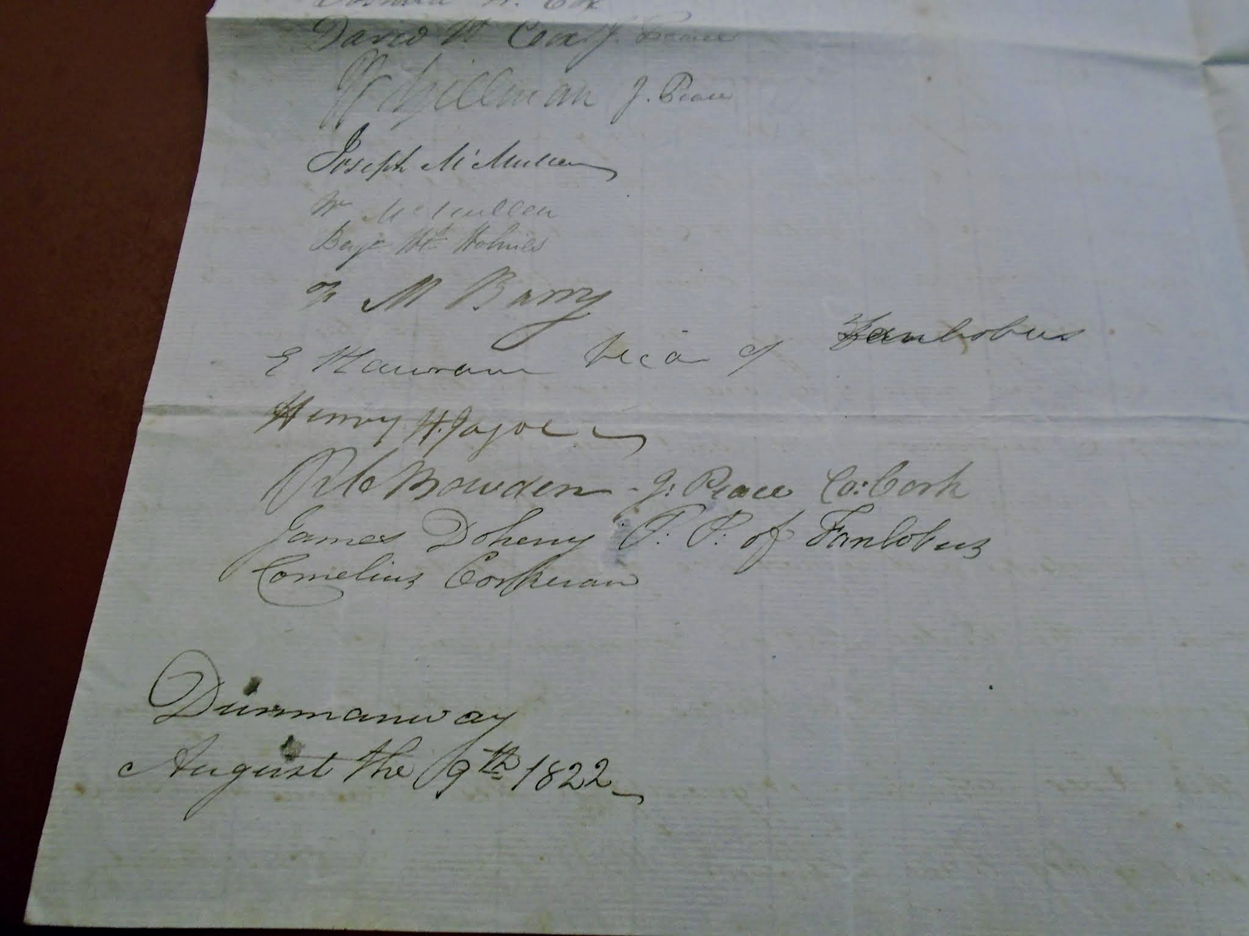..
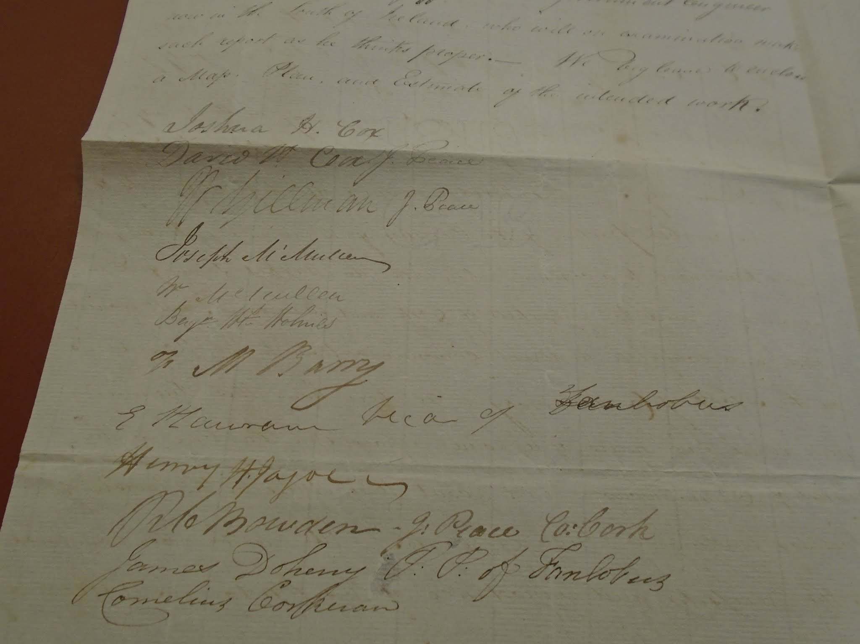..
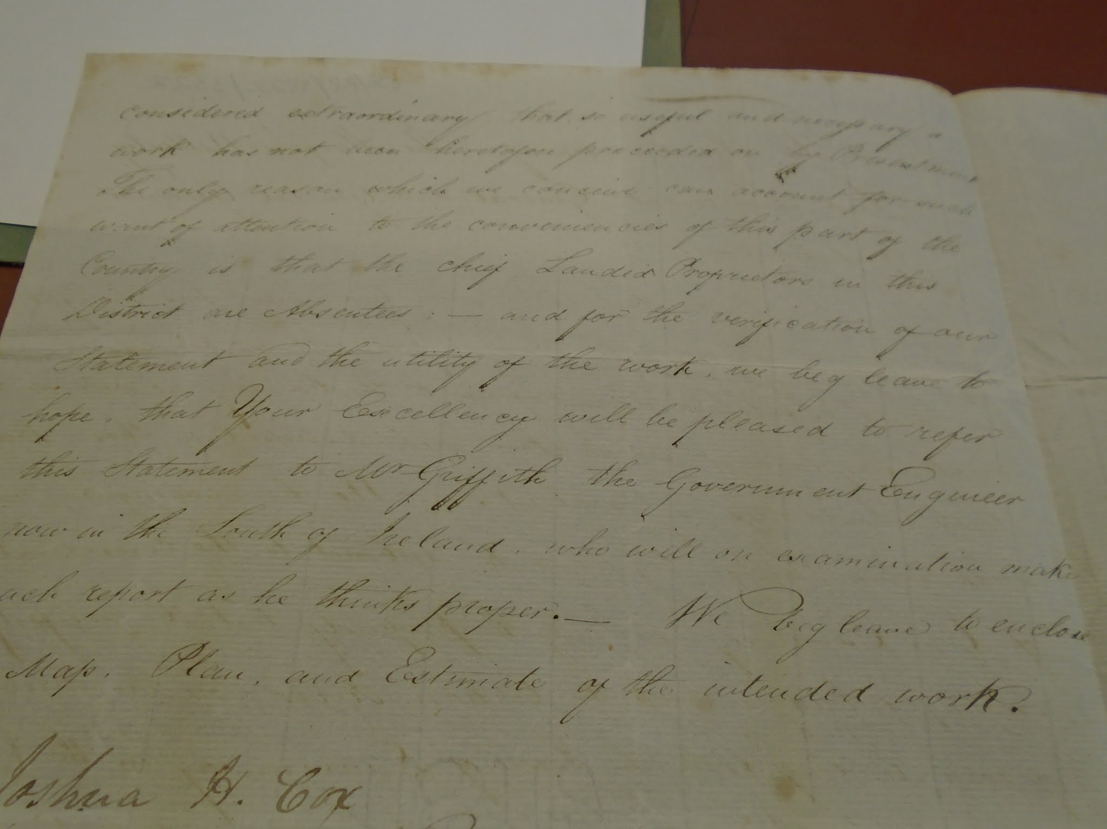..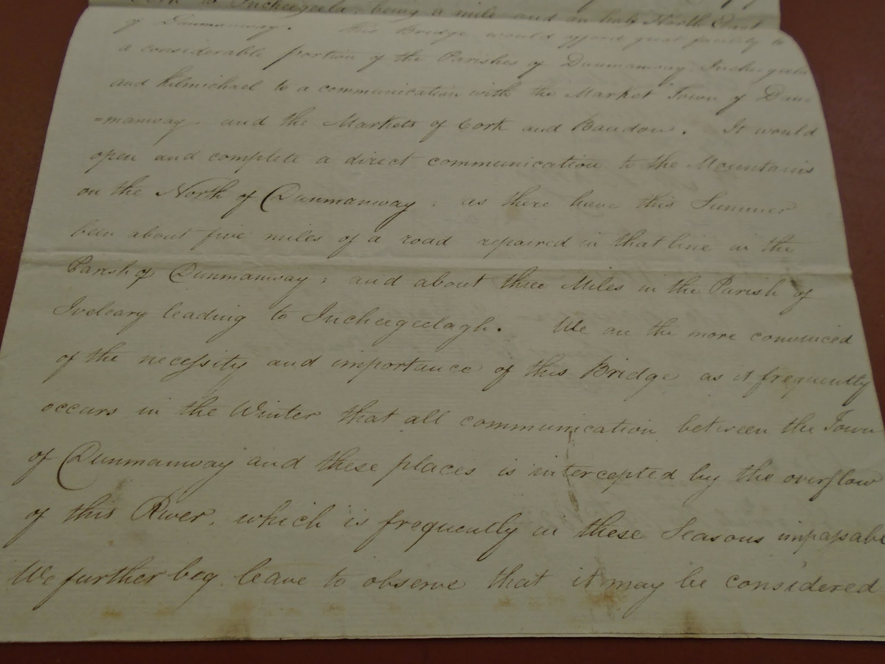..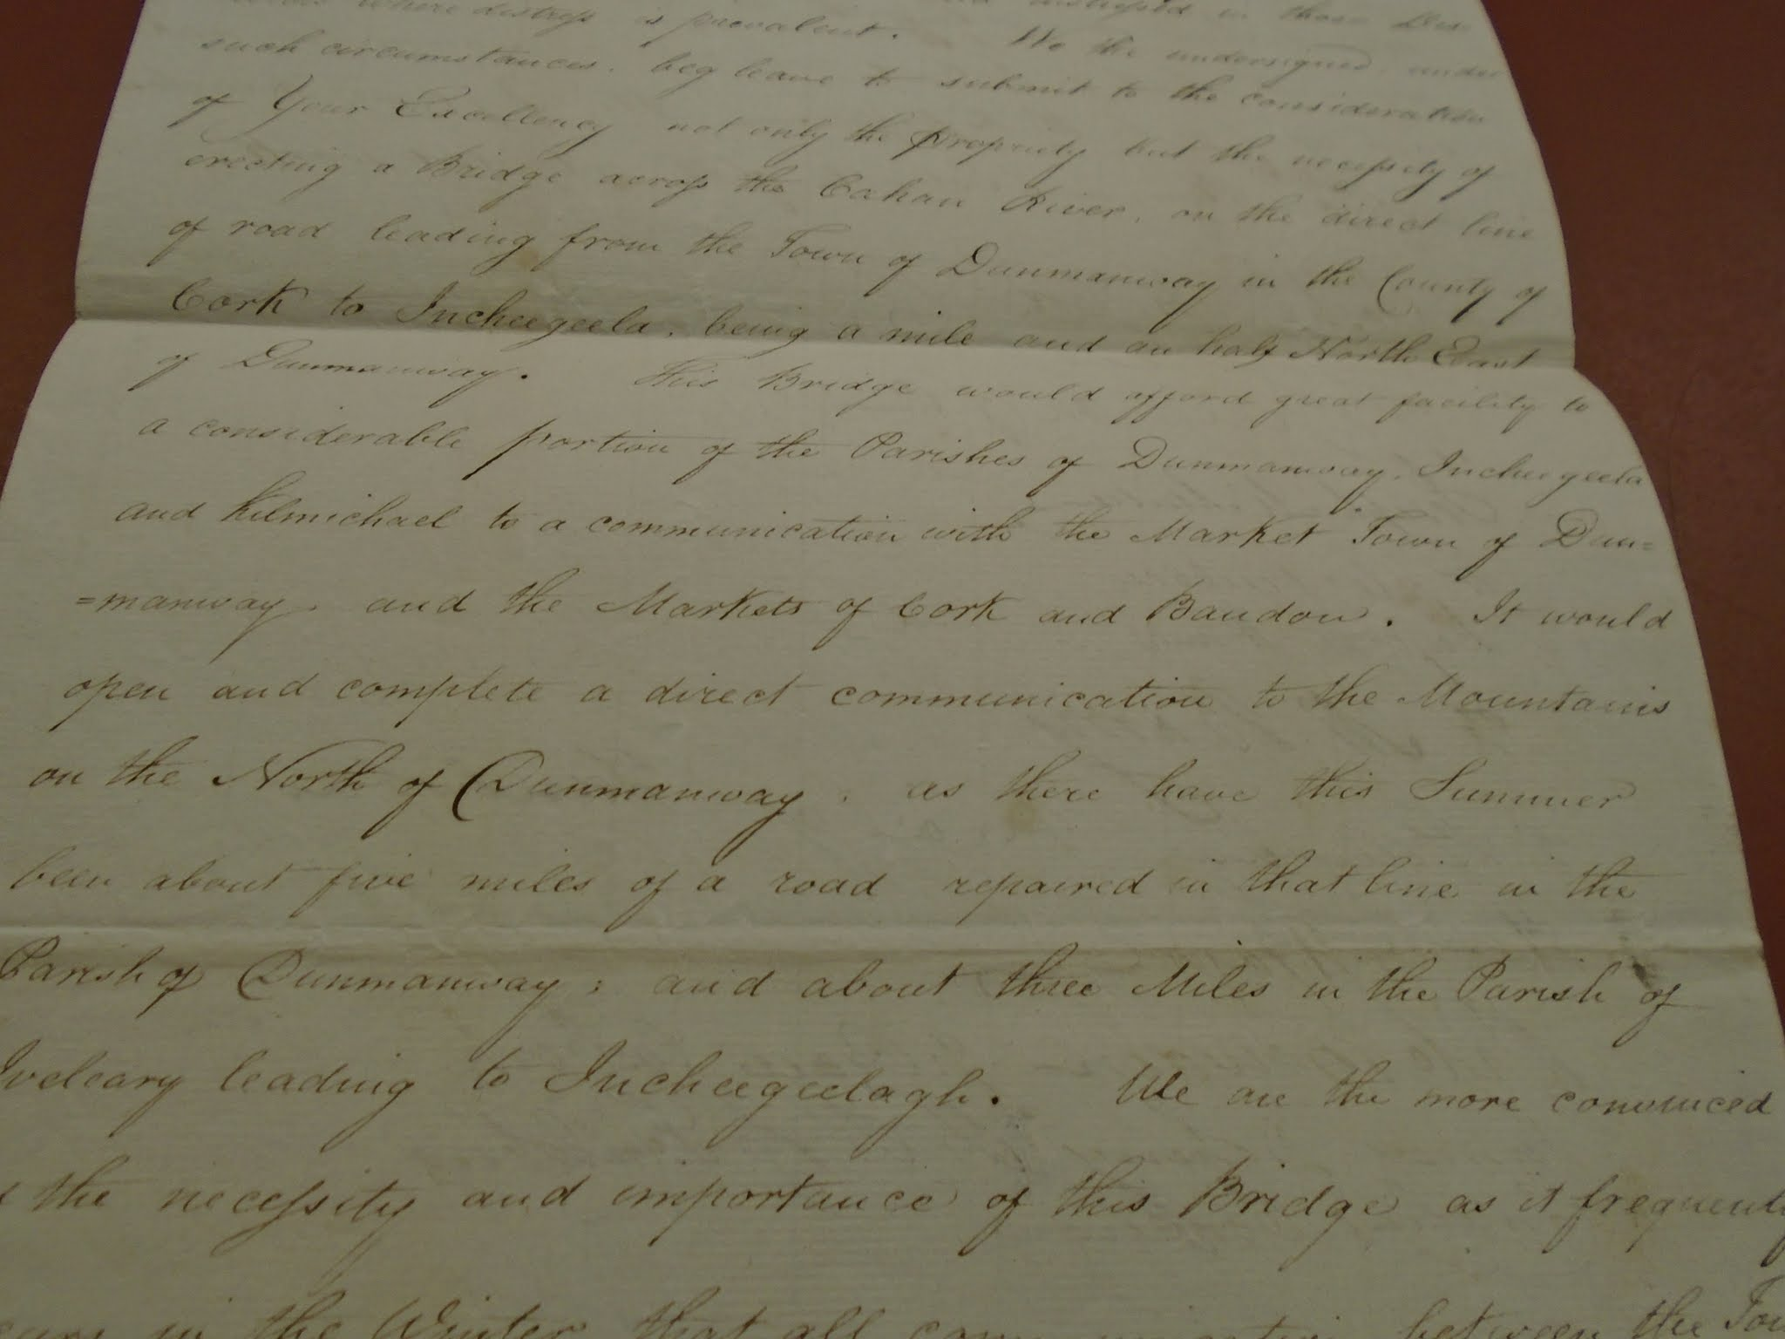..
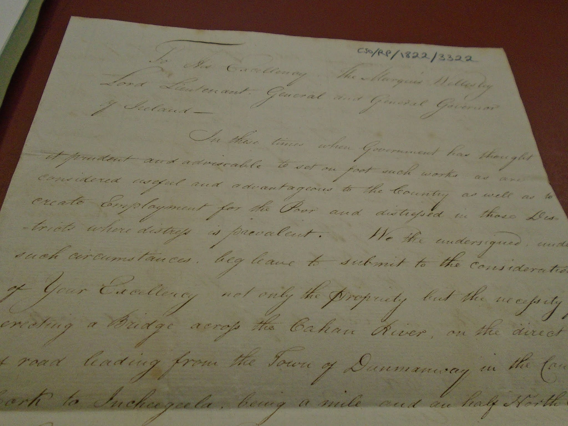..
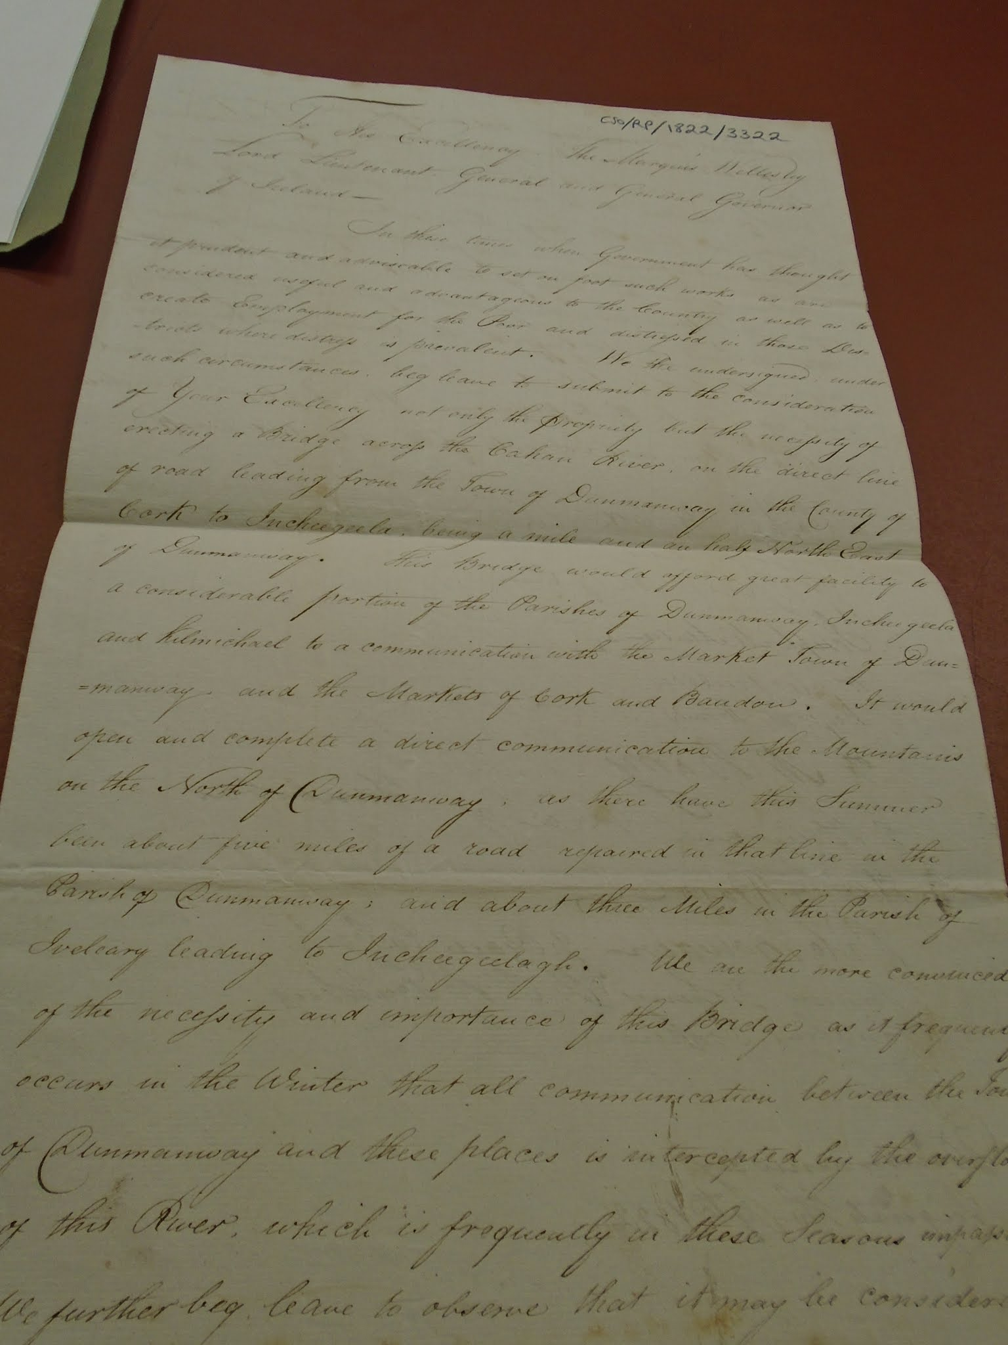..
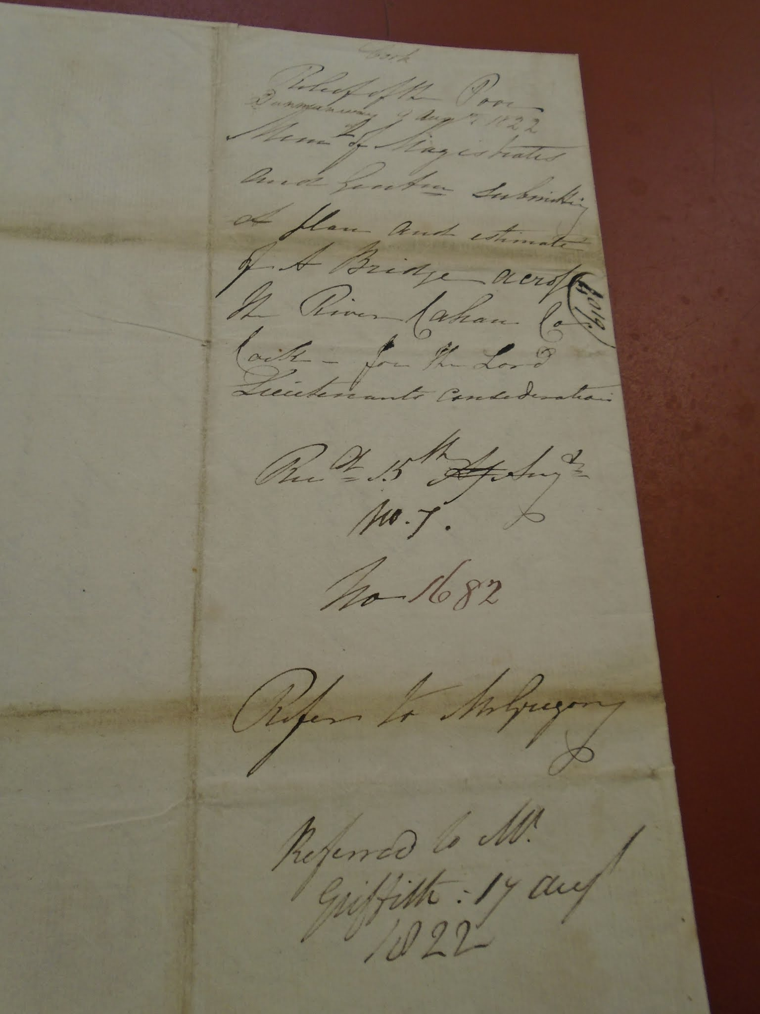..
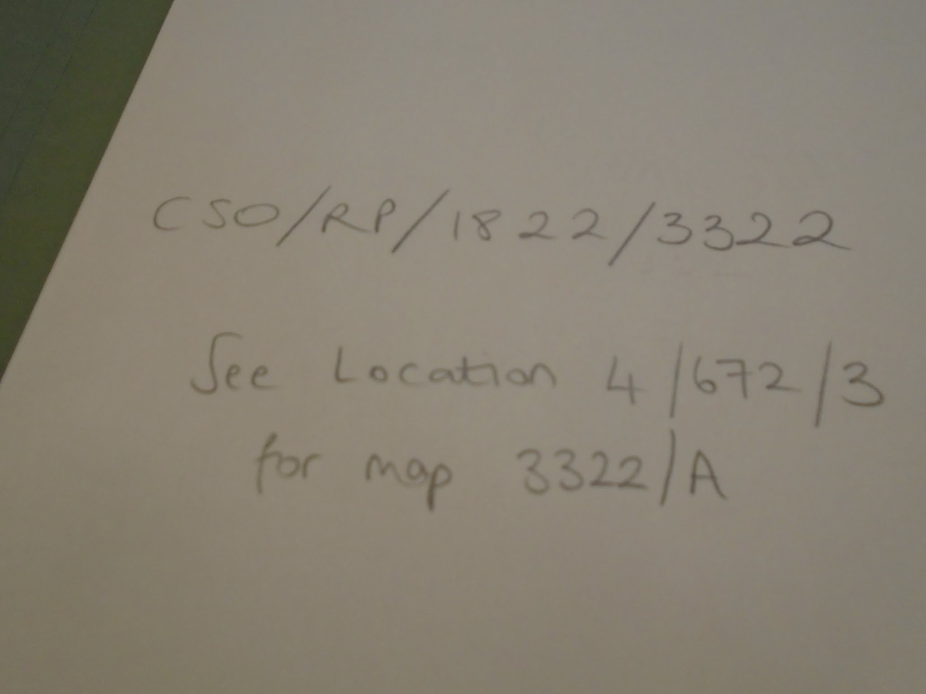

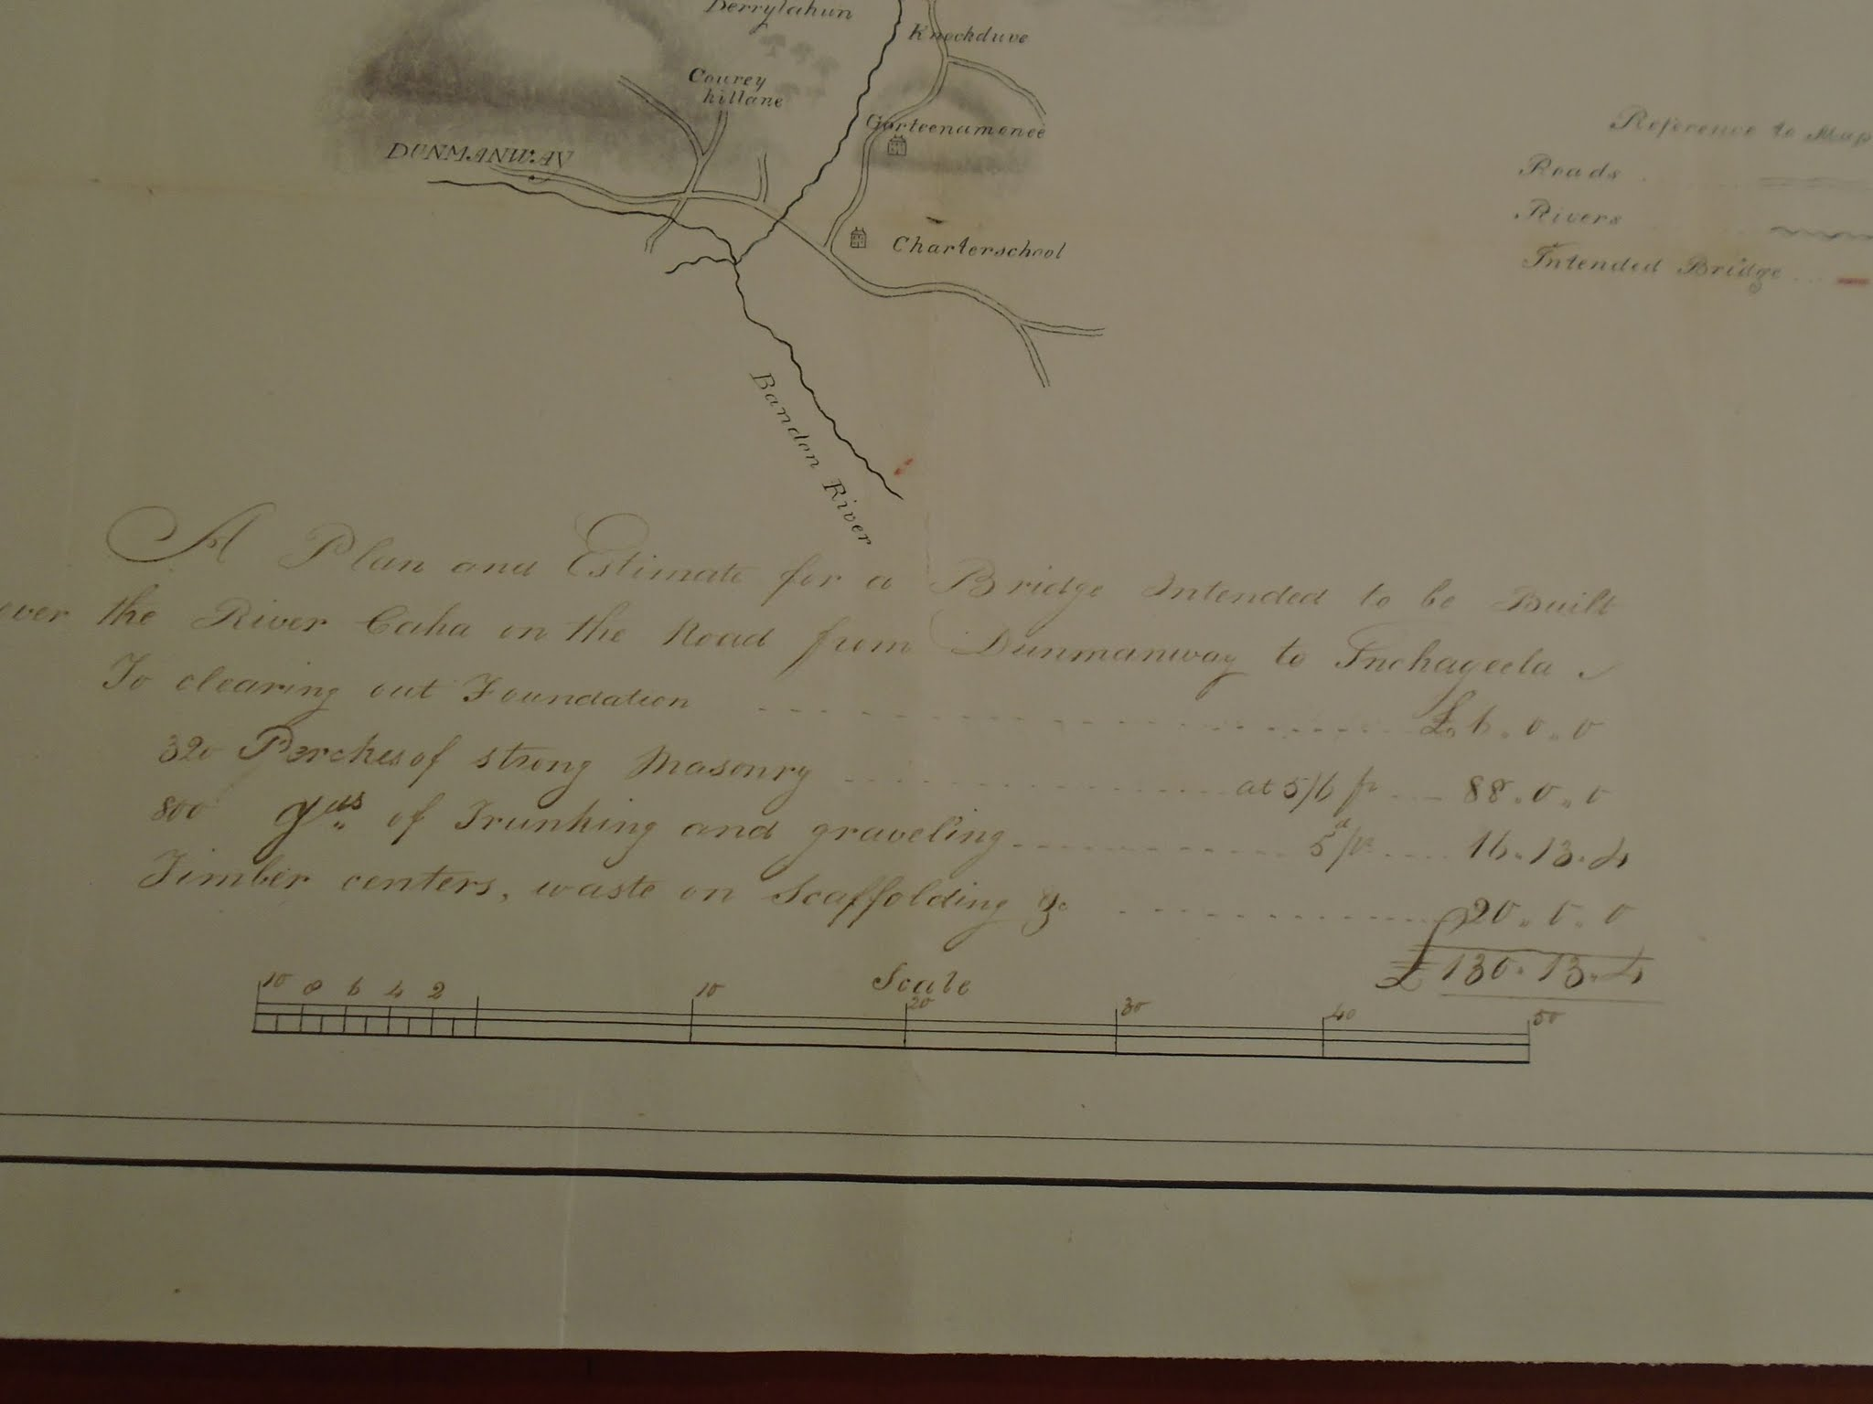.
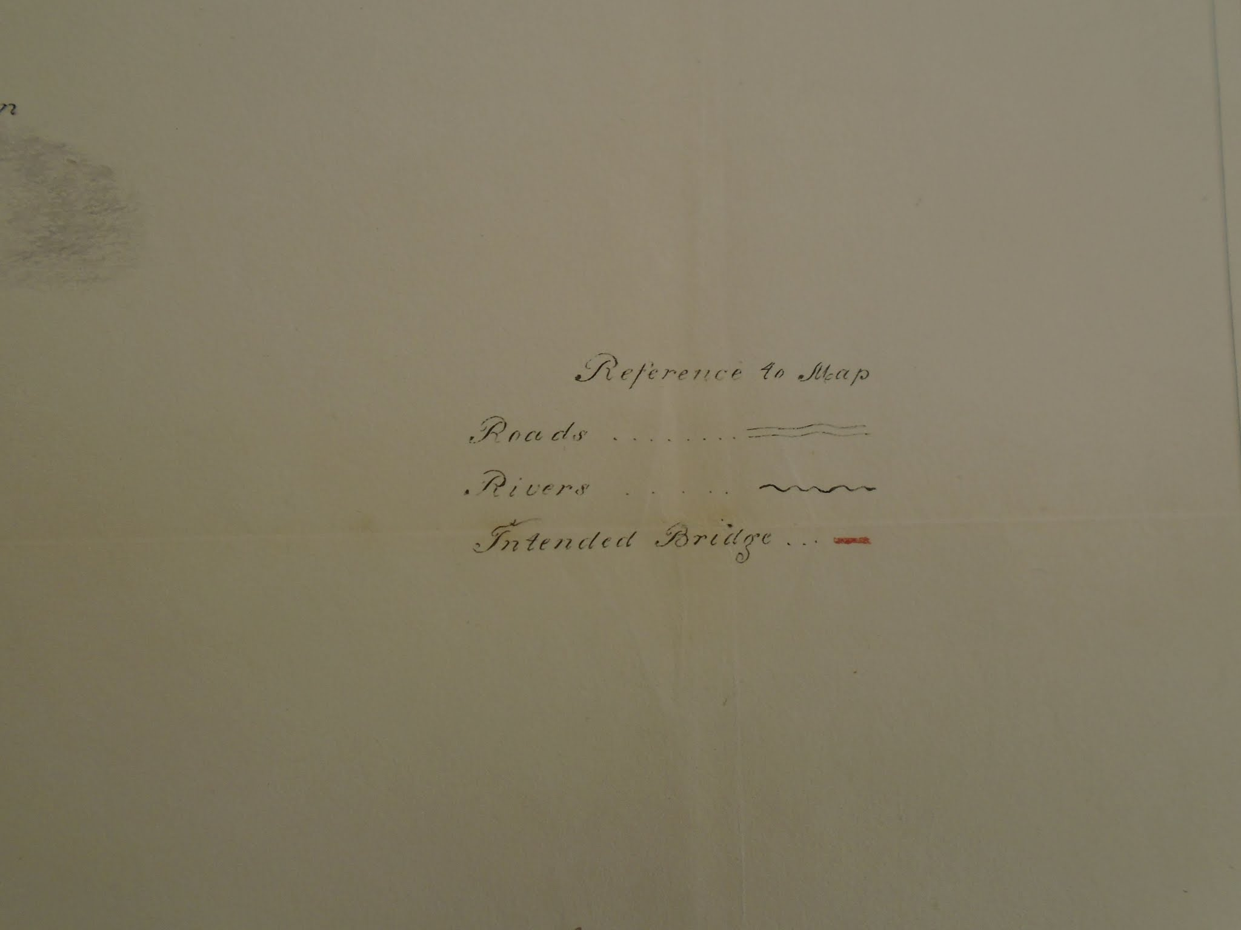.
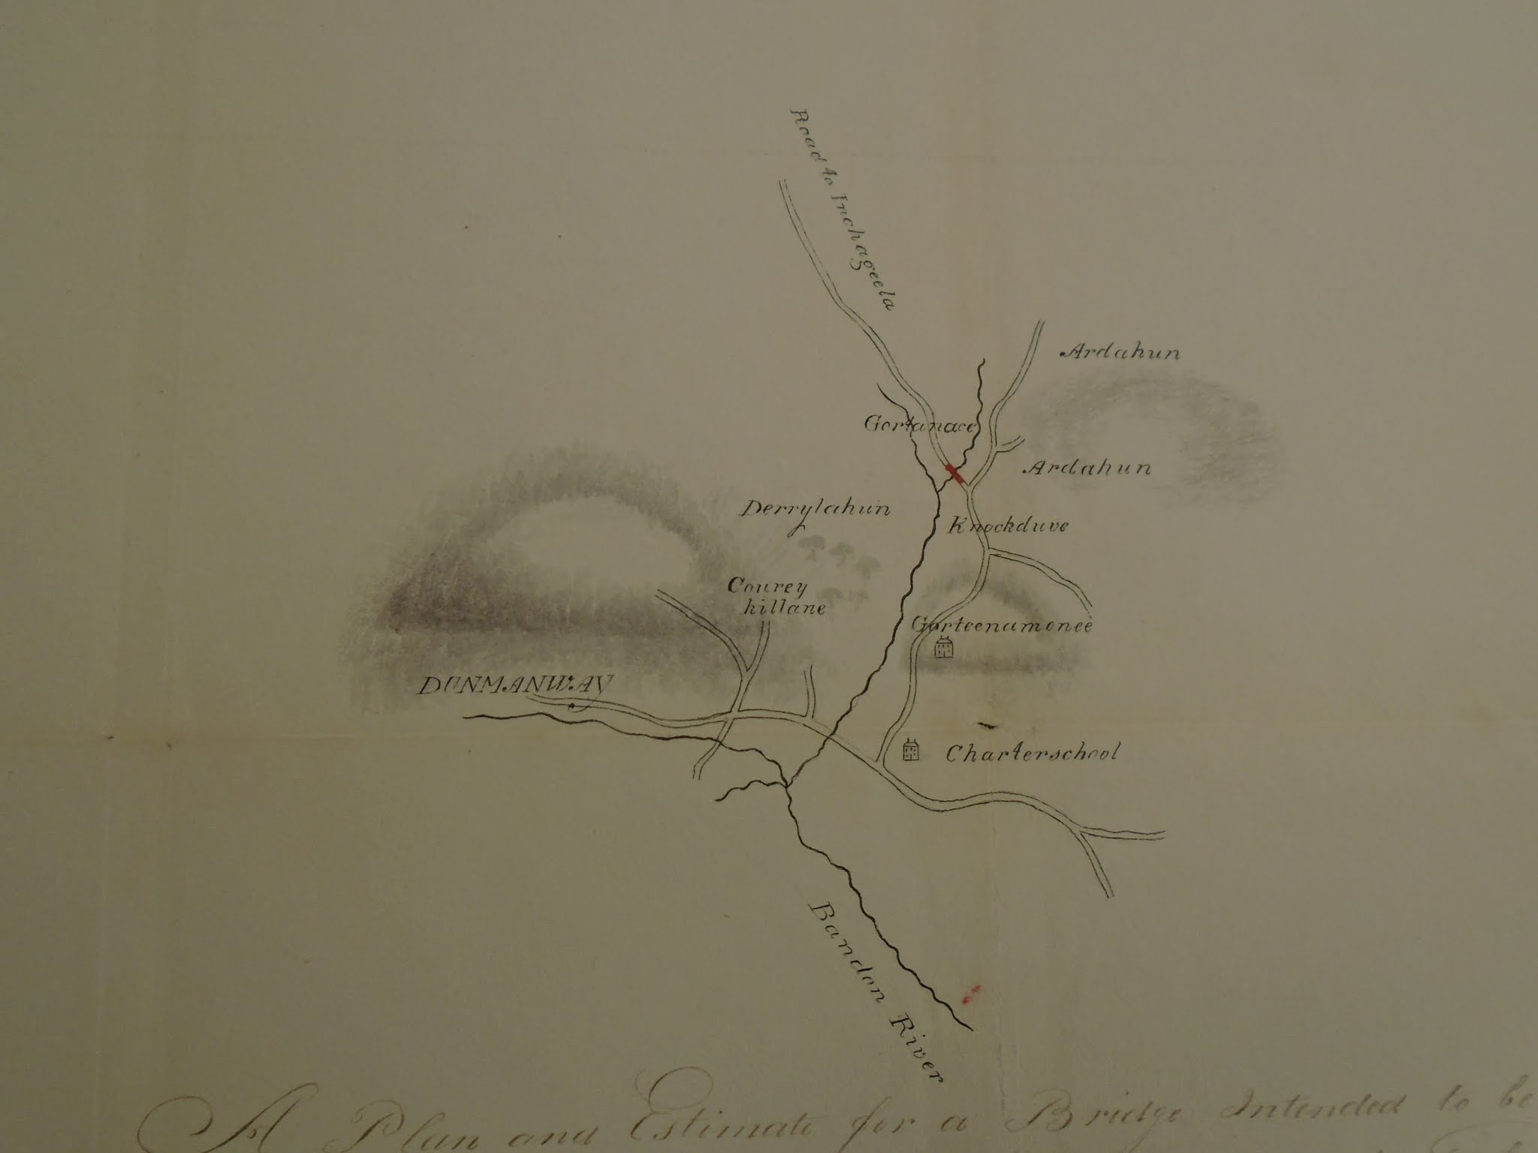
.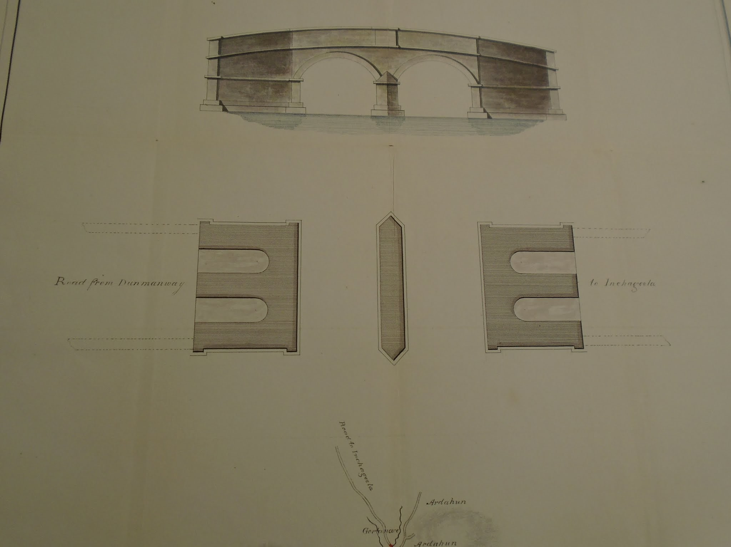.
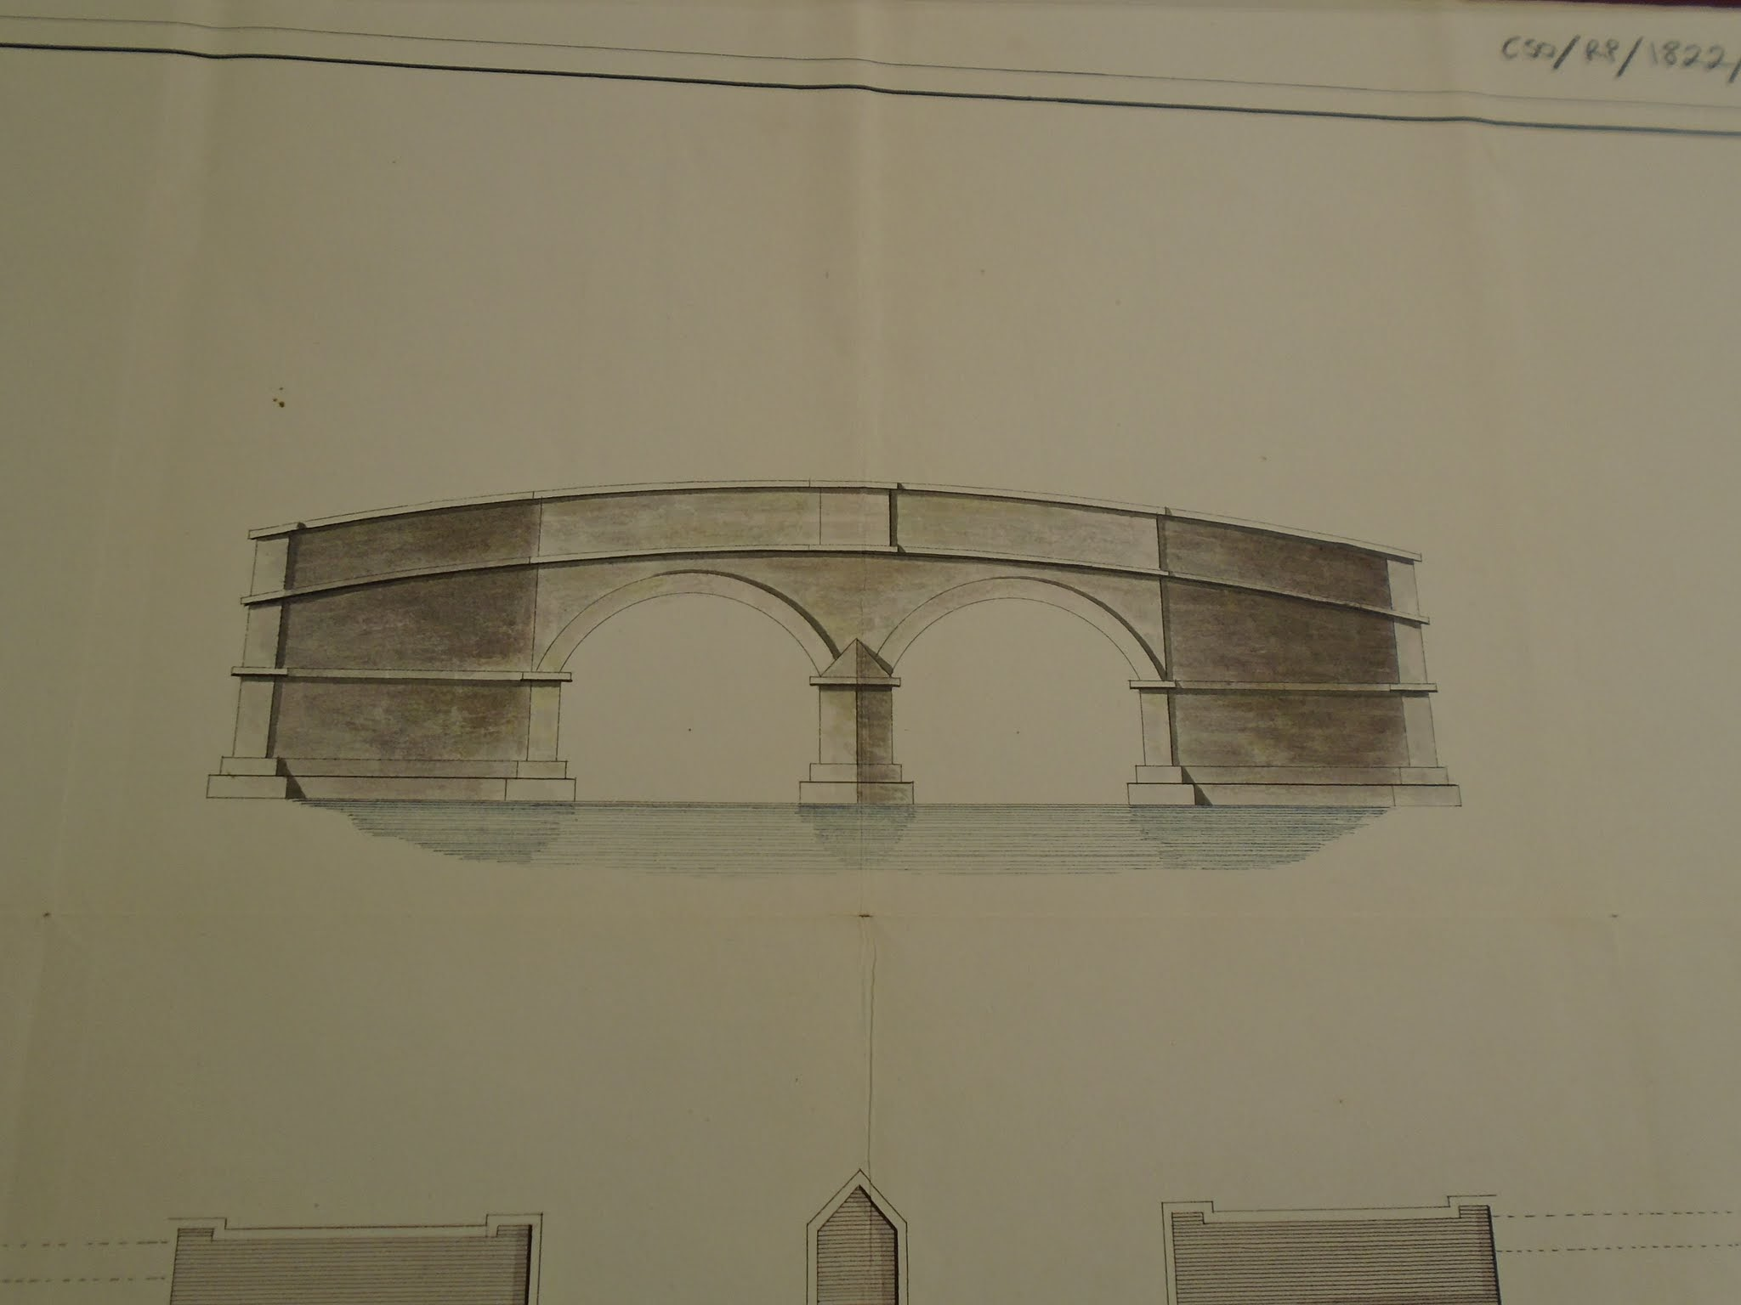
…

…

….

...

http://www.csorp.nationalarchives.ie/search/index.php?simpleSearchSbm=true&category=27&searchDescTxt=dunmanway&simpleSearchSbm=Search#searchfocus
CSO/RP/1823/300
http://www.csorp.nationalarchives.ie/search/index.php?simpleSearchSbm=Search&category=27&searchDescTxt=dunmanway&offset=30&browseresults=true
The reference here is to the presentments of the Grand Jury.
Belfast Newsletter, 30th July 1799
One of a number of families brought down from Antrim c 1740s by Sir Richard Cox.
Shoudhams and some of the Acton, Hamilton, Bryan families were absent with reasonable estates and also some of the Cox family were.

