1725 Rent Roll of Tenants of his Honour Sir Richard Cox, Dunmanway, West Cork

A MEMORANDUM that by bearing date we the 12th day of December one thousand and seventeen twenty and five made between Sir Richard Cox, Knight and Baronet of the first part and his grandson Sir Richard Cox Esq., of the second part and Katherine Evans Daughter of the Right Honourable George Evans Esq., deceased of the third part and Eyre Evans of Bulgadine in the County of Limerick of the fourth part and under their respective hands and seals it was for the considerations there mentioned concluded and agreed upon that … settled? mentioned in a schedule of rents rolls annexed to an article by the Reverend Sir Richard Cox, Richard Cox. Esq., shall be settled conveyed and distributed in manner as in the articles mentioned and to the intent and purpose they particularly specified which schedule of rent roll is in the words and figures or to the effect following viz. 22nd September 1725.

…

Number | Tenants | Lands | Rent | Worth More
No. 1 | William Blair Esq. | Killbarry and part Dunmanway | 150 | 80
 | Widow Moore | House and garden and Shop | 1 10
 | Nicholas Seymor | Two houses and gardens | 2
 | Joseph Bennett | House and garden
 | Mrs. Tonson | House and garden | 1
 | Gilbert Mellefont | Slated house and about three acres | 6 10
 | John Maddy | Slated house and 20 acres | 7
 | Benjamin Stuke | Slated house and 24 acres | 8
 | Andrew Blake | House and 3 acres and half | 8
 | Monsieur | Slated house and garden | 2
 | John Deane | Slated house and garden | 4
 | Thomas Johnson | Slated house and garden | 8
 | Mrs. Stuke | Two houses and gardens | 2
 | William Hurley | House and garden | 1 10
 | Michael? Good | Two houses and gardens | 02 01
 | Philip Redings | House and garden | 01 05
 | John Smith | Slated house about 6 acres | 04 05
 | Richard Bowles | House and gardens | 01 05
 | Fairs and markets |  | 16
 |  |  | 218 10
No. 2 | Mrs. Nots | Slated house and land | 12
 |  | The Paddock 12... | 6
 | Mr. Mellafont | Little Loghfield | 5 10
 | James Moore | House and 2 acres | 2 5
 | John Rhemes | House and garden | 1 10
 |  | Slated house and garden | 4
 | John Pinfold | House and garden | 1 10
 |  | Moulbrack 2 Gneeves | 10
 | Darby Reen Elder? | Derribowan 1 Gneeve | 10
 | Mr. or Michael Mellefont | Derilaghan | 24 10
 | My house and Demesne | 300 acres
 |  | Wood on Kilbarry Mr. Blair Park .. Lacknisharshing, Behinga, Derilahone, and the islands worth now £2,000 and in my grandsons? time may be worth double that | 100
 |  | Coome Clear | 9 15
 |  | Manor Royalties only and increases of rent not reckoned | 307
 |  |  | Richard Cox, Richard Cox (two signatures)
No. 3 | Mr. Warnar (Warner) | Keelcoumligah | 10 10
 |  | Geadencurragh? | 69
 | Widow Hicks | 2 gneeves of same | 9
 | Mr. Hungerford | of the same | 1
 | Maurice Dulea | Glairne 6 Gneeves | 22 10
 | Mr. Warnar | Knockone.... | 80
 |  | The Mill and an acre of Neadencurragh? water
 |  | Note that the said field and half of Kilbee and Lackancreaagh are held by John Young at £90 but are worth £50 an acre. Set by me for 30 years to Mr. Skolfield at 12 pence per ..? in trust for such occasions as may have however .. it may in the settlement because it may happen that I may otherwise supply those occasions and vacate that lease
 |  |  | 142 01
No 4 | William Atkins | Littergorman and Mouligariffen | 40
 |  | The Warren | 6
 | Thomas Owgan | Hippaghan and ... | 21 05
 | Darby Cullinane | Ballygurteen 2 Gneeves | 8
 |  | The Mills and ... | 7
…

….

Cox Magistrates:

Alexander James Cox Esq., Dunmanway, sitting Dunmanway 1835. Refusal to convict those accused of firing at Orange Parade in Dunmanway regarded as partisan.

David Cox, 1822, Dunmanway, Petition of John White, late sub constable, Dunmanway, County Cork, to Richard Wellesley, 1st Marquis Wellesley, Lord Lieutenant, Dublin Castle, requesting grant of financial support due to cessation of payment of one third of salary which became due to him as a result of incapacity arising from injury: recalls that he was deployed by a magistrate at a riot in Dunmanaway on 17 July and ‘when on his duty, in quelling such Riot, was assaulted in the most Violent, and desperate manner, by a large mob, who Knocked him down, with sticks and stones, deprived him of his Sword, with which they Cut and maimed him, in a most Cruel manner, and left him Lifeless on the Ground’, signed by David Cox, justice of the peace, and 6 other persons.Petition of John White, late sub constable, Dunmanway, County Cork, to Richard Wellesley, 1st Marquis Wellesley, Lord Lieutenant, Dublin Castle, requesting grant of financial support due to cessation of payment of one third of salary which became due to him as a result of incapacity arising from injury: recalls that he was deployed by a magistrate at a riot in Dunmanaway on 17 July and ‘when on his duty, in quelling such Riot, was assaulted in the most Violent, and desperate manner, by a large mob, who Knocked him down, with sticks and stones, deprived him of his Sword, with which they Cut and maimed him, in a most Cruel manner, and left him Lifeless on the Ground’, signed by David Cox, justice of the peace, and 6 other persons.

George Cox, 1775, Dunmanway

Henry Cox, 1786 -pre 1826), Manor House, Dunmanway. 1820 signed Memorial for new road Glengariff to Castletownbere as Magistrate. Subscriber 1821 Dr Thomas Wood’s ‘Primitive Inhabitants of Ireland. 182l Joshua eldest son of late Henry Cox Esq, died of fever. Manor House noted by Lewis in 1837 as " a handsome building, erected by the late H. Cox and now the residence of his family" In 1851 occupied by Martha and Catherine Cox and valued at £18. It replaced an earlier house built by Sir Richard Cox, Lord Chancellor of Ireland, at the end of the seventeenth century. Wilson describes this earlier property in 1786 as "adorned with handsome avenues and good plantations". Later the property of the Lucas family,

James Cox, 1733, Dunmanway, witness to Bandon deed 1734, 1737. J.P. then Cork with Richard Cox, J.P. Cork in 1718 deed. Undertaker of Ballyhallwick (Dunmanway) Bridge, Richard Cox Esq., Undertaker, further £40 to be added, £260

Richard Cox, 1699, Bandon. Possibly J.P. then Cork with James Cox, J.P. Cork in 1718 deed. Bridge undertaker

Richard Cox, 1728, Dunmanway, died aged 65, at Dunmanway, Sir Richard Cox, Bart., MP for Clonakilty, succeeded by son Rev. Sir Michael, Bart.

Sir Richard Cox, 1757, Dunmanway. Subscriber James Simon Irish Coinage 1749. On 1741, famine, 500 dead in his parish, ‘burying the dead used to be one of the most religious acts among the Irish is now a burden’. The Papists thought they are bad members of this society are yet better than none. Sir Richard Cox of Ireland in the year of 1733, came to the possession of a large, fruitful but uncultivated tract of land, inhabited by a race of beggars, grown by habitual wretchedness so hardened that tho', no sensible of the smart, they were not ashamed to prefer hunger and idleness to labour and competency. He therefore, directed his thoughts to remedy this evil; and wisely concluded that nothing but the establishment of a staple manufacture on the premises would answer the purpose. For very sufficient reasons he chose the linen; and having procured a quantity of flax seed in 1735, prevailed with them to sow it and by dint of perseverance, and a series of admirable expedients to rectify his own mistakes, to render sloth infamous, to excite emulation, to increase his colony, if it may be so called, and to interest all the passions of those concerned in its success, he at last fixed it on such an establishment, as, if the same laws are observed, bids fair to to perpetual. Already the little town has undergone a wonderful change; for whereas, in 1735, it contained at most but 50 houses, many of them only fit for beggars, it now contains 117 houses, whose inhabitants are fully employed and take pleasure in being so. This is true patriotism and policy united; a sphere of ambition, that every gentleman may follow innocently; laudable, and profitably. Sir Richard Cox introduced families from the North of Ireland to assist, names such as McGivern (McGovern from Leitrim/Fermanagh), Maguire, Pattison and McMullan among others. There is a praise-poem to Sir Richard Cox composed by the otherwise unknown poet Cormac Ó Luinín and transcribed in the hand of Charles O’Conor (1710-1790) in a manuscript held in the library of of Clonalis House, seat of the O’Conors, in Castlereagh, Co. Roscommon. A digital copy is held on the Dublin Institute of Advanced Studies website at ISO [Irish Script on Screen Project]. Died 1763 6 June “Mrs Cox[nee Eliza Turner Becher] , widow of the late Richard Cox, eldest son of Sir Richard Cox” Daughter married John Newman, Dromore House Mallow she died relict 1820.

Cox, Richard, Sir., Dunmanway, succeeded by his son, Rev. Sir Michael - (CC 30/1/1766)

Thomas Cox, 1762, Dunmanway

..
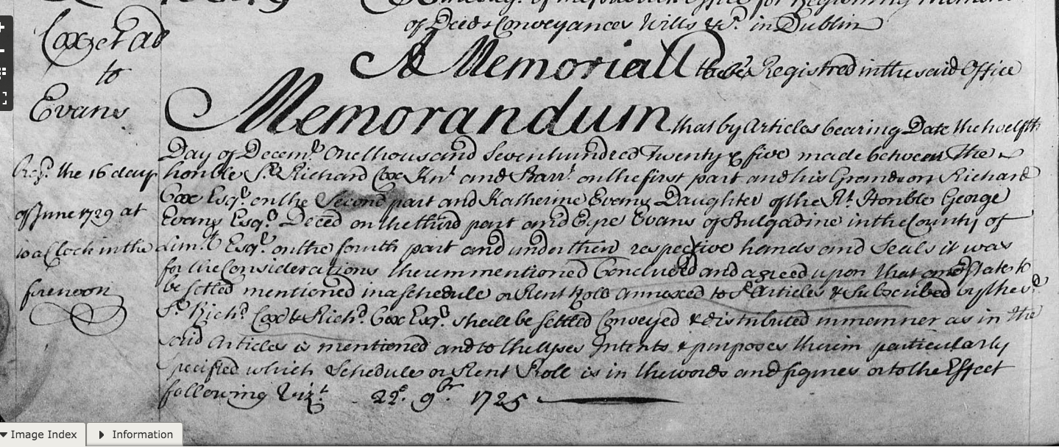
.
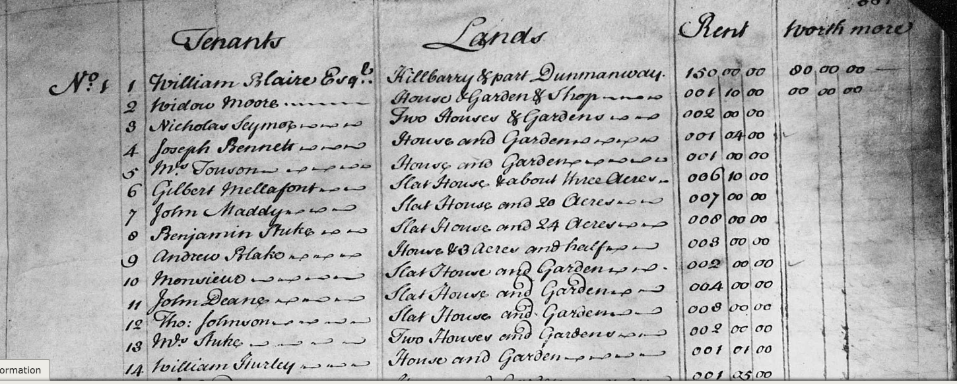
…
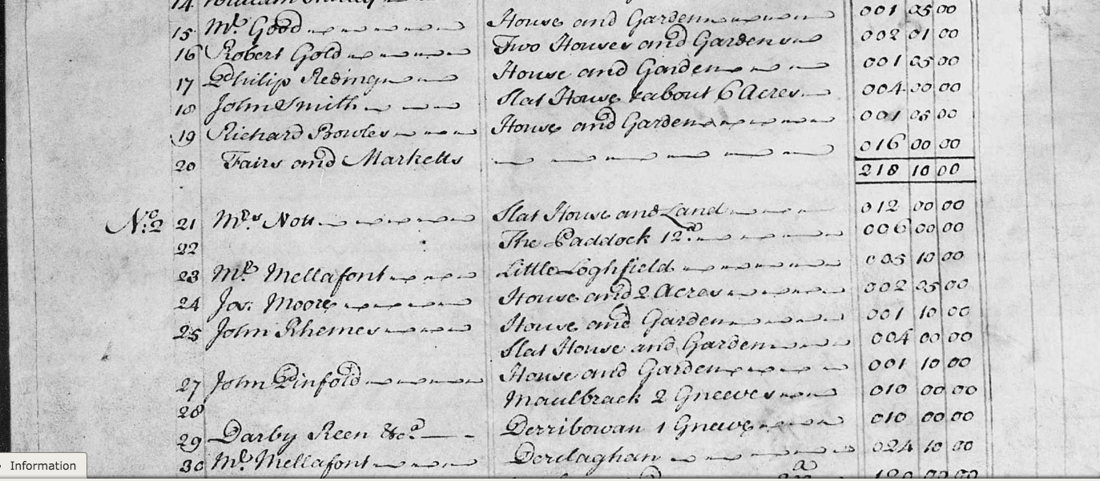..
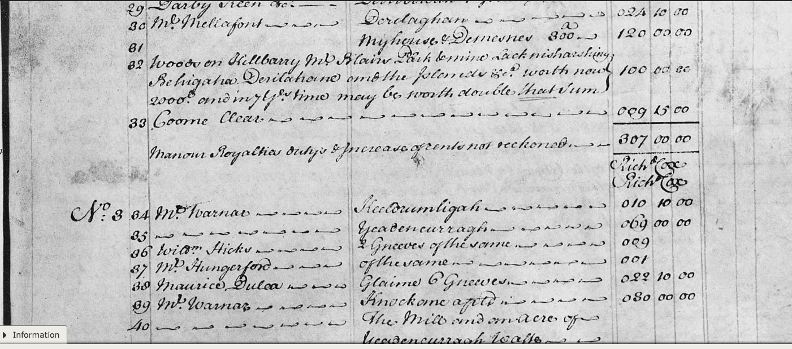..
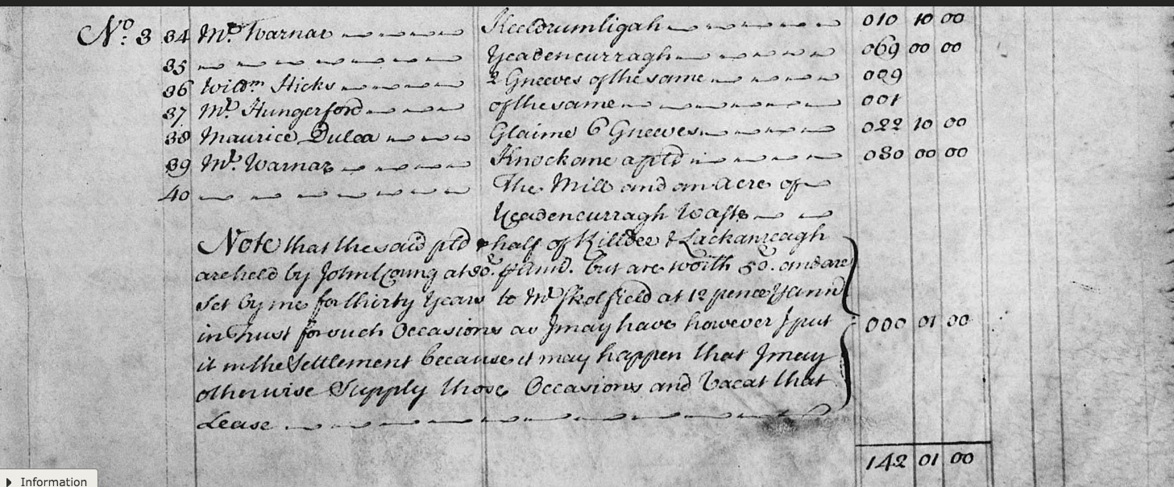..
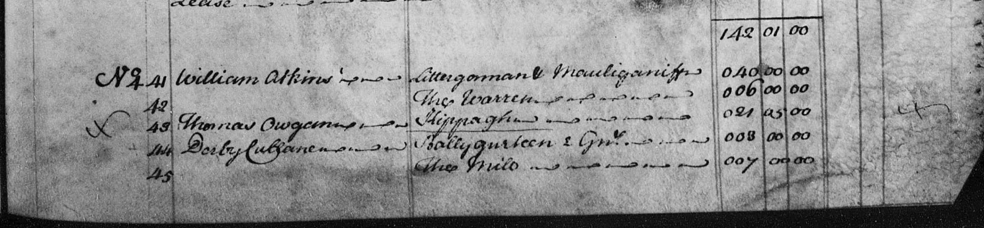..

...
Another Cox rental deed, courtesy Ron Price:

 |  |  | Type of deed | Date of current deed |  | 12 Dec 1725 | Vol | Page | Memorial
 |  |  |  | Date of earlier deed |  |  | 59 | 350 | 40849
No | Role(s) in earlier deed(s) | Role in current deed(s) | Family name | Forename |  | Place |  | Occ or title |  | A
1 |  | O | ALLEN |  | of |  |  | Mr
2 |  | O | ATKINS | William | of
3 |  | O | AUSTEN |  | of |  |  | Mr
4 |  | O | BENNETT | Joseph | of
5 |  | O | BLAIRE | William | of |  |  | Esq
6 |  | O | BLAKE | Andrew | of
7 |  | O | BOWLES | Richard | of
8 |  | O | BROWNE |  | of |  |  | Mr
9 |  | O | COUGHLAN |  | of |  |  | Mr
10 |  | mentioned | COX | Michael | of
11 |  | P2D | COX | Richard | of |  |  | Esq |  | A
12 |  | P1D | COX | Richard | of |  |  | Sir; Bart
13 |  | WM | CRONE | Daniel | of | Cork City
14 |  | O | CULLANE | Darby | of
15 |  | O | DAUNT | William | of
16 |  | O | DEANE | John | of
17 |  | O | DULEA | Maurice | of
18 |  | O | ELMSLEY |  | of |  |  | Mr
19 |  | P4D | EVANS | Eyre | of | Bulgadine, LIM |  | Esq
20 |  | mentioned | EVANS | George | of |  |  | decd; Esq
21 |  | P3D | EVANS | Katherine | of
22 |  | WM | FOLLIOTT | Edward | of
23 |  | O | FRENCH |  | of |  |  | Mr
24 |  | O | GAY |  | of |  |  | Mr
25 |  | O | GOLD | Robert | of
26 |  | O | GOOD |  | of |  |  | Mrs
27 |  | O | GRUE | Dan. | of
28 |  | O | HARRIS | Abell | of
29 |  | O | HARRIS | Abraham | of
30 |  | O | HEDGES |  | of |  |  | Mr
31 |  | O | HICKS | William | of
32 |  | O | HONYFORD | Elery | of
33 |  | O | HONYFORD | William | of
34 |  | O | HUNGERFORD |  | of |  |  | Mr
35 |  | O | HURLEY | William | of
36 |  | O | JENINGS | John | of
37 |  | O | JOHNSON | Thomas | of
38 |  | O | KING |  | of |  |  | Mr
39 |  | O | LITTEN | Anthony | of
40 |  | O | MADDY | John | of
41 |  | WD | MAHONY | William | of | Cork City |  | Esq
42 |  | WD | MASSY | Charles | of | Co Limerick |  | Revd
43 |  | WD | MASSY | William | of | Co Limerick |  | Esq
44 |  | O | MELLAFONT | Gilbert | of
45 |  | WM | MILLERD | Hugh | of | Cork City |  | Mayor
46 |  | O | MOAKES | Dodgin | of
47 |  | O | MOORE |  | of |  |  | Widow
48 |  | O | MOORE | Jos. | of
49 |  | O | MORGAN | Thomas | of
50 |  | O | NOTT |  | of |  |  | Mrs
51 |  | O | OWGAN | Thomas | of
52 |  | O | PINFOLD | John | of
53 |  | O | REDING | Philip | of
54 |  | O | REEN | Darby | of
55 |  | O | RHEMES | John | of
56 |  | O | SEYMOR | Nicholas | of
57 |  | WD WM | SIMINS | William | of | Cork City |  | Gent
58 |  | O | SKOLFIELD |  | of |  |  | Mr
59 |  | O | SMITH | John | of
60 |  | O | STUKE |  | of |  |  | Mrs
61 |  | O | STUKE | Benjamin | of
62 |  | O | TONSON |  | of |  |  | Mrs
63 |  | WD | UNIACKE | Norman | of | Co Cork |  | decd; Doctor of Physick
64 |  | O | WADE |  | of |  |  | Mrs
65 |  | WD | WALLIS | Robert | of | Cork City |  | Notary Public
66 |  | O | WARNAR |  | of |  |  | Mr
67 |  | O | YOUNG | John | of
68 |  | O | YOUNG | John | of
Abstract |  | Comment for person [1] :listed on Rent Roll of estate of Michael Cox in Co Cork  Person [2] :listed as tenant in Rent Roll attached to memorial; probably lands in West Cork  Person [4] :listed as tenant in Rent Roll attached to memorial; probably lands in West Cork  Person [5] :listed as tenant in Rent Roll attached to memorial; probably lands in West Cork  Person [6] :listed as tenant in Rent Roll attached to memorial; probably lands in West Cork  Person [7] :listed as tenant in Rent Roll attached to memorial; probably lands in West Cork  Person [10] :son of said Sir Richard Cox; holds lands in Co Cork  Person [11] :grandson of said Sir Richard Cox  Person [12] :  Person [13] :  Person [14] :listed as tenant in Rent Roll attached to memorial; probably lands in West Cork  Person [16] :listed as tenant in Rent Roll attached to memorial; probably lands in West Cork  Person [17] :listed as tenant in Rent Roll attached to memorial; probably lands in West Cork  Person [19] :  Person [20] :  Person [21] :daughter of said George Evans  Person [22] :  Person [23] :listed as tenant in Rent Roll attached to memorial; probably lands in West Cork  Person [25] :listed as tenant in Rent Roll attached to memorial; probably lands in West Cork  Person [26] :listed as tenant in Rent Roll attached to memorial; probably lands in West Cork  Person [28] :listed as tenant in Rent Roll attached to memorial; probably lands in West Cork  Person [29] :listed as tenant in Rent Roll attached to memorial; probably lands in West Cork  Person [31] :listed as tenant in Rent Roll attached to memorial; probably lands in West Cork  Person [34] :listed as tenant in Rent Roll attached to memorial; probably lands in West Cork  Person [35] :listed as tenant in Rent Roll attached to memorial; probably lands in West Cork  Person [37] :listed as tenant in Rent Roll attached to memorial; probably lands in West Cork  Person [39] :listed as tenant in Rent Roll attached to memorial; probably lands in West Cork  Person [40] :listed as tenant in Rent Roll attached to memorial; probably lands in West Cork  Person [41] :  Person [42] :  Person [43] :  Person [44] :listed as tenant in Rent Roll attached to memorial; probably lands in West Cork  Person [45] :  Person [46] :listed as tenant in Rent Roll attached to memorial; probably lands in West Cork  Person [47] :listed as tenant in Rent Roll attached to memorial; probably lands in West Cork  Person [48] :listed as tenant in Rent Roll attached to memorial; probably lands in West Cork  Person [50] :listed as tenant in Rent Roll attached to memorial; probably lands in West Cork  Person [51] :listed as tenant in Rent Roll attached to memorial; probably lands in West Cork  Person [52] :listed as tenant in Rent Roll attached to memorial; probably lands in West Cork  Person [53] :listed as tenant in Rent Roll attached to memorial; probably lands in West Cork  Person [54] :listed as tenant in Rent Roll attached to memorial; probably lands in West Cork  Person [55] :listed as tenant in Rent Roll attached to memorial; probably lands in West Cork  Person [56] :listed as tenant in Rent Roll attached to memorial; probably lands in West Cork  Person [57] :  Person [58] :listed as tenant in Rent Roll attached to memorial; probably lands in West Cork  Person [59] :listed as tenant in Rent Roll attached to memorial; probably lands in West Cork  Person [60] :listed as tenant in Rent Roll attached to memorial; probably lands in West Cork  Person [61] :listed as tenant in Rent Roll attached to memorial; probably lands in West Cork  Person [62] :listed as tenant in Rent Roll attached to memorial; probably lands in West Cork  Person [63] :  Person [64] :listed as tenant in Rent Roll attached to memorial; probably lands in West Cork  Person [65] :  Person [66] :listed as tenant in Rent Roll attached to memorial; probably lands in West Cork  Person [67] :listed as tenant in Rent Roll attached to memorial; probably lands in West Cork  Person [68] :listed as tenant in Rent Roll attached to memorial; probably lands in West Cork
MS |  |  | Date registered | 16 Jun 1729 |  | Date abstract added |  | 20110722

Abstract made by: Roz McC

Go to film

Copyright © Registry of Deeds Index Project Ireland, 2013–2018

Last updated 8 March 2015

You may be able to see an image of the original document on FamilySearch

http://www.csorp.nationalarchives.ie/search/index.php?simpleSearchSbm=true&category=27&searchDescTxt=dunmanway&simpleSearchSbm=Search#searchfocus
http://landedestates.nuigalway.ie/LandedEstates/jsp/estate-show.jsp?id=3056
Memorial 64419 of 1734
Probably founder of Dunmanway

