1709 Bridge Overseers, Co. Cork, including at Fermoy Ancestors of James Joyce.

The name profile of the Overseers and Undertakers is reflective of the control the Landed families and immigrants from an English background had in control in the Grand Jury at the period. Of around 83 names listed only 18% have a native Irish background, Barry, Conner/Connor, Gould, Fitzgerald, Joyce, Sullivan, some like the Fitzgeralds, Moores and Connors were probably Protestant, there was one from a the original settlers of Bandon Lapp. The remaining 82% number the Landlord families represented by, Becher, Evans, Hedges, Hyde, Crook, Purcell, the Bernards of Bandon had begun to accumulate their estate by purchase, they were to be the Earl of Bandon.

The overseers of Fermoy John Joyce Senior and Junior are probably ancestors of James Joyce

1709 Bridge Overseers, Co. Cork

An account of bridges, presented at several assizes, since the 3rd day of April 1708 to the 26th day of August 1712 inclusive, the sums and the overseers names:

3rd April 1708:---------------------+

- Done. Flesk Bridge in the road from Cork to Rathcormick: Philip Shapman, £40
- Done. Mallow Bridge: Anthony Callaghan, £42
- Hornswater Bridge: Stephen Evans, £10
- Balyneene (Ballineen) Bridge: Mr. Andrew Syms £2 10 shillings
- Carriggoline (Carrigaline) Bridge: Mr. Henry Gillman, £2 10 shillings
- Ballyprevane (Connorville, Ballineen) Bridge: Mr. John Wood, £28 1 shilling 8 pence
- Done. Awnella Bridge: John Cuscok?, £2 10 shillings
- Fermoy Bridge: John Joyce, Senior and Junior, £2 10 shillings
- Macrompe (Macroom): Richard Hedges Esq., £80

28th July 1708

- Carriggegeline (Carrigaline) Bridge: Henry Gilman, £5
- Glanworth Bridge: Randall Roberts Esq., Rev. John Armstead Clerke (Minister Church of Ireland), William Philpot, £40
- Ardskeagh (Buttevant) Bridge: Thomas Creed, £7
- Finished. Flesk Bridge: James Barry, Esq., Undertaker, £20
- Bonca (Dripsey area?) Bridge: Samuel Crook, £50
- Ballyprevane (Connorville, Ballineen) Bridge: John Wood, Richard Crook?, William Wade?, to be…, £30
- Done. Middleton (Midleton) West Bridge, Michael Gould and Richard Bettesworth Esq., Overseers, £10
- Fermoy Bridge: John Joyce, Senior and Junior, 2 shillings
- Fermoy Bridge: arches out of repair, Arthur Hyde Esq., £10,

28th March 1709

- Inishonane (Innishannon) Bridge: John Moore, Clerk (Minister Church of Ireland), £30
- Clydagh Bridge (Mallow): Mr. Mathew Deane, £50
- Ballynterry Bridge and road: Thomas Dyer and Philip Shapman (Chapman?), £49 10 shillings
- Bandon Bridge: William Lapp, Thomas Hosford?, Daniel Connor, James Martine, £200
- Ballyoskerly (Ballinadihy, Aughabulloge?) Bridge, Percy Smyth, £80
- Done Ballydorohene Bridge, Dan Sullivan, Richard Cussane and John Purcell?, £20
- Pedick? Bridge, John Gyford (Gifford), £9 17 shillings
- Carriggeoroghed (Carrigdrohid, Macroom) Bridge, Joseph Osborne, £5
- Adraglin (Araglin?, Fermoy) Bridge, John Joyce Senior and Junior, by agreement, half yearly, £2 11 shillings
- Fermoy Bridge, John Joyce Senior and Junior, by agreement, £2 10 shillings
- Ballynneen (Ballineen) Bridge, Andrew Syms Clerk, £1. 1 shilling
- Funchion Bridge, Edward Hall, Devereux Spratt, £50
- Abbyshowry (Skibbereen), Michael Becher Esq., £100

22nd September 1709

- Done. Moyallow (Mallow) Bridge, Anthony Callaghan, £10
- Moyallow (Mallow) Bridge, for digging shews?, Hugh Lawton, £50
- Fermoy Bridge, John Joyce Senior and Junior, by agreement, half yearly, £2 11 shillings
- Castledod (Charleville) Bridge, Robert Fitzgerald? and Mr. Thomas Temple, £15

23rd March 1709

- Irishtown? Bridge of Bandon, Richard Goodman Clerke, Jas. Martine, £30
- Fermoy Bridge, John Joyce Senior and Junior, £2 10 shillings
- Ardglin Bridge, Samuel Hill, Undertaker, £30
- Funchion Bridge, Edward Hall, and Devereaux Spratt, £50
- Ballyhallwick (Dunmanway) Bridge, William Wade Esq., £40

28th July 1710

- Ballyhallwick (Dunmanway) Bridge, Richard Cox Esq., Undertaker, further £40 to be added, £260
- Bride Bridge, George Bernard? Esq., Thomas Moore, William Philpot, Overseers and Undertakers £60
- Glanworth Bridge: Dispute over legal status of presentments? William Philpot, £6
- Flesk bridge in the road from Cork to Rathcormick, near Charleville: Jasper Tolan and John Browne?, £40
- Fermoy Bridge, John Joyce Senior and Junior, £2 10 shillings
- Inchygeelength (Inchigeela) Bridge, Edward Webber, Edward Brown and William Maylors? £80
- Blackwater Bridge, Richard Philpot and Humphrey Checkley, £15
- Done. Ballydorhan (Ballinadihy, Aughabollogue?), Bridge, Dan Sullivan, John Purcell, £5

27th March 1711

- Fermoy Bridge, John Joyce Senior and Junior, £2 10 shillings
- Done. Awndalow (Newmarket?) Bridge, Dan Sullivan, Charles Webb, Walter Webb, £20
- Cussoos(n?)a Bridge (Kinsale area), John Walton, Richard Busteed, overseers, afterwards Michael Daunt, £10
- Clydagh Bridge (Mallow): Mr. Mathew Deane, money difference to be left to Mr. Mathew Deane, Esq., £15
- Clydagh Bridge (Mallow): Mr. Mathew Deane, for paving and sums? £5
- Murragh Bridge, Arthur Bernard, Esq., £30
- Ballyfereene Bridge, Thomas Crook, Richard Hedges Esq,. John Herrick, Thomas Crook, £30
- Bandon Bridge: John Nash, William Lapp, Daniel Connor, £100
- Doneraile Bridge, Lord Doneraile, £5
- Ardskeagh Bridge (Ballyhea), Nicho Lysaght Esq., £10
- New Mill Bridge, John Clerk ? and Thomas Sealy, £4
- Ovens Bridge, Tim Conner, £20
- Inogreagh? Bridge, Henry Boyle and Michael Goold Esqs., ………. £30
- Ballynneen (Ballineen) Bridge, Andrew Syms Clerk, £1. 5 shilling

31st October 1711

- Fermoy Bridge, John Joyce Senior and Junior, £2 10 shillings
- Blackwater Bridge, Nicholas Leader and Richard Fitzgerald, £15
- Doneraile Bridge, Lord Doneraile, £13
- Done. Awndalow Bridge, Dan Sullivan, Charles Webb, Walter Webb, £15
- Done. Awnalla Bridge, John Longfield Esq., expended in preventing the undermining, £1 5 shillings
- Done. Droghidnagowse Bridge , Michael Goold and John Longfield Esqs., £3 10 shillings
- Ballynavan, Bridge, Ralph Hickie Esq., £6
- Claghnaloohy Bridge, George Bullen and Ja Karny (Kearney?), £10
- Lawny Bridge, Richard Hedges and Arthur Bernard Esqs. £100
- Ballyntose Bridge, Michael Becher, William Wade, Esqs., £20
- Kilfaghtny Bridge, John Hungerford Clerk and Samuel Jervois Junior, £4
- Blackwater Bridge, Nicholas Philpot and Richard Fitzgerald?, £15
- Bond given. Flesk bridge in the road from Cork to Rathcormick, near Charleville: John Burne and John Browne?, to finish to end and to give bod to county? £20
- Clydagh Bridge (Mallow), near Ballynamona: Mr. Mathew Deane Esq., £3

18th March 1711 (Sequence as in ledger)

- Awndalow/Awndaloo Bridge, William Freeman Esq. £250
- Kilmeedy Bridge, Richard Hedges Esq., and Richard Thornhill, £45
- Ballyclogheen and Knockagassane Bridge, Charles Abbott and William Dunsclift, £18
- Done Ballydorohan Bridge, an additional arch, Daniel Sullivan and John Purcell, £5
- Ballynclare Bridge, Michael Becher Esq., £20
- Murragh Bridge, Arthur Bernard, Esq., £30
- Done. Awndalow/Awndaloo Bridge, money advanced Christopher Webb, £38 3 shillings 4 pence
- Done. Awndalow/Awndaloo Bridge, Christopher Webb, for complete finishing and same? £5
- Ballynterry Bridge and Ramprese, Thomas Dyer? and Philip Shapman, £15,
- Ballyglasheen Bridge, Richard Hedges Esq. advanced to prevent being undermined £2 10 shillings
- Fermoy Bridge, John Joyce Senior and Junior, £2 10 shillings

25th August 1712

- Added to another time, Kilmeely Bridge, Captain Hedges and Mr. Thornhill, expended over legal proceedings, £9 6 shillings.
- Kilmeely Bridge, Captain Hedges and Mr. Thornhill, Overseers, for complete furnishing the saem, £30
- Murragh Bridge, over Bandon River, Arthur Bernard, Esq., £100
- Ballybane Bridge (Ballydehob), Hugh Hutchinson Esq., Robert Atking, £20
- Going on. Mallow Bridge: Lawrence Clayton Esq., .. to Mathew Deane, Bart., Ba. Cum.. Esq., £200
- Done. Mallow Bridge, Anthony Callaghan, for his care in lending? Former money laid out £5
- Added to another time. Ballynneen (Ballineen) Bridge, William Wade Esq., £30
- Awbegg (Castletownroche) Bridge, John Spread Junior and John Webb, £30
- Dripsey ? Bridge, Deane Devig?, Richard Croker Esq., £30
- Fermoy Bridge, John Joyce Senior and Junior, £2 10 shillings
- Ballyfereene Bridge, Thomas Crook, among disputes over legal problems? £13 13 shilling
- Ballyfereene Bridge, Thomas Crook (Same overseer), for the complete finishing, £40
- Added to another ...Ballynneen (Ballineen) Bridge, William Wade Esq., £30
- Rowry (Rosscarbery) and Drumaleague (Drimoleague) Bridges, Henry Jones?, Samuel Jervois, £12

Grand Jury Room 15th July 1713.

The undernames overseers are to quote before the Grand Jury for the bridges when they were appointed overseers of respectively?

About? 28th July 1708.
- .
- Thomas Creed, overseer of Ardfreagh Bridge, £7
- Samuel Crook, overseer of Boneeen Bridge, £50

28th March 1709.
- Piercy Smith, overseer of Ballynoskarty Bridge, £80
- John Grifford (Gifford?), overseer of Pellick (Castlelyons) Bridge, £9 17 shillings
- Samuel Hill, undertaker of Ardglin Bridge, £60
- Edward Hall, Devereux Spratt, overseers of Funcihon Bridge, £50

29th September 1709.
- Robert Fitzgerald Esq., and Mr. Thomas Comp.. overseers of Castledon? (Castledod?) , £15

23rd March 1799.
- Adglin Bridge, Samuel Hill Undertaker, £30
- Funchion Bridge, Edward Hall and Devereux Spratt, £10
- Ballyhallwick Bridge, William Wade Esq., £40

28th July 1710
- Ballyhallwick (Dunmanway) Bridge, Richard Cox Esq., Undertaker, £260
- Bride Bridge, George Bernard?, Thomas Moore, William Philpot, £260
- Inchygeelength (Inchegeela) Bridge, George Bernard?, Edward Browns? And Mahony £8
- Blackwater Bridge, Richard Philpot and Humphrey Checkley, £15

27th March 1711
- Murragh Bridge, Arthur Bernard Esq., £30
- Ballyfeeerson Bridge, Richard Hedges Esq., Jur? Herrick, and Thomas Crook, £30
- Ardsheagh Bridge, Richard Lysaght Esq.,£10
- Inogreagh? Bridge, Henry Boyle and Michael Goold Esqs., £20

3rd October 1711

- Ballynovaa Bridge, Ralph Frekes Esq., £6?
- Doneraile Bridge, Lord Doneraile, £13
- Lawny Bridge, Richard Hedges, Arthur Bernard Esqs., £100
- Ballintoro Bridge, Michael Becher, and William Wade, Esqs, £20
- Kilfaghtny Bridge, Jus. Hungerford and .. Samuel? Jervois Junior, £4

18th March 1711

- Awahaloo Bridge, William Haa? Esq., £250
- Kilmeeedy Bridge, Richard Hedges Esq., and Mr. Richard Thornhill, £45
- Ballyclogheen and Knockagarra Bridges, Charles Abbott, and William Domcliff £18
- Ballinclaw Bridge, Michael Becher Esq., £20

26th August 1712

- Killeneedy Bridge, Captain Hedges and Richard Thornhill, £9 6 shillings
- Killeneedy Bridge, Captain Hedges and Richard Thornhill, for complete finishing by law £20
- Murragh Bridge, Arthur Bernard, £100
- Ballybane Bridge, Hugh Hutchinson and Robert Atkins, £20
- Ballyvereene Bridge, William Wrixon? Wade?, £30
- Awbeg Bridge, John Spread Junior and John Webb, £50
- Dripsey ? Bridge, Deane Danos, Richard Croker Esq., £90
- Ballyfereen Bridge, Thomas Crook, £50 12 shillings 6 pence.

Magistrates:

James Barry, 1692, a James Barry Esq., appears as undertaker of Flesk Bridge 1708

James Cox, 1733, Dunmanway, witness to Bandon deed 1734, 1737. JP then Cork with Richard Cox, JP Cork in 1718 deed. Undertaker of Ballyhallwick (Dunmanway) Bridge, Richard Cox Esq., Undertaker, further £40 to be added, £260

Matthew Deane, 1710, Overseer 1709 Clydagh Bridge (Mallow): Mr. Mathew Deane, £50

William Freeman Esq., of Kilbarry, Fermoy, 1703. b. in 1667, who purchased Castle Cor, Co. Cork, from the Chinnery family. He m. Christabella, dau. of Robert Carew, Esq., of Ballinamona, and dying in 1732, left, with three daus., Mary, m. first to Col. Perterson, and secondly, to Joseph Gabbet, Esq., of Caherline; Caherine, m. 1724, to William Philpot, Esq., of Dromagh Castle; and Christabella m. to Joseph Collins, Esq., of Fermoyle, a son and successor. 1711 bridge overseer, Awndalow/Awndaloo Bridge, William Freeman Esq. £250

Michael Goold, 1703. May be bridge overseer, Droghidnagowse Bridge , Michael Goold and John Longfield Esqs., £3 10 shillings

Richard Hedges, 1706, overseer Macroom Bridge 1708 paid £80 for works.

Hugh Hutchinson, 1710, 1712 Overseer, Ballybane (Ballydehob) Bridge, Hugh Hutchinson Esq., Robert Atking, £20. 1714 took informations in Bantry referred to in letter from Captain Lewis Lermond in Bantry to Lieutenant Colonel Manning, his superior officer, in Dublin giving an account of disturbances caused by a 'Clan (O’Mahonys) of loose unaccountable Irish Papists and Privateers' who 'appear with Swords, Cutlashes and Fire Arms, to the Great Terror of the Neighbouring Subjects.' in Crookhaven, Co. Cork. He encloses with the letter supporting letters and statements by Finin Merigoe, Dermod Merigoe, Kedagh Donovan and Cornelius McMurtigh.

Arthur Hyde, 1697, Fermoy, settled from Elizabethan times. 1708, Overseer, Fermoy Bridge: arches out of repair, work by Arthur Hyde Esq., £10.

Samuel Jervois, 1729, Brade, Skibbereen, witness to Bandon deed 1733, 1742, 1743. 1712 bridge overseer, Rowry (Rosscarbery) and Drumaleague (Drimoleague) Bridges, Henry Jones?, Samuel Jervois, £12

William Philpot, 1721, may be father of Henry, TCD, 1711 aged 17 ed Mr. Morgan, Tipperary. Overseer Glanworth Bridge: Randal Robert Esq., John Armstead Clerke?, William Philpot, £40. Probably related to the Freemans also bridge overseers.

Randall Roberts, 1697, Britsfieldstown (Minane Bridge), overseer Glanworth Bridge: Randal Robert Esq., John Armstead Clerke, William Philpot, £40

John Spread, 1719, Forrest?, Subscriber of 1766 'The History of the Irish Rebellion', Cork, 1766. Son probably bridge overseer 1712, Awbeg Bridge, John Spread Junior and John Webb, £50

William Wade, 1698, Overseer, Ballyprevane (Connorville, Ballineen) Bridge: John Wood, Richard Crook?, William Wade, £30

Awbeg Bridge.

Mentioned in Downe Survey Map 1656. Bridge founded on rock. Buttevant old bridge formed part of the ancient route linking Cork and LImerick

Ballinadihy Bridge is an Irish bridge situated 2 km (1.2 mi) south-east of Aghabullogue village in County Cork, Ireland 4.2 km (2.6 mi) north of Coachford village, and is depicted on both the 1841 and 1901 surveyed OS maps. The bridge is located at the meeting point of the townlands of Clonmoyle West and Peake, and lies within both the civil parish and catholic parish of Aghabullogue.

Bandon Bridge:

The town of Bandon Bridge owes its name to the erection of a bridge over the river Bandon by English settlers in the 16th century, although the Irish O’Mahony clan are locally reputed to have built a timber bridge nearby as early as the 14th century. Nonetheless, it is certain that a bridge was constructed here in 1594, joining settlers on the north and south banks of the river. The construction of the bridge facilitated increased trade, allowing the town to develop rapidly and it was shortly after established as a Walled Town, when in 1611, William Newce recommended walling the town. The historic walled town of Bandon is today part of the Irish Walled Town Network. The 1594 bridge was destroyed during heavy flooding in 1765 and a new structure was built in 1773. Parts of this bridge remain contained within the present site, however much of the visible architectural detailing of the structure dates to 1838. The current structure was built in 1773-78, on or near the site of an earlier bridge.

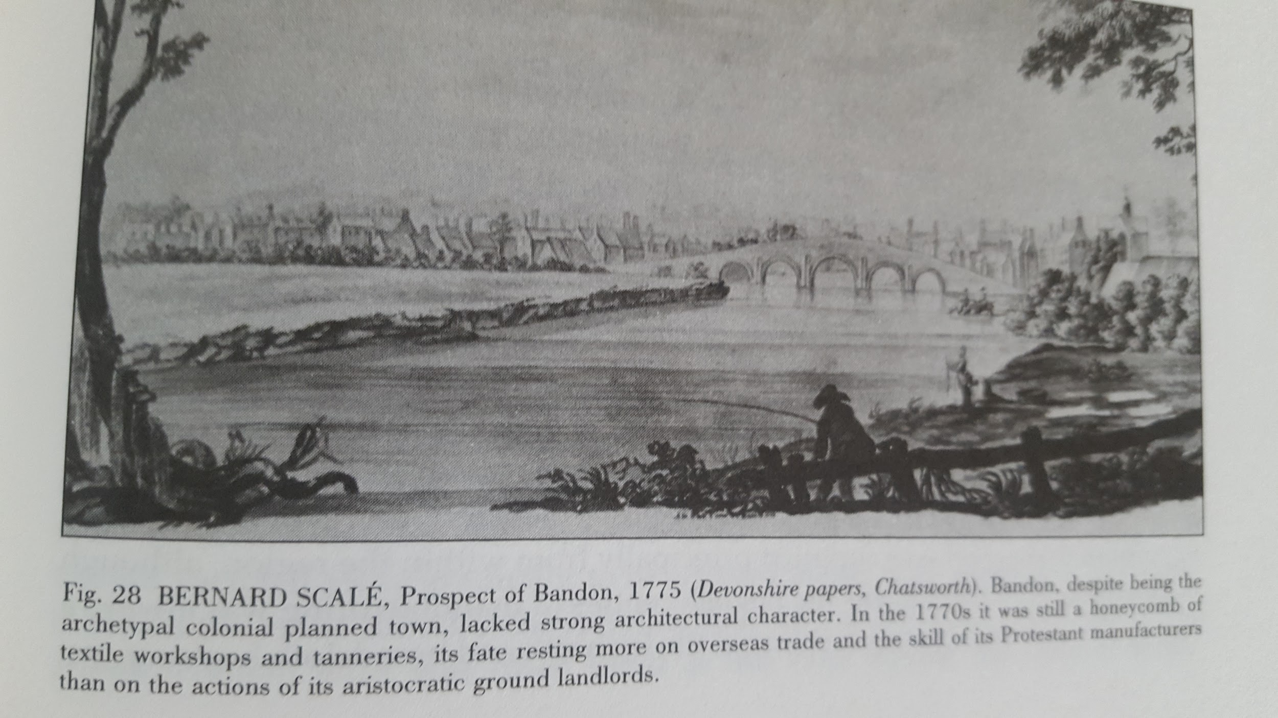

...

….

…

Carrigadrohid Castle and Bridge

The earliest bridge built here, of which there is now no trace, was built in medieval times out of timber. However, it was replaced in the 17th or 18th century by a stone bridge. The structure which stands on the site today is a combination of bridges built at two different dates. The section over the northern half with two semi-circular arches is probably 18th century, and the southern section, made of two wide pointed arches, was added when the original four semi-circular arches were damaged by a flood in 1853. It stands on a rock in the middle of the river Lee, adjacent to the bridge which gives the village its name. It was erected in the 15th century by the MacCarthys of Muskerry, with an extension to the east and an annex to the north being added in subsequent centuries. It was besieged by Parliamentary forces following the Battle of Macroom, and Boetius MacEgan, the Bishop of Ross, was hanged by the reins of his own horse outside the castle having refused to implore the Irish garrison to surrender to the Cromwellian army.

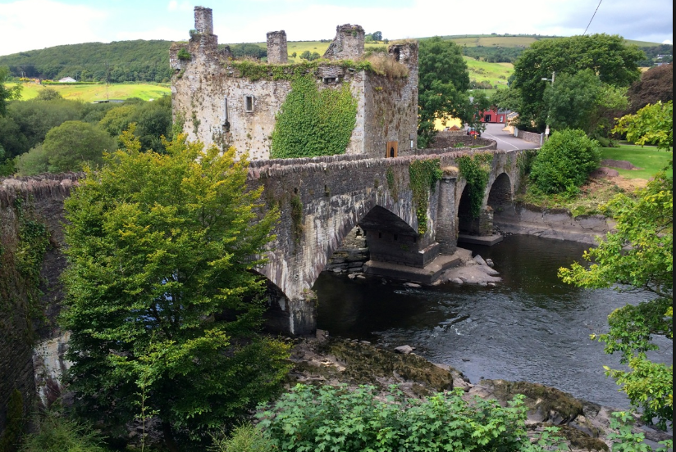

….
..

Clydagh Bridge (Mallow)

….

Fermoy Bridge

….

There is no bridge show in the Down Survey in 1656. The Council Book Of the Corporation of Youghal the Mayor is delegated to go to Cork in 1674 to the Assizes and the Judge ordered £7 to be levied toward the building of Fermoy Bridge.

A timber bridge was built over the Blackwater in 1626 by Richard Boyle The 1st Earl of Cork at a cost of £500. There had been an earlier ferry operated by the Cistercians and this yielded the Earl an income of £25 annually. This bridge was swept away in a flood in 1628, a new bridge was erected in 1687. In 1687 a ‘stately bridge lately built over the Blackwater which cost around £1,500. Smith's History of Cork 1750s described this as a bridge of 13 arches.

Later bridge, road bridge over River Blackwater, dated 1864 and 1865, and built at site of seventeenth-century bridges and of medieval ferry. Coursed rock-faced ashlar piers and spandrels, snecked to parapets having cut-stone copings, chanelled ashlar voussoirs to segmental arches, with cut limestone string course between arches and parapets. Parapets to road having dressed snecked facing. U-cutwaters to piers, with carved limestone caps and imposts, latter continuing as course to underside of arches and to landward abutments, and rock-faced ashlar below. Carved limestone plaque to west parapet wall. Southern three arches accommodate mill race, bounded to north by weir. Rubble limestone approach wall to north side of east parapet marking line of approach to earlier bridge. Wall contains inserted keystone with date 1718, and sandstone overflow arch.

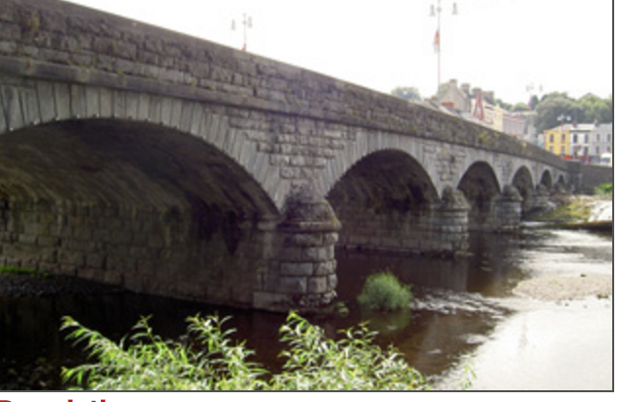

Fermoy Bridge

Bridge erected by Earl of Cork in the 1680s. There had been a ferry which was replaced by the Earl of Cork in 1625 at a cost of £500 as well as the loss of £23 per annum from the ferry service. Tis was washed away in a flood.

….

…

Glanworth Bridge

Earlier bridge built at end of 14th century.

Thirteen-arch slightly hump-backed limestone road bridge over River Funshion, built c.1625, having narrow, unwidened carriageway of 3 metres. Westernmost arch obscured by modern build-up of ground. Random rubble limestone construction, having narrow dressed limestone voussoirs to round arches. Piers built on rock outcropping in river bed. Corbels for support of form work during construction to springing of arches. Rubble limestone V-plan cut-waters to north side. Rubble limestone parapets with remains of vertical stone copings. Thirteen-arch slightly hump-backed limestone road bridge over River Funshion, built c.1625, having narrow, unwidened carriageway of 3 metres. Westernmost arch obscured by modern build-up of ground. Random rubble limestone construction, having narrow dressed limestone voussoirs to round arches. Piers built on rock outcropping in river bed. Corbels for support of form work during construction to springing of arches. Rubble limestone V-plan cut-waters to north side. Rubble limestone parapets with remains of vertical stone copings.

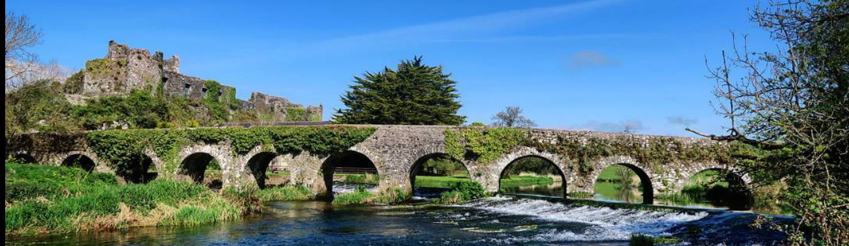
….

...
Innishannon Bridge:

Formerly a ford nearby. The first known mention of Innishannon Bridge comes from a record of a resolution by Kinsale Corporation, in 1665, “to oppose the payment of money towards Innishannon Bridge”. This bridge was completely destroyed in the tsunami of 1755, following an earthquake in Lisbon, Portugal. This earthquake, known as the Great Lisbon Earthquake, is thought to have had a magnitude of 8.5-9, and shockwaves were felt across Europe. It created tidal waves which hit coastlines as far away as North Africa, and the boats in Kinsale harbour are said to have spun around on their moorings. The wave travelled up the estuary of the Bandon River from Kinsale as far as Innishannon, devastating the bridge here.

…

…
…

….

...

Irish Town Bridge Bandon:

First built by the O’Mahonys in the 14th century. Built in 1864 to replace a bridge built by a Mr John Lodden in 1636. Immediately west of this bridge was the East Gate of Bandonbridge. Adjoining this site was the site house in which George Bennett, Historian of Bandonbridge and Bandon Oregon was born.

..

…

‘’

Mallow Bridge;

Lord Deputy Perrot proposed a number of brides in 1584 including Broad Water. It was built after 1588. Earlier was a fair ford in summer on the ‘broadwater’ but in winter and moist weather, there was no passage but in troughs or cotts and even horses had to swim. The bridge was destroyed by the Williamites in 1690.

1712. KInsale Council books records the erection of stone bridge at Mallow to replace existing structure, Law Clayton £200. The presentment was by John Wrixon and John Foulkes, Gents., overseers fro making 2,300 metres of causeway on the high road from Mallow to Kerry. It was granted for paving, ‘the earth being thrown up already by the day's labour’
Mallow Bridge crosses the Blackwater River in Mallow town linking Ballydaheen on the south bank to the town centre. The bridge is an important part of the urban environment, and can be viewed from a new river walkway, accessed from the road to the southeast of the bridge. The area is also important ecologically, constituting part of the Blackwater River SAC. Mallow Bridge is at a strategic crossing point and there is clear documentary evidence that it is on or near the site of earlier bridges. The bridge today is a composite of an early 18th bridge with a mid 19th insertion over the river; the northern half of the bridge dates to 1712, the later southern section was constructed in 1856.
….

1821. Letter from John Musgrave, concerning opposition to proposed bridge over River Blackwater, County Cork. Letter from John Musgrave, concerning opposition to proposed bridge over River Blackwater, County Cork. Letter from John Musgrave, 36 Molesworth Street, Dublin, to Charles Grant, Chief Secretary, Dublin Castle, concerning local opposition to the proposed timber bridge over the River Blackwater, near Youghal, County Cork, because of fears it will hamper navigation of the river. Advises that Thomas Telford, engineer and canal builder, be called upon to carry out a survey of the river, and decide on the matter. Warns that Alexander Nimmo, engineer, would not have the trust of many, as it is his brother, G Nimmo, who has been employed to prepare the plan and estimate for the proposed bridge. CSO/RP/1821/54

1822 File of papers relating to Irish government's approval process for proposed new bridge at Youghal, County Cork, over River Blackwater, to connect Counties Cork and Waterford. Includes petitions from several landed proprietors, in favour of the proposed bridge, and also from those concerned that the bridge will impede the navigation of the river. Also includes report of John Killaly and Alexander Nimmo, Dublin, engineers appointed under Public Works Loans (Ireland) Act 1820 1 Geo IV chapter 81, to Henry Goulburn, Chief Secretary, Dublin Castle, concluding that the benefits to be derived from connecting the 2 counties via the proposed bridge, outweigh any inconvenience to river navigation. However, they oppose the proposed site of the new bridge, and suggest an alternative location along the river. Report signed and sealed by Killaly and Nimmo, 8 February 1822. CSO/RP/1821/728

1822. Letter from William O'Brien, 2nd marquis of Thomond, Rostellan Castle, Cloyne, County Cork, to William H Gregory, Under Secretary of Ireland, Dublin Castle, requesting attention to enclosed letters [not extant] and asking for copy of report by John Killaly and Alexander Nimmo, civil engineers, on proposed bridge over River Blackwater at Youghal, County Cork; includes letter from John Musgrave, Youghal, to Richard Wellesley, 1st Marquis Wellesley, Lord Lieutenant, Dublin Castle, seeking copy of report on bridge ‘that the publick might be enabled to judge whether the objections urged against this publick work on the ground of its injuring the Navigation of the River, were well founded’; encloses letter from Henry Goulburn, Chief Secretary, Irish Office, London, England, to Musgrave, conveying that the report in question has been sent to Gregory; includes copy report from Killaly and Nimmo, Dublin, to the Chief Secretary’s Office, Dublin Castle, indicating resistance to site proposed for bridge on cost grounds and recommending another location just over a mile north of Youghal. CSO/RP/1822/1998

…

Edc
Letter from John Musgrave, Youghal, County Cork, to Henry Goulburn, Irish Office, Westminster, London, England, seeking transmission of report by engineers John Killaly and Alexander Nimmo, on subject of construction of new bridge over the River Blackwater, near Youghal: indicates that three sites for structure have been identified and considers merits of each and potential damage to navigation of river. CSO/RP/1822/2314

…
Other Cork Bridges:

1650. Richard Cox, who built Dunmanway town and brought in a linen industry, was born in Bandon. The town is indebted for its origin to Sir Richard Cox, Lord Chancellor of Ireland in the reign of Wm. III., who obtained from that monarch the grant of a market and fairs, and erected a stately mansion for his own residence. Sir Richard also built the long bridge over the river Bandon, consisting of six arches, exclusively of four under the causeway, and introduced the linen manufacture, for which, under his auspices, this place became one of the principal marts, and the town, in which a colony from England had settled, one of the most flourishing in the south of Ireland

...

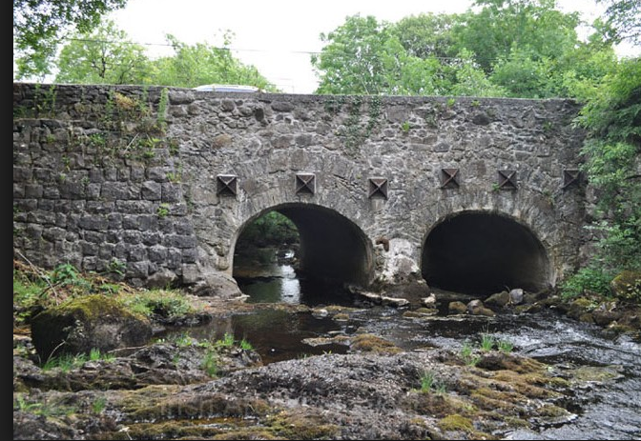

Cork Archives, U229/3/2. Creator O’Flynn Exham Solicitors Archival History/ Source of Acquisition The collection was donated to the Archives in the 1980s by O’Flynn Exham solicitors. The collection contains about 795 items dating from the 18th century, including a Cork Grand Jury document from 1708-13 concerning overseers for bridges in Co. Cork, of special interest due to the almost complete loss of the records for both the county and the city of Cork Grand Juries (U229/3/2)
May be ancestors of James Joyce, the biographer of John Stanislaus Joyce has the family moving to Fermoy after this period. However the connection with stone work would suggest a connection.
Magistrate 1706, Macroom.
Magistrate: Randall Roberts, 1697, overseer Glanworth Bridge: Randal Robert Esq., John Armstead Clerke?, William Philpot, £40. Magistrate: William Philpot, 1721, may be father of Henry, TCD, 1711 aged 17 ed Mr. Morgan, Tipperary.
Magistrate: Arthur Hyde, 1697, Fermoy, settled from Elizabethan times.
Magistrate: Matthew Deane, 1710
http://www.buildingsofireland.ie/niah/search.jsp?type=record&county=CO&regno=20809008
Image courtesy Roaringwater Blog.
Magistrate: Matthew Deane, 1710
Magistrate: Matthew Deane, 1710
Name appears in Dive Downes Bishop of Cork, visitation, Ballydehob, 1699.
Magistrate: Matthew Deane, 1710
O'Donoghue (1986) refers to Ballinadihy Bridge as being located at the southern end of Clonmoyle West townland, and holds the Irish version of Ballinadihy as Béal Áth na Daibhche, meaning 'ford mouth of the hollow'.^{[2]}
End point of turnpike road to Limerick authorised by irish Parliament 1731.
The Armstead family were bankers in Cork with North Cork connections.
Magistrate: Arthur Hyde, 1697, Fermoy, settled from Elizabethan times.
In Marsh’s Library, Dublin.
Lapps, a Cork Merchant family of Huguenot descent. Also in Bandon at period.
Richard Bettsworth (1689-1714), MP for Midleton 1727, family based at Whiterock, Midleton associated with Alan Brodrick of Landed family. Robert Bettsworth probably attorney Cork 1720s family based around Conna, Fermoy.
1723 deed Samuel Crooke, Dorinisky, Barony of Muskerry probably Clondrohid
A number of Martins appear in the Bandon area around this time as merchants. James Martin, Provost, Bandon 1720.
Related by marriage to Bernards of Bandon.
Marriage deed 1711 Joseph Osburne, Clondrohid, wife Jane daughter of John Maunsell deceased various properties.
The Devereaux and Spratt families were at that stage related by marriage. Spratts around Youghal and East Cork.
The name Charles and Walter Webb, Newmarket, appear in appears in a William Philpot/Egan deed 1730
Appears in a 1713 deed party with Deane/Wrixon/O’Keeffe/Badham, his address Ballintubber, Midleton. 1713 Thomas Checkley a clerk to Badham Brettridge Youghal.
May be John Callenane in deed 1713 mentioned Hodder/Newenham Duhallow area.
Wade family members of Gaggin, Bandon in deeds at period Bernaards also appear.
Memorial 64419 of 1734
The bridge maybe further west and perhaps crossing the River Leamawaddra, which flows through Ballybane West and Ballybane East.
1708 deed has his address at Faranshessry, Bandon had lands in Wexford.
Image courtesy Dickson. http://corkcc-cms.cms-migrate.firmstep.com/sites/cork-cms/files/2017-04/Heritage%20Bridges%20Text.pdf
May be brother -in-law of Alan Broderick, of Midleton landed and political family.
Cousin of Alan Brodrick, Midleton, Lawyer, Politician and Landowner
http://corkcc-cms.cms-migrate.firmstep.com/sites/cork-cms/files/2017-04/Heritage%20Bridges%20Text.pdf
Possibly Kearneys of Garretstown House.
O’Keeffe and O’Keeffe and Simington p. 21
O’Keeffe and Simmington, p. 196
O’Keeffe and Simmington, p.77

