1837 Bible, Catholic Bible
West Cork Subscribers

..
..

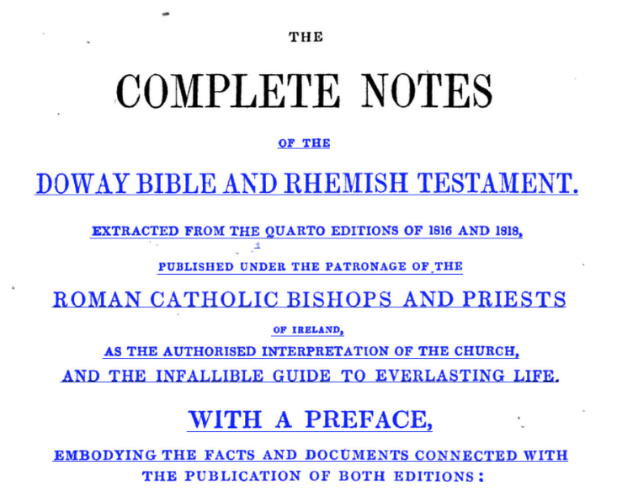

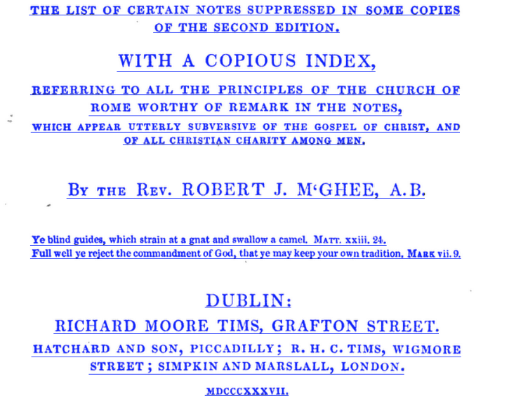..

..
Bandon

Rev. John England, P.P., prominent Bandon family one of whom late 18th century Archbishop of Charlestown, South Carolina
Rev. James Mahony, late P.P
James Kearney, Esq., KIlbrittain, probably related to Kearneys/Rochfords of Garretstown
John Reen
Timothy Murphy
Michael O’Meara
W. McCarthy, Macroom

Clonakilty

Jeremiah Donovan
Patrick Fortune
Timothy Hayes (or O’Hea?)
John Donovan
Timothy O’Brien
Timothy Warren
Jeremih Hanglin

Kinsale

Rev. Dominic O’Gara, near Kinsale
Thomas Rochford, Esq., may be Garretstown Kearney descendant who converted to Catholicism and caused consternation over family nomination of Minister which necessitated special Act of Parliament
Laurence Hayden
Thomas Hackett
Timothy McCarthy
Jeremih Callanan
Daniel Ryan
Patrick ogan
Nicholas Kennedy
John Coleman
Richard Hussey, school
Daniel Sullivan
Mrs O’Brien
Eugene Daly
David Hogan
Mark Donovan
Michael Daly
Patrick Hurly ( as spelled)

Ross

Rev. J. Mullowney, P.P.
John Smith
George Witcherly
B. O’Brien
William O’Hea
James Collins
Daniel Mullowney
John Smith

Skibbereen

Rev. John Power, Balaholo
Sampson Jervois, Esq., probably Brade
Jeremiah O’Driscoll
Maurice Murphy
James McCarthy
Mrs. Ellen Sullivan
Cornelius O’Sullivan
James Uniacke

...

