..

..

Fiants

A fiant was a writ issued to the Irish Chancery mandating the issue of letters patent under the Great Seal of Ireland. The name fiant comes from the opening words of the document, Fiant litterae patentes, Latin for "Let letters patent be made".[1]

Fiants were typically issued by the chief governor of Ireland, under his privy seal;[2] or sealed by the Secretary of State, who served as "Keeper of the Privy Seal", just as the English Secretary of State did in England.[3] Fiants dealt with matters ranging from appointments to high office and important government activities, to grants of pardons to the humblest of the native Irish.[4] Fiants relating to early modern Ireland are an important primary source for the period for historians and genealogists.[5]

The Tudor fiants were especially numerous, many relating to surrender and regrant.[2] A fiant often provides more information than the ensuing letters patent recorded on patent rolls.[6] There are also fiants for which the patent roll does not list any letters patent, either because none were issued or because those issued were never enrolled, through accident or abuse.[7]

Prior to the Act of Explanation 1665, letters patent were enrolled (if at all) after they were granted; under the act, the fiant was enrolled first, and the letters issued afterwards.[8] Thereafter the rolls, which were catalogued in the 19th century, give the same information as the original fiants.
The Public Record Office of Ireland (PROI) held Chancery fiants from 1521 (Henry VIII) up to 1891 (Victoria),[2] as well as Crown and Hanaper fiants (1619–1873),[9] Privy Council of Ireland fiant books (1711–1832),[10] and Signet Office (Chief Secretary for Ireland) fiant books (1796–1830).[11] The originals were destroyed in the 1922 explosion in the Four Courts. The fiants of the Tudor sovereigns had been calendared and published from 1875–90.[12][13] An 1820s manuscript calendar of the fiants of James I and Charles I is available in the National Archives of Ireland.

..

..
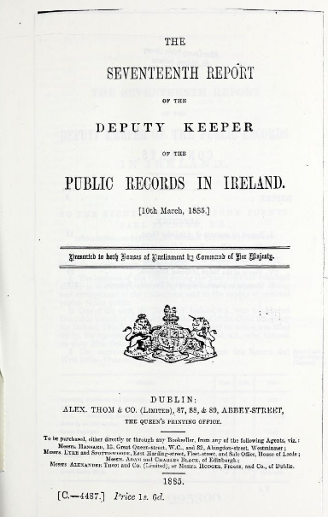..
..

….

A husbandman in England in the medieval and early modern period was a free tenant farmer or small landowner. The social status of a husbandman was below that of a yeoman. The meaning of "husband" in this term is "master of house" rather than "married man".

Land Measurement 10 acres - 1 Gneeve; 2 Gneeves - 1 Sessiagh; 3 Sessiaghs - 1 Tate or Ballyboe; 2 Ballyboes - 1 Ploughland, Seisreagh or Carrow (Carew); 4 Ploughlands - 1 Ballybetagh, or Townland; 30 Ballybetaghs - Triocha Céad or Barony.

Óge, Young, junior

Ny/Nyn, daughter

Rowe possibly Rua, redhead

In England yeoman as "a commoner who cultivates his own land" is recorded from the 15th through 18th centuries. Yeomen farmers owned land (freehold, leasehold or copyhold). Their wealth and the size of their landholding varied.

..

Tudor Fiants
Published in Featured-Archive-Post, Features, Issue 4 (July/August 2015), Volume 23

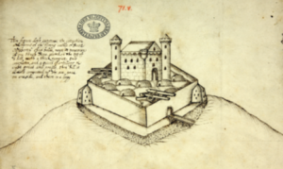
A 1590s image of Burt Castle, Co. Donegal. (NAI)
Digitisation has transformed how we practise family history. There are over 120 million Irish historical records on-line. It is now possible to trace and document Irish families to a much earlier date. This has led to renewed interest in early modern records, 1500–1700. One series of particular interest and use to family historians are the Tudor Fiants.
A ‘fiant’ was a warrant by the deputy or council to the Irish Chancery to prepare letters-patent—published written orders to convey a right, an office, title to property or a pardon. The Fiants are statements of command. The term comes from the first word of the customary opening protocol in these documents: Fiant litterae patentes (‘Let letters patents be made’).
The Irish Fiants don’t survive as a series until Tudor times. (The medieval chancery warrants have survived in sufficient quantities that Irish fiants are one of the ‘categories of substitute material’ used by TCD’s CIRCLE project to reconstruct the rolls of the medieval Irish Chancery.) From 1875, Calendars of the Irish Fiants from 1521 to 1603 were published in the Reports of the Deputy Keeper of the Public Records Office. In 1994 this material was compiled into four volumes and re-published as Irish Fiants of the Tudor sovereigns (De Búrca, Dublin).
Even though the Tudor Fiants are widely available to researchers, they remain an under-used source. Yet they provide detailed evidence for family historians who want to trace Gaelic and Old English families, or to delve into the origin and history of family names and place-names in Ireland.
The Tudor Fiants contain over 120,000 named individuals in Ireland, and provide additional corroborative detail, including status or occupation and usual place of residence. The level of detail recorded in each fiant makes it possible to trace individuals and to identify place-names often to within a present-day parish or barony.
The Fiants document the population beyond the ‘body politic’ of gentry and aristocracy. Coverage is mainly, though not exclusively, of adult men. In addition to the great families that are documented in other sources, the Fiants include aldermen, merchants and artisans in the towns, and yeomen and husbandmen in the countryside. While some fiants include the names of men described as cottiers and labourers, as a rule of thumb these were usually encompassed in the catch-all phrase ‘all other persons inhabiting the country’.
In the late 1500s we find a huge increase in the number of Fiants for Pardons issued. Evidence suggests that these lists of names were compiled from schedules of followers sent in to the council. When you find a name relevant to your research, always look to see who else is in the same group. Researchers can use this evidence to recreate factional groups within a lordship, as well as the lord’s own following, including his military retinue of gallowglass, kerne and horseboys. A particular feature of the Fiants for Pardons is the use of double and even treble patronyms in personal names, to identify the named individual’s grandfather or great-grandfather. With this detailed evidence, it is possible to separate out an individual from his doppelgänger, even when they have a common Christian name. Researchers can also construct distinct lineage groups within an extended family.
Kenneth Nicholls has made extensive use of the Tudor Fiants to recreate family histories of Irish lordships, including Kavanagh and MacCoghlan of Delvin. Nicholls is the only person I’m aware of who has used the Fiants to document individuals moving between different townlands within a joint-lineage landholding (The O’Duinn Manuscript, Irish Manuscripts Commission, 1983).
Calendars of Fiants for the reigns of James I and Charles I were also compiled, but never published. Handwritten copies of these Calendars are available in the National Archives of Ireland. These later series of fiants use a lot of textual contractions and require some interpretation.
Fiona Fitzsimons is a director of Eneclann, a Trinity College campus company, and of findmypast Ireland.
'

..
1560, Fiant 321, John Galway, Gent., Kinsale
..

1585, Fiant. There are pardons to O'Hurleys of Bealnacarriga in 1585, 1601, and in 1641 Randal O'Hurley and his father were attainted. Catherine Collins or Cullinane was the daughter of McCarthy Reagh's physician. - Cork Journal. 1906. p.27. Photo. This castle and Ballinward were built by the Hurleys or O'Murrilys. - - Page 02. BALLINACARRIGA. - Cork Journal. 1906. p.27. In 1517 there was a John O'Murrily, Abbot of the parish of Myross. In 1490 an O'Hurily was Sub-Prior of the Franciscan Convent in Youghal. The Hurleys intermarried with the De Courceys and the Fitzgeralds. P.76. The name means "the mouth of the rock".

1565, Fiant 762, John alias Shane McCoghlan, Cloghan

1567, Fiant 1019, Commission to Sir (-) Coursy Lord Coursy, (Lord Kinsale, to execute martial law under is rule.

1567, Fiant 1010, Donogh McCarthy Reagh Knight and Captain to execute martial law in Carbery

1567, Fiant 1025, Kinsale Friars

1567,Fiant 1043, Crohoure O’Donovan, husbandman

1567, Fiant, 1084, Pardon, Dermot and Donogh McDonnell of Enniskeane

1567, Fiant 1578, Donagh McCarty alias MacCarty Ryegh Kilbrittain.

1567, Fiant 2781, John McDonoghue McDermody McCarthy Britvilleston

Fiant 1299, Kilgobbin
..
1562 Hanged in Cork, Fiant 2196, Rosbrin

1570, Fiant 1545, Grant to John Thyckepenny, Gent., of the Office of Controller, customer or collector of wine duties in Cork, Youghal and Kinsale

1570, Fiant 1580, John McCoghlane, Gent., Arthur McCoghlan, Cloghane

1570, Fiant 1587, Pardon to Donagh McCarthy alias McCarthy Reagh of Kilbrittain, Co. Cork, Knight, Egidius or Owen McCarthy of Donanyne, Florence O’Mahony alias O’Mahony Carbery of Castle Mahony and Florence O’Mahony his son. Fine £30.

1571, Fiant 1850, Pardon to Patrick Meghe (Meade) and Richard meaghe of Kinsale Co. Cork, merchant, for iding the rebel, James FitzMorish.

1572, Grant to Thomas Philpot of Cork of the Office of Searcher and gauger of the Ports of Cork and KInsale. To hold during pleasure with accustomed fees.
..
1573, Fiant 2196, Edmund McSwyne Rossbrin, in Carbery, Colly McEdmund McSwyny, Brian McEdmund McSwyny, Owen McBrien Ygshiddy, Owen McOwen McBrien Yghashidy, Downe McOwen McBrien Yghashidye, Owen McConaghy McConchor J. Donnel, John O’Shirine McTirrelagh, Tirrelagh McShane I Hiren, Melaghlin McTirelagh I Hyryne, Hugh M. Gynillye, Owen McGynillye, Edmund McGynillye and James Buoy Melaghlen I Daly. Fine, 60 good fat cows.

…. Fiant 2242, Cloghane or Lissangle Castle, Caheragh. This belonged to the Clan Dermod McCarthys who also held Kilcoe.

1573, Fiant 2264. Conogher O’Crowly, Yeoman, Molaghe David Óge McDa O’Herlyhy Conogher McDavid and Shane McDa O’Hiherly, Ballyvickydy
..

1573, Fiant 2198, Pardon to Eady Moel Barrie of Kinsale, Co, Cork, Husbandman, William Leary of Same. mariner, and Conchor McDermot M. Bruny of Ballentymore, Kern, fine 40 shillings each.
..
1573, Fiant, 2242, Cloghane, Caheragh

…. Fiant 2249. Rathvarigg is Rathbarry, Lyssycromyn- Lissycremin. Aghe Dullane near Ring, Clonakilty. Downeowrligg-Dunworley.

1573, Fiant 2268. Grant to Nicholas Walsh, Gent., of the Wardship, marriage and custody of the lands of Philip, son and heir to John Roche, late of Kinsale, Co. Cork, merchant. To hold during his minority at a rent of 2 shillings per annum. Fine £10 16 shillings 9 pence

1573, Fiant, 2270. Pardon to Cormock don McCartye of Downenenwy (Dunmanway), Gent., Teig McDermody of Manlytamghaire, Donogh McDermody of same, Teige O’Collan of Malyghanys, Dermod O’Cullan of same, Donald McDermody of Toghir, Teige McShane of Barny-nban, Conoger Morrey of same, Dermod McFlynn of same, Conogher Og O’Cullan of Downmenwy, Donogh McCormyck of Powlytwohill, Donald McConogher O’Culane of Dounmenwy, Conogher McDonill I Cullane of same, Auly McRykard of Clannywollyn, and Fynyn McDonill of Downmenwy, yeomen, Teig O’Cullan, tailor, David Crowley of Kiltllwag, Gent., Conogher O’Cruoly of same Gnnt., Teige O’Mahowny of Tunagh, Conogher O’Mahoune McMorieragh and Karagh McFlynn of Tawny, Gentlemen, Dermot Oge of Lisbyaly, yeoman, Karagh McDonagh of Twonykly, yeoman, and Fynyn McCartie of Kyllahowerr, Gent., Fine One fat cow each.

.. Fiant 2317, Ballydowan in Barry Rowes country is Ballyduvane west of Clonakilty.

1574, Fiant 2382. Confirmation of a decree of the President and Council of Munster decreeing to Connell O’Driscoll, the Proctorship or Office of Economy of the Cathedral of Ross or Rosscarbery, which he held or life by deed from Dermot, some time Bishop, and the Chapter of Ross. The decree and pleadings are set out in full. O’Driscoll appeared by his attorney Marcus Walshe. Was answered by the defendant, Owen McCarthy, by his attorney Rowland Powell, who pleaded a previous title through Sir Donogh McCarthy, Knight. The case came before Sir John Perrott, Lord President of Munster, Matthew Bishop of Cork, and Nicholas Walshe, Second Justice of Munster on the 13th November 1773 and a decree was given to the plaintiff, for default of the defendant in the proceedings, Thomas Burgate was Clerk of the Council of the province of Munster.

1574, Fiant 2412, Pardon to Thomas Philpot of Cork, Gent, Searcher and Gauger of Cork and Kinsale.
..
1574. Fiant 2740. Hearing before Sir John Perrott, President of Munster, Matthew Bishop of Cork, Nicholas Walsh, 2nd Justice, Munster. Claim by Cornell O’Driscoll to Proctorship of Ross Cathedral and Office of economy represented by Maurice Walsh opposes by Owen McCarthy his counsel Rowland Powell. Cornell O’Driscoll confirmed. Clerk to Council of Munster Thomas Burgate.

..
1576, Fiant 2862. Commission to William Drury, Knight, Lord President of Council of Province of Munster .. James Dowdall, Esq., Second Justice of the chief place, Nicholas Walshe, Andrew Skiddy, Esq., John Myagh, Esq., Henry Davells and William Aspley Esquires to the Commissioners for the whole Province of Munster, and in it crosses and marches, adn in the counties of Carbery, Bantry and Desmod, and all places south and east of the River Shenon (Shannon). To muster and array the inhabitants; to cess them for defence of the country, fining and imprisoning those who may be disobedients, to treat with enemies and rebels of the Province, grant safe conducts and conclude terms at discretion and compel the observance of such terms.. To raise the inhabitants and punish rebels and enemies with fire and sword, the Lord President to command the forces in the field in the absence of Deputy, and do all things as contained in instructions to Deputy dated 1573

1577, Fiant 3033. Thady McDermot O’Crowly, (Balhine McCrahie, Cork). Cahill O’Doniwanene, Kern

1577, Fiant 3036. Cornelius McTeige O’Donevan, Cloghtradevlly

1577, Fiant 3038. Florence O’Crowly

1577, Fiant 3039. David O’Crowly, Dromunticlohjie

1577, Fiant 3096. Teige McDermot I Croly, Gent., (Feale, Cork)

1577, Fiant 3096. Conor McTeige McAwloey O’Crolwy, husbandman, (Towneyne, Cork)

1577, Fiant 3103, John O’Heirlehey Ny Baghlen, Yeoman, Baneduff, Cork, (Benduff, Clonakilty?)

1577, Fiant 3150. Pardon O’Regan, O’Donovan.

Of this John T. Collins wrote in 1939 that Knockmockfyne was a townland in Ross then obsolete. It is included in Tranalong and Ballinaclogh. Ricard is used as a name in the O’Donovan, O’Regan an Burke families. Charles McCarthy Reagh forfeited Tralong and Knckmuckfinny in 1641. Teige McShane O’Regan forfeited Ballynacloghagh and Daniel Óge O’Regan, who was pardoned by King James 2 of England for his heroic defence of Charlemont Fort was of this stock.

Remarkably the claim of the O’Regans to be restored to their estates succeeded in Chichester House c 1705. Sir Teague O’Regan of Balltnaclohy and Gortniglogh, Killeenlea, near Leap, Carbery West Cork, Temporary holding of lands from 1615 by Sir Walter Coppinger, loss by forfeiture and subsequent restoration under Articles of Treaty of Limerick 1690, later family including fashionable Dr. O’Regan of Mallow and Legal Luminaries, friend of Daniel O’Connell. Estates finally sold by descendants Cork Cagney family early 20th century to tenants. Some of the extended later family prominent in law or as Harley Street, London specialists.

1577, Fiant 3152. Donogho McConoghor I Morroughrowe, of Gortene Fehe, Bantry, Gorthafahane, Kilcrohane?)

1578, Fiant 1578. Lease to James Hayden, Gent., of the site of the house of the begging friars at Baltimore called the Monastery of Iniscircan with two gardens and a close adjoining. Lease fro 21 years at a fine of £26 8 shillings.

1578, Fiant 3225, Surrender James Galwey, Gent., Kynsale of the Rectory of the Church of Kinsale held under lease No. 321 later Fiant presumably to him No 3237 names James Galweye, Gent., of the Rectory parcel of the possessions of the Monastery of Bath in England for 21 years at a rent of 30 shillings, fine 30 shillings.

1583. Fiant Lease to James Galwey of Limerick, Gent. of the rectory of Kinsale, Co. Cork the tithes and alterages due on the vicars excepted. To hold for 40 years from the determination of Fiant 3237, rent 30 shillings.
..
1578. Fiant 3283. Lease to Connager alias Connor O’Mahowne, Gent., of the Manor and Castle of Rossbrin, near the sea in Co. Cork, and a carew and a half of land and the lands of Illanicumuste, Illemuck, and Capagheglas Dyreconnall the Raheen nd Shenetullaghe, Killaspick Oen, and Gurtneroe being seven and a half carews, the demesne lands of the Manor, Co. Cork, possession of Donnell McCanoagher O’Mahowne attained. To hold for 21 years. REnt £8 17 shillings. Maintaining two English Horsemen. Illancumuste is probably Ballycummisk (Baile Cum Uisce) although there is a theory that it was Horse Island. Illemuch is Filemuck, Capaghelas is Cappaghglass (Cappagh), Dyreconnall is Derryconnell, Raheen is Raheen, Shentullaghe is Shantullaigh(sp?), Killaspick Oen is Stouke (Stuaic an Easpaigh), Gurtneroe is Gurteenroe.

1578, Fiant lands at Kilcrohane lately occupied by O’Dalys Rhymers give to Ormonds.

Fiant/Grant No. 3469 of Elizabeth 1 of 1578 he also shall execute commands of the President of Munster. He and all the inhabitants shall attend the president of Munster when required for the Queen’s Service.
.

1579, Fiant 3535

Pardon to Edmund Fitz John Oge Gibbon, of the Garraldines of Ballylondre, Co. Cork
Edmund McSywny of Beallyheimore, Collne McEdm. McSwyney of same.
Terrelgh O’Gorumley, Fynyn ro McDonaghe O’Sullivane of same.
John McCornell O’Shirin of Kilbrittain.
Thady McCornell O’Gallivain (Galvin?) of Ballihimore, Dermot McFynye O’Mahowny of Creggyn, Donald Oge McDonnell McCartie of Brahillise (Brahalish, Durrus), Donald McFynyne O’Mahowny of Castllemahowne (Castlemahon later site of Lord Bandon residence), Cornelius McTeigeO’Mahownyof Kilpatrick, Phipllip McDonell O’Coghlae of Castllemahowne, John McTeige of same, Thady McDermod McFellem of Durrynenallyn Dermod McRickird McDonnell O’Regaine (O’Regan) of Killynalea; Donald McOwen McDonogh O’Dalie of Montirewarie (Kilcrohane), Thady McDonoghe les O’Muirhillie (Hurley) of Fiall, Dermod McPhilip Oge O’Fihillie of Beldwillen, same co. Donogh Roe McDonoghue Lea O’Muirhille of Fial, Donoogh O’Henrighane of Dwenemowey, Gilliachtyne McCornell O’Hannghane of Dwemoenweie and Donlad O’Dihiertie of Currynelline, yeomen, Herry Browne of Knneal and Patrick Roche FitzPhillip of same merchants, elaghelus O’Sheren of Shepeton, husbandmena fine of 20 shillings. 1579.

1579, Fiant. Lease 1597 for 21 years to Henry Devell, Esq., of various properties, mill, salmon weirs, recories, tithes including Rectory of Kilmccomogue. Rent £5 English and paying Fynine McCormack, late Prior a pension of £4 15 shillings 4 pence English. Fine £6 13 shillings 4 pence.

1579, Fiant 3554. Pardon to Owen O’Swllivan of Berehanen, Knight, Fine 20 shillings at the suit of Lord Barry.

1579. Fiant … John and Ellen Shiegan of KInsale. Tho Lavellan of Cork

1578, 3283 Rossbrin attained

1583, Fiant 4111. Pardon to Michael Browne of Kinsale, Conor of Kyf, Tho FitzEdmond of Br
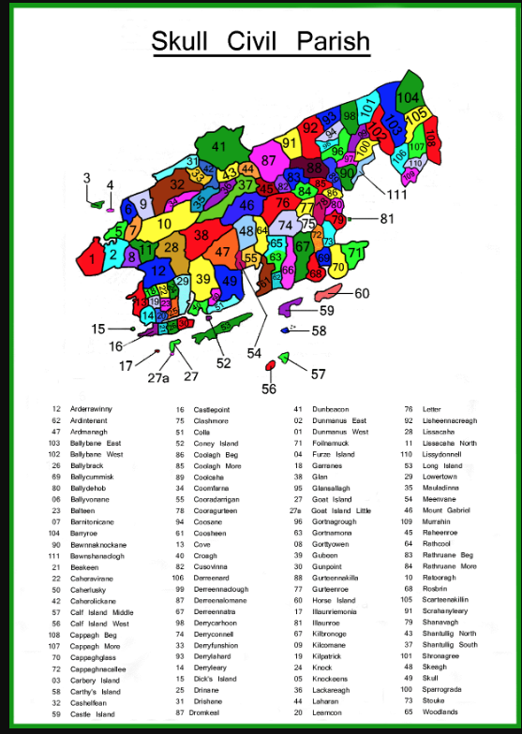..

..
1583. Fiant 4227 Lease To Stephen Water, Cork Gent., and Rob. Coppinger of same merchant of the impost on wine imported at Cork and Kinsale and the havens belonging to them. Rent £550 english , receiving allowances for any wine wne admitted free by warrant of the deputy.

1583. Fiant Lease to James Galwey of Limerick, Gent. of the rectory of Kinsale, Co. Cork the tithes and alterages due on the vicars excepted. To hold for 40 years from the determination of Fiant 3237, rent 30 shillings.

Fiant 4414, Curragh ne Lecky Conoghor McShane Y Morillalias McShane Y Phadyn. Fargan-quyrry

1584, Fiant 4415. Pardon to Fynys O’Driscoyll of Downeshed, Knight, Conoghor Boy O’Driscolyy of same Gent. MacCon McDermod O’Dryscoill of same, Kern. Donell McDermod McBryn of same. Conoghor McDermod McBrian of same, husbandman.
Fymyn McConoghor Mc Da O’Mahon of Leamcon and Fynyn O’Driscoyll of Ryncowlisky, Gentlemen.
Owen Filde alias O’Fihily of BallymacRowan, Donogh glasshulaigh O’Mahon of Kenalbeick, Dermod McFlynyn McTeig Y Mahony of same and Teig McDermod McFynyn Y Mahony of same Gentlemen., Dermod O’Callighan of same, Owin McFynyn McDonogh of Carribry.
Teig O’Hingerdell alias O’Hungerdell of Bantry

Fiant 4416, Pardo to Teig McDermod McCormock, McCartie alias Teige O Norse of Downeboy, Gent, Conogher Croe McDermod I Cullaine of same, Donogh McTeig Y Lihan, alias Guluggah of same,Donogh McCormock, Gaingach McCartie of same, Kern.
David Nase, Donell McTeigIllihan alias Ballaigh, hisbandman, Teig O’Cullaine of Cappagh, Gent., Dermod O’Cullayne and Donell O’Cullayne of same, Kerns.
Conoghor McBrian O’Daly of Cappagh, Kern

1584, Fiant, 4421, Dermod McShane McHurryly and Donnell Row McTeige McQuyne Y Hurrily, Kerns, Bealnacrriggie, (Dunmanway)

1584, Fiant 4489, Ranell (Randal) Óge O’Hurley, Bealnacrriggie, (Dunmanway)

1585. Fiant 3469. Sir Owen McCarthy alias The McCarthy Seneschal or Captain of Country of Carbry or McCarthy Reoghs country

..
Fiant 3305 Lesee of Monastery of Skerkin James Haydon? Rosscarbery, mentioned in Fiant 3696, issue Papal Mandate 14 Kal 1446, Licensed Fyneen O’Driscoll of Ross to build in his territory house of God, St. John the Baptist for Friars Minor of the Observance
..

..
..
1579, Fiant 3354, pardon to Owen O’Swllivan, Berehaven, Knight, fine 20 shillings a number of other North Cork names at suit of Lord Barry.
..
……….
1584, Fiant4552. Ellen Ny Crowly

1584, Fiant 4416, Teig McDermd McTeig I Coughlan, Adrytynain (Ardtennant, Schull?)

1584, Fiant4552. Fynin McTeig Y Crowly, (Kinelly, Cork)

..

1586, Fiant 4848, Philip Buy McDonogh McConnoghor O’Coughlan, Horseboy, Kilbrittain.

1586, Fiant, Tho. Hurley, Horseboy, Cork

..
1601. Fiant. Ardraly (Irish: Ard Ráile) is a townland located in the Barony of West Carbery, in County Cork, Ireland. Archival records of 1601 list Ardrawly from the Calendar to Fiants of reign of Henry VIII.[1]
...
1590, Fiant 5456, Fining McDonnell Mccarty, Drimoleague.

1591, Fiant5688. Conohor McDermod I Crowly, (Carrignicorrie, Cork)

1600, Fiant 6431, Ellen Ny Hierlehy wife of Donogh McDermody Cartie, Currynoedy, Cork

1601, Fiant 6539, Shane McRanell I Hierleighey, Illoinnasnaghe, Cork ,

1601, Fiant6533. Edm. O’Croly (Croleston)

1601, Fiant 6571 Conoghor McDermod Y Donevan

1601, Fiant, 6515 Donell Roe McConoghor O’Donevane, Castledonovan

1602, Fiant6764. Dermod Croly, horseboy, (Kilcrea, Cork)

..

..
P. 204

McDermody McConnaghor Y Mahowny of Fearinm’keanebowy,
Morris McRob. Bottymer of same shoemaker.
Philip Tredyne of same husb., Connoghor Rowe O’Hallishy, of same, yeoman.
Connoghor O’Mahowny, of Culefady, Gent.,
James Tredyne, and Donell Mc Tho. Y Kanife o same, husbandmen, Ellen Tredyne his wife
Shane McDa McShiames Ard, and Donogh Mahowne O’Moroghowe of same husbandmen
Fynen McConnoghor McDonnell Y Mahony of Gurtynymahowny
Shane McDoonogh Y Morihie of Callotre, yeoman
Owen Feilde of Knockygircane, Chirurgeon, Morris McShane Feilde of same.
Shane McConoghor Y Kannife of Brittas, husb, Margaret Dorrife his wife
Conoghor McShane Y Kannife of same, yeomen
Donell O’Mahowny alias Donell Dorigh, of same, husb. Donell McDonogh Oge Y Mahowny of Fynagh, Teige McConnoghor O’Mahony alias Teige ny Sawny of same, gent. Onory ny Cuniffe, his wife
Connoghor McDonell McConoghor O’Mahowny, of same, gent.
Rich. Tredine of me yeoman.
Philip Tredine of same labourer, Dooagh McDonnell McDonogh Oge Y Mahowny, of same , Gent. Teige McDermie

..

1578. Fiant 3283.
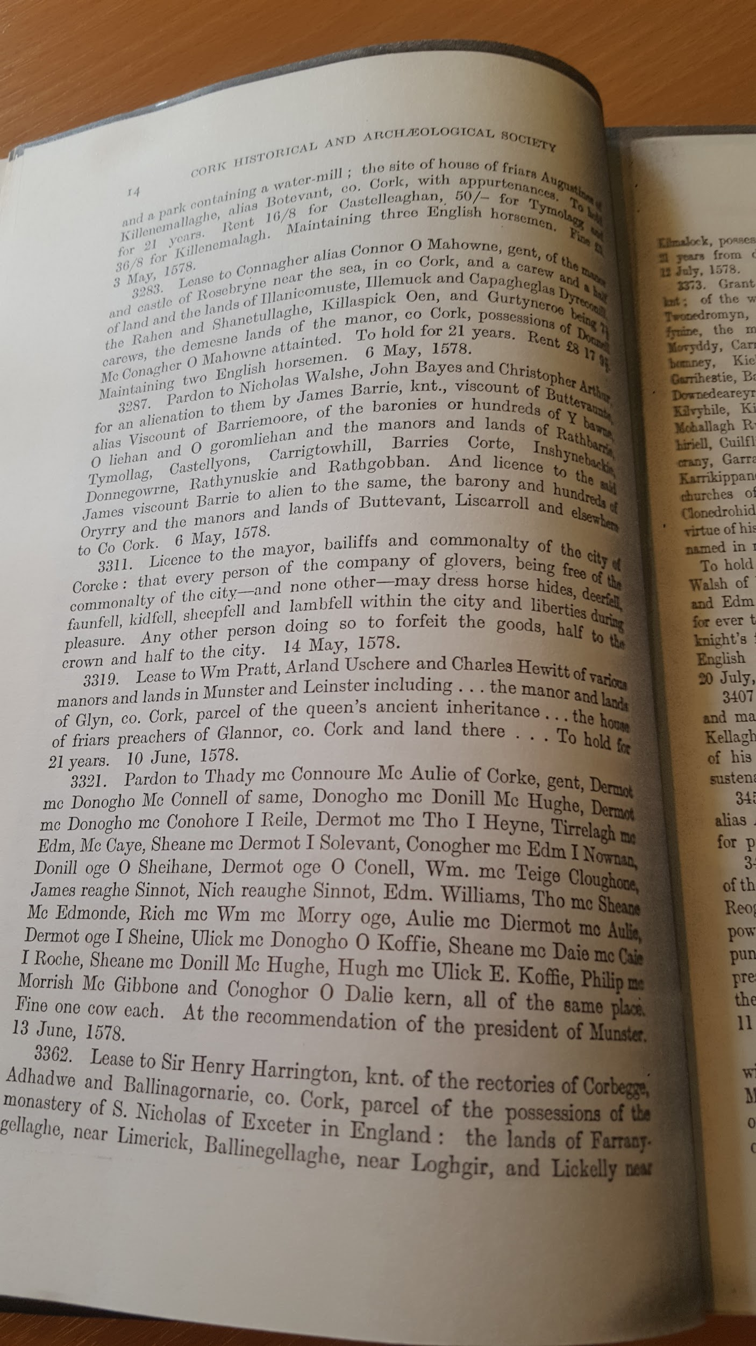...

1585. Fiant 3469

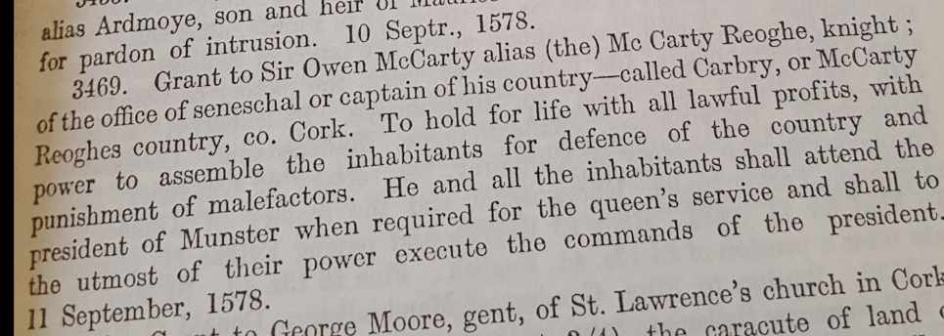
..

1579, Fiant 3535.

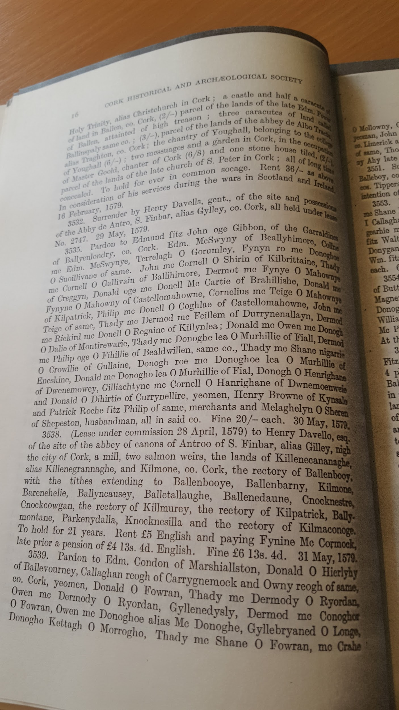..

..
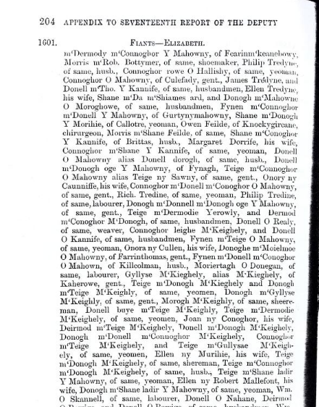
..

P.215
Oge McCridane, Ellis Slabbagh, Edom. (Edmund) fitz David, Conoghor McDonogho O’ Mulpatrick, of same, Richard Prior, of Clone, David McMahowne Molly, of Killhagleragh, Twohill O’Mally, of Aghemarten, Morice McOwen Y Douglea of Gartin, Dermod McShane O’Moher of Ballincorsey, and David McShane O’Moher of same, Provisions as in 6497 - 14th May, xL11 (Cal.P.E. p. 57)

..

..
P. 215

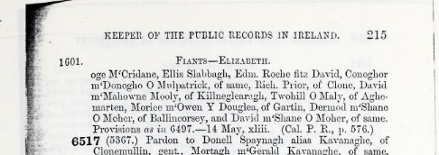..

..

..

1521-1603 Fiants
The Irish fiants of the Tudor sovereigns during the reigns of Henry VIII, Edward VI, Philip & Mary, and Elizabeth I (4 vols., Dublin: Edmund Burke, 1994; NLI Ir 94105 I 1). These documents, unique to Ireland, were created to facilitate the issuing of royal grants and were originally published as a series of appendices to the Reports of the Deputy Keeper of Public Records in Ireland in the late nineteenth century. For many of those Irish chieftains who submitted to English authority under the policy of surrender and regrant, they give long lists of extended family and followers.

..
Fiants of Edward VI, relating to County Cork. Main Author: White, J. Grove Maj. Citation: Journal of the Cork Historical and Archaeological Society , Ser. 1, Vol. II, pp. 250-253, 1893 Format: Journal Article Published: 1893 Subjects: Grove White, James > Col.Public Record Office > Dublin
Fiants

,,
Fiants ‘Calendar of fiants of Henry VIII … Elizabeth’. In PRI repts D.K. 7–22. Dublin, 1875–90. Reprinted as The Irish fiants of the Tudor sovereigns … . 4 vols. Dublin, 1994.

Fiants of Henry VIII relating to County Cork.
Main Author: White, J. Grove Maj. Citation: Journal of the Cork Historical and Archaeological Society , Ser. 1, Vol. II, pp. 229-231, 1893
Format: Journal Article
Published: 1893 Subjects: Grove White, James > Col. Public Record Office > Dublin

Fiants of Philip and Mary relating to County Cork.
Main Author: Grove White, James Col. Other Authors: Grove-White, J. Maj. Citation: Journal of the Cork Historical and Archaeological Society , Ser. 1, Vol. III, pp. 57-58, 1894 Format: Journal Article
Published: 1894 Subjects: Grove White, James > Col. Public Record Office > Dublin

1890 Public Records Office Elizabethan fiants D-Z. http://www.wexfordtown.ie/files/9095-1.pdf

..

Year | Report No. | Appendix No. | Command  paper | Reign | Dates | Fiant Nos.
1875 | 7th | App X | C. 1175 | Henry VIII | 1521–47 | 1–548
1886 | 18th | App VI p.147 | C. 4755 | Henry VIII | 1521–47 | 64a..548 [6793–6797]
1876 | 8th | App IX | C. 1469 | Edward VI | 1547–53 | 1–1257
1886 | 18th | App VI p.148 | C. 4755 | Edward VI | 1547–53 | 159a..1147a [6798–6807]
1877 | 9th | App IV | C. 1702 | Philip and Mary | 1553–58 | 1–276
1886 | 18th | App VI p.149 | C. 4755 | Philip and Mary | 1553–58 | 277–279 [6808–6811]
1878 | 11th | App 3 | C. 2311 | Elizabeth | 1558–70 | 1–1614
1880 | 12th | App V | C. 2583 | Elizabeth | 1570–76 | 1615–2935
1881 | 13th | App IV | C. 2929 | Elizabeth | 1576–83 | 2936–4253
1883 | 15th | App I | C. 3676 | Elizabeth | 1583–86 | 4254–4935
1884 | 16th | App II | C. 4062 | Elizabeth | 1586–95 | 4936–5973
1885 | 17th | App IV | C. 4487 | Elizabeth | 1596–1601 | 5974–6564
1886 | 18th | App VI | C. 4755 | Elizabeth | 1601–03 | 6565–6792
1889 | 21st | App III | C. 5835 | Elizabeth | 1558–1603 | Index A-C
1890 | 22nd | App IV | C. 6180.i | Elizabeth | 1558–1603 | Index D-Z
..
..
.

O'Kief Coshe Mang, Slieve Lougher and Upper Blackwater in Ireland. Dr. Albert Casey (ed.) Alabama: Knocknagree Historical Fund, 1952-1967. 13 volumes, Fiants of Queen Elizabeth relating to Cork & Kerry 1558-1603. Volume 7, p. 2188-2306.

..

..

Sir Teague O'Regan of Ballynacloghy . Main Author: Healy, Francis J.Citation: Journal of the Cork Historical and Archaeological Society , Ser. 2, Vol. XII, pp. 121-125, 1906
Courtesy Wikipedia
Courtesy John Grenham, https://www.johngrenham.com/browse/retrieve_text.php?text_contentid=22
Re reference to Ormonds they are Butlers. The Butlers (Protestants) had lands in Drimoleague post 1640 https://www.libraryireland.com/IrishMusic/XII-2.php
https://www.corklocalstudies.ie/items/show/3992
https://books.google.ie/books?id=0AyDDQAAQBAJ&pg=PA628&lpg=PA628&dq=fiants+of+cork&source=bl&ots=ixtxPTDuUA&sig=lFOELauw33ybaRcMiZ8Na3lc0ek&hl=en&sa=X&ved=2ahUKEwixnr6ty7TfAhVQRhUIHRrQAk04ChDoATADegQIDBAB#v=onepage&q=fiants%20of%20cork&f=false
https://books.google.ie/books?id=0AyDDQAAQBAJ&pg=PA628&lpg=PA628&dq=fiants+of+cork&source=bl&ots=ixtxPTDuUA&sig=lFOELauw33ybaRcMiZ8Na3lc0ek&hl=en&sa=X&ved=2ahUKEwixnr6ty7TfAhVQRhUIHRrQAk04ChDoATADegQIDBAB#v=onepage&q=fiants%20of%20cork&f=false
https://books.google.ie/books?id=0AyDDQAAQBAJ&pg=PA628&lpg=PA628&dq=fiants+of+cork&source=bl&ots=ixtxPTDuUA&sig=lFOELauw33ybaRcMiZ8Na3lc0ek&hl=en&sa=X&ved=2ahUKEwixnr6ty7TfAhVQRhUIHRrQAk04ChDoATADegQIDBAB#v=onepage&q=fiants%20of%20cork&f=false
https://books.google.ie/books?id=0AyDDQAAQBAJ&pg=PA628&lpg=PA628&dq=fiants+of+cork&source=bl&ots=ixtxPTDuUA&sig=lFOELauw33ybaRcMiZ8Na3lc0ek&hl=en&sa=X&ved=2ahUKEwixnr6ty7TfAhVQRhUIHRrQAk04ChDoATADegQIDBAB#v=onepage&q=fiants%20of%20cork&f=false
The West Cork Crowleys are a Sept of the Roscommon McDermotts came south as mercenaries.
https://books.google.ie/books?id=0AyDDQAAQBAJ&pg=PA628&lpg=PA628&dq=fiants+of+cork&source=bl&ots=ixtxPTDuUA&sig=lFOELauw33ybaRcMiZ8Na3lc0ek&hl=en&sa=X&ved=2ahUKEwixnr6ty7TfAhVQRhUIHRrQAk04ChDoATADegQIDBAB#v=onepage&q=fiants%20of%20cork&f=false
https://books.google.ie/books?id=0AyDDQAAQBAJ&pg=PA628&lpg=PA628&dq=fiants+of+cork&source=bl&ots=ixtxPTDuUA&sig=lFOELauw33ybaRcMiZ8Na3lc0ek&hl=en&sa=X&ved=2ahUKEwixnr6ty7TfAhVQRhUIHRrQAk04ChDoATADegQIDBAB#v=onepage&q=fiants%20of%20cork&f=false
https://books.google.ie/books?id=0AyDDQAAQBAJ&pg=PA628&lpg=PA628&dq=fiants+of+cork&source=bl&ots=ixtxPTDuUA&sig=lFOELauw33ybaRcMiZ8Na3lc0ek&hl=en&sa=X&ved=2ahUKEwixnr6ty7TfAhVQRhUIHRrQAk04ChDoATADegQIDBAB#v=onepage&q=fiants%20of%20cork&f=false
https://books.google.ie/books?id=0AyDDQAAQBAJ&pg=PA628&lpg=PA628&dq=fiants+of+cork&source=bl&ots=ixtxPTDuUA&sig=lFOELauw33ybaRcMiZ8Na3lc0ek&hl=en&sa=X&ved=2ahUKEwixnr6ty7TfAhVQRhUIHRrQAk04ChDoATADegQIDBAB#v=onepage&q=fiants%20of%20cork&f=false
https://books.google.ie/books?id=0AyDDQAAQBAJ&pg=PA628&lpg=PA628&dq=fiants+of+cork&source=bl&ots=ixtxPTDuUA&sig=lFOELauw33ybaRcMiZ8Na3lc0ek&hl=en&sa=X&ved=2ahUKEwixnr6ty7TfAhVQRhUIHRrQAk04ChDoATADegQIDBAB#v=onepage&q=fiants%20of%20cork&f=false
https://books.google.ie/books?id=0AyDDQAAQBAJ&pg=PA628&lpg=PA628&dq=fiants+of+cork&source=bl&ots=ixtxPTDuUA&sig=lFOELauw33ybaRcMiZ8Na3lc0ek&hl=en&sa=X&ved=2ahUKEwixnr6ty7TfAhVQRhUIHRrQAk04ChDoATADegQIDBAB#v=onepage&q=fiants%20of%20cork&f=false
https://books.google.ie/books?id=0AyDDQAAQBAJ&pg=PA628&lpg=PA628&dq=fiants+of+cork&source=bl&ots=ixtxPTDuUA&sig=lFOELauw33ybaRcMiZ8Na3lc0ek&hl=en&sa=X&ved=2ahUKEwixnr6ty7TfAhVQRhUIHRrQAk04ChDoATADegQIDBAB#v=onepage&q=fiants%20of%20cork&f=false
https://books.google.ie/books?id=0AyDDQAAQBAJ&pg=PA1744&lpg=PA1744&dq=fiants+Mccarthys&source=bl&ots=ixtxQUIAPG&sig=0Pgm-HO9pBGSPE4CeiKByvF2yTA&hl=en&sa=X&ved=2ahUKEwjL7YHr-bffAhX_RBUIHRKHCvAQ6AEwCnoECAEQAQ#v=snippet&q=hurley&f=false
https://books.google.ie/books?id=0AyDDQAAQBAJ&pg=PA1744&lpg=PA1744&dq=fiants+Mccarthys&source=bl&ots=ixtxQUIAPG&sig=0Pgm-HO9pBGSPE4CeiKByvF2yTA&hl=en&sa=X&ved=2ahUKEwjL7YHr-bffAhX_RBUIHRKHCvAQ6AEwCnoECAEQAQ#v=snippet&q=hurley&f=false
A this stage the O’Doovan held a large part of Carbery, most was lost due to rebellion post 1641. One estate centred at Bawnlahan, remained held by The O'Donovan of whom Daniel converted c 1730. Another branch also Protestant held land around leap these were sold to Lord Riversdale (Tonson/Hull) c 1730. The Castledonovan land were held by the Evansons post 1650mlater disposed of when they moved to Durrus. The Butlers of Drimoleague and the Jervois family had interests in these lands.
1573 James Haydon Provost Marshall Munster, empowered to administer Martial Law. Fiant 2183 of Queen Elizabeth 1 John T. Collins ﻿
The O’Dalys Rhymers and Poets to the McCarthys and O'Mahonys post 1300. Ran a bardic school according to local tradition attended by the sons of the King of Spain.
According to some genealogists the Hurleys migrated from Limerick. John T. Collins who was from the area believed they were local of long standing. It has been suggested that the Protestant family of Hurley teachers and later doctors from Kilmeen are of the direct line from Ballinacarriga Castle.
Sir Henry Sidney writing to the Privy Council from Cork describes the McSwynys as ‘a brood not a little perilous to the province’
Full account by Herbert Gillman in JOurnal of Cork Historical and Archaeological Society, September 1893.
Probably 1573, 1576, 1615 Sir Nicholas Walsh, Chief Justice Common Pleas, 1573. Hearing before Sir John Perrott, President of Munster, Matthew Bishop of Cork, Nicholas Walsh, 2nd Justice, Munster. Claim by Cornell O’Driscoll to Proctorship of Ross Cathedral and Office of economy represented by Maurice Walsh opposes by Owen McCarthy his counsel Rowland Powell. O’Driscoll confirmed. Clerk to Council of Munster Thomas Burgate. 1576. Appointment of Commission for Province of Munster, William Drury, Esq., Lord President of Province of Munster, James Dowdall, 2nd Justice, Province of Munster, Nicholas Walsh, Andrew Skiddy, John Myagh, Henry Davells, William Aspley, to cess the whole Province. Fiant 1862 of Elizabeth 1. John T.Collins 1580 Mr. Justice Walsh repaired to Carbery with Sir Cormac Teigue, Sheriff of County and hanged one of the gallowglasses did the same later in Muskerry.
He was hanged in chain in Cork c 1576 for the murder of his cousin Cormac McFineen McCarthy, who had contested him in the Chieftnship of Gleannachroim. Kitallowe Coill-t-Sealbaigh the O’Crowley territory in the Parish of Fanlobbus (Dunmanway) on each side of the Blackwater (flowing in to the River Bandon near Manch) . c 1457 the poet Donnacha, son of Teige O’Daly, praises David son of Maurice Roche and in recording the raids he took part in states that Coille-Shealbha he made a distant march- John T. Collins.
Tawny is Tawnies near Clonakilty, Lisbaly is Lisbealad near Dunmanway, Twonykyly is Tuath na Coille or Tuath na Coilltche i.e. the tribe land o the wooded country. This district stretched north from Clonakilty. The following townlands are included Tawnies, Youghals, Miles, Templebryan, Skartagh, Garranecore, Knockskagh. As a wedge of Carbery it divided the Barony of Ibane and Barryroe into two parts. Held in the 16th century by a McCarthy Sept possibly connected with those from Cormc na Coille McCarthy. Clonakilty takes its name from this Tuath, Cloghan-na-Coillitche, the causeway or stepping stones of the Tuatha na Coilltche In a grant from James 1 of England to Sir Richard Boyle in 1621 power is given to create the cantred of Twogh-na-Keelty into the Manor of Clonakilty to empark 500 acres for demesne, to appoint a Seneschal, hold fairs and markets.
Later associated with Alleyn family and Evansons of Durrus.
1576 Thomas Burgate Fiant 1576 of Elizabeth Clerk of Munster Council 1574 Office of Collector of Duty at pleasure with fees. 1574 Clerk to Council of Munster Thomas Burgate. John T. Collins
According to John T. Collins, lessee probably a son of Donell McConoghor O’Mahony of Rossbrin who was hanged at Cork in 15632 see Fiant 2196
The Lavellans of Carrigaline ancestors of Puxleys of Berehaven and related by marriage to wife of Timothy O’Donovan, Magistrate and Landlord of Durrus.ONe of the Lavellans and Gould feature in an Admiralty case they were involved c 1580 in continental shipping.
Curraghalickey parish of Drinagh. Curragh ne Lecky Conoghor McShane Y Morillalias McShane Y Phadyn is Cornelius son of John Hurley, alias son of John the son of little Patrick (O’Hurley). Lycerytinglish, is Lettertinlishparish of Castlehaven. Fargan-quyrry denoted individual didn't even have a pot (Chuir, pot or chaldron)
Sir Fineen O’Driscoll of Dunashad or Baltimore heads the list. Ballymacrowan in the Parish of Tullagh near Baltimore. The O’Fehilys were also eminent clerics in the Catholic Church, c1466-1516, Donal O'Fihelly Franciscan Friar, Merton College, Oxford. Born Baltimore. The annals tell us that Donall and Maurice O'Fihelly received tuition in advanced Latin by Finghinn O Mathuna. The O'Fihellys were scions of the O'Driscoll race who hailed from Tuatha Ui Fitcheallaigh which embraces the parish of Ardfield near Clonakilty. C1466-1516, Maurice O'Fihelly, Franciscan Friar, Franciscan College, Milan. Born Baltimore, Lecturer University of Padua, logic, theology, metaphysics, known as 'Flora Mundi', Flower of the World. Elevated to Archbishop of Tuam 1506. The O’Fehilys were also known as the Munitir Ó Hilligh of Ballymaccrown. It's been suggested that some of the Hill families in Carbery derive descent from it. The O’Harringtons of Bantry and Rochfords of Rochfords town outside Cork again feature in this pardon.

