This is a very early working draft pagination and layout will change…

In view of the near total loss of original records any items gratefully received, Pat Crowley

pat25a@gmail.com

Prehistory
Cork Records
Health
Advances from Central Funds
Cess Rates
Baronial Constables
Chief Secretary Papers
Grand Jurors
Listing of Baronial Constables 1863
1780-1860 Grand Jury Returns
1780-1803 Grand Jury Returns
1793-Expenditure including Military
1815 Sample part Presentment Cork City
Grand Juror Attendance major 183301897
Report of Robert Cotter, Secretary 1832
Evidence and Recommendation of Robert de la Coer, Treasurer 1815
1866 Breakdown of County Cess
1786 Resolution re Servants Tips
1840 Provision of Medical Services
Grand Jury Attendances 1837-1899
Staffing, Secretary, Treasurer,Surveyors
County Council 1899
1812 Grand Jury Map Cork
Local Cess Payer Representatives 1834

…

….

Prehistory

The Bridge Act of 1634 made it legal to raise taxes specifically to build or maintain bridges. Up until this period the road systems in Ireland remained a basic network and somewhat neglected. In 1615 the Highway Act introduced a statutory labour system where each parish was required to appoint two parishioners to act as surveyors and each farmer was to send two able bodied men, a team of horses and tools to work on the roads for 6 days a year. While the system worked on the repair of roads its impact was limited. By 1634 the administration passed to County level and was abolished with the introduction of the Grand Jury‟s in 1765.

…
Cork Records

Most of Cork early records were destroyed in a fire at the Courthouse on Good Friday, March 27th, 1891 and with it much of the City’s official records which were stored in the City Treasure and Sheriff’s office. Others were destroyed by the County Council in the 1960s on the move to the new County Hall. In Northern Ireland the PRO has a significant amount of exten records including County Presentent Books for Co. Down. This shows each presentment approved by the Grand Jury and certified such items as the building a new bridges of road works are included. The survival of indictment and presentment books make rather dull reading. The former consist only of the names of prosecutors and defendants in criminal cases, along with the alleged crime and the verdict of the grand jury.

The latter give rather more details. These include details of public works and other projects that received funds from the juries, the sums expended, and the names of those charged with overseeing the work. Occasional entries also record political pronouncements, or highlight local preoccupations with social or economic circumstances.

In both cases the records for each meeting of the court are accompanied by an invaluable list of the names of the grand juror. These can be supplemented by contemporary newspaper reports some of which have now been digitised. Occasionally the 19th century Irish parliamentary records which the University of Southampton have digitalise (eppe project) refer to 18th century Grand Jury records. These lists of grand jurors in combination with other surviving contemporary material, such as estate correspondence and published pamphlets, can give us new insight into both the functions and composition of Ireland's assize grand juries during a crucial period in the country's development.

Local government in early 18th Ireland it is important to acknowledge that those arms of central government which reached directly into the provinces were not conspicuously strong. After the Battle of Boyne in 1690 a faction in Britain proposed to abolish the Army being fearful of the potential threat to Parliament of a strong army. A compromise reached was that a large segment would be garrisoned in Ireland and the cost would be charge on the irish Exchequer. Accordingly a building programme of barracks commenced. would be paid for by the the British Army,

Although the Army largest arm of government, could be seen as essentially a small and often isolated force. Despite having an official establishment of 2,000 men, its effective strength was probably never more than half that, and the implementation of a barrack building programme from 1699 left what troops there were largely confined to the dozen or so garrison towns and a few isolated outposts. While the importance of the military to local economies and the potential influence of the force in disseminating culture modes and values should not be underestimated, it should also be remembered that the official duties they undertook on behalf of the state were limited. Even during major crises, such as the emergence of the Hougher agrarian protest movement in 1712-1713, the actual employment of the military in support of the civil power could be regarded as very much a last resort.he Revenue Service was the

The Revenue Service was the largest civil department. Despite its undoubted importance as a source of patronage and its vital role in filling the Dublin coffers, it employed barely more than I,000 men, and in I715 the salaries of its officers totalled less than £650. Until the Civil Service reforms of the mid 19th century positions such as the Revenue wee in the gift of the powerful political families in the staffing is often the relations or dependant of these families. Often the senior position of these public bodies were sinecures.

Under such circumstances, it was perhaps inevitable that the control and management of provincial Ireland largely devolved on to a number of unpaid local officials and bodies. In urban centres a disparate array of corporate bodies managed affairs In the countryside, some duties were delegated to bodies such as manor courts and parish vestries.

Justices of the peace, appointed by the central government, were charged with various key tasks, but even by mid-century there were fewer than 2,000 magistrates in Ireland, assisted primarily by only unarmed constables. The provision of pension for these constables were a source of frequent representation by the Cork Grand Jury to the Chief Secretary. However, even the powers of Irish justices of the peace were comparatively limited. They never acquired the same powers of summary jurisdiction as their English counterparts, nor did they establish regular petty sessions to deal formally with the minutiae of local business. Nor, apparently, did they exercise the same measure of moral authority.

In Cork an understanding of local administration must be looked at in conjunction with the Magistry. After the consolidation of the British interest in Ireland the control of central authority particularly in remote areas rested with the magistrates generally drawn from the ranks of Planted Landlord families. Even houses built in the early 18th century had defensive features an there is a recurring theme of the threat of insurrection of revolt, revolution.

In 1760 the Lord Chief Baron of the Irish Exchequer could write to his English patron, with some apparent justification, that the vast majority of Ireland's population saw 'very little of government but what they see at the assize. The assizes came to Cork twice yearly a tradition which still continues. Their importance can be gauged at the number of Justices who appear in the Roll of Cork Freemen being made by the City Council from the early 18th century. Until before Independence the procedure adopted on the arrival of the assizes judges was for them to be led into the City from the northern liberties by a dressed military escort. In pre railway days this was a cavalcade of Judges, Barristers and a Coach which operated as a mobile Law Library.

Road Maintenance

Even before the establishment of the 'presentment system' of road maintenance in 1765, which vested almost the entire responsibility for the country's roads in the county authorities, grand juries also wielded considerable fiscal and administrative powers. From the middle of the seventeenth century, provision had been made in law for grand juries to levy money to supplement the system of involuntary labour that was intended to keep up the roads. This mirrored many covenants in contemporary lease which obliged the tenant to provide a certain amount of day labor or for large tenants to provide men and horses on designated days. By the middle of the eighteenth century, as the 'six days labour' was proving increasingly ineffective, and the inhabitants of some areas actually opted to pay sums of money in lieu of the work, the amounts raised for this purpose increased dramatically.

The 1830s returns showed that the local Surveyors the Leahys built a considerable of new road. However these were of their nature piecemeal. Local interest in the Grand Jury could determine the line of road to avoid estates or to run to the gates of estates.

These shortcoming eventually led to Dublin Castle calling on Richard Griffith in the 1820s. It was a mantra of Dublin Castle when in trouble call on Mr. Griffith. His Cork projects included Skibbereen to Crookhaven, Bantry to Skibbereen, Crookhaven to Bantry and the road to north Cork to Banteer. HIs works are characterised by a high degree of engineering excellence. It was said that in building bridges he insisted on going to bed rock for foundations the Grand Jury contractors would be happy with building on gravel resulting in so many were washed away in floods. HIs schemes highlights the deficiencies of the Grand Jury system and might be looked at like the recently completed motorway schemes in Ireland. The effects were dramatic, on the Mizen Peninsula they first wheeled carts made their appearance. Alexander Nimmo (1783-1832), the Scots Engineer who was also involved said the North Cork Road opened up the entire area to commerce with a beneficial result.

By the late 18th century the area within a radius of 30 miles of Cork had a relatively good system of roads, harbours dn the City had a piped water supply. In more remote areas basic provision was rudimentary. When the telegraph came to Dunmanway in 1860 an old man addressed the crowd to give is personal history of local developments. ‘An Old Man Recounts: The First Time I visited Dunmanway c 1790, The Roads were Bad, My Sister and I were in Two Panniers at Each Side of A Horse My Mother on A Saddle in Between, Then Cars with Block Wheels Sawn off of a Thick Tree Bound Round With Iron, Then They Got What They Called Scotch Cars With Spokes and Felloes at Opening of The Office of The Electric and International Telegraph Company, Dunmanway, Co.Cork, 1865. Messages from Cork, London and Crookhaven’.

…

…

….
Health Provision

A network of county infirmaries and fever hospitals was established to serve rural areas in 1765. There were 39 infirmaries by 1839 and about 75 fever hospitals throughout Ireland. These were funded by Grand Jury grants and public subscriptions. Each infirmary was staffed by a surgeon (who usually had a private practice) and was run by a committee who decided who could be admitted. Sick paupers and people with fevers were institutionalised not so much for their own good, as for the benefit of the rest of society.

The county infirmaries which had been under the Grand Jury came under the control of the Cork County Council in 1898 following the the Local Government (Ireland) Act 1898.

Dispensaries

The Poor Law Unions also provided the framework for

a dispensary system introduced in 1851. This was the

…
Advances from Central (Consolidated) Funds

The Grand Jury received advances from central funds towards major projects over and above that raises sin cess. This is a sample from 1829:

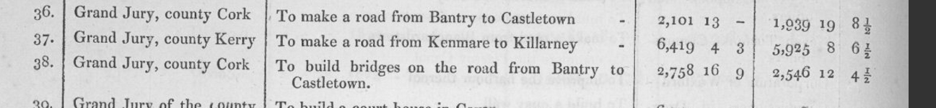

….
When Arthur Young toured Ireland in the I770s he described Irish grand juries as being composed of 'the resident gentlemen, their agents, clergy and respectable tenantry'. For the most part he seems to have been right.

Appointment as a justice of the peace had become, by the 1730s, a mark of prestige in Ireland. It was also seen in later years as a necessary prerequisite effectively to administer and manage an estate.Yet being a magistrate did not guarantee a man a place on a grand jury, nor were grand juries composed wholly of magistrates. As in England, though, justices of the peace were to become increasingly numerous among grand jurors. In Antrim in July 1716 only three grand jurors were in the commission of the peace for the county. By I769 more than half of the County Cork grand jury were Magistrates

…

Baronies as Administrative Units.

In Ireland, a barony (Irish: barúntacht, plural barúntachtaí^{[1]}) is a historical subdivision of a county, analogous to the hundreds into which the counties of England were divided. Baronies were created during the Tudor reconquest of Ireland, replacing the earlier cantreds formed after the original Norman invasion.^{[2]} Some early baronies were later subdivided into half baronies with the same standing as full baronies.
With the coming of the Normans to Ireland in the 12th century the Barony emerged as a unit of administration. Each county was divided into Baronies Cork haveing by 23 of various sizes.
Baronies were mainly cadastral rather than administrative units. They acquired modest local taxation and spending functions in the nineteenth century before being superseded by the Local Government (Ireland) Act 1898.

The County Rates levied by the Cork Grand Jury were levied on a Baronial basis. Under the Grand Jury (Ireland) Act 1836 power was given to amend the Baronies for administrative purposes. The Baronies of Carbery and Muskerry were divided into West and East and the Carberies was further sub divided into East and West Riding reflecting the local topography..

The Baronies of Condon and Clangibon were united as well as Orrery and Kilmore and Ibane and Barryroe.
…

County Rates/Cess

The local charge was known as the Cess which amounted to around 12% of the gross rent on land.

The cess to pay for roads, bridges, and other public works was set in the Baronial ‘Presentment sessions’, where petitioners applied for funding for such works, were originally held as part of the county assizes, though the costs were paid from the barony cess if the work was of local benefit only. The county grand jury was supposed to have included jurors from each barony, though this did not always happen.^{[28]} From 1819,^{[29]} significantly modified in 1836,^{[30]} baronial presentment sessions were held for these purposes, with a local jury picked by the county grand jury from among the barony's highest rate-payers, according to a complicated formula.^{[31]} The baronial presentment sessions were a convoluted process, lacking public confidence and marred by allegations of corruption and favouritism.^{[31]} Special emergency sessions were held during the Famine of the 1840s for the make-work schemes.^{[31]}

Baronial Constables

The collection was entrusted to Baronial Constables. Financial control sees to have been lax. There were a number of examples of Constables being in arrears and allegation of fraud. An attempt was made but not continued to dismiss the Baronial Constable for Beara Patrick O'Sullivan of Millcove, Castletownbere for allege fraud but was not proceeded with. HIs career gives an example of the various political interconnections at the time

‘Big’ Patrick O’Sullivan, Millcove: Castletownbere. Died 1863. Lord Bantry Estate appointed as Seneschal Not legally qualified. Parliamentary Report 1837, Eppi. Baronial collector since 1825 deputy Denis Murphy (Irish speaking) as collector. This entailed the collection of the County Cess for the Grand Jury for the barony of Bere. The Cess amounted to 12% of gross rent. An attempt was proposed but not proceed with to dismiss him for alleged fraud in the collection of the Cess. He was a fit and proper person to conduct 1831 Census with Mr. W. Murphy. Seneschal of Altham, Mill Cove, Berehaven, Bantry and Donemark from 1843. 1841 organising voters from Beara in Conservative interest. Sitting as Grand Juror, Cork 1842, 1844, Cork County Agriculture Society Dinner 1842. Distributing in Beara New England Famine Relief 1847. Millcove. leased by Patrick O'Sullivan from the Earl of Bantry's estate in 1852 when it was valued at £14. O'Sullivan worked as an agent for the White estate. A deeply unpopular Landlord local tradition has it that he used to blow his bugle outside the Church after Sunday Mass to summon his tenants to draw hay or turf or whatever other task he designated. 1856 Chairman Berehaven Board of Guardians.

The house has been demolished though traces of the stone work can still be seen in the gardens which are now part of an art gallery and sculpture display. He was agent for the Beara part of the Bantry estate working with receivers and banks to Lord Bantry while Augustus Payne from the Upton family operated the rest of the estate. His daughter Christina, who emigrated to the Unites States and became the matriarch of a very rich New York family, before ending her days sadly in a mental home. Ellen O'Sullivan, Convent of Faithful Companions of Jesus, Limerick Chronicle died 6/06/1857, dau of Patrick O'Sullivan of Mill Cove, Berehaven, Laurel Hill. Died Peshwar India 1881 Edward O’Sulllivan, Queen's Regiment, youngest son of Patrick O'Sullivan, Esq., Millove, Castletownbere, agent to Lord Bantry and Seneschal.

Patrick O’Sullivan was nephew to Captain Paddy O’Sullivan of Faha also Agent to Lord Bantry whose sister was the mother of Peter McSweeney. 1857 Peter McSwiney, the last lineal descendant of the Mac Finin Dubh O’Sullivans (a 400 year old title), after his eviction from Dereen in Kenmare by the Lansdowne Estate, spent his last days in Ahakista Cottage. Patrick O'Sullivan, Lord Bantry's Agent in Beara, Millcove Castletownbere, Agent to Lord Bantry brought the following to Cork 1841, to vote for Longfield/Leader in a Schooner, 'Sophia' via Adrigole and Bantry. Longfield paid expenses. Jeremiah O'Sullivan, Murtagh O'Sullivan, Daniel Florence O'Sullivan, Daniel Jeremiah O'Sullivan, Timothy O'Sullivan, Roger O'Sullivan, Timothy O'Sullivan, Simms (Protestant), Denis O'Sullivan, From Adrigole, Daniel Murphy (his deputy Irish speaking), Richard O'Sullivan (Protestant), Daniel Michael O'Sullivan, James Neill, William Murphy, Murtagh Kelly.
Another family who were Baronial Constables were the Swantons of Ballydehob. They had a reputation for industry and probity. Their position as Baronial Constables may account for them become major middlemen on various estates in Carbery from the late 18th century.

Chief Secretary Dublin Castle papers.

The papers of the Chief Secretary for 1818 to 1822 have been digitalised and among the is a an application 1822 from Richard B. Cotter, Secretary of the Cork Grand Jury calling for a suspension of the levy. It is not clear if this was in addition to the cess.

1807 Militia Bounty:
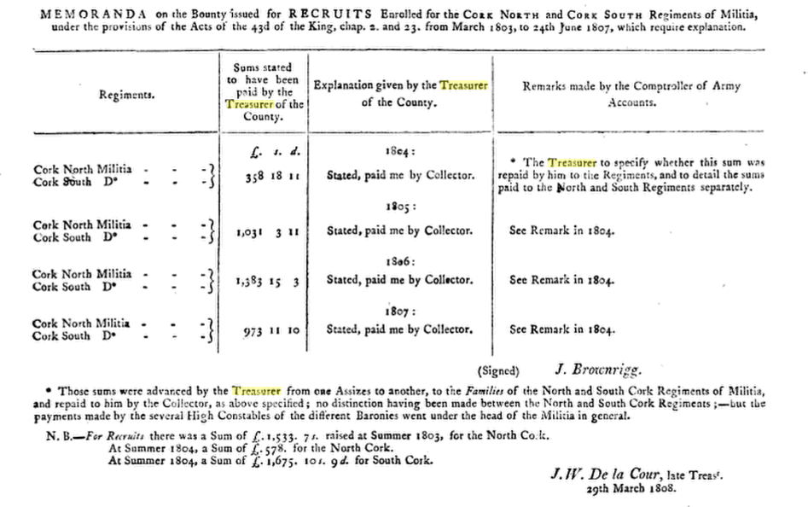

There are frequent applications to the Chief Secretary for employment as Baronial Constables backed up by affidavits from Magistrates and MPs and professions of Loyalty of prior military service in the recent wars. Some of the correspondence suggest pretty drastic methods by the Baronial Constables of collecting the cess through the employment of ‘drivers’ to seize cattle and impound them in local pounds and sell. There are pleas for short term loans for the Grand Jurys and requests to suspend the cess in Tipperary and the collection would lead to ruin because of the local great distress. A recurring theme is the severity of the Cess and its unfairness.

The Grand Jury submitted a list of the jurors for the County for 1815 to 1819 and the City for 1817 to 1819 which is still available. There is correspondence concerning the proposed House of Industry on the Gaol grounds and objections from 40 prisoners who would lose their gardens. The Gaol was overcrowded and there were application by way of Memorials from the Grand Jury submitted by the High Sheriff, Jammet Browne, to move convicts due to transportation to Van Diemen's Land to another depot.

Before the establishment of the RIC the Grand Jury had a jurisdiction in policing which is reflected in the correspondence concerning pensions for constables in some cases for up to 30 years service. The allocation of addition judicial sitting was a matter for Dublin Castle and there are frequent requests from Cork to extend quarter session and the sitting towns in this regard. 1821 Richard Hare Viscount ennismore writing in this regard.

In the genel correspondence a move to improve public health can be discerned with application for fever hospitals and to open new dispensaries.

Letter 1820 from William Jones Clerk of the Crown and Peace (State Solicitor) re new draft legislation which he says will make Clerks of Crown entirety dependant on Grand Jury.
…

David Nolan, ‘The County Cork Grand Jury 1836-1898’, unpublished 1974 MA Thesis Boole Library, UCC gives a backdrop to the Cork Grand Jury. As he says in his introduction most of the early records were lost in the fire of the Court Courthouse in 188 and many of the surviving records were destroyed by Cork County Council at the time to the move to the new County Hall in the 1960s. Mr. Nolan relied heavily on back issues of the Cork Constitution for his thesis.

….
Grand Jurors
…

…

…

…

1815 Grand Jury Co. Cork, 23 in Number | Charles Henry Leslie, Foreman | George Henry Jeffreys | William H. M. Hodder
Charles Evanson | John Forster | William Lumley | Thomas Gibbings
John Nicholas Wrixon | Richard Lane | Sir Anthony Perrier | Joseph Garde
Henry Bagnell, The Younger | Thomas Deane | Thomas Cuthbert | William Beamish
Stephen Roche | Simon Dring | William Wise | Thomas Sarsfield
Richard B. Shears | Edward Creed | Thomas Parsons Boland | Gerrard Callaghan

…

….

Letter 1821 from Francis Woodley, Frankfort, County Cork, near Tallow, County Waterford, magistrate, to William Gregory, Under Secretary, Dublin Castle, concerning a threatening notice posted in village of Conna, County Cork, warning anyone who pays or collects tithes, and threatening any landlord who does not reduce rents by sixty percent. States that he has advised his son, Francis George, a high constable of the barony of Kinnatalloon, to collect the county cess immediately. Expresses hope that the majority of farmers remain 'well affected'.

1840 G. Standish Barry M.P. in a Submission to the Commissioners appointed by the British Parliament maintained that the level of surety provided by the Baronial Constables was poor, ‘very tottery if not insolvent’.
The Commissioners recommended that collection be put into the hands of poor law collectors who would do so at a lower poundage than the Baronial Constables

1870 Bandon: Poole Horatio T. Esq, Baronial High Constable.

1881 Clonakilty: Baronial High Constable’s Office, The Square – W. Hungerford, High Constable

1863 Baronial High Constables (County Cess Collectors) | Barony
Bantry and Bere | John O’Sullivan, Mill Cove, Castletownbere
Barretts | George Stawell Ware, Woodfort, Mallow
Barrymore | Henry Barry, Ballyadam, Carrigtwohill
Condons and Clongibbons | John J. Therry/Terry, Springville
Cork | John Thomas Wakeham, Springhill, Glanmire
East Division East Carbery | George Sandes, Dunowen, Clonakilty
West Division East Carbery | Adam N. Meade, River View, Enniskeane
East Division West Carbery | James W. Levis, Skibbereen
West Division West Carbery | John B. Fleming, Ballydehob
Courceys and Kinsale | Michael Gallwey, Kinsale
Duhallow | Robert De la Cour, Fairy Hill. Mallow
Fermoy | Arthur Williamson, Summerhill, Mallow
Ibane and Barryroe | D. McCarthy Gallwey
Imokilly | Henry Weiland/Welland, Killeagh, Midleton
Kerrycuuihy | William Daunt, Springhill,Carrigaline
Kinalea | Simon Newenham, Maryboro’, Douglas
Kinnalmeaky | Horatio T. Poole, Mayfield, Bandon
Kinnattaloon | William R. Bowles, 1861 Robert Boles, Ahern.
East Muskerry | Horace H. Townsend, Woodside, Blarney

West Muskerry | Devonsher P. Hawkes, Macroom
Orrery and Kilmore | Samuel Uppington, Mallow

…
1780-1860 Grand Jury Returns.

.
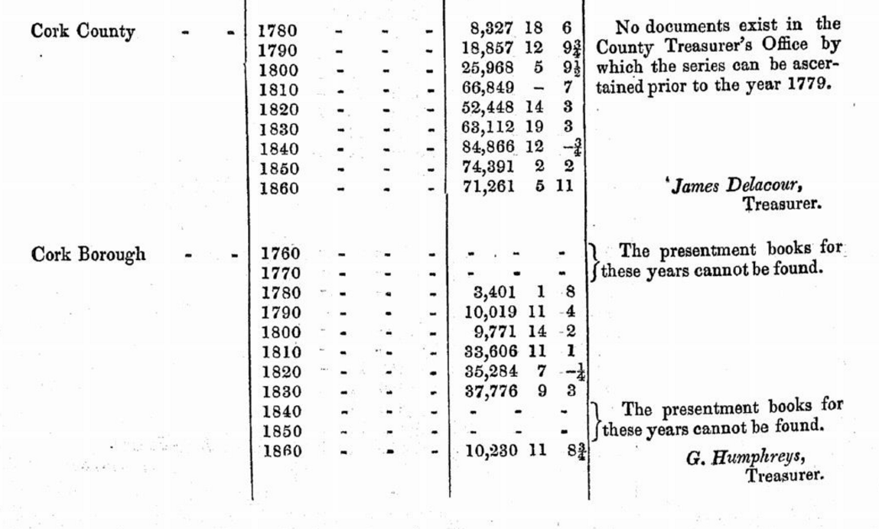

….

…..

…..

..

..

1793-1803 Grand Jury Expenditure including on Militia

…
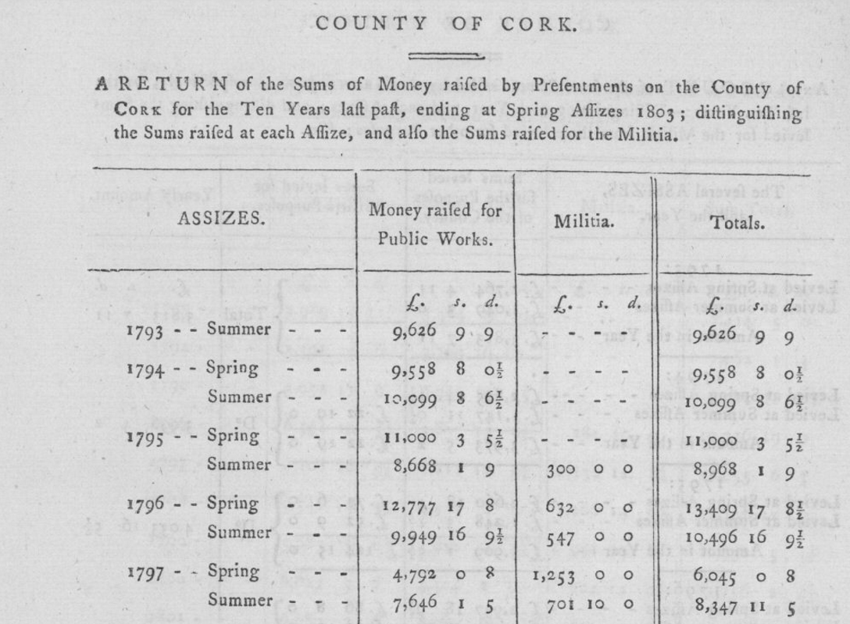
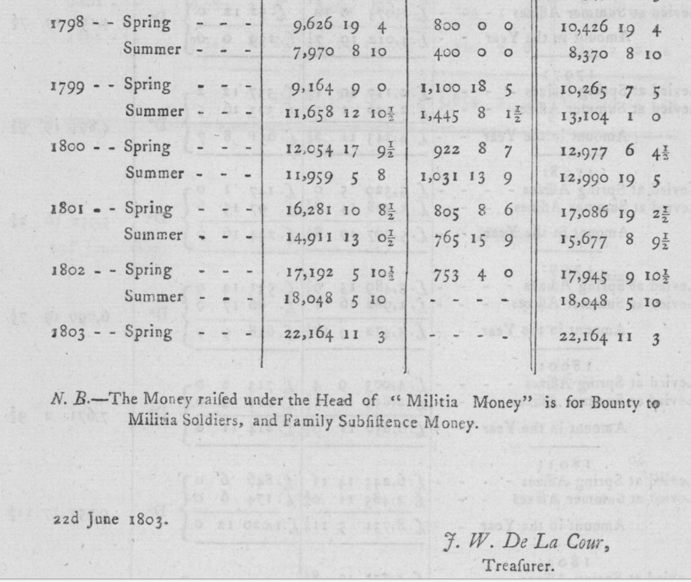
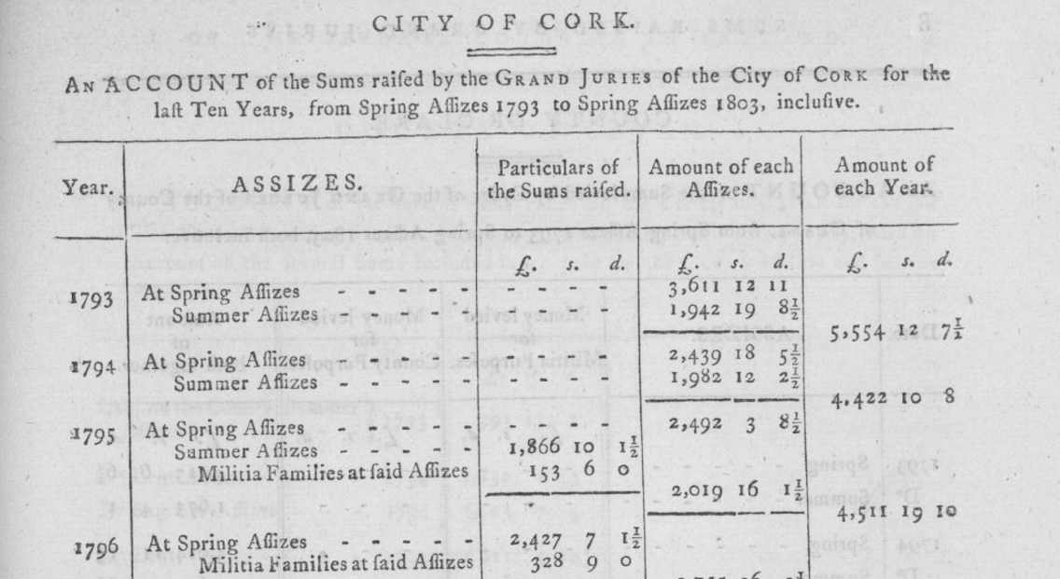
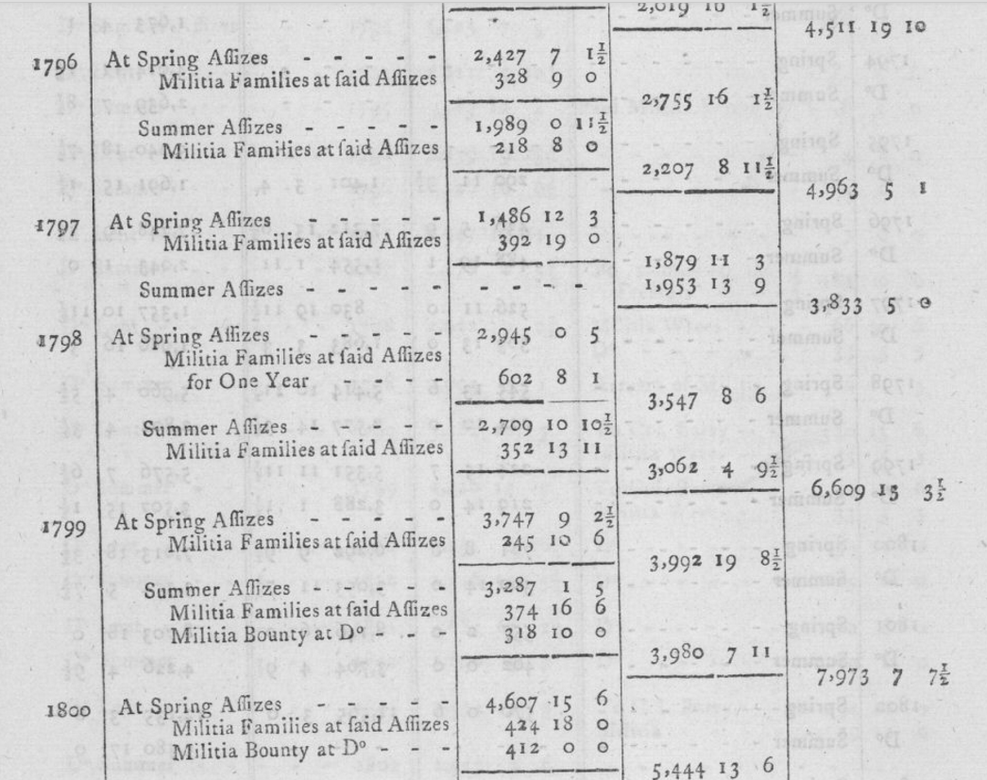
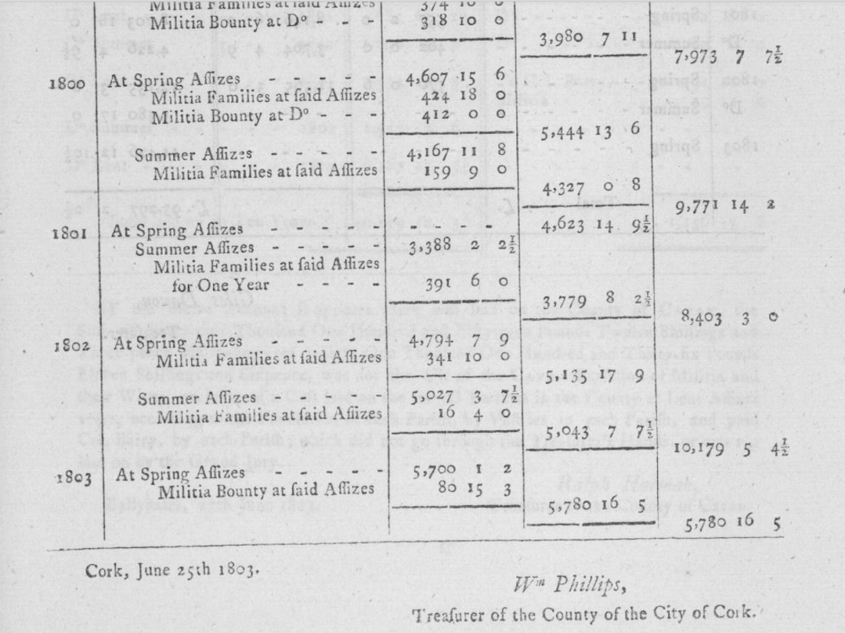
..
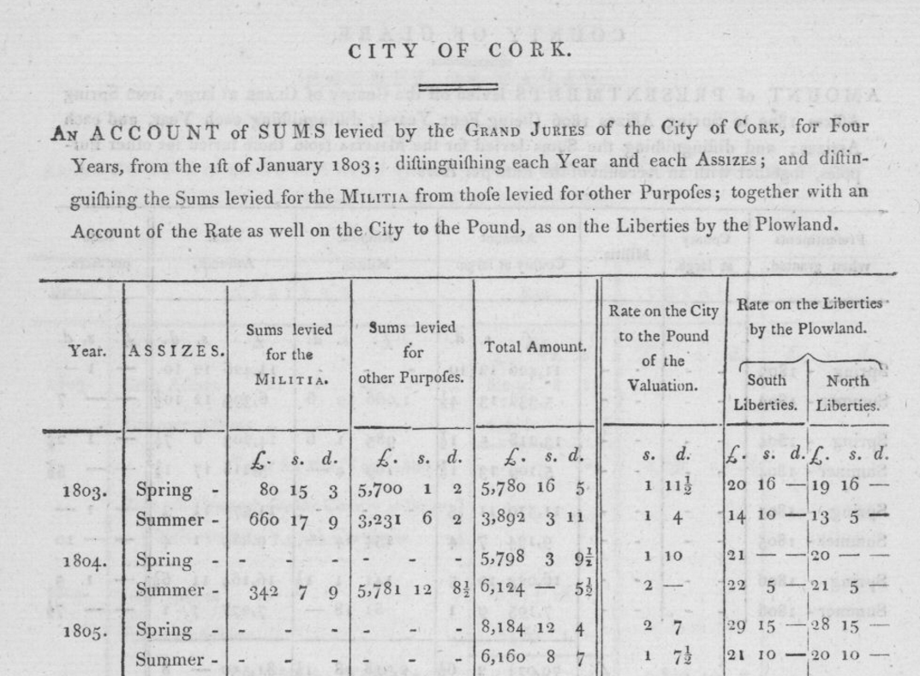
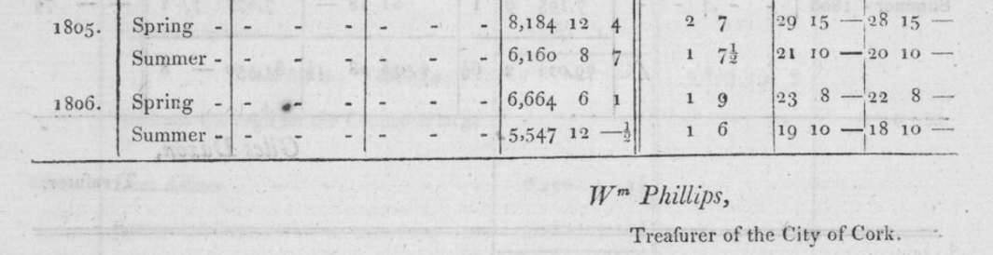
..
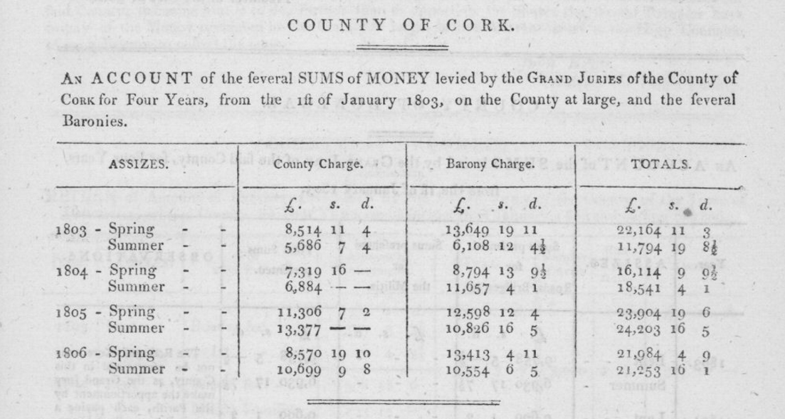..

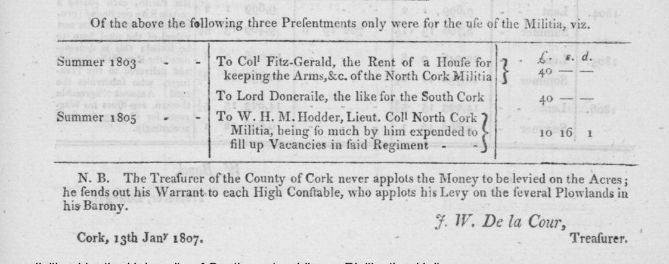
..
…\\

…
Sample Presentment 1815 Cork City.

It is interesting later in the presentments there is provision for compensation for property owners affected by roadworks.

….
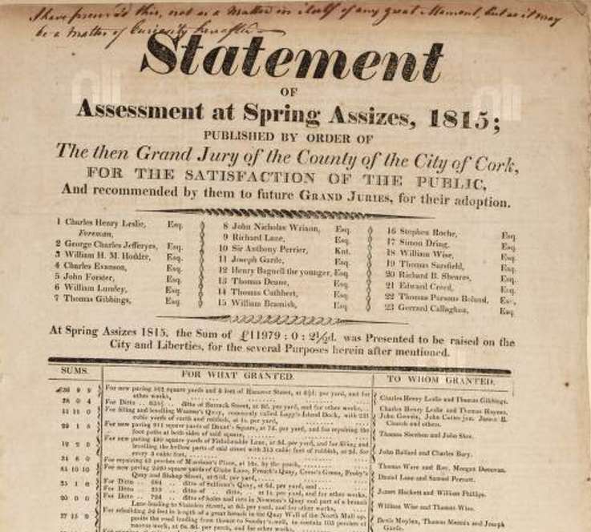

..

...
Grand Jury Cess 1837-1897

Year | Grand Jury County Gross Cess in £ rounded
1837 | 68
1848 | 106
1867 | 85
1877 | 91
1887 | 106
1897 | 120

…..

Report of Richard B. Cotter, Secretary to Cork Grand Jury 20th October 1822:

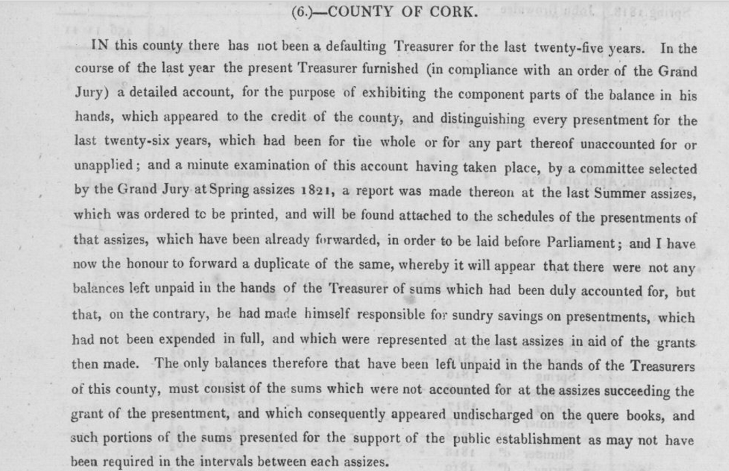
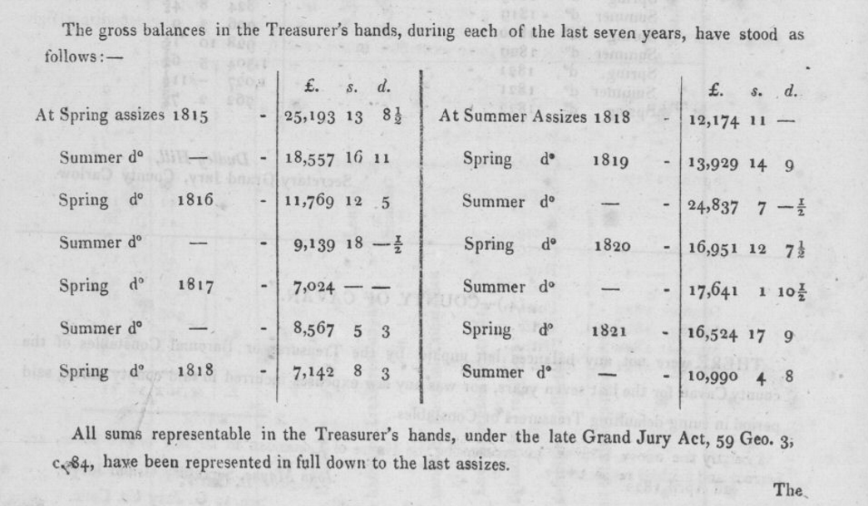
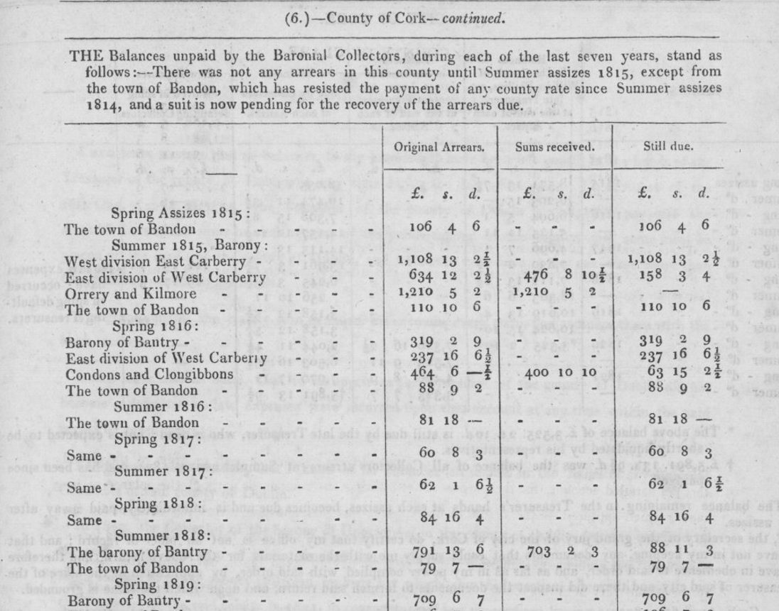
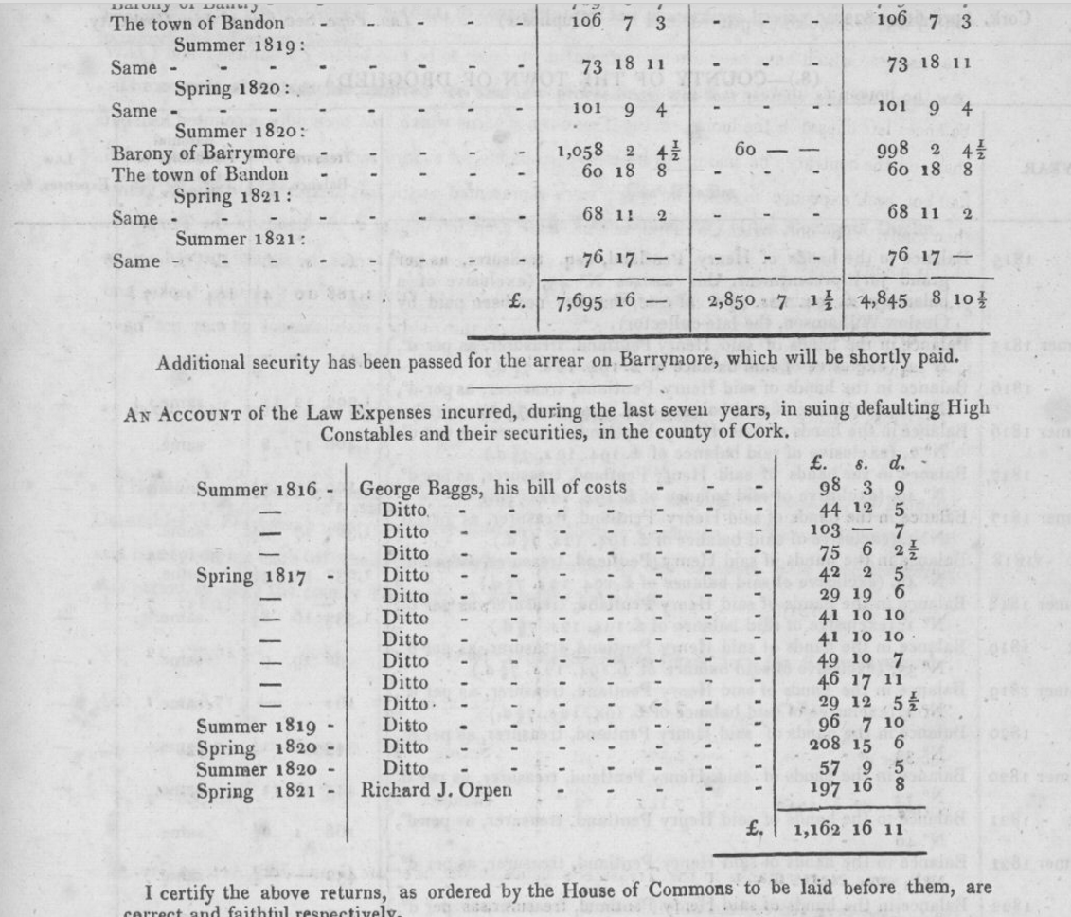

…..

1822 Financial Statement for Co. Cork

This is a good example of the scope and extend to the responsibilities of the Grand Jury.

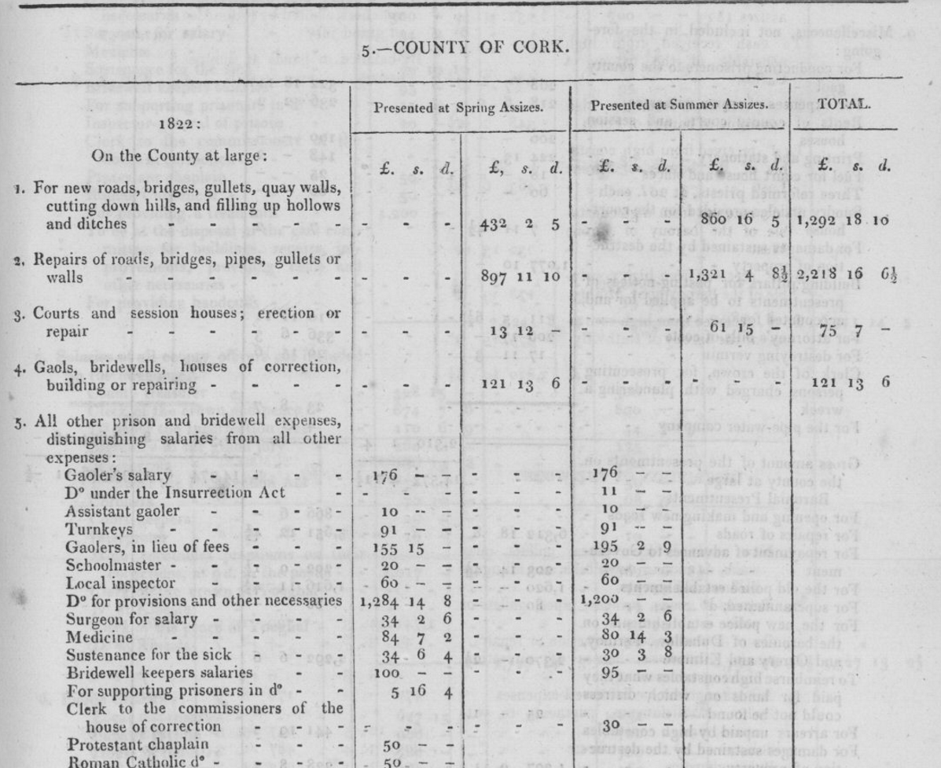

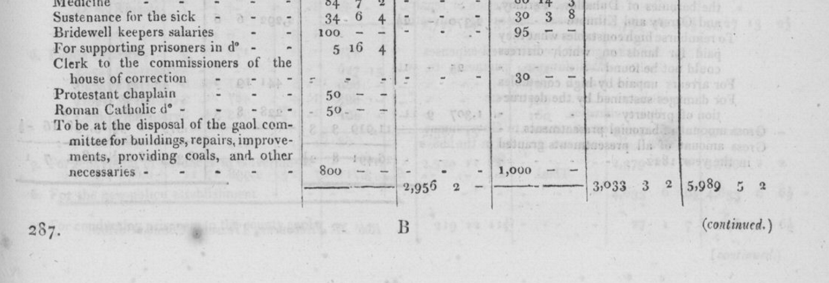
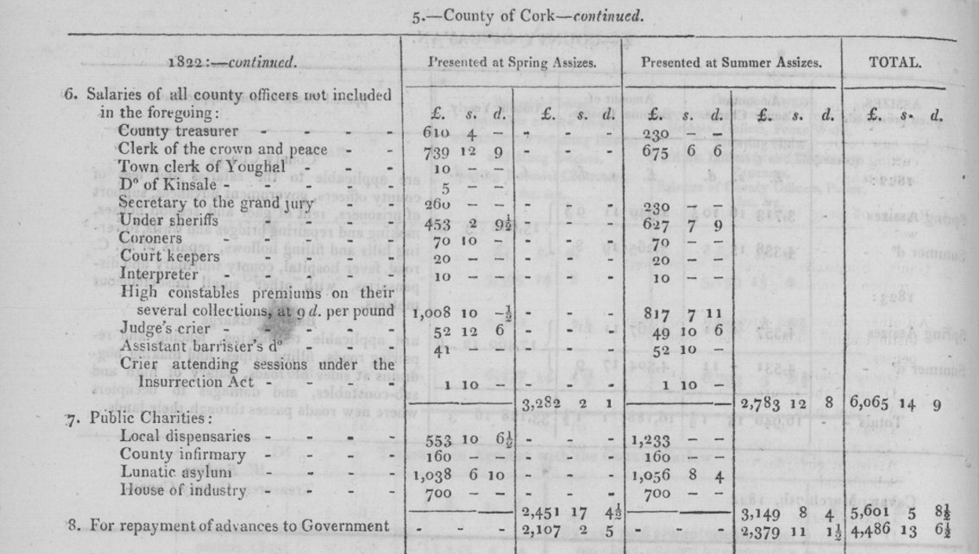
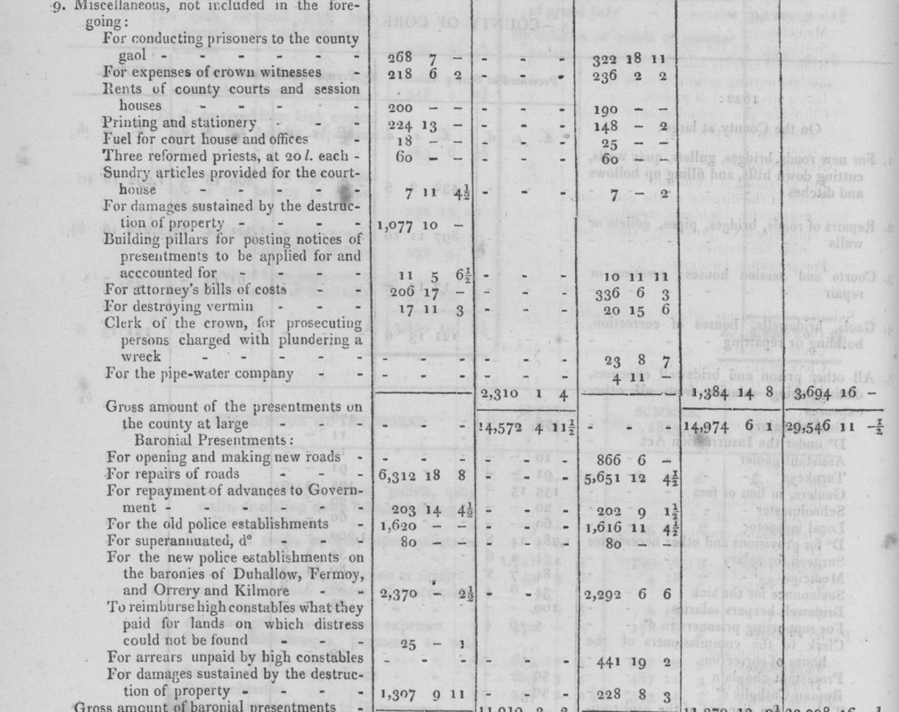
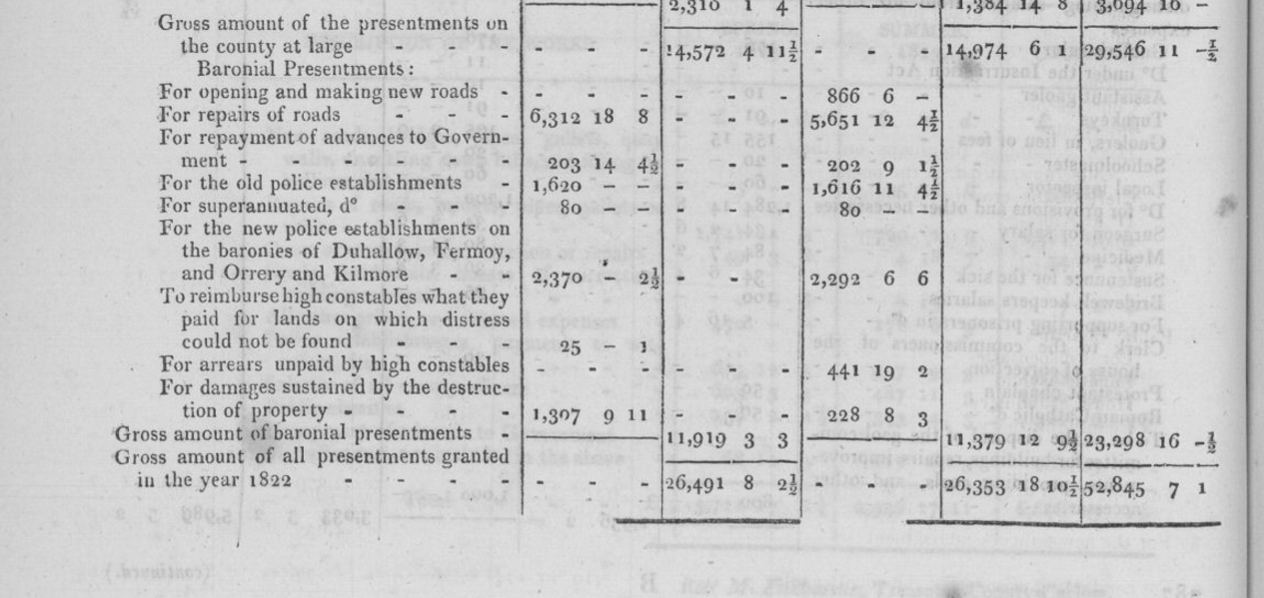
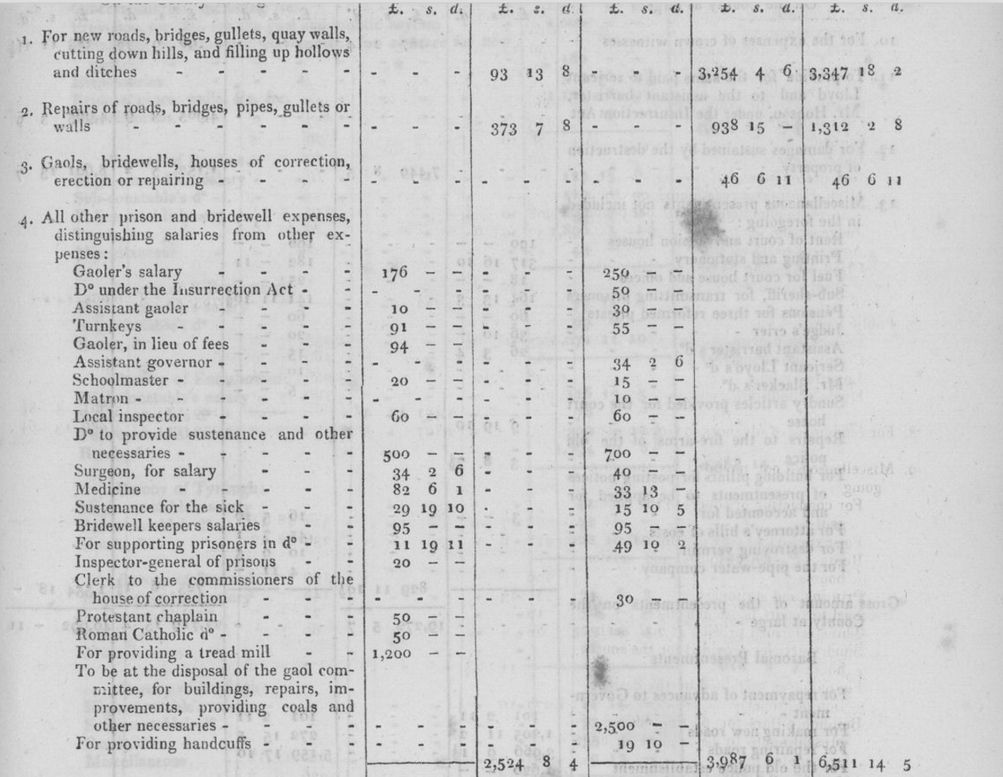
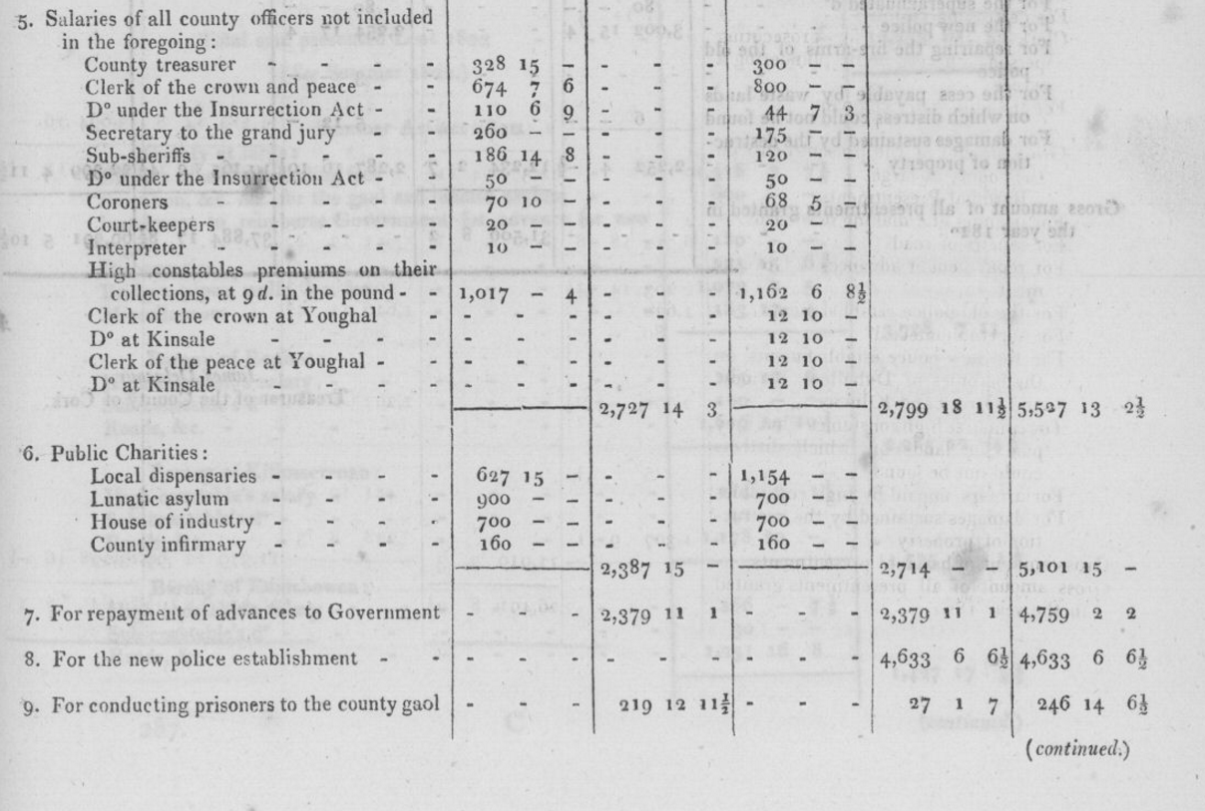
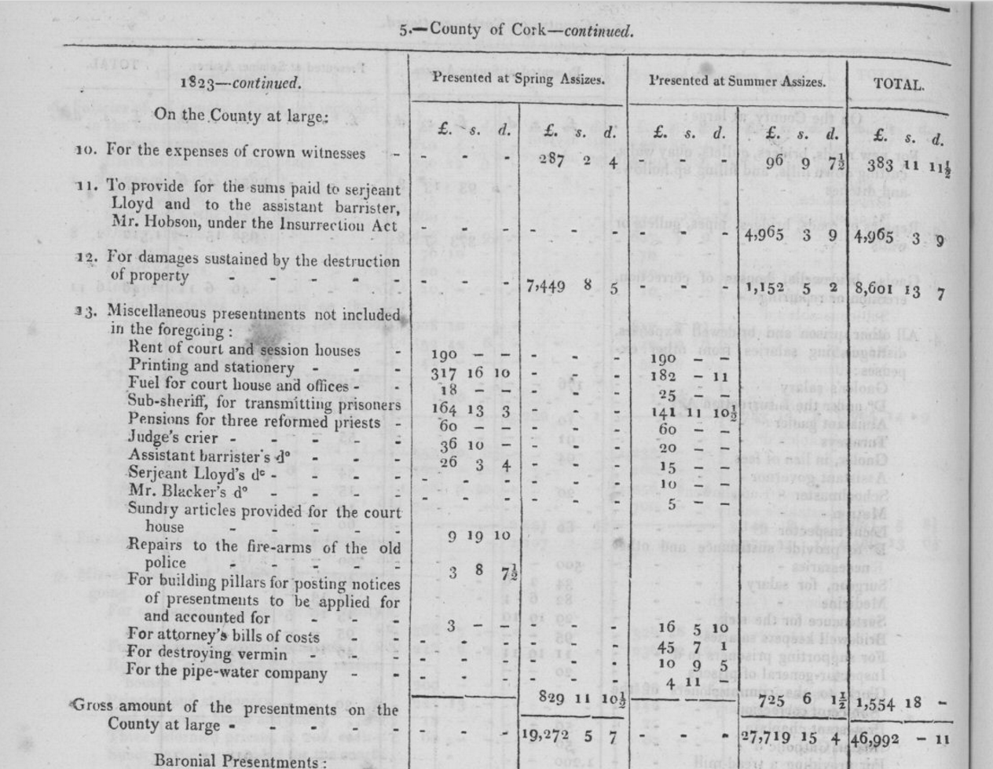
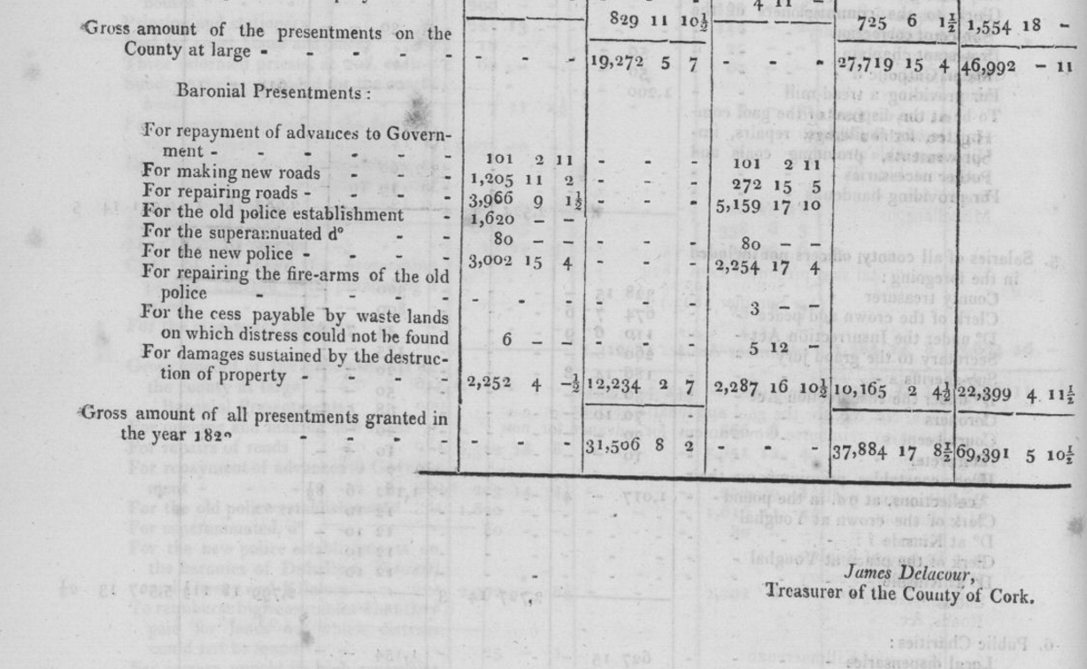

‘’’

….

…

Report from the Select Committee on Grand Jury Presentments, Ireland By Great Britain. Parliament. House of Commons. Select Committee on Grand Jury Presentments (Ireland). Evidence of Treasurer Robert De La Cour on Evils of Existing System 1815:..
.
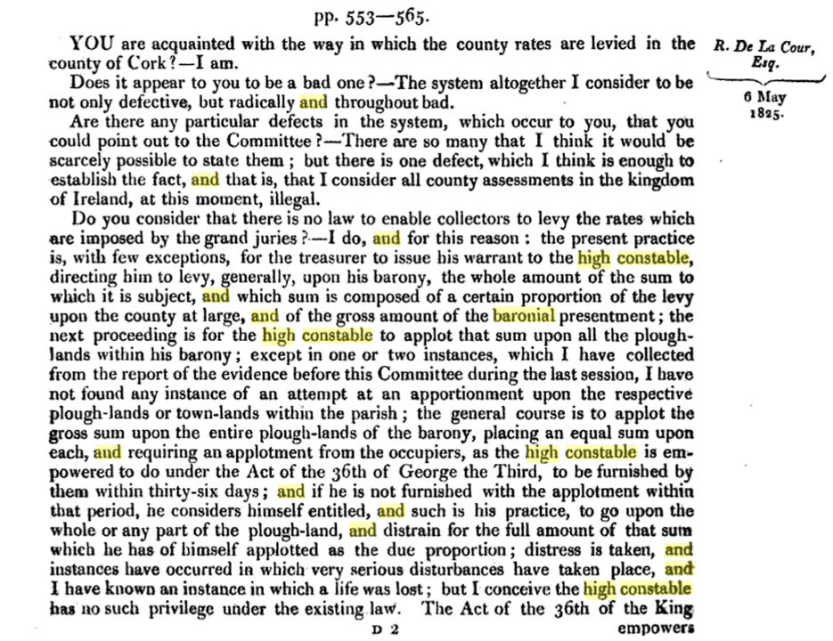
.
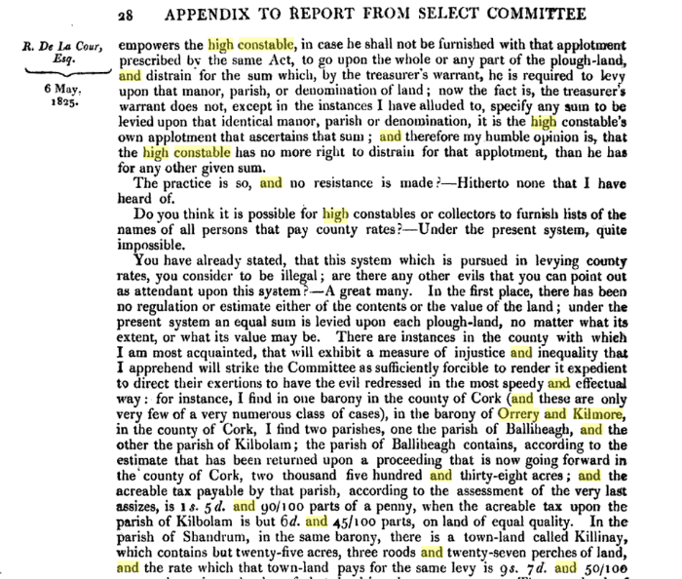
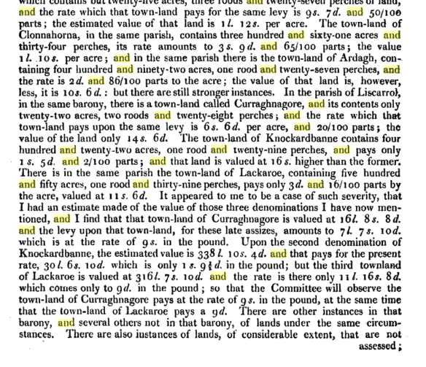
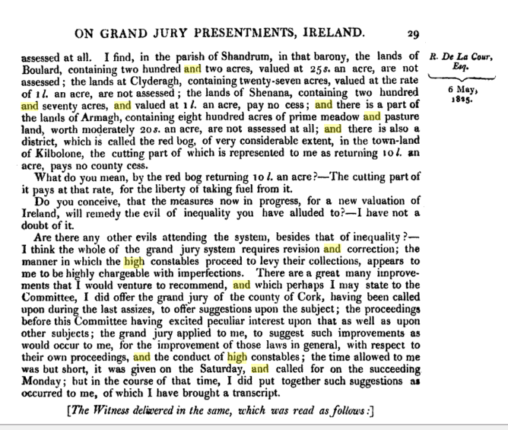

His evidence continued can be followed here:

https://books.google.ie/books?id=LmY1AQAAMAAJ&pg=PA28&lpg=PA28&dq=Orrery+and+Kilmore+baronial+high+constable&source=bl&ots=YB5jGMFkes&sig=a0Ei2wOIsgcca9z4YfT2Ch2HLFE&hl=en&sa=X&ved=0ahUKEwjElvnt8NjQAhWDOsAKHYV9DYoQ6AEIOTAG#v=onepage&q=Orrery%20and%20Kilmore%20baronial%20high%20constable&f=false

- Suggests that labourers be paid weekly suspect they have an account with their overseer or contractor
- Parish inspectors of roadworks leave an amount to be desired
- Recommends independent county engineers appointed by Lord Lieutenant

Evidence of Alexander O'Driscoll, unhappy that out of 23 possible Grand Jurors none for Baronies of Carbery:
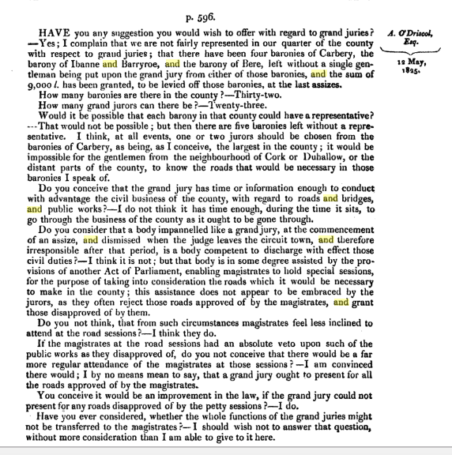

1866 Breakdown for Cork City and County of County Cess:

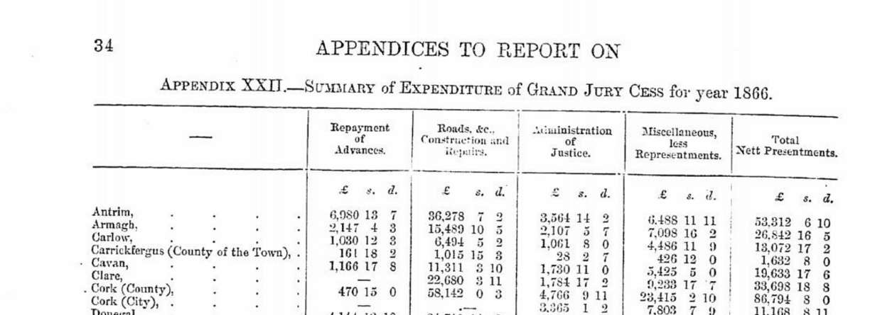
…….
..

….

Grand Jurors

The composition of the Grand Jury and its staff from the late 17th century reflect the background of Cork’s ruling elite of County Landed families and City Merchants, Protestant. In this it mirrors the composition of the Magistrates. Within the State Church until 1870, the Church of Ireland the majority of the Jurors came from an English Planter background from the 1580s, the early North Cork families tended to marry into local Gaelic and Norman Aristocracy Barry, Fitzgerald, O’Callaghan Families with similar backgrounds such as the Dalys, Drings, Meades, O’Donovans, McCarthy, O’Briens, Roches, Ronaynes or the Hiberno-Norse Cotters and Coppingers, converted because of the penal Laws or Marriage such as the Mccarty heiress who brought 10,000 acres into Shouldham ownership in the 1710s and appears in the Convert Rolls. In a sense the Shouldhams are a sub sept of the McCarthys. There are slightly more exotic backgrounds sun as the German Cramer, Notter, the Huguenot Besnard, De la Coers, Madras, Perrier, Teulon. Due to extensive marriage over time the elite is in fact much more diverse ethnically than is generally supposed.

In the Magistry the last Catholics appointed wee in the 1680s until a small number for Co. Cork in the late 18th century. By around 1800 the balance of economic advantage had shifted to the Catholics ironically aided by the Penal Laws which locked the out of the land market and ensured that they embraced commerce. In evidence to a Parliamentary enquiry in 1828 some months before he took his seat in the British Parliament Daniel O'Connell was complaining that the Bank of Ireland only hd four clerkships occupied by Catholics despite having most of the cash on deposit and the shares in the joint stock company. Similar evidence was given to another Parliamentary enquiry in the early 1820s by the parish priest of Bantry Fr. Barry who said that half pay officers from the Napoleonic Wars were preferred on £40 a year as jurors that assizes to Catholic on £1,500 per annum.

From the early 19th century the wealthy Catholics slowly make their way into the Grand Jury.

…

1765 Resolution not to give servant tips on being entertained at their master's house | John Conway Colthurst | John Hyde | Robert Uniacke Fitzgerald | Richard Townsend
Richard Longfield | Robert Rogers | William Conner | Abraham Devonshire | Samuel Hutchinson
Richard Fitzgerald | Riggs Faulkiner | John Rye | Abraham Morris | Roger Bernard
John Bernard | Boyle Aldworth | Francis Kearney | Walker Izod | George Pigot
Godfrey Baker | Luke Grant | Usher Philpot | William Parks | Henry Bullen
Thomas Poles | Christopher Conran | William Coles | Stephen Denroche | Hugh Lautin (Lawton?)
Humphrey Crowley | John Parker on behalf of County Grand Jury | William Crofts on behalf of County of City of Cork Grand Jury | Walker Colthurst | JOhn Colthurst
Emanuel Moore | Thomas Wran (Owgan?) | John Lapp | Joseph Wetherall | Andrew Franklin
Francis Rowlat | Henry N. Nixon | Walter Traverse | Kevin Moore | John Bullen

…
1782 At the Spring Assizes the Grand Jury of Cork, Colonel Richard Townsend was the Foreman, passed the following resolution; “Resolved that we think it necessary to declare no power has a right to make laws for this Kingdom save only the King, Lords and Commoners of Ireland and that we will with our lives and fortunes maintain and defend the Irish Parliament in such a declaration of rights and in any measure they may think proper to defend it.

…
1799 City Grand Jury Spring Assizes, approve of the contemplated act of Legislative Union.
….

1814. John Anderson of Fermoy presented petition against Catholics being Foremen of Grand Jury alleged by Daniel O’Connell this got him Knightship from Duke of Rutland
1840. September Cork High Sheriff invited G.S. Barry M.P. to act as Foreman Cork Grand Jury first Catholic since Gould in 1680s
1865. Richard W. Goold Adams, Esq., of Jamesbrook, has accepted the invitation of Henry Lavallen Puxley, Esq., High Sheriff, to act as Foreman of the Grand Jury at the coming Spring Assizes for the County of Cork.
…

…..

….
1840 Provision for Medical Services
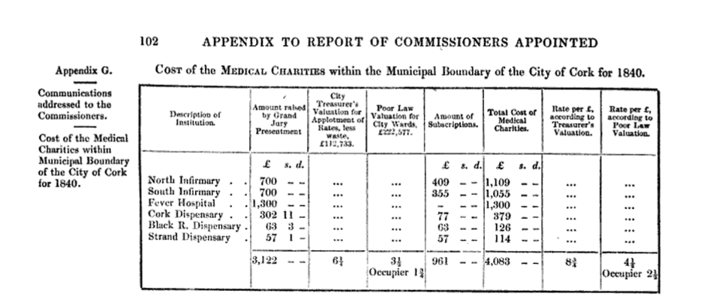
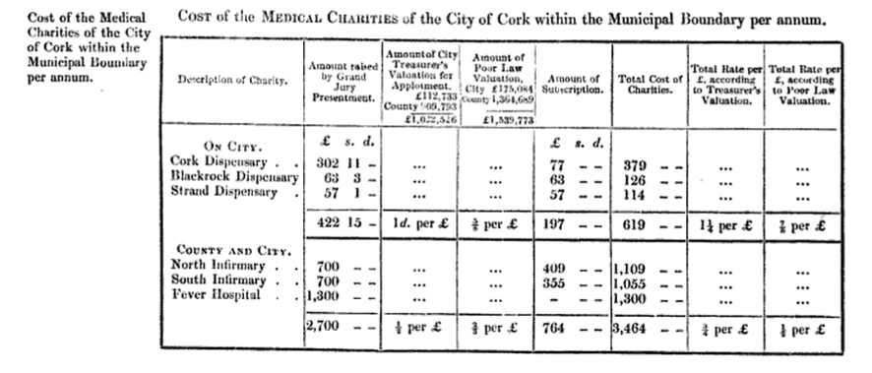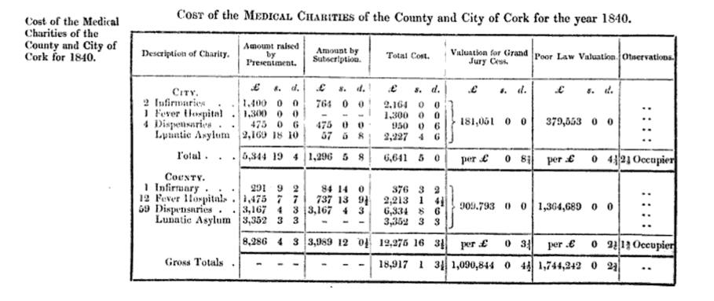
….

….

….

….

Grand Juror Attendances 1837-1899

In Noland’s thesis of Cork Grand Jury he provides a detailed table of attendances this listing has been abstracted with the more frequent attendees.

Name | Address | Attendance at Presentment Sessions 1837-1899
Richard Willis Goold Adams | Jamesboro | 14
Richard Oliver Aldworth | Upper Dromore/Newmarket Court | 24
Colonel Richard William Aldworth | Newmarket Court | 13
John Edward Barrett | Carriganass Castle, Bantry | 36
Captain James Barry | Ballyclough, Mallow | 15
John Harold Barry | Ballyvorane, Buttevant | 30
Thomas Beamish | KIlmaloda, Clonakilty | 12
John Wrixon Becher Bart. | Ballygiblin and Castlehyde | 11
Sir William Wrixon Becher Bart. | Ballygiblin, Mallow | 12
Henry Bernard Boyle Bernard | Castle Bernard and Coolmain Castle | 20
Lieutenant Colonel Thomas F. Bourke | Prospectville (Passage west?) | 19
Henry Bradder | Modeligo, Fermoy | 16
Jonathan Bruce | Prothurst, Kanturk | 10
Major Bruce, later described as Phineas | Little Island | 10
William Cooke Collis | Castlecollis | 15
Sir George St. J. Colthurst | Blarney Castle | 14
George Conway Colthurst | Blarney Castle 16
Daniel Conner | Manch, Dunmanway | 13
Daniel Conner | Manch, Dunmanway | 41

Charles Purdon Cooke | Ballyclough Castle, Mallow | 20
William Coppinger | Coppinger’s Court (Barryscourt Midleton?) | 10
Sir James Laurence Cotter | Rockforest, Mallow | 11
John Courtenay | Ballydesmond, MIdleton | 15
Marmaduke Cramer | Rathmore, KInsale | 32
Edward Daly | Kinsale | 19
Colonel William Daly | Knockrobin, Kinsale | 13
Simon Dring | Rockgrove | 18?
Nicholas Dunscombe | Mount Desert, Cork | 31
R.V.P. Fitzgerald | Corkbeg, Whitegate, Midleton | 16
Lionel John Fleming | Newcourt, Skibbereen | 12
Abraham John Forster | Garretstown Kinsale | 11?
Savage French | Cuskinny, Cobh | 11
Thomas George French | Marino, Cobh | 14
Thomas St. John Grant | Kilmurray, Kilworth | 16
Stephen Grehan | Clonmeen, Kanturk | 13
Richard John Maxwell Gumbleton | Glenatore, Tallow, Co, Waterford | 24
John Isaac Heard | Pallastown, KInsale | 24
Robert Heard | Pallastown, KInsale | 32
Thomas Bousefield Herrick | Scilly, KInsale | 18

Thomas Arthur Ludlow Herrick | Clancoole, Bandon | 10
William Henry Moore Hodder | Hoddersfield, Carrigaline | 13
William Henry Moore Hodder possibly Junior | Hoddersfield, carrigaline | 12
Thomas Hungerford | Cahirmore, Clonakilty | 11?
Thomas Hungerford | The Island, Inchydoney, Clonakilty | 18
Samuel Hutchins | Ardnagashel, Bantry | 13
William Johnson | Castlelyons | 28
Thomas Watson Knowles | Oatlands, KInsale | 18
Henry Eustace Leader | Mount Leader, Millstreet | 11
Daniel Francis Leahy | Shanakiel, Cork | 12
Thomas Leahy | Derryniha | 16
Thomas John Leahy | Derryniha | 28
William Burton Leslie | Courtmacsherry | 31
Mountifort Longfield | Castlemartyr, Midleton | 18
Richard Longfield | Longueville, Mallow | 15
Richard Edward Longfield | Longueville, Mallow and Waterloo | 14
George Montgomery | Killea, Mitchelstown | 12
Captain Anthony Hackman Morgan | Bunaulin, Caheragh, Skibbereen | 144? For 1866 to 1898
William Richard Meade | Ballymartle, KInsale | 51
James Morrogh | Old Court, Doneraile | 23

James McCarthy | Laurentium and Currymount, Buttevant | 16
John Nason | Newtown Lodge, Fermoy | 12
Robert Nettles | Nettleville Macroom | 21
William Worth Newenham | Coolmore, Carrigaline | 11
John Richard Newman | Dromore House, Mallow | 18
William Norwood | Ballyhalwick, Dunmanway | 11
Thomas O’Brien | Ballyhalwick?, Dunmanway | 11
Thomas O’Brien | Monteagle, KIldorrery | 14
The O’Donovan, Henry Winthrop O’Donovan | Lissard, Skibbereen | 17
The O’Donovan Morgan William O’Donovan | Lissard, Skibbereen | 10
Timothy O’Donovan, pivotal figure with Deasys of Clonakilty early Catholic Magistrate | O’Donovan’s Cove, Durrus, Bantry | 8
Alexander O’Driscoll | Norton Cottage, Skibbereen | 12 (1838-1840)
Standish O’Grady | Aghamart, Carrigaline | 14
John McCarthy O’Leary | Coomlogane, Millstreet | 34
James Henry Payne | Beechmount, Upton, Bandon | 12
John Warren Payne | Beach House, Bantry | 30, 1867-1899
William Symms Bird | Bantry | 3, (1889-1894)
George E. Barrett | Carriganass Castle, Bantry | 7, (1861-1871)
Maskelyne Alcock | Bandon | 3, (1837-1841)
Hewitt Powell | Cahermore | 21

Hewitt Poole | Mayfield, Bandon | 10
Richard Roberts | Ardmore, Passage West | 16
Richard Tonson Rye | Ryemount, Macroom | 37
Robert Massey Dawson Sanders | Sandes Park, Charleville | 11
Dominic Patrick Ronayne | Doughcloyne, Cork | 22
Edmond Anderson Shouldham | Coolkelure, Dunmanway | 31
Captain Somerville | The Prairie, Schull | 13
William Alcock Jones Stawell | KIlbrittain Castle, Kinsale | 10
George Beamish Teulon | Bandon | 14
Horace Townsend | Derry Clonakilty and Woodside | 12
Richard Townsend | Myross wood Skibbereen and Garrycloyne | 20
James Travers | Butlerstown, Clonakilty | 15
Lieutenant Colonel Robert Travers | Timoleague | 50
Henry Wallis | Drishane, Millstreet | 16
Thomas Ware | Woodford, Mallow | 11
Sir Augustus Riversdale Warren | Warrenscourt, Lissarda, Macroom | 16
John Borlase Warren | Ryemount, Crookstown, Macroom | 17
John Hamilton White | Drombroe, Bantry | 14
Robert Hedges Eyre White | Glengariff Castle, Bantry | 25
Henry Young Lindsay | Leemount, Cork | 10

…

…

….

Staff

Secretaries

County
1765 John Parker
1819 Davys Tuckey, also Clerk to Commissioner for Building House of Correction Commissioner Court of Exchequer , Proctor Consistory Court.
1821 Thomas Pope, 1818 Under Sheriff
1820, 1822, 1838, Richard B(ailey?) Cotter, Freeman of Cork, had been Attorney pe 1795 to Grand Jury, appointed 1820 serves under pleasure of Grand Jury. Office in Courthouse two clerks three during Assizes, £324 per annum has previously (to 1840) other fees as Secretary to building House of Correction and Bridewell.
1840, William Johnson, Vosterburg, Cork.

City

1765 William Crofts
1832 Denham Franklin appointed after contested election 1832 serves subject to Grand Jury satisfaction. £120 salary does not permit employment of clerks, continues as Solicitor for private businesses.

Descriptions 1840 of Messrs Delacour and Lane of Duties

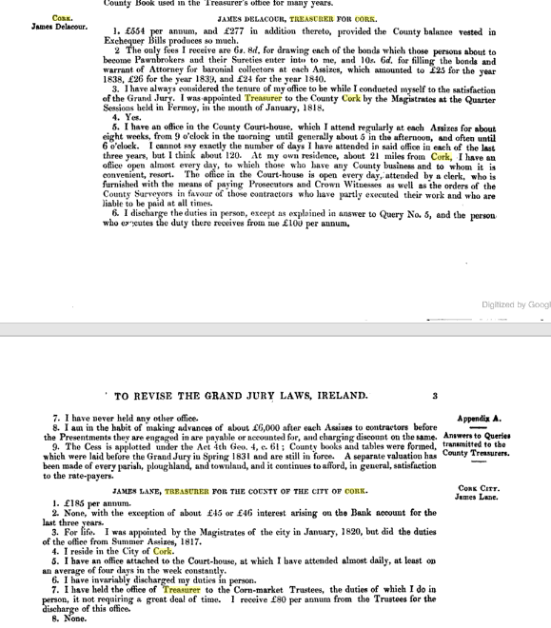

…

Treasurer County.

1790 James Walsh Delacour described as late 1808
1808 Robert Delacour

1823 William De la Cour
1818,1836, 1861 James Delacour, Sunnyhill, Mallow, appointed 1818 by Magistrates at Mallow Quarter Sessions, salary £554 and fees of £277,

Treasurer City

1807, James Brett
1817, James Lane, appointed for life from 1820 by Cork Magistrates doing position since 1817, salary £185, fee from interest £45 and fee of £80 from Corn Market Trustees.
1840. Late treasurer defaulted to the extent of £460
1861 G. Humphries

County Surveyors.

1834, Edmund Leahy, West Riding, resides Cork. Appointed 1834 holds under will of Lord Lieutenant, full time, £300 per annum with £50 for clerk and expenses. Three assistants at a total cost of £150. 143 miles of new road at 1840 and 971 maintained since appointment Office at courthouse, spends two thirds of time internally the balance at road works. `Private practice but very little.

1834, Patrick Leahy, East Riding and County of the City of Cork. Glanmire demesne of Glenville. Appointed 1834 holds under will of Lord Lieutenant, full time, £300 per annum with £50 for clerk and expenses assisted at no cost to county by son qualified engineer. During is tenure at 1840 had erected 120 miles of new road 1,904 miles under maintenance. Four assistants at a total cost of £200 pa. Office at courthouse, spends two thirds of time internally the balance at road works. In 1835 and 1836 also acted as Architect for Ecclesiastical Commissioners for Munster at £200 pa declined due to pressure of work.
1861, East Riding , W. A. Tracey, Cork

1861, West Riding, Nathaniel Jackson, South Mall, Cork

….

….

Local Government (Ireland) Act 1898.

Local government was totally reformed under the Local Government (Ireland) Act in 1898. The power of the County Grand Juries, and the poor law guardians was eventually replaced by more representative local authorities. Counties, as opposed to poor law unions, were re-established as the main unit of local government, except now they were controlled by elected councils. Cork became a county boroughs, controlled by an elected corporation.

In Cork the County Council took over the offices and personnel of the Grand Jury.

A third tier of government was introduced at the sub- county level. Towns with a population of 1,500 became urban districts with their own town council. The rest of each county was divided into rural districts (largely based on the poor law unions). Urban and rural districts had designated local powers, but were subservient to the counties. This system of local government has remained more or less intact for over 100 years. The only significant change was the abolition of rural districts in 1925.

…..

Grand Jury Map Co. Cork.

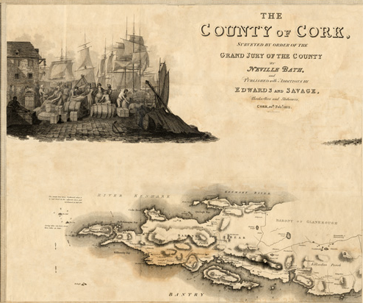....
..
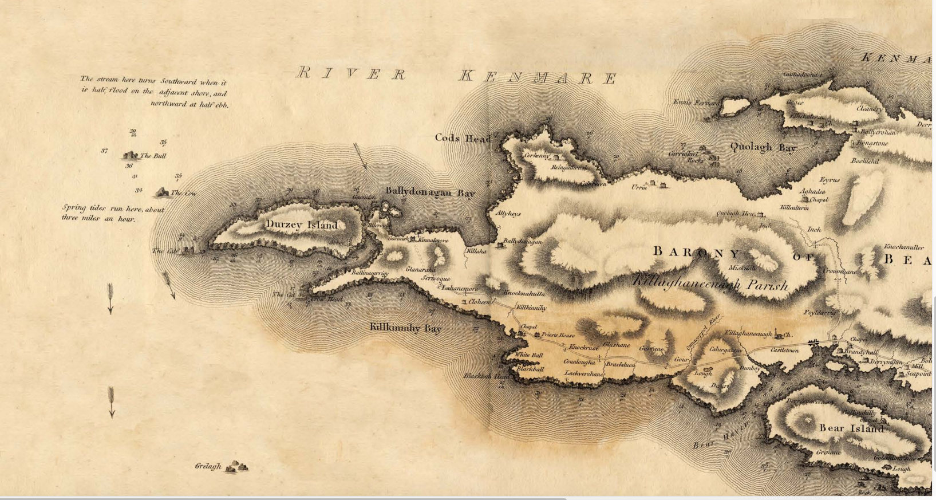
..
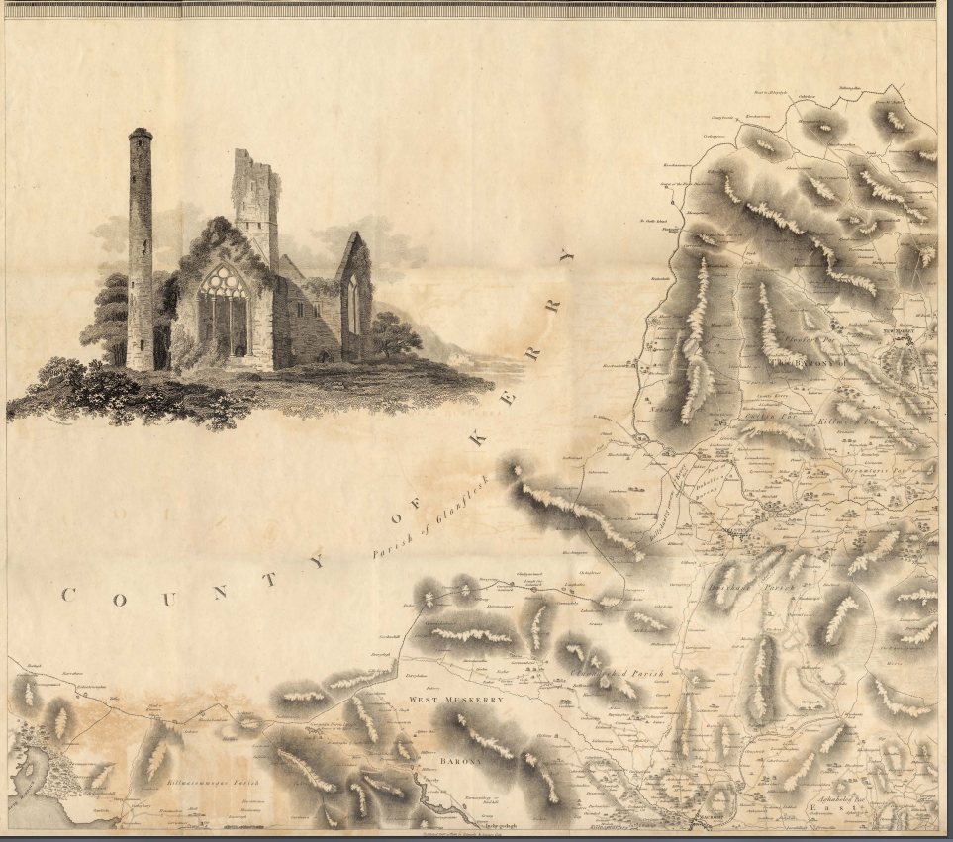
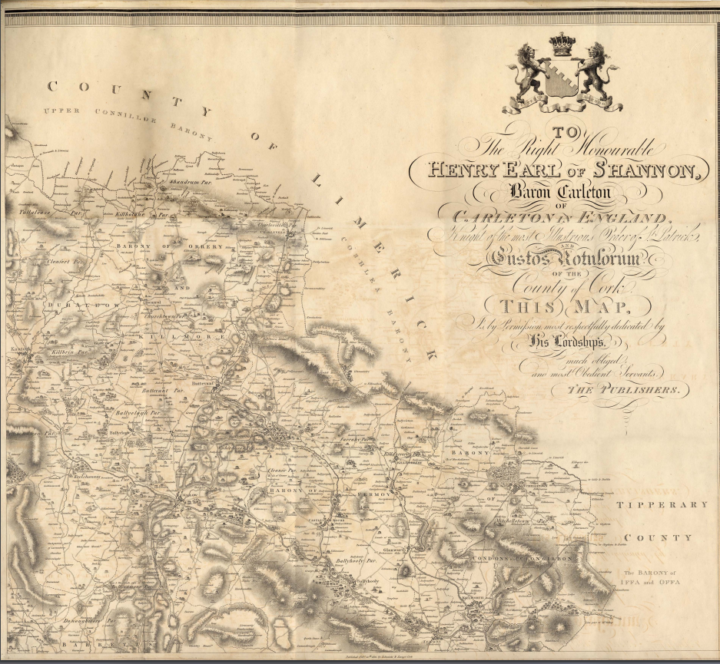

…
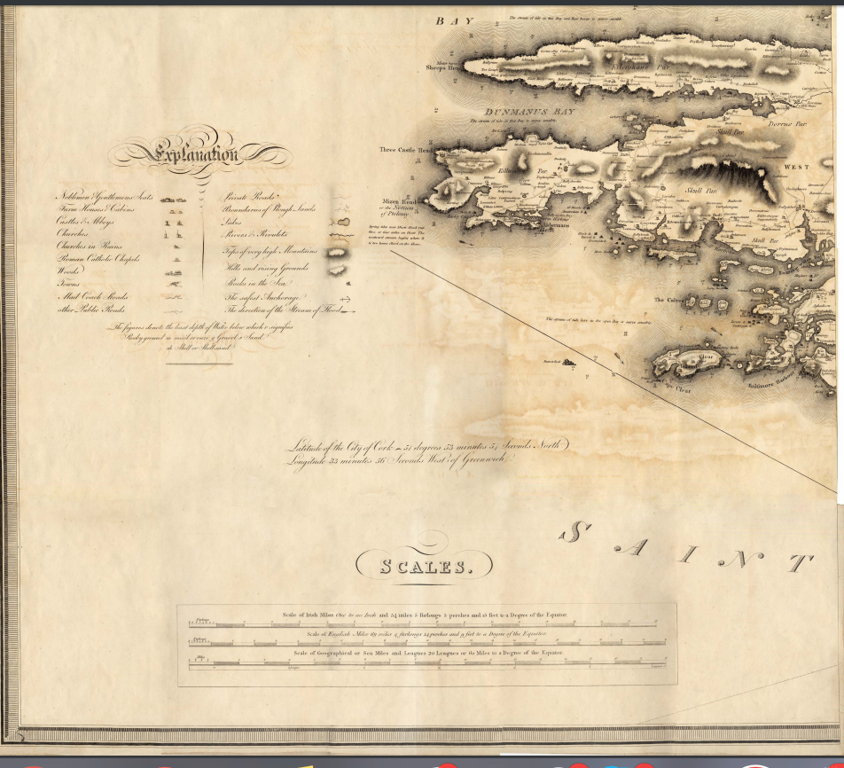
…
..
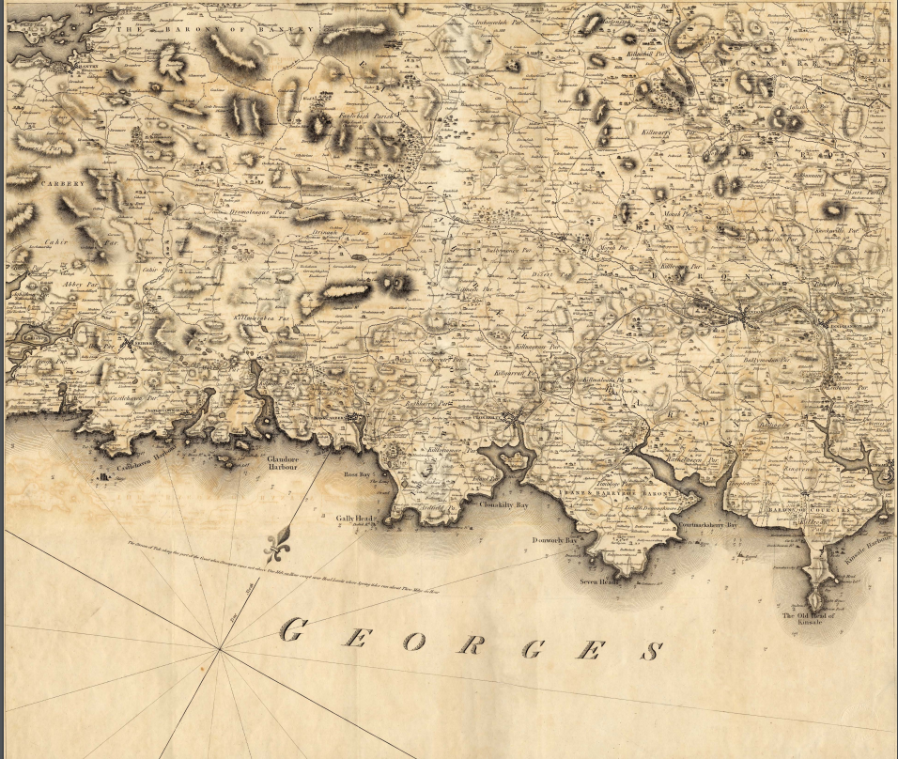
..

.
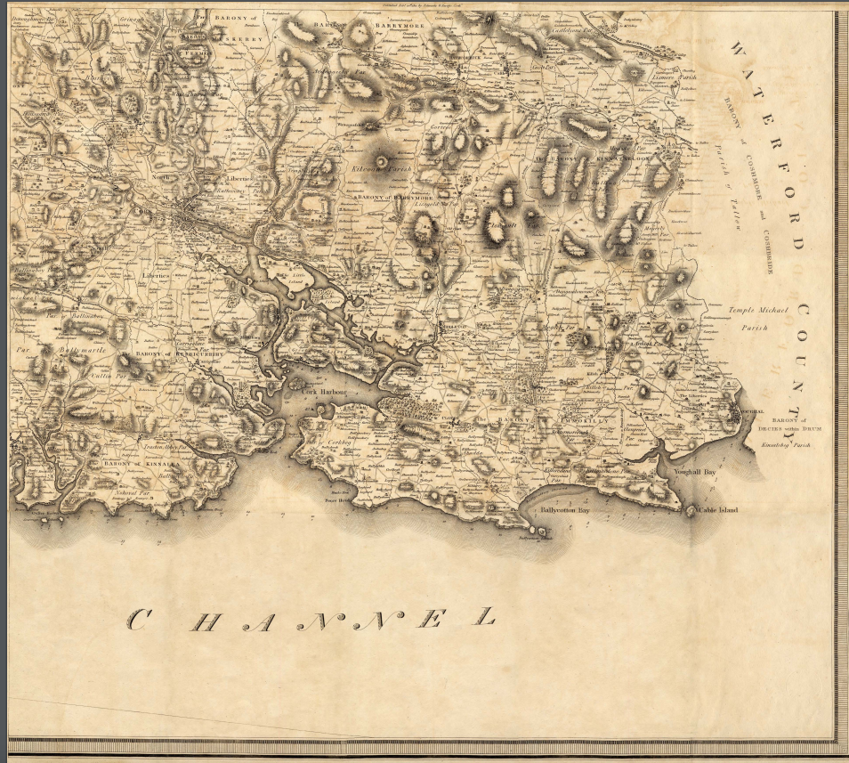
..

……

THE SOUTHERN REPORTER & CORK COMMERCIAL COURIER : TUESDAY 8 APRIL 1834, County Cork
NAMES and PLACES of RESIDENCE of the CESS PAYERS nominated by the County Grand Jury at the last Assizes, to be associated with the Magistrates at Special Road Sessions to be holden in and for the several Baronies within the County, preparatory to the next Assizes, pursuant to Act 3 and 4 Wm. 4, ch. 78.

Barony of Bere | John O’Sullivan Cameatringane | David Kinnigan, Bawn | Edward Puxley, Oaklodge | William Trenwith, Droumdir
James Downing, Castletown | Daniel Sullivan, Dramguiven | Roger O’Sullivan, Seapoint | John Harrington, Killmacowen | Timothy O’Sullivan, Connahanavoe
Richard Martin, Clonee | John Harrington, Grenane | Timothy O’Sullivan, Castletown | William Murphy, Inchintaaglin | William Trenwith, Droumdir
Timothy O’Sullivan, Castletown

Barony of Bantry | William O’Sullivan Carriganass | Michael Sullivan, Droumlickeerue | John O’Connell, Bantry | Richard Levis, Rooska
William Pearson, Droumclough | Daniel O’Sullivan, Reedonegan | Jeremiah O’Sullivan, Droumadureen | John Cotter, Lisheens, | James Vickery, Mullagh
Rec. Henry Sadler, The Glebe | John Godson, Bantry | Richard Pattison, Cappanabowl | John Kingston, Bantry | Samuel Vickery, Franchagh
William Pearson, Cahirdaniel | Robert Vickery, Dunbittern | Daniel Mellifont, Donemark | John Hamilton White, Droumbroe | Samuel Daly, Droumkeal
John S. Bird, Bantry | William Warren, Reendesert | William Vickery, Rooska | Denis Lehane, Trenmadry | John Brien Corkery, Bantry

Barony of Barretts | Richard H. Purcell, Burnfoot | Daniel Swiney, Coolroe | Philip Rubie, Knocknamarruv | Nicholas Kirby, Carhue. Coachford
Richard Donovan, Lisheen, Ballincollig | John Denlay, Kilnagloree | Jeremiah Coakley, Pluckanes, Donaghmore | Henry Lindsey, Meeshal, Coachford | John Swiney, Classes, Ballincollig
James Goolden, Gurrane | Henry Rubie, Knockane | Peter Galwey, Lisnahoundrum | Edmund Murphy, Currylea | Rev. Mr. Stopford, Knocknalier
Cornelius Hogan, Grenaghbeg, | Timothy Murphy, Old Abbey | William H. Low, Ballyfeareen | William Callaghan, Classes, Ballincollig | James Kelly, Newcastle
John Hennessy, Kilblaffar | William Haynes, Temple Hill | John Swiney, Manglin | Cornelius O’Leary | Thomas Batten

Barony of East Division East Carbery | Jonas Stawell, KIlbrittain | Edward G. Good, Phale | William Daunt, Willsgrove | Hibernicus Scott, Coolemain
Andrew poole, Kilrush | John Beechinor, Knockscagh | Michael Crowley, Farranasheshires | Peter Neill, reenroe | Edward Cottrell, Ballinadee
George Dunne, KInsale | James Hayes, Castleview | Major Scott, Farrangark | John beamish, Carhur | Richard Wheeler, Fort Prospect
John Tresilian, Cuttowrane | William Daun, Kilcaskin | Thomas Bailie, Ballybackeen | George Cornwall, Bandon | Winspear Toye, Clonakilty
Henry Cornwall, Bandon | John Howe, Glounavirane | Rev. W. Connor, Doundaniel | Major Broderick, Maryborough | William Austen, Skeafe

Barony of West Division East Carbery | William Scott, East Drinagh | William Norwood, Ballihalwick, Dunmanway | Herbert Gillman, Clounties, Dunmanway | Alexander J. Cox, Kilbarry, Dunmanway
Nicholas B. Jagoe, Kilronan, Dunmanway | Benjamin Holmes, Dunmanway | John Gillman Mylane | James Redmond Barry, Glandore House | John Ranclaud, Kilfinan
Richard Baylie, Ballivoreen, Glandore | Robert Starkie, Cregane, Rosscarbery | Walter Starkie, Burgatia, Rosscarbery | Abraham Beamish, Kilmacabea, Leap | John Wolfe, Coolcraheen, Dunmanway
Rev. Jones? Jones, Drumbeg, Leap | Thomas Hungerford, Farley Cottage, Clonakilty | Richard Wolfe, Caherkirky, Clonakilty | Rev. Joshua Wood, Ross | William Clarke, Clounties, Dunmanway
John Brien, Mohony | James Hayes, Frehanes, Rosscarbery | George Sealy, Kinneigh, Bandon | Arthur Burchill, Kilnscroonagh | Thomas Bradfield, Manch, Dunmanway
 | Abraham Beamish, Kilmacabea, Leap

Barony of East Division West Carbery | Rev. John Wright, Killinah | Gibbs Ross, Smorane, Skibbereen | Alexander McCarthy, Laherdaly | Philip Somerville, Union Hall
John Swanton, Killinagh | George Long, Paddock, Skibbereen | Philip Attridge, Carrigfada | John Sweetnam, Clover Hill, Skibbereen | Robert evans, Ardraly, Skibbereen
George Beamish, Lakemount, Skibbereen | Richard Swanton, Hollyhill, Aughadown, Skibbereen | Nathaniel Lannon (Lannin), Gortnaclohy, Skibbereen | Henry Newman, Gurtnamuckla, Caheragh | Henry Right (Wright?), Skibbereen
Hugh Jagoe, Lahina | Arthur Attridge, Riverview | Francis Beamish, Skibbereen | Robert Ellis, Carrihaliccca | William Young, Letter Scanlan, Skibbereen
William Louth, Glandore House | John Levis, Leighluinn | George Evans, Drimindad, | William Taylor, Drimindah

Barony of West Division West Carbery | Thomas Roberts, Quolah | Robert Swanton, Ratruane, Schull | Alexander O'Driscoll, Gurtnascrena, Drimoleague | Alexander Evans, Lisangle, Caheragh
Philip Somerville, Maulavodera, Ballyehob | Charles Dukelow, Durrus | William C. Browne, Crowe | William Long, Greenmount, Ballydehob | Richard Swanton, Ratruane, Ballydehob
Rev. Edward Alcock, Clashadoo Glebe, Durrus | Murty Houlahane, Clahane, Caheragh | George Vickery Inchegerig, Caheragh | William Vickery, Ballycomane, Durrus | James McCarthy, Ballydevlin, Goleen
James Swanton, Marsh, Skibbereen | Timothy O’Donovan, O’Donovan’s Cove, Durrus | Andrew Caverly, Ardentenant, Schull | William Newman, Woodlands, Schull | Joseph Wolfe, Ballycumisk, Schull

Barony of Condons and Clongibbons | John Anderson, Ashfield, Fermoy | John Martin, Castlehyde | George Johnson, Duntahon | William Austen, Fermoy
Henry Wigmore, Kilbarry, Fermoy | Cornelius O’Brien, Manning, Fermoy | George Ryal. Cornhill, Glanworth | George Luckey, Clondulane, Fermoy | Edward Creed, Leitrim, Fermoy
Thomas Carroll, Kilmagner, Fermoy | Henry Decie, Douglas, | Henry Baylie, Ardglare, Fermoy | William Hill, Kiltrusnan, Fermoy | Thomas Casey, Gurrane, Fermoy
William Connell. Ballyfana, Fermoy | Patrick O’Mara, Ballykendley, Fermoy | Michael O’Brien, Kilaclog | Joseph Carey, Straw Hall, Fermoy
Garrett May, Modeliga, Conna, Fermoy | Thomas Campion, Leitrim, Fermoy | Andrew Sullivan, Fermoy | Maurice Donegan, Macroney, KIlworth | John Hyde, Castlehyde Cottage, Fermoy

Barony of Courceys | John Bullen, Ballyhandle, Timoleague | James B. Gibbons, Ballinspittle | Thomas Tresilian, Currahaly, Barryroe | John Collins Senior, Gortnacrusha, Ballinspittle
George Sealy, Lispatrick, KIlbrittain | Daniel Sullivan, Kilmore | Daniel Dempsey, Lispatrick | Joseph Hourihane, South Gortnacrusha, Ballinspittle | John Collins, North Gortnacrusha, Ballinspittle
William Connell, Drumdirigh | William Galway, Ballinora | John Sullivan, Coolbawn, Barryroe | Denis Griffin, Ballincurrig, Barryroe | Denis Griffin Junior, Ballincurrig,
Laurence Donovan Ballincurrig, Courtmacsherry | Jeremiah Bohane, Old Court, Courtmacsherry | David Manning, Old Court, Courtmacsherry | David Manning, Ballymackner | John Dempsey, Ballymackner
John Mansfield, Ballymackner | Michael Dempsey, Dooneen, Ardfield, Clonakilty | William Quinn, Crohane (Creghane), Barryroe | Patrick Connell, Bogstown | Edward Long, Knockgurrum

Barony of Duhallow | Charles D. Purcell, Mallow | Patrick McCarthy, Kanturk | Richard Smith, Newmarket | Timothy Shine, Corbally
Cornelius Sheehan, Clonmeen, Banteer | Rowland Burke, Bantyre | Richard O’Callaghan, Killenligh | ---Lloyd, Milliew | Richard Terry, Bettyville, Mallow
Matthew Fitzpatrick, Freemount, Kanturk | Nicholas Philpot Leader, Nashville, Kanturk | William Sharpe, Glenmount, Kanturk | John Philpot, Clonribbon, Kanturk | Francis Burton, Curras, Kanturk
George Bolster, Curraghbower, Lombartstown | John Twomey, Dysart, Dripsey? | Timothy Guinee (Guiney), Knockaclarig, Rockchapel | Henry Newman, Droumoneen | James Nunan (Noonan), Curraheen, Kanturk
Daniel McAuliffe, Fortgraddy, Millstreet | William Sullivan, Tullylease, Kanturk | Timothy Croning, Assolas, Kanturk | ---Sherlock, Ballyheen, Kanturk | Jeremiah Lane, Coonahane

Barony Imokilly | Crofton Uniacke, Ballyre | Patrick Lawlor, Mount Uniacke | William Hall, Garranjames, Castlemartyr | Thomas Welsh, Dromada
James Hanning, Kilcone | James Gleeson, Lisquinlan, Castlemartyr | Jonas Smyth, Ballyshane, Cloyne | John Canny, Ballyglashine | John Carden, Midleton
Richard Hall, Gathnagark | Rec. C. Harte, Lisquinlan | Rev. William Boles, Springfield, Castlemartyr | Walter Atkin, Careystown | Daniel Hamhreys, Midleton
James Fitzgerald, Carrigacrump, Cloyne | Patrick Smiddy, Carrigshehan | William Abbott, Shangarry | R.P. Fitzgerald, Corkbeg, Whitegate | Christopher Upton, Cloyne
Edward Roche, Trabolgan, Cloyne | Jonas Smith, Inch, Cloyne | John Connor, Ballymacandrick, Cloyne | Rev. R. Longfield, Castlemary | R. Travers, Mosastown

….

….

….

….

Southern Reporter and Cork Commercial Courier 11 June 1831
Robert Scoble. Author of O'Sullivan piece was published as Chapter 7 of book Raven: The Turbulent World of Baron Corvo (Strange Attractor Press, London, 2013).
http://www.dippam.ac.uk/eppi/documents/9835/page/215836
http://www.dippam.ac.uk/eppi/documents/15390/page/399635
http://www.dippam.ac.uk/eppi/documents/9508/page/210267
http://www.dippam.ac.uk/eppi/documents/8322/page/196221
Laings Directory: http://www.corkpastandpresent.ie/places/streetandtradedirectories/1863laingdirectory/files/assets/basic-html/page105.html
Chief Secretary papers: http://www.csorp.nationalarchives.ie/search/index.php?simpleSearchSbm=true&category=27&searchDescTxt=high+constable&simpleSearchSbm=Search#searchfocus
http://www.csorp.nationalarchives.ie/search/index.php?simpleSearchSbm=Search&category=27&searchDescTxt=high+constable&offset=20&browseresults=true
http://www.dippam.ac.uk/eppi/documents/14301/page/369732
https://books.google.ie/books?id=8iA6AQAAMAAJ&pg=PA823&lpg=PA823&dq=delacour+grand+jury+treasurer&source=bl&ots=Gu7TCzsDXu&sig=WBMqYoN0SS3PMu1ugOF8WeEBTBs&hl=en&sa=X&ved=0ahUKEwik58uO3NvQAhWlBsAKHSo1BKAQ6AEIITAC#v=onepage&q=delacour%20grand%20jury%20treasurer&f=false
https://books.google.ie/books?id=LFQSAAAAYAAJ&pg=RA1-PA2&lpg=RA1-PA2&dq=de+la+cour+treasurer+cork&source=bl&ots=Ib9Lg1PIHq&sig=0NSYvrdoHHbBZFs0sInULGI5hb8&hl=en&sa=X&ved=0ahUKEwiykJXm_tzQAhWlJMAKHbQOBwE4ChDoAQgJMAA#v=onepage&q=de%20la%20cour%20treasurer%20cork&f=false
https://books.google.ie/books?id=LFQSAAAAYAAJ&pg=RA1-PA2&lpg=RA1-PA2&dq=de+la+cour+treasurer+cork&source=bl&ots=Ib9Lg1PIHq&sig=0NSYvrdoHHbBZFs0sInULGI5hb8&hl=en&sa=X&ved=0ahUKEwiykJXm_tzQAhWlJMAKHbQOBwE4ChDoAQgJMAA#v=onepage&q=%20cork&f=false
https://books.google.ie/books?id=LFQSAAAAYAAJ&pg=RA1-PA2&lpg=RA1-PA2&dq=de+la+cour+treasurer+cork&source=bl&ots=Ib9Lg1PIHq&sig=0NSYvrdoHHbBZFs0sInULGI5hb8&hl=en&sa=X&ved=0ahUKEwiykJXm_tzQAhWlJMAKHbQOBwE4ChDoAQgJMAA#v=onepage&q=%20cork&f=false
https://books.google.ie/books?id=LFQSAAAAYAAJ&pg=RA1-PA2&lpg=RA1-PA2&dq=de+la+cour+treasurer+cork&source=bl&ots=Ib9Lg1PIHq&sig=0NSYvrdoHHbBZFs0sInULGI5hb8&hl=en&sa=X&ved=0ahUKEwiykJXm_tzQAhWlJMAKHbQOBwE4ChDoAQgJMAA#v=onepage&q=%20cork&f=false
Cork Examiner 2nd March 1865.
http://www.astro.wisc.edu/~townsend/tree/record.php?ref=213
http://www.academicroom.com/article/local-elite-creation-early-hanoverian-ireland-case-county-grand-jury
Neal Garham: http://www.academicroom.com/article/local-elite-creation-early-hanoverian-ireland-case-county-grand-jury
http://www.dippam.ac.uk/eppi/documents/10229/page/226454
Skibbereen & West Carbery Eagle; or, South Western Advertiser 07 January 1865
Dr. Casey Collection, item 2389, John T. Collins newspaper extracts originally from Kearney family Garretstown House.
Heritage Bridges of County Cork. Published by Heritage Unit of Cork County Council 2013

