Tithes

Tithes were a medieval tax of one tenth of crops. The benefits went to the clergy who were expected to provide civil services out of it. In Cork Richard Boyle (ancestor the the Dukes of devonshire and numerous other lines) managed by underhand methods in the early 17th century to acquire most of the Diocesan tithes. A large part was ‘impropriate’ and in time were traded as any form of property. Much of the later trouble with tithes came from the vigorous enforcement to entitlements by tithe proctors who sometime acquired the tithes or received a significant proportion of money collected.

The Tithe Composition Act of 1823 provided that a special Vestry could appoint an arbitrator to determine the amount of tithe. The exemption of pasture from tithe was abolished in 1824. The amount of tithe was fixed at 21 years. Schull implemented tithe composition in 1826. KIlmoe followed in 1828, Aughadown in 1829 and Kilcoe in 1830. In Kilcoe the tithe of £215 of which went to the Rector Rev. Henry Stewart the balance to the ‘lay impropriator’, Lord Audley.

The local tithe compositions were extremely high, of Durrus £350 of which £170 to the lay Impropriator originally the Earl of Donoughmore in the 1820 it was divided into Nathaniel Evanson for Durrus and he and Alexander O'Driscoll for Kilcrohane, Schull Parish was £850, Kilmoe £500, Dunmanway £461 in contrast to Watergrasshill near Cork of £43. Tithes payable Rev. Edward Jones Alcock, Durrus, of £320 Sterling is due and payable by the year to the said Reverend Edward Jones Alcock, the composition from the tithes claimable by him as figure of such part of said Parish as is commonly known by the name of Durrus or Parish of KIlcrohane is payable to the Reverend Alcock Vicar of the said Parish the sum of £170.

After the depression starting at the end of the Napoleonic Wars in 1815 the earlier measure to alleviate tithes was inadequate and widespread agitation broke out. The Reverend Robert Traill, Rector of Schull wrote, ‘One clergyman within 30 miles of us has been murdered, and another most narrowly escaped with his life by taking refuge in the house of a priest. The ungodly are rising up, and these poor deluded Roman Catholics are caballing to deprive me of my tithes, alas!. What wickedness is this?

Tithe agitation drew on the earlier activities of the Whiteboys. As late as 1822 Richard O’Donovan, of Bawnlahan said the Whiteboys had been caught in a pitched battle with police and troops on January 25th nine had been found guilty of Insurrection Act and hanged. This was prompted by and Excise raid on a poteen making operation which developed into a running battle with the Whiteboys.

From 1834 the anti tithe meetings combined with Repeal meetings but largely with the same organisers.

The Tithe Act of 1833 reduced tithes by 25% and converted it into a tax into a rent charge to be collected by the Landlord wit the rent.

By 1838 there were public meetings in Skibbereen and Bandon where all sides agreed to look for ‘an equitable arrangement of tithes’ and asked parliament to make the necessary arrangements.

1832: The Reverend Messrs. Quin and Kelleher, the Roman Catholic Clergy of Muintervara, West Cork, were arrested on Saturday, the 15th September or having attended at a Tithe meeting. Bail was immediately procured in the person of Richard O’Donovan Esq, the Chairman of the late Anti-Tithe meeting in the Parish and Timothy O’Donovan Esq at Ardahill, Kilcrohane.
The men from Muintervara (Durrus/Kilcrohane) who have the distinguished honour of being the first Western district to have given the death blow to the Tithe system, proceeded under the conduct of Richard O’Donovan Esq of Tullagh and Timmy O’Donovan Esq at Monster Meeting Mount Gabriel 1832. Most of the tithes of the Dioceses of Cork were acquired by underhand means by Richard Boyle, The Great Earl of Cork in the early 17th century. For Durrus/Kilcrohane they were acquired by Nathaniel Evansons and shared between him and the local Church of Ireland Minister aided by Tithe Proctors

Cess Tax

The cess was generally in the region of 12% of gross rents and was used by the Grand Jury (the predecessor of the County Council established in 1899) to fund works such as road and bridges. The collection was done by Baronial Constables who charged a poundage, They had a staff of drivers dn presumably proctors who enforced payment. A popular method of extraction was the seizing of cattle, pigs or other livestock. They were then detained in local pounds until sale. The memory lives on in local speech with the phrase ‘Bad cess to you’.

1843 Baronial Constables. Bantry and Bere, John O’Sullivan. Bandon town, Horace Poole. East Division, West Carbery, Samuel Levis. West Division West Carbery, William Swanton.

Cess Payers.

NAMES and PLACES of RESIDENCE of the CESS PAYERS nominated by the County Grand Jury at the last Assizes, to be associated with the Magistrates at Special Road Sessions to be holden in and for the several Baronies within the County, preparatory to the next Assizes, pursuant to Act 3 and 4 Wm. 4, ch. 78.

Barony of Bere | John O’Sullivan Cameatringane | David Kinnigan, Bawn | Edward Puxley, Oaklodge | William Trenwith, Droumdir
James Downing, Castletown | Daniel Sullivan, Dramguiven | Roger O’Sullivan, Seapoint | John Harrington, Killmacowen | Timothy O’Sullivan, Connahanavoe
Richard Martin, Clonee | John Harrington, Grenane | Timothy O’Sullivan, Castletown | William Murphy, Inchintaaglin | William Trenwith, Droumdir
Timothy O’Sullivan, Castletown

Barony of Bantry | William O’Sullivan Carriganass, Kealkil | Michael Sullivan, Droumlickeerue | John O’Connell, Bantry | Richard Levis, Rooska
William Pearson, Droumclough, Bantry | Daniel O’Sullivan, Reedonegan | Jeremiah O’Sullivan, Droumadureen | John Cotter, Lisheens, | James Vickery, Mullagh, Bantry
Rec. Henry Sadler, The Glebe | John Godson, Bantry | Richard Pattison, Cappanabowl, Bantry | John Kingston, Bantry | Samuel Vickery, Franchagh
William Pearson, Cahirdaniel, Bantry | Robert Vickery, Dunbittern, Bantry | Daniel Mellifont, Donemark | John Hamilton White, Droumbroe | Samuel Daly, Droumkeal
John S Bird, Bantry | William Warren, Reendesert | William Vickery, Rooska | Denis Lehane, Trenmadry | John Brien Corkery, Bantry

Barony of East Division West Carbery | Rev. John Wright, Killinah | Gibbs Ross, Smorane, Skibbereen | Alexander McCarthy, Laherdaly | Philip Somerville, Union Hall
John Swanton, Killinagh | George Long, Paddock, Skibbereen | Philip Attridge, Carrigfada | John Sweetnam, Clover Hill, Skibbereen | Robert evans, Ardraly, Skibbereen
George Beamish, Lakemount, Skibbereen | Richard Swanton, Hollyhill, Aughadown, Skibbereen | Nathaniel Lannon (Lannin), Gortnaclohy, Skibbereen | Henry Newman, Gurtnamuckla, Caheragh | Henry Right (Wright?), Skibbereen
Hugh Jagoe, Lahina | Arthur Attridge, Riverview | Francis Beamish, Skibbereen | Robert Ellis, Carrihaliccca | William Young, Letter Scanlan, Skibbereen
William Louth, Glandore House | John Levis, Leighluinn | George Evans, Drimindad, | William Taylor, Drimindah

Barony of West Division West Carbery | Thomas Roberts, Quolah | Robert Swanton, Ratruane, Schull | Alexander O'Driscoll, Gurtnascrena, Drimoleague | Alexander Evans, Lisangle, Caheragh
Philip Somerville, Maulavodera, Ballyehob | Charles Dukelow, Durrus | William C. Browne, Crowe | William Long, Greenmount, Ballydehob | Richard Swanton, Ratruane, Ballydehob
Rev. Edward Alcock, Clashadoo Glebe, Durrus | Murty Houlahane, Clahane, Caheragh | George Vickery Inchegerig, Caheragh | William Vickery, Ballycomane, Durrus | James McCarthy, Ballydevlin, Goleen
James Swanton, Marsh, Skibbereen | Timothy O’Donovan, O’Donovan’s Cove, Durrus | Andrew Caverly, Ardentenant, Schull | William Newman, Woodlands, Schull | Joseph Wolfe, Ballycumisk, Schull

1825 Criticisms of Magistrates:

1825. File of documents containing criticisms of magistrates from Augustus Webber, Cork and recommending individuals to appear before an investigation on the state of Ireland. Letter from Augustus Webber, Cork, to Robert Peel, Home Secretary, stating that he has made a tour of Ireland and observing that there exists in that county ‘a strong opinion that the laws are unjustly administered by the Magistry’ in parts of west Cork were ‘intelligent gentry are so few and where local prejudices and family ties so much abound’. Suggesting that Mr Boile of Beerhaven, Mr Boyce of Bantry and Mr Hutchinson (probably Hutchins) of Bantry could be called to give evidence before the committee investigating the state of Ireland. Also covering letter from Peel, Whitehall, [London], to Goulburn and copy of reply from Goulburn, stating that they have a sufficient number of witnesses to appear before the committee.

Letter from James Morgan Cooke, late lieutenant, Royal Cork City Regiment, Bantry, County Cork, to Henry Goulburn, Chief Secretary of Ireland, Dublin Castle, seeking appointment as chief constable in the police establishment in any part of Ireland or another post under government. Complains of an increase in local harassment by adherents of the Roman Catholic Church since his failed attempt to procure arms from government for a local volunteer Protestant corps. Laments since his deputation to the Earl of Bantry [Richard White] he is ‘completely persecuted’ and wishes to escape with his family from so ‘great a set of Jesuits as ever escaped from the gloomy walls of Maynooth’. Also second letter from Cooke to Goulburn, acknowledging his failed application for employment and remarking on the heightened political atmosphere present in the town. Encloses copy of ‘a song in praise of [Daniel] O’Connell which has been sung for the last two days in this town’ [not present]. CSO/RP/1825/1918.

1825. File of material relating to a dispute between Lieutenant J Boileau, inspecting commander of the coast guard, and Captain Morty O’Sullivan, magistrate, and the police of Castletown, Berehaven, County Cork. Includes letter from Boileau, Castletown, to Henry Goulburn, Chief Secretary, Dublin Castle, stating his objection to the arbitrary rule of O’Sullivan and to the unlawful conduct of the local police constabulary, especially that of Mr Coote, chief constable. Alleges on a number of occasions the police placed in prison those accused of relatively minor offences and contends that O’Sullivan’s speech is ‘so gross, that it would deter a gentleman from appearing before him’ as magistrate. Claims to be a person of ‘pacific disposition’ and requests intervention of government to correct the abuses complained of, 17 March 1825. Also includes copy letter from O’Sullivan to William H Gregory, Under Secretary, Dublin Castle, defending his own behaviour and that of the police of Castletown. Remarks that members of the coast guard are treated in the same way as any other person under the law. He casts doubt over Boileau’s attitude to the duties of the police and magistracy, 20 March 1825. Also includes copy letter from Maxwell J Blacker, barrister, Dublin, to Gregory, inclosing copy proceedings of investigation of charges against the magistrate and police on foot of charges raised by Boileau. Indicates the public inquiry heard in Bantry, County Cork, on 16 April 1825, brought into consideration a total of 11 charges, and led to a verdict of improper behaviour by the police. Annotation from Richard Wellesley, 1st Marquis Wellesley, Lord Lieutenant [on back of Blacker’s letter], advises ‘I think it would be the best course to remove the Chief Constable with the whole party [of police]’ from the district, 16; 27 April 1825.

Voting Background.

From 1793 to 1829 voters were restricted to people with at least a 40 shilling (£2) freehold/leasehold. It did not have to be a freehold a lease was sufficient. Year to year annual rents did not count.

This included many Catholics voters from 1793 (Catholic Relief Act 1793) firstly for the Irish Parliament and after 1801 for the United Kingdom Parliament.

In the Catholic Relief Act of 1829 the qualification restriction was raised to £10 and it remained this way until 1885. This excluded many Catholic and Protestant who were previously entitled to vote.

Many professional people like doctors lived in towns and you can see from Griffiths Valuation that a fine town house may only be valued at 5 or 6 £. It is because of this you see their voting rights are based on property they held elsewhere. You also come across candidates and their supporters giving their supporters / tenants leases so that they could vote. After the election these leases were often returned.

The 40s freeholder remained for a number of years beyond 1829 for borough/local elections.

The voting lists available online at “Fictitious Voters” is a strange name for the voting lists. It arises out of the fact that many people were awarded freedom of the towns and cities. These people could vary from visiting Military Officers, Royalty etc etc...........In theory all “Freemen” were entitled to vote in elections but non resident freemen were disfranchised in 1829 being in theory “fictitious voters” ....... not that they ever came to vote.

Applications to set up National Schools Durrus, West Cork 1830.

Some of the people involved are in the following list E.Evanson may be Alleyn Evanson.
Father Quinn applied from Durrus and the form is in the National Archive. The Durrus school set up in 1810 was in the grounds of the Chapel where the National School is located. The old church was on the site until it was replaced c 1900. Father Quinn’s application 16th November 1830 ED1/13/74/2, signed by for Roman Catholics Richard O’Donovan, Timothy O’Donovan, Richard Tobin, Edmond Tobin, Daniel Daly, Richard O’Donovan, John Murphy, John Carthy, Thomas Cormack?, Elias Roycroft, Andrew Caverly, Richard Caverly, Protestants E. Evanson, Richard L. Blair, Thomas Ferguson, Thomas Duklow, Charles Ducklow, John Ducklow. Rev Alcock of the Church of Ireland was asked to consent but declined but his parishioners signed.

Rev. Thomas Barry. -1853)

St. Patrick's College, Maynooth Co Kildare, Ordained 1810. Appointments South Parish, PP : 1847 - 3/12/1853 Bantry PP : 1822 - 1847 Passage West PP : 1812 - 1822 South Parish CC : 1810 - 1812

Subscriber Lewis Directory 1837. Gave evidence to 1844 Commission Law and practice in respect to the occupation of land in Ireland. Parish Priest since 1823. Knows of no property more improved than that of Mr. White of Inchiclough tenants generally have leases.

1824. Petition of the superintending committee of the Bantry Poor School, County Cork, to Richard Wellesley, 1st Marquis Wellesley, Lord Lieutenant, Dublin Castle, requesting advance of funds to aid purchase of books and requisites for use of their teaching establishment. Conveys they have a school house for use of the Roman Catholic children of the neighbourhood, which was established primarily upon funds given by bequest from Reverend Daniel A Croly [Crolly], late parish priest of Bantry. Salaries of the school master and mistress are ‘paid from the half penny collection at the Chapel door’ in addition to some local subscriptions. Protests they cannot accept assistance from Protestant societies advocating use of scriptures ‘without note or comment’ since such is contrary to dogma and perceived to be part of a ‘proselytizing scheme’. Petition signed by Reverend Thomas Barry, parish priest and 5 other persons. With draft reply annotated on base indicating the Lord Lieutenant has no funds for the purpose envisaged. Aid may only be obtained from those societies who are concerned with the education of the poor of Ireland. [Contains list of names not given in this description]

Dictionary of Ireland 1837. Thanked Assessors as Independent Liberal Elector for Impartiality in 1835 elections. 1835 the following thanked for their fairness in conducting recent election, James O'Brien, Thomas Parsons Boland, Charles Evanson, Daniel Connellan, George Wade Foot ,Richard (Rickard?) Donovan, a delegation was selected to give thanks Rickard Deasy (Chairman), Thomas Coppinger, Esq., JP, Midleton, Rev .J Barry, P.P., Bantry, Rev. J. Doheny, P.P., Dunmanway, T. Dennehy, Esq., Martin Farrell, Esq., Daniel Clanchey, Esq., Charleville, J.P., Deputy Chairman D. Geran Junior. Fermoy,

Organiser meeting of Loyalty of Catholics of Bantry to King 1825. Included were Morty O’Sullivan, Daniel O'Sullivan, Reendonegan, John Young, Morgan Connell Esq., Alexander O’Donovan Esq., William McCarthy Esq., Point House,. Subscriber 1843 to Cenotaph for late Rev. Dr. English. Signed Testimonial to Resident Magistrate, John Gore Jones, Bantry, 1844. Assisting 1848 Henry J. Fawcett, Practical Instructor on Husbandry of Visit to Bantry.

Attributed to him

There was a Parson
Who loved ‘divarshun’
And ne’er was harsh on
His flock so few,,,
The tithe was heavy
That he died levy
And he kept a ‘bevy’
Of tithing men...

Rev. Michael Collins

HIs evidence to Parliamentary Enquiry in Southern Reporter and Cork Commercial Courier 26 March 1825. Protestant Half Pay Officers on £40 a year preferred as Quarter Session Jurors in Bantry to Opulent Catholics the likes of Deasy, Clonakilty on £2,000 a year.

Morgan Connell,

Probably brother of John O’Connell. Secretary Catholic Rent 1825.

Alexander Donovan/O’Donovan

Vote in 1841 election based on 20 freehold at Glounagorrin, Bantry. Gave evidence to 1844 Commission Law and practice in respect to the occupation of land in Ireland. Meeting of Loyalty of Catholics of Bantry to King 1825. Included were Morty O’Sullivan, Daniel O'Sullivan, Reendonegan, John Young, Morgan Connell Esq., Alexander O’Donovan Esq., William McCarthy Esq., Point House. 1845 Quarter Session Juror.

Roger Downing

Proposing Resolution Bantry Catholic Meeting 1826. Slater 1846 Tobacco Manufacturer, Main St. Described as wily Kerryman. Brother of Timothy McCarthy Downing, born Kenmare, Skibbereen Solicitor, MP. and landowner. The discovery of this object (The Brahalish Brooch) was first reported to John Windele by one of He reported the find of the Brahalish Hoard in Durrus to John Windle 1843. In a letter dated 4 January 1843, he states ‘You have at top, the size of the piece of Gold found at Brahalish, 4 Mile Water, it weighs 3⅝ ozs avoirdupois Wt. both ends are in the form of a Cup; with a narrow Carving inside of the edges, the outside of the ends, and the greater part if not the entire of the handle are carved as above;You will perceive by the Size and Wt. of the article that it is not Solid, the oining being visible on the inside of the handle, it appears to be of the purest gold; I need not say that the finder sets a great value on his God Send; he says he is certain of finding more of it; that he dreamt 30 years since that there was gold hidden where he found this article. It would not astonish me, if he rooted up half his farm in search of the precious metal. If this Article lies in your way and that I can be of any assistance in purchasing it, I am at your service. Comment Windele notes that the finder’s name was Owen Sullivan (referred to as Eugene Sullivan by Roger Downing) and that the find-place was the site of an ancient fort, the article having been found under the root of a hawthorn. John 2nd son of David Galwey Downing, Berehaven Catherine eldest daughter of later Roger Downing, Bantry

Charles Dukelow, Carrigboy (Durrus).

Father Quin's (PP Durrus) application for national School, 16th November 1830 ED1/13/74/2, signed by for Roman Catholics Richard O'Donovan, Timothy O'Donovan, Richard Tobin, Edmond Tobin, Daniel Daly, Richard O'Donovan, John Murphy, John Carthy, Thomas Cormack?, Elias Roycroft, Andrew Caverly, Richard Caverly, Protestants E. Evanson, Richard L. Blair, Thomas Ferguson (Clashadoo), Thomas Duklow (Clashadoo), Charles Ducklow, John Ducklow. Rev Alcock of the Church of Ireland was asked to consent but declined but his parishioners signed. He is listed as a Cess Payer for the Barony of West Carbery in 1834 with other locals including Rev. Edward Alcock of Clashadoo and William Vickery of Ballycomane. This nomination was by the County Grand Jury to sit with Magistrates on road presentments.

Thomas Dukelow, Clashadoo, Durrus.

Probably from Crottees married into Clashadoo on his 1810 marriage to Frances Coughlan. She is probably of the extended Coughlan family of Carrigmanus likely pre Celtic in origin. Converted to Protestantism c 1600 associated with Hulls and Boyles. Jeremy/Jeremiah of the family an Attorney, seneschal and manager of Devonshire Waterford Estate renting with his brother in law Nathaniel Evanson from c 1720 including Clashadoo. William Vickery member of Select Vestry St James, Durrus, with Thomas Dukelow. 1845 Quarter Session Juror. The Durrus Dukelows part of an emigration of Durrus and Schull Protestants to Rochester, New York. Through the Republican Party they created a political machine known as the ‘99 cousin’ which dominated city government in the mid and late 19th century a pelia of the Irish Catholic machines in other US cities. The Catholic branch of the family descended from John Dukelow emigrated to East London and with Durrus Swantons and Hurleys were active as Fenians in the 1860s. Later one of the extended family provided accommodation in a lodging house to Michael Collins when he went to London to work as a Post Office clerk.

Father Christopher Freeman,

Curate, Bantry from 1836. Gave evidence to 1844 Commission Law and practice in respect to the occupation of land in Ireland. Estate owners in fee, Lord Bantry rents high but not rigidly exacted, some dispossessed by Lord Kenmare found refuge on his estate, resident. Lord Kenmare on expiry of middle men leases from 1840 widespread evictions. His estate comprises 23,000 acres with a population of 3,400. Richard White of Inchiclough, Robert White most tenants have leases. Mr. Wallace, a Scotch Gentleman resident in USA.

Some sympathy with Landlords as estates so heavily encumbered no leeway in some cases forced to evict. Worst lcl Landlord Lord Kenmare since 1840 through his agent Galwey.
Extensively involved with PP Father Michael Barry in anti-tithe agitation, collecting O’Connell rent, Repeal.

Arthur Hutchins:

1824. Letter from Anthony Hutchins (probably Arthur) , magistrate, Ardnagashel, near Bantry, County Cork, to Henry Goulburn, Chief Secretary of Ireland, Irish Office, Westminster, London, offering observations on causes of instability in Irish society. Concludes the upper classes have failed in their responsibilities to the lower orders, providing neither a fair measure of justice nor general employment; in such circumstances there is ‘still the strongest necessity for continuing the Insurrection Act’. Traces much of social disquiet to factors such as corrupt use of public money in grand jury presentments and to an unfair administration of the law in tithe cases; advocates that legal consideration of tithe cases be conducted by assistant barristers at general sessions rather than by local magistrates. Observes should modification be made to the tithe or to status of church property ‘it will probably tend to the decline of the Protestant Religion in Ireland’. Offers assistance to government on necessary measures to bring stability to Irish society.

Samuel Hutchins

Gave evidence to 1845 Commission Law and practice in respect to the occupation of land in Ireland. Obliged by Lord Kenmare to evict at Derry Dew. Has land in Macroom, Carbery near Skibbereen, near Charleville and in Barony of Fermoy.

John Shea Lawlor Esq., Gurteenroe

Attending dinner in Tralee for the Liberator 1844, probably related to Denis She Laloe ex JP `Castlelough, Co. Kerry.

John Jagoe (probably the Liberal Protestant) 1826 Rent charge assigned 1833 to John O’Connell esq., over Glounathana also named Morgan O’Connell, Merchant, Liverpool, James O’Connell, Merchant, Cork Attorney Timothy Collins. Pigot 1824 places him at Lahern. 1857 Landed Estate Sale with Tenant Listing of Jagoe/O'Connor Estate, Bantry (Knockavolig, Clogeragh, Dereengrenough, East and West Caheragolane, Ardrara) Extended Family Probably include Youngs Fish Merchants Bantry, Dr. O'Connor United Irishman Transported to Australia, John Jagoe Fishery Commissioner Political Liberal, John Jagoe Barrister, Mother Beninga Pioneer Womens Education Townsvile Australia, Dowes and Coughlans of Carrigmanus.

 |  |  | Type of deed | Date of current deed |  | 17 Oct 1833 | Vol | Page | Memorial
 |  |  | Indented Deed | Date of earlier deed |  |  | 183308 | 227 | 183308227
No | Role(s) in earlier deed(s) | Role in current deed(s) | Family name | Forename |  | Place |  | Occ or title |  | A
A |  | P1 | JAGOE | John | of | Lahern, Co Cork |  | Esq
B |  | P2 | O'CONNELL | Morgan | of | Liverpool, Lancashire, England |  | merchant
C |  | P3 | O'CONNELL | John | of | Bantry, Co Cork |  | merchant
D |  | WD WM | CONNELL | James | of | City of Cork |  | merchant |  | A
E |  | WD WM | COLLINS | Timothy | of | City of Cork |  | Attorney at Law |  | A
Abstract |  | A granted to B the rent charge for the lands of Glaunathana as held by an 1826 lease from the Earl of Bantry.
MS |  |  | Date registered | 17101833 |  | Date abstract added |  | 20140222

...

Daniel McCarthy Esq., Gortnascreehy.

Piggot lists 1824. Proposing Resolution Bantry Catholic Meeting 1826.

Rev. Robert Morritt, Creagh Glebe, Skibbereen, Pre 1821. Letter 1821 to Chief Secretary re lawlessness in Creagh, lack of military forces and poor calibre of police. Notorious tithe extractor whose actions led to an affray at Castlehaven in which life was lost. At the subsequent hearing into affray he accepted that the Skibbereen Magistrates were hostile to him. Later Rector Castlehaven where he was almost universally hated for tithe extraction. He was reported as having neighbouring magistrates hear 600 summons against his parishioners re tithes owing. Lord Carbery in 1823 said Morritt was English in that year he had extracted £2,300 out of his tithes of £2,700. He seems to have resigned his living some time after. Later Paris 1828 Defamation action while in English Protestant Establishment In Paris against three Anglican Clergymen

Michael Murphy, Donemark.

Pigot lists 1824 at Newtown. Gave evidence to 1845 Commission Law and practice in respect to the occupation of land in Ireland (Devon Commission), Protestant. Farmer formerly on Lord Kenmare’s estate family held for 200 years, and hugely improved with tenants having hundreds of pounds worth of trees unregistered due to confidence in earlier Lords Kenmare now possessed without compensation. County Freeman of Cork City voting in Cork City Election 1837. Holds mills and purchases corn. Extensive ruins of mills still there at Donemark Bridge towards sea

1829 Michael Murphy with Lord Bantry funds from Dublin Castle. Murphy may have later difficulties as he may have had a personal liability for this advance.

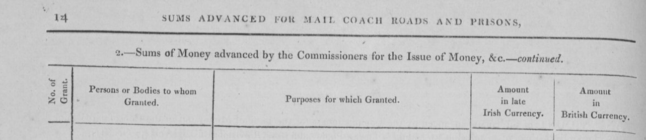

Murnanes, Letterlickey, Durrus. Hutchinson Estate Sale 1853 lists John O'Connell as Representative of John Murnane and other lease of 320 acres at a rent of £54 by lease of 1808 by Stephen Hutchinson to Owen, John, Denis, Timothy, Daniel Murnane for the lives of Owen and Patrick Murnane and Daniel Duggan of whom Owen Murnane and Daniel Duggan were still living. Part of a network of similar families such as McCarthys of Letterlickey, O’Sullivans, Millers and shopkeepers Durrus, Tobins Kilcrohane, Shannons Brahalish, Fitzgeralds of Baltimore. These families intermarried and from the mid 19th century many priests, teachers, nuns and medical professional emerge from this class.

Jeremiah O’Connell Esq., Bantry

1840 Secretary Bantry O’Connell Annuity. 1841 vote based on £50 freehold at Upper Lissane. 1842 Secretary of delegation to Lord Mayor of Dublin, Daniel O’Connell with John O’Hea, JP, Clonakilty to address Tory opposition. 1843 letting of Deendonegah House then occupied by Arthur Hutchinson JP contact Jeremiah O’Connell Esq. 1843 dinner for Alderman Lyons, Cork with other leading Liberal figures. Married 1845 Mary Frances daughter of Daniel Murphy, Bellville, Cork by her uncle Dr. Murphy. 1845 Provisional Committee Bantry to Bandon Railway. Signed Testimonial to Resident Magistrate, John Gore Jones, Bantry, 1844. Banquet for Liberator in Cork 1845 Address from West Carbery and Bantry by Father Thomas Barry, with Father Freeman, Jeremiah O’Connell, John O’Connell, Bantry, McCarthy Downing, Solicitor, Skibbereen, Daniel Welply Skibbereen. Distributing in Bantry New England Famine Relief 1847. 1850 Ivy Cottage, Bantry. Not sure if same, Jeremiah O'Connell, Esq., J.P., of Beach House, Bantry, co. Cork. Died 1878, at St. Mary's, Frankfort-avenue, Rathgar, County Dublin.

John O’Connell Esq., Bantry.

Gave evidence to 1844 Commission Law and practice in respect to the occupation of land in Ireland. Landlord in fee, middleman, agent to proprietor abroad, merchant, farmer. Property in Skibbereen. Probably the John Connell referred to in evidence of Father Collins to Parliament Commission as opulent Bantry excluded from Quarter Session Jury as he was a Catholic. 1825. Wanted an Active Young Man Conversant with the Linen Business, Apply John O'Connell, Bantry or Henry O'Regan, South Main St., Cork, Must Speak the Irish language.

The name appears in Bantry rental for 1837 receiver of Estate rents as a lease of 1796 for 3 lives and 31 years in the town at a rent of £5 5 shillings fairly substantial among other rents. 1826 Rent charge assigned 1833 from John Jagoe (probably the Liberal Protestant) over Glounathana also named Morgan O’Connell, Merchant, Liverpool, James O’Connell, Merchant, Cork Attorney, Timothy Collins. Around 1830 purchased around 700 acres from Lord Riversdale probably his O’Donovan in-laws estate at Ardahil, Kilcrohane. Tenants most refractory men in the country, prize fighters, and the head of a faction, they paid no rent. rent in arrears by four years forgave three encouraged tenants who previously were prize fighters. Now model farmers. Adopted system from Sir William Beecher for cottiers of fixing the rent for an acre of ground at 10s, the rent for the potato garden, the turf bog, the cabbage garden so as to give them the opportunity of rearing pig. Took 1838 assignment of Warner of Reendesert lands at Cappanaloha witnesses Edmond O’Sullivan, Draper, and Jeremiah O'Connell, Gent.

In 1838 noted for being indefatigable in the Liberal interest where at voter registration 15 were registered as opposed to 6 ‘Orangemen’ the tenants of Timothy O’Donovan JP were chiefly among those who registered. Presented Address of West Carbery and Bantry to Liberator at Cork Banquet attended by 550 with Fathers Barry, Freeman, McCarthy Downing, Solicitor, Skibbereen, Daniel Welply Skibbereen. 1841 election vote based on £50 freehold at Glaundart. 1847 organised petition re Board of Works in activity of 1,400 of 4,000 with John Shea Lawlor and was Secretary to meeting at Bantry Chapel with Revs Michael Barry, Freeman, Roger Downing, Dr. Michael Burke. Assisting 1848 Henry J. Fawcett, Practical Instructor on Husbandry of Visit to Bantry brought his to his estates and at a public meeting promised his tenants seeds. Renting from Bantry estate. 1860 letter from Timothy O’Donovan JP, Durrus to Dr. John O'Donovan, Antiquarian: In reply to your queries I have to mention Timothy O’Donovan … who was married to a grand niece of Daniel O’Connell died some years ago. leaving a numerous family he left a considerable fortune in land and money. The lands were let by his sons to the late John O'Connell of Bantry and are now in the proprietorship of his brother Mr. James O’Connell of London.

John O’Connell Esq., retired 1838 from extensive trade in woollen and linen. Pigot 1824 as John O’Connell Linen Draper, North St. and Morgan Connell Corn, Coal and Salt Dealer, Main St. Not sure if he his is the same as landowner.

Morgan Connell of Bantry

Re Memorandum by [Stephen N Elrington] providing an eye witness account of a meeting of the Catholic Association, in Dublin on 9 December 1824. Daniel O’Connell (later M.P. The Liberator) also denied the accusation in ‘The Courier’ newspaper claiming that the Catholic Convention had been engaged in the last rebellion noting that one of his relatives had loyally arrested a French Officer at Bantry Bay. Morgan Connell of Bantry, [County Cork] in a letter, requested 1000 copies of the address which was ‘read from the altar’;CSO/RP/CA/1824/32

Timothy O’Donovan, Esq., Ardahill, Kilcrohane.

1835 Bantry Catholic Rent. Timothy O’Donovan JP, 1844 in a letter to Dr. John O’Donovan, Antiquarian, also refers to Timothy O’Donovans of Adahill, Kilcrohane as on death being quite wealthy.

James O’Regan.

Wanted 1824, an Active Young Man Conversant with the Linen Business, Apply John O'Connell, Bantry or Henry O'Regan, South Main St., Cork, Must Speak the Irish language. Possibly the same O’Regan family. Pigot’s Directory has James and Charles Regan at The Strand as Gentlemen. 1829 Application May 1829 at Bandon Quarter Sessions by James O'Regan, Draper, Cork, to register Freehold over profit rent at Kealties, Durrus, under lease from Warham Atkins for two lives. O’Regan, James, Cork Profit rent out of the lands of Keaties, Parish of Durrus, held for 2 Lives under the late Warham Atkins £20. Probably part of delegation from Bantry Committee with Sullivan, O’Connor and M. Connell attending Catholic Rent meeting at Durrus Chapel presided over by Father James Quin and a Committee appointed there. James and Patrick O’Regan listed at The Strand, Bantry in Pigot 1824. James O'Regan and Charles O'Regan may be associated with Timothy O'Donovan Magistrate of nearby O'Donovan's Cove in collecting Catholic rent.

Daniel O’Sullivan Esq., Reendonegan.

Pigot 1824. Paid up Bantry Member Catholic Association 1825. In 1794 Timothy O’Donovan. A Landlord of the Ardahill, Kilcrohane, branch was born and married Mary daughter of Daniel O’Sullivan of Reendonegan House, Bantry and Hanora O’Connell. She was the aunt of Daniel O’Connell who secured Catholic Emancipation in 1828. Vote in 1841 election based on £50 freehold at Farrannamagh, Kilcrohane.

John O’Sullivan, Cametringane, Berehaven. Attending Great Meeting re Poor Law in 1840, Bantry. Married 1833 Mary Ann only daughter of Herbert Baldwin. Father of Herbert Baldwin O’Sullivan, JP 1863, Clonilla House, Macroom. Possible brother of Patrick O’Sullivan, Millcove, Seneschal to Lord Bantry.

Morty O’Sullivan, Magistrate, Castletownbere, 1825. File of material relating to a dispute between Lieutenant J Boileau, inspecting commander of the coast guard, and Captain Morty O’Sullivan, magistrate, and the police of Castletown, Berehaven, County Cork. Includes letter from Boileau, Castletown, to Henry Goulburn, Chief Secretary, Dublin Castle, stating his objection to the arbitrary rule of O’Sullivan and to the unlawful conduct of the local police constabulary, especially that of Mr Coote, chief constable. Alleges on a number of occasions the police placed in prison those accused of relatively minor offences and contends that O’Sullivan’s speech is ‘so gross, that it would deter a gentleman from appearing before him’ as magistrate. Claims to be a person of ‘pacific disposition’ and requests intervention of government to correct the abuses complained of, 17 March 1825. Also includes copy letter from O’Sullivan to William H Gregory, Under Secretary, Dublin Castle, defending his own behaviour and that of the police of Castletown. Remarks that members of the coast guard are treated in the same way as any other person under the law. He casts doubt over Boileau’s attitude to the duties of the police and magistracy, 20 March 1825. Also includes copy letter from Maxwell J Blacker, barrister, Dublin, to Gregory, enclosing copy proceedings of investigation of charges against the magistrate and police on foot of charges raised by Boileau. Indicates the public inquiry heard in Bantry, County Cork, on 16 April 1825, brought into consideration a total of 11 charges, and led to a verdict of improper behaviour by tby the police. Annotation from Richard Wellesley, 1st Marquess Wellesley, Lord Lieutenant [on back of Blacker’s letter], advises ‘I think it would be the best course to remove the Chief Constable with the whole party [of police]’ from the district, 16; 27 April 1825.
1823. File of papers concerning complaint made against conduct of Mortough O'Sullivan, magistrate, County Cork. Contains letter from John Boyce, Bantry, County Cork, inspector of fisheries, to Henry Goulburn, Chief Secretary, Dublin Castle, complaining of the 'negligence' of several local magistrates, and chiefly of the conduct of Mortough O'Sullivan, of barony of Bere, County Cork. Claims that O'Sullivan, '…. reports and suppresses as he thinks most conducive to his own interests with Mr Hedges Eyre to whom he is agent in that barony'. Complains in particular, at O'Sullivan's conduct as a magistrate during an investigation of charges preferred against Boyce, over 'corrupt application of funds' placed in his charge. These included O'Sullivan's attempted use of 'a common novel' instead of the bible, to take falsified sworn testimonies from witnesses. Boyce attributes O'Sullivan's alleged hostility towards him, to Boyce's exertions as an inspector of fisheries, and specifically, his report to the board of fisheries concerning money expended on erecting fishery piers on O'Sullivan's land, which, 'were works of inutility [sic] - and gross misapplications of public money', 31 August 1823. Also letter from O'Sullivan, Coulagh, Castletown Bearheaven, County Cork, to Goulburn, refuting Boyce's allegations of magisterial misconduct, 26 September 1823; with subsequent annotations by William Conyngham Plunket, Attorney General, and Goulburn. Also further letter from O'Sullivan to Goulburn, renewing his denial, and noting that, 'if the Individual making such unfounded Charges on me, holds any official Situation under the Government, His Excellency may be Graciously pleased to visit him with Some mark of his Displeasure', 28 September 1823. Also letter from Boyce, Bantry, to Goulburn, requesting a copy of O'Sullivan's reply to the o the charges, 19 October 1823. CSO/RP/1823/1416

‘Big’ Patrick O’Sullivan, Millcove: Castletownbere. Died 1863. Lord Bantry Estate appointed as Seneschal Not legally qualified. Parliamentary Report 1837, Eppi. Baronial collector since 1825 deputy Denis Murphy (Irish speaking) as collector. This entailed the collection of the County Cess for the Grand Jury for the barony of Bere. The Cess amounted to 12% of gross rent. An attempt was proposed but not proceed with to dismiss him for alleged fraud in the collection of the Cess. He was a fit and proper person to conduct 1831 Census with Mr. W. Murphy. Seneschal of Altham, Mill Cove, Berehaven, Bantry and Donemark from 1843. 1841 organising voters from Beara in Conservative interest. Sitting as Grand Juror, Cork 1842, 1844, Cork County Agriculture Society Dinner 1842. Distributing in Beara New England Famine Relief 1847. Millcove. leased by Patrick O'Sullivan from the Earl of Bantry's estate in 1852 when it was valued at £14. O'Sullivan worked as an agent for the White estate. A deeply unpopular Landlord local tradition has it that he used to blow his bugle outside the Church after Sunday Mass to summon his tenants to draw hay or turf or whatever other task he designated. 1856 Chairman Berehaven Board of Guardians.

The house has been demolished though traces of the stone work can still be seen in the gardens which are now part of an art gallery and sculpture display. He was agent for the Beara part of the Bantry estate working with receivers and banks to Lord Bantry while Augustus Payne from the Upton family operated the rest of the estate. His daughter Christina, who emigrated to the Unites States and became the matriarch of a very rich New York family, before ending her days sadly in a mental home. Ellen O'Sullivan, Convent of Faithful Companions of Jesus, Limerick Chronicle died 6/06/1857, dau of Patrick O'Sullivan of Mill Cove, Berehaven, Laurel Hill. Died Peshwar India 1881 Edward O’Sulllivan, Queen's Regiment, youngest son of Patrick O'Sullivan, Esq., Millove, Castletownbere, agent to Lord Bantry and Seneschal.

Patrick O’Sullivan was nephew to Captain Paddy O’Sullivan of Faha also Agent to Lord Bantry whose sister was the mother of Peter McSweeney. 1857 Peter McSwiney, the last lineal descendant of the Mac Finin Dubh O’Sullivans (a 400 year old title), after his eviction from Dereen in Kenmare by the Lansdowne Estate, spent his last days in Ahakista Cottage. Patrick O'Sullivan, Lord Bantry's Agent in Beara, Millcove Castletownbere, Agent to Lord Bantry brought the following to Cork 1841, to vote for Longfield/Leader in a Schooner, 'Sophia' via Adrigole and Bantry. Longfield paid expenses. Jeremiah O'Sullivan, Murtagh O'Sullivan, Daniel Florence O'Sullivan, Daniel Jeremiah O'Sullivan, Timothy O'Sullivan, Roger O'Sullivan, Timothy O'Sullivan, Simms (Protestant), Denis O'Sullivan, From Adrigole, Daniel Murphy (his deputy Irish speaking), Richard O'Sullivan (Protestant), Daniel Michael O'Sullivan, James Neill, William Murphy, Murtagh Kelly.

Obituary 1863

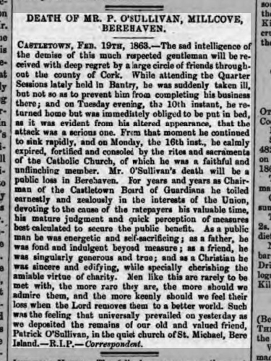
…

O’Sullivans Landholdings from Bantry Estate:

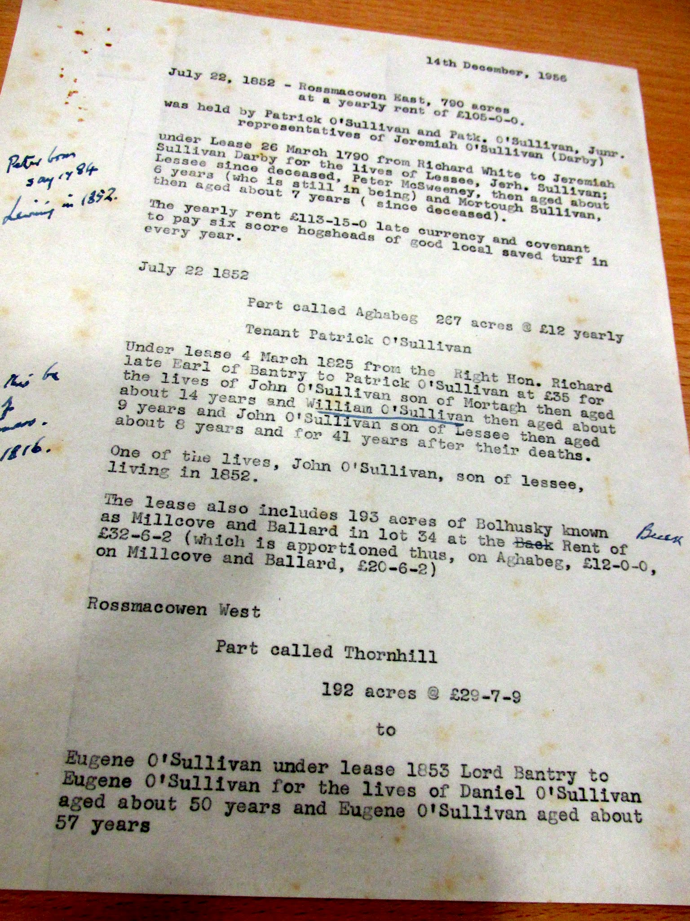
….

William O’Sullivan Esq., Carriganass Castle.

Goodwin YoungHatter, Cork probably from Banty. Obtained judgement 1807 against Simon White Esq., Glengarriff Castle assigned 1825 to William O'Sullivan, Esq., Carriganass Castle, Gave evidence to 1844 Commission Law and practice in respect to the occupation of land in Ireland. Witnesses at Bantry (Rev Christopher Freeman Curate, Richard White Esq. Landlord, Michael Murphy Miller Middleman Donemark, William Neale, Rev. Somers Payne, Land Agent, John O'Connell Esq., Rev. Thomas Barry Parish Priest, Samuel Hutchins Esq. Landlord, Alexander Donovan, Patrick Tobin Farmer Gortavallig Kilcrohane, Timothy Connor, Cornelius Connor, Cornelius Henry Donovan, into Her Majesties Commissioners into The Law and Practice of Occupation of Land in Ireland.

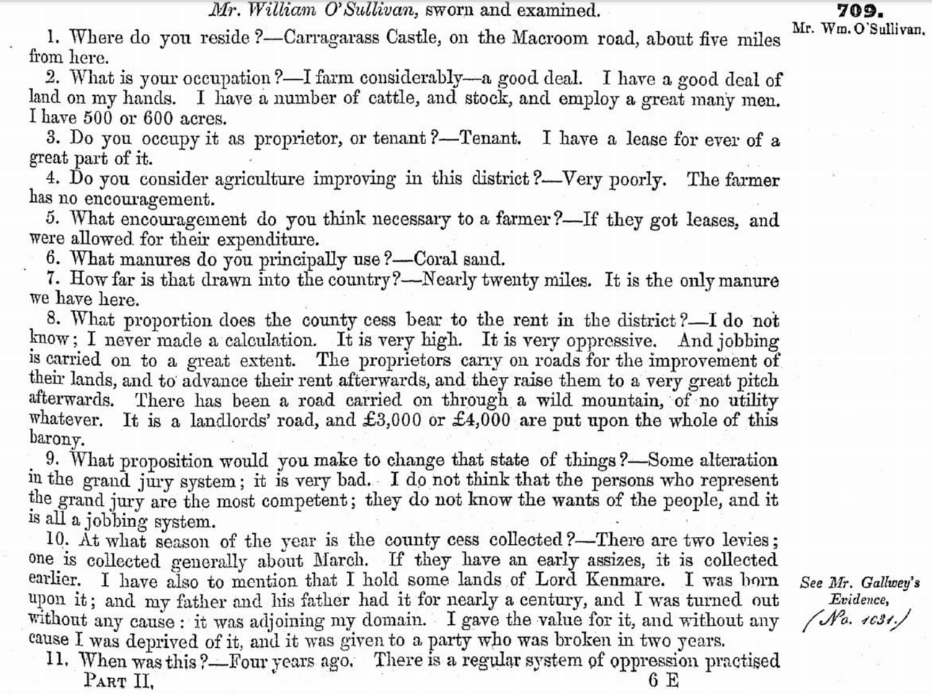
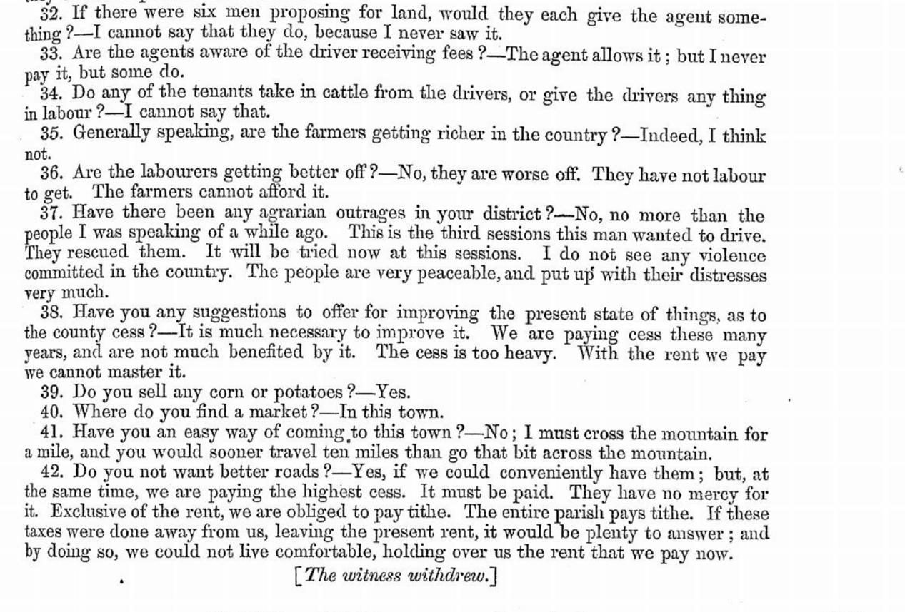

Lease of Ahiel where he was born and in the family for 100 years from Lord Kenmare not renewed in 1840. Has 500 to 600 acres employs a great number of men.
William O’Sullivan, Esq., Carriganass Castle, native Ahill. Game Certificate 1802. Purchased Carriganass from David Mellifont, Donemark in 1817 for £250 and £50 rent previously had been tenant with Maurice Flynn. Hamilton White had left, in his will, cash sums to Richard Blair Esq., Galway (nephew from Blair’s Cove, Durrus), who had received various lands in lieu. By this deed Blair assigned these lands to William O’Sullivan, Carriganass in 1822. Has 500-600 acres from Kenmare Estate. Subscriber 1832 Bantry poor Relief. Decried by Assistant Magistrate for rapacious behaviour toward tenants ‘God help the tenants of the Country with Such landlords’. Enduring bad feeling with McCarthy Downing Skibbereen Solicitor. Accused of being agent to Sir William Draper. Son William called to the Bar 1844. Signed Testimonial to Resident Magistrate, John Gore Jones, Bantry, 1844. In 1848 seizing cattle at Scart, Bantry for alleged overdue rent to his father with Daniel, John and Cornelius Manning and Eugene and Stephen Sullivan he was imprisoned for 3 months and fined £20 for assault. Son, William, Barrister, made a Magistrate 1850 on recommendation of Earl of Bandon superceded after two days. Prosecuted in Cork for criminal libel. Daughter married Barrett who took over estate. According to John Windle he contemplated the restoration of Carriganass Castle. Brother Jeremiah in Brennymore, Kealkil his daughter married Portuguese Captain Jose Biaia later resident in Kealkil. 1854 large farm at Kilcrea with quarry to let apply William O’Sullivan of Daniel O’Sullivan, Church St., Cork. Complained that in 1840 his lease of Ards (2 very large farms 3 miles inland) was not renewed by Lord Kenmare. This lease commences in 1756 between William Sullivan, an attorney who married the daughter of Rev. Schofield who had the lands. The lives in a lease for three lives of Richard Cox, son of the Archbishop of Cashel, and Richard and George sons of Sir Richard Cox of Dunmanway at a rent of £52. Grandson QUILL, Albert William, in occupation pre 1908

Rev. Somers Payne, Upton, Innishannon.

Gave evidence to 1844 Commission Law and practice in respect to the occupation of land in Ireland. Head agent to Lord Berehaven son agent to Lord Bantry he was agent to both. Whole country calls out for improvement. Not a more oppressed set of people in the world then the labourers in this country. No agrarian outrages since 1822.

‘King’ Tobin, Kilcrohane.

Lord Bantry remarked that Tobin of Lower Letter had done more than all the magistrates to root out ‘Whiteboyism’ and that he was ‘King of the West’ after which he was known as ‘King Tobin’. He lived to the great age of ninety-six years, and was well known for three quarters of a century as the King of the West. He related how he watched, when a boy, the French fleet sailing up Bantry Bay. King Tobin, although uneducated, was a very intelligent, shrewd, honest man. He was one of Nature’s noblemen. His son, the present King of the West, a P.L.G. of the Bantry Union, farms extensive tracts of land which have been held by his ancestors under the Evanson family, for generations. In the 19th century the Tobins of Kilcrohane were the local agents to that part of the Bantry Estate. In one reputed instance the ‘King’ he cleared an area of the smaller tenants. It was said locally of the Tobins that they would be seen on a horse, with a gun and a dog.
The Kilcrohane 'King', Tobins were part of a network of prosperous Catholic families in the general area. these would include The McCarthys and Murnanes from 1820s leases of Hutchinson estate. The Catholic Shannons who married into the Tobins would be in the category, there were Wards Minor Landlords of Glenlough and Droumatinaheen early 1800s. The Rosses of Glendart and Crowleys of Ballyourane, Caheragh. These families even though far apart tended to inter marry and as the 19th century went up produced clergy, teachers and later professionals.

Richard Tobin Junior, probably in the 1850s in Durrus but from Letter, Kilcrohane, was probably a member of the Bantry Board of Guardians from the late 1850s and represented Cess Payers at meetings of Magistrates. One of the Richard Tobins was probably the contractor with Thomas Donovan who got the contract for the road repair from Durrus to Kilcrohane 1869 for £2.

William Vickery of Ballycomane, Durrus.

He is listed as a Cess Payer for the Barony of West Carbery in 1834 with other locals including Charles Dukelow, Carribboy, Rev. Edward Alcock of Clashadoo. Family later Methodist. This nomination was by the County Grand Jury to sit with Magistrates on road presentments.
The Vickery lease of Ballycomane is registered in the Registry of Deeds from around 1784. The Bantry and Durrus Vickeries were heavily intermarried with the O’Sullivan Hurrig family from the marriage in the 1780s of Michael O’Sullivan and Mary Vickey of Whiddy Island. Some in the family claim descent from Michael to O’Sullivan Bere. There are a very large number of worldwide descendants from the Ballycomane Vickeries. The Vickeries of Ballycomane were prominent in the Church of Ireland in the early 19th century as Vestrymen, the family later converted to Methodism. They feature prominently as progressive farmers winning prizes at Agricultural shows. 1827, William Vickery member of Select Vestry, Durrus with Thomas Dukelow. 1829 voter registration Vickery, William, Ballycamade (Ballycomane). 1830 Tithe Applotment shows two James and William Vickery in Ballycomane with a combined valuation of almost £40, very high for the area. 1841 Election. William Vickery voting for Conservatives Leader, Longfield. £20 freeholder registered 1840. Griffith Valuation, 1850 shows the Vickeries as both tenants of Lord Carbery and also the Lessors of a number of smaller farms. The 1901 census interestingly George Vickery has both Irish and English, in the household return the house is 1st class he also owns the Hurley house possibly working on farm

Richard White, Inchiclough, Bantry.

Gave evidence to 1844 Commission Law and practice in respect to the occupation of land in Ireland. Resident since 1827. Does not hold a third of the property of Lord Bantry of Mrs. White of Glengariff the White family. Leases clauses against sub letting.

Cork Examiner 20 May 1846

1834. Cess Payers

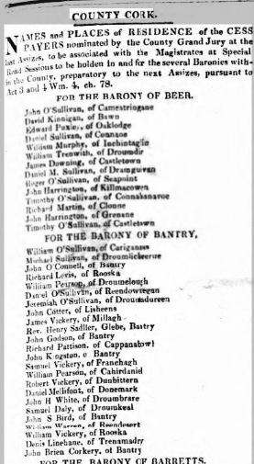
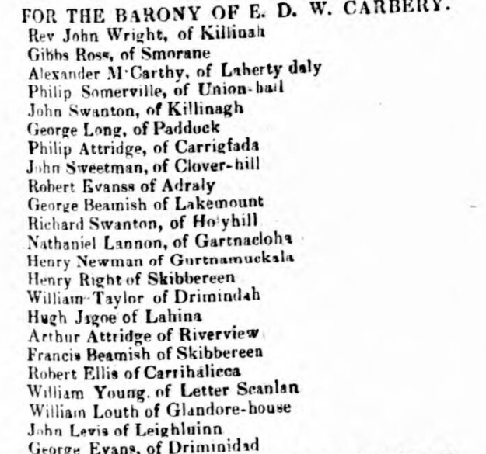
…..
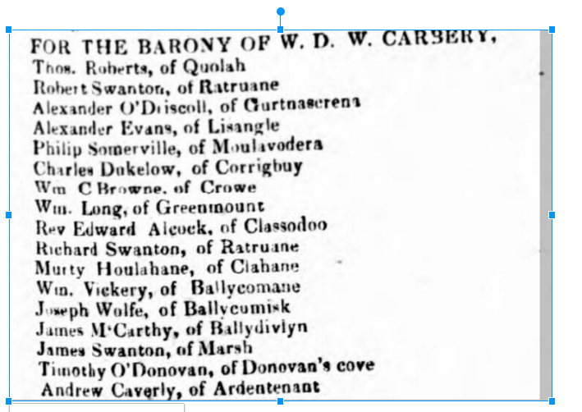

……

……

……

……
Beginning of Political Machine: Disputed Election 1841

Box from West Division of West Carbery, Co. Cork. For Leader Longfield John Abraham Jagoe, Kilronan, Derrycarhoun. Thomas Baldwin, Skibbereen, Shounlalla. William Baldwin, Castletowsend. St. George Brown, Rockboro, Killeanleagh. Thomas Ducklow (Dukelow), Cresadoe (Clashadoo). Robert Evans, Arderaly (Aughadown). Rev. Alleyn Evanson, Four Mile Water, Durrus. Hungerford Baldwin Evanson, Four Mile Water, Durrus. Brother Rev. Alleyn. Richard Tonson Evanson, Ardoguina, Durrus. Lionel John Fleming, Newcourt, Skibbereen, William Long, Greenmount (Ballydehob). Rev. Richard Walton Marmion, Cook St., Cork, The Island. Philip Somerville, Union Hall. William Theophilus Sims, Bantry. James Sullivan, West Clonee (Durrus). Related to Vickerys. Rev. Godfrey Clarke Charles William Smith, Lissabrinny. Robert Swanton, Gortnagrough (Ballydehob). William Vickery, Ballycommane (Durrus). Benjamin Shaw Wood, Sidney Place, Cork, Farran. John Smith Wood, Mount Pleasant, Caheragh. For O’Connell/Roche, mostly £10 freeholders/leaseholders, some registered since 1835. Robert Barrett, Falabawn. James Barry, Barraghavella Denis Bohane, Dunore (Kilcrohane). John Brown, Knuck. Philip Bryan (Probably O’Brien), Glenlough (Ahakista). Jeremiah Crowley, Barraghville(Caheragh). John Collins, Adruvanaha. Patrick Collins, Goulane. Jeremiah Connor, Barraghavilla (Caheragh). Denis Donovan (Roe), Rearhanagh. Rev. David Dore, Cloncugger, Caheragh, built church 1823. Cornelius Driscoll, Keeltoane (Caheragh), Denis Driscoll, Ardmanagh (Schull). Joseph Driscoll, Ardmanagh. Richard Driscoll, Keeltomane. Timothy Donovan, Gurranes. Daniel Duggan, Bantry. Patrick Goggin, Killeenleagh (Caheragh). Timothy Hourihane, Caheragh. James Lucey, Balteen. Andrew McCarthy, Upper Lessane, Skibbereen. Charles McCarthy, Lissane. Cornelius McCarthy, Derreengreenough. Daniel McCarthy, Upper Lissane. James McCarthy, Upper Lissane. Timothy McCarthy, Upper Lissane. Patrick McCarthy, Ballyadown or Bishopsland (Cahergah). William McCarthy, Bandon, Droumourtneen. John Murnane, Letterlickey, Owen Murnane, Letterlickey, Timothy Murnane, Letterlickey (two of same name) Timothy Murnane, Letterlickey, Patrick Murnane, Letterlickey. Patrick Neil, Achiard. James O’Callaghan, Barnatonicane. Jeremiah O’Connell, Upper Lessane. Daniel O’Donovan, Norton Cottage (Skibbereen), Rearahanaugh, Skibbereen. James O’Hea, Derreenivirche. Patrick O’Hea, Killeenleagh. Thomas O’Hea, Dreeneveragh. Daniel O’Sullivan, City of Dublin, Farramand (Farranamanagh, Kilcrohane?) Daniel Regan, Deelish. John Salter, Ballydehob. Cornelius Sullivan, Ardahill (Kilcrohane). Denis Sullivan, Ballydehob. Edmund Tobin, Gortavollig (Kilcrohane), Patrick Tobin, Gortavollig, John Young, Barraghavella. Robert Young, Rearhanagh. Thomas Young, Rearhanagh.

…..

…..

…….
Bantry, West Cork, Quarter Sessions, February 1842.

Chaired by Mr. Moody, Assistant Barrister, East Riding, Magistrates, Mr. Little Resident Magistrate, Dr. Gillman, Richard White (Lord Bantry family), Michael Warren, Alexander O'Driscoll (Middle Man, Caheragh, married to Miss Evans, Lissangle). Juries: William Lannin (Possibly later Master Workhouse may be from Dromreague), Elias Roycroft (Rooska), William Roycroft, Robert Warren, Samuel Daly, George Vickery, Edward Barry, Michael Sullivan (Possibly Tedagh), John Warner, Cornelius O'Leary, Alexander O'Donovan Possibly Clerk Petty Sessions), Robert Vickery, Daniel Sullivan, George O'Connor (Landowner Bantry/Skibbereen), Thomas Dukelow (Durrus possibly Clashadoo), Michael Sullivan, Thomas Kingston, Michael Foley, Jeremiah Sullivan, T Williamson (Durrus), James Sullivan, Thomas Vickery.
….
……

……
1862 Quarter Sessions Bantry.

In Lord Carbery’s 1830 pamphlet he says there were two primary Assizes supplemented with six in each of the two Cork County Ridings West and East. This is one of them where criminal as well as presentment business was done.

Bantry, West Cork, Quarter Sessions July 1862 Chaired by Robert Johnstone Esq., Chairman, Magistrates: J H Townsend, F Davies Resident Magistrate, F Bennett, R. H. Notter (Crookhaven), J. W.Payne (Land Agent), William Beamish Baldwin, George Robinson (Possibly Skibbereen Landlord). Jurors: Patrick O'Sullivan (Foreman), Daniel McCarthy, C. and H. Thomas (Possibly Mines), Alexander Blair (Blair's Cove, Coolculaghta, Durrus, The Cottage, Schull, Landlord), Samuel Baily, Daniel O'Conner, (Possibly Landlord, Bantry), William Young (Merchant), William Jagoe (Merchant), Richard Hungerford Evanson (Ardgoena, Durrus, Landlord), George Swanton (Possibly Fortlodge, Ballydehob), William Bennett, Thomas T Curtayne, Denis W Murphy, Cornelius O'Leary, William Tisdall (Donemark), Stephen Browne, William Ross (Possibly Drimoleague), John Ross, Timothy Downing, Samuel Jagoe, William Morris (Friendly Cove, Durrus, Landlord), T. D. Notter (Crookhaven, Landlord).

….

http://www.dippam.ac.uk/eppi/documents/11941/page/282465, 1844, Parliamentary Commission into Law and practice in respect to the occupation of land in Ireland: minutes of evidence, land tenure, middlemen.
Bantry Historian Paddy O’Keeffe reckoned that around 1820 there were either 10 or 22 half pay officers in the Banty area. He thought quite a number were Catholic.
http://www.dippam.ac.uk/eppi/documents/11594/page/270349
Probably from Clashadoo married into Coughlan farm by marrying Frances Coughlan 1810 now part Clashadoo Johnson farm.
Ancestors of JHK’s mother.
Robert Scoble. Author of O'Sullivan piece was published as Chapter 7 of book Raven: The Turbulent World of Baron Corvo (Strange Attractor Press, London, 2013).
Cork Examiner 20 March 1850
Supplement to the Trials of the Rev. Robert Morritt, A.M. Prebendary of Ross, Rector and Vicar of Castlehaven, and Domestic Chaplain to Field Marshal Lord Beresford, Duke of Elvas. By an Anti-Conspirator. Cork: Printed by John Connor, Grand-Parade, 1819. pp. 36. COPAC locates the BL copy only. Not in NLI
Dublin Morning Register 25 May 1825
Ardahill, Kilcrohane, after his death the land was sold by his sons to the O’Connells of Bantry.
Southern Reporter and Cork Commercial Courier 15 February 1838
The cess would typically amount to around 12% of the gross rent.
Father Patrick Hickey, Famine in West Cork, p. 96.
Sheeps Head Company Blog: From a series of articles that appeared in The West Cork Eagle (the Skibbereen Eagle) in 1872
Irish Manuscript Commission digital edition of Kenmare Estate papers, p235.
Probably married to a descendant of Bantry Galweys who settled in Lisbon, and through earlier married to Mellifont acquired various lands..
Quoted in Donald Mckay, ‘Flight from Famine’ The coming of the Irish to Canada’, Natural Heritage Books, Toronto, 2009.
Donald McKay, p 50
From Tithe Applotment Certificate available online National Archives.
Cork Antiquarian, Historical and Descriptive Notices of the City of Cork, etc By John Windle
QUILL, Albert William, M.A., ex-Scholar,T.C.D. ; barrister-at-law : Member of Irish; b. Kerry ; e. surv. s. of Thomas Quill and Ellen, d. of William O'Sullivan of Carriganass Castle, Co. Cork (d. 1900), d. of Rev. James P. Chute. Rector of Ballyheige, Co. Kerry ; one s. Educ. :Old Hall Green, Herefordshire, Dublin. Mr. Quill was one of the few Roman Catholic Scholars of T.C.D., before the abolition of tests. The name is an English corruption of the Celtic O'Cuil, and one of his ancestors (O'Cuil) was chief poet of Munster in the 12th century. On his mother's side he claimed descent from the O'Sullivan Bere, through William O'Sullivan, his maternal grandfather. Publications : joint editor with Mr. Hamilton of The Land-Owner's Guide ; The new Irish Land Acts The History of Tacitus ; Poems. Address : 1 Trevelyan Terrace, Brighton Road, Rathgar, Dublin ; Carriganass Castle, Bantry, Co. Cork. Died 1 Feb. 1908.
:RIA Windele MS. 12 L 8, pp. 269–71
Southern Reporter and Cork Commercial Courier 24 November 1825
Southern Reporter and Cork Commercial Courier 24 November 1825
1005 5 Feb. 1847 Copy lease made between Richard, 1st Earl of Bantry, Bantry House, and William O’Sullivan, Carriganass Castle, for the lands of Carriganass, containing 10 gneeves in the half-Barony of Bantry, already in his possession. It is for three lives, at a yearly rent of £21, payable half yearly on the 25th March and the 28th September. This is a renewal of a lease made between Hamilton White and David Mellefont, Donemark, on 7th September 1786. O’Sullivan agrees to serve in the courts of the Manor of Bantry, when summoned, and to buy his malt at the Malt house of Bantry owned by the Earl.
Southern Reporter and Cork Commercial Courier 11 June 1831
Southern Reporter and Cork Commercial Courier 08 September 1832 Health. Father Barry, P.P. Bantry., Chairing Bantry Board of Health 1832 Subscriptions for Poor Relief, John S. Bird, Esq., Treasurer Western Committee London £40. Earl of Bantry £10, Viscount Berehaven £5, Richard White £5, Countess of Bantry £2, John White £3, Rev. Somers Payne £2, Doctors Clarke, Lucas, Herbert Gillman £1 each, Richard Lawlor £5 Rev. Thomas Barry £3, Michael Galwey £3, William O’Sullivan £2, Miss Bird £2, John Gillman £1.10, Daniel O’Sullivan £1.10
Item 1020, Bantry papers, Boole Library, UCC, 20 Sept. 1852 . Agreement between Richard, 2nd Earl of Bantry and John O’Connell (Merchant), Beach Farm, Co.Cork, leasing a premises in Bantry town for 200 years, a yearly rent of £10, payable half-yearly on the 29th September and the 25th March.
Notes Appointed Vicar Capitular of the Diocese of Cork on the death of Bishop John Murphy on the 1st April, 1847. His name, with the names of Fr. Theobald Mathew and Fr. William Delany, was forwarded to the Holy See for the vacant See of Cork. The latter named was appointed bishop of Cork (1847-1886). For a more detailed insight into life and times of Fr. Barry, we would recommend: (a) 'A history of the Diocese of Cork - from the Penal Era to the Famine' , by Evelyn Bolster, p. 264, 295, 313, 315, 319. (b)'A history of the Diocese of Cork - the Episcopate of William Delany, 1847 - 1886' ,by Evelyn Bolster, p. 3 - 12. His memorial tablet may be seen in the northern transept of St. Finbarr's (South) Church, Cork City Date Of Death 3/12/1853
Registry of Deeds 1851, 4, 94 , recites the title to the lands, the will of Timothy O’Donovan deceased Ardahill, his disposals and the sale of the interest subject to annuities and a jointure to the widow Mary O’Donovan to James O’Connell, Beach Farm, Bantry, witnessed Julie Collins Kilcrohane and Denis Kelly and Denis Sullivan, Yeomen, Bantry. Another deed the memorial of which is 1855,18,29 recites various payments to the children of Timothy O’Donovan, late Ardahill deceased and recites the title as originating with a lease of 17th March 1752 to commence 1st November 1782 by Dr John Whetcombe, Bishop of Clonfert, Kilmacduragh and Kilfenora and his wife Eliza to William Roberts of Derryclivane, lands at Kerkin, Dromnea, Gurtahilla Ruskeragh 6 gneeves for 999 years and a rent of £150 per annum.
Southern Reporter and Cork Commercial Courier 08 April 1834
THE SOUTHERN REPORTER & CORK COMMERCIAL COURIER : TUESDAY 8 APRIL 1834, County Cork
Southern Reporter and Cork Commercial Courier 17th February 1845.
Southern Reporter Cork Commercial Courier 19th July 1862.
Chief Secretary papers, CSO/RP/1826/948
http://www.csorp.nationalarchives.ie/search/index.php?simpleSearchSbm=Search&category=27&searchDescTxt=bantry&offset=90&browseresults=true
Chief Secretary Papers, CSO/RP/1824/1423
http://www.csorp.nationalarchives.ie/search/index.php?simpleSearchSbm=Search&category=27&searchDescTxt=bantry&offset=80&browseresults=tru
http://www.csorp.nationalarchives.ie/search/index.php?simpleSearchSbm=Search&category=27&searchDescTxt=bantry&offset=90&browseresults=true
Chief Secretary Papers: Memorial of Timothy Connelly, farmer, Baunisial, Castle Haven [Castlehaven, County Cork], to [Richard Wellesley], Lord Lieutenant, complaining that he is being persecuted for tithe rent arrears by Thomas Evans, to whom the rents were signed over by Rev Robert Morrit. Claiming that in 1823, Morrit, curate of Castlehaven, sent a guard of constables to extract tithe rent and that during a confrontation several parishioners were killed. Following an investigation Morrit was removed from the parish but before he left he sold his tithe entitlement to Evans,’a mercenary poor man’ who has brought Connelly to the Petty Sessions of Skibbereen. Mentioning Richard Townsend, collector, Castletownsend. Includes annotation from JS Townsend stating that the Lord Lieutenant has no power to intervene. Petition of Michael Mahony, Fornangh [Forenaght], parish of Castle Haven, barony of east division of West Carbery, County Cork, to Richard Wellesley, 1st marquis Wellesley, Lord Lieutenant, Dublin Castle, complaining of unjust treatment at the hands of Reverend Robert Moritt, Church of Ireland clergyman of Castle Haven, following Mahony falling into arrears with his tithe payments. Mahony refers to his financial distress; the refusal of Morritt's tithe proctor to accept part-payment from Mahony; and subsequent attempts to seize the family's mare from Mahony's young son. States that the boy has since been served with a summons to appear at court in Skibbereen, County Cork. Emphasises his hardship and requests that government investigate his case and Morritt's 'method of managing His Tithes' [annotation indicates petition received 9 August 1823]. Subsequent pencil annotation on reverse by Henry Joy, Solicitor General, stating his opinion on the matter.
Dr. Casey
The following is an extract from the southern report of the Cork Commercial Courier of the 19th July, 1832 in relation to an anti-tithe meeting on Mount Gabriel.
Southern Reporter and Cork Commercial Courier, 27th January 1835.
https://irishdeedsindex.net/mem.php?memorial=546272

