Early/EEDY History in Ireland

The following history is based on data available from many sources in Ireland as noted, as well as from the early correspondence between Robert and Jane Eedy in New Brunswick and family in Ireland and the letters between William Eedy of Clifton and John Wolfe Eddy of St. Mary’s, Ontario. Suppositions must be made to fill in the gaps.

In his 18 October 1877 letter, quoted later in this chapter, William Eedy noted that “Jonathan settled at Killdee with Sir Michael Cox…and Nicholas Eedy settled at Killbree, near Clonakilty…” and that Nicholas “was marrked (sic)” to Hannah Knowles.

It is interesting to note that a Jonathan Eedy married Elizabeth Bateman in 1742 as recorded in the Parish Register for Kilmeen. Killdee is in Kilmeen Parish, a few miles west of Bandon and northwest of Clonakilty approximately halfway between the towns of Clonakilty and Dunmanway. According to the Kilgarriff Church records, Jonathan and Elizabeth had a son Charles who was born 1745. Charles married Ann Hanglin in 1783, Index to Cork & Ross Marriage Licence Bonds.

William Eedy goes on to state that Nicholas had sons, as noted below, and “several daughters”. This early Eedy history has been documented as indicated and compared with records of a number of family researchers from many branches of Nicholas and Hannah’s family. Father Paul Crowley and Father Peter Eedy, both Eedy descendants, researched the Eedy family for many years. Paul corresponded with Robert Cheyne Eddy (Generation 5) in the 1970s and both Paul and Peter corresponded with Elizabeth (Eedy) Brown, a descendant of John Wolfe Eedy. Philip Eedy in Wales has carried on the work of Paul and Peter.

Nicholas Eedy married Hannah Knowles in Kilbree in 1740.

(Historical Note: Abraham Beamish married Jane Knowles in 1740. Samuel Beamish of Knockavoher, son of Abraham Beamish of Lahana, married Ann Morris 21 November 1778 at St. Fin Barre, Cork. Samuel and Ann Beamish had 4 sons and 1 daughter, Mary. “Mary, daughter of Samuel Beamish of Knockavoher married 1813, by licence, Robert Eady of Bean Hill, Co. Cork, *second son of John Knowles Eady of Knochavoher. Robert and Mary had no issue.” [This information comes from the Beamsih Family History compiled by Richard Piggot Beamish and published by Guy & Co. of Cork in 1869 and 1892 and updated by C.T.M. Beamish in 1949. *See further information following concerning this marriage and matter of issue].

Nicholas and Hannah had four sons. Hannah died and Nicholas was married for the second time to Elizabeth French on 16 January 1752 at St. Fin Barre’s Cathedral, by Mr. Cottrell. This marriage is recorded in the Index to Cork and Ross Marriage Licence Bonds, 1750-1845. According to William Eedy, Nicholas also had several daughters although Sarah is the only one identified by records. Sarah Eedy married Thomas Wolfe in 1777, Index to Cork and Ross Marriage Licence Bonds, 1750-1845. It is not known at this time by whom Nicholas had his daughters.

The first land transaction found to date is a lease between Nicholas Eedy and William Morris made in December 1753.

Morris to Eddy
Registered the 7 of aug 1754
at clock at noon

No. 114027

To the Register appointed by Act of Parliament for the Public Registering of Deeds Conveyances & Wills

Memorial of an Indenture of Lease bearing Date the Twentyeth Day of December one thousand seven Hundred and fifty three and made between William Morris of Castlesalem in County of Corke Gentleman of the one part & Nicholas Eddy the Younger of Kilbree in said County Farmer of the other part, Whereby said William Morris did Demise Lett and to farm Lett unto the said Nicholas Eddy All that part of the Lands of Knockavohir then in the Tenure and possession of Laurence Carthy and Dennis Keoghane Bounded on the East with the Lands of Kellnecally on the South by Carruegariffe and on the West side by the road Leading from Ross to Curraghneloher & on the North by the furze Ditch in the Mountain from that road to Killnecally Southward of Glandine Situate in Barony of Carbery and County of Corke containing two Gneeves and one half Gneeve. To hold with their appurtenances unto said Nich. Eddy his Heirs Exec & Adms and Assigns for the Term of Nine Hundred and Ninety Nine years to Commence from the Twenty fifth day of March then Next coming at the yearly rent of Eighteen pound ten Shillings Payable Half Yearly – To which said Indenture of lease William Morris and Nich Eddy put their Hands & Seals, and Witness thereto are Thos French of Lisseerimee in the Co Corke farmer & John Horan of Castlesalem in the sd County Yeoman, & this mem is witnessed by said Thos French and Isaac Hewett of Corke Gent

Sealing the above Memorial 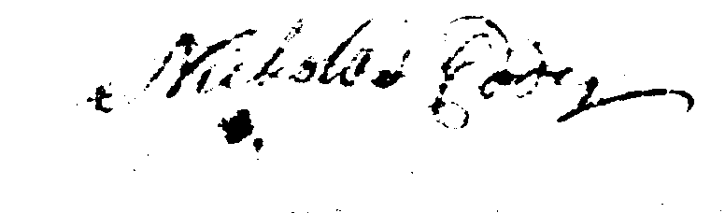
Thos French
Isaac Hewett

The above named Thomas French this day made oath before me that he saw the Indenture of lease (of which the above is a Memorial) duly Executed by the above Names, William Morris and Nicholas Eddy and that he also saw the said Nicholas Eddy sign and Seal the above Memorial and this Deponent sayth he is a Subscribing Witness to said Indenture of Lease and Memorial and that the name Thomas French Subscribed as a witness to said Indenture of Lease and Memorial is his this Deponents proper hand-writing

Justices present “Thomas French” Sworn before me at the City of
Corke this 3d day of August 1754
By virtue of a Commission forth of
His Majestys Court of Excheqr in
Ireland to me Directed for taking
Affds
“Wm Heard”

It has not been proven when Nicholas died. In 1766, Letters of Administration, which were known as “Admons”, were issued for “Nicholas Eedy, of Knockavohor, Farmer”. If a person died intestate, i.e., without making a will, an administration enabled the estate to be wound up. Before 1815, Letters of Administration were not legally compulsory and Admons were usually only applied for if either a large amount of money was involved or if a family was unable to agree how the estate should be divided. In 1775, the will of “Nicholas Eedy of Keelbree (sic)” was probated.

According to Ross Eddy, Generation 5, whose legal career and expertise focused on estates and wills, letters of administration and probate of a will for the same individual was most unlikely, especially with a nine year time span. Further, the person handling the affairs of the deceased would be referred to as an “administrator(trix)” in the case of a person dying intestate with letters of administration being issued, and as “executor(trix) for an individual who died leaving a will which was probated.

Based on the use of the term “Admin.” in the following deed of assignment dated 1771, it can be assumed that Nicholas, husband of Hannah Knowles and Elizabeth French, died intestate in 1766 and that the will that was probated in 1775 for “Nicholas Eedy of Keelbree (sic)” was that of his son or his nephew.

Elizabeth Eedy, as Administrix of Nicholas Eady of Killbree, transferred the lands of Knochavoher to Robert Eedy. The deed of assignment does not indicate a relationship between Elizabeth and Robert but I infer that she was Elizabeth French, second wife of Nicholas Eedy, transferring land to her eldest stepson, Robert.

Eedy to Eedy ~ Registered 16 May 1771 at ½ after 11 o’clock in the forenoon.

No. 186251 To the Register appointed by Act of Parliament for Registering Deeds Conveyances Wills and so forth ~ Memorial of an Indenture of Assignment bearing Date the twenty seventh Day of April one thousand seven hundred and seventy one and made Between Eliz(abe)th Eedy Admin. of the Goods Credits and Chattels of Nicholas Eedy the Younger late of Killbree in the County of Corke Farmer Deceased of the one part and Robert Eedy of Killbree aforesaid Gentleman of the other part Reciting that William Morris of Castlesalem in the County of Corke Gentleman did by Indenture of Lease bearing Date the twentieth day of December one thousand seven hundred and
fifty three demised and to farm let unto the said Nicholas Eedy the Younger All That part of the Lands of Knockavoher then in the tenure and occupation of Lawrence Carthey and Dennis Keoghan bounded on the East side with the lands of Killnecally on the south by Carregarriffe and on the West side by the Road leading from Ross to Carraghelohev and on the North by the Furze Ditch in the Mountain from that Road to Killnecally Southward of Glanndine which Lands are Situate in the Barony of Carbery in said County and Computed and deemed to be and contains two Gneeves and one half Gneeve of Lands be the same more or less. To hold unto the said Nicholas Eedy his Exec(utor)s and Admin(istrator)s and Assigns from the twenty fifth Day of March then next ensuing for the Term of Nine hundred and ninety nine Years at the yearly Rent of Eighteen pounds ten shillings and payable half yearly by which said Indenture of Assignment the said Eliz(abe)th Eedy for and in Consideration of the sum of three hundred and fifty five pounds and to her in Hand paid by the said Robert Eedy did grant bargain sell assign and makeover unto the said Robert Eedy his Exe(cutor)s Adm(inistrat)ors and Assigns All That the aforesaid part of the said Lands of Knockavoher as demised as aforesaid by the said William Morris to the said Nicholas Eedy Deceased To hold unto the said Robert Eedy his Exe(cutor)s Adm(inistrat)ors and Assigns for the remainder of the said term of nine hundred and ninety-nine Years which was then to come and unexpired at the Rent and Covenants in the said Recited Indenture of Lease Contained To which said Indenture of Assignment the said Eliz(abe)th Eedy and Robert Eedy put their Hands and seals Witness thereto are Thomas Foott of the City of Corke Gentleman and John Austen of the said City Gentleman and this Memorial is witnessed by the said Thomas Foott and Wm Reader Carr of the said City Gentleman.

Being present at Signing and The above named Thomas Foott came this Day
Sealing the above Memorial before me and made Oath that he saw the Indenture
Thomas Foott of Assignment of which the above is a Memorial duly
Wm. Reader Carr executed by the above named Eliz(abe)th Eedy & Robert Eedy and that he also saw the said Robert Eedy sign and seal the above Memorial and that he this Depon. is a Subscribing Witness to the said Indenture of Assignment and Memorial.

Justices Present “Thomas Foott”
? Mayor
Wm. Snow Sworn before me at the City of Corke
This 29th day of April 1771 by Virtue of a Commission forth of his Majesty’s Court of Exchequer in Ireland to me directed for taking affidavits & I know the deponent

The four sons of Nicholas and Hannah, according to tradition, were:

- Robert Eedy, who was born in 1741, married Lydia Stanley 17 September 1779 at St. Fin Barre’s, Index to Cork and Ross Marriage Licence Bonds, 1750-1845. Robert died at the age of 62 in 1803 and is buried in the Kilgarriff Churchyard, Clonakilty, pictured below.

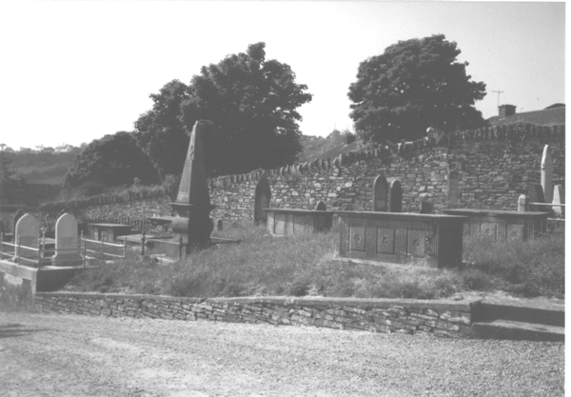

It would appear that Robert and Lydia had the following children: Nicholas, born about 1781; Robert, born about 1786; John Knowles, born about 1787; Mary, born about 1788 and Lydia who married Thomas Wolfe in 1817, Index to Cork and Ross Marriage Licence Bonds, 1750-1845.
A Nicholas Eedy married Mary Warner 1807, Index to Cork and Ross Marriage Licence Bonds, 1750-1845, and they had a son Nicholas, born 1816 and described as “of Knockavoher” and a daughter Susan born 1818. The son Nicholas married Susan Tanner in 1846. (Picture of headstone in the Kilgarriff Churchyard, Clonakilty follows.)

John Knowles Eedy married Mary Stanley 18 February 1819 by licence. John Knowles Eedy had a son Robert who was baptized 16 July 1826, Kinneigh Parish. The son Robert married twice – Honora Cahalane 14 April 1836 and Nora Donaghue 16 April 1842. Robert and Nora had a son Stephen who was the grandfather of (Father) Peter Eedy and (Father) Paul Crowley.

Lydia Eedy who married Thomas Wolfe had a daughter Lydia. Lydia Wolfe married William Eedy. From Church of Ireland Records, Parish of Kilmeen: “William Eedy, full age, bachelor, farmer, Knockea, Kilmeen Parish, son of Nicholas Eedy, farmer, married Lydia Wolfe, full age, spinster, Kilgarriff Parish, daughter of Thomas Wolfe, on 22 April 1856 at Kilmeen Parish in the presence of Robert Eedy and Robert Wolfe.” On 18 January 1871, at Kilmeen Parish, “Samuel Ford, full age, bachelor, farmer of Knockea, son of Samuel Ford, farmer, married Lydia Eedy, full age, widow, of Knockea, daughter of Thomas Wolfe in the presence of Robert Wolfe and Henry Ford. Church of Ireland Records, Parish of Kilmeen.

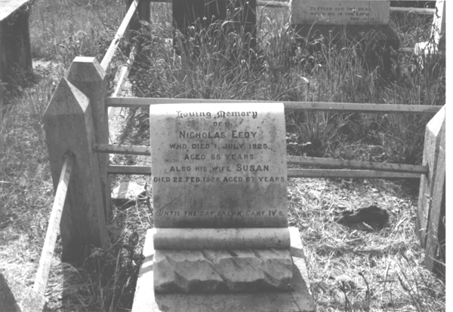

Loving Memory
Of Nicholas Eedy
Who Died 1 July 1925
Aged 65 Years
Also his wife Susan
Died 22 February 1928, Aged 67 Years
Until The Day Break Cant. IV6

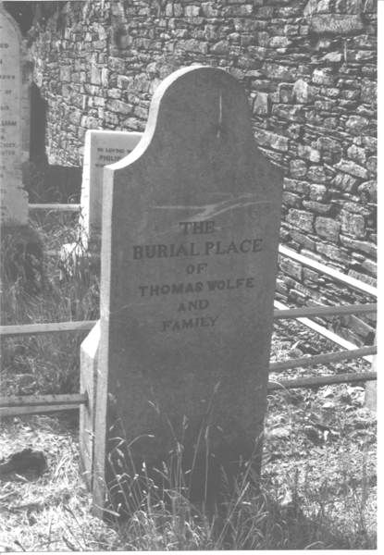 “The Burial Place of Thomas Wolfe and Family”
Kilgarriff Churchyard

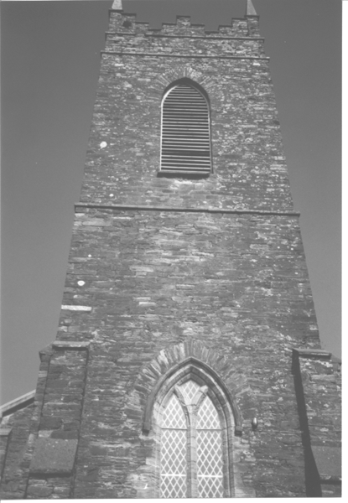
Kilgarriff Church, Clonakilty, 1991
William and Lydia Eedy “of Knockea” had a daughter Mary Ellen who married Samuel Beamish Eddy in 1888. Their son, William George Eddy married Susan(na) Johnson in 1920. George and Susan(na)’s son William Edward married Lily Helen in 1923.

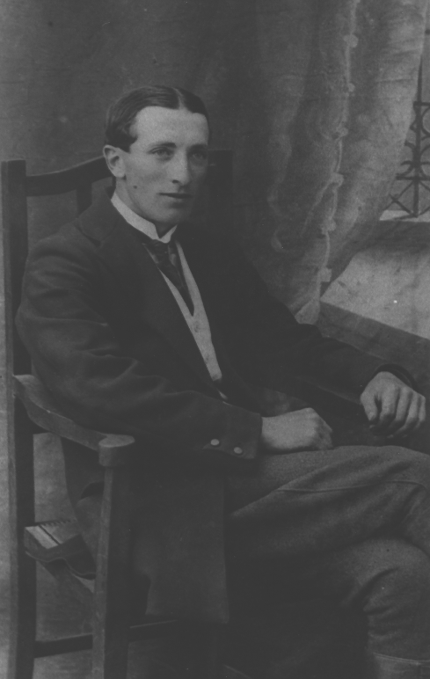
William George Eddy

Knockea, later to be known as Lisroe, passed to William Edward and Lily (Helen) Eedy. In 1991, Isabel (Generation 5) and Catherine (Generation 6) Eddy visited Willy and Lily and took the following picture.

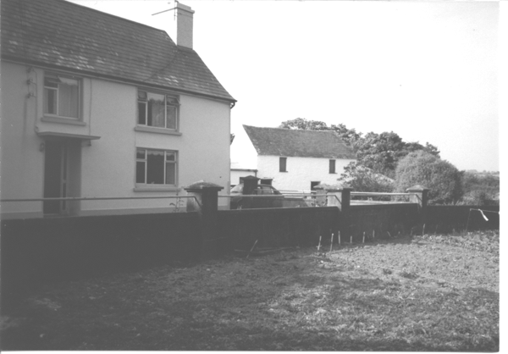
In 1971 Paul Crowley wrote that “the old stone house at Ring probably dates from about 1760 but the Eedys may already have been living there from an earlier date. The Letter Estates (5 miles from Clonakilty on the Enniskeane Road) dates from about 1760 and is owned by Victor Eedy. Knockee (sic) [renamed Lisroe] is a neighbour to Letter, dating from about the same period, and is owned by William Eedy. Enniskeane, the present house owned by John (Jack) Eedy was an old militia barracks (1820-30) but the property dates back to an earlier period. Knockavoher – another old family seat dating from about 1760. There has been doubt as to whether Ring or Knockavoher was the first stone house in West Cork…” (All of these locations are marked on the map, Appendix I.)

Catherine assumes that the house pictured in the foreground on page 20 is the original one “ruthlessly modernized”. To quote from a letter written to Catherine by Isabel in October 1974 after a visit she and Bob had to Ireland,

“Willie’s old mother, whom he calls Mam, said to me solemnly, ‘Me mother-in-law told me this house was built with Blood and Hair.’ ‘It was, too,’ said Lily, ‘when we had to get the roof repaired we found tufts of hair under the rafters!’ Whose blood and hair they were talking about I [Isabel] didn’t discover. Imagine having a circle of stones, like a miniature Stonehenge, in your upper field, and the ruins of an old tower within sight on a neighbour’s property…The elder Mrs. Eedy’s mother was also an Eedy, so she and her husband George were cousins. Willy inherited the farm from his Uncle Nicholas.” Willy went on to explain that the ruins just outside the window were “the red ring fort where the Danes were about A.D. 900”. Lisroe means “red ring fort”.

We turn to deeds and marriage settlements to provide information concerning some of Robert and Lydia’s children. The first document pertaining to these children is for their daughter, Mary Eedy, described in a marriage settlement dated 1 September 1803:

No. 571 312 385364 “made between Osmond Bennet of Forkhill, Co. Cork of the first part and Thomas Bennett of the second part and Mary Eddy of Knockea, daughter of Robert Eddy, deceased of the third part. Reciting a marriage intended between Thomas Bennett and Mary Eddy. Whereby Osmond Bennett granted to Thomas Bennett the lands of Kilgarriff held from the Earl of Shannon. “Witnesses: Nicholas Eddy of Kinseale (sic) and John Bennett of Kilgarriff, gentlemen. Memorial witnesses: said Nicholas Eddy and John Eddy of Kinsale. Nicholas Eddy swore the deed 11 June 1805”.

The second document begins “Robert Eady and John Eady of Beanhill… of the one part” They are later referred to in the document as the “aforesaid Robert Eady second eldest son and John Knowles Eady. The language of this document – “aforesaid” – applies to both Robert and John and implies that they were both sons of Robert Eedy, deceased.
Clearly, from reading this document, Robert who married Mary Beamish is the son of Robert Eedy and Lydia (Stanley) Eedy and not the second son of John Knowles Eedy as recorded in the 1949 Beamish Family History quoted earlier on page 14.

Deed No. 747-197-508332, dated 6 February 1813 and registered December 1820, is a marriage settlement between Robert Eady and Mary Beamish, reciting the last Will and Testament of Robert Eady of Knockea dated 20 June 1803.

To the Register appointed by act of parliament for the publick Registry of Deeds & Soforth

A memorial of an Indented deed bearing date the sixth day of February one thousand Eight hundred and thirteen and made between Robert Eady and John Eady of Bean hill in the County of Cork farmers of the one part ~ Mary Beamish daughter of Samuel Beamish of Knockavoher farmer Spinster of the second part and John Morris of Droumliky and Nicholas Eady of Knuckea in said County farmers of the third part Whereby after reciting that a marriage was intended between the said Robert Eady and Mary Beamish & that the then late Robert Eady of Knuckea deceased by his last will & testament bearing date the twentieth day of June one thousand Eight hundred and three did give & bequeath to the aforesaid Robert Eady second eldest son and John Knowles Eady all that and those the lands of Knockavoher share and share alike for the term thereof unexpired, the said Robert Eady and John Knowles Eady in consideration of said intended marriage & the other considerations t

unexpired, the said Robert Eady and John Knowles Eady in consideration of said intended marriage & the other considerations therein mentioned did grant [black area] and confirm unto the said John Morris and Nicholas Eady (In their actual possession then being by virtue of the [black area] sale for a year therein mentioned) That part of the lands of Knockavoher in the County of Cork then in the possession of said Robert Eady & his under tenants To Hold the same on trust ? and to permit said Mary Beamish and her assigns in case she should survive said Robert Eady forever and take for ? sum of twenty pounds sterling payable half yearly as therein mentioned with ?? in case of non-payment??? For the other trust therein mentioned which Indenture ? the Execution by all the same parties ? and by William Eady of Sarrue in the County of Cork farmer and William Beamish of Knockavoher in said County Gentleman and this memorial is witnessed by the said William Beamish and by John Eddy of RossCarberry in said County House Carpenter.

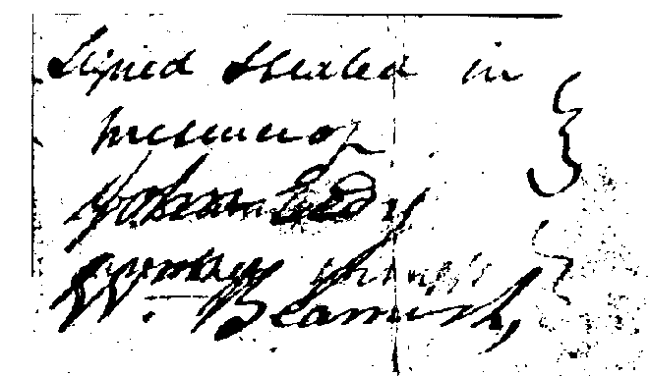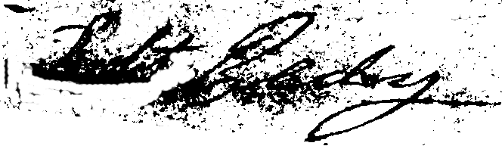

The above named William Beamish maketh oath that he is a subscribing witness to the Indenture whereof the above writing is a memorial & also to the above memorial & said he saw the said Indenture executed by the said Robert Eady John Knowles Eady Mary Beamsih John Morris & Nicholas Eady & this Memorial Executed by the said Robert Eady and that the name William Beamish signed subscribed as witness to said Indenture & this memorial respectively is this deponents proper name and hand writing.

“Wm Beamish” Sworn before me at Roscarbery in the County of Cork this first day of December /19 by virtue of commission forth of his Majesty’s Court of Kings Bench in Ireland to me directed for taking affidavits. I know the Deponent.
“Edward Williamson”

This document is in very poor condition with some of the words being illegible. It also appears that Robert Eedy wrote his signature over that of John Knowles Eedy although this is not apparent in the scanned signature.

There has been confusion for researchers relating to John Knowles Eedy and Robert Eedy and Mary Beamish. In the Beamish Family history referred to on page 14, Robert, husband of Mary Beamish, is noted as the second son of John Knowles Eedy. That history also stated that Robert and Mary left no issue.

Father Paul Crowley researched this branch of the family and prepared several papers in 1971 with references to the individuals noted below although he did not name the father. Philip Eedy of Wales expanded upon his work. Philip may have relied on a portion of the Beamish history in that he names John and Robert as the sons of John Knowles Eedy in his family history of 2001. Philip notes that Robert, son of John Knowles Eedy and Mary Beamish are the parents of Robert, Samuel, Anne and Nicholas. We do know from records that John Knowles Eedy married Mary Stanley and that they did have a son Robert who was baptized 16 July 1826. [Their son Robert would have been only 10 years old at the time of the marriage of Robert to Honora Cahalane in 1836, referred to below.]

Deed No. 747-197-508332 clearly implies that John Knowles Eedy and Robert Eedy were brothers, sons of Robert who died in 1803 and that Mary Beamish married Robert, the son of Robert who died in 1803. Other than this discrepancy, Philip presents a very interesting history of the descendants of Robert, son of Robert and Lydia Eedy.

“In 1813, Robert Eedy of Beanhill married Mary Beamish…They were to have four children – (1) Robert born 1814, (2) Samuel, (3)Anne and (4)Nicholas.

The first son, Robert was the father of Abraham and Stephen Eedy, two of the brothers who immigrated to Cardiff in the 1880s…On 14 April 1836, Robert married Honora Cahalane in Leap. They had two children, Mary, born 1837 and Robert born 1841…Honora died and Robert Senior married [for a second time] Nora Donaghue on 16 April 1842. Nora was the mother of Abraham and Stephen. Robert was probably the wildest of the Eedy sons at Knockavoher. He was a handsome man, fond of fine clothes, horses, high living and drink. It appears that he was fond of one of three cousins from the Clonakilty side (Knockea, Letter, Ring or Pike). This cousin became pregnant by Robert and she brought the newborn child to Knockavoher and handed him over to Robert’s father. [This event must have taken place after the death of Honora.] Robert’s father did everything he could to persuade Robert to marry his cousin but Robert adamantly refused to do so…The appearance of an illegitimate child at Knockavoher led to harsh words between Robert and his father…Robert met Nora Donaghue and were married. This marriage did not please the family at Knockavoher because Nora was a Catholic…Robert’s father built him a small house on the Knockavoher estate and gave him about 27 acres of land. Nora took Robert’s illegitimate son into her own house and brought him up…Nora and Robert had eight boys and one daughter of their own. They were – James Eedy, born 1843; John Eedy, born 1847; Mary Eedy, born 1851; Nicholas Eedy, born 1852; Samuel Eedy, born 1853; Abraham Eedy, born 1857; William Eedy, born 1858; George Eedy, born 1862 and Stephen Eedy, born 1862. Without Robert’s knowledge, Nora had all the children baptized as Catholics…It was only once Robert’s boys grew up that the Eedy family at Knockavoher discovered that they were Catholics. Robert’s reckless life and wild living led to endless trouble. He ran into debt and was unable to pay the mortgage on his farm at Knockavoher. Robert’s father…paid the mortgage but to ensure that the Knockavoher estate would remain free from debt and kept intact, Robert’s father built him another farm at Cooldreen. Robert’s brother Samuel was given the farm at Knockavoher.

In the early 1970s Nora O’Donovan provided this account of Robert’s fall from grace. Nora was the daughter of Samuel Eedy…It is unknown whether the account is true or an elaboration on a few facts. However what is known is that according to…Paul[Crowley] Nora was a very sharp person able to recount the smallest of facts…The last born of Robert and Nora’s sons, twins George and Stephen moved to Cardiff in 1885 and their older brother Abraham followed them in 1889.

Samuel (2) married Anne Barrett in 1843 and had six children, four sons and two daughters. The oldest son John inherited Knockavoher from his father.

If you refer to the Griffiths Evaluation of 1852, you will notice that Knockavoher consisted of several farmsteads, four of which were owned by members of the Eedy family – Robert, Samuel, Nicholas and Mary’s husband, Jeremiah Connolly (the three sons and daughter of Robert of Beanhill). When Samuel received Knockavoher from his father, he was simply receiving another farmstead and adding to the land that he had already inherited. Samuel owned by far the biggest portion of land (52 acres) at Knockavoher. By 1901, only a John Eedy and Edward Eady are listed at Knockavoher. Despite the difference in spelling, both were sons of Samuel Eedy…In 1959, at auction, a Catholic ‘Sonny Collins’ bought the farm.”

Philip describes Knockavoher “as the oldest of the four Eedy properties. Situated north of Leap, it is suggested that it was the first stone house in West Cork. In 1959 it passed out of the Eedy family.

The next document concerning Robert is between his widow, Lydia and Robert William Honnor.

Deed No. 751-303-526438, dated 21 April 1820, is a release of a mortgage between Lydia Eady, Widow and Primary Legatee of Robert Eady of Knockee, Deceased and George Stanley of Enniskeane, the other Executor of Robert Eady, to Robert William Honnor. This document recited a mortgage, dated 7 May 1753, of the French family who received 176 from Nicholas Eady on the lands of Kilmoylerane. The said French family being in default, the lands were now “Vested in Law” (but not in Equity – in other words, the French family could retake this land on payment of the mortgage to Honnor – the details of default by and to whom are not given). Lydia makes over to Honnor the deed of mortgage for an unspecified sum for a period of 1,000 years. (See Deed No. 751-503-511038 below.)

The following deed is made in 1820 between Nicholas Edy of Knuckee (sic) and Robert William Honnor.

A Nicholas Eedy is either named or a signatory to almost all of the documents dated after 1771 herein referred to – the 1772 lease of 88 acres of Knockee (sic); as a witness to the 1803 marriage settlement of Mary Eedy and Thomas Bennett; with John Morris as the third party named in the 1820 marriage settlement between Robert and Mary Beamish and as a party to the deed of surrender with Robert William Honner in 1820. In 1973, Rosemary Ffolliott speculated that Robert and Lydia had a son Nicholas. I would concur that Nicholas was the first-born son of Robert and Lydia (Stanley) Eedy.

No. 511038

To the Register appointed by act of Parliament for Registering Deeds Wills Conveyances
and Soforth

Memorial of an Indented Deed of Surrender bearing date the twenty first day of April in the year of our Lord one thousand eight hundred and twenty and made or purporting to be made Between Nicholas Edy of Knuckee in the County of Cork farmer of the one part and Robert William Honner of the City of Cork Esqr of the other part reciting that Robert Horner late of Cregane in the County of Cork Esqr now deceased by Indenture of Lease bearing date the twentieth day of September one thousand Seven hundred and Seventy two demised granted Let and to farm let unto Nicholas Edy and Robert Edy both of Ahinully farmers In the County of Cork aforesaid All that part of the Lands of Knuckee then in their possession containing Eight eight acres Three roods and Seven perches be the same more or less situate in the Barony of East Carbery and County of Cork To hold same to the said Nicholas and Robert Edy their heirs Exors Admors and Assigns from the first day of May then last during the natural life and lives of the said Robert Edy party thereto and of Nicholas Edy Second Son and William Edy third son of Nicholas Edy deceased and the survivors and Survivor of them at the yearly rent of Thirty five ten shillings and four pence payable as therein (ink blob) reciting that the Estate and Interest which the said Nicholas and Robert Edy had in said demised premises was vested in said Nicholas Edy party thereto and that the Estate which was of the said Robert Honner is now vested in said Robert William Honner Party thereto And that said Nicholas Edy proposed and agreed to Surrender his Estate and interest in said Lands and premises to Robert William Honner Said Deed of which this is a Memorial therefore witnessed that the said Nicholas Edy in pursuance of said agreement and for divers other good and sufficient causes and considerations and also in consideration of the Sum of ten Shillings to him in hand paid the receipt whereof was thereby acknowledged gave granted Surrendered and yielded up unto the said Robert William Honner All That and Those said mentioned lands of Knuckee containing Eighty eight acres three roods and Seven perches more or less Situate in the Barony of East Carbery and County of Cork aforesaid with the rights members and appurtenances thereunto belonging or in any wise appertaining in as large ample and beneficial a manner as Same were demised to said Nicholas and Robert Edy by said Indenture of Lease therein recited and all the Estate right title and interest trust possession property claim and domains both at Law and in Equity of him the said Nicholas Edy of in and to the Same and every part thereof together with said therein recited Lease To Hold land laws & premises with their appurtenances thereby granted surrendered and yielded up or mentioned so to be unto the said Robert William Honner his heirs and assigns from henceforth for ever to the end and intent that the Estate granted by said therein recited Lease may merge and be all together extinguished in the Estate of him the said Robert William Honner which said Deed contains many other Covenants and Clauses and the same and this Memorial are respectively witnessed by Robert Tresilian of the Town of Bandon in the County of Cork Atty at Law and Richard Tresilian of said place Gent
Sealed and Executed in 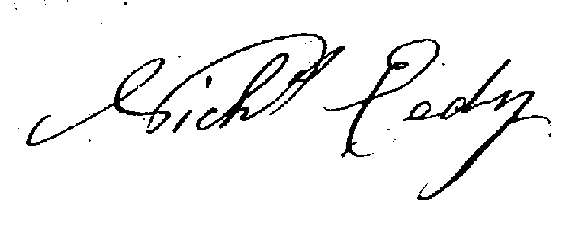
The presence of

“Robert Tresilian” The above Robert Tresilian maketh oath and saith that
“Richard Tresilian” he saw the Deed whereof the above writing is a Memorial duly executed by the parties thereto and also saw the above Memorial duly perfected by the above named Nicolas Edy and Saith the name Robert Tresilian Subscribed as a Witness attesting the due execution of said Deed and Memorial respectively is this Deponents proper name and handwriting.

Sworn before me this 21st day of April 1820 (twenty) in the Town of Bandon in the County a Commor for taking affs by Virtue of a Commission forth of his Majesty Court of Exchequer to me directed. And I know the Dep(onent)

- Nicholas Eedy was the second son of Nicholas and Hannah as confirmed by Deed No. 511038. Nicholas married Elizabeth Pine in 1761. Their marriage is recorded in the Index to Cork and Ross Marriage Licence Bonds, 1750-1845. No information concerning children of Nicholas Eedy and Elizabeth (Pine) Eedy has been found to date.

Nicholas’s father died in 1766 as noted in The Index of Admons and Bonds. There are two other entries in the Index of Wills and Probate and the Index of Admons and Bonds, Diocese of Cork & Ross for a Nicholas Eedy. In 1775 the will of Nicholas Eedy of Keelbree (sic) is probated and in 1789, Admons are issued for a Nicholas Eddy of Johnston (near Dunmanway). Which one of these entries applies to this Nicholas remains unknown.

- William Eedy was the third son of Nicholas and Hanna, born 1743. William married Mary Stanley in 1773, Index to Cork and Ross Marriage Licence Bonds, 1750-1845. There are no further details of this marriage. William died intestate in1794 when letters of administration were issued for “William Eedy of Killeens, farmer”. Index to Admons and Deeds, Diocese of Cork & Ross, District Registry Cork.

William and Mary had a son Robert who was baptized 15 July 1787 at the age of 1½ years. His sponsors were Thomas Bateman, Robert Eedy and Lydia Eedy. (The Church of Ireland Parish Registers of Murragh, Co. Cork.). Robert married Jane Morgan, born 1789, on 12 June 1813 at Murragh, as recorded in the Church of Ireland Parish Registers of Murragh, Co. Cork. It is this Robert who is our forbear.

Again, deeds provide interesting information.

Deed No. 442 12 285730, dated 5 July 1790 is an indenture of mortgage from Joseph Stanley of Carhue, Farmer to William Eady of Killeens, farmer, for 25. The original grant to Joseph by his father David Stanely was for the lives of “Joseph, David the Younger, and James”. It is believed that Mary was a sister to Lydia, Joseph, David the Younger and James.

William and Mary also had two daughters – Lydia who married Wills Anstice. Although no marriage record was found for Lydia and Wills, the baptisms of five of their children were recorded at Ballymodan, Bandon, between 1819 and 1827. Correspondence between Lydia and Wills and Robert and Jane sheds invaluable light on their lives in Ireland.

A daughter Susan married a Huston (Hewston). Again, valuable information is gleaned from the correspondence between Robert and his family and we learn that Susan immigrated to Canada at some point with the following children – William, John, May (Mary) and Sally. Sally married William Farrell and their names appear on the list of “in town” members of the Bathurst and New Bandon Circuit, Methodist Society, page 32, New Brunswick Archive Film # 1126. The family left New Brunswick for Upper Canada.

4. Jonathan Eedy married Rebecca Wolfe of West Dunmanway, 20 May 1766, at St. Nicholas, Index to Cork and Ross Marriage Licence Bonds, 1750-1845.

The following documents, as transcribed from the originals, confirm Jonathan’s role as churchwarden in Kilmeen Parish in 1788. Charles Eedy one of the “Protestant Parishioners” is assumed to be the son of Jonathan Eedy and Elizabeth (Bateman) Eedy. The documents were provided by Sharon Haggerty, London, Ontario, whose gr-gr-grandfather James Haggertie, Jr. brought them with him when he immigrated to Ontario in 1827.

Number 1:

We the Undernamed Applotters at a Vestry holden in the Parish Church of Kilmeen, Easter Monday March 24th 1788. To Applot the Sum of Ten P’ds agreed on in S’d Vestry to be (assessed?) on the Inhabitants of the Parish of Kilmeen, as a Maintenance for James Haggertie, Parish Clerk at the rate of Eight Shillings and ninepence ? on Each and every Plowland in S’d Parish being 22 in Number and ten Gneeves Part of anoth’r Plowland.

Given under our Hands this 24th day of March 1788

John Wolfe
George Fuller
Fran’c Smyth
Jam’s Haggertie

The above, being the Second Transcript of the Applotment of the Sum of ten pounds for the maintenance of the Parish Clerk which was this day Confirm’d and finally Ascertaind, We the Rect’r Church Wardens and Protestant Parishioners in Vestry Assembled do hereby Subscribe our Names to it Pursuant to the Statues in order that one Part may remaine with the Church Warden and the other be delivered to the Parish Clerk Given under our Hands this 20th day of April 1788

Isaac Watkins Rect’r
Jam’s Haggertie Church
Jonathan Eedy Wardens
John Wolfe
George Fuller
Franc’s Smyth
Charles Eedy

Number 2:

We the Undernamed Applotters at a Vestry Holden in this Parish Church of Kilmeen, Easter Monday March 24th 1788. To Applot the Sum of two Pounds seventeen Shillings and one Penney agreed on in S’d Vestry as a Parish Coss for the repairs of the Parish Church and other Necessary Charges in S’d Parish, do hereby Applot the S’d on the Inhabitants of the Parish of Kilmeen at the rate of two Shillings and Sixpence on Each and every Plowland in S’d parish being twenty two in number and ten Gneeves Part of another Plowland

Given under our Hands this 24th day of March 1788

John Wolfe
George Fuller
Fran’c Smyth
James Haggertie

The Above, being the Second Transcript of the Applotment of the Parish Coss which was this day finally ascertain’d and confirm’d in Vestry, We the Rect’r Church Wardens and Protestant Parishioners do hereby Subscribe our Names to it Pursuant to the Statue in order that one Part may remaine with the Rect’r and Parishioners and the other Part be delivered to the Church Wardens to collect and receive the Same with all convenient Expedition

Given under our Hands this 20th day of April 1788

Isaac Watkins Rect’r
Jam’s Haggertie Church
Jonathan Eedy Wardens
John Wolfe
George Fuller
Franc’s Smyth
Charles Edey

Number 3:

To James Haggertie and Jonathan Eedy
Church Wardens of the Parrish of Killmeen

County of Cork ~ We the under named Justices of Peace for the Said County do hereby Impow’r and authorize you and Each of you to collect and Receive the Sum of twelve Pounds Seventeen Shillings and one Penney Sterling in the annex’d assessments and applotments Mentioned from the Inhabitants of the Parrish of Killmeen at the rate of eleven Shillings and Sixpence on Each and Every Plow Land in Said Parrish and if any of the Said Inhabitants Shall Refuse or Neglect to Pay the Money Charged on them by S’d Assessments we do hereby also Impower and Authorize you or Either of You to levy the Same by Distress and Seal of the Goods of such Person and Persons who shall Refuse or Neglect to pay the same turning the Pluss? If any therebe after Deducting the charges of Such Distress and Seal

Given under our hands and Seal this 26th day of June 1788

Henry Cox
John Bernard

(Historical Note - The Irish Linen Board released a list of almost 60,000 individuals who had received awards for planning a specified acreage of flax. Those who planted 1 acre were awarded 4 spinning wheels and those growing 5 acres were awarded a loom. This list was dated 1796. Charles Eedy, Kilmeen Parish is noted.)

Information concerning Jonathan and Rebecca’s children is as follows:

William Eedy, born 1767 and described as “of Saroo” married Susanna Hill (daughter of David Hill) in 1806, Index to Cork and Ross Marriage Licence Bonds 1750-1845. William of Saroo and Susanna had a son William, baptized 24 April 1814 and five daughters. They immigrated to Clifton, New Brunswick in 1828. William Eedy who died 15 March 1839 and his wife Susan (sic) who died 21 October 1852, are both buried in the Old Anglican Cemetery, formerly known as the King’s Burying Ground, Douglas Avenue, Bathurst, New Brunwick. It should be noted that James Hewston (sic) in his 31 December 1828 letter and Wills and Lydia Anstis in their 29 May 1830 letter refer to William and his family.

Their son William married his cousin, Susan Hill (1820-1916) and had four sons and three daughters. The sons were – William Wallace (1846-1900), David, Horace and Thomas Boyle (1861-1923). William Wallace married Janet Hamilton Cook (1859-1933) and they had sons Duncan and Donald. A great deal of information about William and Susan Eedy’s family is contained in the records of Gloucester County, New Brunswick.

According to tradition, the second son of Jonathan and Rebecca (Wolfe) Eddy was
John Eedy, born 1785, Church of Ireland Parish Registers South & West Cork. The span of time between the births of these two men is 18 years. This would not be unusual if there were many children, with William being the oldest and John being one of the youngest. But there is confusion with respect to John Eedy. Kilmeen Parish Records indicate that there were two John Eedys – one married to Elizabeth and one married to Anne and that both couples had children baptised during the same period of time. These two men, with their families, immigrated to New Brunswick. Some of their descendants eventually settled in Ontario as set out in the records below.

From Killmeen Parish Records we know that a John Eedy married Elizabeth Tanner 21 or 29 January 1807, by licence, Church of Ireland Records, Kilmeen Parish. Elizabeth was the daughter of Richard Tanner. John and Elizabeth are described as “of Saroo”. According to the Parish of Kilmeen Records, two of the following children were baptized in Ireland:

Charles, baptized 17 January 1808, Kilmeen Parish. Charles married Ellen/Eleanor ? According to the 1861 Census for London Township, Charles is listed as being 51. His wife, Elleanor (sic) is age 37, and his children are John, age 19, Elizabeth, age 16; Jane, age 11; Martha, age 8 and Mary Ann, age 5. This census notes that he lives next door to Jonathan. He died in Middlesex County, Ontario in 1874.

Richard, baptized 27 August 1815, Kilmeen Parish. Richard married Ellen Wolfe of Skibbereen, County Cork. He died in 1889 and Ellen died in 1911; both are buried in Birr Cemetery, London Township, Ontario. Richard and Ellen had the following children which is confirmed by the 1861 Census for London Township. Richard is noted as age 41 and his wife Elleanor (sic), age 30 and their 4 children - John Wolfe Eedy, age 6 (born 1854 in London Township); Elizabeth, age 4; Mary Ann, age 3 and Charles, age 1. They were living on Lot 8, Concession 16. John Wolfe Eedy became a public school principal. Later he went into the newspaper business and, in 1899, owned a controlling interest in the St. Thomas Daily Times. He became owner of The St. Mary’s Journal. He had one daughter, Irene, who married Archibald Gillies and had no children; and one son, Lorne Alden Richard Eedy, born 10 July 1881 at Elginfield, Middlesex County, Ontario, who married Margaret Grace Evelyn Wilson.

Jonathan, born 1821, died 1870, Middlesex County, Ontario. In the 1841 Census for Biddulph Township, Jonathan was living in a one storey log house. On the 1851 census, Jonathan is listed as a widower. His wife Martha Clarke, who he married in 1832 according to the Diocese of Cork & Ross Marriage Licence Bonds, died by the time of the census in 1851. Their children are listed as follows – Anne, baptised 1 September 1833, Kilmeen Parish Records; Susan, baptised 3 May 1835, Kilmeen Parish Records; Jonathan, baptised 16 July 1837, Kilmeen Parish Records; Mary, baptised 14 February 1841, Kilmeen Parish Records, Martha, born 1843, Canada and Eliza, born 1846, Canada. Jonathan is listed in the 1861 Census for London Township as being 50, living with his brother Richard and family. His daughter Anne married Daniel Rattle. According to The London Advertiser, 25 February 1870, “On the 24th inst., at the residence of Daniel Rattle, Adelaide Street, Jonathan Eaddie (sic), father-in-law of the above, aged 63 years. The funeral will leave the residence of D. Rattle tomorrow (Saturday) at 10 o’clock a.m., to the family burying ground, 13th concession London Township”. His daughter Susan married William Hill and they had two children, Louisa born 1863 and Robert born 1865. Susan died 16 February 1868. William Hill died 10 May 1869.

Jonathan Eedy’s will was proved and registered in the Surrogate Court of the County of Middlesex and reads as follows.

I, Jonathan Eedy of the Township of London, Dominion of Canada, do make and publish this, my last Will and Testament in Manner and form following, that is to say ~
First, my funeral expenses and all my just debts to be paid
Secondly, I give and bequeath to my two grandchildren Louisa Martha Hill and Robert James Hill, children of my daughter Susan Hill, the sum of two hundred dollars each to be put out at interest until they arrive at the age of twenty one years or if either of them should die before arriving at that age, the survivor to have the whole amount, in default the amount to be equally divided amongst all my other grandchildren.
Thirdly, I give to my daughter, Martha Eedy, the sum of forty dollars in addition to her other portion.
Fourthly, my daughter, Eliza James to pay to my Executors the sum of one hundred and thirty dollars with interest thereon as much as will be due thereon at the time of my decease.
Fifthly ~ the one hundred and thirty dollars mentioned above, there to be added to the principal and interest to the Mortgage in my favour from Mr. John Dearness of Biddulph and Alexander Grant of Biddulph together with whatever monies I may possess at my decease, and then to be equally divided amongst my four daughters – Ann Rattle, Mary Burton, Martha Eedy and Eliza James.
And lastly I hereby institute and appoint Mr. Daniel Rattle and James Burton to be Executors for this my last Will and Testament.
In testimony whereof I have hereunto set my hand and seal this thirteenth day of November one thousand eight hundred and sixty nine.

Joseph, born 1824, died 1910, Middlesex County, Ontario. He is listed on the 1861 Census, London Township as living close to Charles and Richard. According to the census, Joseph was 36, his wife Elizabeth was 34 years old and their 7 children were Elizabeth, age 14; John, age 11; Jane, age 9; Richard, age 7; Edward, age 4; Charles, age 2 and Sarah, age 1.

Edward, lived in Biddulph Twp., Middlesex Co. An article which appeared in the Supplement to The Canadian Free Press, February 14, 1868, page 3, together with the following burial information suggests that Edward may have committed suicide on the same day his son Edward died.

“Suicide in London Township – We learn that a man named Edey, who resides on the 16th concession of London Township, committed suicide on Saturday eight last by cutting his throat with a razor. He was in unsound mind, and no special reason is assigned for the rash act. He was in independent circumstances and leaves a wife and four young children.”

Buried in the cemetery at Birr, Ontario, Row XI is Maria Lindsay, 1829-June 25, 1914, “Married Edward Eedy”; Edward Eedy, 1853 – February 8, 1868; John Eedy, 1856 – September 22, 1863; William Eedy, 1858 – July 29, 1874; Jane Eedy, 1861- June 19, 1874; Jonathan Eedy, 1866- October 22, 1895. Edward Eedy Sr. is not buried with his family.

William, born 1836 died 1869, Middlesex Co. On the 1861 Census, William is noted as 51 years; his wife Jane is 31 years and their 5 children are – John, age 6; Elizabeth, age 4; Will, age 5; ?, age 2 and a baby, age 1. There is also an 18 year old servant. Jane Lindsay died 16 September 1866. William married Sarah Parkinson 13 August 1867. The marriage record noted that the parents of William are John and Elizabeth Eedy.

William Eedy’s will is entered and registered as No. 67 on 24 February 1869, London Township.

I, William Eedy of the Township of London in the County of Middlesex and Province of Ontario, Yeoman of the age of thirty-eight years and being of sound mind and memory do make, publish and declare this my last will and testament in manner following to wit. My will is that my funeral charges and just debts shall be paid by my executors hereinafter named. The residue of my estate and property which shall not be required for the payment of my just debts – funeral charges and the expenses after doing the execution of this my will and the administration of my estate I give, devise and dispose thereof as follows that is to say.
First, I give and bequeath to my wife Sarah Eedy, the sum of one thousand dollars out of the proceeds of my farm, which I have this day sold to my brother John Eedy for the sum of four thousand dollars, the said sum of one thousand dollars to be paid to her in manner following. One hundred dollars immediately after my decease and the remaining nine hundred dollars in one year from that date.
Second, I will and devize (sic) that my four sons, John, William, Richard and Edward Eedy shall be paid each the sum of seven hundred dollars, as they severally become of the full age of twenty-one years, the same to be paid out of the proceeds of the sale of my estate as aforesaid by my brother John Eedy.
Third, I give, devize (sic) and bequeath all the rest and residue of my estate, real and personal and mixed including horses, cattle, sheep, farming utensils, hay, grain and household furniture of what nature or kind soever to the care of my Executors hereinafter named to be appropriated by them to the payment of my just debts and other lawful expenses connected with the disposal of my estate, and in case after the payment of my just debts and expenses as aforesaid there yet remains a surplus in their hands, I will and devize (sic) that the same shall be divided equally between my four sons heretofore named as they respectively become of age.
And lastly, I hereby appoint my three brothers, Charles Eedy, Richard Eedy and John Eedy to be the executors of this my last will and testament and enjoining upon them severally the faithful carrying out of the intentions herein set forth.
I further wish and will that in case of the death of any of my four sons before mentioned before they arrive at the age of twenty-one years the appotionment (sic) allotted to him shall be divided share and share alike between the remaining survivors and I hereby revoke all former last wills and testaments by me heretofore at any time made.
In witness whereof I have hereunto set my hand and affixed my seal this twenty third day of January in the year of our Lord one thousand eight hundred and sixty-nine.

According to the Kilmeen Parish Records, a John and Anne Eedy of Saroo had the following children baptised in Ireland:

Sarah, baptised 7 May 1809
Elizabeth, baptised 9 December 1810
Jonathan, baptised 20 December 1812
Susan, baptised 12 February 1815. Susan married Edward W. Ellis who
was born 1805 in Ireland. She died 19 August 1885 in Bathurst, N.B.
Mary, baptised 5 June 1817
William, baptised 9 May 1824. In the Stonehaven Cemetery, New
Brunswick there is a headstone for Ellen, Wife of William Eady who died at the age of 42 on 16 January 1868. Also named on the headstone are their children – William, 21 September 1880, 19 years; Rebecca, wife of James Ellis, 21 February 1881, 26 years and Robert H., 6 October 1882, age 17. According to the parish records of St. George’s Anglican Church, Bathurst, New Brunswick “Ellen, wife of William Eedy and daughter of ___Sargent of New Bandon, aged 41 years was buried by in the graveyard of St. George’s Church this 19th day of January 1870 by me Wm. LeB. McKiel, Rector.”

In the Death and Burial Records of St. George’s Anglican Church, Bathurst, New Brunswick Archives Film #1099 , the following entry is noted which probably refers to John Eedy of Saroo:

John Eedy aged 96 years, a native of Ireland and for many years a resident of New Bandon was buried in the grave yard of St. George’s Church, Bathurst, this 15th February 1870 by me Wm. LeB. McKiel, Rector

According to Volume 5 of Gravestone Inscriptions, Gloucester County, John Eddy, Native of Ireland, Age 90 years; his son Jonathan 1810 – 1893; his children Rachel 1847-1897; Johnathan (sic) 1860-1878; also 3 grandchildren, are buried in Christ Church Anglican Cemetery, Clifton, Gloucester County, New Brunswick.

A further entry in the Death and Burial Records for St. George’s Anglican Church, Bathurst most likely refers to the wife of Jonathan, the son of John and Anne, noted above.

Elizabeth Edy aged 80 years died 8 May 1899 and was buried at the cemetery at Tetagouche, Parish of Bathurst this 9th May 1899 by Rev. Wm. Harrison, a Methodist Minister. Mrs. Edy above named, widow of Jonathan Edy lived at the Parish of New Bandon until a few months before her death when she with her son Jonathan moved to Rose Hill, Tetagouche.

Records do not confirm the parentage of these two Johns. Theoretically, one was the son of Jonathan and Rebecca (Wolfe) Eedy; grandson of Nicholas and Hannah (Knowles) Eedy and one was the son of Charles and Ann (Hanglin) Eedy; grandson of Jonathan and Elizabeth (Bateman) Eedy. Our Robert Eedy was the grandson of Nicholas and Hannah (Knowles) Eedy.

Elizabeth Eedy Brown, who was the granddaughter of John Wolfe Eedy, attributed John, the progenitor of their line to Jonathan Eedy and Elizabeth Bateman who were married in 1742 in the Parish of Kilmeen. From Appendix 4 – Eedy Family from the booklet entitled Jasper Taylor and His Descendants:

“Jonathan Eedy, brother of Nicholas Eedy above, settled at Killdee, County Cork, Ireland, on the estate of Sir Michael Cox. From him descends John Eedy, pioneer of the Eedy family in Ontario.

First generation in Ontario – John, son of Charles Eedy, was born about 1785 and married, in Ireland, a daughter of Richard Tanner, “a fine, honest farmer” of Carriga Yreanan (in English: Sunny Rock), County Cork, Ireland. John Eedy with his wife and family went to Canada about 1844. His eldest son was Edward, whose daughter Victoria married John R. Campbell of Kelowna, B.C. and died in 1947. His second son was Richard.

Second generation in Ontario – Richard Eedy was born in 1815 at Skibbereen, County Cork, Ireland, near Bantry Bay. He went to Canada with his parents about 1844. He died in 1889 in London township, Middlesex County, Ontario, as the result of being kicked by a horse. His wife was Ellen Wolfe, who was born in 1833 in County Cork, Ireland. She died in 1911 near Granton, Middlesex County, Ontario. They had a son, John Wolfe Eedy.

Third generation in Ontario – John Wolfe Eedy was born 26 November 1854 near Granton, Middlesex County, Ontario and died 27 September 1932. He married Sarah Ellen Walden, daughter of Thomas Walden (who was born 6 May 1806 at Killashandra, County Cavan, Ireland, went to Canada about 1820, and died 28 April 1886 at Elginfield, Middlesex County, Ontario) and his second wife, Mary Kennedy.

William Eedy, Sr. of Clifton, New Brunswick and John Wolfe Eedy of St. Mary’s, Ontario either shared the same great-grandparents or their great-grandfathers were brothers. The following letters do not indicate the relationship.

Letter from William Eedy, Clifton, Gloucester County, New Brunswick to John Wolfe Eedy, St. Mary’s, Ontario, dated April 4th, 1877. William wrote to John Wolfe Eedy because he saw his name as a brother Mason – hence the references to Lodge S.T., the British Templars, and “in Faith and Charity”.

Clifton Gloucester NB April 4th 77

Dear Sir

I make bold to write you these few lines, at present we are strangers to each other but still we might be very near relations. I saw your name on the Western Advertiser and Weekly Liberal January 12th in connection with Lodge S.T. and excited my curiosity to know who you are and hope you will at your first convenience, my name is William Eedy and my grandmothers name was Wolfe, was born in Ireland County of Cork near Ross Carbery my Fathers name Wm. Eedy we came to this country in 1828 we are Church of England & Loyalists but un initiated, and I had cousins whose mother name was Wolfe they came to this country but I cannot say where John & William sons of Jonathan Eedy Clonakilty shoemaker you possibly might be a son to one of them as them & we are now rather aged to take office in the Lodge but I am a member of the United Temperance Association and have just changed its name from the British Templars So in Faith and Charity I request your answer Sir, our name is not a scarce one in the World I have seen it often & met several but never saw it spelled by any as by you before xcept our family and the connections of the families gives me great hopes that yet we will be better acquainted

(no signature)

William Eedy wrote a second letter dated 18 October 1877, obviously in response to John Wolfe Eedy’s reply to his original letter of April.

Mr. John W. Eedy,

Dear Sir,

Received yours of the 9th yesterday and I freely forgive the delay and accept the excuse you give and hope these lines will find all the Eedy’s up there well and happy as it leaves us at present, thanks to a merciful God.

Truth, Sir, when you say I can find a relationship. When you said Rossmore Par, Killdee, I got the key. We are related, the same blood runs through our veins though it is a long distance. Now I will tell you I will have to go back to the days of the Commonwealth of England. When Oliver Cromwell marshalled the Invincibles, in his ranks were two brothers, Jonathan and Nicholas Eedy as you will find in history. He came to Ireland which held out for Charles the First when it was subdued a great many of his (Cromwell) officers got the confiscated estates. Their men settled on them as tenants both for protection to the landlords and to keep the Irish in subjection. Now, Sir, those two men were our ancestors. Jonathan settled at Killdee with Sir Michael Cox. I am pretty sure that Jonathan was the father of Charles. You know the remaining part and Nicholas Eedy settled at Killbree, near Clonakilty on the estate of Colonel Allen who lived in England. They were Welshmen. That Nicholas Eedy was marrked (sic) to Hannah Knowles. His sons were Nicholas, Jonathan, William and Robert with several daughters. This Jonathan was father of William Eedy of Saroo. His mother’s name was Rebecca Wolfe from west of Dunmanway. This Wm. Eedy of Saroo was my father and my mother’s name was Susan Hill, daughter of David Hill of the same plowland. Now, Sir, I think I have shown you what I promised. My father was the man your father can remember coming to this country. It was in 1828. At that time I was only thirteen years old. I have no brother. I had five sisters. Four are still living and settled close by. My father was sixty-three years old when he came to this country. He died in 1839 and my mother in 1857 and their bones are in Christ Churchyard, Bathurst.

I got this history of the family from father and I can well remember to see your grandfather John Eedy at Saroo and afterwards to see him and Nicholas Eedy of Knockea (Knockey, Lyre, Clonakilty) who was the son of Robert Eedy, and my father in a tent at Balagurteen fair the year before we left home taking a farewell glass of whiskey. And I had mine and if your father and me met I think we would likewise.

And now, I will tell you that I know your other grandfather, Richard Tanner, of Carriga Greanan which in English is Sunny Rock, perfectly well and a fine honest farmer he was (this is no policy) and his oldest son Joseph he was married to a Miss Buttimore. She was a small sized woman. He was very tall and Edward the son that worked the farm. I can’t say that I can recollect any of the daughters, but one that was married to John Parret. I saw her funeral. The old gentleman was twice married. The last was a widow Rashley. I forgot that another was married to Edward Rashley, her son and Mrs. Tanner’s daughter Fanny Rashley was married to John Hill my uncle. These were all descendants of Cromwell’s Ironsides and I am happy to say pure and undefiled protestant blood at your side and mine so far and I hope will keep so forever.

And again I will tell you I was married to a cousin of mine. Her maiden name was Susan Hill. We have four sons and three daughters living and we buried one son and two girls. The boys’ names are William, David, Horace and Thomas. You might see some of them yet in your country. Wm. was in Wisconsin awhile and got sick there and came home. He is at present in St. Johns, N.B. at carpenter work. When West he worked with a Canadian who told him he knew several of the Eedy’s in Upper Canada.

Your friend and relative,
Wm. Eedy, Sr.

Writing again on 9 December 1878, William provided interesting details of day-to-day life in Clifton and he expressed personal political views, which reflect his time. Unfortunately, his letter did not contain any further family history. It is transcribed exactly as written.

Clifton Gloucester Dec. 9th 1878

My Dear Realations (sic) & Friends

I received your letter and post cards all in due time which would give me the greatest pleasure if I could meet the appointment but it was impossible as I had not health of it to under take the journey. I got a bad cold in July & by the rainy weather I did not fully recover yet & an uncertainty if I will but the Lords Will be Done We are strangers & pilgrims as our Father were & if we cannot meet in America I hope we may meet in the New Jerusalem where there will be joy ever more.

It is true I could have written before now but putting (sic) off from day to day its come this late for which I ask you indulgence & if my life & health is spared I hope to do better. I was glad to see ye were all in good health and that ye had an abundant harvest which is a great blessing to be paid for a mans labour in a Salubrious healthy climate as Ontario must be but our climate seams to be improving as we have no snow yet & very little frost but considerable rain. I am sorry to tell you that our crops did not do well this last season there was too much rain & fog. Wheat got the rust & is a very poor crop so did some oats and as a general thing potatoes got blighted very early they were small and are rotting in the cellars they will be scarce for see hay was abundant but there is no market for it and fish was very plenty in our Bay but the Yanky fisher men glutted their markets so we have no sale for our mackrel catching them was lost time salt the English Government should have left our fish to our selves it will help toward annexation for where your treasure is there will your heart be also after all their bunkum they paid the award but we must have better times surely with the Infallible emaculate Sir John it seems there was no Paccifac (sic) Scandal or we have very short memories```and how is it that your county could do no better than return a Coughlan certainly an Irish Papist worse than our Anglin for he is true Protestant blood but a turn coat he was born in Clonakilty & partly Wolfe he is a good orator.

Now Dear Friend having said so much on every other subject a few words on our newly arrived Nobility they passed by in the night we heard the guns fired its 17 miles to the station I am tired of reading the ovations it savors of Idolitry but it may be on account of the old puritan blood still in these veins I do love our Queen our country & its Laws but I would not bow down & worship them it might be wiser to spare the praise till we see what good will be done for us they will cost us dear enough for their visit.. with its true times cannot be much worse than at present. But there is a move making here to run a branch line from the intercolonal to Shippagan if New foundland will come in the union this winter its moved by Honr. Robert Young of our Local Legisture the govmt. Gives 5000 Lots per mile & will be made by a company it would stir up the stagnation they want to get a free right of way I will give it but am afraid it will be too far back from the shore it is about 60 miles, the Domn Governt are making a brake water in Shippagan these years past so the start is made.

Now Dear Friend when I said I would sell my farm it was an impossibility for money is too scarce down here many farmers foolishly get in debt to merchants & they sell to all that want to buy cheaper than I could again the Boys count this the finest country in world now I ask you if we could not raise a trade if you could sell our fish mackrel cod flake flerrin (?) we want flour corn meal I do not know what the freight would be by Rail per Bl from Bathurst Gloucester to London Ont. Think it over it just came in my mind as I am writing I could by 100 Barrels mackrel for flour at 6¢ your cheap flour would do Now I will tell you there is an old Gentleman in London that know me well Benjamine Dawson Esq his son is editor of the London Herrald We came by some disconvenance this last summer by the failure of Ferguson Rankin & Co. my Boys lumbered for them last winter & the logs are not disposed of yet don’t think we will loss much.

Now Dear Friend I will conclude by wishing you & your Family Friends & our Relatives a Merry Xmas and Happy New Year & believe me

Your Well Wisher

William Eedy Sr.

The following photographs illustrate the striking family resemblance between John Wolfe Eddy and George Samuel Eddy. Clearly there are very strong Eedy/Eddy genes.

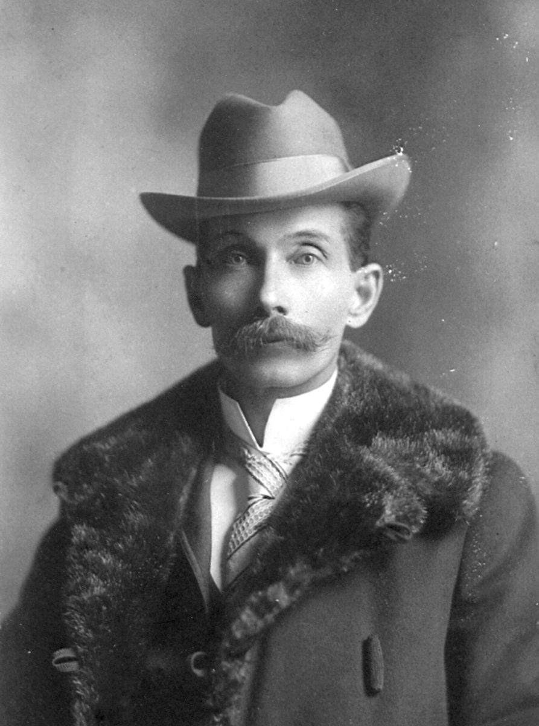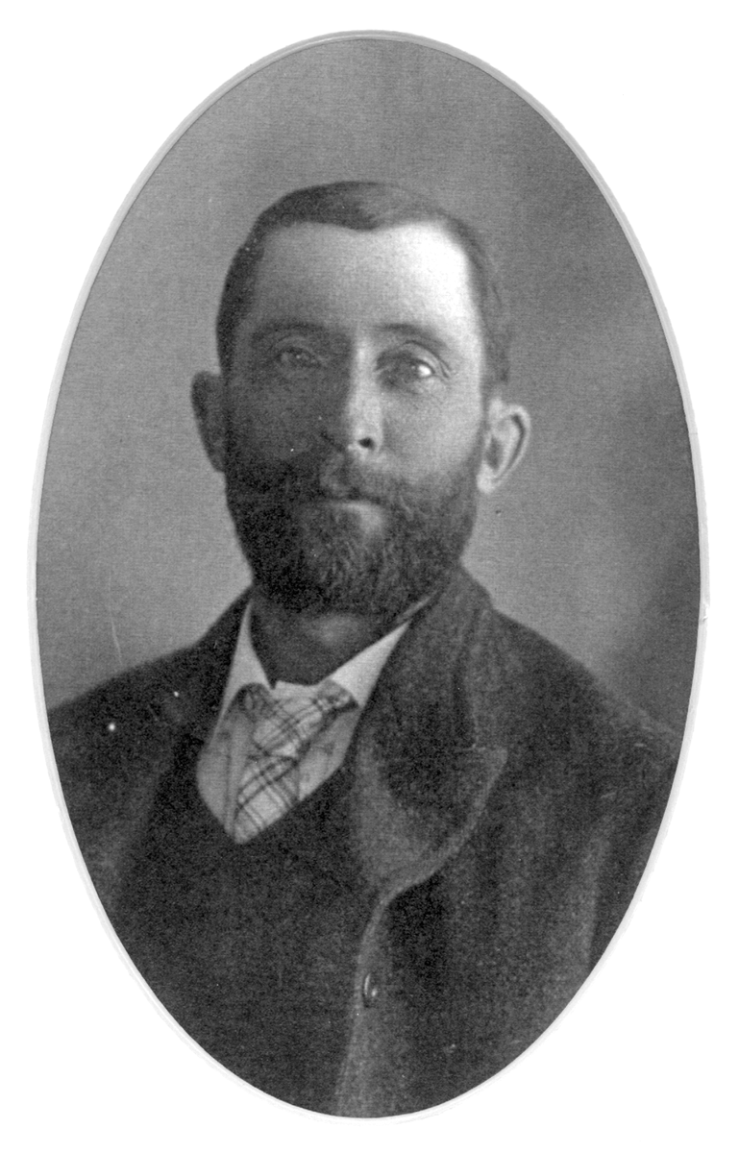
John Wolfe Eedy George Samuel Eddy
born 26 November 1854 born 6 January 1863
near Granton, Middlesex County, Ontario in Bathurst, New Brunswick

